**Install windowsdesktop-runtime-6.0.22-win-x86.exe**

This .NET 6.0 package is needed for OM6629 programming

**Install arm-gnu-toolchain-13.3.rel1-mingw-w64-i686-arm-none-eabi.exe**

**Please choose add path to the environment variables.**

**Install Git-2.51.1-64-bit.exe**

**Open Git Bash here**

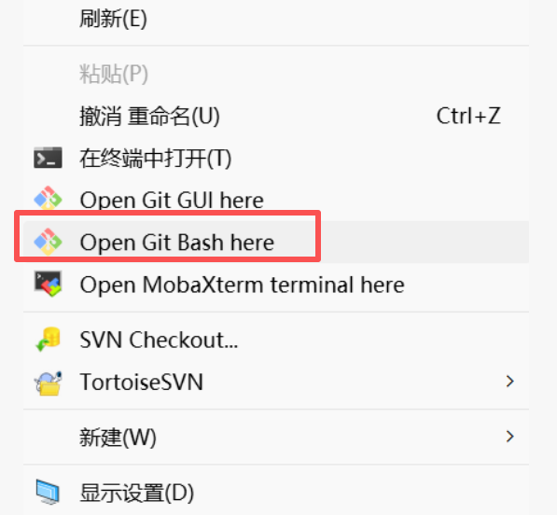

Try **arm-none-eabi-gcc.exe –version** to make sure the installation is ok or not

