一、规格需求

二、第二版更改

1. 尺寸（分辨率）限制：加在头部
只有文生图模式才可以设定尺寸。头部信息示例：text-img,320x320

识图模式服务器下发数据包示例
识图模式，本轮对话结束的标志：
JSON: {"code":200,"message":"对话完成！","flag":"normal","info":"mp3 response end!","index":15,"asr_info":"","instruction_word":"","url":"","unix_timestamp":null,"alarm_cyc":null,"file_path":"","push_ahead":"","skill":""}

固定渲图模式参数设定
img-img,ghibli = 网红日漫风
img-img,3d = 3D风
img-img,real = 写实风
img-img,angel = 天使风
img-img,cartoon = 动漫风
img-img,makoto = 日漫风
img-img,princess = 公主风
img-img,dream = 梦幻风
img-img,ink = 水墨风
img-img,new_monet = 新莫奈花园
img-img,watercolor = 水彩风
img-img,monet = 莫奈花园
img-img,marvel = 精致美漫
img-img,cyber = 赛博机械
img-img,korean = 精致韩漫
img-img,chinese_ink = 国风-水墨
img-img,romantic = 浪漫光影
img-img,ceramic = 陶瓷娃娃
img-img,chinese_red = 中国红
img-img,clay = 丑萌粘土
img-img,doll = 可爱玩偶
img-img,game = 3D-游戏_Z时代
img-img,movie = 动画电影
img-img,toy = 玩偶

请求头
（1）文生图(支持回传尺寸大小)：text-img,320x320
（2）文+图生图: text&img-img //根据文字描述进行渲染，服务器只返回图片数据
- 文图生文(万物识图): text&img-text //自由设定文本内容+图，服务器返回文本和语音
（4）图生图(需传对应风格): img-img,movie //固定模式渲染[传固定参数]

三、问题集

1.RECV RST
服务器下发完最后一笔，如果设备端有发送的行为，会有概率性RECV RST；原因是服务器断开连接，设备端有发送行为。
[18:22:08.032] [00:00:21.588]Received binary data, total_len:270
[18:22:08.032] [00:00:21.589]JSON: {"code":200,"message":"发送语音文件！","flag":"normal","info":"mp3 response sending!","index":1,"asr_info":"它们都是白色的，","instruction_word":"","url":"","unix_timestamp":null,"alarm_cyc":null,"file_path":"","push_ahead":"","skill":""}}
[18:22:08.032] [00:00:21.598][RECV RST]
[18:22:08.032] [00:00:21.606][RECV RST]
[18:22:08.064] [00:00:21.640] . Warning Socket Recv timeout
[18:22:08.112] [00:00:21.690] . Warning Socket Recv timeout
[18:22:08.160] [00:00:21.740] . Warning Socket Recv timeout
[18:22:08.223] [00:00:21.790] . Warning Socket Recv timeout
[18:22:08.271] [00:00:21.840] . Warning Socket Recv timeout
Debug: 不要求服务器死等，但是要把收ACK包的时间拉长。

最后一个JSON包index字段设置有问题
没有跟旧的协议一致。
[18:48:22.473] [00:00:06.896] . Recv messge size = 285
[18:48:22.473]
[18:48:22.473] [00:00:06.897]Received binary data, total_len:285
[18:48:22.473] [00:00:06.897]JSON: {"code":200,"message":"发送语音文件！","flag":"normal","info":"mp3 response sending!","index":2,"asr_info":"杯身上有浅棕色的心形图案。","instruction_word":"","url":"","unix_timestamp":null,"alarm_cyc":null,"file_path":"","push_ahead":"","skill":""}
[18:48:22.689] [00:00:07.111] . Recv messge size = 15377
[18:48:22.689]
[18:48:22.689] [00:00:07.112]Received binary data, total_len:15377
[18:48:22.689] [00:00:07.113]head:qyai
[18:48:22.689] [00:00:07.113]data_type:0
[18:48:22.689] [00:00:07.113]total_seq:4
[18:48:22.689] [00:00:07.114]seq:0
[18:48:22.689] [00:00:07.114]data_sum:1682864
[18:48:22.689] [00:00:07.114]len:15360
[18:48:22.689] [00:00:07.115]app recv data_type:0, last_pkg:0
[18:48:22.689] [00:00:07.116]this seq rev done
[18:48:23.052] [00:00:07.475] . Recv messge size = 15377
[18:48:23.052]
[18:48:23.052] [00:00:07.476]Received binary data, total_len:15377
[18:48:23.052] [00:00:07.477]head:qyai
[18:48:23.052] [00:00:07.477]data_type:0
[18:48:23.052] [00:00:07.477]total_seq:4
[18:48:23.052] [00:00:07.478]seq:1
[18:48:23.052] [00:00:07.478]data_sum:1751726
[18:48:23.052] [00:00:07.478]len:15360
[18:48:23.052] [00:00:07.478]app recv data_type:0, last_pkg:0
[18:48:23.052] [00:00:07.479]this seq rev done
[18:48:23.287] [00:00:07.710] . Recv messge size = 15377
[18:48:23.287]
[18:48:23.287] [00:00:07.711]Received binary data, total_len:15377
[18:48:23.287] [00:00:07.711]head:qyai
[18:48:23.287] [00:00:07.712]data_type:0
[18:48:23.287] [00:00:07.712]total_seq:4
[18:48:23.287] [00:00:07.712]seq:2
[18:48:23.287] [00:00:07.713]data_sum:1728036
[18:48:23.287] [00:00:07.713]len:15360
[18:48:23.287] [00:00:07.713]app recv data_type:0, last_pkg:0
[18:48:23.287] [00:00:07.714]this seq rev done
[18:48:23.524] [00:00:07.923][RECV FIN]
[18:48:23.524] [00:00:07.924] . Recv messge size = 14897
[18:48:23.524]
[18:48:23.524] [00:00:07.925]Received binary data, total_len:14897
[18:48:23.524] [00:00:07.926]head:qyai
[18:48:23.524] [00:00:07.926]data_type:0
[18:48:23.524] [00:00:07.926]total_seq:4
[18:48:23.524] [00:00:07.927]seq:3
[18:48:23.524] [00:00:07.927]data_sum:1853950
[18:48:23.524] [00:00:07.927]len:14880
[18:48:23.524] [00:00:07.928]app recv data_type:0, last_pkg:1
[18:48:23.524] [00:00:07.929]this seq rev done
[18:48:23.524] [00:00:07.929] . Recv messge size = 236
[18:48:23.524]
[18:48:23.524] [00:00:07.930]Received binary data, total_len:236
[18:48:23.524] [00:00:07.931]JSON: {"code":200,"message":"对话完成！","flag":"normal","info":"mp3 response end!","index":0,"asr_info":"","instruction_word":"","url":"","unix_timestamp":null,"alarm_cyc":null,"file_path":"","push_ahead":"","skill":""}":null,"file_path":"","push_ahead":"","skill":""}
[18:48:23.524] [00:00:07.934]===============info:mp3 response end!

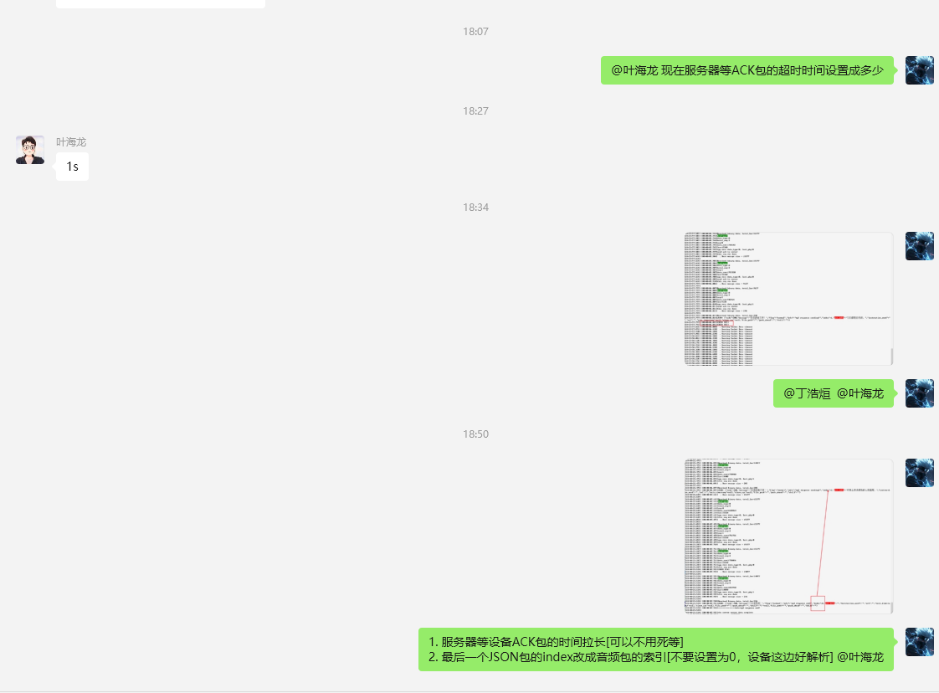

JSON包打印乱码

内存问题，printf没有遇到结束符就一直打印下去。处理如下图【基于临时的debug代码】：
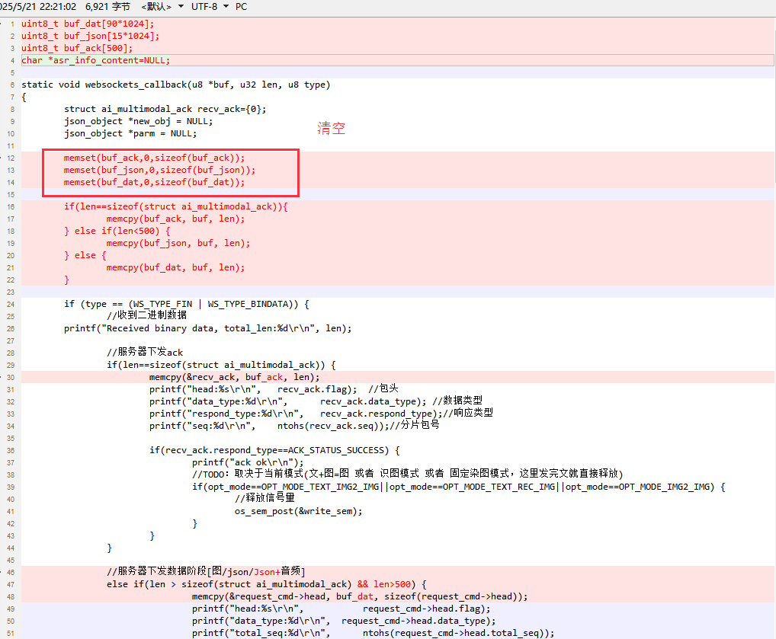

协议栈打印
每一轮对话完成，都有这些协议栈的打印，是正常的：
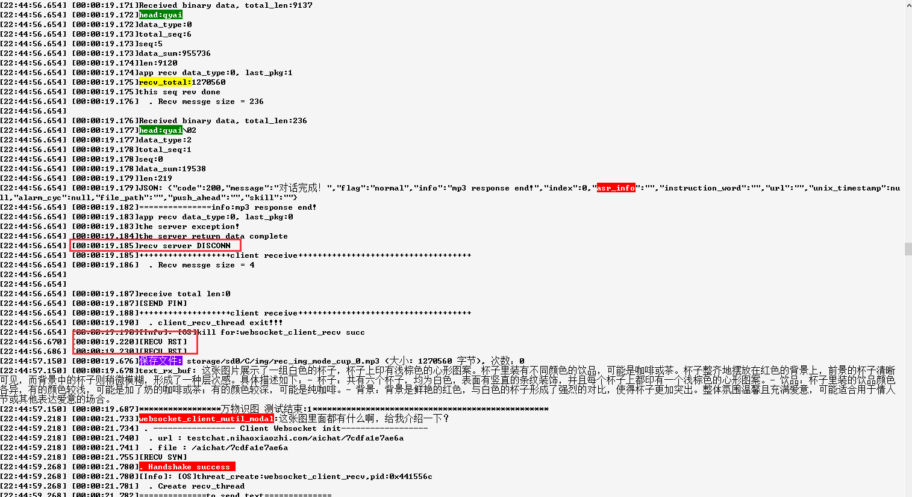
但是服务器可以断开慢一点【服务器断太快，设备端有些消息看不到】。
解决：服务器收到ACK包后，每一轮对话的最后，延迟一下再断开。

风险和内存覆盖问题
可以排除。因为callback是串起来做的。不会有内存覆盖问题。所以可以直接用callback里面的buf:
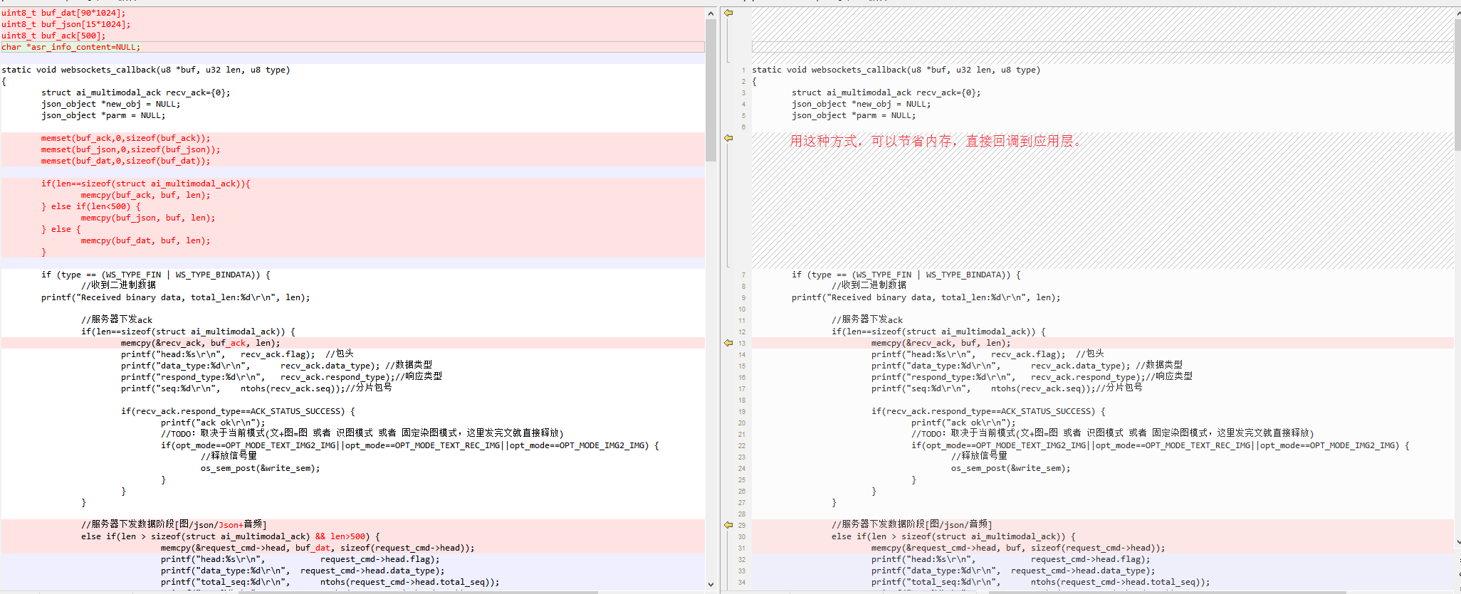

代码整理和流程审核

万物识图模式流程


