微擎插件安装教程

安装、更新与卸载

http://s.we7.cc/index.php?c=wiki&do=view&id=1&list=384

微擎

https://www.kancloud.cn/donknap/we7/136556

微信公众号：点了码

点餐后台账号：

http://www.dianlema.net

admin11 / 12345678

管理员

admin / apestar2017Diancan

数据库：

http://116.62.184.110:8888/index.php?

zijidelu/apestar2017Diancan

root/zijidelu

ftp：116.62.184.110

jieqiang/jq123456

zijidelu/apestar2017

数据库：

http://116.62.184.110:8888/Runtime/pm_1521_ea4f3288fba413ee2a26124dae1faeb8/

root/zijidelu

http://116.62.184.110:8888/index.php?

jieqiang/jq123456

你全站搜索 //hjay

黄傑:

带标记的就是我改的，部分可能有缺失

======================

蜂鸟配送：https://open.ele.me/documents?to=%2Fdocument%2Fpage%2FsettleInH

达达配送：http://newopen.imdada.cn/#/development/file/add?_k=e8dkrg

蜂鸟

dianlema_order@163.com / Dlm654321

达达帐号

13696929853 / dlm654321

达达 开发者：dianlema / dlm654321

蜂鸟配送：

<https://open.ele.me/documents?to=%2Fdocument%2Fpage%2FsettleInH>

达达配送：

<http://newopen.imdada.cn/#/development/file/add?_k=e8dkrg>

http://ddd.apestar.cn/web/index.php?c=home&a=welcome&do=platform&

admin 12345678

这分代码有加了蜂鸟配送

我:

http://ddd.apestar.cn/web/index.php?c=site&a=entry&op=post&id=3&storeid=3&do=stores2&m=weisrc_dish

我:

D:\www\users\dc.jieqiangtec.com\addons\weisrc_dish\fengniao.php

蜂鸟配送：

https://open.ele.me/documents?to=%2Fdocument%2Fpage%2FsettleInH

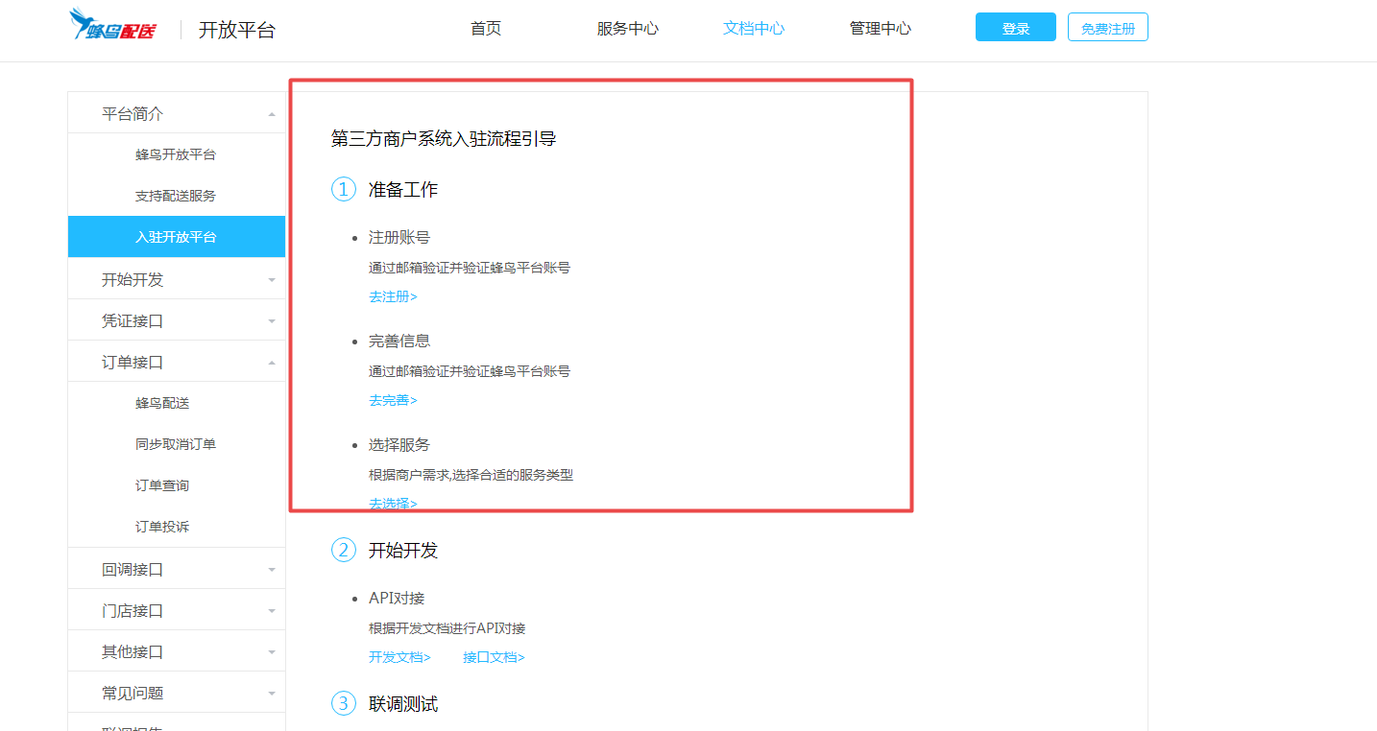

1.前期接口账号申请好。

代码，数据库最新

代码打包成*tar.gz，数据库导出sql。

后台配置信息

前端订单创建

后端接口查询展示在前端

了解接口文档，熟悉“点了吗”业务流程

达达配送：

<http://newopen.imdada.cn/#/development/file/add?_k=e8dkrg>

商家后台门店信息加个Tab“配送设置”

配送类型：1、门店配送 2、蜂鸟配送（设置相对于参数） 3、达达配送（设置相对于参数）

<http://www.dianlema.net/web/index.php?c=site&a=entry&op=post&id=21&storeid=21&do=stores2&m=weisrc_dish>

<http://dc.jieqiangtec.cn/web/index.php?c=site&a=entry&op=post&id=21&storeid=21&do=stores2&m=weisrc_dish>

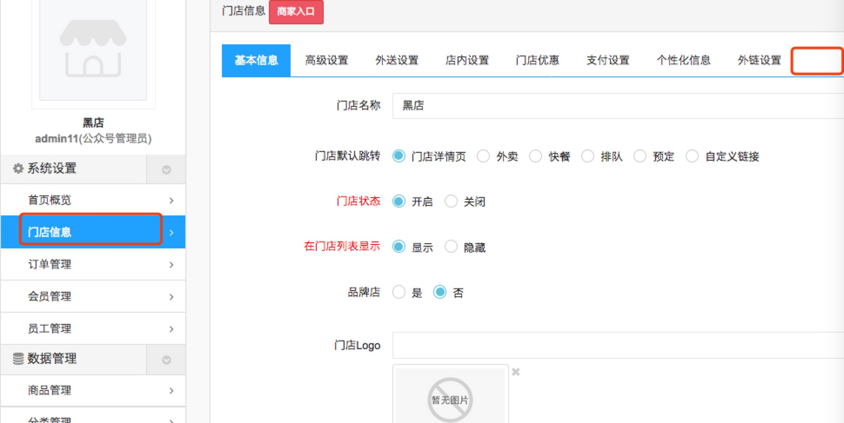

2、公众号在订单详情显示配送相关信息。（入口 你看加哪里合理就加哪里）

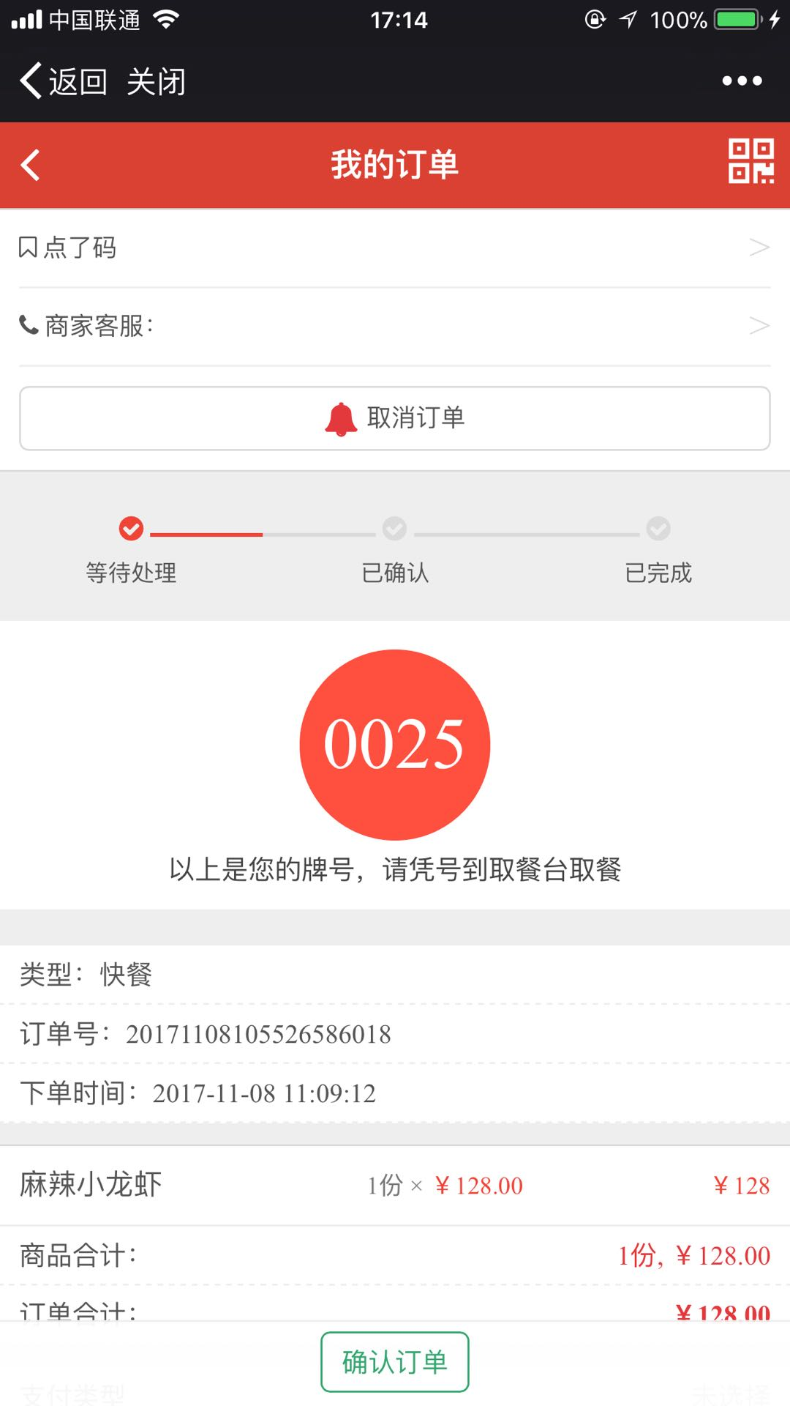

## 20171130

D:\www\users\dc.jieqiangtec.com\addons\weisrc_dish\inc\mobile\orderdetail.inc.php

**include** "../../addons/weisrc_dish/DadaOpenapi.php";

$obj = new DadaOpenapi($config);

报错

## 20171128

这块内容判断严谨些，判断时达达还是蜂鸟，还有达达返回的参数是否和蜂鸟一致，模板页也要做相应修改

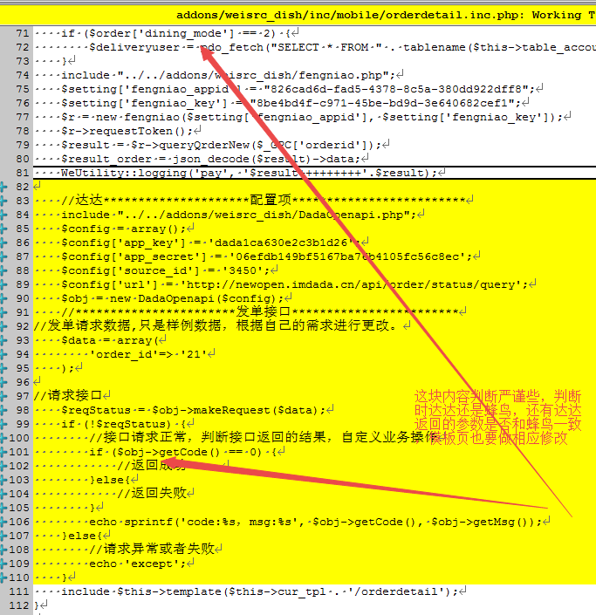

这个is_fengniao看下是哪边配置的，加个is_dada配置项去，有可能后期两项都不配置

<http://dc.jieqiangtec.cn/web/index.php?c=site&a=entry&op=display&do=setting&m=weisrc_dish>

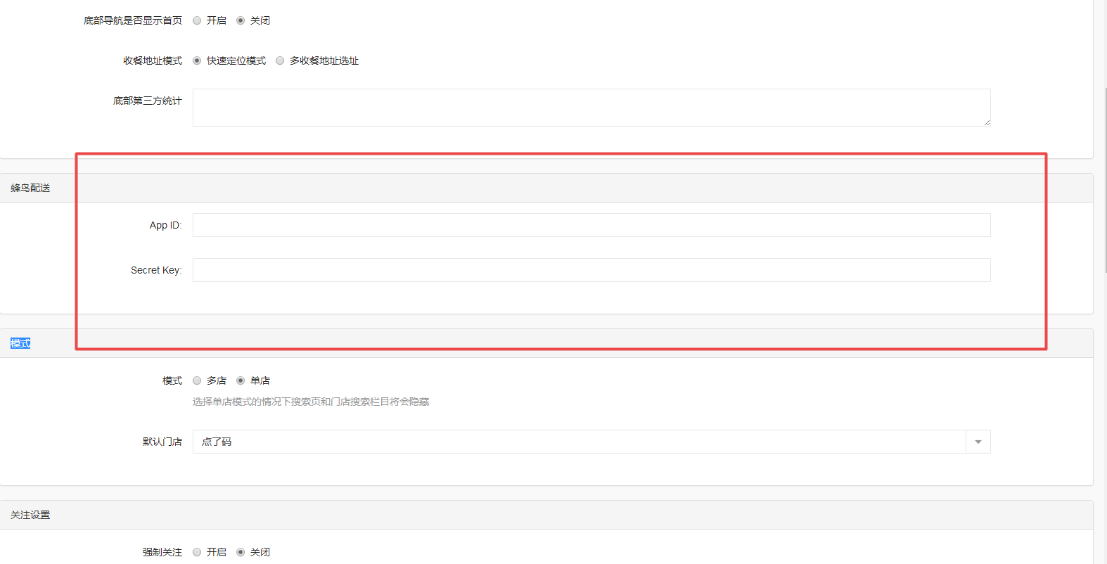

配置开启op=setting&do=stores2

<http://dc.jieqiangtec.cn/web/index.php?c=site&a=entry&op=setting&do=stores2&m=weisrc_dish>

D:\www\users\dc.jieqiangtec.com\addons\weisrc_dish\template\web\stores_setting.html

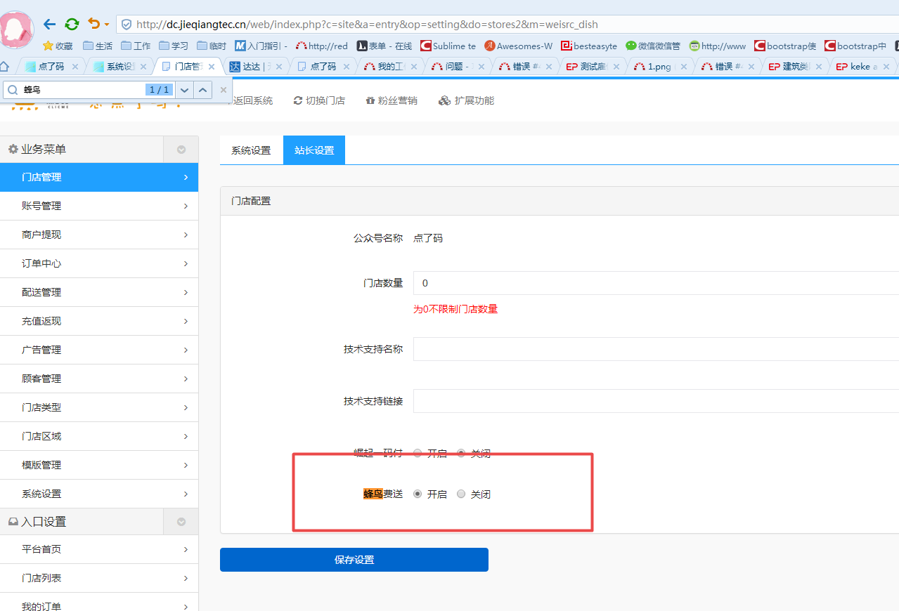

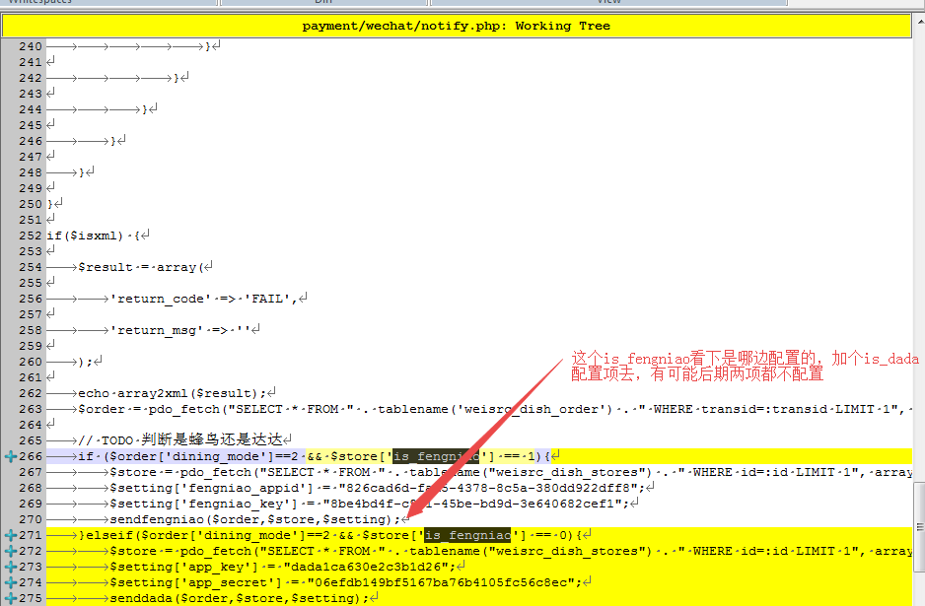

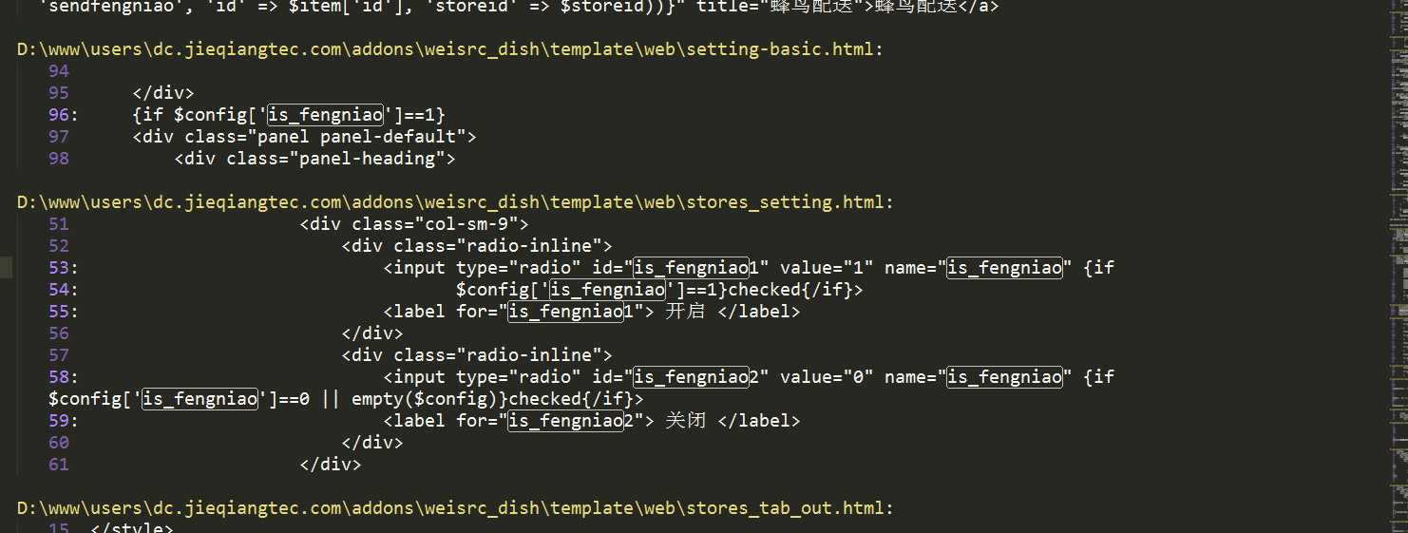

D:\www\users\dc.jieqiangtec.com\addons\weisrc_dish\template\web\stores_setting.html L51

后台取消订单

<http://www.dianlema.net/web/index.php?c=site&a=entry&op=display&storeid=21&do=order&m=weisrc_dish>

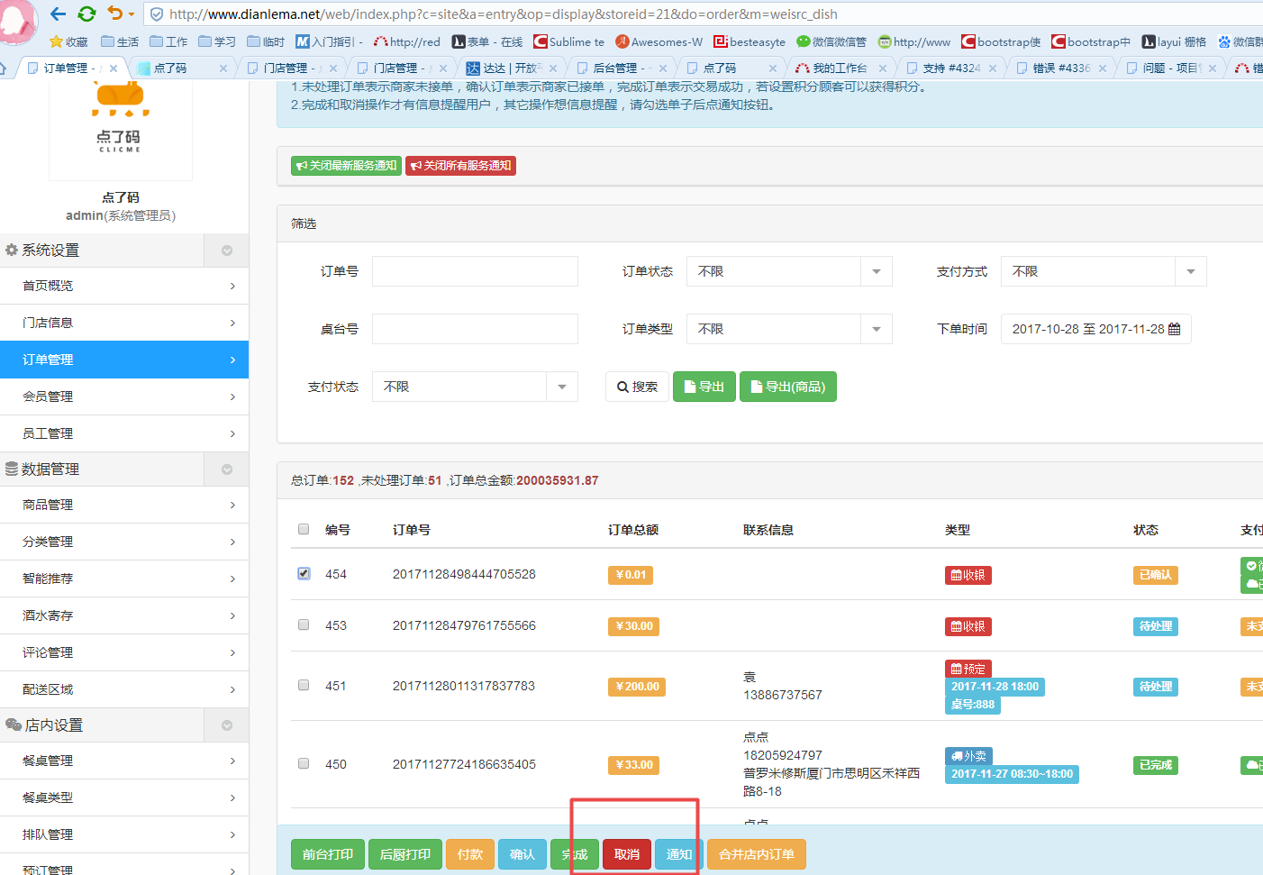

## 20171127

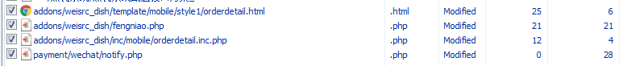

addons\weisrc_dish\template\mobile\style1\orderdetail.html

addons\weisrc_dish\fengniao.php

addons\weisrc_dish\inc\mobile\orderdetail.inc.php

payment\wechat\notify.php

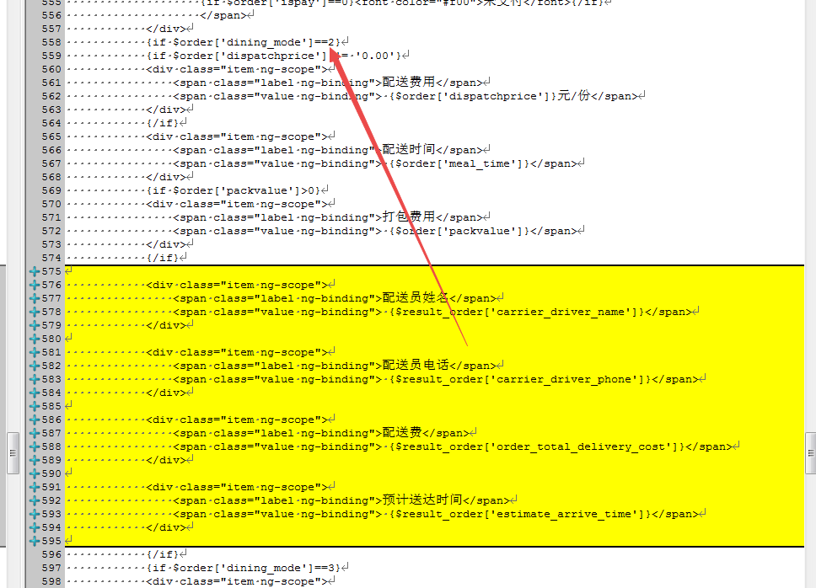

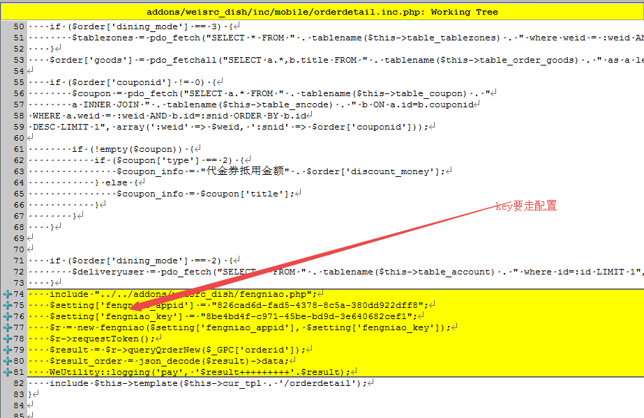

<http://www.dianlema.net/web/index.php?c=site&a=entry&op=post&id=21&storeid=21&do=stores2&m=weisrc_dish>

外送时间和费用

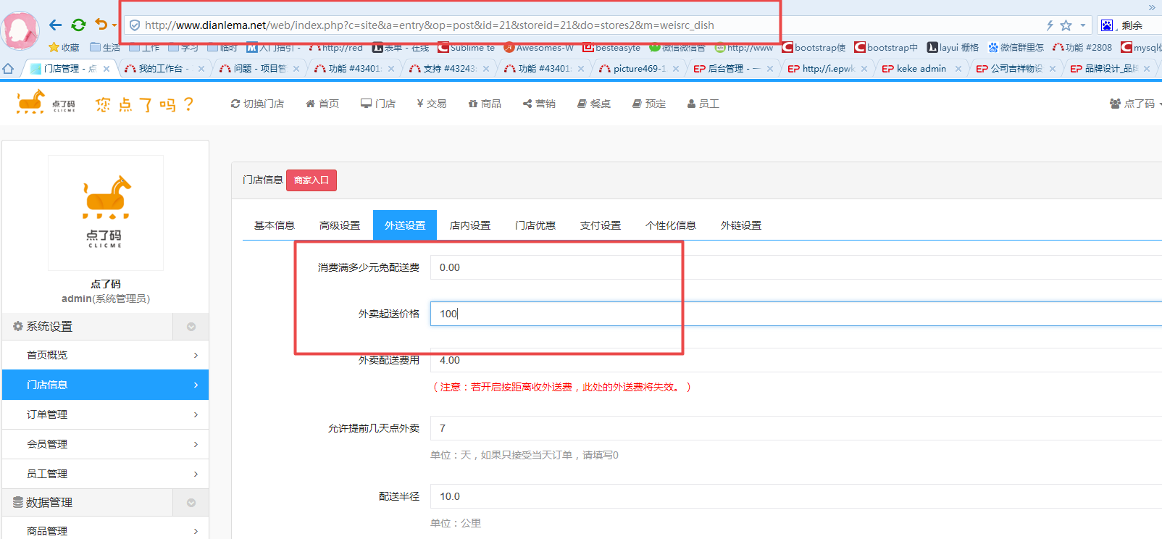

满减活动

<http://www.dianlema.net/web/index.php?c=site&a=entry&op=display&storeid=21&do=coupon&m=weisrc_dish>

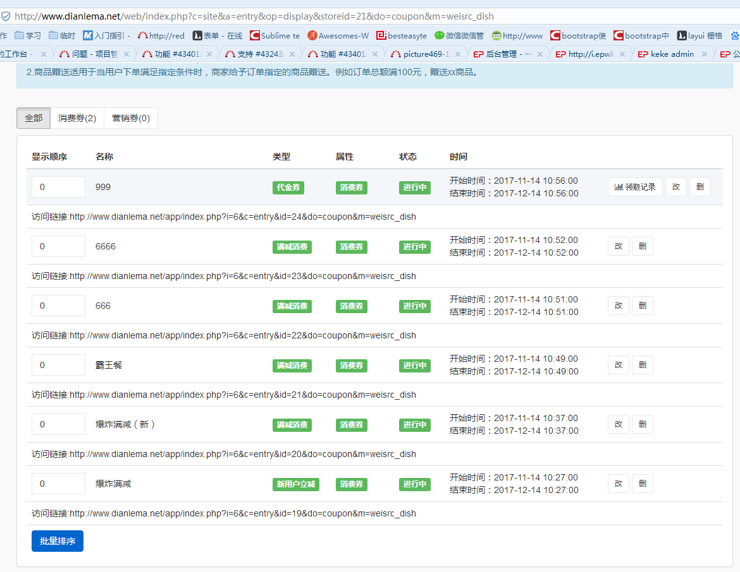

促销管理

http://www.dianlema.net/web/index.php?c=site&a=entry&op=post&id=24&storeid=21&do=coupon&m=weisrc_dish

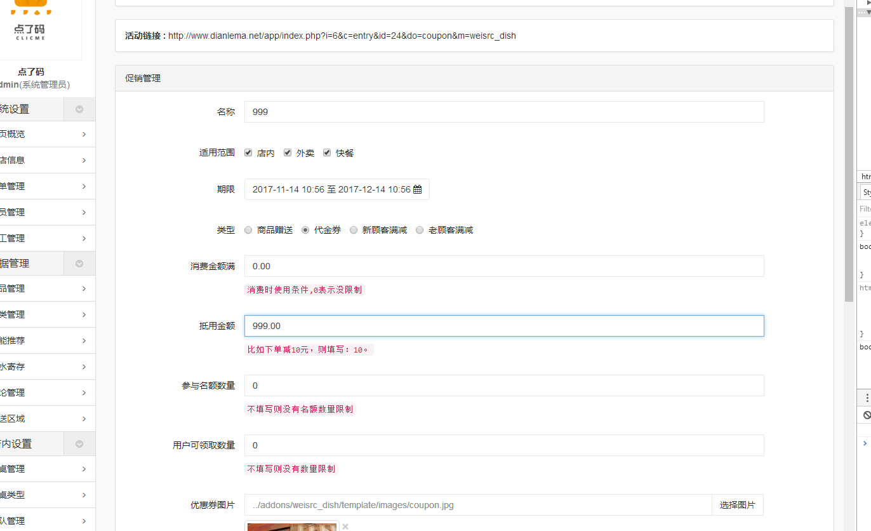

## 20171125

请在微信客户端打开链接

https://open.weixin.qq.com/connect/oauth2/authorize?appid=wxf906fe71b74173e8&redirect_uri=http%3A%2F%2Fdc.jieqiangtec.cn%2Fapp%2F.%2Findex.php%3Fi%3D6%26c%3Dentry%26do%3Dindex%26m%3Dweisrc_dish&response_type=code&scope=snsapi_base&state=0&connect_redirect=1#wechat_redirect

门店信息

经纬度

电话号码

地址

素菜价格：

<http://www.dianlema.net/web/index.php?c=site&a=entry&op=display&storeid=21&do=goods&m=weisrc_dish>

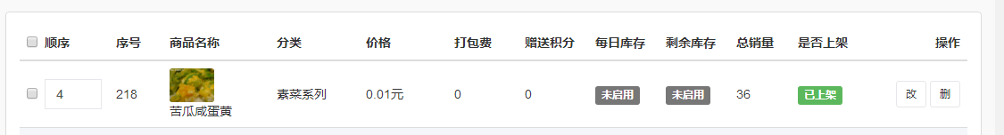

接单时间：

<http://www.dianlema.net/web/index.php?c=site&a=entry&op=post&id=21&storeid=21&do=stores2&m=weisrc_dish>

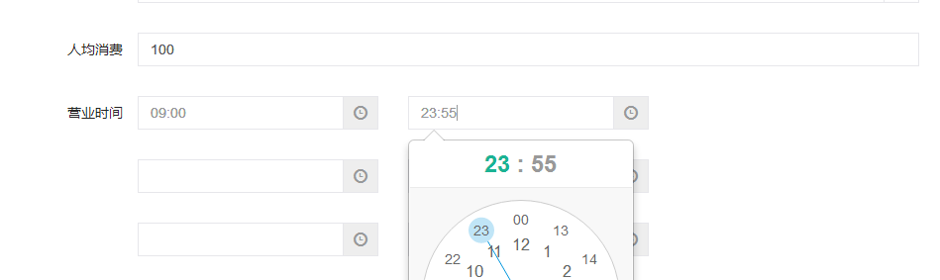

订单详情：

<http://www.dianlema.net/app/index.php?i=6&c=entry&orderid=429&do=orderdetail&m=weisrc_dish&from=singlemessage>

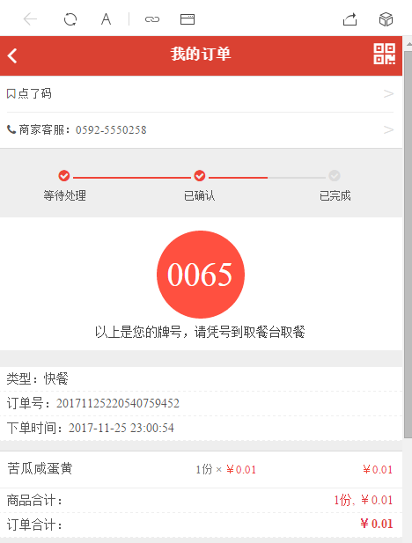

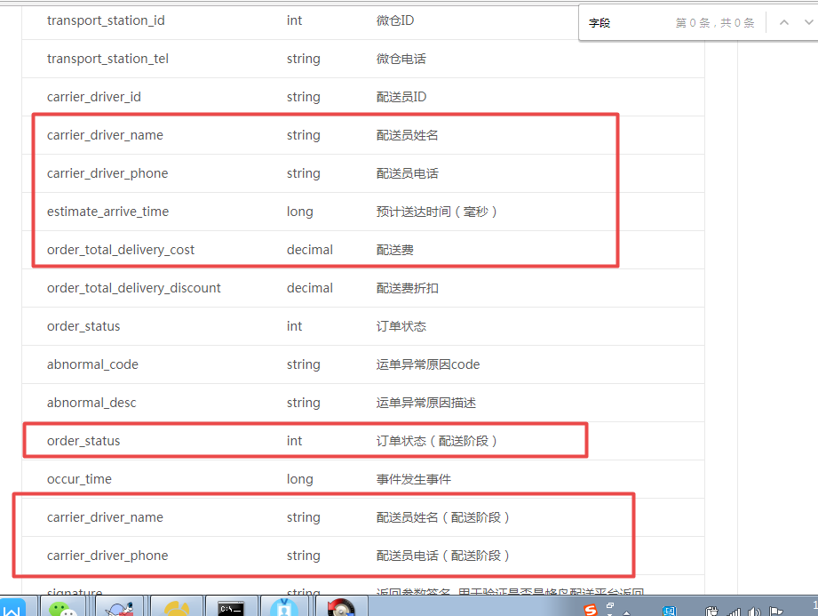

## 20171123

更新**码上微点餐**

*/**  
 * 码上点餐  
 *  
 * 作者:迷失卍国度  
 *  
 * qq : 15595755  
 */*

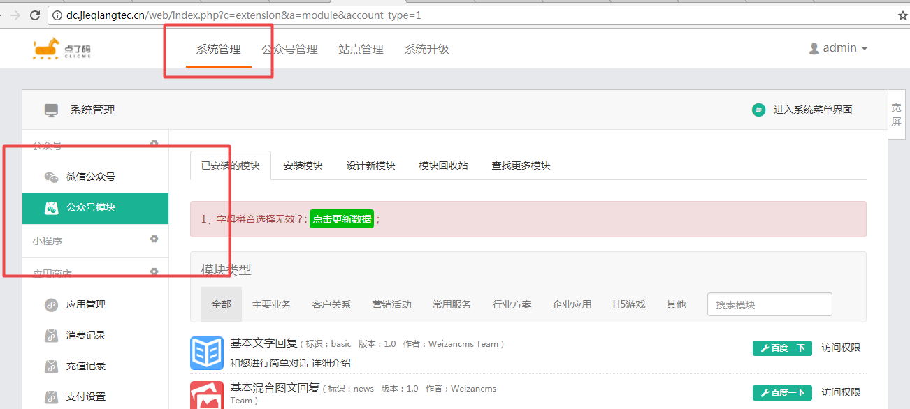

<http://dc.jieqiangtec.cn/web/index.php?c=extension&a=module&account_type=1>

控制器

D:\www\users\wc.jieqiangtec.com\web\source\profile\payment.ctrl.php

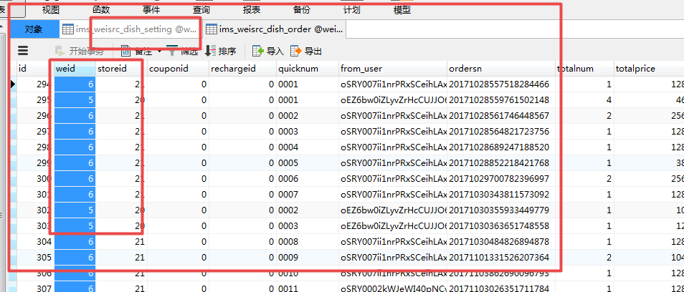

ims_weisrc_dish_order.weid = ims_weisrc_dish_setting.weid

======================

蜂鸟配送：https://open.ele.me/documents?to=%2Fdocument%2Fpage%2FsettleInH

达达配送：http://newopen.imdada.cn/#/development/file/add?_k=e8dkrg

蜂鸟

dianlema_order@163.com / Dlm654321

达达配送：http://newopen.imdada.cn/#/development/file/add?_k=e8dkrg

达达帐号

13696929853 / dlm654321

达达 开发者：dianlema / dlm654321

##### 注册信息

注册手机号：

****13696929853****

商户ID:

****3450****

##### 大客户信息

编辑

企业全称：

****厦门点了码科技有限公司****

城市：

****厦门****

联系人：

****陈成果****

联系地址：

****厦门市思明区演武西路180号世茂海峡大厦A座4501之一****

邮箱地址：

****dianlema_order@163.com****

联系号码：

****13696929853****

蜂鸟

dianlema_order@163.com / Dlm654321

## **基本信息**

[编辑](https://open.ele.me/javascript:;)

**App ID**

826cad6d-fad5-4378-8c5a-380dd922dff8

**Secret Key:**

**8be4bd4f-c971-45be-bd9d-3e640682cef1**

[显示密钥](https://open.ele.me/javascript:;)

**商户名称**

点了码

**商户官网**

http://www.dianlema.net

**经营类型**

快餐便当

**公司全称**

厦门点了码科技有限公司

**联系人名**

陈成果

**联系方式**

13696929853

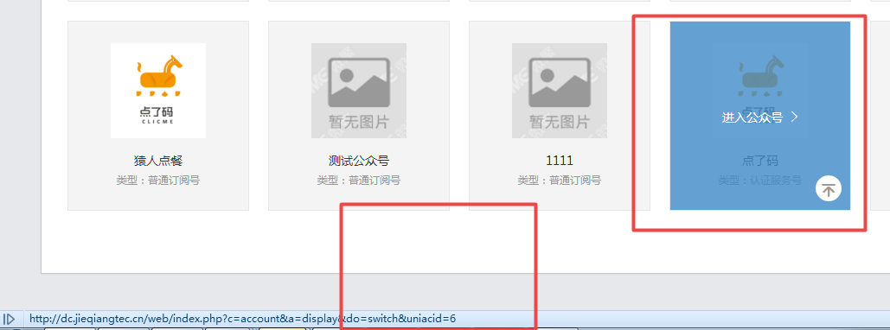

我:

http://dc.jieqiangtec.cn/app/index.php?i=6&c=entry&m=weisrc_dish&do=deliveryorder

我:

<http://www.dianlema.net/app/index.php?i=6&c=entry&id=21&do=detail&m=weisrc_dish>

http://www.dianlema.net/app/index.php?i=6&c=entry&m=weisrc_dish&do=deliveryorder

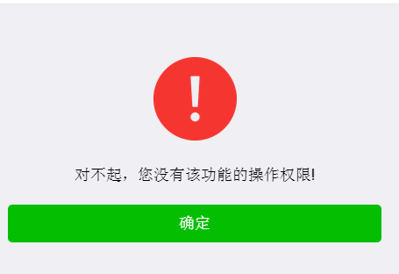

对不起，您没有该功能的操作权限!

确定

后台配置

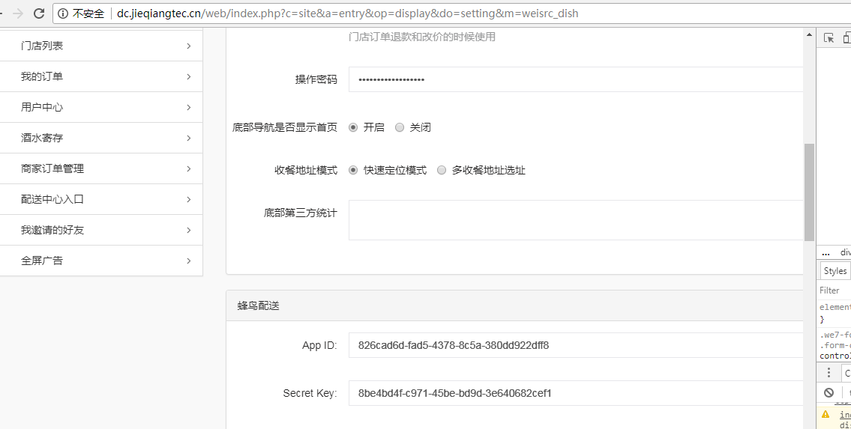

我:

D:\www\users\dc.jieqiangtec.com\addons\weisrc_dish\template\web\setting-basic.html

我:

<http://dc.jieqiangtec.cn/web/index.php?c=site&a=entry&op=post&id=21&storeid=21&do=setting&m=weisrc_dish>

UPDATE `weizan1`.`ims_weisrc_dish_setting` SET `id`='6', `weid`='6', `title`='', `thumb`='', `storeid`='21', `mode`='1', `is_notice`='1', `entrance_type`='0', `entrance_storeid`='0', `order_enable`='0', `dining_mode`='0', `istplnotice`='1', `tpltype`='1', `tplneworder`='SviWMOq3xN1xYzMmLPEk0sr3LvcqiHWW6Xl9w9kGTqk', `tplnewqueue`='c9o152PtYBh3-dNhO_9CjRFrUeY56F--6TKDVzFP2e4', `tploperator`='oBql7vepU09miSZP4rOuZLMc7FeItrJ5XaqAUJTuUCo', `tplboss`='', `link_card_name`='', `link_card`='', `link_sign_name`='', `link_sign`='', `searchword`='admin', `tpluser`='oSRY007ii1nrPRxSCeihLAxANMB8', `sms_enable`='0', `sms_username`='', `sms_pwd`='', `sms_mobile`='', `email_enable`='0', `email_host`='smtp.qq.com', `email_send`='', `email_pwd`='', `email_user`='微点餐', `email`='', `getcash_price`='0', `fee_rate`='0.00', `fee_min`='0', `fee_max`='0', `is_commission`='0', `commission_level`='1', `commission_mode`='0', `commission_money_mode`='0', `commission1_rate_max`='0.00', `commission1_value_max`='0', `commission2_rate_max`='0.00', `commission2_value_max`='0', `commission3_rate_max`='0.00', `commission3_value_max`='0', `commission_settlement`='0', `delivery_mode`='2', `delivery_commission_mode`='1', `delivery_money`='2.00', `delivery_cash_price`='20', `delivery_rate`='100.00', `delivery_order_max`='999', `delivery_auto_time`='3', `delivery_finish_time`='0', `link_recharge`='', `link_recharge_name`='', `wechat`='1', `alipay`='0', `credit`='0', `delivery`='1', `is_speaker`='0', `is_auto_address`='1', `is_show_home`='0', `is_operator_pwd`='0', `tiptype`='0', `tipbtn`='0', `tipqrcode`='', `operator_pwd`='apestar2017Diancan', `apiclient_cert`='1', `apiclient_key`='1', `rootca`='1', `share_title`='', `share_desc`='', `share_image`='', `follow_url`='', `follow_title`='', `follow_desc`='', `follow_logo`='', `site_logo`='images/6/2017/10/x7rOGqFfUT2rZZRFdRar3Q6OSauRy7.png', `isneedfollow`='0', `statistics`='', `dateline`='1509085601', `tplapplynotice`='', `is_contain_delivery`='0', `fengniao_appid`='', `fengniao_key`='', `is_verify_mobile`='0', `dayu_appkey`='', `dayu_secretkey`='', `dayu_verify_code`='', `dayu_sign`='', `commission_keywords`='', `credit_mode`='1', `payx_credit`='0', `fengniao_mode`='1', `is_auto_commission`='0', `auto_commission_coin`='0', `tplmission`='' WHERE (`id`='6');