版权替换20140822

1.版权替换

2.静态资源替换

1.版权替换

- 权限控制
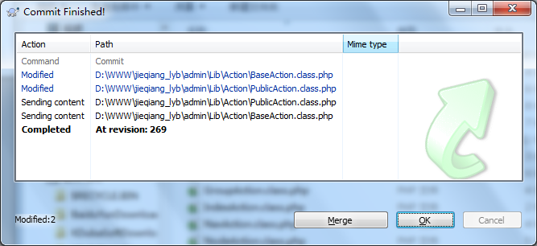Modified: D:\WWW\jieqiang_lyb\admin\Lib\Action\BaseAction.class.php
Modified: D:\WWW\jieqiang_lyb\admin\Lib\Action\PublicAction.class.php

BaseAction.class.php
// 顶部菜单
$model = M("group");
// $top_menu =$model->field('id,title')->where('status=1')->order('sort ASC')->select();

$role_id = D('admin')->where('id='.$_SESSION['admin_info']['id'])->getField('role_id');
$node_ids_res = D("access")->where("role_id=".$role_id)->field("node_id")->select();

$node_ids = array();
foreach ($node_ids_res as $row) {
array_push($node_ids,$row['node_id']);
}

// var_dump($node_ids);
// 节点id
$ids = implode(',', $node_ids);
// 增加在cms_access的条件
//如果是超级管理员，则可以执行所有操作
// $id = intval($_REQUEST['tag'])==0?6:intval($_REQUEST['tag']);
if($_SESSION['admin_info']['id'] == 1) {
$where = "auth_type<>2 AND status=1 AND is_show=0 ";
}else{
$where = "auth_type<>2 AND status=1 AND is_show=0 AND id in ($ids)";
}

// var_dump($where);
$list =M("node")->where($where)->Distinct(true)->field('group_id')->order('sort DESC')->select();
// var_dump($list);
// var_dump(count($list));
if (count($list) == 1) {
// 分组id
$gId = $list[0] ['group_id'];
$top_menu =$model->field('id,title')->where("status=1 AND id = $gId")->order('sort ASC')->select();
} else {
// 分组id
foreach ($list as $key => $value) {
$gIds[] = $value['group_id'];
}
$gIds = implode(',', $gIds);
$top_menu =$model->field('id,title')->where("status=1 AND id in ($gIds)")->order('sort ASC')->select();
}

PublicAction.class.php
//显示菜单项
$id = intval($_REQUEST['tag'])==0?6:intval($_REQUEST['tag']);
// var_dump($id);
$menu = array();
$role_id = D('admin')->where('id='.$_SESSION['admin_info']['id'])->getField('role_id');
$node_ids_res = D("access")->where("role_id=".$role_id)->field("node_id")->select();

$node_ids = array();
foreach ($node_ids_res as $row) {
array_push($node_ids,$row['node_id']);
}

// var_dump($node_ids);
$ids = implode(',', $node_ids);
// var_dump($ids);exit;
//读取数据库模块列表生成菜单项
$node = M("node");
// $where = "auth_type<>2 AND status=1 AND is_show=0 AND group_id=".$id;

// 增加在cms_access的条件
//如果是超级管理员，则可以执行所有操作
if($_SESSION['admin_info']['id'] == 1) {
$where = "auth_type<>2 AND status=1 AND is_show=0 AND group_id=".$id;
}else{
$where = "auth_type<>2 AND status=1 AND is_show=0 AND id in ($ids) AND group_id=".$id;
}

// var_dump($where);

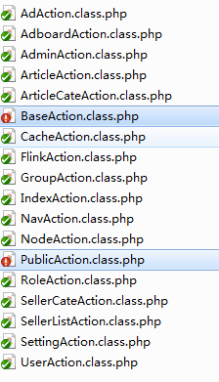

- MobileCms 移动应用软件后台管理系统程序替换

/** kit_admin-v1.1.0 MIT License By http://kit/zhengjinfan.cn e-mail:zheng_jinfan@126.com */
;/**
* Name:utils.js
* Author:Van
* E-mail:zheng_jinfan@126.com
* Website:http://kit.zhengjinfan.cn/
* LICENSE:MIT
*/

/**
* Name:loader.js
* Author:Van
* E-mail:zheng_jinfan@126.com
* Website:http://kit.zhengjinfan.cn/
* LICENSE:MIT
*/

/** kit_admin-v1.1.0 MIT License By http://kit/zhengjinfan.cn e-mail:zheng_jinfan@126.com */

// +----------------------------------------------------------------------
// | 后台管理系统
// +----------------------------------------------------------------------

// +----------------------------------------------------------------------
// | MobileCms 移动应用软件后台管理系统
// +----------------------------------------------------------------------
// | provide by ：phonegap100.com
//
// +----------------------------------------------------------------------
// | Author: htzhanglong@foxmail.com
// +----------------------------------------------------------------------

// +----------------------------------------------------------------------
// | JieQiangCms 移动应用软件后台管理系统
// +----------------------------------------------------------------------
// | provide by ：JieQiang.com
//
// +----------------------------------------------------------------------
// | Author: 1569501393@qq.com
// +----------------------------------------------------------------------

/*
// +----------------------------------------------------------------------
// | JieQiangCms 街墙内容管理系统
// +----------------------------------------------------------------------
// | provide by ：www.jieqiang.com
// +----------------------------------------------------------------------
// | Author: 1569501393@qq.com
// +----------------------------------------------------------------------
*/

// +----------------------------------------------------------------------
// | JieQiangCms 移动应用软件后台管理系统
// +----------------------------------------------------------------------
// | provide by ：jieqiang.com
//
// +----------------------------------------------------------------------
// | Author: 1569501393@qq.com
// +----------------------------------------------------------------------

/*
// +----------------------------------------------------------------------
// | JieQiangCms 街墙内容管理系统
// +----------------------------------------------------------------------
// | provided by : www.jieqiang.com
// +----------------------------------------------------------------------
// | Author : 1569501393@qq.com
// +----------------------------------------------------------------------
// | @@街墙科技，值得信赖@@
// +----------------------------------------------------------------------
*/

- MobileCms 移动应用软件后台管理系统样式替换
phonegap100.com

/*
// | MobileCms 移动应用软件后台管理系统
// +----------------------------------------------------------------------
// | provide by ：phonegap100.com
//
// +----------------------------------------------------------------------
// | Author: htzhanglong@foxmail.com
// +----------------------------------------------------------------------
*/

/*
// +----------------------------------------------------------------------
// | JieQiangCms 移动应用软件后台管理系统
// +----------------------------------------------------------------------
// | provide by ：JieQiang.com
//
// +----------------------------------------------------------------------
// | Author: 1569501393@qq.com
// +----------------------------------------------------------------------
*/

- MobileCms 移动应用软件后台管理系统
phonegap100.com

JieQiang.com

- MobileCms 移动应用软件后台管理系统
phonegap100

JieQiang

phonegap

JieQiang

http://www.zycpark.com

http://www.JieQiang.com

树根cms
JieQiangCms

htzhanglong@foxmail.com
1569501393@qq.com

2.静态资源替换
D:\www\users\mobilecms.jieqiangtec.com\statics\admin\build\js\tab.js

mainUrl: 'admin.php?m=Public&a=main', 默认

./=》__ROOT__/statics/admin/
KIT ADMIN=》EPWK ADMIN
www.zhengjinfan.cn=》www.epwk.com
blog.zhengjinfan.cn=》www.epwk.com

KITADMIN=》EPWKADMIN

__PUBLIC__/admin/css/common.css=》__ROOT__/statics/admin/css/common.css

blog.zhengjinfan.cn=》www.epwk.com
blog.zhengjinfan.cn=》www.epwk.com
blog.zhengjinfan.cn=》www.epwk.com
blog.zhengjinfan.cn=》www.epwk.com
blog.zhengjinfan.cn=》www.epwk.com
blog.zhengjinfan.cn=》www.epwk.com

KIT ADMIN

