

Compressed Sensing for Wideband Signal

Processing

Chen Hao

School of Computer Engineering

A Process report submitted to the School of Computer Engineering
of Nanyang Technological University

in partial fulfillment of the requirements for the
degree of Doctor of Philosophy

Supervisor: Assoc. Prof. Vun Chan Hua

January 2015

Acknowledgements

I would like to express my sincere and great gratitude to my supervisor, Assoc Prof.
Vun Chan Hua for his kind guidance and encouragement. It is a great honor to work with
him. I own my sincere appreciate to all my friends in CeMNet. Without their help, my first
year study and research in NTU can not process well.

Contents

1 Introduction

2 Compressed Sensing 14
2.1 Introduction . . . . . . . . . . . . . . . . . . . . . . . . . . 14
2.2 Sparsity: A Reasonable Assumption . . . . . . . . . . . . . 15
2.2.1 Definition of sparse signals . . . . . . . . . . . . . . 15
2.3 Model of Sparse Reconstruction . . . . . . . . . . . . . . . 16
2.3.1 Null Space Property . . . . . . . . . . . . . . . . . 17

2.3.2 Restricted Isometry Property . . . . . . . . . . . . . 18
2.3.3 Robust Recovery . . . . . . . . . . . . . . . . . . . 18
2.3.4 Minimum Samples . . . . . . . . . . . . . . . . . . 19
2.4 Sensing Matrix . . . . . . . . . . . . . . . . . . . . . . . . 20
2.4.1 Random Matrix . . . . . . . . . . . . . . . . . . . . 20
2.4.2 Deterministic Matrix . . . . . . . . . . . . . . . . . 21
2.4.3 Partial Random Structural Matrix . . . . . . . . . . 21
2.5 Reconstruction Algorithms . . . . . . . . . . . . . . . . . . 23
2.5.1 Convex Optimisation . . . . . . . . . . . . . . . . . 24
2.5.2 Combinatorial Algorithms . . . . . . . . . . . . . . 24
2.5.3 Greedy Algorithms . . . . . . . . . . . . . . . . . . 25

Chapter 2

Compressed Sensing

Compressed sensing is a novel research area introduced by Donoho [18] and by Candes,
Romberg, and Tao [9] in 2006, and since then has already become a key concept in various
areas of applied mathematics, computer science, and electrical engineering. It surprisingly
predicts that high-dimensional signals, which allow a sparse representation by a suitable
basis or, more generally, a frame, can be recovered from what was previously considered
highly incomplete linear measurements by using efficient algorithms. This chapter shows
an introduction to and a survey of compressed sensing.

2.1 Introduction

In the real world, people often observe and save signals in digital devices for further analy-
sis, e.g., medical image imaging, CT tomography. Using the discrete sampling and storage,
the system are prospected to exactly reconstruct the original signals. If we assume that orig-
inal signal is 1 × N vector, the observation behaviour can be modelled as a sensing matrix
A with a size of m × N . Then the sampled data y can be described as
y = Ax, (2.1)

Then an important question emerges:

CHAPTER 2. COMPRESSED SENSING

· In order to reconstruct signal x, at least how many samples y are needed?
Traditional linear algebra theory states that unique solution of (2.1) exists if m = N . That
is to say, we need at least N samples y. However, consider a case when the signal x is
sparse, which indicates most of values in x are zero or relatively small, is there any method
to reconstruct x using smaller numbers of observations y? (m < N )
Conventionally, if m < N , the the equation (2.1) is underdetermined, so various so-
lutions exist which means it cannot uniquely recover the original signal x. However, if
the x is sparse, then the answer maybe Yes: Using the theory of the compressed sensing
(CS), surprisingly it allows a possible sparse information’s reconstruction from a very few
numbers of samples y (m << N ), where the sparse information can naturally exist (such
as x) or generated by orthogonal basis decomposition (such as x = As where s is sparse,
A is the basis e.g. wavelets decomposition). Consequently, the CS provides an possible
method to reduce the number of observations theoretically. In conclusion, the task of CS
can be abstracted as:

· Find the minimum number of observations for the sensing matrix.
· Design reconstruction algorithm to uniquely recover original signals via those obser-
vations.

2.2 Sparsity: A Reasonable Assumption

2.2.1 Definition of sparse signals

To state the problem mathematically precisely, let now x ∈ RN ×1 be our signal of interest.
As prior information, we either assume that x itself is sparse, i.e., it has very few K non-
zero coefficients in the sense that

(2.2)

15

CHAPTER 2. COMPRESSED SENSING

is small, or that there exists an orthonormal basis or a frame Ψ such that x = Ψs, where x is
a linear combination of few k basis chosen from Ψ, and s is the corresponding coefficients
of representing x in the domain constructed by the basis Ψ, k is termed as the sparsity.
For real world signals, a variety of representation systems can be used to provide sparse
approximations. If this is not the case, more data sensitive methods such as dictionary
learning algorithms, in which a suitable representation system is computed for a given
set of test signals, are available This process is customarily termed dictionary learning.
The most well-known adaptive learning algorithm is the K-SVD algorithm introduced by
Aahron, Elad, and Bruckstein in [19]. In this chapter, we will assume throughout that x is
already a sparse vector or can be sparse represented.

2.3 Model of Sparse Reconstruction

When the x is sparse, an intuitive solution of the underdetermined equation (2.1), equals
the solution of the problem (P0), which aims to find the minimum numbers of supports in
x as following:
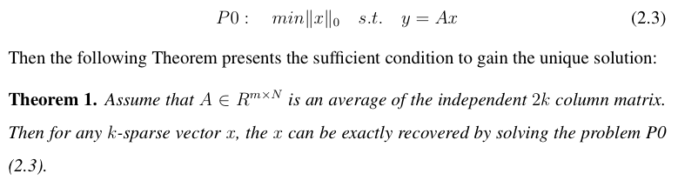

Hence, according to Theorem 1, then there is a coding and decoding of (A, ∆) such
that x = ∆(Ax), which means 2k times the number of observations is sufficient for recon-
struction. However, solving the problem P0 is very difficult. In fact, P0 is an NP-complete
problem [20].
So could we find a more efficient decoding algorithms? The answer maybe Yes if some
condition is satisfied. In this case, using the solution of the following problem P1, which is

16

CHAPTER 2. COMPRESSED SENSING

termed as Basis Pursuit (BP) or l1-norm minimisation, we can uniquely reconstruct x.

(2.4)

For solving the problem P1, various types of recovery algorithms exist, which can be
sorted as convex optimisation, greedy, and combinatorial algorithms (section 2.5), and each
one having its own advantages and disadvantages. Here in this section, we provide the
widely used linear programming (LP) as an example to solve P1:
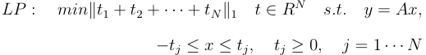

(2.5)

2.3.1 Null Space Property

According to (2.4), the sparse reconstruction is achievable when P1 equals P0. So lets
return to the question: when P1 equals P0? In order to develop this question, the null space
of sensing matrix plays a important role, which is defined as N (A) = {x : Ax = 0}. Then
the null space property and its corresponding theorem are given to answer that question,
and presents us the sufficient and necessary condition for P1 = P0:
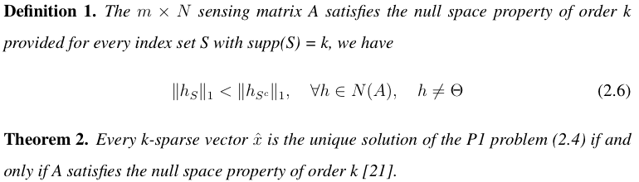

According to the Theorem 2, the equivalent condition for the existence of a unique
sparse solution of (P1) can now be stated in terms of the null space property (NSP). Then
manyconvexoptimisationalgorithmandgreedymethodcanbeappliedtosolveP1problem
(section 2.5.1).

17

CHAPTER 2. COMPRESSED SENSING

2.3.2 Restricted Isometry Property

Although the NSP and the Theorem 2 presents us an equivalent condition to get unique
reconstruction through solving P1, however, how to verify the sensing matrix satisfying
NSP in (2.6) is computational complex, so NSP is not practically useful.
Then a more intuitive concept termed as Uniform Uncertainty Principle or Restricted
Isometry Property (RIP) is introduced in [9]. It measures the degree to which each subset
of k column vectors of the sensing matrix A is close to being an isometry.

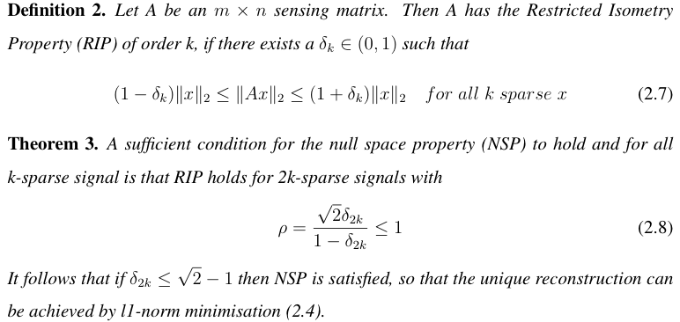

According to the Theorem 3, an equivalent condition for the existence of a unique
sparse solution of (P1) can now be stated in terms of RIP. If the sensing matrix satisfies the
RIP, then for any k-sparse vector x, the Euclidian distance of projected x ( i.e. Ax ) and x
still keep very close if the δ2k in (0, 1) is relatively small.

2.3.3 Robust Recovery

Back to our original task in compressed sensing framework in section 2.1, which aims at
designing a efficient coding and decoding procedure, we now can use RIP-satisfied matrix
for encoding, and l1-norm minimisation as decoding to recover k-sparse signals. However,

18

CHAPTER 2. COMPRESSED SENSING

in the real world, signals sometimes are not strictly sparse signals, but usually approximate
sparse. For such signals, is the framework of coding (RIP matrix projection) and decoding
(l1-norm minimisation) still suitable? Interestingly, the answer is yes, it still can be better
done: First, we define the concept of the best k-term approximation error:
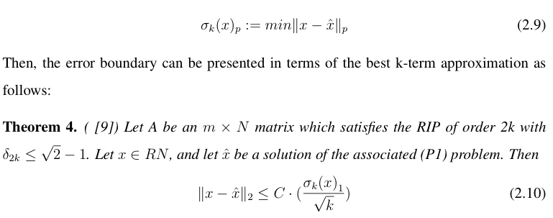

2.3.4 Minimum Samples

Lets return to the question in section 2.1: In order to reconstruct signal x, at least how
many samples y are needed? The [22] shows the following Theorem which presents a
lower boundary:

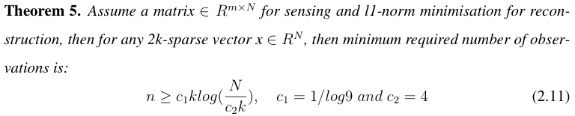

Following this Theorem, any under determined sensing matrix requires at least O(klog( N/k)
samples for sparse reconstruction in (2.4). Then a new question emerges: Since the Theo-
rem 3 presents a unique sparse solution of (P1) stated in terms of RIP, can this sensing and
recovery approach (RIP-matrix sensing and l1-norm minimisation) reach the lower bound-
ary of the minimum required samples that is O(klog( N/k ))? The following section answers
this question with respect to various of sensing matrix.

19

CHAPTER 2. COMPRESSED SENSING

2.4 Sensing Matrix

Verification for RIP is not practical, for the RIP serves for every possible sparse vector,
and [23] demonstrates that testing whether a matrix satisfies RIP is NP-hard. However,
fortunately, we can often construct the matrix satisfying RIP by using randomness, which
gives a practical way for creating the sensing matrix.

2.4.1 Random Matrix

We consider two types of random matrices: Gaussian random matrix and Bernoulli ran-
dom matrix. The Gaussian random matrices refers to the matrix whose elements ai,j are
independent random variables and subject to the distribution N (0, 1). The Bernoulli matrix
refers to the matrix whose elements ai,j has the same probability to be 1 or -1.

2.4.1.1 Probability Reconstruction

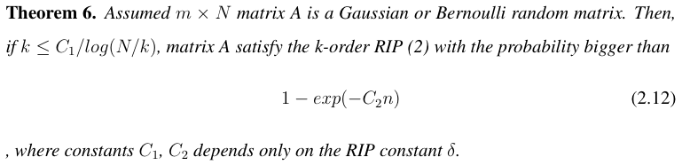

The Theorem shows that the Gaussian or Bernoulli random matrices satisfies the k =
O(n/log(N/k)) order RIP, indicating that these random matrices reach the lower boundary
of the minimum required samples that is O(klog( N/k )) in (5). Therefore, these random
matrices presents an efficient and optimal coding and decoding method, which involve
random sensing matrix projection and l1-norm minimisation respectively, and apply the
minimum amount of observations.

20

CHAPTER 2. COMPRESSED SENSING

2.4.2 Deterministic Matrix

Although a random matrix (Gaussian or Bernoulli) has high probability to satisfies RIP and
provide optimal coding and decoding method in terms of number of samples, in practice, it
is more desirable to construct a deterministic matrix because the certainty in matrix is more
attractive. For example, from the perspective of structural decoding algorithms, determin-
istic matrix helps to reduce memory cost and improve reconstruction speed. The current
construction methods for deterministic matrix are mainly based on the property of matrix
coherence:

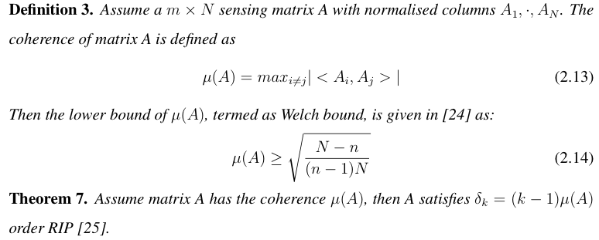

Combining the Theorem 7 with the Welch bound in definition 3, the sensing matrix A
must satisfy the k = √2n RIP. Hence, if we only investigate matrix coherence, we hardly
get the lower boundary of the minimum required samples O(klog( N/k )) in (5). Thus, how
to construct the deterministic RIP matrix to match this lower bound of required samples is
still an open issue [26].

2.4.3 Partial Random Structural Matrix

Since there exists problem in constructing a deterministic matrix, and since there is always
not enough freedom for building random Gaussian matrix subject to physical or other con-
straints in applications, at the moment, a new type of matrix structure is investigate as it

21

CHAPTER 2. COMPRESSED SENSING

has a combination features of partial randomness and partial deterministic design, which is
termed as the partial random structural matrix. It becomes popular since most applications
have constraints in design sensing matrix, although many those matrix cannot reach the
optimal boundary of minimum required samples O(klog( N/k )) in (5).

2.4.3.1 Random Partial Fourier Matrix

When we randomly choose m rows in the Fourier matrix Ψ to generate a m × N matrix, the
matrix becomes the random partial Fourier matrix Ψm. Part of random Fourier matrix has
a strong application background. For example, the randomly observed partial frequency
information can be fully recovered by l1-norm minimisation [27]. And according to the
CS theory which has a m × N sensing matrix where m << N , the sampled points m is
far less than original required number N under Nyquist rate. In addition, we just apply
the random sample behaviour so that the low-rate CS sampling is achieved. In [28], the
number of minimum samples is proven as n = O(k(logN )^4).

2.4.3.2 Rademacher Matrix

The Rademacher random variable takes only values -1 and +1 with the same likelihood.
In hardware design, it can be easily implemented, so the [15] use this sequence in a pre-
mixer for random projection, and successfully designs a low rate analog to digital converter
based on the CS framework, and terms this architecture as the random demodulator (details
in the next chapter). From the theoretical aspect, the required minimum samples m =
O(klog^6 (N) ). In practise, however, simulations show that the random demodulator requires
just O(klog(N/k)) samples to stably reconstruct the signal. This result reaches the optimal
boundary of minimum required samples O(klog( N/k )) in (5).

22

CHAPTER 2. COMPRESSED SENSING

2.4.3.3 Random Circulant Matrix

In many cases where signal convolution is involved, the circulant matrix always exists
whose each row is shifted compared to its neighbours. This is because that any n-point
circular convolution of two sequences x and h is h * x = Hx, where H is the
corresponding N × N circulant matrix to original impulse response h. In CS framework,
the randomness is embedded into each elements of the matrix, e.g. Rademacher random
variable is often implemented for constructing each row of circulant matrix, which forms
a partial m × N random circulant matrix. Then paper [29] proves that a partial random
circulant matrix satisfies k order RIP when the number of samples m = O((slogN )^(3/2)),
where N is the length of the pulse. Also, the required number of samples do not reach
the optimal bound in (5). In practise, these matrices are so important in signal processing
applications and wireless communications where convolutions widely occur.

2.4.3.4 Specific Signal Processing Matrix

Many tasks signal processing do not really require full signal information but rather to solve
maybe inference or estimation problems. In these case, fully sensing may not be sufficient
so that specific sensing matrix need to designed. For instance, in [30], a compressive filter-
ing matrix is introduced, which aims at sensing and directly extracting useful information
without recovery. This area relates to the Compressive Signal Processing (CSP, details in
chapter 5), and how to measure the minimum required number of samples is still an open
issue.

2.5 Reconstruction Algorithms

In this section, we will provide a brief overview of the different types of algorithms typ-
ically used for sparse recovery. Convex optimisation algorithms require very few mea-
surements but are computationally more complex. On the other extreme are combinatorial

23

CHAPTER 2. COMPRESSED SENSING

algorithms, which are very fast, and often sub-linear, but require many measurements that
are sometimes difficult to obtain. Greedy algorithms are in some sense a good compromise
between those extremes concerning computational complexity and the required number of
measurements.

2.5.1 Convex Optimisation

In section 2.3.2 we already stated the convex optimisation problem (P1) as (2.4). If the
measurements are affected by noise, a conic constraint is required and the minimisation
problem needs to be changed to basis pursuit de-noising (BPDN) [31] problem, which
allows some measurement mismatch of > 0:
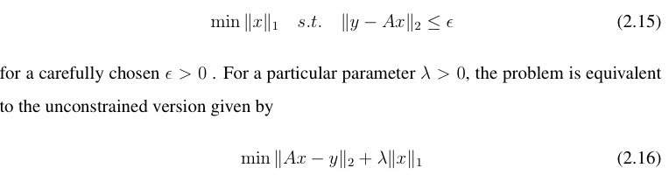

Developed convex optimisation algorithms specifically adapted to the compressed sensing
include interior-point methods [9], projected gradient methods [32], and iterative thresh-
olding [33].

2.5.2 Combinatorial Algorithms

Thesemethodsapplygrouptestingtohighlystructuredsamplesoftheoriginalsignal. From
the various types of algorithms, the HHS pursuit [34] and haining pursuit [35] are popular
algorithms, which require many measurements but achieve extremely rapid computational
speed for sparse signal reconstruction. They are sensitive to noise as they strongly rely on
the group testing of highly structured samples.

24

CHAPTER 2. COMPRESSED SENSING

2.5.3 Greedy Algorithms

Greedy algorithms iteratively approximate the coefficients and the support of the original
signal. They have the advantage of being very fast and easy to implement. Often the the-
oretical performance guarantees are very similar to, for instance, l1 minimisation results.
Greedy algorithms are usually looking for the following approximate solution of the prob-
lem (P0):
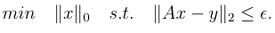
(2.17)

The basic idea is to choose the least column in A in order to form an approximate represen-
tation of y. The most commonly used as a greedy algorithm for OMP algorithm [36], which
is a widely used for sparse reconstruction and develops the process of matching pursuit. As
shown in Algorithm 1, it progressively manages to find the support of the unknown sparse
signal: Give an acquisition system y = Ax where x is K sparse vector and a m × N sensing
matrix A, each iteration of OMP selects one support λ of the vector x which contributes the
most to the observation y. This selection method is based on testing the correlation values
between the current columns of A and residue r. The OMP iteration would not stop before
the residue r becomes relatively small. The OMP algorithm also has many developed ver-
sions, such as StOMP [18], regularised OMP (ROMP) [37], and compressive sampling MP
(CoSaMp) [38].

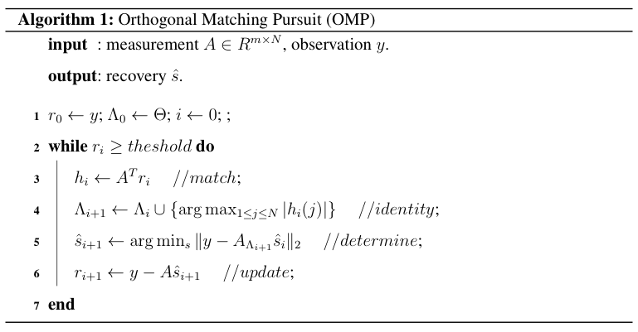

25

CHAPTER 2. COMPRESSED SENSING

Bibliography

[1] J. M. Moura, “What is signal processing?[president’s message],” Signal Processing
Magazine, IEEE, vol. 26, no. 6, pp. 6–6, 2009.

[2] A. V. Oppenheim, R. W. Schafer, J. R. Buck et al., Discrete-time signal processing.
Prentice-hall Englewood Cliffs, 1989, vol. 2.

[3] J. D. Broesch, Digital Signal Processing: Instant Access: Instant Access. Newnes,
2008.

[4] H. Mamaghanian, N. Khaled, D. Atienza, and P. Vandergheynst, “Compressed sens-
ing for real-time energy-efficient ecg compression on wireless body sensor nodes,”
Biomedical Engineering, IEEE Transactions on, vol. 58, no. 9, pp. 2456–2466, 2011.

[5] M. Lustig, D. L. Donoho, J. M. Santos, and J. M. Pauly, “Compressed sensing mri,”
Signal Processing Magazine, IEEE, vol. 25, no. 2, pp. 72–82, 2008.

[6] K. Danckaert, K. Masselos, F. Cathoor, H. J. De Man, and C. Goutis, “Strategy for
power-efficient design of parallel systems,” Very Large Scale Integration (VLSI) Sys-
tems, IEEE Transactions on, vol. 7, no. 2, pp. 258–265, 1999.

[7] E. J. Cands and M. B. Wakin, “An introduction to compressive sampling,” Signal
Processing Magazine, IEEE, vol. 25, no. 2, pp. 21–30, 2008, 1stV.

[8] C. K. Chui, An introduction to wavelets. Academic press, 1992, vol. 1.

BIBLIOGRAPHY

[9] E. J. Cand`es, J. Romberg, and T. Tao, “Robust uncertainty principles: Exact signal
reconstruction from highly incomplete frequency information,” Information Theory,
IEEE Transactions on, vol. 52, no. 2, pp. 489–509, 2006.

[10] R. G. Baraniuk, “Compressive sensing,” IEEE signal processing magazine, vol. 24,
no. 4, 2007.

[11] W. Bajwa, J. Haupt, A. Sayeed, and R. Nowak, “Compressive wireless sensing,” in
Proceedings of the 5th international conference on Information processing in sensor
networks. ACM, 2006, pp. 134–142.

[12] R. G. Baraniuk, “Single-pixel imaging via compressive sampling,” IEEE Signal Pro-
cessing Magazine, 2008.

[13] S. Foucart and H. Rauhut, A mathematical introduction to compressive sensing.
Springer, 2013.

[14] M. Lustig, D. Donoho, and J. M. Pauly, “Sparse mri: The application of compressed
sensing for rapid mr imaging,” Magnetic resonance in medicine, vol. 58, no. 6, pp.
1182–1195, 2007.

[15] J. A. Tropp, J. N. Laska, M. F. Duarte, J. K. Romberg, and R. G. Baraniuk, “Beyond
nyquist: Efficient sampling of sparse bandlimited signals,” Information Theory, IEEE
Transactions on, vol. 56, no. 1, pp. 520–544, 2010.

[16] M. Mishali and Y. C. Eldar, “Expected rip: Conditioning of the modulated wideband
converter,” in Information Theory Workshop, 2009. ITW 2009. IEEE. IEEE, 2009,
pp. 343–347.

[17] J. N. Laska, J. P. Slavinsky, and R. G. Baraniuk, “The polyphase random demodula-
tor for wideband compressive sensing,” in Signals, Systems and Computers (ASILO-

28

BIBLIOGRAPHY

MAR), 2011 Conference Record of the Forty Fifth Asilomar Conference on. IEEE,
2011, pp. 515–519.

[18] D. L. Donoho, Y. Tsaig, I. Drori, and J.-L. Starck, “Sparse solution of underdeter-
mined systems of linear equations by stagewise orthogonal matching pursuit,” Infor-
mation Theory, IEEE Transactions on, vol. 58, no. 2, pp. 1094–1121, 2006.

[19] M. Aharon, M. Elad, and A. Bruckstein, “¡ img src=”/images/tex/484. gif” alt=”\ rm
k”¿-svd: An algorithm for designing overcomplete dictionaries for sparse represen-
tation,” Signal Processing, IEEE Transactions on, vol. 54, no. 11, pp. 4311–4322,
2006.

[20] G. Davis, S. Mallat, and M. Avellaneda, “Adaptive greedy approximations,” Con-
structive approximation, vol. 13, no. 1, pp. 57–98, 1997.

[21] R. A. DeVore, “Deterministic constructions of compressed sensing matrices,” Journal
of Complexity, vol. 23, no. 4, pp. 918–925, 2007.

[22] R.GribonvalandM.Nielsen, “Sparserepresentationsinunionsofbases,” Information
Theory, IEEE Transactions on, vol. 49, no. 12, pp. 3320–3325, 2003.

[23] A. S. Bandeira, E. Dobriban, D. G. Mixon, and W. F. Sawin, “Certifying the restricted
isometry property is hard,” arXiv preprint arXiv:1204.1580, 2012.

[24] L. Welch, “Lower bounds on the maximum cross correlation of signals (corresp.),”
IEEE Transactions on Information theory, pp. 397–399, 1974.

[25] A. Weil, “On some exponential sums,” Proceedings of the National Academy of Sci-
ences of the United States of America, vol. 34, no. 5, p. 204, 1948.

[26] Z. Xu, “Deterministic sampling of sparse trigonometric polynomials,” Journal of
Complexity, vol. 27, no. 2, pp. 133–140, 2011.

29

BIBLIOGRAPHY

[27] E. J. Candes and T. Tao, “Near-optimal signal recovery from random projections:
Universal encoding strategies?” Information Theory, IEEE Transactions on, vol. 52,
no. 12, pp. 5406–5425, 2006.

[28] M. Rudelson and R. Vershynin, “On sparse reconstruction from fourier and gaussian
measurements,” Communications on Pure and Applied Mathematics, vol. 61, no. 8,
pp. 1025–1045, 2008.

[29] H. Rauhut, J. Romberg, and J. A. Tropp, “Restricted isometries for partial random
circulant matrices,” Applied and Computational Harmonic Analysis, vol. 32, no. 2,
pp. 242–254, 2012.

[30] M. A. Davenport, P. T. Boufounos, M. B. Wakin, and R. G. Baraniuk, “Signal pro-
cessing with compressive measurements,” Selected Topics in Signal Processing, IEEE
Journal of, vol. 4, no. 2, pp. 445–460, 2010.

[31] S. S. Chen, D. L. Donoho, and M. A. Saunders, “Atomic decomposition by basis
pursuit,” SIAM journal on scientific computing, vol. 20, no. 1, pp. 33–61, 1998.

[32] M. A. Figueiredo, R. D. Nowak, and S. J. Wright, “Gradient projection for sparse
reconstruction: Application to compressed sensing and other inverse problems,” Se-
lected Topics in Signal Processing, IEEE Journal of, vol. 1, no. 4, pp. 586–597, 2007.

[33] T. Blumensath and M. E. Davies, “Iterative hard thresholding for compressed sens-
ing,” Applied and Computational Harmonic Analysis, vol. 27, no. 3, pp. 265–274,
2009.

[34] A. C. Gilbert, M. J. Strauss, J. A. Tropp, and R. Vershynin, “One sketch for all: fast
algorithms for compressed sensing,” in Proceedings of the thirty-ninth annual ACM
symposium on Theory of computing. ACM, 2007, pp. 237–246.

30

BIBLIOGRAPHY

[35] ——, “Algorithmic linear dimension reduction in the l 1 norm for sparse vectors,”
arXiv preprint cs/0608079, 2006.

[36] S. G. Mallat and Z. Zhang, “Matching pursuits with time-frequency dictionaries,”
Signal Processing, IEEE Transactions on, vol. 41, no. 12, pp. 3397–3415, 1993.

[37] D. Needell and R. Vershynin, “Uniform uncertainty principle and signal recovery via
regularized orthogonal matching pursuit,” Foundations of computational mathemat-
ics, vol. 9, no. 3, pp. 317–334, 2009.

[38] D. Needell and J. A. Tropp, “Cosamp: Iterative signal recovery from incomplete and
inaccurate samples,” Applied and Computational Harmonic Analysis, vol. 26, no. 3,
pp. 301–321, 2009.

31

