

Compressed Sensing for Wideband Signal

Processing

Chen Hao

School of Computer Engineering

A Process report submitted to the School of Computer Engineering
of Nanyang Technological University

in partial fulfillment of the requirements for the
degree of Doctor of Philosophy

Supervisor: Assoc. Prof. Vun Chan Hua

January 2015

Acknowledgements

I would like to express my sincere and great gratitude to my supervisor, Assoc Prof.
Vun Chan Hua for his kind guidance and encouragement. It is a great honor to work with
him. I own my sincere appreciate to all my friends in CeMNet. Without their help, my first
year study and research in NTU can not process well.

Contents

1 Introduction

2 Compressed Sensing 14
2.1 Introduction . . . . . . . . . . . . . . . . . . . . . . . . . . 14
2.2 Sparsity: A Reasonable Assumption . . . . . . . . . . . . . 15
2.2.1 Definition of sparse signals . . . . . . . . . . . . . . 15
2.3 Model of Sparse Reconstruction . . . . . . . . . . . . . . . 16
2.3.1 Null Space Property . . . . . . . . . . . . . . . . . 17

2.3.2 Restricted Isometry Property . . . . . . . . . . . . . 18
2.3.3 Robust Recovery . . . . . . . . . . . . . . . . . . . 18
2.3.4 Minimum Samples . . . . . . . . . . . . . . . . . . 19
2.4 Sensing Matrix . . . . . . . . . . . . . . . . . . . . . . . . 20
2.4.1 Random Matrix . . . . . . . . . . . . . . . . . . . . 20
2.4.2 Deterministic Matrix . . . . . . . . . . . . . . . . . 21
2.4.3 Partial Random Structural Matrix . . . . . . . . . . 21
2.5 Reconstruction Algorithms . . . . . . . . . . . . . . . . . . 23
2.5.1 Convex Optimisation . . . . . . . . . . . . . . . . . 24
2.5.2 Combinatorial Algorithms . . . . . . . . . . . . . . 24
2.5.3 Greedy Algorithms . . . . . . . . . . . . . . . . . . 25

Chapter 2

Compressed Sensing

Compressed sensing is a novel techniques introduced by Donoho [18] and by Candes,
Romberg, and Tao [9] in 2006, and since then has become a key concept in various
areas of applied mathematics, computer science, and electrical engineering. It
demonstrats that high-dimensional signals that allow a sparse representation through a suitable
basis or, more generally, a frame, can be recovered by using effective algorithms from what was previously considered
highly incomplete linear measurements. This chapter presents
an introduction to and a survey of compressed sensing.

2.1 Introduction

In many real world applications, signals are usually sampled and stored in digital devices for further analy-
sis, such as medical image imaging and CT tomography. From the discrete sampling and storage,
the system are expected to be able to exactly reconstruct the original signals using observations as less as possible.
Assuming that the original signal is 1 × N vector, the observation behaviour can be modelled as a sensing matrix A with a size of m × N . Then the sampled data y, an m × 1 vector, can be described as
y = Ax, (2.1)

Then an important question arises:

CHAPTER 2. COMPRESSED SENSING

· In order to reconstruct signal x, what is the minimum samples are needed in y?
Conventional linear algebra theory states that unique solution of (2.1) exists only if m = N . That
is to say, at least N samples are needed in y. However, consider a case when the signal x is
sparse, which means most of the values in x are zero or relatively small, can
x be reconstruct using smaller numbers of observations y? (i.e. with m < N )
Conventionally, if m < N , equation (2.1) is underdetermined, such that multiple possible solutions exist. This means it is not possible to uniquely recover the original signal x. However, if
the x is sparse, then the answer maybe Yes, based on the the technique of Compressed Sensing(CS). That is, CS allows a possible sparse information’s reconstruction from a very few
numbers of samples y (m << N ).The sparse characteristics can naturally exist (such
as x) or generated by orthogonal basis decomposition (such as x = As where s is sparse,
A is the basis e.g. wavelets decomposition). As such, the CS approach provides a feasible
method to theoretically reduce the number of observations required. The essence of the CS
is hence to

· find the minimum number of observations for the sensing matrix.
· design a reconstruction algorithm to uniquely recover original signals via those obser-
vations.

2.2 Sparsity

2.2.1 Definition of sparse signals

Consider a signal x ∈ RN ×1 .
whichis sparse; i.e., it has very few non-zero coefficients K in the sense that

(2.2)

is small, or that there exists an orthonormal basis Ψ such that x = Ψs, where x is
a linear combination of few k basis chosen from Ψ, s is the corresponding coefficients
of representing x in the domain constructed by the basis Ψ.k is then termed as the sparsity.
For real world signals, a variety of representation systems can be used to provide sparse
approximations. If this is not the case, more data sensitive methods (comment: what do you mean by ‘data sensitive’ such as dictionary
learning algorithms, in which a suitable representation system is computed for a given
set of test signals, are available.
The most well-known adaptive learning algorithm is the K-SVD algorithm introduced by
Aahron, Elad, and Bruckstein in [19]. In this chapter, it is hence assumed throughout that x is
already a sparse vector or can be sparse represented.

2.3 Model of Sparse Reconstruction

When the x is sparse, an intuitive solution of the underdetermined equation (2.1) is equals to
the solution of the problem (P0), which aims to find the minimum numbers of supports in
x as follows:
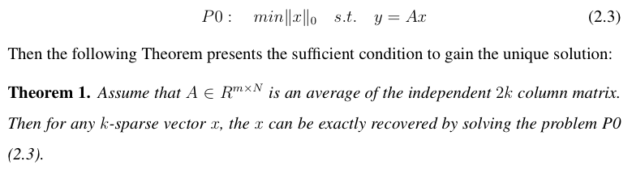

Hence, according to Theorem 1[?], then there is a coding and decoding of (A, ∆) such
that x = ∆(Ax), which means 2k times the number of observations is sufficient for recon-
struction. However, solving the problem P0 is very difficult. In fact, P0 is an NP-complete
problem [20].

Is there a more efficient decoding algorithms available? The answer maybe Yes if some
conditions are satisfied. In this case, using the solution of the following problem P1, which is

termed as Basis Pursuit (BP) or l1-norm minimisation, x can be uniquely reconstructed.

(2.4)

To solve the problem P1, various types of recovery algorithms exist, such as
convex optimisation, greedy, and combinatorial algorithms (section 2.5), where each is
having its own advantages and disadvantages. In this section, the
widely used linear programming (LP) is used as an example to solve P1:
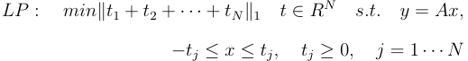

(2.5)

2.3.1 Null Space Property

According to (2.4), the sparse reconstruction is achievable when P1 equals P0. But
when does P1 equal to P0? To answer this question, the null space
of sensing matrix, defined as N (A) = {x : Ax = 0}, plays an important role.
The null space property (NSP) and its corresponding theorem are given below that
presents the sufficient and necessary condition for P1 = P0:
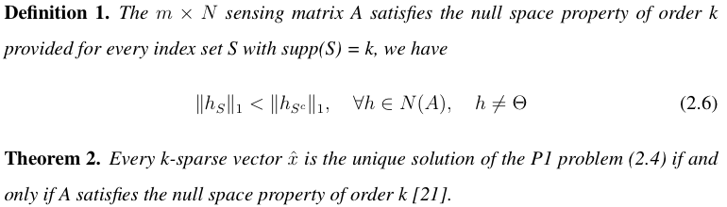

According to the Theorem 2[21], the equivalent condition for the existence of a unique
sparse solution of (P1) can now be stated in terms of the NSP. Then
many convex optimization algorithms and greedy methods can be applied to solve the P1problem
(Refer section 2.5.1 for more detail).

17

CHAPTER 2. COMPRESSED SENSING

2.3.2 Restricted Isometry Property

Although the NSP and the Theorem 2 presents us an equivalent condition to obtain unique
reconstruction through solving P1, how to verify the sensing matrix satisfying
NSP in (2.6) is computational complex, which render the NSP approach not practically feasible.
A more intuitive concept termed as Uniform Uncertainty Principle, or Restricted
Isometry Property (RIP), is introduced in [9]. It measures the degree to which each subset
of k column vectors of the sensing matrix A is close to being an isometry.

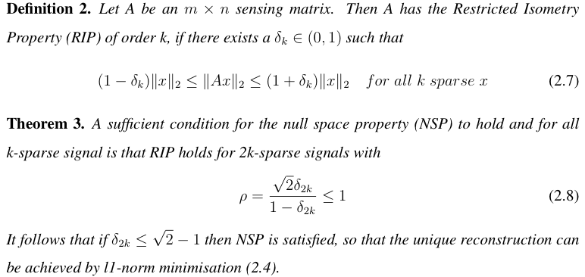

Based on the Theorem 3[9], an equivalent condition for the existence of a unique
sparse solution for (P1) can now be stated in terms of RIP. If the sensing matrix satisfies the
RIP, then for any k-sparse vector x, the Euclidian distance of projected x ( i.e. Ax ) and x
remain very close if the δ2k in (0, 1) is relatively small.

2.3.3 Robust Recovery

To
design a efficient coding and decoding procedure, a RIP-satisfied matrix can hence be used
for encoding, together with the l1-norm minimisation for decoding to recover the k-sparse signals. However,

18

CHAPTER 2. COMPRESSED SENSING

real world signals sometimes are not strictly sparse, but rather approximate
sparse. For such signals, the RIP matrix projection and the
l1-norm minimisation decoding will still be applicable
First, the concept of the best k-term approximation error is defined as follows:
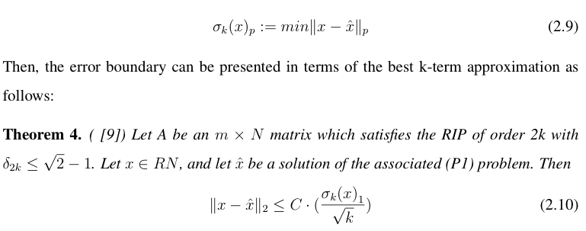

2.3.4 Minimum Samples

[22] presents the following Theorem 5 that defined a
lower boundary for the minimum number of samples y required to reconstructed signal x.

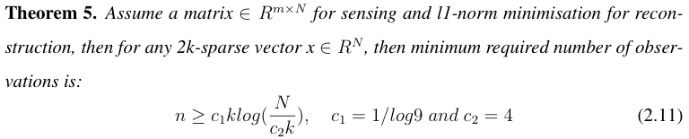

Based on this Theorem, any under-determined sensing matrix will require at least O(klog( N/k)
samples for sparse reconstruction required by (2.4).

19

CHAPTER 2. COMPRESSED SENSING

2.4 Sensing Matrix

While Theorem 3 presents a unique sparse solution of (P1) stated in terms of RIP, whether RIP-matrix sensing and l1-norm minimisation can attain the lower boundary of O(klog( N/k )) will depend on the sensing matrix.
Verification for RIP is not practical since
testing a matrix satisfiying RIP is NP-hard.
However it is posssible to construct a matrix satisfying RIP by using randomness, which
gives a practical way for creating the sensing matrix. In this section, we will introduce some widely used implementation of those sensing matrices, as well as the corresponding reconstruction performance in terms of the magnitude of minimum required samples.

2.4.1 Random Matrix

Two types of random matrices are considered here: Gaussian random matrix and Bernoulli ran-
dom matrix. The Gaussian random matrices refers to the matrix whose elements ai,j are
independent random variables and subject to the distribution N (0, 1). The Bernoulli matrix
refers to the matrix whose elements ai,j has the same probability to be 1 or -1.

2.4.1.1 Probability Reconstruction

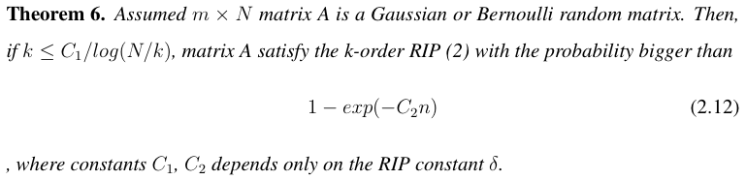

(comment: where do the theorems that you quote come from? You need to indicate the surce)
Theorem 6[ x] shows how the Gaussian and Bernoulli random matrices can satisfy the k =
O(n/log(N/k)) order RIP, indicating that these random matrices reach the lower boundary
of the minimum required samples that is O(klog( N/k )) in (5). Hence these random
matrices presents an efficient and optimal coding and decoding method, which involve
random sensing matrix projection and l1-norm minimisation respectively, that can achieve the
minimum amount of observations requirement.

20

CHAPTER 2. COMPRESSED SENSING

2.4.2 Deterministic Matrix

While a random matrix (Gaussian or Bernoulli) has high probability to satisfies RIP and
provide optimal coding and decoding method (in terms of number of samples), it
is more desirable in practice to construct a deterministic matrix
For example, from the perspective of structural decoding algorithms, determin-
istic matrix helps to reduce memory cost and improve reconstruction speed[reference?]. The current
construction methods for deterministic matrix are mainly based on the property of matrix
coherence[x]:

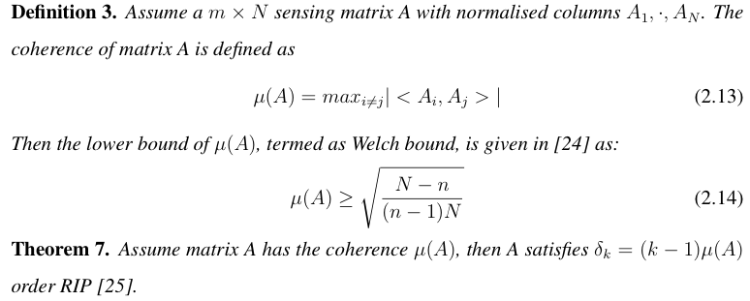

Combining Theorem 7 with the Welch bound in Definition 3, the sensing matrix A
must satisfy the k = √2n RIP. Hence using matrix coherence only would not
schieve the minimum required samples O(klog( N/k )) in (5). How
to find a deterministic RIP matrix that matches this lower bound of required samples is
still an open issue [26].

2.4.3 Partial Random Structural Matrix

Another type of matrix structure that is being investigated is

21

CHAPTER 2. COMPRESSED SENSING

one that uses a combination features of partial randomness and partial deterministic design, which is
termed as the partial random structural matrix. It becomes popular since most applications
have constraints in the design of sensing matrix, even though many od these matrix cannot reach the
optimal boundary of minimum required samples O(klog( N/k )) in (5).

2.4.3.1 Random Partial Fourier Matrix

Random Partial Fourier matrix Ψm is obtained by randomly choosing m rows in the Fourier matrix Ψ to generate a m × N partial
random Fourier matrix. It has
a strong application background, because in many cases, extracting the sparse frequency information using randomness and sub-Nyquist sampling involves Fourier decomposition and generates this sensing matrix. For example, the randomly observed partial frequency
information can be fully recovered by l1-norm minimisation [27].

[28] proves that the
number of minimum samples required is s n = O(k(logN )^4).

2.4.3.2 Rademacher Matrix

The Rademacher random variable takes only values of -1 and +1 with the same likelihood.
In hardware design, it can be easily implemented. [15] uses this sequence in a pre-
mixer for random projection, and successfully designs a low rate analog to digital converter
based on the CS framework, and terms this architecture as the random demodulator (details
in the next chapter). From the theoretical aspect, the required minimum samples is m =
O(klog (N) )^6. (comment: a mistake in this formula?) However, simulations show that the random demodulator requires
just O(klog(N/k)) samples to stably reconstruct the signal, which is equal to the optimal
boundary of minimum required samples O(klog( N/k )) indicated in (5).

22

CHAPTER 2. COMPRESSED SENSING

2.4.3.3 Random Circulant Matrix

In many cases where signal convolution is involved, the circulant matrix always exists
whose each row is shifted compared to its neighbours. This is because that any n-point
circular convolution of two sequences x and h is h * x = Hx, where H is the
corresponding N × N circulant matrix to the original impulse response h. In CS framework,
the randomness is embedded into each elements of the matrix, e.g. Rademacher random
variable is often implemented for constructing each row of circulant matrix, which forms
a partial m × N random circulant matrix. [29] proves that a partial random
circulant matrix satisfies k order RIP when the number of samples m = O((klogN )^(3/2)),
where N is the length of the pulse. Hoeever the required number of samples do not reach
the optimal bound in (5). In practise, these matrices are important in signal processing
applications and wireless communications where convolutions are widely used.

2.4.3.4 Specific Signal Processing Matrix

Many signal processing tasks do not really require full signal information but rather is used to solve
Issues such as inference (comment: you mean interference) or estimation problems. In these case, full sensing itself will not be sufficient (comment: not clear)
so that specific sensing matrix need to designed. For instance, in [30], a compressive filter-
ing matrix is introduced, which aims at sensing to directly extracting useful information
without recovery. This area relates to the Compressive Signal Processing (CSP, details in
chapter 5)but the minimum required number of samples is still an open
issue.

(comment: it is probbaly better to put the detail of 2.4 in Appendix, and just summarise and compare the various sensing Matrices here)(Comment: I will make a summary in the next version)

2.5 Reconstruction Algorithms

This section, provide a brief overview of the different types of algorithms
used for sparse recovery. Convex optimisation algorithms require very few mea-
surements but are computationally more complex. On the other extreme are combinatorial

23

CHAPTER 2. COMPRESSED SENSING

algorithms, which are very fast, and often sub-linear, but require many measurements that
are sometimes difficult to satisfy. Greedy algorithms are a good compromise
between those extremes in terms of computational complexity and the required number of
measurements.

2.5.1 Convex Optimisation

In section 2.3.2 the convex optimisation problem (P1) is presented as (2.4). If the
measurements are affected by noise, a conic constraint is required and the minimisation
problem needs to be changed to the basis pursuit de-noising (BPDN) problem [31], which
allows some measurement mismatch of \epsilon > 0: (‘\epsilon’ is last latex-symbol in 2.15, and my final latex based PDF will not emerge this version mistake)
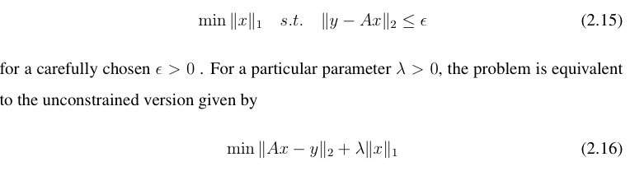

Convex optimisation algorithms developed specifically for the compressed sensing
include interior-point methods [9], projected gradient methods [32], and iterative thresh-
olding [33].

2.5.2 Combinatorial Algorithms

These methods apply group testing to highly structured samples of the original signal. From
the various types of algorithms, the HHS pursuit [34] and haining pursuit [35] are popular
algorithms, which require many measurements but achieve extremely rapid computational
speed for sparse signal reconstruction. However, they are sensitive to noise as they strongly rely on
the group testing of highly structured samples.

24

CHAPTER 2. COMPRESSED SENSING

2.5.3 Greedy Algorithms

Greedy algorithms iteratively approximate the coefficients and the support (comment: what do you ‘su[[ort’?] of the original
signal. They have the advantage of being very fast and easy to implement. The the-
oretical performance are often very similar to the l1 minimisation results.
Greedy algorithms usually looks for the following approximate solution of the prob-
lem (P0):
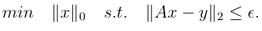
(2.17)

The basic idea is to choose the least number of column required in A in order to form an approximate represen-
tation of y. The most commonly used greedy algorithm is the OMP algorithm [36]. It is
widely used for sparse reconstruction and develops (comment: not clear) the process of matching pursuit. As
shown in Algorithm 1[?], it progressively find the support of the unknown sparse
signal. Given an acquisition system y = Ax, where x is K sparse vector and a m × N sensing
matrix A, each iteration of OMP selects one support λ of the vector x that contributes the
most to the observation y. This selection method is based on testing the correlation values
between the current columns of A and residue r. The OMP iteration would only stop after
the residue r becomes relatively small (comment: how small is relativelly small?). There are many implementation of the OMP algorithms
such as StOMP [18], regularised OMP (ROMP) [37], and compressive sampling MP
(CoSaMp) [38].

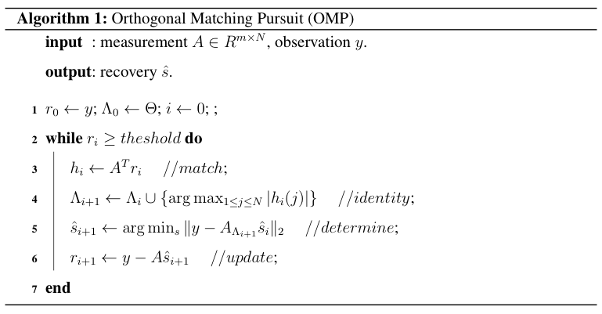

25

2.6 Summary
(comment: you should provide a summary of the chapter here to link the various issue discussed, and then lead into the next chapter.)

In this chapter, we have talked about the basic theorems in CS framework, and shows the possibility to reconstruct signals based on their sparse information from a small group of randomly projected samples. Since the required number of observations in CS are relatively small than that in traditional Nyquist sampling framework, it is expecting that the bottleneck of Nyquist rate in Sampling front-end could be solved by the CS. Next chapter will introduce the recent CS related applications in reducing the sampling rate of analog to digital converters.

CHAPTER 2. COMPRESSED SENSING

Bibliography

[1] J. M. Moura, “What is signal processing?[president’s message],” Signal Processing
Magazine, IEEE, vol. 26, no. 6, pp. 6–6, 2009.

[2] A. V. Oppenheim, R. W. Schafer, J. R. Buck et al., Discrete-time signal processing.
Prentice-hall Englewood Cliffs, 1989, vol. 2.

[3] J. D. Broesch, Digital Signal Processing: Instant Access: Instant Access. Newnes,
2008.

[4] H. Mamaghanian, N. Khaled, D. Atienza, and P. Vandergheynst, “Compressed sens-
ing for real-time energy-efficient ecg compression on wireless body sensor nodes,”
Biomedical Engineering, IEEE Transactions on, vol. 58, no. 9, pp. 2456–2466, 2011.

[5] M. Lustig, D. L. Donoho, J. M. Santos, and J. M. Pauly, “Compressed sensing mri,”
Signal Processing Magazine, IEEE, vol. 25, no. 2, pp. 72–82, 2008.

[6] K. Danckaert, K. Masselos, F. Cathoor, H. J. De Man, and C. Goutis, “Strategy for
power-efficient design of parallel systems,” Very Large Scale Integration (VLSI) Sys-
tems, IEEE Transactions on, vol. 7, no. 2, pp. 258–265, 1999.

[7] E. J. Cands and M. B. Wakin, “An introduction to compressive sampling,” Signal
Processing Magazine, IEEE, vol. 25, no. 2, pp. 21–30, 2008, 1stV.

[8] C. K. Chui, An introduction to wavelets. Academic press, 1992, vol. 1.

BIBLIOGRAPHY

[9] E. J. Cand`es, J. Romberg, and T. Tao, “Robust uncertainty principles: Exact signal
reconstruction from highly incomplete frequency information,” Information Theory,
IEEE Transactions on, vol. 52, no. 2, pp. 489–509, 2006.

[10] R. G. Baraniuk, “Compressive sensing,” IEEE signal processing magazine, vol. 24,
no. 4, 2007.

[11] W. Bajwa, J. Haupt, A. Sayeed, and R. Nowak, “Compressive wireless sensing,” in
Proceedings of the 5th international conference on Information processing in sensor
networks. ACM, 2006, pp. 134–142.

[12] R. G. Baraniuk, “Single-pixel imaging via compressive sampling,” IEEE Signal Pro-
cessing Magazine, 2008.

[13] S. Foucart and H. Rauhut, A mathematical introduction to compressive sensing.
Springer, 2013.

[14] M. Lustig, D. Donoho, and J. M. Pauly, “Sparse mri: The application of compressed
sensing for rapid mr imaging,” Magnetic resonance in medicine, vol. 58, no. 6, pp.
1182–1195, 2007.

[15] J. A. Tropp, J. N. Laska, M. F. Duarte, J. K. Romberg, and R. G. Baraniuk, “Beyond
nyquist: Efficient sampling of sparse bandlimited signals,” Information Theory, IEEE
Transactions on, vol. 56, no. 1, pp. 520–544, 2010.

[16] M. Mishali and Y. C. Eldar, “Expected rip: Conditioning of the modulated wideband
converter,” in Information Theory Workshop, 2009. ITW 2009. IEEE. IEEE, 2009,
pp. 343–347.

[17] J. N. Laska, J. P. Slavinsky, and R. G. Baraniuk, “The polyphase random demodula-
tor for wideband compressive sensing,” in Signals, Systems and Computers (ASILO-

28

BIBLIOGRAPHY

MAR), 2011 Conference Record of the Forty Fifth Asilomar Conference on. IEEE,
2011, pp. 515–519.

[18] D. L. Donoho, Y. Tsaig, I. Drori, and J.-L. Starck, “Sparse solution of underdeter-
mined systems of linear equations by stagewise orthogonal matching pursuit,” Infor-
mation Theory, IEEE Transactions on, vol. 58, no. 2, pp. 1094–1121, 2006.

[19] M. Aharon, M. Elad, and A. Bruckstein, “¡ img src=”/images/tex/484. gif” alt=”\ rm
k”¿-svd: An algorithm for designing overcomplete dictionaries for sparse represen-
tation,” Signal Processing, IEEE Transactions on, vol. 54, no. 11, pp. 4311–4322,
2006.

[20] G. Davis, S. Mallat, and M. Avellaneda, “Adaptive greedy approximations,” Con-
structive approximation, vol. 13, no. 1, pp. 57–98, 1997.

[21] R. A. DeVore, “Deterministic constructions of compressed sensing matrices,” Journal
of Complexity, vol. 23, no. 4, pp. 918–925, 2007.

[22] R.GribonvalandM.Nielsen, “Sparserepresentationsinunionsofbases,” Information
Theory, IEEE Transactions on, vol. 49, no. 12, pp. 3320–3325, 2003.

[23] A. S. Bandeira, E. Dobriban, D. G. Mixon, and W. F. Sawin, “Certifying the restricted
isometry property is hard,” arXiv preprint arXiv:1204.1580, 2012.

[24] L. Welch, “Lower bounds on the maximum cross correlation of signals (corresp.),”
IEEE Transactions on Information theory, pp. 397–399, 1974.

[25] A. Weil, “On some exponential sums,” Proceedings of the National Academy of Sci-
ences of the United States of America, vol. 34, no. 5, p. 204, 1948.

[26] Z. Xu, “Deterministic sampling of sparse trigonometric polynomials,” Journal of
Complexity, vol. 27, no. 2, pp. 133–140, 2011.

29

BIBLIOGRAPHY

[27] E. J. Candes and T. Tao, “Near-optimal signal recovery from random projections:
Universal encoding strategies?” Information Theory, IEEE Transactions on, vol. 52,
no. 12, pp. 5406–5425, 2006.

[28] M. Rudelson and R. Vershynin, “On sparse reconstruction from fourier and gaussian
measurements,” Communications on Pure and Applied Mathematics, vol. 61, no. 8,
pp. 1025–1045, 2008.

[29] H. Rauhut, J. Romberg, and J. A. Tropp, “Restricted isometries for partial random
circulant matrices,” Applied and Computational Harmonic Analysis, vol. 32, no. 2,
pp. 242–254, 2012.

[30] M. A. Davenport, P. T. Boufounos, M. B. Wakin, and R. G. Baraniuk, “Signal pro-
cessing with compressive measurements,” Selected Topics in Signal Processing, IEEE
Journal of, vol. 4, no. 2, pp. 445–460, 2010.

[31] S. S. Chen, D. L. Donoho, and M. A. Saunders, “Atomic decomposition by basis
pursuit,” SIAM journal on scientific computing, vol. 20, no. 1, pp. 33–61, 1998.

[32] M. A. Figueiredo, R. D. Nowak, and S. J. Wright, “Gradient projection for sparse
reconstruction: Application to compressed sensing and other inverse problems,” Se-
lected Topics in Signal Processing, IEEE Journal of, vol. 1, no. 4, pp. 586–597, 2007.

[33] T. Blumensath and M. E. Davies, “Iterative hard thresholding for compressed sens-
ing,” Applied and Computational Harmonic Analysis, vol. 27, no. 3, pp. 265–274,
2009.

[34] A. C. Gilbert, M. J. Strauss, J. A. Tropp, and R. Vershynin, “One sketch for all: fast
algorithms for compressed sensing,” in Proceedings of the thirty-ninth annual ACM
symposium on Theory of computing. ACM, 2007, pp. 237–246.

30

BIBLIOGRAPHY

[35] ——, “Algorithmic linear dimension reduction in the l 1 norm for sparse vectors,”
arXiv preprint cs/0608079, 2006.

[36] S. G. Mallat and Z. Zhang, “Matching pursuits with time-frequency dictionaries,”
Signal Processing, IEEE Transactions on, vol. 41, no. 12, pp. 3397–3415, 1993.

[37] D. Needell and R. Vershynin, “Uniform uncertainty principle and signal recovery via
regularized orthogonal matching pursuit,” Foundations of computational mathemat-
ics, vol. 9, no. 3, pp. 317–334, 2009.

[38] D. Needell and J. A. Tropp, “Cosamp: Iterative signal recovery from incomplete and
inaccurate samples,” Applied and Computational Harmonic Analysis, vol. 26, no. 3,
pp. 301–321, 2009.

31

