

Compressed Sensing for Wideband Signal

Processing

Chen Hao

School of Computer Engineering

A Process report submitted to the School of Computer Engineering
of Nanyang Technological University

in partial fulfillment of the requirements for the
degree of Doctor of Philosophy

Supervisor: Assoc. Prof. Vun Chan Hua

January 2015

Abstract

Acknowledgements

I would like to express my sincere and great gratitude to my supervisor, Assoc Prof.
Vun Chan Hua for his kind guidance and encouragement. It is a great honor to work with
him. I own my sincere appreciate to all my friends in CeMNet. Without their help, my first
year study and research in NTU can not process well.

Contents

1 Introduction

2 Compressed Sensing

3 Compressed Sensing based Analog to Digital Converter
3.1 Introduction . . . . . . . . . . . . . . . . . . . . . . . . . .
3.1.1 Sensing Matrix Modelling . . . . . . . . . . . . . . 4
3.2 Random Demodulator . . . . . . . . . . . . . . . . . . . . . 5
3.2.1 Acquisition Model . . . . . . . . . . . . . . . . . . 5
3.2.2 Fast Reconstruction . . . . . . . . . . . . . . . . . . 7
3.3 Modulated Wideband Convertor . . . . . . . . . . . . . . . 7
3.3.1 Acquisition Model . . . . . . . . . . . . . . . . . . 8
3.3.2 Fast Reconstruction . . . . . . . . . . . . . . . . . . 10
3.4 Non-Uniform Sampling . . . . . . . . . . . . . . . . . . . . 11
3.5 Conclusion . . . . . . . . . . . . . . . . . . . . . . . . . . 14

List of Figures

3.1 Block diagram of random demodulator (RD). The compo-
nents includes a pseudo-random sign generator, a low-pass
filter, and a sub-Nyquist ADC . . . . . . . . . . . . . . . . 5
3.2 Block diagram of modulated wideband convertor (MWC).
The components includes parallel periodic waveforms mix-
ers, low-pass filters, and sub-Nyquist ADCs . . . . . . . . . 8
3.3 Block diagram of the relationship between the spectrum of
the output yi(n) and the input X(f ) In this example, chan-
nels 1 and m linearly combines the original the spectrum
segments around lfp, ¯lfp, ˜lfp with different weights cil. . . . 9
3.4 Block diagram of Continuous to Finite (CTF) for the joint
supports detection . . . . . . . . . . . . . . . . . . . . . . . 11
3.5 A pseudo-randomly sample pattern for single pure tone sig-
nal of length 300 . . . . . . . . . . . . . . . . . . . . . . . 12

3.6 BlockdiagramoftherandomsamplingCSADC(RS-ADC).
The components includes a pseudo-random sign generator,
a low-pass filter, and a sub-Nyquist ADC . . . . . . . . . . 13

List of Tables

Chapter 1

Introduction

Chapter 2

Compressed Sensing

Chapter 3

Compressed Sensing based Analog to

Digital Conversions

Traditional Nyquist Theory becomes cumbersome when an acquisition system processes
signals which contains relatively high frequency components. In this chapter, we
discuss recent applications embedding CS into ADCs to reduce the sampling rate and im-
prove ADCs performance. This chapter focuses on the CS based ADCs design, categories
different popular CS-ADCs in areas of wireless communication, and finally discusses the
architectures and compare the performance.

3.1 Introduction

Analog-to-Digital Converter (ADC) is a key components in signal acquisition and pro-
cessing systems. Ideally, each sampling event should result in the signal value at the spe-
cific sampling instant. However, in practice, there are many factors that limit the ADC
performance such as system noise, phase offset and magnitude error, inter-symbol
interference which are related to aperture uncertainty (i.e., jitter) in the sampling instant [19].

CHAPTER 3. COMPRESSED SENSING BASED ANALOG TO DIGITAL CONVERTER

Furthermore, these effects become more serious at higher input signal frequencies, since
the signal’s slew-rate (i.e., rate of change of a signal) is proportional to the signal frequency
such that a small jitter or aperture uncertainty can generate non-idealities which cause a sig-
nificant error in high-speed sampling, hence affect the performance in modern signal
acquisition and processing systems which acquire high frequency signal inputs.
However, the CS technique has provided alternative approaches to meet the requirement for high-speed analog to digital conversions in the form of
. CS
based analog-infromation conversion (AIC) which include random demodulator [1], modulated wideband converter [2] and non-
uniform sampler [3]. These AIC architectures have been demonstarted to achieve measurmnt of high resolu-
tion high frequency signals using low frequency sub-Nyquist samplings
In addition, CS also enables systems to acquire relatively small number of samples, which
reduce the power cost for sensing and storage. From these aspects, these CS based ADCs provides several advanatges and is hence studied here.
.

3.1.1 Sensing Matrix Modeling

Although a random matrix (Gaussian or Bernoulli, Chapter 2.4.1) has high probability to satisfies RIP and provide optimal coding and decoding method in terms of number of samples, in practice, it is more desirable to construct a deterministic matrix because the certainty in matrix is more attractive. For instance, the deterministic matrix, the Fourier matrix, always exists when we develop the sparsity in frequency domain. For another example, integrate-and-dump sampling matrix is often necessary for describing the sampling behavior in ADCs. As a result, due to these implementation constraints, in CS based ADCs design, partial random and partial deterministic matrix is essential and always used to describe the sensing model, although some of them have not reached the optimal minimum number of samples O(k log N/k) in Chapter 2.4.1.1.

In the following CS-ADC
applications, most of the sensing matrices used are based on partial random structural matrices, which are
analysed in the sub-section named Acquisition Model. Their corresponding reconstruction
performances (in terms of sampling rates / minimum required samples) are then discussed in
the sub-section named Fast Reconstruction.

4
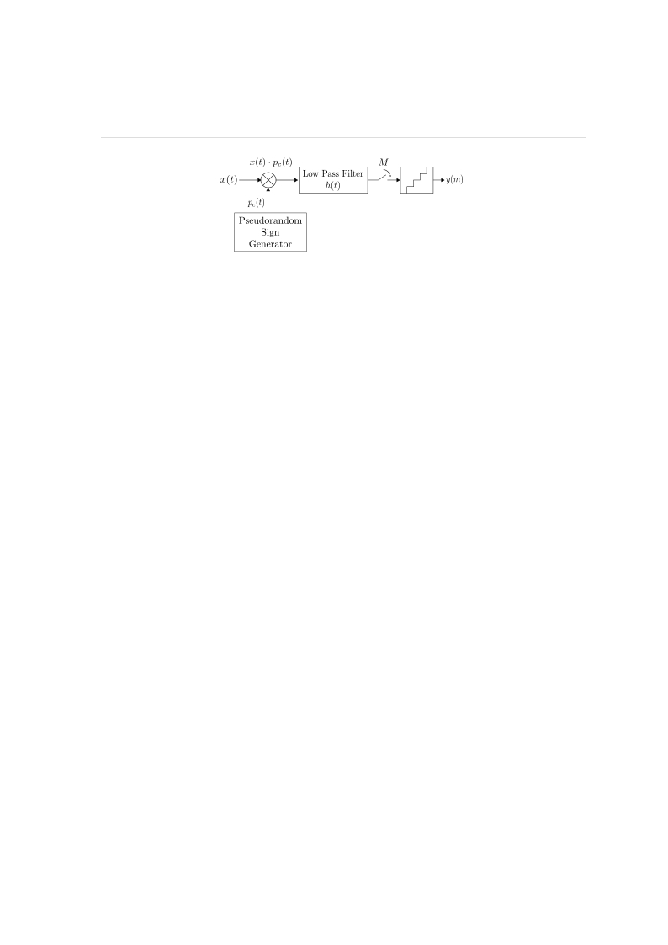

CHAPTER 3. COMPRESSED SENSING BASED ANALOG TO DIGITAL CONVERTER

Figure 3.1: Block diagram of random demodulator (RD). The components includes a
pseudo-random sign generator, a low-pass filter, and a sub-Nyquist ADC.

3.2 Random Demodulator

Random Demodulator (RD) [1] is a new and more popular ADCs for CS-based signal
acquisition and processing.
A k-sparse input signal x(t) is first mixed with the chipping sequence pc(t) which is a
waveform constructed by pseudo-random variables of {±1} (termed as chipping sequence).
The mixed product component x(t) · pc(t) is then passed through an anti-aliasing low pass
filter h(t), before being sampled at a uniform interval but at a lower sampling rate of m
which is of the order O(Klog(N/K)) which is much lower than the normal required rate
corresponds to N (since K << N ). The most widely used reconstruction algorithms for
RD are those based on OMP and CoSaMP greedy pursuit. Experimental results [1] demon-
strates that the minimal sampling rate needed is only 1.7K(log(N/K)) and in addition,
it provides better SNR performance when compared with conventional Nyquist rate based
ADCs.

3.2.1 Acquisition Model

Give that x = Ψs, where Ψ is the discrete time Fourier transform (DFT)
matrix and s is K sparse coefficients, the RD measurement Φ can then be described
as a combination of two matrices, representing the chipping sequence pc(n) and sub-Nyquist

5

CHAPTER 3. COMPRESSED SENSING BASED ANALOG TO DIGITAL CONVERTER

sampling action, respectively.
First, the action of mixing chipping sequence pc(n) can be represented using a diagonal
matrix D where the value of its non-zero items (diagonal items) are chosen pseudo-randomly
from the set {−1, +1} as shown in (3.1):

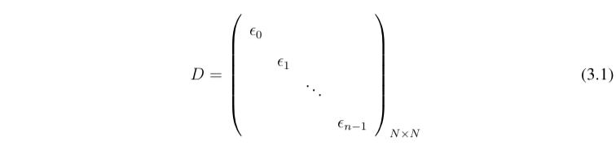

Next, the action of the sampling at a sub-Nyquist rate M where
M divides the Nyquist rate N , then each sample is the sum of N/M consecutive entries of
input signal [4]. From these, the sampling behaviour can be treated as an M × N matrix
Φ as shown in (3.2), where each row has N/M successive entries beginning with its mN/M + 1 th (comment: check this in the final version)
item, where m = 0, 1,...,N − 1 refers to the column number.
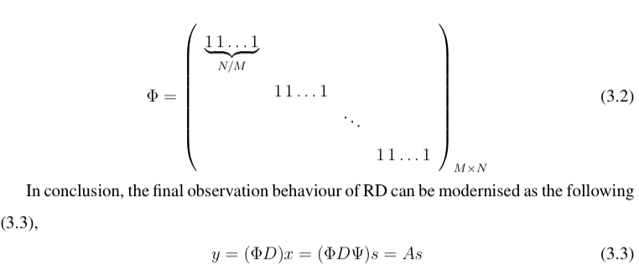

(3.3)

where ΦD stands for the architecture shown in Figure 3.1 and A is the final measurement for
sparse components s, which provides stable and robust reconstruction if A satisfies the RIP.

6

CHAPTER 3. COMPRESSED SENSING BASED ANALOG TO DIGITAL CONVERTER

3.2.2 Fast Reconstruction

Convex optimisation and greedy pursuits such as OMP and CoSaMP have both been developed and applied to this RD
architecture for reconstruc-
tion [5,6]. Experimental results [1] shows the necessary minimal
samples for stable reconstruction for this architecture is ‘1.7K(log(N/K)) + 1’ which is similar
to the theorcial minimum sample number O(K(log(N/K)) (where K << N ) required in
CS using random matrix [7]. Hence, the required samples for CS
is much less than 2N samples neededusing
Nyquist sampling. Besides, [1] also find out that the robustness of RD surpasses that of
the traditional Nyquist sampling by meauring the signal-to-noise ratio (SNR) in different
situations.

3.3 Modulated Wideband Convertor

Modulated Wideband Converter (MWC) [2] is an approach that applies the CS theory for
traditional blind multi-band signal receivers [8], where the carrier frequency is either time-
variant or unknown. Figure 3.2 shows the architecture of the MWC, which consists of
parallel channels of RD based sub-Nyquist rate ADCs.
Each periodic sequence (at TP interval) of pi(t) with minimum duration of Tp/M is
mixed with the input multi-band signal x(t). This shifts each channel spectrum by ∆fp
(fp = 1/Tp ) which is then filtered to the baseband for sampling by sub-Nyquist ADCs.
Reconstruction is done by support detection via continuous to finite block (CTF) which is
shown in Figure 3.4, followed by signal reconstruction. The CTF block com-
prises of frame construction and the multiple measurement vectors (MMV) reconstruction,
and the signal reconstruction can be achieved by a direct pseudo-inverse operation based
on results of the CTF block.

7

CHAPTER 3. COMPRESSED SENSING BASED ANALOG TO DIGITAL CONVERTER

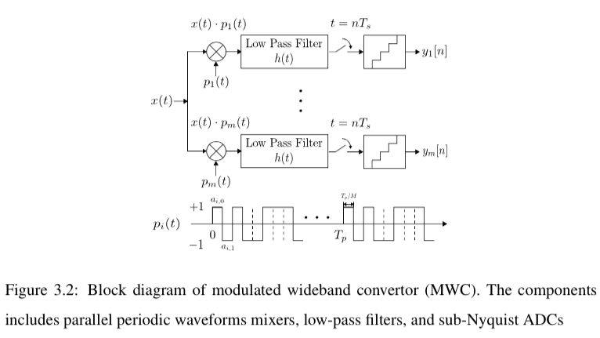

3.3.1 Acquisition Model

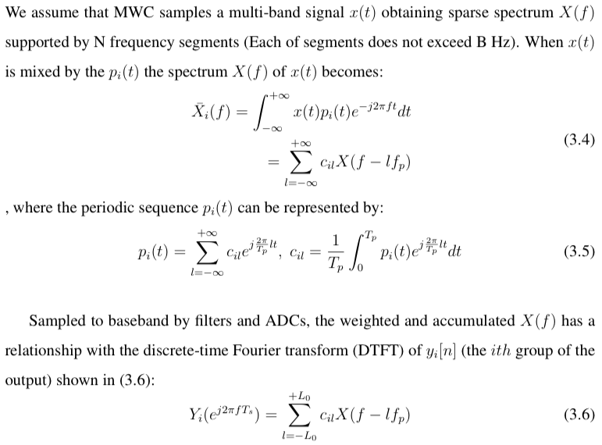

8

CHAPTER 3. COMPRESSED SENSING BASED ANALOG TO DIGITAL CONVERTER

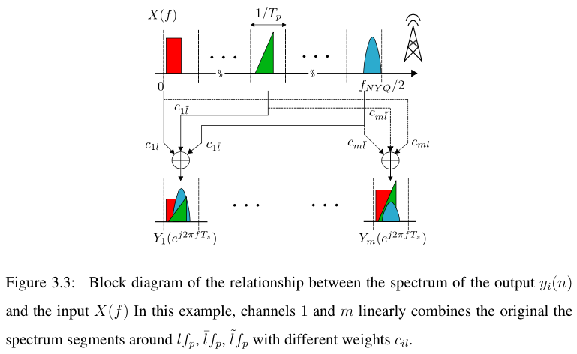

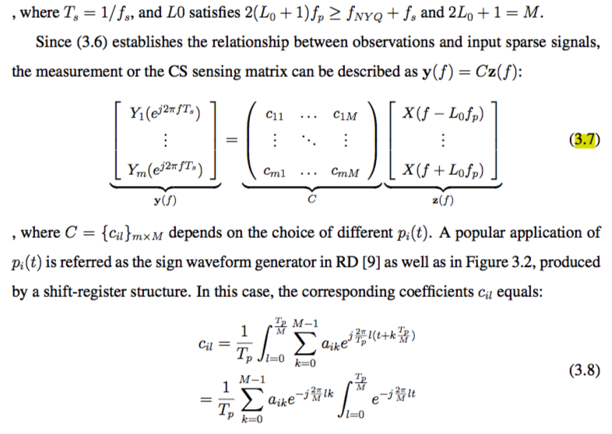

9

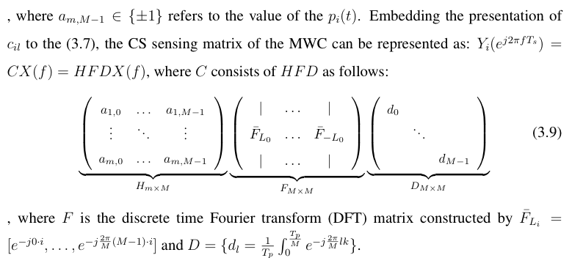

3.3.2 Fast Reconstruction

Considering the CS measurement in (3.7) , recovering the z(f ) where each row X(f − lfp)
presents sparse spectrum segments can be regarded as recovering a infinite set of joint
sparse vectors. This problem can be solved by changing it to the problem of multiple
measurement vectors (MMV) [10] which has been implemented as shown in Figure 3.4:
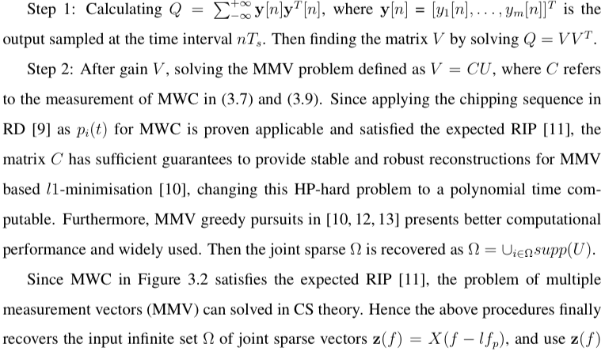

10



CHAPTER 3. COMPRESSED SENSING BASED ANALOG TO DIGITAL CONVERTER

Figure 3.4: Block diagram of Continuous to Finite (CTF) for the joint supports detection

recover the x[nTs], the recovery of the blind multi-band signal in time domain:

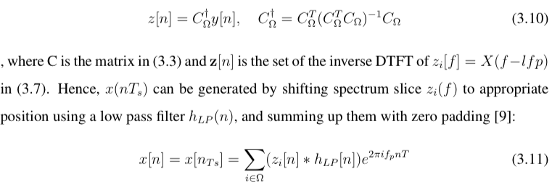

As a result, in practical applications the experimental results indicates that stable recov-
ery of the MWC in Figure 3.2 requires roughly O(4Nlog(M/2N )) channels to estimate
the correct support \Omega. As C_{\Omega} and y[n] are known, the original signal x[n] can be recovered by (3.10) and (3.11).
[14] also compares a modulated wide-band converter(MWC) and a random
demodulator(RD) from aspects of hardware complexity, robustness and
computational load. The results show that the two structures contain sim-
ilar hardware complexity, but the MWC outperforms the RD in computational load and
robustness to model mismatch.

3.4 Non-Uniform Sampling

Apart from the modulated based CS architectures such as random demodulators (RD) or
modulated wideband converters (MWC) which uniformly samples the mixed input analog
signals at a slow rate, another variation for CS based architecture is the non-uniform sampling (NUS).
This is based on the theory of information recovery from random samples[3] driven by a pseudo

11

CHAPTER 3. COMPRESSED SENSING BASED ANALOG TO DIGITAL CONVERTER

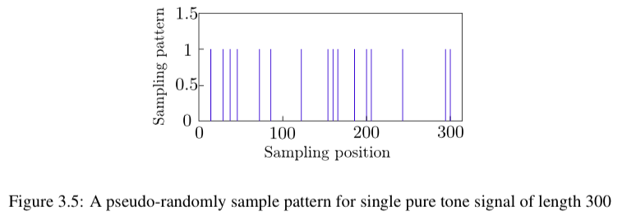

random clock that produce, on average a sub-Nyquist sampling rate. An example of this sampling
pattern is shown in Figure 3.5[3], and an instance of NUS application implemented by multi-
plexers is shown in Figure 3.6[20].

3.4.0.1 Acquisition Model and Reconstruction

When the number of measurements is reduced randomly to make the signal x under-
sampled with a low average sampling rate, the behaviour of the non-uniform
sampler (NUS) [15] based CS acquisition model can be represented as a matrix represen-
tation:

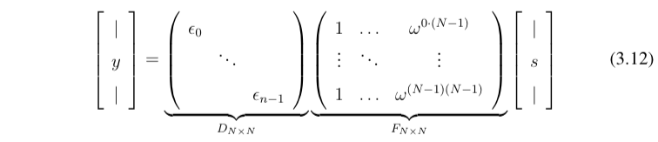

, where the matrix multiplication between F and s stands for the input signal x which
contains sparse spectrum s, and F is the full discrete time Fourier transform (DFT) matrix.
The diagonal matrix D represents the behaviour of non-uniform sampling, where the value
of diagonal items are chosen pseudo-randomly from {0, 1}.
The NUS based CS acquisition model establishes a sensing matrix A which equals to DF
in 3.12. A can be regarded as a random partial Fourier matrix FT which consists of ran-
domly chosen columns of the discrete Fourier matrix(DFT) and indexed by T . According

12

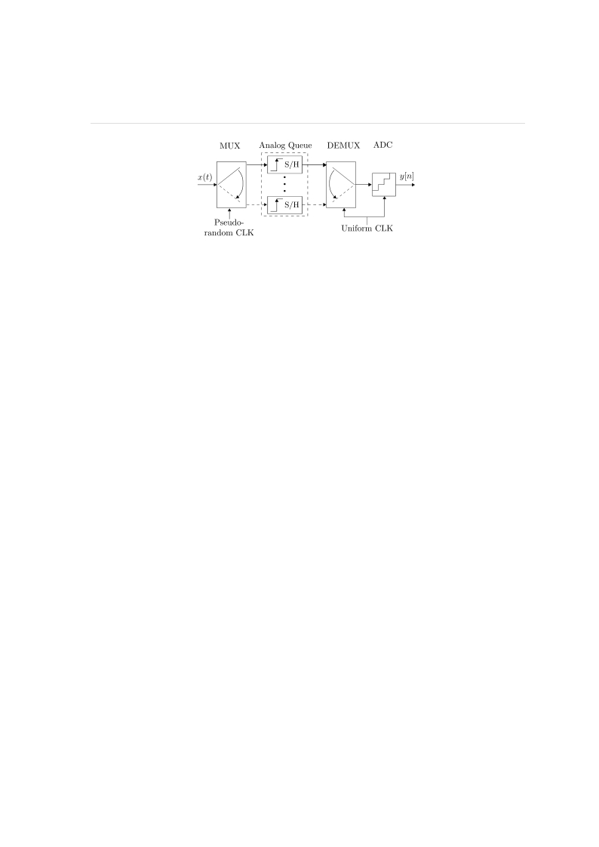

CHAPTER 3. COMPRESSED SENSING BASED ANALOG TO DIGITAL CONVERTER

Figure 3.6: Block diagram of the random sampling CS ADC (RS-ADC). The components
includes a pseudo-random sign generator, a low-pass filter, and a sub-Nyquist ADC

to [3], the matrix A satisfies the RIP in compressive sensing so the acquisition model in
(3.12) produces a stable reconstruction of s via l1-minimisation using m ≥ O(slog(N/s))
samples [3]. In addition, many greedy algorithms such as OMP and CoSaMP can also
be used for fast reconstruction for this architecture [16].

3.4.0.2 Implementation

There are several variations to the implementations of the CS based non-uniform sampling architectures
[3,16–18]. Among these implementations, the random sampling compressive sensing ADC
(RS-ADC) shown in Figure 3.6 is likely to be the prevailing design. The implementation
uses an input multiplexer driven by a non-uniform clock to switch the signal among several
parallel S/H based analog queues. A low rate ADC (e.g. Successive Approximation ADC)
is then used to convert the stored samples, performing at uniform intervals but operating at sub-
Nyquist average rate. Greedy pursuit algorithms such as OMP and CoSaMP are then used
to perform fast reconstruction for this architecture.
However, the main problem of applying RS-ADC lies in sampling high frequency sig-
Nals. Since the ADC and input MUX perform inherent bandwidth limitations modeled as a
lowpass filter preceding the uniform sampling, acquisitions for high frequency signals re-
sults in a loss of the spectrum components. Besides, the high switching speed of the MUX
increases noise and reduces the power efficiency.

13

CHAPTER 3. COMPRESSED SENSING BASED ANALOG TO DIGITAL CONVERTER

3.5 Summary

Modern digital signal processing applications deal with a large amount of data, resulting
in enormous numbers of observations and requiring high speed sampling in the front-end
of systems according to conventionalNyquist theorem. To overcome this problem, the compressive
sensing based ADC (CS-ADC) ishave been investigated and reported in this chapter.
.
Mathematical and theoretical foundations, as well
as implementation instances are discussed for the RD, MWC, and NUS based architectures. Reconstruction performance
are also discussed, which shows the computational efficiency and high speeds archievable based on
CS-ADCs. It is anticipated that CS-ADCs will be used widely in the ADC front-ends for
many high frequency and wideband signal processing systems that are commonly encountered in many wireless de-
vices such as ultra-wideband communications and cognitive radios, which will be further elaborated
in the following chapters of this report.

14

Bibliography

[1] J. A. Tropp, J. N. Laska, M. F. Duarte, J. K. Romberg, and R. G. Baraniuk, “Beyond
nyquist: Efficient sampling of sparse bandlimited signals,” Information Theory, IEEE
Transactions on, vol. 56, no. 1, pp. 520–544, 2010.

[2] M. Mishali and Y. C. Eldar, “Blind multiband signal reconstruction: Compressed
sensing for analog signals,” Signal Processing, IEEE Transactions on, vol. 57, no. 3,
pp. 993–1009, 2009.

[3] T. Ragheb, S. Kirolos, J. Laska, A. Gilbert, M. Strauss, R. Baraniuk, and Y. Massoud,
“for analog-to-information conversion via random sampling,”
in Circuits and Systems, 2007. MWSCAS 2007. 50th Midwest Symposium on. IEEE,
2007, pp. 325–328.

[4] S. Kirolos, J. Laska, M. Wakin, M. Duarte, D. Baron, T. Ragheb, Y. Massoud, and
R. Baraniuk, “Analog-to-information conversion via random demodulation,” in De-
sign, Applications, Integration and Software, 2006 IEEE Dallas/CAS Workshop on.
IEEE, 2006, pp. 71–74.

[5] D. Yang, H. Li, G. D. Peterson, and A. Fathy, “Compressed sensing based uwb re-
ceiver: Hardware compressing and fpga reconstruction,” in Information Sciences and
Systems, 2009. CISS 2009. 43rd Annual Conference on. IEEE, 2009, Conference
Proceedings, pp. 198–201.

BIBLIOGRAPHY

[6] L. Bai, P. Maechler, M. Muehlberghuber, and H. Kaeslin, “High-speed compressed
sensing reconstruction on fpga using omp and amp,” Rn, vol. 1, p. 0, 2012.

[7] D. L. Donoho, “High-dimensional centrally symmetric polytopes with neighborliness
proportional to dimension,” Discrete & Computational Geometry, vol. 35, no. 4, pp.
617–652, 2006.

[8] W. C. Black Jr and D. Hodges, “Time interleaved converter arrays,” Solid-State Cir-
cuits, IEEE Journal of, vol. 15, no. 6, pp. 1022–1029, 1980.

[9] M. Mishali and Y. C. Eldar, “From theory to practice: Sub-nyquist sampling of sparse
wideband analog signals,” Selected Topics in Signal Processing, IEEE Journal of,
vol. 4, no. 2, pp. 375–391, 2010.

[10] ——, “Reduce and boost: Recovering arbitrary sets of jointly sparse vectors,” Signal
Processing, IEEE Transactions on, vol. 56, no. 10, pp. 4692–4702, 2008.

[11] ——, “Expected rip: Conditioning of the modulated wideband converter,” in Infor-
mation Theory Workshop, 2009. ITW 2009. IEEE. IEEE, 2009, pp. 343–347.

[12] J. Chen and X. Huo, “Theoretical results on sparse representations of multiple-
measurement vectors,” Signal Processing, IEEE Transactions on, vol. 54, no. 12, pp.
4634–4643, 2006.

[13] L. Sun, J. Liu, J. Chen, and J. Ye, “Efficient recovery of jointly sparse vectors.” in
NIPS, 2009, pp. 1812–1820.

[14] M. Mishali, Y. C. Eldar, and A. J. Elron, “Xampling: Signal acquisition and process-
ing in union of subspaces,” Signal Processing, IEEE Transactions on, vol. 59, no. 10,
pp. 4719–4734, 2011.

[15] E. J. Cands and M. B. Wakin, “An introduction to compressive sampling,” Signal
Processing Magazine, IEEE, vol. 25, no. 2, pp. 21–30, 2008, 1stV.

16

BIBLIOGRAPHY

[16] P. Maechler, N. Felber, A. Burg et al., “Random sampling adc for sparse spec-
trum sensing,” in Proc. European Signal Processing Conference (Eusipco), 2011, pp.
1200–1204.

[17] J. Laska, S. Kirolos, Y. Massoud, R. Baraniuk, A. Gilbert, M. Iwen, and M. Strauss,
“Random sampling for analog-to-information conversion of wideband signals,” in De-
sign, Applications, Integration and Software, 2006 IEEE Dallas/CAS Workshop on.
IEEE, 2006, pp. 119–122.

[18] D. J. Rogers, R. Elkis, S. Chin, and M. A. Wayne, “Compressive rf sensing using a
physical source of entropy,” in Statistical Signal Processing Workshop (SSP), 2011
IEEE. IEEE, 2011, Conference Proceedings, pp. 609–612.

[19] Abari, Omid, et al. "Why analog-to-information converters suffer in high-bandwidth sparse signal applications." Circuits and Systems I: Regular Papers, IEEE Transactions on 60.9 (2013): 2273-2284.

[20] Slavinsky, John P., et al. "The compressive multiplexer for multi-channel compressive sensing." Acoustics, Speech and Signal Processing (ICASSP), 2011 IEEE International Conference on. IEEE, 2011.

17

