

Compressed Sensing for Wideband Signal

Processing

Chen Hao

School of Computer Engineering

A Process report submitted to the School of Computer Engineering

of Nanyang Technological University

in partial fulfillment of the requirements for the

degree of Doctor of Philosophy

Supervisor: Assoc. Prof. Vun Chan Hua

January 2015

Abstract

Acknowledgements

I would like to express my sincere and great gratitude to my supervisor, Assoc Prof.

Vun Chan Hua for his kind guidance and encouragement. It is a great honor to work with

him. I own my sincere appreciate to all my friends in CeMNet. Without their help, my first

year study and research in NTU can not process well.

Contents

1 Introduction

2 Compressed Sensing

3 Compressed Sensing based Analog to Digital Converter

4 Compressive Ultra Wideband Positioning

4.1 Introduction . . . . . . . . . . . . . . . . . . . . . . . . . .

4.1.1 Literature Review . . . . . . . . . . . . . . . . . . . 5

4.1.2 Contribution . . . . . . . . . . . . . . . . . . . . . 6

4.2 Model of Traditional UWB Positioning . . . . . . . . . . . 6

4.2.1 Compressive Receivers . . . . . . . . . . . . . . . . 7

4.2.2 Compressive Transmitters . . . . . . . . . . . . . . 8

4.3 Proposed Work: Energy Aware Random Mixing Transmitters 9

4.3.1 Introduction . . . . . . . . . . . . . . . . . . . . . . 10

4.3.2 System Model . . . . . . . . . . . . . . . . . . . . 10

4.3.3 Simulation Results . . . . . . . . . . . . . . . . . . 11

4.4 Conclusion . . . . . . . . . . . . . . . . . . . . . . . . . . 13

5 Wideband Cognitive Spectrum Sensing 14

5.1 Introduction . . . . . . . . . . . . . . . . . . . . . . . . . . 14

5.2 Hypothesis Test Model for Spectrum Sensing . . . . . . . . 16

5.3 Traditional Detection Method . . . . . . . . . . . . . . . . . 16

5.3.1 Narrowband Detection . . . . . . . . . . . . . . . . 16

5.3.2 Nyquist Wideband Detection . . . . . . . . . . . . . 18

5.4 Sub-Nyquist Wideband Detection . . . . . . . . . . . . . . 20

5.5 CS based Detection Method . . . . . . . . . . . . . . . . . 21

5.5.1 Introduction to Compressive Spectrum Sensing . . . 21

5.5.2 Compressive Detectors Overview . . . . . . . . . . 22

5.5.3 An Instance: CS based Cognitive Radar System . . . 23

5.6 Challenges and Discussion . . . . . . . . . . . . . . . . . . 25

5.6.1 Long-Time Feedback Delay . . . . . . . . . . . . . 25

5.6.2 Mismatch for Traditional Signal Processing . . . . . 25

5.6.3 High Energy Cost . . . . . . . . . . . . . . . . . . . 25

5.7 Conclusion . . . . . . . . . . . . . . . . . . . . . . . . . . 26

6 Future Work: Novel Signal Processing for CS Spectrum Sensing 27

6.1 Introduction to CSP . . . . . . . . . . . . . . . . . . . . . . 27

6.1.1 Literature Review . . . . . . . . . . . . . . . . . . . 28

6.1.2 Proposed Research . . . . . . . . . . . . . . . . . . 28

6.2 Potential CSP Applications In Spectrum Sensing . . . . . . 29

6.2.1 CSP based Filtering . . . . . . . . . . . . . . . . . 29

6.2.2 CSP based Detection . . . . . . . . . . . . . . . . . 31

6.2.3 CSP based Estimation . . . . . . . . . . . . . . . . 32

6.2.4 Other Related Wideband Processing with CSP . . . 34

6.3 Conclusion . . . . . . . . . . . . . . . . . . . . . . . . . . 36

List of Figures

4.1 Blockdiagramofcompressivereceiverimplementedbyran-

dom demodulator (RD). The components of RD includes

a pseudo-random sign generator (PRSG), a low-pass filter

(LPF), and a sub-Nyquist ADC . . . . . . . . . . . . . . . . 8

4.2 Blockdiagramoflow-ratecompressiverandommixingUWB

positioning system. . . . . . . . . . . . . . . . . . . . . . . 9

5.1 (a) The existence of unused spectrum resources; (b) The

concept of spectrum holes . . . . . . . . . . . . . . . . . . 15

5.2 Block diagrams for traditional narrowband detection archi-

tectures: a) matched filtering detector; b) energy detector;

c) feature detector . . . . . . . . . . . . . . . . . . . . . . . 17

5.3 Block diagrams for Nyquist wideband detectors architec-

tures: a) multiband joint detector; b) wavelet detector; c)

sweep-tune detector; d) filter-bank detector . . . . . . . . . 19

5.4 Block diagrams for compressive wideband sensing archi-

tectures: a) random demodulation based detector; b) modu-

lated wideband converter-based detector . . . . . . . . . . . 22

5.5 Block diagrams for mean square error and error detection

performance of the proposed compressive cognitive radar

systems . . . . . . . . . . . . . . . . . . . . . . . . . . . . 24

6.1 Block diagram of exchanging order of circulant matrix. H

is corresponding impulse response of filter, Φ is the com-

pressed sensing matrix. The exchanging sacrifice is the loss

of rows in the results (matrix in the right side of equal sign). 30

6.2 BlockdiagramofperformancecomparisonbetweentheCSP

detector (compressive signal processing based detector) and

ED (energy detector) from aspect of signal to noise ratio and

detection error. . . . . . . . . . . . . . . . . . . . . . . . . 31

6.3 Block diagram of lookup table for sparsity order estimation

through signal-to-noise ratio (SNR) and asymptotic eigen-

value probability distribution function (aepdf). For exam-

ple, if the value of aepdf = 7.26 for the compressive case

in SNR = 2db, it can be estimated that the sparsity order of

spectrum occupancy is 0.6 . . . . . . . . . . . . . . . . . . 33

6.4 Histogram for the estimated shift in SNR = 2. From left to

right, top to bottom, compression ratio = 0.1 ... 1. The true

shift was set to 5 in all trials . . . . . . . . . . . . . . . . . 35

6.5 Blockdiagramofthecompressivesensingphase-lockedloop

(CS-PLL). The components includes the pre-CS sampler,

phase detector, loop filter, oscillator and the feed-back CS

multiplier . . . . . . . . . . . . . . . . . . . . . . . . . . . 36

List of Tables

Chapter 1

Introduction

Chapter 2

Compressed Sensing

Chapter 3

Compressed Sensing based Analog to

Digital Converter

Chapter 4

Compressive Ultra Wideband

Positioning

In this chapter, we focus on one of the popular ultra wideband (UWB) wireless applica-

tion – impulse-radio ultra-wideband (IR-UWB) positioning system. The proposed UWB

positioning system shows the potential advantages if we implement CS projection in the

transmitter of the UWB positioning system according to the experiment result. Besides,

Our proposed compressive UWB positioning presents a novel view of energy trade-off de-

sign, which is implemented by a low-rate random-projection at transmitters and low rate

ADCs at receivers. It is clear that this design significantly reduce the peak frequency in the

system with acceptable rate increase in receivers’ ADC sampling rate.

4.1 Introduction

Ultra-wide band (UWB) communication is widely used in wireless communication and as-

sociated with features as extreme wide transmission bandwidth, low-power consumption,

shared spectrum resources in wide ranges etc [1]. Among all applicable areas, UWB based

accurate positioning and tracking in short range communication become popular since it

CHAPTER 4. COMPRESSIVE ULTRA WIDEBAND POSITIONING

provides resilient to multipath fading in hostile environment and outstanding robustness

even in low signal-to-noise (SNR) situations [2]. In addition, the requirements of high data

rate and limitations of battery supply lead the impulse-radio ultra-wide band (IR-UWB) to

become a suitable communication technique in short range high data rate communication.

As a result, applications based short-distance wireless sensor networks(WSNs) where large

numbers of portable instrument, are widely deployed such as indoor positioning, surveil-

lance, home automation, etc.

However, high data rate transmission puts huge pressure on signal detection at ADCs

at receivers, which indicates the sampling rate becomes a main bottleneck to the IR-UWB

system. This paper focuses on the IR-UWB indoor positioning, aims at solving the bottle-

neck of sampling rate by using a recent novel technique termed compressed sensing (CS),

aforementioned in Chapter 2. It indicates that CS based IR-UWB systems can possibly

detect high frequency sparse signals under a sub-Nyquist sampling rates that far below the

Nyquist rate (twice the IR-UWB bandwidth). This result is advantageous which releases

the bottleneck of the large bandwidth constraints on ADC at UWB receivers, and con-

sequently reduces storage limits and improves energy efficiency in IR-UWB positioning

systems.

4.1.1 Literature Review

Recently some researches manage to embed CS reconstruction algorithms, e.g. revised or-

thogonal matching pursuit, at UWB receivers. These algorithms successfully improve the

SNR of the received signal before they are sent to the stages of time of arrival (TOA) based

positioning algorithm. Consequently, this method increases the performance of entire po-

sitioning accuracy [3]. For hardware implementation of the new CS based UWB receivers,

most of them apply the hardware structure termed the random demodulator (RD) [4], and

consequently this new CS-UWB receiver successfully reduces the sampling rate signifi-

cantly compared to the Nyquist rate [5].

5

CHAPTER 4. COMPRESSIVE ULTRA WIDEBAND POSITIONING

On the other hand, some researches embed the CS technique mainly at UWB trans-

mitters. They develop a waveform-based precoding transmitter, in order to fulfil a random

projection of the UWB generated pulses [6]. Followed by sub-Nyquist sampling ADCs at

receivers, the sampled signals are sent to TOA based algorithm for calculating the location

of the UWB transmitter. Simulation results show that the new CS-UWB transmitter man-

age to significantly decrease the sampling rate of receivers successfully improves accuracy

of traditional UWB positioning system.

However, both CS-UWB receivers and CS-UWB transmitters suffer from high-data rate

random mixing operation, where PN sequence at mixers is required to reach the extremely

high Nyquist rate ( e.g. beyond 10 GHz). This requirement generates heavy burden on

bandwidth of hardware mixers and additionally increases a high frequency noise.

4.1.2 Contribution

To solve this problem, our proposed work proposes an advanced low-rate CS-UWB posi-

tioning system: For the CS-UWB transmitter, it implements a relatively low-rate random

projection matrix to slow down the mixing rate. For CS-UWB receivers, they sacrifices a

small degree of compression ratio to keep equivalent performance as those positioning sys-

tem using traditional CS-UWB transmitters. As a result, the trade-off between the random

mixing rate and the sub-Nyquist sampling rate makes our system to become a more energy

balanced, and consequently gains a better performance in entire power consumption and

energy efficiency.

4.2 Model of Traditional UWB Positioning

Extremely wide transmission bandwidths of the IR-UWB offers outstanding multipath

resolutions for accurate positioning in indoor environment. Consider a typical UWB indoor

communication model where distributed UWB receivers (base stations) are placed in an

6

CHAPTER 4. COMPRESSIVE ULTRA WIDEBAND POSITIONING

area to detect the location of a moving UWB transmitter (tag). The transmitter periodically

broadcasts Gaussian shaped pulse p(t) through an indoor multipath channel, and receivers

detect signals for time of arrival (TOA) based positioning calculation. The received signals

can be described as (4.1):

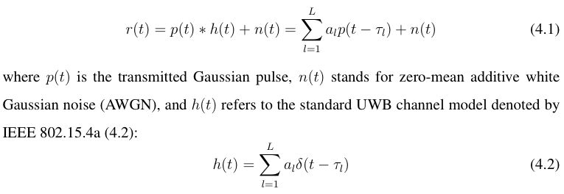

Here al and τl are the gain and delay corresponding to the i-th path in the channel model.

The L defines the total number of propagation paths, and δ(t) is the Dirac delta function.

Based on the fact that geometrical difference yields different time of arrivals, the received

signals at the different receivers are collected for TOA based algorithm. At last accurate

position of the transmitter is calculated based on TOA [7]. In addition, since both transmit-

ted pulses and components of multipath channel can be regarded as approximately sparse,

the received IR-UWB signals becomes sparse, and consequently the CS framework is ap-

plicable for UWB positioning [5].

4.2.1 Compressive Receivers

Typical recent researches embed the CS reconstruction algorithm at UWB receivers to im-

prove the SNR of the received signal. As a result, it not only increases the performance

of the positioning accuracy [3], but also reduces the sampling rate to a relatively low level

compared to the Nyquist rate. Among these compressive receivers, most of them develop

the random demodulator (RD) [4] as the main structure of CS based UWB receivers [5].

In this system, each compressive receiver realises the RD architecture that composed

7



CHAPTER 4. COMPRESSIVE ULTRA WIDEBAND POSITIONING

Figure 4.1: Block diagram of compressive receiver implemented by random demodulator

(RD).ThecomponentsofRDincludesapseudo-randomsigngenerator(PRSG),alow-pass

filter (LPF), and a sub-Nyquist ADC

of a pseudo-random sign generator (PRSG), a low pass filter (LPF), and a sub-Nyquist rate

analog-to-digital converter (ADC), shown in Fig.4.1.

Then the transmitted UWB signals are collected by group of low-rate distributed ADCs

only using a minimal sampling rate of 1.7K(log(N/K)) [4], where N stands for Nyquist

rate and K is the sparsity in transmitted UWB signals. Results in [8] demonstrates that the

new system successfully improves positioning accuracy.

4.2.2 Compressive Transmitters

On the other hand, some researches embed the CS technique at the UWB transmitter

and regarded it as a better solution than compressive receivers in terms of system hard-

ware power efficiency. The new architecture contains a random tap FIR at the transmitter,

which accomplishes the CS random projection before UWB signals are transmitted [6].

Followed by distributed sub-Nyquist rate ADCs, the down-sampled signals are collected

for TOA based algorithm. Simulation result [6] shows that the new compressive transmit-

ter is suitable for detecting the indoor channel model with higher accuracy than traditional

TOA based method. This architecture is also suitable for indoor positioning because the

transmitted signal pulse and channel model keep the same. Besides, it meanwhile saves

more energy cost since it contains less hardware mixers than compressive receiver based

8

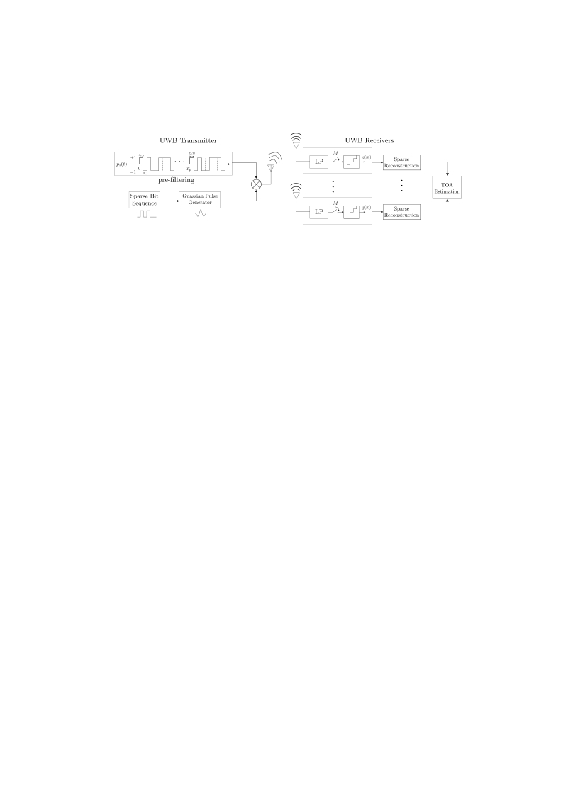

CHAPTER 4. COMPRESSIVE ULTRA WIDEBAND POSITIONING

Figure 4.2: Block diagram of low-rate compressive random mixing UWB positioning sys-

tem.

UWB system. However, the complexity of implementation a high data rate random tap FIR

filters brings additional cost and becomes a main difficulty in applications.

4.3 ProposedWork: EnergyAwareRandomMixingTrans-

mitters

In this section, we follows the architecture of waveform-based pre-coding at the transmitter

[6], we proposed a new compressive random mixing transmitters for UWB positioning.

The main purpose of this system is to slow down the high rate mixing operation when

building CS framework at transmitters. Simulation results demonstrate that our proposed

CS-based UWB positioning scheme successfully decreases the high rate mixing operation

by sacrificing a slight compression ratio (< 10%) or small increase on average error (<

1mm). The new CS-UWB TOA positioning system can achieve a much higher positioning

accuracy than the traditional system in mm level. Future research will focus on how to

reduce the reconstruction running time so that the real-time performance can be enhanced.

This aim relates to the compressive signal processing that will be mentioned in the next

chapter.

9

CHAPTER 4. COMPRESSIVE ULTRA WIDEBAND POSITIONING

4.3.1 Introduction

As mentioned, both compressive receivers and compressive transmitters suffer from high-

data rate random projection operation, where the alternative rate of pseudo-random se-

quence is required (often equal or above 5 GHz in such cases). This requirement generates

a heavy burden on bandwidth of hardware mixers and high frequency noise.

In order to solve this problem but meanwhile preserve the energy efficient feature

in compressive transmitters, this paper propose an low-rate compressive random mixing

(CRM) UWB positioning system shown in Fig.4.2: At the transmitter side, the new sys-

tem provides a relatively low-rate pseudo-random sequence to mix the generated Gaussian

pulses. At the receivers’ side, it sacrifices the compression ratio (or sampling rate) to catch

up with the equivalent performance as that in the compressive receivers based UWB sys-

tem. As a result, the trade-off between the random projection rate and the sub-Nyquist

sampling rate offers a more energetic balanced system, where no hardware devices suffers

from the limitation brought from the high data rate sequence. In addition, the positioning

accuracy is successfully improved compared to the original UWB system.

4.3.2 System Model

Based on the IR-UWB indoor positioning system model in (4.1), the new structure of our

system can be regarded as shown in Fig.4.2. At the transmitter, the a pseudo-random se-

quence (PRS) whose variables are chosen from −1, +1 are generated using a relatively

low sub-Nyquist alternative rate. When a UWB pulse generated, first it will be randomly

mixed by the pseudo-random sequence, and then broadcasted to indoor environment from

the transmitter. Afterwards, receivers directly down-sample the signals at a relatively low

rate. Finally, after processing the sparse reconstruction (i.e OMP or BP), the original TOA

based algorithm can work for indoor positioning. In addition, these steps at receivers can

be executed pipelined as [5]. Hence, based on the workflow of the new architecture, the

10

CHAPTER 4. COMPRESSIVE ULTRA WIDEBAND POSITIONING

math model of this system can be represented as following matrix form (4.3):

Macintosh HD:Users:chenhao:Desktop:Screen Shot 2015-02-23 at 11.39.42 pm.png

where y are discrete sampled observations from low rate ADCs at receivers, and x is the

generated UWB Gaussian pulses at traditional transmitters. Here H is the correspondingly

Toeplitz matrix, which presents the signal convolution using IEEE 802.15.4a model in (4.2),

and F stands for the random projection step, which is a diagnose matrix whose variables

are randomly chosen from {−1, +1} but alternatives at a sub-Nyquist low rate. The D

represents the downsampling behaviour. It is a m × N matrix (m << N ) with 0-1 entries

, and each of its rows contains a block of m/N contiguous ones, which has been used for

simulationin[9]. Then ˆx canbereconstructedfromvarioussparsereconstructionalgorithm

such as BP, OMP and CoSaMP. At last, the recovered signal ˆx is applied for TOA based

positioning estimation.

4.3.3 Simulation Results

This experiment uses Matlab to evaluate the performance of the proposed system. In the

simulation, the UWB waveform is a periodic simple pulse that is shaped by the second

derivative Gaussian wave with a pulse duration of 1ns. The bandwidth of this signal is

8GHz. The UWB channel model is based on the IEEE 802.15.4a CM1 model for line of

sight (LOS) indoor environment, and zero-mean additive white Gaussian noise (AWGN) is

added to generate an average SNR of 10dB. The simulation results cover random points in

an area of 10m × 10m × 10m space.

CS Basis pursuit denoising (BPDN) algorithm is used at the receiver to perform the

reconstruction process. Figure 4 shows the results of the reconstruction successful rate

against the receivers sampling rates. Existing RD based system achieves 100% successful

reconstruction starting at 200MHz sampling rate, but requires 10GHz PN sequence at each

receiver. Our proposed system use much lower rate PN sequence (1GHz or 500MHz)

11

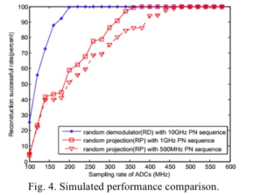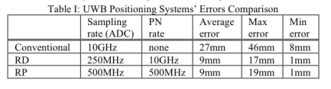

CHAPTER 4. COMPRESSIVE ULTRA WIDEBAND POSITIONING

at the transmitter and achieve 100% successful reconstruction at 350MHz and 500MHz

sampling rate. Hence, accuracy of the lower rate PN sequence system can be improved by

using higher sampling rate at the receiver. Therefore, the simulation result shows that the

proposed system can apply trade-off among random projection rate, sub-Nyquist sampling

rate and reconstruction rate. This design significantly reduce the peak frequency (Nyquist

rate in mixing waveform or receiving end) in the system with acceptable rate increase in

receivers’ ADC sampling rate.

Table I compares the accuracy of the two CS based systems against conventional UWB

based system which uses hypothetical 10GHz Nyquist sampling rate. Both CS based sys-

tems produces much lower errors then the conventional UWB based system, while the

proposed RP system has similar performance as the RD based system.

12

CHAPTER 4. COMPRESSIVE ULTRA WIDEBAND POSITIONING

4.4 Conclusion

The compressed sensing is proven effective to improve the accuracy of IR-UWB posi-

tioning. However, most of papers do not concern the design complexity and energy cost

in their implementations, for instance, the random mixing waveform is of extremely high

frequency (in GHz). Our proposed compressive UWB positioning present a novel view of

energy trade-off design, which is implemented by a low-rate random-projection at transmit-

ters and low rate ADCs at receivers. This design significantly reduce the peak frequency

(Nyquist rate in mixing waveform or receiving end) in the system with acceptable rate

increase in receivers’ ADC sampling rate.

13

Chapter 5

Wideband Cognitive Spectrum Sensing

Cognitive Radio (CR) has been attracting many attention in recent researches with respect

to the potential better utilisation performance of limited spectrum resources. In this chapter,

we first propose an overview of cognitive radio networks. Then we focus on the bottleneck

in its front-end sampling devices and investigate the typical CS framework for spectrum

sensing in CR.

5.1 Introduction

As the wireless techniques keep fast developing, the limited spectrum resource seriously

restrictsthefastincreasingdemandformoreaccessiblebandwidth. Asaresult, thedynamic

spectrum access (DSA) becomes necessary and popular, which enables unused spectrum

accessed opportunistically, shown in figure 5.1.(a).

Following this idea, the cognitive radio (CR) develops aiming at optimizing utilisa-

tion of idle bands for communications, without doing harm to the primary users (licensed

spectrum) [10]. Correspondingly, the CR devices have to sense the environment (includ-

ing spectrum usage, noise level etc) quickly and accurately, and reconfigure themselves to

adapt the varying circumstance.

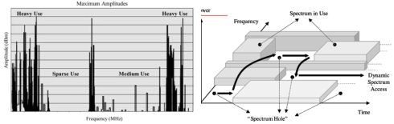

CHAPTER 5. WIDEBAND COGNITIVE SPECTRUM SENSING

(a) (b)

Figure 5.1: (a) The existence of unused spectrum resources; (b) The concept of spectrum

holes

Therefore, in cognitive radios, the first and important procedure is to sense the unused

bandwidth, termed as the spectrum holes and shown in figure 5.1.(b). If the band is detected

as unused, the CR networks will use it for further communication. Otherwise, the CR

moves to find other spectrum holes, or stays in the same band but avoid interference by

changing its transmission power or modulation model.

However, trends of communicating requires higher frequency and wider bandwidth. As

a result, signal acquisition significant is crucial according to the Nyquist sampling theory.

What’s worse, since CR should not generates additional interference to the licensed users,

CR must limits its working power to a relatively low level (if CR do not change its mod-

ulation model). The demand for sensing with low power contradicts with the requirement

for sensing in high sensitivity. Thus this contradiction makes the signal acquisition much

more difficult.

In conclusion, spectrum sensing becomes one of the most crucial problem for cognitive

radios, and it is still an open issue. Then, compressed sensing will be introduced to be

embedded into traditional spectrum sensing algorithms, in order to solve the problem and

enhance the overall performance.

15

CHAPTER 5. WIDEBAND COGNITIVE SPECTRUM SENSING

5.2 Hypothesis Test Model for Spectrum Sensing

The aim of spectrum sensing is to decide whether a particular sub-band of the spectrum is

available or not. In other words, the procedure is to discriminate based on two hypotheses

in equation 5.1:

H0 : y[n] = w[n]

H1 : y[n] = w[n] + x[n]

(5.1)

, where x[n] is the primary user’s signal, y[n] is the vectorial observation, w[n] is the

noise, and n refers to time slots. The hypothesis 1 suggests that the primary user’s signal

exists, while hypothesis 0 suggests no. Typically, the decision is made by comparing a

predetermined threshold with test statistic Λ(y) in equation 5.2:

Macintosh HD:Users:chenhao:Desktop:Screen Shot 2015-02-23 at 11.44.12 pm.png

Then the performance of a detector is quantified by the receiver operating characteristics

(ROC) curve, which presents the probability of detection PD = Prob(Λ(y) > α,H1) and

false alarm probability Pf a = Prob(Λ(y) > α,H0).

5.3 Traditional Detection Method

5.3.1 Narrowband Detection

In this section, typical spectrum sensing approaches are introduced. Narrowband sensing

algorithms can be suitably applied when the channel frequency response is flat. The fol-

lowing figure 5.2 demonstrates most typical architectures in narrowband spectrum sensing.

5.3.1.1 Matched filter

In the figure 5.2.(a), the matched filtering (MF) detector [11] is presented. when the signal

to be detected is perfectly known (i.e. mean and variance), the optimal test statistic is

16

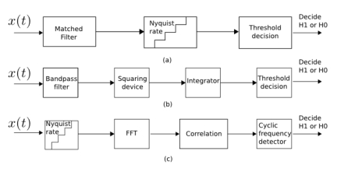

CHAPTER 5. WIDEBAND COGNITIVE SPECTRUM SENSING

Figure 5.2: Block diagrams for traditional narrowband detection architectures: a) matched

filtering detector; b) energy detector; c) feature detector

produced by matched filter by correlating the received signal to a template. However, the

signal cannot always be known in practise, so sometimes it’s not applicable. Besides, the

carrier synchronisation is also a remained difficult problem.

5.3.1.2 Energy detector

In the figure 5.2.(b), the energy detector (ED) [12] is presented. In the case where the sig-

nal to be detected does not present structure template, the ED can produce the optimal test

statistic by directly analysis the power and variance of the received signal. The implemen-

tation of ED is simple, but it suffers from poor detection results in low SNR environment.

Besides, the ED cannot distinguish different primary signals at the same time.

5.3.1.3 Feature detector

In the figure 5.2.(c), cycle-stationary feature detection (FD) [13] is presented. If discrimi-

nation for primary signals and higher detection performance are required, the FD exploits

the cyclic non-stationary features from primary signals. The cyclic features can be found

in many typical modulated signals, for instance, in the orthogonal frequency-division mul-

17

CHAPTER 5. WIDEBAND COGNITIVE SPECTRUM SENSING

tiplexing (OFDM) contains cyclic features in correlation structure due to the cyclic prefix

(CP) between transmitted data. However, the computational cost is relatively high and long

running time delay is always existing.

5.3.2 Nyquist Wideband Detection

In the scenarios where the bandwidth is sufficiently larger than coherence bandwidth of

channel, wideband sensing is more suitable than narrowband sensing. For instance, it can

be used for sensing the ultra-high-frequency (UHF) TV band, ranging from 300 MHz to

3 GHz, while the narrowband sensing providing single binary decision over whole spec-

trum is always not suitable for identifying individual spectrum access opportunities. The

following figure 5.3 demonstrates the typical architectures for wideband spectrum sensing

and detection.

5.3.2.1 Multiband joint detector

In figure 5.3.(a), the multiband joint detector (MJD) [14] is presented. The MJD first

uses serial-to-parallel conversion (S/P) to divide samples into parallel data streams, then it

process the FFT to divide spectrum X(f) into groups of narrowband spectrum. Then each

binary hypothesis detection is performed and joint optimised at last. The high sampling

rate and lower speed of joint optimisation is the main bottleneck.

5.3.2.2 Wavelet detector

In figure 5.3.(b), the wavelet detector [15] is introduced. The wavelet analysis of power

spectral density (PSD) can provide significant border symbols of two neighbour sub-bands,

the aim of detection becomes a spectral edge detection problem. However, the high sam-

pling rate is also the bottleneck.

18

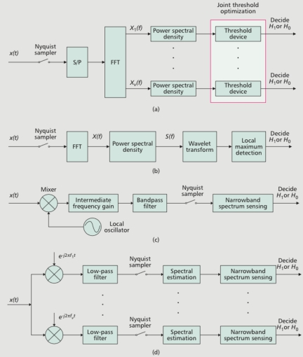

CHAPTER 5. WIDEBAND COGNITIVE SPECTRUM SENSING

Figure 5.3: Block diagrams for Nyquist wideband detectors architectures: a) multiband

joint detector; b) wavelet detector; c) sweep-tune detector; d) filter-bank detector

19

CHAPTER 5. WIDEBAND COGNITIVE SPECTRUM SENSING

5.3.2.3 Sweep-tune detector

In figure 5.3.(c), the sweep-tune detector [14,16] is displayed. This detector uses a special

frequency mixing technique that ’sweep’ across the frequency range of interest, to down-

converts signals to a lower frequency. The adaptive local oscillator (LO) is used for ’sweep’

procedure. However, the procedure of ’sweep’ mixing generates too much time to wait.

5.3.2.4 Filter-bank detector

Also using the idea of down-conversion, the figure 5.3.(d) shows the structure of filter-

bank detector [16]. Not only following the technique which ’sweep’ mixing the interest

of signals, it also applies parallel structure to speed up the processing time by using filter-

bank. As a result, the time cost of mixing reduces but the implementation cost largely

increase.

5.4 Sub-Nyquist Wideband Detection

Different from Nyquist wideband detection, the sub-Nyquist spectrum sensing applies the

multi-coset (MC) sampling, multi-rate (MR) sampling, or compressed sensing (CS) to re-

duce the required sampling rate. Before talking about CS based sampling, first we take

brief look at MC and MR sampling.

5.4.0.5 Multi-Coset Sampling

The multi-coset (MC) sampling [17] applies blocks of parallel consecutive samples with

special time offsets to sample, so that each channel has a task of low-rate sampling. Then

joint spectrum recovery and further detection can be performed. The main difficulty is how

to perform sampling channel synchronisation with highly accurate time offsets. The quality

of the specific offsets is crucial for robustness in its spectral reconstruction.

20

CHAPTER 5. WIDEBAND COGNITIVE SPECTRUM SENSING

5.4.0.6 Multi-Rate Sampling

The multi-rate (MR) sampling [18] uses various sampling rates to wrap different sparse

spectrum onto individual channels, and then use joint sparse spectrum recovery for further

energy detection. Time synchronisation is no longer needed compared to the MC. But

instead, the sacrifice is the hardware cost for parallel structure, as well as the increased

sampling rate compared to original CS although the MR’s sampling rate is still less than

Nyquist rate.

5.5 CS based Detection Method

5.5.1 Introduction to Compressive Spectrum Sensing

Cognitive spectrum sensing is another typical application suitable for compressed sensing.

The applicability of Compressive spectrum sensing (CSS )mainly lies in two aspects:

**Sampling Rate:** The trend of higher frequency transmission is also suitable for cognitive

radio, which leads to higher rate sampling rate at receivers. Thus it’s reasonable to develop

the CS based spectrum sensing techniques to reduce the sampling rate.

**Flexibility and Energy**: The cognitive radio requires flexibility for sensing various types

of signals (TV signal, cell phone, satellites etc) in a relatively wide bandwidth. However,

normal wideband spectrum detection uses filtering or mixing for down-conversion (then

low-rate sampling). This approach require difficult analog implementations such as adap-

tive local oscillator(LO) for filter-banks(FB). Inversely, if the CS is used, then the system

can get wider sensing (frequency) ranges without the hardware of LO or FB.

Therefore, theCSbecomepopularincognitivespectrumsensing. Thefigure5.4demon-

strates the typical architectures in wideband spectrum sensing, and briefly analyse CS de-

tectors. The similar CS based architecture can also be viewed in chapter 2.

21

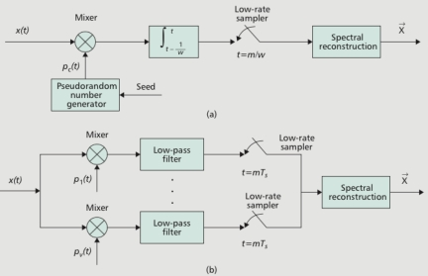

CHAPTER 5. WIDEBAND COGNITIVE SPECTRUM SENSING

Figure 5.4: Block diagrams for compressive wideband sensing architectures: a) random

demodulation based detector; b) modulated wideband converter-based detector

5.5.2 Compressive Detectors Overview

5.5.2.1 Demodulation based Detector

Figure 5.4.(a) presents the random demodulation (RD) based detector [9], which is an

analog-to-information converter (AIC) for finite-length and discrete-time signals, and con-

sists of pseudorandom wave generator, a mixer, and a low-rate ADC. The detailed archi-

tecture of RD is introduced in chapter 2. The reconstruction of RD sampled data involves

l1-norm minimization (e.g. based BP, LASSO) or greedy method (e.g. OMP). This design

is simple, but easily affected by model mismatches and design imperfections.

5.5.2.2 Modulated Wideband Converter based Detector

Figure 5.4.(b) displays the modulated wideband converter (MWC) based detector [19] for

the case where multichannel signals are designed to be detected. The MWC can be con-

sidered as a parallel structure of RD, and its architecture is introduced in chapter 2. The

22

CHAPTER 5. WIDEBAND COGNITIVE SPECTRUM SENSING

reconstruction of MWC involves the multiple measurement vector (MMV) sparse recovery

which exploits the fact that the columns of original spectrum coefficients share the same

sparsity pattern. Compared to the RD, MWC provides robustness against the noise and

model mismatches.

5.5.2.3 Cooperative Compressive Spectrum Sensing

Cooperativeversionsofspectrumsensingisanopenissue, whichaimsatsolvingthehidden

terminal problem [10] and improve sensing accuracy. The cooperative version of compres-

sive wideband sensing have been developed [20,21]. Here, individual radios can make a

local decision about the presence or absence of a primary user, and these results can then

be fused in a centralised or decentralised manner. However, a greater cooperation gain can

be achieved by fusing all the compressed measurements, again in a centralised or decen-

tralised manner. In general, such measurement fusion requires that each cognitive radio

knows the channel state information (CSI) from all primary users to itself [20], which is

cumbersome. But recent extensions show that measurement fusion can also be carried out

without CSI knowledge [22].

5.5.3 An Instance: CS based Cognitive Radar System

In [23] the CS is embedded to enhance the performance of cognitive radar that use wide

operating frequency bandwidths for spectrum sensing and sharing. The compressive cog-

nitive radar utilises the typical CS techniques, including the random demodulation (RD)

for signal acquiring, basis pursuit de-noising (BPDN) algorithm and discrete cosine basis

(DCT)forsparsereconstruction, andclassicalenergydetector(ED)forhypothesisanalysis.

The experimental results figure 5.5 shows the CS based radar has appealing perfor-

mance in low sampling rate (using only < 30% of the total samples of the original signal)

and low detection error in high SNR cases. But in low SNR environment, the proposed

system still struggles and suffers.

23

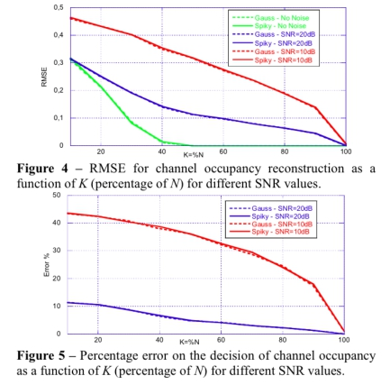

CHAPTER 5. WIDEBAND COGNITIVE SPECTRUM SENSING

Figure 5.5: Block diagrams for mean square error and error detection performance of the

proposed compressive cognitive radar systems

24

CHAPTER 5. WIDEBAND COGNITIVE SPECTRUM SENSING

5.6 Challenges and Discussion

The compressed sensing based wideband spectrum sensing for cognitive radio provide its

outstanding feature in reducing the sampling rate. However, the corresponding drawbacks

emerge in real-time ability and energy consumption, mainly due to its computational ex-

pensive non-linear reconstruction and energy consuming characters:

5.6.1 Long-Time Feedback Delay

Accuarcy is cruical for primary detection. Hence, if we applies CS for sampling, the con-

vex optimisation (e.g.basis pursuit) is always needed for data recovery since it provides

better accuracy and robustness comparing to greedy methods (chapter 2). However, con-

vex optimisation is time consuming, which cause too long time to fast feed-back. Since

feed back is very important for CR, which is responsible to avoid interference and quick

reconfiguration, agility and reconfigurablity may reduce.

5.6.2 Mismatch for Traditional Signal Processing

The reconstruction algorithms for CS is non-linear, which indicates that the recovered data

are not directly suitable for conventional digital signal processing where traditional recov-

ering only requires cardinal sinc interpolation (linear process). This brings difficulty in

directly reuse the traditional method for sensed data.

5.6.3 High Energy Cost

TheheavyreconstructionforCSnotonlybringslargetime-delay, butalsoadditionalenergy

cost. Compared to linear recovery in traditional approaches, the CS based signal detection

additionally required the block for spectrum recovery before further hypothesis detection.

25

CHAPTER 5. WIDEBAND COGNITIVE SPECTRUM SENSING

5.7 Conclusion

Cognitive radio has been widely used and attracting many research attentions in its spec-

trum sensing techniques. In this chapter, traditional sensing approaches such as energy

detection and feature detection are introduced. In order to solve the detection task for

wideband and high frequency signals, compressed sensing based spectrum sensing (CS-

CSS) is introduced and demonstrated. However, the compressively sampled data does not

directly match the traditional processing algorithms.

Thenherecomesthequestion: whatifwedirectlyperformhypothesisdetectionwithout

CS reconstruction? If the idea is achievable, the additional energy cost will be eliminated

so that the entire energy reduces. Besides, not only detection, if we can expand this idea

to filtering, estimation, then more intelligent-based scheme for cognitive radio can be sup-

ported in physical layer. The answer refers to our future research aims that shown in the

next chapter.

26

Chapter 6

Future Work: Novel Signal Processing

for CS Spectrum Sensing

In the last chapter 5, we have discussed the main drawback in compressed sensing based

spectrum sensing (CS-CSS) which derives from the computational non-linear CS recon-

struction. As a fact, the CS framework sacrifices the time and energy performance in recon-

struction produce (in return, the sampling rate is reduced). In order to solve this problem,

this chapter focuses on exploring the potential approach of directly analysing compressive

measurements without fully CS reconstruction. The new approach is termed as compres-

sive signal processing (CSP), and it will be used for compressive spectrum sensing (CSS)

in cognitive radio network (CRN), so that the drawback may be overcome in our proposed

CSP based CSS systems.

6.1 Introduction to CSP

The compressed sensing based wideband spectrum sensing for cognitive radio provides its

outstanding feature in reducing the sampling rate. However, the corresponding drawbacks

emerge in real-time ability and energy cost, mainly due to its computational complex non-

CHAPTER 6. FUTURE WORK: NOVEL SIGNAL PROCESSING FOR CS SPECTRUM SENSING

linear reconstruction and energy cost in entire cognitive radio systems.

However, many signal processing applications such as detection, classification, estima-

tion and filtering do NOT require entire signal reconstruction [24]. For instance, cognitive

radios are aiming at processing the hypothesis detection rather than fully recovering the

primary signals. In these cases, the aim of CS fully recovery is no longer necessary, so pro-

cessing schemes like ’directly analysis without recovery’ or ’partial recovery then analysis’

become possible and applicable for cognitive spectrum sensing.

This novel idea derives from the compressive signal processing (CSP) [24], which aims

at extracting information directly from compressive samples without fully recovery.

6.1.1 Literature Review

In [25], the shift retrieval problem for compressive samples is researched. Rather than

recovering CS data then analysing the shifted distance, the author develops efficient al-

gorithms and proofs for directly recognising the shift distance from CS data. Valsesia et

al [26] develops the circulant sensing matrix based processing for compressive measure-

ments, which displays an potential CSP application for convolution based models and is

suitable for filtering or channel impulse response involved cases. Especially, for cognitive

radio spectrum detection, a CSP based energy detector is designed in [27]. Further, Guo et

al develops CSP for feature detector in [28] and pattern clustering is achieved.

6.1.2 Proposed Research

Since so far the CSP concept is always only defined in the theory level and has not been

widely applied to CSS field, we believe there still exists many worthy research area and

cases for CSP based spectrum sensing. In other words, CSP based cognitive spectrum

sensing is still a relative new approach which applies the CS but throw away some CS

drawbacks for CR spectrum sensing.

28

CHAPTER 6. FUTURE WORK: NOVEL SIGNAL PROCESSING FOR CS SPECTRUM SENSING

6.2 Potential CSP Applications In Spectrum Sensing

The following sections are organised as different function introduction for CSP based cog-

nitive radio spectrum sensing, including filtering, detection, estimation. Some related po-

tential application for CS-UWB and CS demodulation are also introduced.

6.2.1 CSP based Filtering

In scenarios where cognitive spectrum sensing requires filters, the design cost for analog

filters are expensive. Here we may use CSP based filtering to transform the analog filter to

digital filter, which omits the implementation of hardware design for filters.

6.2.1.1 Filter Domain Transform

Assume that the filter’s impulse response is h (with length of Nh) and its corresponding

matrix form is H, then H is a circulant sensing matrix.

Then, according to a CSP related theory in [26], it possible to exchange the H and

Φ (compressed sensing matrix), sometimes in CS frameworks, the effect of analog filter

equals the effect processed by digital filters. The compressive measurements y can be

directly processed by filtering H without recovery in some cases 6.1 as follows:

Macintosh HD:Users:chenhao:Desktop:Screen Shot 2015-02-23 at 11.47.53 pm.png

, where the Φ is compressed sensing matrix with size of m × N . Consequently, by moving

the filtering from analog to digital part, large amount of hardware complexity could be

omitted.

6.2.1.2 Interference filtering

In cases where useless information is redundancy for further recovery in CS framework,

or specifically where some sub-bands are priorly known in the compressive cognitive spec-

trumsensing, systemusingCSPcanregardthoseuselessinformationasinterference, which

29

δ

CHAPTER 6. FUTURE WORK: NOVEL SIGNAL PROCESSING FOR CS SPECTRUM SENSING

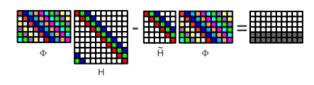

Figure 6.1: Block diagram of exchanging order of circulant matrix. H is corresponding

impulse response of filter, Φ is the compressed sensing matrix. The exchanging sacrifice is

the loss of rows in the results (matrix in the right side of equal sign).

applies CSP to achieve the procedure of ’sample-then-filter’ to compressive data rather than

sample-recover-then-filter it.

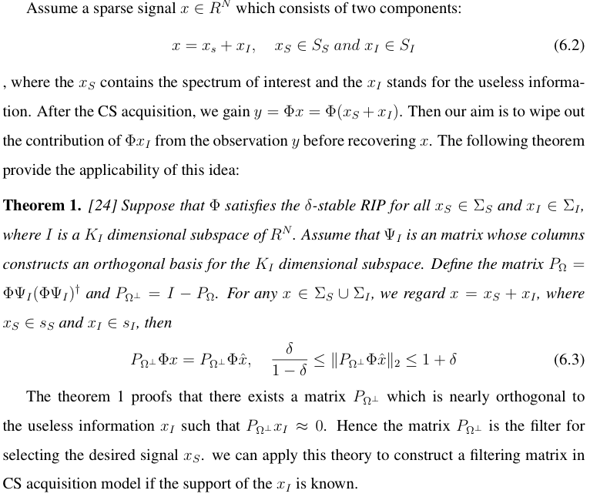

30

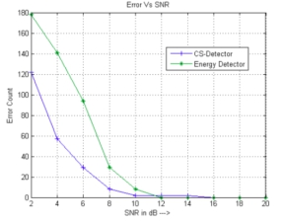

CHAPTER 6. FUTURE WORK: NOVEL SIGNAL PROCESSING FOR CS SPECTRUM SENSING

Figure 6.2: Block diagram of performance comparison between the CSP detector (com-

pressive signal processing based detector) and ED (energy detector) from aspect of signal

to noise ratio and detection error.

6.2.2 CSP based Detection

6.2.2.1 CSP based Energy Detector

Davenport et al [24] develops the theorem to directly build up hypothesis detection directly

through compressed samples. Assume the detection is based on two hypotheses in

H0 : y = Φw

H1 : y = Φ(w + s)

(6.4)

, where s is the primary user’s signal, y is the vectorial observation, Φ is compressed

sensing matrix (e.g. the random demodulation), and w stands for the noise. Then the

following equation 6.5 presents the structure of CSP based detector.

Macintosh HD:Users:chenhao:Desktop:Screen Shot 2015-02-23 at 11.50.24 pm.png

In [27], the experimental results of comparing CSP-detector and traditional energy detector

(ED), is shown in figure 6.2. It has been shown that CS based Detector can provide better

Error vs SNR performance.

31

CHAPTER 6. FUTURE WORK: NOVEL SIGNAL PROCESSING FOR CS SPECTRUM SENSING

One defect of this simulation result is that, the paper does not discuss blind sensing

techniques for cases where the information of primary signal s is unknown to us. Thus

further developing for CSP based blind sensing is a potential direction.

6.2.2.2 CSP based Cyclic Feature Detector

Guo et al [28] develops CSP for feature detector in and achieves pattern clustering. The

workgeneratesthecompressivespectrummeasurementbyutilizingboththecyclic-stationary

feature and sparsity prior knowledge at the spectrum sensing front end. Then the paper ap-

plies the compressive CSP without the need of signal or feature reconstruction.

However, as the author states that [28], the CSP feature detection model is still simple.

So how to analyze the spectrum pattern recognition performance in a more complicated

CRN environment is open issue. For instance, with large-scale SUs and non-Poisson PU

traffic models. Also, More efficient machine learning schemes (such as information geom-

etry) can be used to recognize the PUs signal patterns after obtaining the CS samples via

CSP scheme.

6.2.3 CSP based Estimation

Since the signal-to-noise-ratio, sparsity order are crucial factors which seriously affects the

performance of compressive detectors, CSP based estimation becomes popular for cogni-

tive radio.

This technique make CR be able to directly predict the level of sparsity or noise, so that

CR can vary the sampling rate or change the detection algorithms based on those predicted

information.

6.2.3.1 Sparsity Order Estimation

For instance, the sparsity order of the spectrum occupancy is time-varying in CR networks.

If CR intends to fully exploit the CS framework, the sampling rate of CS receiver should

32

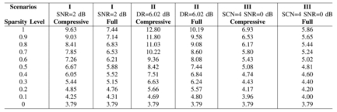

CHAPTER 6. FUTURE WORK: NOVEL SIGNAL PROCESSING FOR CS SPECTRUM SENSING

Figure 6.3: Block diagram of lookup table for sparsity order estimation through signal-to-

noise ratio (SNR) and asymptotic eigenvalue probability distribution function (aepdf). For

example, if the value of aepdf = 7.26 for the compressive case in SNR = 2db, it can be

estimated that the sparsity order of spectrum occupancy is 0.6

keeping adjusting to sparsity orders.

Therefore, estimating the sparsity orders in very important, and the [29] develops an

approach which analysis sparsity order through asymptotic eigenvalue probability distri-

bution function (aepdf) from the covariance matrix of the compressively sampled primary

signal. In details, the aepdf is related to the sparsity order via a lookup table in figure 6.3.

However, this paper does not apply the estimated information into further process in

spectrum sensing to pursuit higher efficiency in adaptive sampling rate. So next we can

apply the idea to further improvement of sensing efficiency.

6.2.3.2 Noise Level Estimation

For CR networks, the signal-to-noise ratio (SNR) affects the performance of spectrum de-

tectors. For example, the energy detector (ED) is simple and fast, but with poor perfor-

mance in low SNR scenarios; Feature detectors (FD) are complex and slow, but have strong

robustness to noise. In [30], the author similarily build up a lookup table relating the noise

estimation with the eigenvalue probability distribution function in covariance matrix of the

compressively sampled primary signal.

Then if we have the access to estimate the SNR in CRN, we can achieve the following

33

CHAPTER 6. FUTURE WORK: NOVEL SIGNAL PROCESSING FOR CS SPECTRUM SENSING

spectrum sensing approach in the future:

**Hybrid Spectrum Sensing:** If we have known the SNR, we can design a more intelligent

two stage detector. In the coarse stage, a quick search is done over a wide bandwidth,

and in the fine stage, the sensing is done over the individual candidate sub-bands in that

bandwidth, one at a time. the coarse stage is based on energy detection due to its fast

processing. If the test statistics is larger than a predefined threshold, then the band is

consideredoccupied. Otherwise, afinestageisperformedwhereacycle-stationarydetector

is implemented due to its robustness at the low SNR regime. (For sparsity level, we can

judge whether the CS based detector suitable if there exists dense channel occupancy by

primary users)

**Adaptive Spectrum Sensing:** In case when a CR successfully know the primary signals’

SNR, the CR can intelligently choose optimal detection algorithms based on SNR related

performance of detectors. For instance, if the SNR is detected to be very low, then cycle-

stationary detection algorithm can be used due to its robustness at the low SNR regime.

Otherwise, the energy detector can be used since it’s fast and accurate enough in high SNR

regime. Extending this idea of selecting various of detector based on CSP estimation, we

can select the optimal detector adaptively. This will provide future cognitive radio more

flexibility to the varying environment.

6.2.4 Other Related Wideband Processing with CSP

6.2.4.1 CSP based TOA for UWB Positioning

Maximizing the cross-correlation between the two signals is one of the key steps in time-

of-arrival (TOA) algorithms which have been applied in compressive UWB positioning in

chapter 4. In that system, the procedures at receiving end can be abstracted as (1) low-rate

sampling, then (2) CS fully reconstruction, finally (3) TOA algorithm based locationing.

34

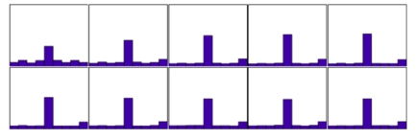

CHAPTER 6. FUTURE WORK: NOVEL SIGNAL PROCESSING FOR CS SPECTRUM SENSING

Figure 6.4: Histogram for the estimated shift in SNR = 2. From left to right, top to bottom,

compression ratio = 0.1 ... 1. The true shift was set to 5 in all trials

However, the (2) CS fully reconstruction may sometimes Not necessary if we borrow the

theorem.

According to [25], where the shift retrieval problem for compressive samples is investi-

gated, we may directly recognising the shift distance from CS data without recovery. Now

the thoerem has not been embedded into UWB positioning, so the CSP-TOA positioning is

a possible research application in the future.

6.2.4.2 CSP based Demodulation

A compressive sensing phase-locked loop (CS-PLL) [31], is designed for directly extract-

ing the phase and frequency from compressively sampled modulated signal without sparse

recovery. Since the restricted isometry property (RIP) of CS ensures that the standard in-

ner product between x[n] and u[n] is approximately the same as that in the compressively

sensed version produced by y[m] and u[n] [24], hence, the inner products in the standard

PLL and that in the CS-PLL are nearly the same, ensuring the consistence between the

standard PLL θ[n] and the CS-PLL’s output θ[m]. The presentation of the θ[m] can be pre-

sentedas θ[m] = k y[k]v[k]h[m−k], wheretheindex m indicatesthelowersamplingrate

compared with the Nyquist rate index n. In addition, the compressive sensing operations Φ

which apply the RD’s architecture consist of a input pseudo-random sequence, a mixer, a

integrator, and a low-rate sampling ADC, which is the same as the random demodulator’s

35

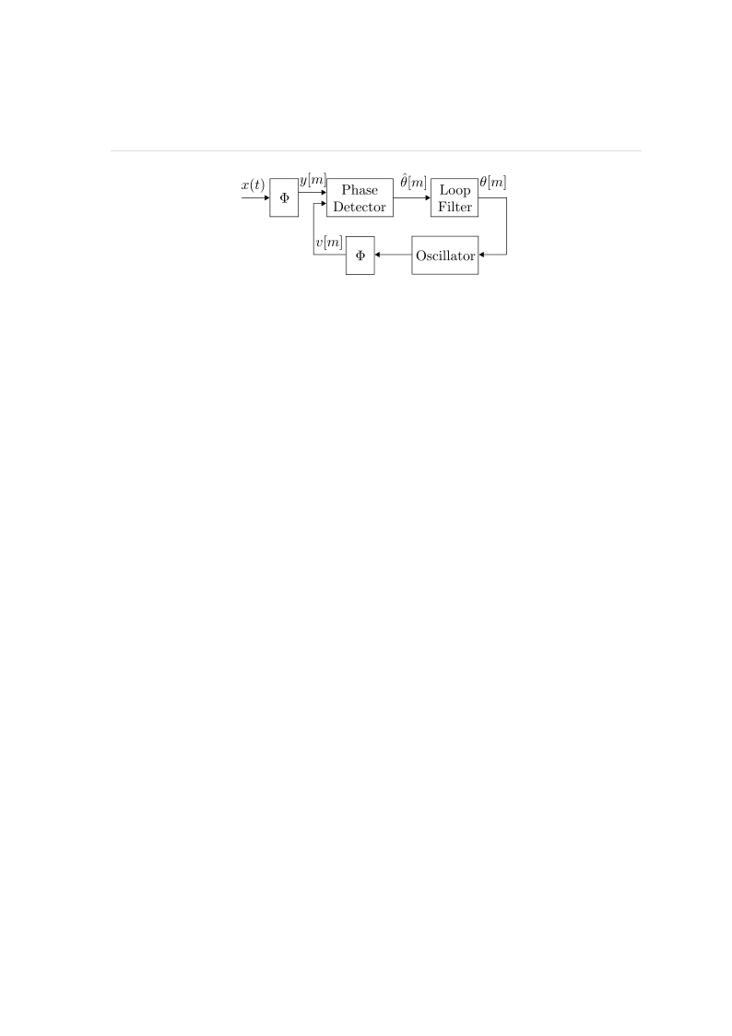

CHAPTER 6. FUTURE WORK: NOVEL SIGNAL PROCESSING FOR CS SPECTRUM SENSING

Figure 6.5: Block diagram of the compressive sensing phase-locked loop (CS-PLL). The

components includes the pre-CS sampler, phase detector, loop filter, oscillator and the feed-

back CS multiplier

architecture in chapter 2.

This CS-PLL has many application fields if the FM demodulation is necessary in com-

pressivesenseddata. Whenwesuccessfullyapplythistechnique, wedonnotneedrecovery,

but directly demodulate original information from the received modulated signals.

6.3 Conclusion

In the this chapter, we have followed the discussion of the main drawback in compressed

Sensing based spectrum sensing (CS-CSS) which derives from the computational non-linear

CS reconstruction, and then propose the idea of signal processing directly on compressively

sampled data (CSP) without fully recovery. Then we introduce our future potential work

which will embed CSP into cognitive spectrum sensing, including CSP based filtering, CSP

based detection, and CSP based estimation. Some other possible CSP applications in UWB

positioning and signal demodulation are also introduced. We hope that by utilise the CSP

in spectrum sensing, a high real-time performance, high flexible ,energy efficient hardware

could be achieved in the future.

36

Bibliography

[1] J. L. Paredes, G. R. Arce, and Z. Wang, “Ultra-wideband compressed sensing: chan-

nel estimation,” Selected Topics in Signal Processing, IEEE Journal of, vol. 1, no. 3,

pp. 383–395, 2007.

[2] D. Cassioli, M. Z. Win, and A. F. Molisch, “The ultra-wide bandwidth indoor chan-

nel: from statistical model to simulations,” Selected Areas in Communications, IEEE

Journal on, vol. 20, no. 6, pp. 1247–1257, 2002.

[3] M. Banitalebi-Dehkordi, J. Abouei, and K. N. Plataniotis, “Compressive-sampling-

based positioning in wireless body area networks,” Biomedical and Health Informat-

ics, IEEE Journal of, vol. 18, no. 1, pp. 335–344, 2014.

[4] S. Kirolos, J. Laska, M. Wakin, M. Duarte, D. Baron, T. Ragheb, Y. Massoud, and

R. Baraniuk, “Analog-to-information conversion via random demodulation,” in De-

sign, Applications, Integration and Software, 2006 IEEE Dallas/CAS Workshop on.

IEEE, 2006, pp. 71–74.

[5] D. Yang, H. Li, G. D. Peterson, and A. Fathy, “Compressive sensing tdoa for uwb

positioning systems,” in Radio and Wireless Symposium (RWS), 2011 IEEE. IEEE,

2011, pp. 194–197.

BIBLIOGRAPHY

[6] P. Zhang, Z. Hu, R. C. Qiu, and B. M. Sadler, “A compressed sensing based ultra-

wideband communication system,” in Communications, 2009. ICC’09. IEEE Inter-

national Conference on. IEEE, 2009, pp. 1–5.

[7] A. A. D’Amico, U. Mengali, and L. Taponecco, “Toa estimation with the ieee 802.15.

4a standard,” Wireless Communications, IEEE Transactions on, vol. 9, no. 7, pp.

2238–2247, 2010.

[8] D. Yang, H. Li, Z. Zhang, and G. D. Peterson, “Compressive sensing based sub-mm

accuracy uwb positioning systems: A space–time approach,” Digital Signal Process-

ing, vol. 23, no. 1, pp. 340–354, 2013.

[9] J. A. Tropp, J. N. Laska, M. F. Duarte, J. K. Romberg, and R. G. Baraniuk, “Beyond

nyquist: Efficient sampling of sparse bandlimited signals,” Information Theory, IEEE

Transactions on, vol. 56, no. 1, pp. 520–544, 2010.

[10] I. F. Akyildiz, W.-Y. Lee, M. C. Vuran, and S. Mohanty, “Next generation/dynamic

spectrum access/cognitive radio wireless networks: a survey,” Computer Networks,

vol. 50, no. 13, pp. 2127–2159, 2006.

[11] H. V. Poor, An introduction to signal detection and estimation. Springer, 1994.

[12] H. Urkowitz, “Energy detection of unknown deterministic signals,” Proceedings of

the IEEE, vol. 55, no. 4, pp. 523–531, 1967.

[13] S. Enserink and D. Cochran, “A cyclostationary feature detector,” in Signals, Sys-

tems and Computers, 1994. 1994 Conference Record of the Twenty-Eighth Asilomar

Conference on, vol. 2. IEEE, 1994, pp. 806–810.

[14] Z. Quan, S. Cui, A. H. Sayed, and H. V. Poor, “Optimal multiband joint detection for

spectrum sensing in cognitive radio networks,” Signal Processing, IEEE Transactions

on, vol. 57, no. 3, pp. 1128–1140, 2009.

38

BIBLIOGRAPHY

[15] Z. Tian and G. B. Giannakis, “A wavelet approach to wideband spectrum sensing for

cognitive radios,” in Cognitive Radio Oriented Wireless Networks and Communica-

tions, 2006. 1st International Conference on. IEEE, 2006, pp. 1–5.

[16] B. Farhang-Boroujeny, “Filter bank spectrum sensing for cognitive radios,” Signal

Processing, IEEE Transactions on, vol. 56, no. 5, pp. 1801–1811, 2008.

[17] R. Venkataramani and Y. Bresler, “Perfect reconstruction formulas and bounds on

aliasing error in sub-nyquist nonuniform sampling of multiband signals,” Information

Theory, IEEE Transactions on, vol. 46, no. 6, pp. 2173–2183, 2000.

[18] H. Sun, A. Nallanathan, C.-X. Wang, and Y. Chen, “Wideband spectrum sensing for

cognitive radio networks: a survey,” Wireless Communications, IEEE, vol. 20, no. 2,

pp. 74–81, 2013.

[19] M. Mishali and Y. C. Eldar, “Expected rip: Conditioning of the modulated wideband

converter,” in Information Theory Workshop, 2009. ITW 2009. IEEE. IEEE, 2009,

pp. 343–347.

[20] Z. Tian, “Compressed wideband sensing in cooperative cognitive radio networks,”

in Global Telecommunications Conference, 2008. IEEE GLOBECOM 2008. IEEE.

IEEE, 2008, pp. 1–5.

[21] Y. Wang, A. Pandharipande, Y. L. Polo, and G. Leus, “Distributed compressive wide-

band spectrum sensing,” in Information Theory and Applications Workshop, 2009.

IEEE, 2009, pp. 178–183.

[22] Z. Fanzi, C. Li, and Z. Tian, “Distributed compressive spectrum sensing in coopera-

tive multihop cognitive networks,” Selected Topics in Signal Processing, IEEE Jour-

nal of, vol. 5, no. 1, pp. 37–48, 2011.

39

BIBLIOGRAPHY

[23] P. Stinco, M. Greco, F. Gini, and M. L. Manna, “Compressed spectrum sensing in

cognitive radar systems,” in Acoustics, Speech and Signal Processing (ICASSP), 2014

IEEE International Conference on. IEEE, 2014, pp. 81–85.

[24] M. A. Davenport, P. T. Boufounos, M. B. Wakin, and R. G. Baraniuk, “Signal pro-

cessing with compressive measurements,” Selected Topics in Signal Processing, IEEE

Journal of, vol. 4, no. 2, pp. 445–460, 2010.

[25] H. Ohlsson, Y. C. Eldar, A. Y. Yang, and S. S. Sastry, “Compressive shift retrieval,”

in Acoustics, Speech and Signal Processing (ICASSP), 2013 IEEE International Con-

ference on. IEEE, 2013, pp. 6034–6038.

[26] D. Valsesia and E. Magli, “Compressive signal processing with circulant sensing ma-

trices,” arXiv preprint arXiv:1403.2835, 2014.

[27] A. Appaiah, A. Perincherry, A. S. Keskar, and V. Krishna, “Spectrum sensing in

cognitive radio based on compressive measurements,” in Emerging Trends in Com-

munication, Control, Signal Processing & Computing Applications (C2SPCA), 2013

International Conference on. IEEE, 2013, pp. 1–6.

[28] M. Guo, F. Hu, Y. Wu, S. Kumar, and J. D. Matyjas, “Feature-based compressive

signal processing (csp) measurement design for the pattern analysis of cognitive ra-

dio spectrum,” in Global Communications Conference (GLOBECOM), 2013 IEEE.

IEEE, 2013, pp. 1131–1136.

[29] S. K. Sharma, S. Chatzinotas, and B. Ottersten, “Compressive sparsity order estima-

tion for wideband cognitive radio receiver,” in Communications (ICC), 2014 IEEE

International Conference on. IEEE, 2014, pp. 1361–1366.

[30] ——, “Compressive snr estimation for wideband cognitive radio under correlated

scenarios,” in Wireless Communications and Networking Conference (WCNC), 2014

IEEE. IEEE, 2014, pp. 713–718.

40

BIBLIOGRAPHY

[31] S. R. Schnelle, J. P. Slavinsky, P. T. Boufounos, M. A. Davenport, and R. G. Bara-

niuk, “A compressive phase-locked loop,” in Acoustics, Speech and Signal Processing

(ICASSP), 2012 IEEE International Conference on. IEEE, 2012, pp. 2885–2888.

41