

Compressed Sensing for Wideband Signal

Processing

Chen Hao

School of Computer Engineering

A Process report submitted to the School of Computer Engineering

of Nanyang Technological University

in partial fulfillment of the requirements for the

degree of Doctor of Philosophy

Supervisor: Assoc. Prof. Vun Chan Hua

January 2015

Abstract

Acknowledgements

I would like to express my sincere and great gratitude to my supervisor, Assoc Prof.

Vun Chan Hua for his kind guidance and encouragement. It is a great honor to work with

him. I own my sincere appreciate to all my friends in CeMNet. Without their help, my first

year study and research in NTU can not process well.

Contents

1 Introduction

2 Compressed Sensing

3 Compressed Sensing based Analog to Digital Converter

3.1 Introduction . . . . . . . . . . . . . . . . . . . . . . . . . .

3.1.1 Sensing Matrix Modelling . . . . . . . . . . . . . . 4

3.2 Random Demodulator . . . . . . . . . . . . . . . . . . . . . 5

3.2.1 Acquisition Model . . . . . . . . . . . . . . . . . . 5

3.2.2 Fast Reconstruction . . . . . . . . . . . . . . . . . . 7

3.3 Modulated Wideband Convertor . . . . . . . . . . . . . . . 7

3.3.1 Acquisition Model . . . . . . . . . . . . . . . . . . 8

3.3.2 Fast Reconstruction . . . . . . . . . . . . . . . . . . 10

3.4 Non-Uniform Sampling . . . . . . . . . . . . . . . . . . . . 11

3.5 Conclusion . . . . . . . . . . . . . . . . . . . . . . . . . . 14

List of Figures

3.1 Block diagram of random demodulator (RD). The compo-

nents includes a pseudo-random sign generator, a low-pass

filter, and a sub-Nyquist ADC . . . . . . . . . . . . . . . . 5

3.2 Block diagram of modulated wideband convertor (MWC).

The components includes parallel periodic waveforms mix-

ers, low-pass filters, and sub-Nyquist ADCs . . . . . . . . . 8

3.3 Block diagram of the relationship between the spectrum of

the output yi(n) and the input X(f ) In this example, chan-

nels 1 and m linearly combines the original the spectrum

segments around lfp, ¯lfp, ˜lfp with different weights cil. . . . 9

3.4 Block diagram of Continuous to Finite (CTF) for the joint

supports detection . . . . . . . . . . . . . . . . . . . . . . . 11

3.5 A pseudo-randomly sample pattern for single pure tone sig-

nal of length 300 . . . . . . . . . . . . . . . . . . . . . . . 12

3.6 BlockdiagramoftherandomsamplingCSADC(RS-ADC).

The components includes a pseudo-random sign generator,

a low-pass filter, and a sub-Nyquist ADC . . . . . . . . . . 13

List of Tables

Chapter 1

Introduction

Chapter 2

Compressed Sensing

Chapter 3

Compressed Sensing based Analog to

Digital Converter

Traditional Nyquist Theory becomes cumbersome when an acquisition system processes

widebandsignalswhichcontainsarelativelyhighfrequencycomponent. Inthischapter, we

discuss recent applications embedding CS into ADCs to reduce the sampling rate and im-

prove ADCs performance. This chapter focuses on the CS based ADCs design, categories

different popular CS-ADCs in areas of wireless communication, and finally discusses the

architectures and compare the performance.

3.1 Introduction

Analog-to-Digital Converters (ADCs) are key components for signal acquisition and pro-

cessing systems. Ideally, each sampling event should result in the signal value at the spe-

cific sampling instant. However, in practice, there are main factors that limit the ADC

performance (e.g. increase system noise, phase offset and magnitude error, inter-symbol

interference etc) such as uncertainty in the sampling instant (i.e., jitter) and the finite sam-

pling bandwidth, manifested as a weighted integration over a small time interval around

CHAPTER 3. COMPRESSED SENSING BASED ANALOG TO DIGITAL CONVERTER

the sampling instant (i.e., aperture).

What is worse, those effects become more serious at higher input signal frequencies, as

the signal slew-rate (i.e., rate of change of a signal) is proportional to the signal frequency

so that a small jitter or aperture uncertainty can generate non-idealities which cause a sig-

nificant error in high-speed sampling, especially effects the performance in modern signal

acquisition and processing systems which requires high frequency signal inputs.

The CS has enabled alternative solutions to this problem for high-speed ADCs in the

area of CS based analog-information-convertion (AIC). Well-known applications of CS

based AIC include random demodulator [1], modulated wideband converter [2] and non-

uniform sampler [3]. It has been claimed that these AIC architectures enable high resolu-

tion at high frequencies while only using low frequency, which are sub-Nyquist ADCs.

In addition, CS enable systems to acquire relatively small number of samples which

reduce the power cost for sensing and storage. From these aspects, the CS based ADCs are

important and needed to be investigated.

3.1.1 Sensing Matrix Modelling

Sincethereisalwaysnotenoughfreedomforbuildingrandommatrix(GaussianorBernoulli)

subject to physical or other constraints in hardware implementations as well as the ADC de-

signs, at the moment, the combination design comprised of partial randomness and partial

deterministic (or termed as partial random structural matrix) becomes popular since most

applications have constraints in design sensing matrix such as dictionary (Fourier basis)

or channel impulse response, although many those combination design cannot reach the

optimal boundary of minimum required samples O(log(N/K)). In the following CS-ADC

applications, most of the sensing matrices that are partial random structural matrices are

analysed in their sub-section named Acquisition Model, and corresponding reconstruction

performances (in terms of sampling rates / minimum required samples) are displayed in

sub-section named Fast Reconstruction.

4

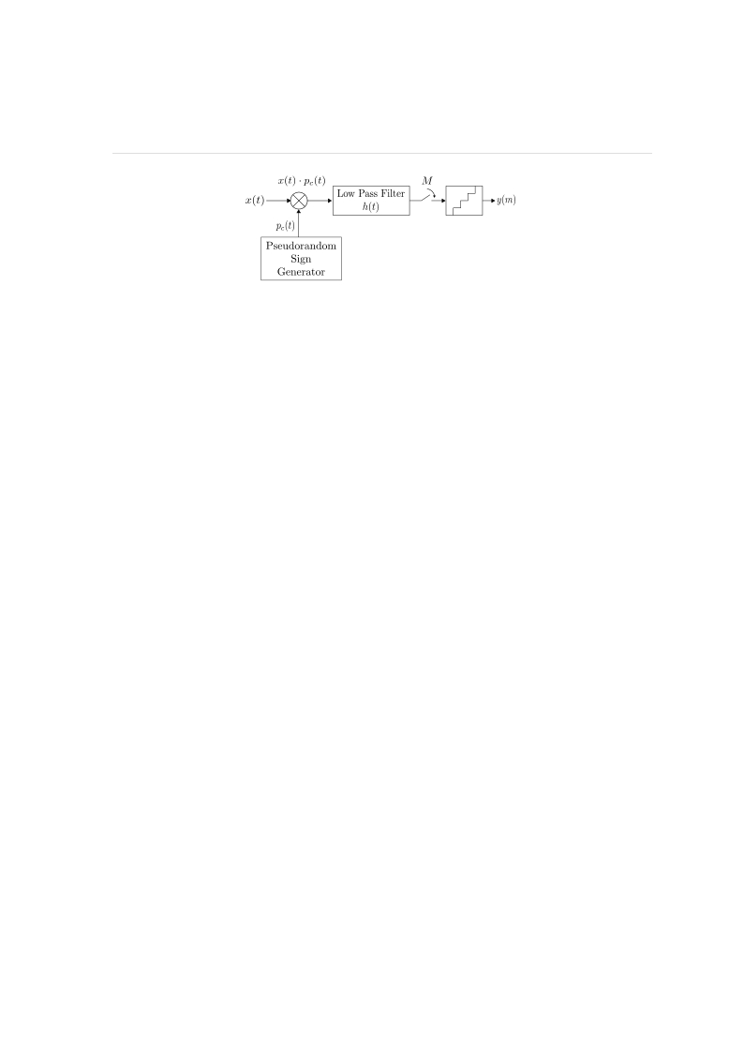

CHAPTER 3. COMPRESSED SENSING BASED ANALOG TO DIGITAL CONVERTER

Figure 3.1: Block diagram of random demodulator (RD). The components includes a

pseudo-random sign generator, a low-pass filter, and a sub-Nyquist ADC.

3.2 Random Demodulator

Random Demodulator (RD) [1] is a newer and more popular ADCs for CS-based signal

acquisition and processing.

The k-sparse input signal x is first mixed with the chipping sequence pc(t) which is a

waveformconstructedbypseudo-randomvariablesof {±1} (termedaschippingsequence).

The mixed product component x(t) · pc(t) is then passed through an anti-aliasing low pass

filter h(t), before being sampled at a uniform interval but at a lower sampling rate of m

which is of the order O(Klog(N/K)) which is much lower than the normal required rate

corresponds to N (since K << N ). The most widely used reconstruction algorithms for

RD are those based on OMP and CoSaMP greedy pursuit. Experimental results [1] demon-

strates that the minimal sampling rate needed is only 1.7K(log(N/K)) and in addition,

it provides better SNR performance when compared with conventional Nyquist rate based

ADCs.

3.2.1 Acquisition Model

We first assume the RD acting on the discrete time domain instead of the continuous-time

domain. We first suppose x = Ψs, where Ψ is the discrete time Fourier transform (DFT)

matrix and s is K sparse coefficients. Next, the RD measurement Φ can be described

as a combination of two matrices representing chipping sequence pc(n) and sub-Nyquist

5

CHAPTER 3. COMPRESSED SENSING BASED ANALOG TO DIGITAL CONVERTER

sampling action, respectively.

First, we consider the action of mixing chipping sequence pc(n) described as diagonal

matrix D where the value of non-zero items (diagonal items) are chosen pseudo-randomly

from the set {−1, +1} as shown in (3.1):

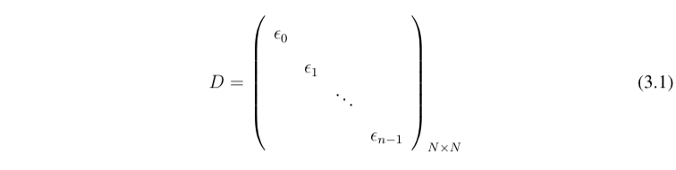

Next, we consider the action of the sampling at a sub-Nyquist rate M . Suppose that

M divides the Nyquist rate N , then each sample is the sum of N/M consecutive entries of

input signal [4]. In summary, this sampling behaviour can be treated as an M × N matrix

Φ in (3.2) where each row has N/M successive entries beginning with its mN/M + 1 th

item, where m = 0, 1,...,N − 1 refers to the column number.

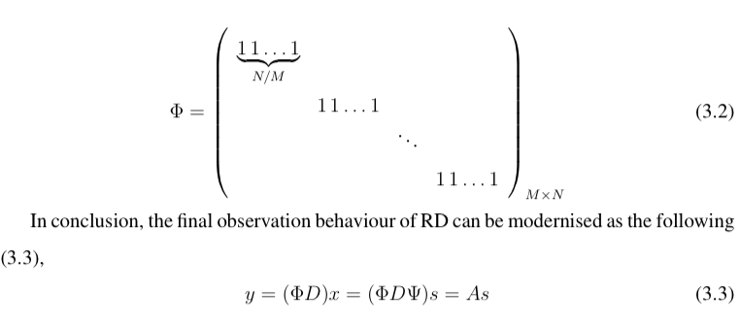

(3.3)

where ΦD stands for the architecture in Figure 3.1 and A is the final measurement for

sparse components s, providing stable and robust reconstruction if A satisfies the RIP.

6

CHAPTER 3. COMPRESSED SENSING BASED ANALOG TO DIGITAL CONVERTER

3.2.2 Fast Reconstruction

Convex optimisation and greedy pursuits have been both developed and applied in this

architecture such as OMP and CoSaMP, and they have been widely used for reconstruc-

tion for RD [5,6]. According to experimental results of RD [1], the necessary minimal

samples for stable reconstruction for this architecture is 1.7K(log(N/K)) + 1 and similar

to the theoretical results [7] stating the theorcial minimum number in compressive sam-

pling using random matrix. Hence, the required samples for CS reseaches a magnitude

of OK(log(N/K)) (K << N ) and considered much less than 2N samples needed for

Nyquist sampling. Besides, [1] also find out that the robustness of RD surpasses that of

the traditional Nyquist sampling by testing of the signal-to-noise ratio (SNR) in different

situations.

3.3 Modulated Wideband Convertor

Modulated Wideband Converter (MWC) [2] is an approach that applies the CS theory for

traditional blind multi-band signal receivers [8], where the carrier frequency is either time-

variant or unknown. Figure 3.2 shows the architecture of the MWC, which consists of

parallel channels of RD based sub-Nyquist rate ADCs.

Each periodic sequence (at TP interval) of pi(t) with minimum duration of Tp/M is

mixed with the input multi-band signal x(t). This shifts each channel spectrum by ∆fp

(fp = 1/Tp ) which is then filtered to the baseband for sampling by sub-Nyquist ADCs.

Reconstruction is done by support detection via continuous to finite block (CTF) which is

shown in Figure 3.4, and the followed signal reconstruction, where the CTF block is com-

prised of frame construction and the multiple measurement vectors (MMV) reconstruction,

and the signal reconstruction can be achieved by a direct pseudo-inverse operation based

on results of the CTF block.

7

CHAPTER 3. COMPRESSED SENSING BASED ANALOG TO DIGITAL CONVERTER

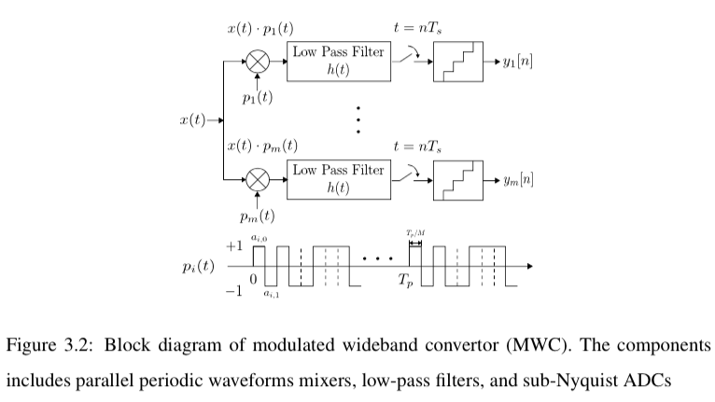



3.3.1 Acquisition Model

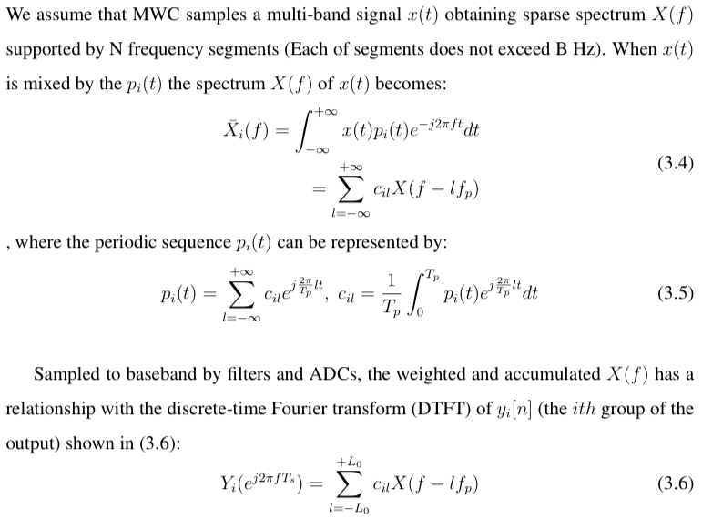

8

M

CHAPTER 3. COMPRESSED SENSING BASED ANALOG TO DIGITAL CONVERTER

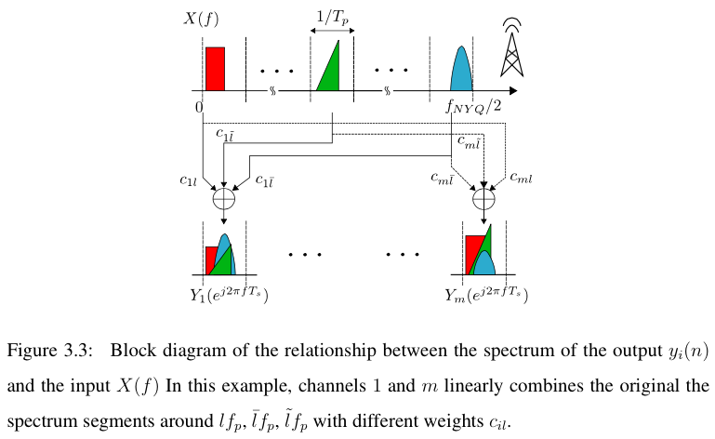



9













e−j 2π

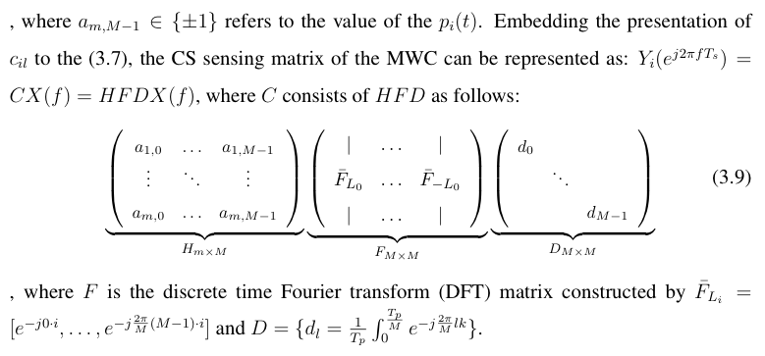

3.3.2 Fast Reconstruction

Considering the CS measurement in (3.7), recovering the z(f ) where each row X(f − lfp)

presents sparse spectrum segments can be regarded as recovering a infinite set of joint

sparse vectors. This problem can be solved by changing it to the problem of multiple

measurement vectors (MMV) [10] and has been implemented as Figure 3.4:

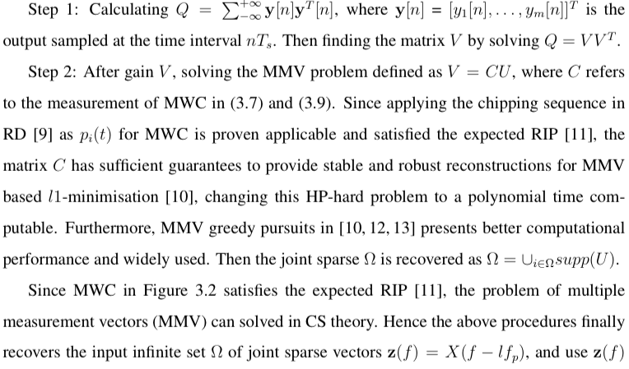

10



CHAPTER 3. COMPRESSED SENSING BASED ANALOG TO DIGITAL CONVERTER

Figure 3.4: Block diagram of Continuous to Finite (CTF) for the joint supports detection

recover the x[nTs], the recovery of the blind multi-band signal in time domain:

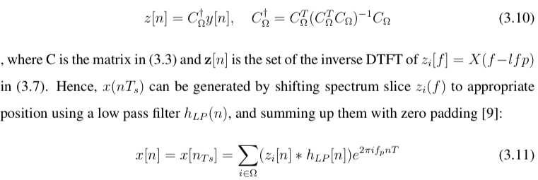

As a result, in practical applications the experimental results indicates that stable recov-

ery of the MWC in Figure 3.2 requires roughly m ≈ 4Nlog(M/2N ) channels to estimate

the correct support.

Moreover, the comparison of a modulated wide-band converter(MWC) and a random

demodulator(RD) is provided in [14] from aspects of hardware complexity, robustness and

computational load. As shown in experimental results, the two structure contains the sim-

ilar hardware complexity, but the MWC outperforms the RD in computational load and

robustness to model mismatch [14].

3.4 Non-Uniform Sampling

Apart from the modulated based CS architectures such as random demodulators (RD) or

modulated wideband converters (MWC) which uniformly samples the mixed input analog

signals at a slow rate, another novel CS architecture is the non-uniform sampling (NUS),

basedonthetheoryofinformationrecoveryfromrandomsamples[3], isdrivenbyapseudo

11

CHAPTER 3. COMPRESSED SENSING BASED ANALOG TO DIGITAL CONVERTER

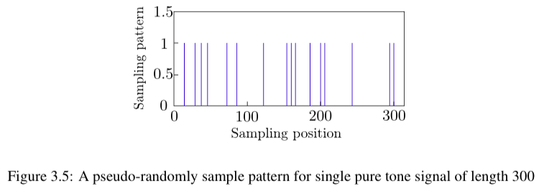

random clock that produce a sub-Nyquist rate on average. An example of this sampling

pattern is shown in Figure 3.6, and an instance of NUS application implemented by multi-

plexers is shown in Figure 3.6.

3.4.0.1 Acquisition Model and Reconstruction

Considering randomly reducing the number of measurements make the signal x under-

sampled with a low average sampling rate, we presents the behaviour of the non-uniform

sampler (NUS) [15] based CS acquisition model can be represented as a matrix represen-

tation:

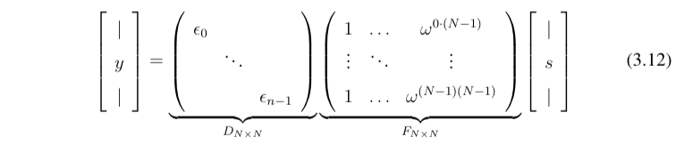

, where the matrix multiplication between F and s stands for the input signal x which

contains sparse spectrum s, and F is the full discrete time Fourier transform (DFT) matrix.

The diagonal matrix D represents the behaviour of non-uniform sampling, where the value

of diagonal items are chosen pseudo-randomly from {0, 1}.

The NUS based CS acquisition model establishes a sensing matrix A which equal DF

in 3.12 and can be regarded as a random partial Fourier matrix FT which consists of ran-

domly chosen columns of the discrete Fourier matrix(DFT) and indexed by T . According

12

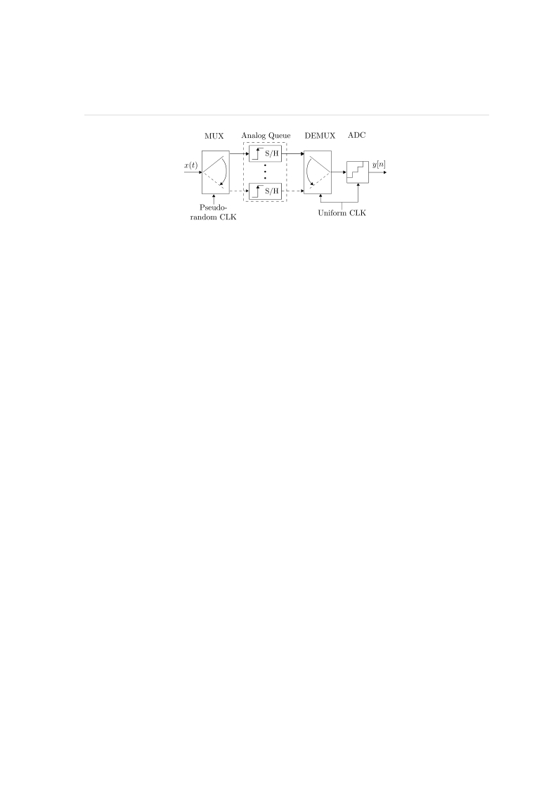

CHAPTER 3. COMPRESSED SENSING BASED ANALOG TO DIGITAL CONVERTER

Figure 3.6: Block diagram of the random sampling CS ADC (RS-ADC). The components

includes a pseudo-random sign generator, a low-pass filter, and a sub-Nyquist ADC

to [3], the matrix A satisfies the RIP in compressive sensing so the acquisition model in

(3.12) produces a stable reconstruction of s via l1-minimisation using m ≥ O(slog(N/s))

samples [3]. In addition, many greedy algorithms such as OMP and CoSaMP are also

implemented as fast reconstruction for this architecture [16].

3.4.0.2 Implementation

Common implementations of the CS based non-uniform sampling architectures varies from

[3,16–18]. Among these implementations, the random sampling compressive sensing ADC

(RS-ADC) is likely to be the prevailing design shown in Figure 3.6. The implementation

uses an input multiplexer driven by a non-uniform clock to switch the signal among several

parallel S/H based analog queues. A low rate ADC (e.g. Successive Approximation ADC)

is used to convert the stored samples, performing at uniform intervals but operating at sub-

Nyquist average rate. Greedy pursuit algorithms such as OMP and CoSaMP are then used

to perform fast reconstruction for this architecture.

However, the main problem of applying RS-ADC lies in sampling high frequency sig-

nals: since the ADC and input MUX perform inherent bandwidth limitations modeled as a

lowpass filter preceding the uniform sampling, acquisitions for high frequency signals re-

sults in a loss of the spectrum components. Besides, the high switching speed of the MUX

increases noise and reduces the power efficiency.

13

CHAPTER 3. COMPRESSED SENSING BASED ANALOG TO DIGITAL CONVERTER

3.5 Conclusion

Modern digital signal processing applications deal with a large amount of data, resulting

in enormous numbers of observations and requiring high speed sampling in the front-end

of systems according to the Nyquist theorem. To overcome this problem, the compressive

sensing based ADC (CS-ADC) is studied recently, and in this chapter, we provide a com-

prehensive survey of the novel CS-ADC designs in terms of architectures. We have traced

origins of this technology and presented mathematical and theoretical foundations, as well

as implementation instances including RD, MWC, and NUS. Reconstruction performance

are discussed, which shows the computational efficiency and high speeds are achieved in

CS-ADCs. Consequently, CS-ADCs become widely applied as sampling front-ends in

many high frequency signal or wideband signal processing systems in many wireless de-

vices such as ultra-wideband communications and cognitive radios that we will mentioned

as our CS applications in the following chapters.

14

Bibliography

[1] J. A. Tropp, J. N. Laska, M. F. Duarte, J. K. Romberg, and R. G. Baraniuk, “Beyond

nyquist: Efficient sampling of sparse bandlimited signals,” Information Theory, IEEE

Transactions on, vol. 56, no. 1, pp. 520–544, 2010.

[2] M. Mishali and Y. C. Eldar, “Blind multiband signal reconstruction: Compressed

sensing for analog signals,” Signal Processing, IEEE Transactions on, vol. 57, no. 3,

pp. 993–1009, 2009.

[3] T. Ragheb, S. Kirolos, J. Laska, A. Gilbert, M. Strauss, R. Baraniuk, and Y. Massoud,

“Implementation models for analog-to-information conversion via random sampling,”

in Circuits and Systems, 2007. MWSCAS 2007. 50th Midwest Symposium on. IEEE,

2007, pp. 325–328.

[4] S. Kirolos, J. Laska, M. Wakin, M. Duarte, D. Baron, T. Ragheb, Y. Massoud, and

R. Baraniuk, “Analog-to-information conversion via random demodulation,” in De-

sign, Applications, Integration and Software, 2006 IEEE Dallas/CAS Workshop on.

IEEE, 2006, pp. 71–74.

[5] D. Yang, H. Li, G. D. Peterson, and A. Fathy, “Compressed sensing based uwb re-

ceiver: Hardware compressing and fpga reconstruction,” in Information Sciences and

Systems, 2009. CISS 2009. 43rd Annual Conference on. IEEE, 2009, Conference

Proceedings, pp. 198–201.

BIBLIOGRAPHY

[6] L. Bai, P. Maechler, M. Muehlberghuber, and H. Kaeslin, “High-speed compressed

sensing reconstruction on fpga using omp and amp,” Rn, vol. 1, p. 0, 2012.

[7] D. L. Donoho, “High-dimensional centrally symmetric polytopes with neighborliness

proportional to dimension,” Discrete & Computational Geometry, vol. 35, no. 4, pp.

617–652, 2006.

[8] W. C. Black Jr and D. Hodges, “Time interleaved converter arrays,” Solid-State Cir-

cuits, IEEE Journal of, vol. 15, no. 6, pp. 1022–1029, 1980.

[9] M. Mishali and Y. C. Eldar, “From theory to practice: Sub-nyquist sampling of sparse

wideband analog signals,” Selected Topics in Signal Processing, IEEE Journal of,

vol. 4, no. 2, pp. 375–391, 2010.

[10] ——, “Reduce and boost: Recovering arbitrary sets of jointly sparse vectors,” Signal

Processing, IEEE Transactions on, vol. 56, no. 10, pp. 4692–4702, 2008.

[11] ——, “Expected rip: Conditioning of the modulated wideband converter,” in Infor-

mation Theory Workshop, 2009. ITW 2009. IEEE. IEEE, 2009, pp. 343–347.

[12] J. Chen and X. Huo, “Theoretical results on sparse representations of multiple-

measurement vectors,” Signal Processing, IEEE Transactions on, vol. 54, no. 12, pp.

4634–4643, 2006.

[13] L. Sun, J. Liu, J. Chen, and J. Ye, “Efficient recovery of jointly sparse vectors.” in

NIPS, 2009, pp. 1812–1820.

[14] M. Mishali, Y. C. Eldar, and A. J. Elron, “Xampling: Signal acquisition and process-

ing in union of subspaces,” Signal Processing, IEEE Transactions on, vol. 59, no. 10,

pp. 4719–4734, 2011.

[15] E. J. Cands and M. B. Wakin, “An introduction to compressive sampling,” Signal

Processing Magazine, IEEE, vol. 25, no. 2, pp. 21–30, 2008, 1stV.

16

BIBLIOGRAPHY

[16] P. Maechler, N. Felber, A. Burg et al., “Random sampling adc for sparse spec-

trum sensing,” in Proc. European Signal Processing Conference (Eusipco), 2011, pp.

1200–1204.

[17] J. Laska, S. Kirolos, Y. Massoud, R. Baraniuk, A. Gilbert, M. Iwen, and M. Strauss,

“Randomsamplingforanalog-to-informationconversionofwidebandsignals,” in De-

sign, Applications, Integration and Software, 2006 IEEE Dallas/CAS Workshop on.

IEEE, 2006, pp. 119–122.

[18] D. J. Rogers, R. Elkis, S. Chin, and M. A. Wayne, “Compressive rf sensing using a

physical source of entropy,” in Statistical Signal Processing Workshop (SSP), 2011

IEEE. IEEE, 2011, Conference Proceedings, pp. 609–612.

17