System info: SNR: 10 dB; Error (average) vs Sampling Rate of ADC

|  |  |  |  |  |  |  |  |  |  |
| --- | --- | --- | --- | --- | --- | --- | --- | --- | --- |
| Err(mm)\Rate(MHz) | 200 | 300 | 400 | 500 | 750 | 1000 | 1500 | 2000 | 2500 |
| random demodulator | 26.1 | 16.2 | 15.9 | 13.8 | 12.3 | 9.8 | 8.4 | 3.3 | 2.8 |
| rand proj,  5Ghz PN | 10.0 | 5.4 | 4.1 | 3.0 | 2.7 | 1.7 | 1.2 | 1.1 | 1.0 |
| rand proj,  2.5Ghz PN | 9.9 | 5.2 | 4.8 | 4.7 | 3.2 | 3.1 | 3.0 | 2.7 | 1.9 |
| rand proj,  1.25Ghz PN | 80.8 | 23.0 | 7.9 | 6.1 | 4.8 | 4.4 | 3.5 | 3.4 | 3.3 |

Fig version: Full

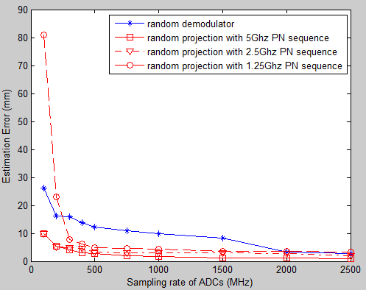

Fig version: Sample Rate in [300, 2500]

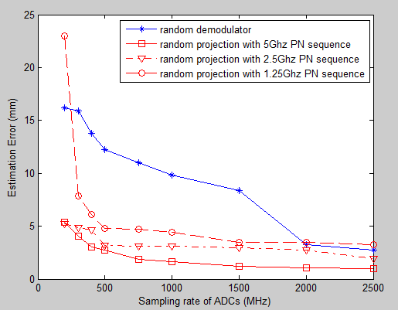

Fig version: Sample Rate in [300, 1000]

