# 

# 1 方法：

## 1.1目标函数（极大似然估计）：

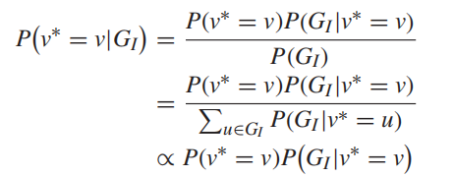

**转化为最大后验概率估计MAP：**

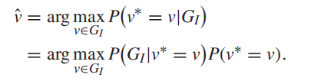

### 1.1.1第一部分：通过贪心方式近似构建GI

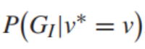

**表示选择v，假设v为源点v*的条件下观察到GI的概率。**

**例子：**

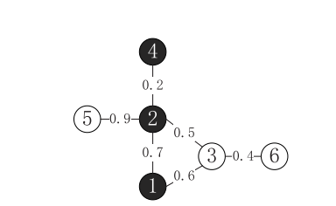

**贪心构建GI传播子图算法流程：**

遍历所有感染点：

初始化队列；

将该点加入到队列中；

队首元素出队；

从该点开始，贪心选择（所有感染点一阶邻域中）感染概率最大的点；

将感染概率最大点加入到队列中；

计算**Pi=Pi+**

更新该加入点**邻居节点**的感染概率：



按照（所有感染点一阶邻域中）概率大小选择排序插入到队列之中

### 1.1.2第二部分：先验概率构建

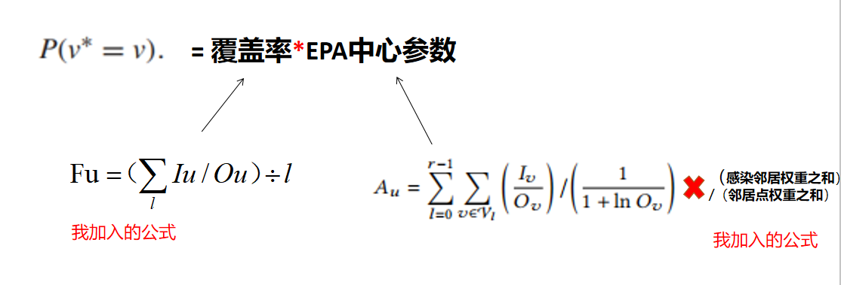

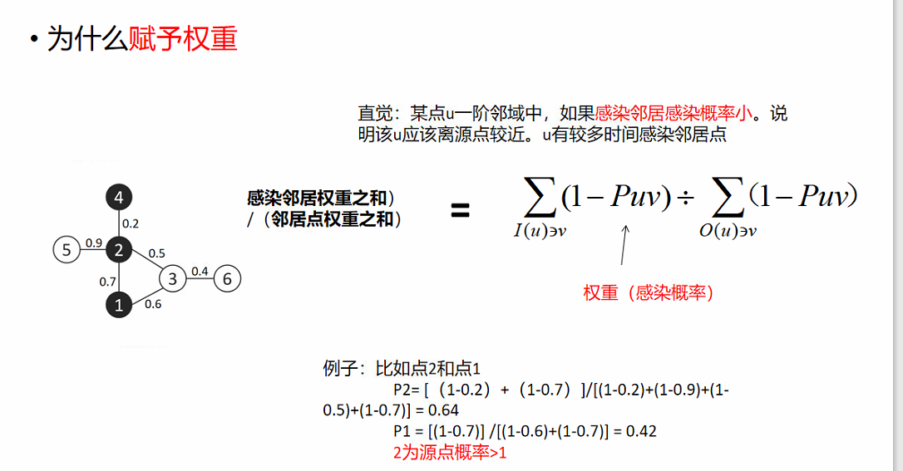

# 2 时间复杂度分析

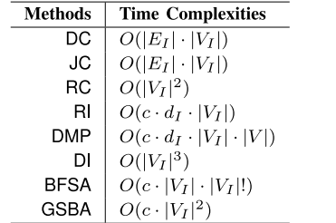

**Our O(VI3)**

# 3 效果

## 3.1评价指标：

**准确率，拓扑距离，定源等级**

## 3.2 实验：

数据集总览

|  |  |  |  |
| --- | --- | --- | --- |
| **表现较好数据集** | | | |
| 数据集名称 | 点数目 | 边数目 | 网络密度 |
| Scale_free | 500 | 996 | 0.798% |
| power-grid | 4941 | 6594 | 0.054% |
| GA-GrQc | 5242 | 14496 | 0.105% |
| Ca-astroph | 17903 | 197031 | 0.123% |
| **表现较差数据集** | | | |
| Email-eu-core | 1005 | 25571 | 5.06848% |
| Face-book | 4039 | 88234 | 1.28199% |
| Wiki-vote | 7066 | 100736 | 0.404% |
|  |  |  |  |
|  |  |  |  |

### 3.2.1第一个数据集

|  |  |  |  |
| --- | --- | --- | --- |
| 数据集名称 | 点数目 | 边数目 | 网络密度 |
| Scale_free | 500 | 996 | 0.798% |

**实验结果:**

|  |  |  |  |  |  |  |  |  |
| --- | --- | --- | --- | --- | --- | --- | --- | --- |
| **感染点数目/准确率** | **RC** | **DC** | **JC** | **RV** | **DI** | **EPA+** | **GSBA** | **Our** |
| **20** | 0.15 | 0.11 | 0.24 | 0.09 | 0.1 | 0.28 | 0.31 | **0.39** |
| **30** | 0.05 | 0.0 | 0.24 | 0.03 | 0.02 | 0.11 | 0.25 | **0.37** |
| **40** | 0.08 | 0.01 | 0.17 | 0.03 | 0.01 | 0.1 | 0.21 | **0.31** |
| **50** | 0.08 | 0.04 | 0.11 | 0.03 | 0.02 | 0.07 | **0.22** | **0.22** |
| **60** | 0.04 | 0.02 | 0.08 | 0.0 | 0.0 | 0.04 | 0.12 | **0.19** |
| **70** | 0.0 | 0.0 | 0.02 | 0.01 | 0.0 | 0.0 | 0.08 | **0.10** |
| **80** | 0.07 | 0.02 | 0.07 | 0.01 | 0.01 | 0.02 | 0.13 | **0.14** |
| **90** | 0.03 | 0.01 | 0.08 | 0.0 | 0.0 | 0.04 | 0.06 | **0.12** |
| **100** | 0.05 | 0.0 | 0.04 | 0.0 | 0.0 | 0.03 | 0.15 | 0.14 |

|  |  |  |  |  |  |  |  |  |
| --- | --- | --- | --- | --- | --- | --- | --- | --- |
| **感染点数目/拓扑距离（越低越好）** | **RC** | **DC** | **JC** | **RV** | **DI** | **EPA** | **GSBA** | **Our** |
| **20** | 1，21 | 1.32 | 1.16 | 1.43 | 1.49 | 0.89 | 0.99 | **0.68** |
| **30** | 1.53 | 1.71 | 1.23 | 1.7 | 1.82 | 1.22 | 1.08 | **0.79** |
| **40** | 1.46 | 1.72 | 1.38 | 1.79 | 1.87 | 1.36 | 1.25 | **0.88** |
| **50** | 1.68 | 1.86 | 1.65 | 2.01 | 2.12 | 1.52 | 1.51 | **1.02** |
| **60** | 1.94 | 2.1 | 1.81 | 2.29 | 2.37 | 1.85 | 1.68 | **1.25** |
| **70** | 1.99 | 2.21 | 2.0 | 2.35 | 2.38 | 1.79 | 1.77 | **1.36** |
| **80** | 1.96 | 2.29 | 2.08 | 2.4 | 2.36 | 1.93 | 1.71 | **1.48** |
| **90** | 2.02 | 2.21 | 1.92 | 2.39 | 2.42 | 2.0 | 1.97 | **1.51** |
| **100** | 1.94 | 2.1 | 1.97 | 2.37 | 2.31 | 1.9 | 1.9 | **1.44** |

|  |  |  |  |  |  |  |  |  |
| --- | --- | --- | --- | --- | --- | --- | --- | --- |
| **感染点数目/定源等级（越低越好）** | **RC** | **DC** | **JC** | **RV** | **DI** | **EPA** | **GSBA** | **Our** |
| **20** | 0.28 | 0.40 | 0.30 | 0.37 | 0.51 | 0.18 | 0.15 | **0.14** |
| **30** | 0.32 | 0.38 | 0.28 | 0.41 | 0.61 | 0.17 | 0.15 | **0.11** |
| **40** | 0.32 | 0.40 | 0.25 | 0.39 | 0.59 | 0.16 | 0.14 | **0.09** |
| **50** | 0.34 | 0.45 | 0.30 | 0.47 | 0.62 | 0.20 | 0.14 | **0.12** |
| **60** | 0.46 | 0.50 | 0.35 | 0.49 | 0.68 | 0.22 | 0.21 | **0.12** |
| **70** | 0.40 | 0.50 | 0.34 | 0.51 | 0.66 | 0.21 | 0.16 | **0.13** |
| **80** | 0.46 | 0.44 | 0.30 | 0.44 | 0.71 | 0.28 | 0.21 | **0.15** |
| **90** | 0.43 | 0.49 | 0.34 | 0.07 | 0.66 | 0.28 | 0.23 | **0.15** |
| **100** | 0.42 | 0.44 | 0.31 | 0.45 | 0.58 | 0.24 | 0.23 | **0.14** |

### 3.2.2第二个数据集：

|  |  |  |  |
| --- | --- | --- | --- |
| 数据集名称 | 点数目 | 边数目 | 网络密度 |
| power-grid | 4941 | 6594 | 0.054% |

|  |  |  |  |  |  |  |  |  |
| --- | --- | --- | --- | --- | --- | --- | --- | --- |
| **感染点数目/准确率** | **RC** | **DC** | **JC** | **RI** | **DI** | **EPA** | **GSBA** | **Our** |
| **50** | 0.02 | 0.03 | 0.06 | 0.03 | 0.0 | 0.04 | 0.07 | **0.08** |
| **100** | 0.0 | 0.01 | 0.04 | 0.0 | 0.01 | 0.01 | 0.05 | 0.03 |
| **150** | 0.01 | 0.01 | 0.01 | 0.0 | 0.0 | 0.0 | 0.04 | 0.01 |
| **200** | 0.01 | 0.01 | 0.01 | 0.0 | 0.01 | 0.01 | 0.01 | 0.0 |
| **250** | **0.01** | 0.0 | 0.0 | 0.0 | **0.01** | 0.0 | 0.0 | **0.01** |
| **300** | 0.01 | 0.01 | 0.01 | 0.01 | 0.0 | 0.01 | 0.0 | **0.02** |
| **350** | **0.01** | 0.0 | **0.01** | 0.0 | **0.01** | 0.0 | 0.0 | **0.01** |
| **400** | 0.0 | **0.02** | 0.01 | 0.0 | 0.0 | **0.02** | 0.01 | **0.02** |
| **450** | 0.0 | 0.0 | 0.0 | 0.0 | 0.0 | 0.0 | 0.0 | 0.0 |

|  |  |  |  |  |  |  |  |  |
| --- | --- | --- | --- | --- | --- | --- | --- | --- |
| **感染点数目/拓扑距离** | **RC** | **DC** | **JC** | **RI** | **DI** | **EPA** | **GSBA** | **Our** |
| **50** | 2.48 | 2.46 | 2.51 | 2.55 | 3.07 | 2.28 | 2.28 | **1.95** |
| **100** | 3.68 | 3.58 | 3.76 | 3.77 | 4.92 | 3.48 | 3.21 | **2.95** |
| **150** | 3.77 | 3.83 | 4.23 | 3.99 | 5.36 | 3.59 | 3.36 | **3.14** |
| **200** | 4.39 | 4.47 | 4.84 | 4.65 | 5.73 | 4.21 | 4.3 | **3.6** |
| **250** | 4.45 | 4.19 | 4.69 | 4.4 | 6.24 | 4.14 | 7.84 | **3.58** |
| **300** | 5.26 | 5.04 | 5.11 | 5.41 | 7.38 | 5.01 | 8.58 | **4.27** |
| **350** | 5.25 | 4.91 | 5.29 | 5.26 | 7.14 | 4.85 | 8.1 | **4.18** |
| **400** | 5.81 | 5.44 | 5.62 | 5.79 | 7.55 | 5.2 | 9.2 | **4.63** |
| **450** | 6.05 | 5.28 | 5.86 | 5.83 | 8.38 | 5.48 | 9.27 | **4.89** |

|  |  |  |  |  |  |  |  |  |
| --- | --- | --- | --- | --- | --- | --- | --- | --- |
| **感染点数目/rank** | **RC** | **DC** | **JC** | **RI** | **DI** | **EPA** | **GSBA** | **Our** |
| **50** | 0.40 | 0.38 | 0.35 | 0.35 | 0.50 | 0.34 | 0.25 | **0.21** |
| **100** | 0.47 | 0.43 | 0.42 | 0.40 | 0.58 | 0.41 | 0.24 | 0.26 |
| **150** | 0.41 | 0.39 | 0.39 | 0.36 | 0.55 | 0.36 | 0.20 | 0.23 |
| **200** | 0.46 | 0.42 | 0.43 | 0.43 | 0.52 | 0.43 | 0.28 | 0.29 |
| **250** | 0.40 | 0.38 | 0.36 | 0.40 | 0.53 | 0.42 | 0.55 | **0.26** |
| **300** | 0.50 | 0.44 | 0.39 | 0.41 | 0.60 | 0.47 | 0.52 | **0.30** |
| **350** | 0.47 | 0.42 | 0.43 | 0.44 | 0.56 | 0.42 | 0.50 | **0.29** |
| **400** | 0.48 | 0.45 | 0.44 | 0.46 | 0.56 | 0.45 | 0.51 | **0.31** |
| **450** | 0.46 | 0.43 | 0.41 | 0.43 | 0.57 | 0.46 | 0.45 | **0.30** |

**小版本**

|  |  |  |  |  |  |  |  |  |
| --- | --- | --- | --- | --- | --- | --- | --- | --- |
| **感染点数目/准确率** | **RC** | **DC** | **JC** | **RV** | **DI** | **EPA+** | **GSBA** | **Our** |
| **20** |  |  |  |  |  |  |  |  |
| **30** |  |  |  |  |  |  |  |  |
| **40** |  |  |  |  |  |  |  |  |
| **50** |  |  |  |  |  |  |  |  |
| **60** |  |  |  |  |  |  |  |  |
| **70** |  |  |  |  |  |  |  |  |
| **80** |  |  |  |  |  |  |  |  |
| **90** |  |  |  |  |  |  |  |  |
| **100** |  |  |  |  |  |  |  |  |

|  |  |  |  |  |  |  |  |  |
| --- | --- | --- | --- | --- | --- | --- | --- | --- |
| **感染点数目/拓扑距离（越低越好）** | **RC** | **DC** | **JC** | **RV** | **DI** | **EPA** | **GSBA** | **Our** |
| **20** |  |  |  |  |  |  |  |  |
| **30** |  |  |  |  |  |  |  |  |
| **40** |  |  |  |  |  |  |  |  |
| **50** |  |  |  |  |  |  |  |  |
| **60** |  |  |  |  |  |  |  |  |
| **70** |  |  |  |  |  |  |  |  |
| **80** |  |  |  |  |  |  |  |  |
| **90** |  |  |  |  |  |  |  |  |
| **100** |  |  |  |  |  |  |  |  |

|  |  |  |  |  |  |  |  |  |
| --- | --- | --- | --- | --- | --- | --- | --- | --- |
| **感染点数目/定源等级（越低越好）** | **RC** | **DC** | **JC** | **RV** | **DI** | **EPA** | **GSBA** | **Our** |
| **20** |  |  |  |  |  |  |  |  |
| **30** |  |  |  |  |  |  |  |  |
| **40** |  |  |  |  |  |  |  |  |
| **50** |  |  |  |  |  |  |  |  |
| **60** |  |  |  |  |  |  |  |  |
| **70** |  |  |  |  |  |  |  |  |
| **80** |  |  |  |  |  |  |  |  |
| **90** |  |  |  |  |  |  |  |  |
| **100** |  |  |  |  |  |  |  |  |

### 3.2.3第3个数据集

|  |  |  |  |
| --- | --- | --- | --- |
| 数据集名称 | 点数目 | 边数目 | 网络密度 |
| GA-GrQc | 5242 | 14496 | 0.105% |

|  |  |  |  |  |  |  |  |  |
| --- | --- | --- | --- | --- | --- | --- | --- | --- |
| **感染点数目/准确率** | **RC** | **DC** | **JC** | **RI** | **DI** | **EPA** | **GSBA** | **Our** |
| **50** |  |  |  |  |  |  |  |  |
| **100** |  |  |  |  |  |  |  |  |
| **150** |  |  |  |  |  |  |  |  |
| **200** |  |  |  |  |  |  |  |  |
| **250** |  |  |  |  |  |  |  |  |
| **300** |  |  |  |  |  |  |  |  |
|  |  |  |  |  |  |  |  |  |

|  |  |  |  |  |  |  |  |  |
| --- | --- | --- | --- | --- | --- | --- | --- | --- |
| **感染点数目/拓扑距离** | **RC** | **DC** | **JC** | **RI** | **DI** | **EPA** | **GSBA** | **Our** |
| **50** |  |  |  |  |  |  |  |  |
| **100** |  |  |  |  |  |  |  |  |
| **150** |  |  |  |  |  |  |  |  |
| **200** |  |  |  |  |  |  |  |  |
| **250** |  |  |  |  |  |  |  |  |
| **300** |  |  |  |  |  |  |  |  |

|  |  |  |  |  |  |  |  |  |
| --- | --- | --- | --- | --- | --- | --- | --- | --- |
| **感染点数目/rank** | **RC** | **DC** | **JC** | **RI** | **DI** | **EPA** | **GSBA** | **Our** |
| **50** |  |  |  |  |  |  |  |  |
| **100** |  |  |  |  |  |  |  |  |
| **150** |  |  |  |  |  |  |  |  |
| **200** |  |  |  |  |  |  |  |  |
| **250** |  |  |  |  |  |  |  |  |
| **300** |  |  |  |  |  |  |  |  |

### 3.2.4第4个数据集

|  |  |  |  |
| --- | --- | --- | --- |
| 数据集名称 | 点数目 | 边数目 | 网络密度 |
| Ca-astroph | 17903 | 197031 | 0.123% |

|  |  |  |  |  |  |  |  |  |
| --- | --- | --- | --- | --- | --- | --- | --- | --- |
| **感染点数目/准确率** | **RC** | **DC** | **JC** | **RI** | **DI** | **EPA** | **GSBA** | **Our** |
| **50** | 0.23 | 0.07 | 0.11 | 0.05 | 0.08 | 0.24 | 0.24 | **0.35** |
| **100** | 0.24 | 0.04 | 0.06 | 0.01 | 0.09 | 0.14 | 0.08 | **0.25** |
| **150** | 0.24 | 0.03 | 0.09 | 0.0 | 0.02 | 0.13 | 0.01 | **0.24** |
| **200** |  |  |  |  |  |  |  |  |
| **250** |  |  |  |  |  |  |  |  |
| **300** |  |  |  |  |  |  |  |  |

|  |  |  |  |  |  |  |  |  |
| --- | --- | --- | --- | --- | --- | --- | --- | --- |
| **感染点数目/拓扑距离** | **RC** | **DC** | **JC** | **RI** | **DI** | **EPA** | **GSBA** | **Our** |
| **50** | 0.95 | 1.29 | 1.17 | 1.57 | 1.26 | 0.88 | 1.06 | **0.71** |
| **100** | 0.91 | 1.47 | 1.42 | 1.73 | 1.27 | 0.97 | 1.33 | **0.82** |
| **150** | 1.02 | 1.91 | 1.67 | 2.11 | 1.65 | 1.24 | 2.5 | **0.97** |
| **200** |  |  |  |  |  |  |  |  |
| **250** |  |  |  |  |  |  |  |  |
| **300** |  |  |  |  |  |  |  |  |

|  |  |  |  |  |  |  |  |  |
| --- | --- | --- | --- | --- | --- | --- | --- | --- |
| **感染点数目/rank** | **RC** | **DC** | **JC** | **RI** | **DI** | **EPA** | **GSBA** | **Our** |
| **50** | 0.23 | 0.46 | 0.37 | 0.46 | 0.47 | 0.19 | 0.14 | **0.10** |
| **100** | 0.16 | 0.48 | 0.40 | 0.54 | 0.45 | 0.23 | **0.13** | **0.13** |
| **150** | 0.14 | 0.45 | 0.35 | 0.47 | 0.50 | 0.22 | 0.52 | **0.10** |
| **200** |  |  |  |  |  |  |  |  |
| **250** |  |  |  |  |  |  |  |  |
| **300** |  |  |  |  |  |  |  |  |
|  |  |  |  |  |  |  |  |  |

## 3.3 表现较差数据集

### 3.3.1 第一个数据集

|  |  |  |  |
| --- | --- | --- | --- |
| 数据集名称 | 点数目 | 边数目 | 网络密度 |
| Wiki-vote | 7066 | 100736 | 0.404% |

|  |  |  |  |  |  |  |  |  |
| --- | --- | --- | --- | --- | --- | --- | --- | --- |
| **感染点数目/准确率** | **RC** | **DC** | **JC** | **RI** | **DI** | **EPA** | **GSBA** | **Our** |
| **50** | **0.2** | 0.0 | 0.1 | 0.0 | 0.1 | 0.1 | 0.6 | 0.4 |
| **100** | **0.4** | 0.0 | 0.0 | 0.0 | 0.1 | 0.1 | 0.5 | 0.3 |
| **150** | **0.3** | 0.0 | 0.1 | 0.0 | 0.1 | 0.1 | 0.0 | 0.2 |
| **200** | **0.5** | 0.0 | 0.0 | 0.0 | 0.0 | 0.0 | 0.0 | 0.2 |
| **250** | **0.1** | 0.0 | 0.2 | 0.0 | 0.0 | 0.1 | 0.0 | 0.1 |
| **300** | **0.2** | 0.0 | 0.0 | 0.0 | 0.0 | 0.0 | 0.0 | 0.1 |
| **350** | **0.1** | 0.0 | 0.0 | 0.0 | 0.0 | 0.0 | 0.0 | 0.0 |

|  |  |  |  |  |  |  |  |  |
| --- | --- | --- | --- | --- | --- | --- | --- | --- |
| **感染点数目/拓扑距离** | **RC** | **DC** | **JC** | **RI** | **DI** | **EPA** | **GSBA** | **Our** |
| **50** | **1.0** | 1.8 | 1.6 | 2.0 | 1.3 | 1.0 | 0.7 | 0.7 |
| **100** | **0.8** | 1.8 | 1.6 | 1.8 | 1.1 | 1.2 | 0.8 | 1.0 |
| **150** | **1.0** | 2.2 | 1.5 | 1.9 | 1.3 | 1.4 | 2.2 | 1.2 |
| **200** | **0.6** | 1.9 | 1.7 | 1.8 | 1.4 | 1.5 | 2.0 | 1.2 |
| **250** | **1.4** | 2.0 | 1.7 | 2.1 | 1.7 | 1.5 | 2.2 | 1.5 |
| **300** | **1.3** | 2.1 | 2.1 | 2.2 | 1.6 | 1.7 | 2.2 | 1.4 |
| **350** | **1.2** | 2.1 | 2.。1 | 2.3 | 1.7 | 1.5 | 2.5 | 1.5 |

|  |  |  |  |  |  |  |  |  |
| --- | --- | --- | --- | --- | --- | --- | --- | --- |
| **感染点数目/rank** | **RC** | **DC** | **JC** | **RI** | **DI** | **EPA** | **GSBA** | **Our** |
| **50** | **0.20** | 0.53 | 0.49 | 0.56 | 0.74 | 0.13 | 0.06 | **0.04** |
| **100** | **0.15** | 0.72 | 0.63 | 0.60 | 0.56 | 0.20 | 0.09 | **0.04** |
| **150** | **0.24** | 0.83 | 0.65 | 0.65 | 0.68 | 0.41 | 0.59 | **0.19** |
| **200** | **0.09** | 0.75 | 0.67 | 0.58 | 0.61 | 0.38 | 0.47 | 0.19 |
| **250** | **0.15** | 0.84 | 0.71 | 0.71 | 0.80 | 0.61 | 0.60 | 0.37 |
| **300** | **0.12** | 0.69 | 0.71 | 0.44 | 0.81 | 0.63 | 0.58 | 0.42 |
| **350** | **0.27** | 0.70 | 0.67 | 0.59 | 0.72 | 0.57 | 0.55 | 0.37 |

### 3.3.2第二个数据集

|  |  |  |  |
| --- | --- | --- | --- |
| 数据集名称 | 点数目 | 边数目 | 网络密度 |
| Email-eu-core | 1005 | 25571 | 5.06848% |

|  |  |  |  |  |  |  |  |  |
| --- | --- | --- | --- | --- | --- | --- | --- | --- |
| **感染点数目/准确率** | **RC** | **DC** | **JC** | **RI** | **DI** | **EPA** | **GSBA** | **Our** |
| **50** | **0.3** | 0.0 | 0.0 | 0.1 | 0.2 | 0.2 | 0.2 | **0.3** |
| **100** | 0.6 | 0.0 | 0.1 | 0.0 | 0.2 | 0.3 | 0.5 | 0.4 |
| **150** |  |  |  |  |  |  |  |  |
| **200** |  |  |  |  |  |  |  |  |
| **250** |  |  |  |  |  |  |  |  |
| **300** |  |  |  |  |  |  |  |  |
|  |  |  |  |  |  |  |  |  |

|  |  |  |  |  |  |  |  |  |
| --- | --- | --- | --- | --- | --- | --- | --- | --- |
| **感染点数目/拓扑距离** | **RC** | **DC** | **JC** | **RI** | **DI** | **EPA** | **GSBA** | **Our** |
| **50** | 0.9 | 1.6 | 1.4 | 1.5 | 1.0 | 0.9 | 1.1 | **0.8** |
| **100** | **0.5** | 1.8 | 1.2 | 1.6 | 1.0 | 0.9 | 0.8 | 0.8 |
| **150** |  |  |  |  |  |  |  |  |
| **200** |  |  |  |  |  |  |  |  |
| **250** |  |  |  |  |  |  |  |  |
| **300** |  |  |  |  |  |  |  |  |

|  |  |  |  |  |  |  |  |  |
| --- | --- | --- | --- | --- | --- | --- | --- | --- |
| **感染点数目/rank** | **RC** | **DC** | **JC** | **RI** | **DI** | **EPA** | **GSBA** | **Our** |
| **50** | 0.36 | 0.58 | 0.53 | 0.50 | 0.46 | 0.16 | 0.15 | **0.08** |
| **100** | 0.11 | 0.59 | 0.50 | 0.64 | 0.37 | 0.18 | **0.10** | **0.10** |
| **150** |  |  |  |  |  |  |  |  |
| **200** |  |  |  |  |  |  |  |  |
| **250** |  |  |  |  |  |  |  |  |
| **300** |  |  |  |  |  |  |  |  |

### 3.3.3第3个数据集

|  |  |  |  |
| --- | --- | --- | --- |
| 数据集名称 | 点数目 | 边数目 | 网络密度 |
| Face-book | 4039 | 88234 | 1.28199% |

|  |  |  |  |  |  |  |  |  |
| --- | --- | --- | --- | --- | --- | --- | --- | --- |
| **感染点数目/准确率** | **RC** | **DC** | **JC** | **RI** | **DI** | **EPA** | **GSBA** | **Our** |
| **50** | 0.0 | 0.0 | 0.0 | 0.1 | 0.0 | 0.2 | 0.0 | 0.1 |
| **100** | 0.2 | 0.0 | 0.0 | 0.2 | 0.2 | 0.1 | 0.2 | **0.3** |
| **150** | 0.0 | 0.0 | 0.0 | 0.0 | 0.0 | 0.0 | 0.0 | **0.1** |
| **200** | 0.0 | 0.0 | 0.0 | 0.0 | 0.0 | 0.1 | 0.0 | 0.0 |
| **250** | 0.0 | 0.0 | 0.0 | 0.0 | 0.0 | 0.0 | 0.0 | 0.0 |
| **300** | 0.0 | 0.0 | 0.0 | 0.0 | 0.0 | 0.0 | 0.0 | 0.0 |

|  |  |  |  |  |  |  |  |  |
| --- | --- | --- | --- | --- | --- | --- | --- | --- |
| **感染点数目/拓扑距离** | **RC** | **DC** | **JC** | **RI** | **DI** | **EPA** | **GSBA** | **Our** |
| **50** | **1.0** | 1.1 | 1.1 | 1.4 | 1.1 | 0.8 | 1.5 | 1.0 |
| **100** | **0.8** | 1.2 | 1.2 | 1.0 | 0.8 | 1.2 | 1.1 | **0.8** |
| **150** | **1.0** | 1.4 | 1.2 | 1.5 | 1.0 | 1.3 | 1.9 | 1.2 |
| **200** | **1.0** | 1.3 | 1.1 | 1.7 | 1.0 | 0.9 | 2.0 | 1.2 |
| **250** | **1.1** | 1.4 | **1.2** | 1.5 | 1.0 | **1.2** | 2.0 | 1.2 |
| **300** | **1.1** | 1.2 | 1.2 | 1.8 | **1.1** | **1.1** | 1.7 | **1.1** |

|  |  |  |  |  |  |  |  |  |
| --- | --- | --- | --- | --- | --- | --- | --- | --- |
| **感染点数目/rank** | **RC** | **DC** | **JC** | **RI** | **DI** | **EPA** | **GSBA** | **Our** |
| **50** | 0.49 | 0.60 | 0.6 | 0.54 | 0.47 | 0.08 | 0.35 | **0.07** |
| **100** | 0.38 | 0.62 | 0.59 | 0.44 | 0.32 | 0.08 | 0.23 | **0.06** |
| **150** | 0.46 | 0.66 | 0.60 | 0.61 | 0.49 | 0.13 | 0.60 | **0.08** |
| **200** | 0.54 | 0.37 | 0.37 | 0.60 | 0.32 | 0.18 | 0.53 | **0.16** |
| **250** | 0.54 | 0.47 | 0.49 | 0.50 | 0.33 | 0.17 | 0.47 | **0.14** |
| **300** | 0.59 | 0.31 | 0.33 | 0.59 | 0.31 | 0.14 | 0.47 | **0.12** |