**Title:** Relationship between female’s income and numbers of children in family.

**Domain:** Communities. Human Right

**Introduction:**

The report identifies the relationship between number of children and female’s income in the family, thus identify the role of women in wealth family and poor family with many children to find any difference. The social value of this research is to see whether women’s role is limited by the number of children in a family, and if so, what support should the government provide to protect their right.

This report analyzes 32 Local Government Areas(LGA) within the Metropolitan Melbourne area, in the 2011 census survey.

**It seeks to answer the following research questions:**

1relationship between women’s income and numbers of children in a family.

2relationship between women’s unpaid house work and numbers of children

3Whether female in wealthy family is more economic independent that female in poor family, given both have children more than 3.

**Dataset:**

Working Population Profile from Australian Bureau of Statistics(ABS):

<http://www.censusdata.abs.gov.au/census_services/getproduct/census/2011/communityprofile/LGA21110?opendocument&navpos=100>

Basic Community Profile from (ABS):

<http://www.censusdata.abs.gov.au/census_services/getproduct/census/2011/communityprofile/LGA21110?opendocument&navpos=100>

1, Using datasheet B24, Number of Children Ever Born by Age of Parent

2, Using datasheet B02, selected Medians and Averages.

3. Using datasheet B17, Total personal income (weekly) by age by sex

The above two dataset’s link are just from 1 Local Government Areas. The research using data from 32 LGAs.

**Processing Process:**

Extracting the percentage of family with more than 2 children in each LGA.

Extracting the median income in each LGA.

Selecting top 5 richest area and bottom 5 poorest area based on the percentage of family in that LGA with more than two children.

Looking into that area, seeing the female weekly income by age.

Plotting female weekly income against the number of children in the selecting area

**Conclusion:**

The result show a strong negative relation (R = - 0.845) such that family with female higher income is less likely to have multi children, which implies that female’s economic independence is limited by number of children.

However, further investigation still needed. For instance, we haven’t separate the wealthy family and poor family case. Data for unpaid childcare, unpaid housework are also not integrated into the dataframe.

**Initial Investigation**

In the initial Investigation, we have extracted data from 32 LGA basic community profile. To simplify, we defined high_income to be weekly earning greater than 1000 dollars, and multi_children to be family greater than or equal to 3 children.

The ratio of this to is defined to be the number that fits the definition divides by the total number in each LGA.

And we find the Pearson Correlation between female_high_income_ratio and multichildren_ratio

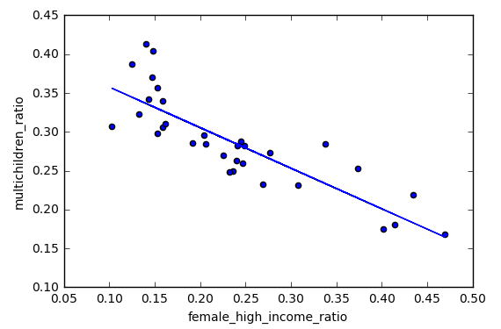



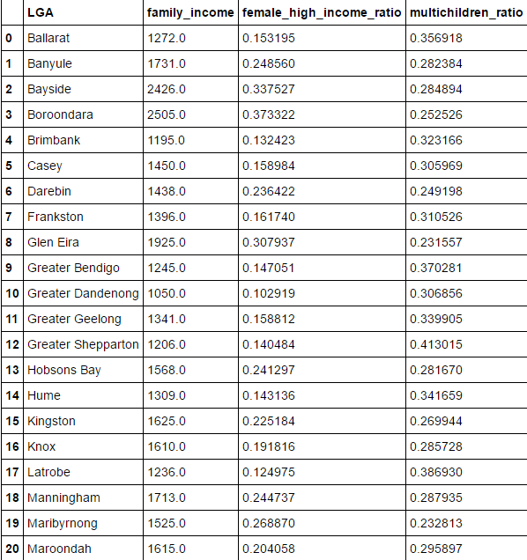

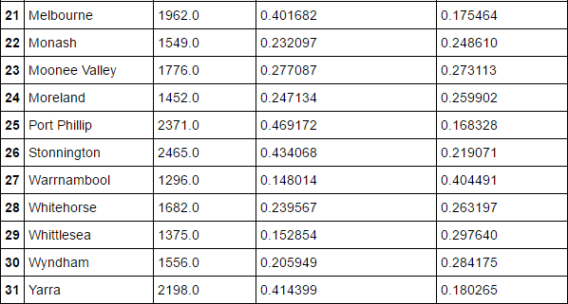 **Defination**

**High income is defined to be annual income greater than 94328 after tax, from ABS**

**Which is 1814 dollar aweek**

<http://www.news.com.au/finance/money/budgeting/do-you-consider-yourself-a-struggling-comfortable-or-rich-australian/news-story/4a177834df5e2840343fbd708a884ea6>