1. 建立初工程
2. 选程所用芯片芯片号
3. 建立工程框架，加入相关文件，**注：STM32_CMSIS需要引入**

**”startup_stm32f10x_hd.s”**

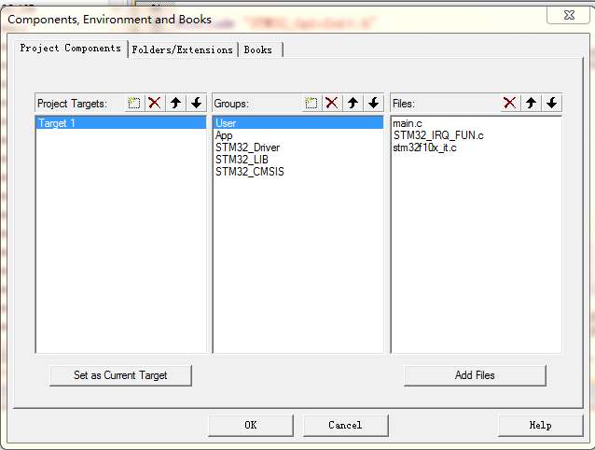

1. 设置OUTPUT选项卡：

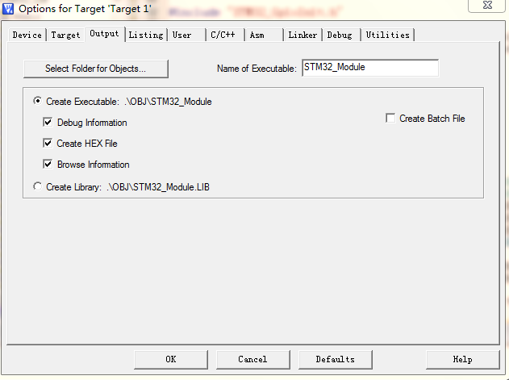

1. 设置Listing选项卡

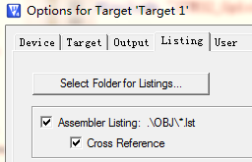

1. 设置“C/C++”选项卡

USE_STDPERIPH_DRIVER,STM32F10X_HD

.\Includes;.\Includes\STM32_LIB;.\Includes\User;.\Includes\App;.\Includes\STM32_CMSIS;.\Includes\STM32_Driver

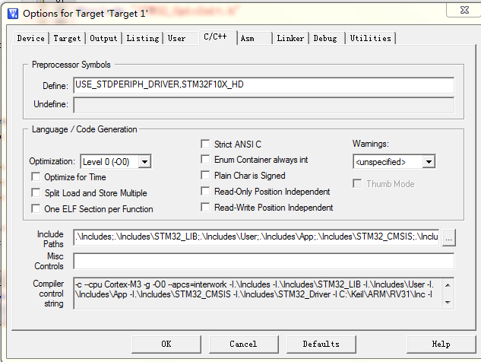

1. 设置Debug选项卡

