Task 3 Networking

1. Experimental Purposes
（1）Connecting networks through routers.
（2）Learn the operations on routers and the basic skills for networking
（3）Static routing
（4）RIP configuration

2. Experimental Environment
（1）Network topology
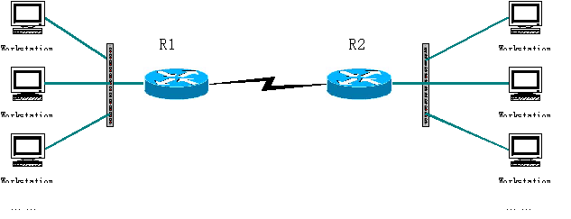
（2）Experiment devices
Two routers, two switches (optional), two PCs and cables.
（3）Experiment requirements
Given 3 C-class Network addresses: 192.168.1.0，192.168.2.0，192.168.3.0. (Just for example. You can design the networks as you like.)
- Using the above topology to design network, explain the address for each node and interface.
Please describe the commands/steps to configure these IP addresses
- Using static routing, to enable the workstations to communicate with each other.
Explain the routing entries on each router
Explain the commands/steps to configure routing entries
- Using dynamic routing, to enable the workstations to communicate with each other.
Explain RIP/OSPF
Explain the commands/steps to configure dynamic routing
（4）Testing and confirmation
How can you test and confirm that the network is working fine?

