**Scope Statement for AUSGRID - NET CAD - AUTOCAD 2016 – ARX – Update Certification Number of Title Block of drawing**

Version 1.0

*The scope statement is an agreement among the project team, the project sponsor and key stakeholders. It represents a common understanding of the project for the purpose of facilitating communication among the stakeholders and for setting authorities and limits for the project manager and team. The scope statement includes relating the project to business objectives, and defining the boundaries of the project in multiple dimensions including approach, deliverables, milestones, and budget.* **Table of Contents**

A. Summary 3

B. Business Objectives 3

C. Project Description 3

E. Additional Diagrams / Workflows 5

### A. Summary

The AUSGRID AutoCAD 2016 requires additional function to update certification number of a title block of all layouts in a drawing.

### B. Business Objectives

1. **Business Need**

Following are the reasons to meet the business requirement to update certificate number on all layouts of a drawing in AutoCAD 2016 using a command / function.

* Certificate numbers needs to be added in all layouts of drawing files .

1. **Product Description (Solution)**

*.*

* .NET API will be provided to fill the certificate number in a UI, upon update, will update the certificate number on all layouts of the opened drawing.

1. **Deliverables**

*.*

* AutoCAD 2018 customized plug-in DLLs

### C. Project Description

1. **Scope**

**Includes:**

The scope includes the update of certificate number in ##-## format only in the title block of a layout of the drawing. All layouts containing the certificate number in the title block will be updated on providing the format using a UI.

**Does Not Include:**

Additional changes to existing customization are not in the scope.

1. **Completion Criteria**

* AutoCAD 2018 customized plug-in DLLs will conclude the completion criteria.

1. **Risk Assessment**

Schedule creep based on the resource availability.

1. **Constraints**

N/A

1. **Dependency Linkages**

N/A

1. **Impacts**

N/A

1. **Measures of Project Success**

N/A

1. **Assumptions**
   * AutoCAD 2016 is used
   * Certificate number is available only in the title block of the layout.
2. **Critical Success Factors**

Users able to update the newly provided certificate number in all layouts of the given drawing will be considered as critical success factor.

### E. Additional Diagrams / Workflows

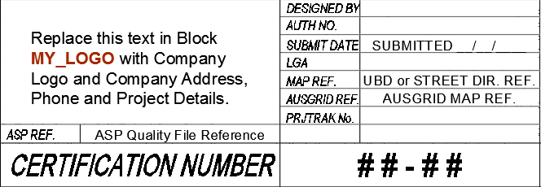

**Fig. 1**

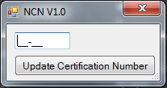 **Fig. 2**

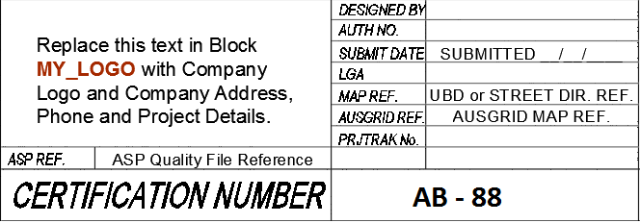

**Fig. 3**