1. AcadUtils
   * + In AcadUtils there is no any call for below dialogue
     + AcadUtils.dll reference used in some project
     + 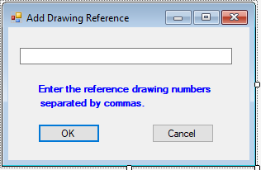

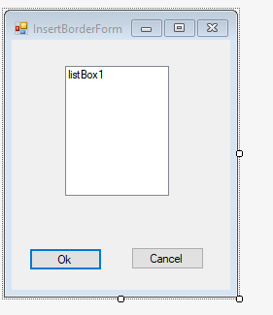

1. AllocateCableNo
   * + Command Names: Cables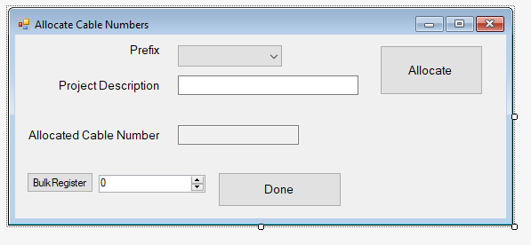
2. Banner
   * + Command Names : Banner

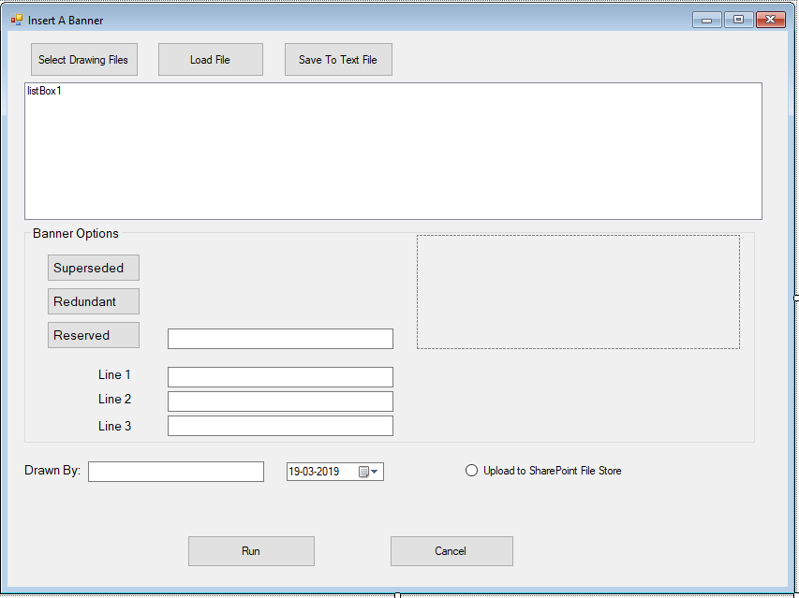

1. cableFinder
   * + Command Names : cf

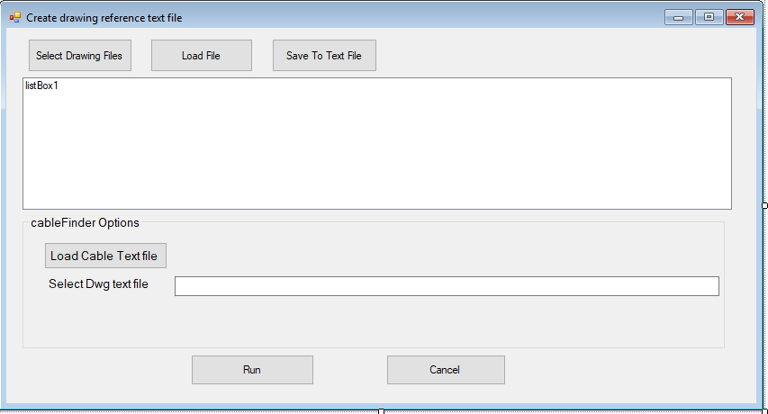

1. CableUpdater
   * + Command Names : CU

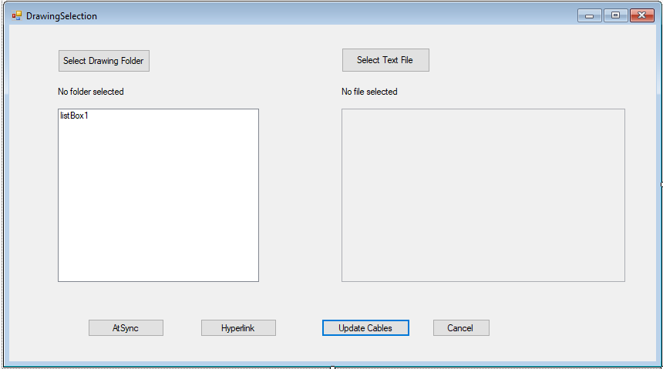

1. HyperlinkAddingOnSave
   * + Command Names :
       - * AddDocEvent
         * RemoveDocEvent
         * DocBeginDocClose : internal methods
         * DocBeginSave : internal methods
2. RegisterDwg
   * + Command Names : NewDwg

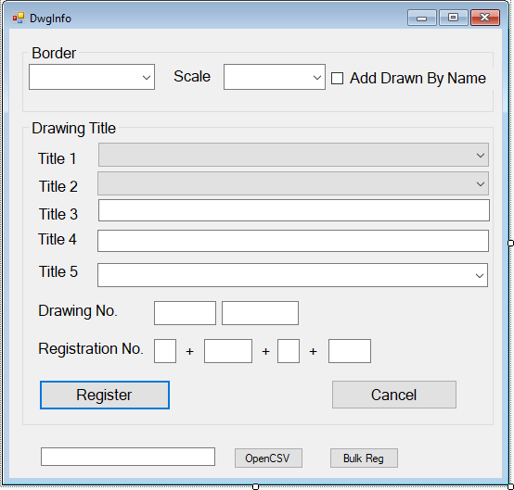

1. RibbonSetup
   * + Command Names : B2
2. TextReplace
   * + Command Names : fr

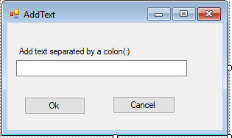

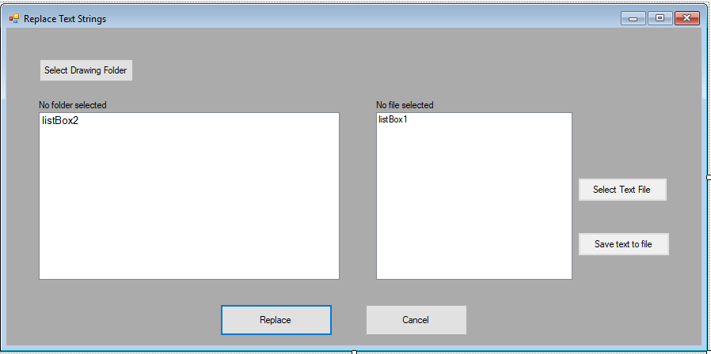

1. Upload2SP
   * + Command Names : U2SP

