

Real-time Control System
by Daniel Green
December 1995

Abstract

Perhaps the most important aspect of any computer game is its frame rate. In general, higher frame rates are better than less, and consistent frame rates are better than inconsistent frame rates. In 3D games, the greatest contributing factor to frame rates is scene complexity. Different 3D games address the situation in different ways. Some 3D games are constructed such that the entire scene can be rendered within a given time on the target platform. First person fighter games fall into this category. Other games use more complex worlds, but restrict the viewpoint so that it’s never possible to too much of it within view at any one time. Race games often use this strategy by restricting the view to always be from the race track. More general type 3D games need more sophisticated solutions.

This paper proposes a reusable control system that can manage arbitrarily complex scenes so as to deliver a 3D representation for each frame that contains the maximum complexity possible at a consistent frame rate. Further, the complexity of the scenes will be distributed so that the more important objects will be rendered with greater detail than less important ones so that the overall visual richness of the experience is maximized.

Additional benefits of the system allow for vastly improved collision detection, behavior control and memory management within simulation type applications. The design is also independent of any particular rendering system.

The design is closely based on one described in the SIGGRAPH ‘93 paper Adaptive Display Algorithm for Interactive Frame Rates During Visualization of Complex Visual Environments.

LOD Objects

The fundamental concept is that of Level of Detail objects or LODs. If most or all of the objects in a scene have been modelled in more than one version where some versions are modelled in greater detail - and therefore more realistic - than other versions, then its possible to render the detailed versions of objects that are close enough for the viewer to see that detail, and to use simpler models of objects that are so far away that fine details wouldn’t be visible anyway. Three or four different versions of each object at successively lower detail could be created in order to minimize visible discontinuities when one version is substituted for another.

A nieve implementation of LOD handling would set a distance threshold for each version of each object. There are several reasons why this is not an adequate solution. The most important reason is because you’d still have no guaranteed frame rate since the frame rate would still degrade roughly linearly with the number of visible objects. It would simply run faster than if no LOD controls were used.

The approach taken here attempt to select the best LOD version for each visible object so that the time to render each frame is kept constant and the more important objects are rendered at higher levels of detail than other objects. Frame times are kept constant by selecting a polygon budget based on the times spent rendering subsequent frames. E.g. if the previous frame rendered 5000 polygons in 90% of the target time, then the next frame should be budgeted approximately 5500 polygons.

The importance of an object is a weighted sum of several factors. The size of the object on the screen (directly related to its distance from the viewer) is the most important factor, and therefore is weighted the highest. The apparent speed of the object across the screen is also important since it’s harder to discern details of a quickly moving object. For example, if the viewer is chasing a moving object, then that object will often appear nearly stationary in the center of the screen while the scenery will appear to be moving quickly past. When it appears to move slowly, the object being followed would then be drawn in greater detail than the scenery. If the chaser nearly missed a pedestrian, than for the one frame when that person’s face filled half the screen, the face would be rendered in high detail allowing the viewer to “see the whites of his eyes” in that frame because it suddenly became very important in that frame due to its size even though it was quickly moving past. Each object will also have an intrinsic importance. People are more important than signs which are more important than trees, etc.

Real-time Classes

The most important class in the system is the ROI (Real-time Object Instance) class. An object of this class represents an instance of some unique object in the simulation. Applications subclass from this class to create application specific classes. In figure 1 below, the objects in the Lego games subclass from this class to create people, cars, trees, etc. Other games would customize for monsters, guns, etc. It’s also possible to use the Real-time system without wiring it directly into the games. That’s just the most direct way. One could simply sub-class from the ROI to create a proxy class that can shadow the real game objects. Such a proxy class would only need to be able to access the real objects in order to represent them to the Real-time system. This is a way one could easily use the runtime system from a game written in another language.

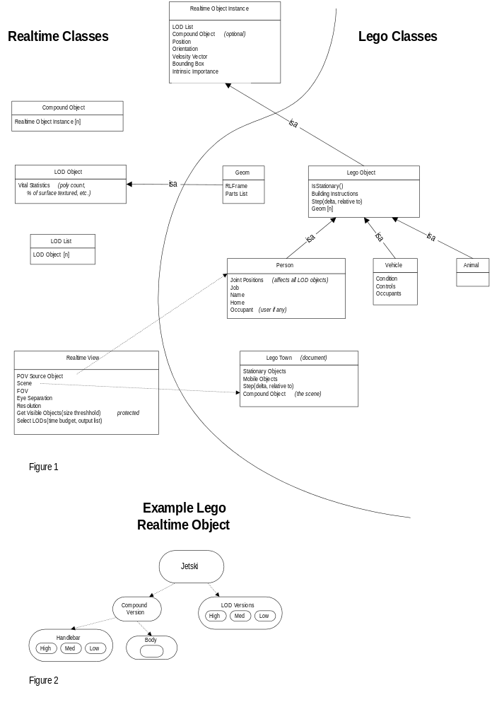

The features of ROI objects that must be represented include their gross physical features such as position, orientation, size, velocity and geometry. Note that the actual physical geometry (the exact polygons, vertices and their attributes) is never accessible to the real-time system. This makes the system completely independent from any particular rendering library. There is a cost associated with each polygon and vertex which will vary from renderer to renderer and from platform to platform, and those costs will be estimated either empirically, or via a separate tuning application.

Each ROI object contains an LODList object which represents the geometry of the object. An LODList is simply a list of zero or more LODObjects. An LODObject represents an actual piece of geometry which can be drawn using a fixed number of polygons and vertices. The assumption is that the objects in an LODList represent the same object but at different resolutions from the highest resolution first down through the simplest object at the end. All objects in an LODList should be the same size, but each should contain roughly ten times fewer polygons than the last one, until the last one in each list which will often be a simple box of the average color of the fully detailed version.

The job of the real-time system is to select the set of LODObjects from the LODLists of the visible objects for each frame that will generate the greatest realism within the time constraints. Each LODObject at a given time contributes a certain amount of benefit to the scene at a given cost. The value of a particular object depends on many things including its size on the screen, its velocity on the screen, and its complexity. Its cost depends mostly on its size and complexity.

The problem of selecting one object from a set of object lists that maximizes benefit for a given total cost is a version of the well known knapsack problem which is known to be NP-complete. For this reason and others, it’s important to keep to a manageable size, the number of LODLists to be selected from at each frame. To solve this problem, the scenes are represented hierarchically. The internal nodes of real-time scene trees are represented by objects of the class CompoundObject. A CompoundObject is simply a list of ROIs where all of the instances in the list must be drawn in order to draw that node. So an ROI really contains an LODList and an optional CompountObject. When an ROI containing a CompoundObject is to be drawn, either its LODList will be used (i.e. one of the LODObjects in the list will be drawn), or every object in its compound object will be drawn. Figure 2 below shows an example of an ROI that has a CompoundObject. Either one of its LODObjects is drawn, or the body and one of its handlebar LODObjects is drawn.

The root of the entire scene is therefore represented by a single CompoundObject containing the highest level objects and object clusters. A pointer to the scene object is stored in a high-level object of class RealtimeView which represents a point of view within a scene being drawn. One RealtimeView would exist for each user or display of the simulation.

The introduction of a scene hierarchy allows for a pre-LOD selection traversal of the scene tree in order to collect the set of LODLists from which to do the LOD selection. This pre-selection traversal is a pruning step which attempts to choose the 200 or so LODLists that together best represent the entire scene. The criteria for choosing a node’s CompoundObject or its LODList depends completely on that object’s relative size on the screen. Of course objects completely outside the view frustum are culled away completely. Objects with sizes less than a certain threshold will simply use their LODLists, whereas larger objects will cause the traversal to recurse into their CompoundObjects. The size threshold is chosen so that the number of LODLists chosen for the LOD selection stage is roughly a target number. The threshold is adjusted up or down slightly at each frame depending on whether the last frame selected less or more than the target number. The target number is chosen so that the cost of the entire LOD selection process is always negligible compared to the time needed to render the scene.

To perform the LOD selection for a view of a scene, the application first creates a RealtimeView containing a pointer to the scene object to be drawn, plus a pointer to an ROI to use as a virtual camera. The position and orientation of the given object are used together with the field-of-view (FOV) information stored in the RealtimeView to define the visible view frustum. Notice that its very natural to use a person or vehicle object as the view source for first-person games. For a simple static view, an ROI can be used which has no geometry or other game function other than to be a point of view.

For each frame then, the application advances all the moving objects to their new locations and handles any state changes needed. It then calls the view’s SelectLODs method giving it a time budget. The output of this method is the list of LODLists chosen in the pre-selection traversal, plus the indices into those lists of the LODObjects to render. The application then renders the indicated objects. The actual selection of which LODObject to render from each LODList uses the fast greedy algorithm described in the reference paper. One of the costs associated with each LODObject in a list will depend on whether the RealtimeView had selected that same object in the previous frame. There will be a slight penalty associated with switching representations in order to minimize the distractions that can occur when LOD representations are changed. Each RealtimeView will therefore keep a private reference copy of the selection list it output in the previous frame.

Notice that there are many additional advantages that applications can get from the resulting lists. For one thing, the Application knows that no objects outside the given lists are visible in that view. It could then choose to not perform collision detection on objects not in the list because the viewer couldn’t see the resulting problems anyway. It could also choose not to update the joint angles or other expensive behaviors for animating articulated objects not on the list. In other words, poor behavior may be O.K. if it isn’t seen. The application can even choose not to load geometries into memory until they are needed, and can unload objects which haven’t been needed for some time, and thereby become very space efficient.

Conclusions

A design for platform and game independent real-time control system has been presented which will allow any simulation-based 3D game to provide the most realistic imagery possible at a consistent frame rate across platforms having widely varying 3D capabilities. This system will provide a strategic advantage to Mindscape by allowing titles using this system to scale their visual complexity to fit any machine without any additional programming effort. A further marketing benefit to Mindscape could be achieved from increased technical visibility in the marketplace by exposing a “frame rate” slider to the user allowing them to adjust the frame rate verses realism tradeoff to their taste.

