Data Mining in AutoCAD with Data Extraction

Ben Rand

Job Industrial Services, Inc.

Learning Objectives

* Learn how to create tables and text labels in AutoCAD based on drawing data
* Learn how to extract data across multiple drawing files
* Learn how to link Excel spreadsheets with AutoCAD data
* Learn how to customize data extraction using sorting, filtering, formulas, and totals

Description

Your drawings contain a potential gold mine of information. But are you getting the most out of them? In this class, you'll learn to dig deep into your drawings using the powerful Data Extraction tool. You'll learn how to easily extract golden nuggets of data, and then easily reuse that data in a variety of ways. Together, we'll build automated Index to Drawings sheets and coordinate tables. We’ll even combine AutoCAD data and Microsoft Excel data to unleash the power of your AutoCAD DWG™ files.

Speaker(s)

Ben Rand has been using AutoCAD software since Release 12. He learned to program using LISP in AutoCAD, worked his way up through VBA, VB6 and VB.NET, and now spends most of his days programming in C# (occasionally still in AutoCAD!). He has worked in the Industrial Engineering field for more than 17 years as a CAD Manager, developer and IT Director. In 2013, he was the 2013 Top DAUG overall winner at AU, and he served a mentor for the AutoCAD Mentor All-Star team. Ben is the proud father of four children and enjoys reading and playing a variety of sports including pickleball, volleyball, and tennis. In 2018, Ben was a member of a USTA men's league tennis team that won a national title and another team that was the finalist.

Introduction

We all know that our drawings are valuable tools used to convey information about our design to other people so that what we design can be built. Some of this information is easy enough to read by looking at dimensions and other annotations on the drawing.

But there’s a lot of other information lurking beneath the surface, including block attribute data, as well as all sorts of geometric information. In this lab, we’ll be exploring how the powerful Data Extraction tool can help you be more efficient, productive and accurate.

Lab Data Set

Files for the lab are located in **C:\DATASETS\Ben Rand\AS197578-L**. Be sure and open **Handout.pdf** file which contains all the instructions for the exercises.

As we go through the exercises, I’ll demonstrate each exercise for the class, explaining some of the details, then let you go to work. Please ***watch*** the demo so you get the gist of where the exercise is headed. Don’t try to keep up while I do the demo—I’m going to work fast so you’ll have time to work! I’ve tried my best to make the handout very detailed. If you get lost, raise your hand and one of my lab assistants or I will be happy to help you.

Creating tables and text labels in AutoCAD based on drawing data

We’ll start with an architectural example, using Floor Plan Sample.dwg. In this drawing, we have a floor plan of one floor of an office building. The plan includes offices, cubicles, and other rooms, and identifies where major furniture (desks, chairs, etc) are located along with standard office equipment such as phones and computers.

Exercise #1: Adding Text Labels Linked to Object Properties

In this exercise, we’re going to place some “tile” hatch in the restrooms, then add a text annotation that calculates the square footage for us automatically. Open the **Floor Plan Sample.dwg**. I’m assuming in the instructions below that you know how to create layers, and hatch areas, so I’ll only provide detail in those areas when I want something specific. I’ll be more detailed when we get to how we’re going to extract data to create the annotations.

TIP: If you need assistance during the exercise, signal one of the lab assistants or me and we’ll be happy to help you.

1. Locate the two restroom areas located below the elevator lobby (room 6001) and to the left of the “Printer Island”.

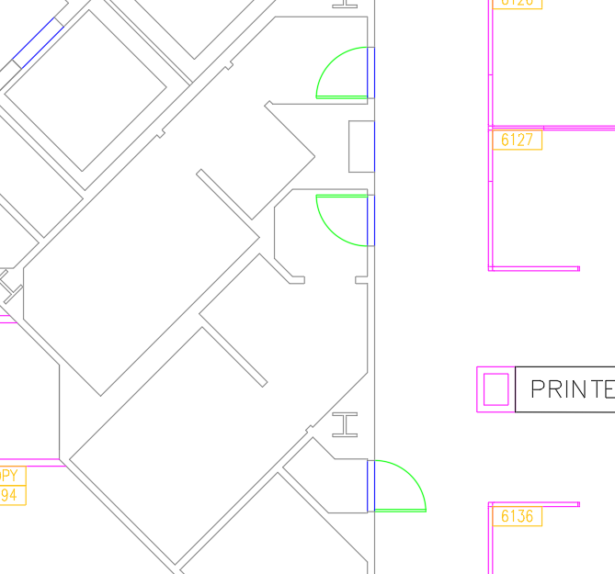

Figure 1 Restroom Area for Hatching

1. Use the **LAYFRZ** command  then select either of the restroom doors to freeze the E-F-Door layer.
2. Use **Layer Properties** to create a new layer  named “Tile”, color 101, and set current.

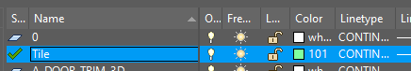

Figure 2 Adding a New Layer for the Tile

1. On the **Home** tab, locate the **Draw** panel, then click the **HATCH** button .
2. Select pattern **ANSI37** and set the scale to **120**.

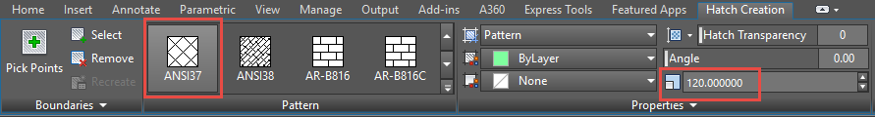

Figure 3 Hatch Settings for Tile

1. Pick a point inside either of the restrooms—but not both!
2. Click **Close Hatch Creation** or press **Enter** (or the Space Bar) to end the command.
3. Repeat steps 5-8 to hatch the other restroom.

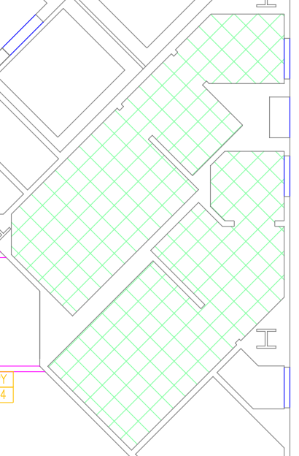

Figure 4 Tile Hatched Restrooms

1. On the **Home** tab, locate the **Annotation** panel, then click the **Text** button.

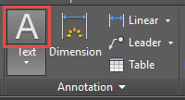

Figure 5 Annotation Panel

1. Draw a box approximately as shown below.

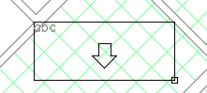

Figure 6 Text Box Boundaries

1. Type “TILE: “ then right-click in the text box and choose **Insert Field** to open the **Field** dialog box.

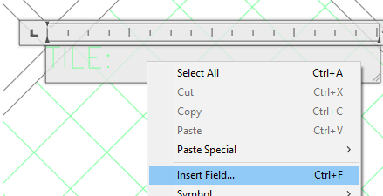

Figure 7 Inserting a Field into an Annotation

1. Under **Field Category**, choose **Objects**.
2. Under **Field Names**, choose **Object.**
3. Next to **Object type**, click the **Select Object** button .

TIP: These annotations could easily go in paperspace as well. When it comes time to select objects, AutoCAD “sees” modelspace entities right through viewports, so as long as it’s visible through a viewport, you can select the target object.

1. In the drawing, select either of the hatch objects.
2. Under **Property**, select **Area**.
3. Under **Format**, select **Architectural**.
4. Under **Precision**, select **0.00**.

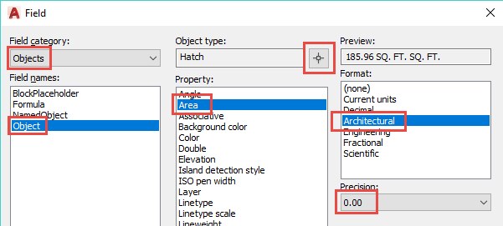

Figure 8 Field Settings for Hatch Object

1. Click **OK**.
2. On the **Text Editor** tab, locate the **Style** panel, then click the **Mask** button.

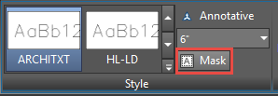

Figure 9 Mask button

1. Check **Use background mask** and **Use drawing background color**, then click **OK**.
2. Click **Close Text Editor** on the ribbon tab.
3. If necessary, adjust the text box size by selecting it and using the grips.
4. Repeat steps 10-24 to add another annotation for the other restroom.

TIP: You can copy the previous annotation, then double-click to edit it. Right-click the field portion and choose Edit Field. You can then select the other restroom hatch, and verify all the settings. Once you’ve closed the text editor, the new annotation should show the other restroom’s tile area.

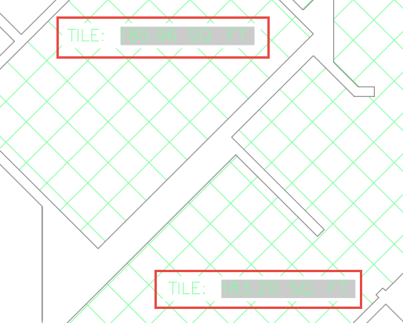

Figure 10 Linked Annotations

This is very useful. And because the fields are linked to the hatch’s area property, any change to the hatch area is automatically reflected in the text annotations! Easy…and accurate.

Exercise #2: Creating a Furniture Report

In this exercise, we’ll take our first look at the Data Extraction tool to find out how much furniture is in the plan.

1. Open the **Floor Plan Sample.dwg** file located in the lab files folder.
2. Zoom in to the upper left area of the drawing.
3. Turn on **Quick Properties** if it’s not on already (the button turns blue).

TIP: The Quick Properties button  is located on the status bar. If you can’t see it, you may need to add it by clicking the Customization button  at the far right end of the status bar, then checking Quick Properties.

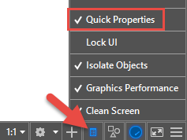

Figure 11 Turning on Quick Properties

1. Select a few of the blocks representing office furniture. You’ll see the names of several blocks such as FNPHONE, CHAIR7, COMPUTER, and DESK3.

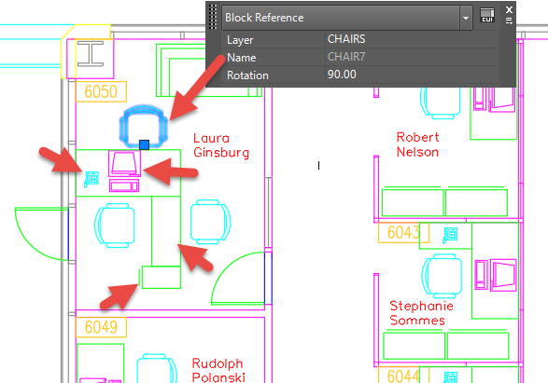

Figure 12 Select blocks to see Quick Properties

You have a decision to make here. Do you want the table (report) to be in model space, or on a layout? I prefer most of my annotations to go on a layout as it’s easier to deal with text height and other considerations.

1. Select the **Layout1** tab[1] in the lower left corner of the drawing area.
2. On the Ribbon, click the **Insert** tab, and locate the **Linking & Extracting** panel.
3. Click the **Extract Data** button.

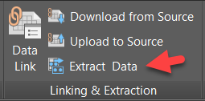

Figure 13 Extract Data Command

1. Select Create a new data extraction, then click Next.

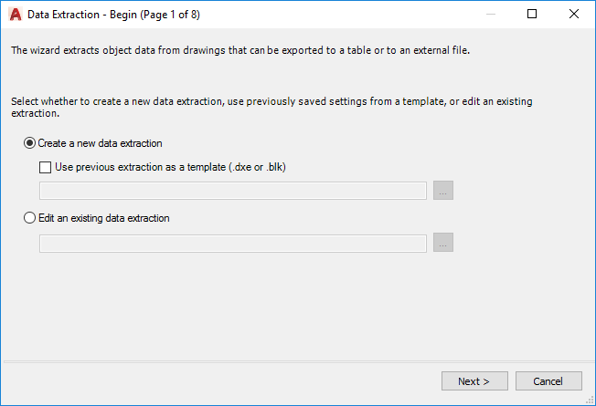

Figure 14 Data Extraction 1: New or Existing DXE?

1. Select a folder and file name for your DXE file, I’ll name mine **FurnitureTakeOff.dxe**.

TIP: When you use the Data Extraction command, you’ll either be creating a new file, or editing an existing one. This DXE file is separate from the drawing (or drawings!) from which the data is to be extracted. It’s an important file that needs to be preserved along with the DWG files, so typically save these files in the same folder as your DWG files.

1. Click **Save** to move to the next step.

By default, AutoCAD includes the current drawing as the Data source, but you can also include other drawings, using the Add Folder or Add Drawings button. We’ll explore these options later in the lab.

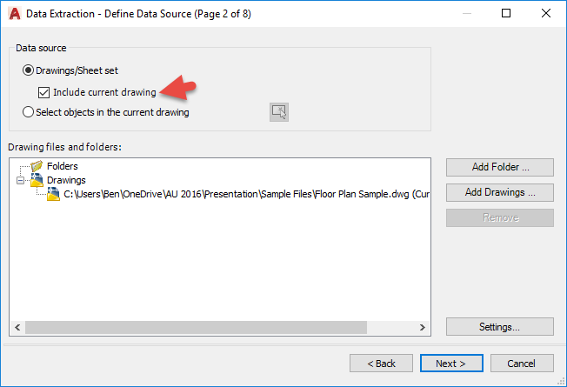

Figure 15 Data Extraction 2: Which Drawings?

1. Verify that **Include current drawing** is checked, then click **Next**.
2. In step 3, right-click the list of objects detected in the drawing and choose **Uncheck all**.
3. Check **Chair7**, **Computer**, **Desk2**, **Desk3**, **FC15X27A**, **FC42X18D** and **FNPHONE**.

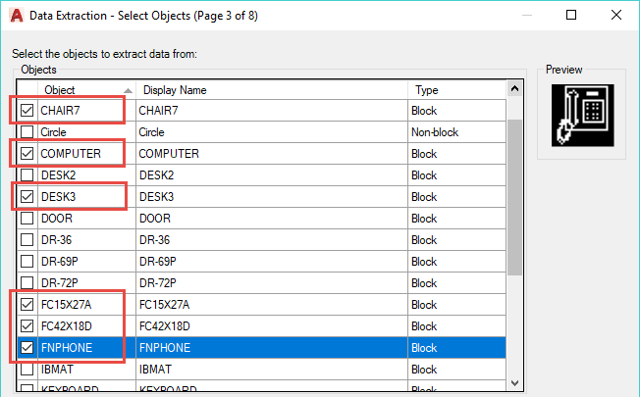

Figure 16 Data Extraction 3: Which Objects?

1. In step 4, uncheck the **Layer** property, then right-click and choose **Invert Selection**. Only the Layer property should be checked.

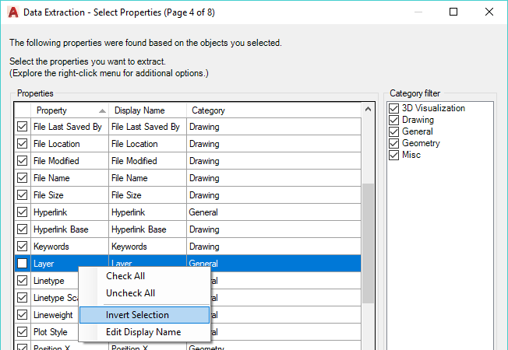

Figure 17 Data Extraction 5: Which Properties?

TIP: The Invert Selection technique can really save you a lot of clicks when you only want a few properties—which is generally the case.

For this report, we don’t really want the layer name in our output, but the wizard forces us to choose something. We’ll hide this in the next step as we’re really after the block names, and the count of items found in the drawing.

1. Click **Next**.

WARNING: This sample drawing includes some non-uniformly scaled blocks, which AutoCAD will warn you about. Just click OK and proceed with the wizard.

1. In step 5, right-click the **Layer** column and choose **Hide column**.

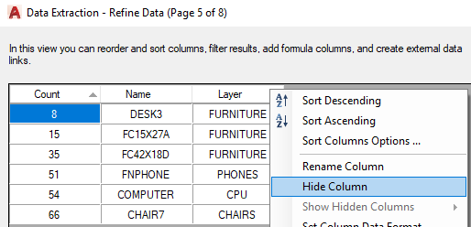

Figure 18 Data Extraction 5: What columns and settings?

1. Drag the **Name** column to the left of the Count column.

TIP: It’s difficult to see but if you look carefully, you’ll see a blue bar appear to the left of the Count column when you’ve dragged the Name column far enough. Release the mouse button when you see the blue bar. I enlarged the screenshot below so you can (hopefully) see it better.

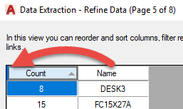

Figure 19 Rearrange columns using drag and drop

1. Click on the **Name** column to sort on that column.
2. Be sure that **Combine identical rows**, **Show count column** and **Show name column** are all checked.

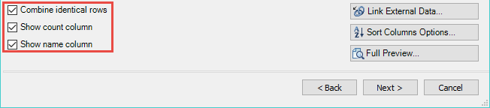

Figure 20 Data Extraction 5 (continued)

1. Click **Next**.
2. In Step 6, check the **Insert data extraction table into drawing** check box.

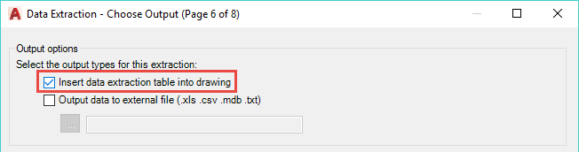

Figure 21 Data Extraction 6: Where to Output to?

1. Click **Next**.
2. In Step 7, enter the title **Furniture Take-Off**.

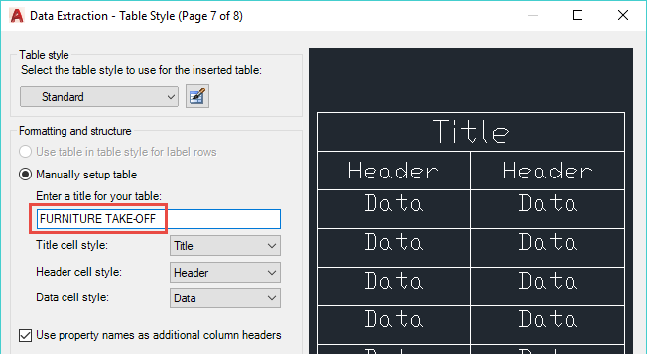

Figure 22 Data Extraction 7: Which Table Style Settings?

1. Click **Next**.
2. Click **Finish**, then pick an insertion point somewhere in the drawing.

TIP: If you get this far and realize, “Oh no! I’m still on the Model tab!” All is not lost. Just hit ESC to cancel inserting the table. Switch to Layout1 and start Extract Data again. Choose the Edit option in step 1, then locate the DXE file which has been created. Click Next all the way through the wizard, as all the settings are preserved. After you click Finish, you can pick the insertion point on the layout tab.

One of the terrific benefits of using data extraction to create tables is that as your design evolves, your tables are easy to update.

1. On the Model tab, copy some of the furniture a few times somewhere else in the drawing.
2. On the Layout1 tab, select the take-off table, right-click and choose **Update Table Data Links**. Notice how the count column updates to reflect your changes.

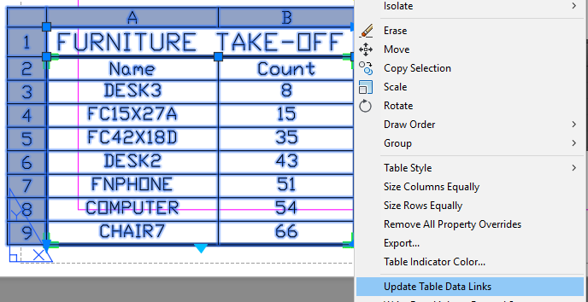

Figure 23 Update Table Data Links

We went quickly through the Data Extraction wizard. Don’t worry, we’ll be doing several more exercises and looking more in-depth at some of the settings. But in a nutshell, steps 2 through 4 of the wizard are about selecting or filtering what data to include in the report. First we identify the drawing or drawings, then we select which object types, then we select which specific properties or attributes.

In step 5, we refine the data by rearranging, hiding or renaming columns, and applying formatting. Step 6 is where we decide where to output to. And step 7 appears when we output to a table, and allows us to choose style settings for the table.

Exercise #3: Extracting Data Across Multiple Drawing Files

Reports often need to include information spread across multiple drawings. For example, suppose you want to create a Sheet Index that identifies the sheet number and title of all sheets (drawings) in your project. Fortunately, Data Extraction handles this quite easily.

NOTE: An index to drawings can be created using Sheet Set Manager, but not everyone uses Sheet Sets. If you already use Sheet Sets and that functionality, think of other ways you can use this technique to create multi-drawing reports. For example, maybe you are designing a multi-story building with each floor in its own drawing. You need to get a restroom fixture count across all floors.

1. In Windows Explorer, open the **\Multiple** folder in your course files. Take a moment to open one or more of the files to familiarize yourself with them.
2. Each drawing in this folder is a different “sheet”—a drawing with a title block. Each drawing references one or more files located in the **\Multiple\Res** folder via xreferences.

For purposes of this exercise, we’re not particularly interested in the xrefs. What we’re after is information in the title blocks located on each of the “sheet” drawings.

1. Open the **T-01** file.
2. Note that a Sheet Index table exists on the drawing in the lower right corner. We’re going to recreate this (as closely as possible) using Data Extraction.
3. Start the **Data Extraction** command (Home > Linking & Extraction).
4. Create a new data extraction file and call it **Index to Drawings.dxe**.
5. In Step 2, uncheck **Include current drawing**, then click the **Add Folder** button.
6. Click the **…** (browse) button next to the **Folder** box.
7. Verify you’re in the **Multiple** folder, then click Open.
8. Check **Automatically include new drawings added in this folder to the data extraction**.
9. Uncheck **Include subfolders**.
10. Check **Utilize wild-card characters to select drawings**.
11. Enter **?*-*.dwg** into the wild-card box.

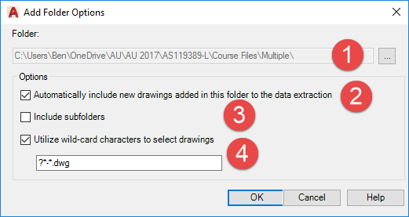

Figure 24 Add Folder Options settings

There’s a lot going on here. Your path will likely vary from the one shown above (1). When you choose the “automatically include new drawings” option (2), AutoCAD will rescan the folder anytime you update the data-linked table and add new drawings in. Think about that: a Sheet Index that can update itself (or schedules, etc.)! We don’t want to include subfolders (3) in this case, but obviously there are situations where you might want this to happen. The “utilize wild-card characters” option (4) gives us some interesting flexibility. We can choose to include drawings only when the file name matches certain patterns. This powerful option warrants a little extra explanation.

Understanding Wild-Card Options

We only have two wild-card characters to work with, but we can do some powerful and interesting filtering with them.

?: Represents any *single* character (alpha, numeric or otherwise) but expects a character to be there.

*: Represents any number of characters (alpha, numeric or otherwise) but doesn’t necessarily expect a character to be there.

Below are a few wild-card patterns and the results when applied to the **\Multiple** folder.

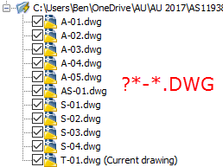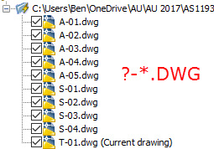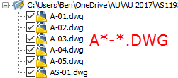

From left to right we see:

* **?*-*.DWG**: A character (A, S, T, etc.) followed by 0 or more characters, followed by **-**, followed by 0 or more characters, followed by **.DWG**. This is the pattern for our numbered “sheet” drawings, but would not pick up files like “Floor plan.dwg” or “Elevation.dwg”.
* **?-*.DWG**: A character (A, S, T, etc.) followed by **-**, followed by 0 or more characters, followed by **.DWG**. Note that the returned list *excludes* AS-01.dwg because of the extra character (S) in between the A and the -.
* **A*-*.DWG**: The letter A, followed by 0 or more characters, followed by **-**, followed by 0 or more characters, followed by **.DWG**. This excludes all the **S-** and **T-** drawings.

1. Click **OK**.

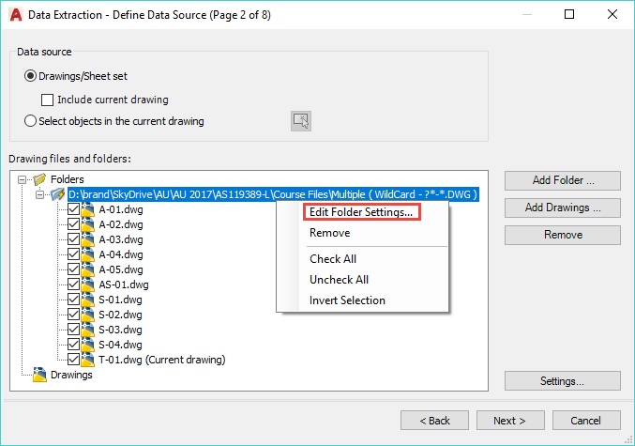

Figure 25 Folder Settings with Wild-Card Filtering

The figure above shows the folder settings and results of using the wild-card option. If you entered the wild-card incorrectly, just right-click the folder and choose **Edit Folder Settings…** to try again.

1. Click **Next**.

WARNING: You’ll get a message about Drawing Unit Mismatch. This won’t be a problem for this exercise, but could be an issue if you were doing an extraction of geometric data. In this case, click **Yes** to continue.

1. Under **Display options**, uncheck **Display all object types** and check **Display blocks with attributes only**. This will trim down the list of objects to choose from considerably.

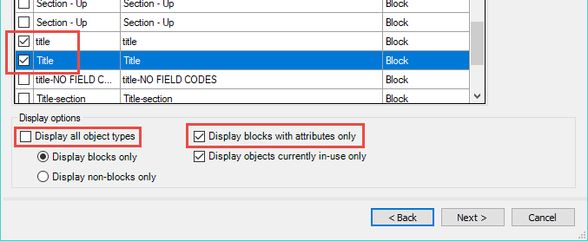

Figure 26 Displaying blocks with attributes only

1. Scroll down until you find the **title** and **Title** blocks, and unselect those two.

NOTE: The sample drawings use the same block but in at least one drawing, the block is named “title” and in the others it is named “Title”, Data Extraction thinks these are two different blocks. No matter, we’ll just include both.

1. Right-click and choose **Invert Selection**.
2. Click **Next**.
3. In the **Category filter**, use any technique you want so that **Attribute** is the only checked option.
4. In the **Properties** list, use any technique you want so that **Sheet_Content1**, **Sheet_Content2** and **X** are the only checked properties.

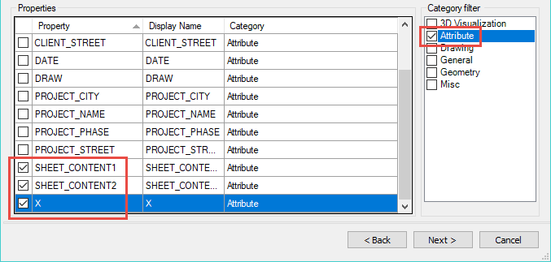

Figure 27 Selecting Title Block Attributes

1. Click **Next**.
2. Uncheck **Show count column**, **Show name column**, and **Combine identical rows**.
3. Move column **X** to be the left-most column.
4. Right-click column **X** and choose **Rename column**.
5. Change the name to **Sheet Number**.
6. Repeat steps 24-25 to rename column **Sheet_Content1** to **Title Line 1**.
7. Repeat steps 24-25 to rename column **Sheet_Content2** to **Title Line 2**.
8. Click the **Sheet Number** column to sort on that column.

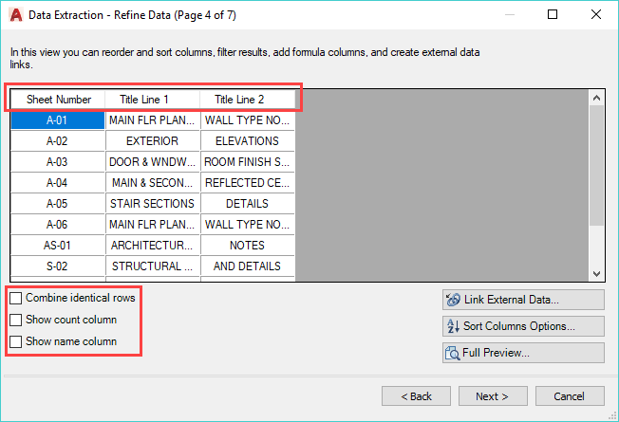

Figure 28 Rearranging and Renaming Columns

1. Click **Next**.
2. Check **Insert data extraction table into drawing**, then click **Next**.
3. Change the **Table style** to **Sheet Index**.
4. Enter the title **SHEET INDEX** in the box provided.

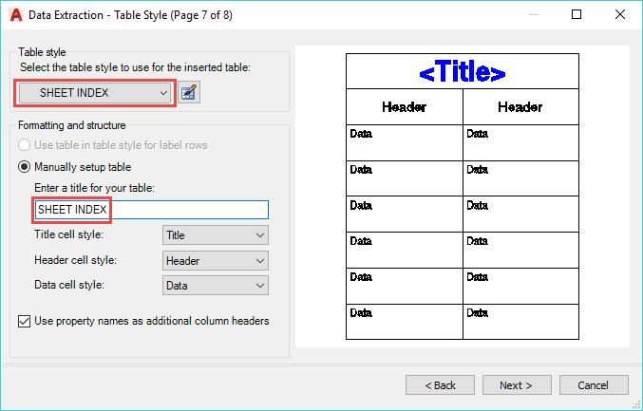

Figure 29 Table style settings

1. Click **Finish**, then select an insertion point in your drawing to place the table.

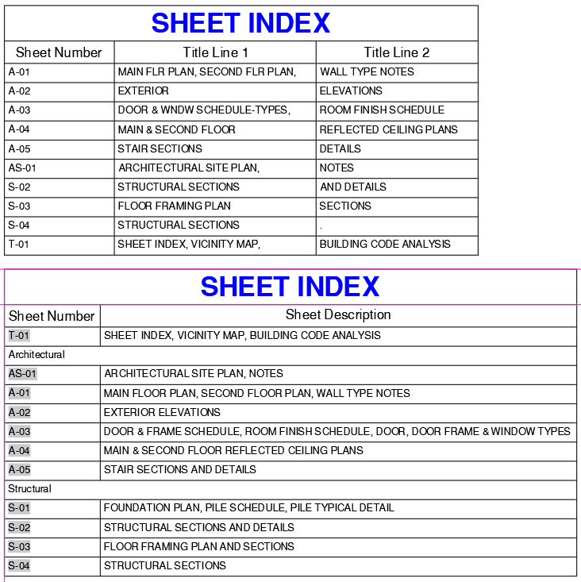

Figure 30 Sheet Index via Data Extraction (top)

As much as I would like to have the table match exactly with the hand-generated table, there are some limitations to what we can do.

* We can’t “group” results so that all the A- drawings are under an “Architectural” row, and S- drawings are under a “Structural” row.
* We can’t concatenate the text in one column with the text in another (Title Line 1 + Title Line 2), the way we could in Excel. #Sad
* There’s no way to float the T-01 drawing to the top.

Despite these limitations, you *do* get a sheet index that can be updated whenever new drawings are added to the folder.

Bonus Exercise #1

If you have time, try saving one of the A- drawing as **A-06.dwg**, then open the new drawing and change the attribute in the lower right corner to “A-06”. Also copy one of the drawings and save it as **Elevations.dwg**. Then update your Sheet Index table by right-clicking and choosing **Update Table Data Links**. Which drawings appeared on the index? Which didn’t , and why?

Bonus Exercise #2

Although we can’t “group” the different drawings by type in the table, there is a way we can basically get the same result. If you have time, see if you can figure it out. I will give you a hint in the form of a screenshot.

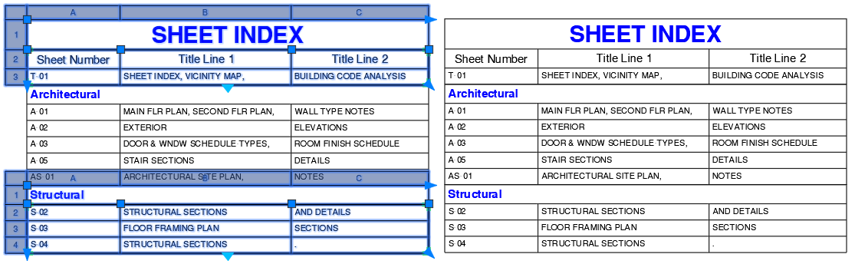

Figure 31 Hint for creating "grouped" tables

You’ll have to experiment a bit—or see if I’ve succeeded in stumping my lab assistants ;).

You can close the **T-01.dwg** file.

Exercise #4A: Customizing data extraction using sorting, filtering, formulas, and totals

When we use data extraction, we frequently need to do additional things with that data, such as sorting or filtering the data, and adding formulas and totals.

1. Open the Landscaping.dwg file. This sample has a site plan from which we want to get the square footage of various landscaping materials, represented by hatch objects.
2. Use the **Data Extraction** command to start a new dxe file, and name it the same as the sample drawing.
3. In step 3, select **Hatch** as the type of objects to extract data from.
4. In step 4, select **Area** and **Layer** as the properties to extract.

Step 5 of the wizard we’ve seen before, but this time we want to have our table display the summed total of the area of “like” hatch objects (“like” being hatches on the same layer should all be summed together). We also need to convert the area from square inches to square feet, and format the output appropriately.

1. In step 5, uncheck **Show count** and **Show name**.
2. Rearrange the columns so **Layer** is first.
3. Click on the **Layer** column header once to sort in ascending order.
4. Verify that **Combine identical rows** is checked.
5. Right-click in the **Area** column and choose **Combine record mode > Sum values**.

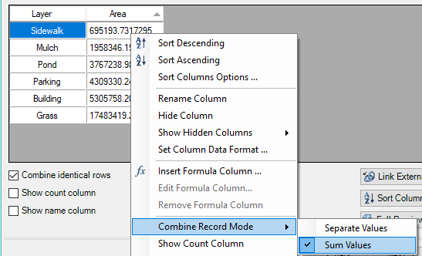

Figure 32 Summing values in a column

1. Right-click in the **Area** column and choose **Set column data format**.
2. Select **Decimal** and set the precision to **0**.
3. Click on **Additional Format**, then set the **Conversion factor** to **0.0069**, **Suffix** to “ **s.f.**”, and set the **Thousands** separator to **‘,’ (Comma)**.

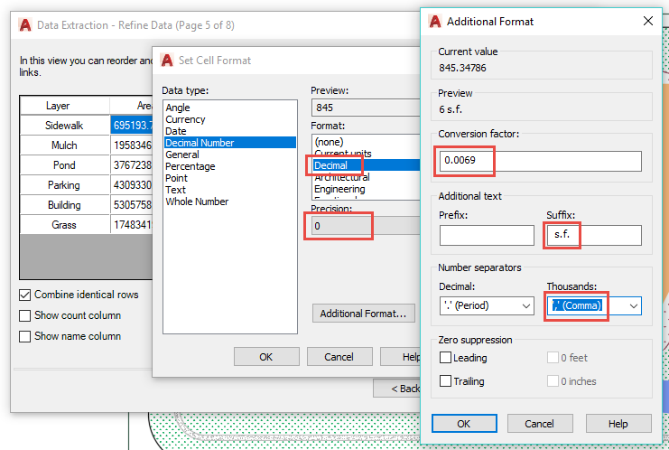

Figure 33 Converting area to square feet

1. Click OK twice to return to the Data Extraction wizard.

We’re pretty close, but what if we wanted to exclude hatches on certain layers? For example, maybe we don’t want to report the Building footprint. We can accomplish this using Filter Options.

1. Right-click the **Layer** column and choose **Filter Options**.
2. Uncheck **Building** and click OK.

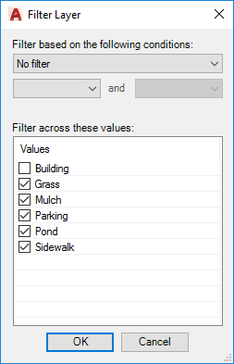

Figure 34 Filtering a column

1. Rename the Layer column as **Material**.

To see a total of the “landscaped” areas, we need to add a footer row with a formula to sum the **Area** column values.

1. Right-click the **Area** column and choose **Insert totals footer > Sum**.

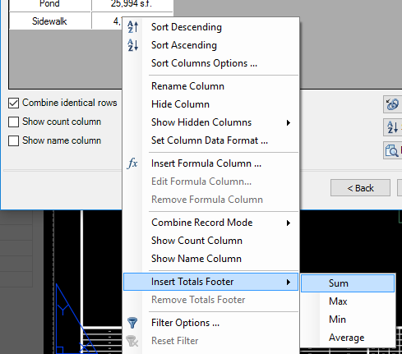

Figure 35 Inserting a total footer

1. Click **Next**, and insert a data extraction table with the title “LANDSCAPING MATERIALS” into the drawing.

Exercise #4B: Linking Excel spreadsheets with AutoCAD data

A common workflow in many offices is to enter tabular data into an Excel spreadsheet. Frequently this data needs to be displayed in CAD drawings as well. For that, we can link a table in AutoCAD with a “Data Link” to an Excel table. That’s good for getting information *into* our drawing, but this lab is focused on leveraging data already in our drawings. It turns out that we can do a hybrid approach, combining data from our drawings, with data in a spreadsheet, and outputting the combined data to a table in our drawing.

In exercise 4A, we created a landscaping materials table using hatch areas from our drawing. Let’s link this data to cost data coming from an Excel spreadsheet to calculate our total estimated costs for the project.

In your sample files folder is an Excel file named Landscaping Costs.xlsx. Your task is to add a **Cost** column to the Landscaping Materials table you created, but data-linked from Excel. Once you have that linked, you’ll insert a formula column that multiplies the Area * Cost to provide the Total Cost for each material.

TIP: In order to calculate the Area column, we have to make the column value numeric. So you’ll need to edit the Area column and remove the suffix we added previously. You can rename the column to **Area (s.f.)** so the point gets across.

1. Select any cell in the LANDSCAPING MATERIALS table you created in Exercise 4A, the choose **Data Extraction > Edit Data Extraction Settings**.
2. Click **Next** until you arrive at Page 4 of 7 (where you see the preview of the data).
3. Right-click the Area column and rename it **Area (s.f.)**.
4. Right-click the **Area (s.f.)** column, and choose **Set column data format**.
5. Click **Additional Format**.
6. Remove the **Suffix** we input earlier, then click OK twice.
7. Click **Link External Data**.

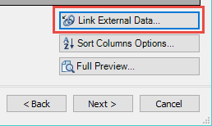

Figure 36 Linking External Data

1. Click **Launch External Data Manager** .
2. In Data Link Manager, click **Create a new Excel Data Link**.
3. Enter **Landscaping costs** as the name of the data link.

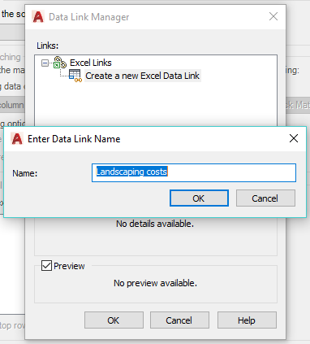

Figure 37 Creating a Data Link

1. Click OK.
2. Click the **Browse** button .
3. In the course files folder, select **Landscaping Costs.xlsx** and click Open.
4. Under Link Options, verify that **Sheet1** is selected, then click OK.

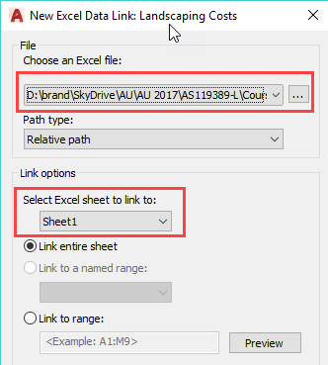

Figure 38 Excel Data Link

1. Under Excel Links, verify that **Landscaping Costs** is selected, then click OK.
2. Under **Drawing data column**, select **Material**.
3. Under **External data column**, select **ID**.
4. Click **Check Match**.

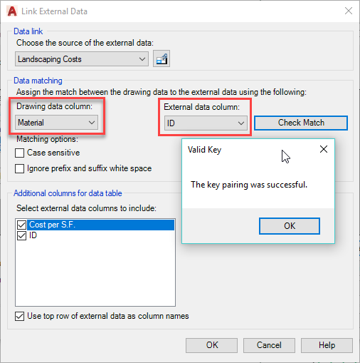

Figure 39 Identifying Keys

Identifying these “keys” is crucial for getting the external data to link up. Your Excel file must contain *unique* values in the external data column--“ID” in the example used here. AutoCAD matches this up with a value you identify as the drawing data column--“MATERIAL” in the example shown here, which is the renamed column representing the layer names in the drawing.

1. Click OK.
2. Verify the **Cost per S.F.** box is checked, and uncheck the **ID** column.
3. Click OK.

Back in page 4, you’ll see a preview of the newly added Cost per s.f. data. Now let’s add a formula to calculate the total cost.

1. Right-click the Cost per S.F. column and choose **Insert Formula Column**.
2. Enter **Total Cost** as the Column name.
3. Double-click **Area (s.f.)** then click the **Multiply** button, then double-click **Cost per S.F.** then type in the box: **/ 144**.

EEK! Major error here that was pointed out to me in class. The underlying Area value is in the drawing’s units (inches), not the *reported* value of the Area (s.f.) column which has a calculation applied via the Additional Format we applied earlier. Here, we need to divide by 144 to get a valid result.

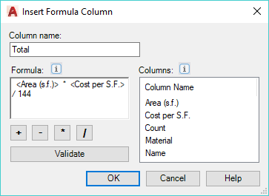

Figure 40 Insert a Formula Column

1. Click OK.
2. Insert a totals footer to sum the Total Cost column.
3. Right-click the Total Cost column and choose **Set column data format**.
4. Set the Data type to **Currency**, the Precision to **0**, then click OK.

NOTE: As I was preparing this exercise, the wizard threw an error if I set the format to currency *before* adding the totals footer to the Total Cost column. It may have been a fluke, but adding the totals footer first, then applying the format seemed to work better for me.

1. Click Next until you get through the wizard, then click **Finish**.

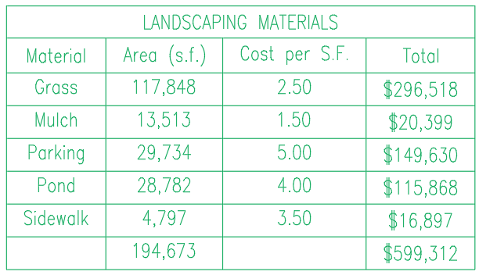

Figure 41 Completed table with linked cost and calculated totals

Exercise #5: More Linking Excel spreadsheets with AutoCAD data

If we have time, I wanted to give you one more chance to practice linking Excel spreadsheets with AutoCAD data. In this exercise, we’ll use an Excel file listing standard architectural keynotes and descriptions, and an AutoCAD drawing containing keynote “bubbles” identifying various materials. We’ll then create a table containing a KEYNOTES schedule that is specific to the drawing—only the keynotes actually called out on the drawing appear on the schedule.

1. In the course files, open the \Keynotes\CSI.xlsxfile in Microsoft Excel. This file contains a few items from the CSI MasterFormat® catalog.
2. Note the **ID** column contains *unique* entries. These can be numeric or alphanumeric, they just have to be unique. The **Description** column contains a material description corresponding to the key with which it is associated.

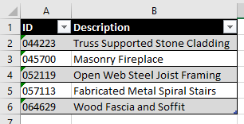

Figure 42 Excel file containing CSI keynotes

1. Close the **CSI.xlsx** file.
2. Open the **Keynote Sample.dwg** file in that same folder. The drawing contains a section through part of a wall, with a few items called out by CSI number.

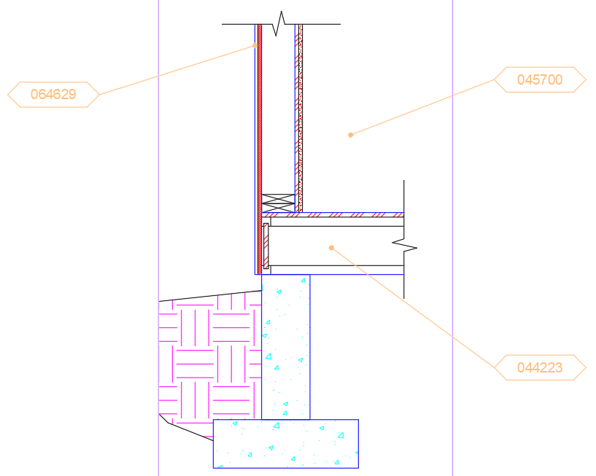

Figure 43 Keynote Sample drawing

The point of this exercise is to build a sheet-specific Keynotes table, showing the description (from the Excel file) corresponding to the callouts actually used in the drawing.

1. Start the Data Extraction wizard, and create a new data extraction file named **Keynotes.dxe**.
2. Select the **Keynote** block in step 3.
3. Select the **Keynote** attribute in step 4.
4. In step 5, do the following:
5. Uncheck **Show count column** and **Show name column**.
6. Click the **Link External Data** button.



Figure 44 Linking External Data

1. Click **Launch Data Link Manager **.
2. Click **Create a new Excel Data Link** and enter the name **CSI**.
3. Browse to the sample files directory and select CSI.xlsx**.**
4. Verify that **Sheet1** is selected and **Link entire sheet** then click OK twice.

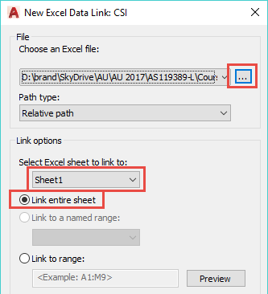

Figure 45 Excel Data Link

1. Select **KEYNOTE** in the **Drawing data column** and **ID** in the **External data column**, then click **Check Match**.

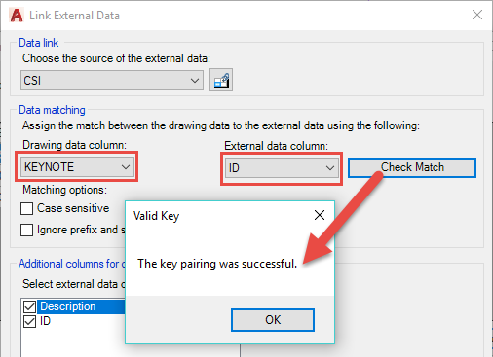

Figure 46 Data matching

Identifying these “keys” is crucial for getting the external data to link up. Your Excel file must contain *unique* values in the external data column (“ID” in the example used here). AutoCAD matches this up with the value you identify as the drawing data column (“KEYNOTE” in the example shown here).

1. You can select any additional columns from your Excel file to add to any data you’re extracting from AutoCAD itself.
2. Click **OK** to return to step 5.

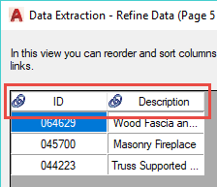

Figure 47 Linked columns

1. Rename the ID column to **Key** and sort on that column.
2. In step 6, select **Insert data extraction table**.
3. In step 7, enter **KEYNOTES** as the title for your table.
4. Finish the wizard and insert your table.

You can close the Keynote Sample.dwg when you are finished.

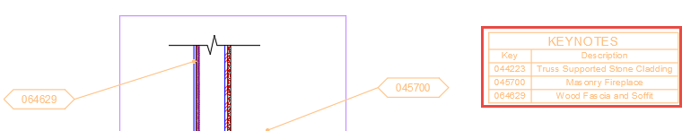

Figure 48 Finished data-linked table

Bonus Exercise #3

Do we still have more time? Great! Let’s build a room schedule, then look at what needs to happen when we add an attribute to the block upon which our data extraction depends.

1. Open the **Floor Plan Sample.dwg** we used earlier in the lab.
2. Create a layer named Schedules and make it the active layer.
3. On the ribbon, go to **Insert > Linking & Extraction**, then click **Extract Data**.
4. Create a new data extraction named **RoomSchedule.dxe**.
5. In step 3, select only the **RMNUM** block.
6. In step 4, select only the **NUMBER** attribute.
7. In step 5, do the following:
8. Uncheck the **Show count** and **Show name** column boxes.
9. Click on the NUMBER column to apply sorting (6001 should be at the top).
10. Insert the data extraction table into the drawing, with a table title of **ROOM SCHEDULE**.

If you started the data extraction command in modelspace, the table will be quite small. We’ll deal with that in a few minutes. While functional, our room schedule leaves a bit to be desired. First, it’s a very lengthy table that will be hard to fit on paper when we print this out. Let’s take advantage of table breaking to help us out.

1. Select the table.
2. Using the grip at the very bottom middle of the table, drag up until you’ve created three roughly equal columns.

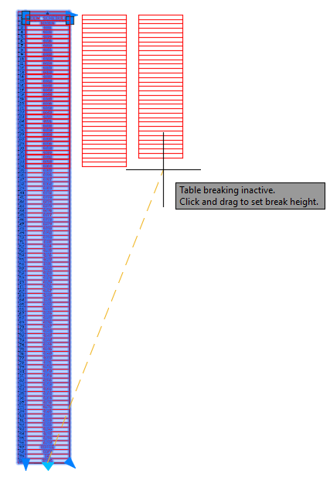

Figure 49 Resizing the table

1. Select the table, right-click and choose **Properties**, then set the **Repeat top labels** property to **Yes**.

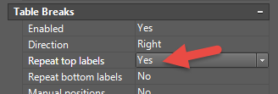

Figure 50 Repeating Column Labels

The second problem with our Room Schedule is that there just isn’t very much information available. Seems like it would be more useful if we could see who is assigned to each room. However, that attribute was not available on the RMNUM block. Let’s update the block definition to carry more useful data.

1. Zoom out so you can see the floor plan, then locate one of the RMNUM blocks.
2. Select the block, then right-click and choose **Block Editor**.

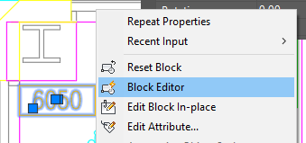

Figure 51 Editing a block definition

1. Copy the NUMBER attribute and paste a copy below the rectangle.
2. Double-click the new attribute and set the **Tag** to “Occupant”, **Prompt** to “Name of Occupant” and **Default** to “-”, then click OK.
3. Select the attribute, right-click and choose **Properties**.
4. Set the **Invisible** property to **Yes**.

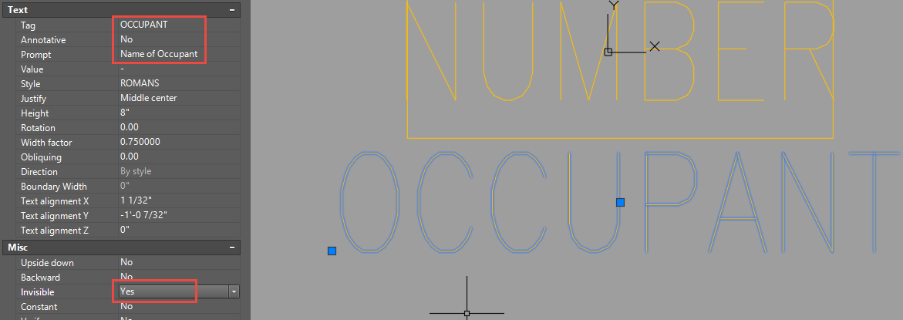

Figure 52 Adding an attribute to a block definition

Of course, it may be useful to have the Occupant attribute displayed on the drawing. This would make having the “extra” text version on the drawing obsolete, and the approach I would likely use myself. Here though, I want to demonstrate that attributes don’t have to be visible on the drawing to be extractable.

1. Click the **Close Block Editor** button then choose **Save changes**.
2. Double-click one of the RMNUM blocks to edit the attributes.

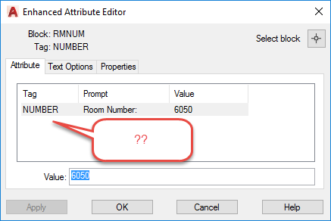

Figure 53 Where's the new attribute?

Wait. Shouldn’t there be two attributes now? Whenever you add or remove attributes from a block which has already been inserted into the drawing, you need to use the ATTSYNC command to synchronize any existing block references with the attributes in the block’s definition.

1. Click Cancel to exit the Attribute Editor, then go to **Insert > Block Definition**, then click the **Block Definition** drop-down, then choose **Synchronize** (or type ATTSYNC).

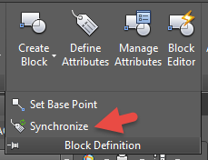

Figure 54 Synchronize after adding new attributes to existing blocks!

1. Choose **Select**, then select a RMNUM block, then select **Yes**.
2. Double-click one of the RMNUM blocks again and you should see the new attribute available for editing.

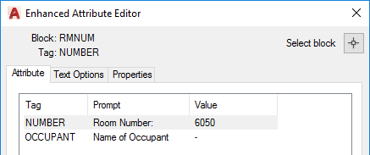

Figure 55 New Attribute appears after Synchronize

Take a few minutes and add the occupant name (red text in the room) to the Occupant attribute of several RMNUM blocks. You don’t need to do them all, but do several so we can see them on the Room Schedule table.

We now need to update our Data Extraction (dxe) file to include the new attribute we just added.

1. Select the ROOM SCHEDULE table, then select one of the cells within the table.

For some reason, this allows the Data Extraction submenu to appear when we right-click, whereas it does NOT appear if the whole table is selected.

1. Right-click and choose **Data Extraction > Edit Data Extraction Settings…**.

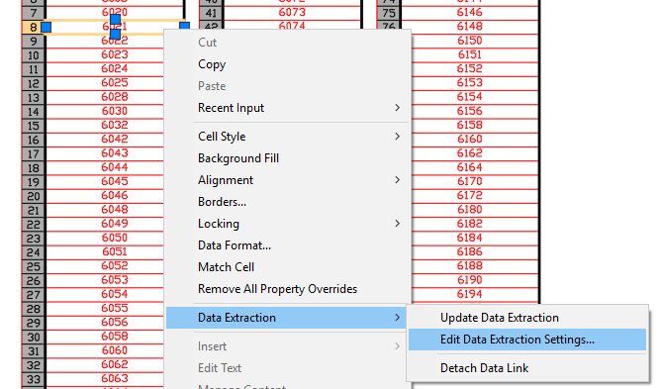

Figure 56 Edit Data Extraction settings

1. Click **Next** until you get to step 3.
2. Check the **Number** and **Occupant** attributes, then click **Next**.
3. Click the **Full Preview** button to see a preview of your table. Close the preview when you’re finished.

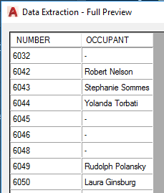

Figure 57 Data Extraction Preview

1. Right-click the **NUMBER** column and choose **Rename Column**, then change the column name to **ROOM #**.

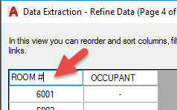

Figure 58 Changing Column Names

1. Click **Next** through the wizard, then click **Finish**.
2. Adjust the columns again so there are only three, as before.
3. Adjust the column widths by selecting the table, then clicking and dragging the column width grip, as shown below.

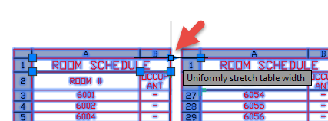

Figure 59 Uniformly resize column widths

Unfortunately, the row heights don’t automatically adjust.

1. To resize the row heights, select the rows that are too tall, then right-click and choose **Properties**.
2. Set the **Cell height** to something very small (like 0.1”). AutoCAD will set the height as small as possible while still fitting the text + the specified cell margin. You may need to do this a few times to “reset” any affected rows.

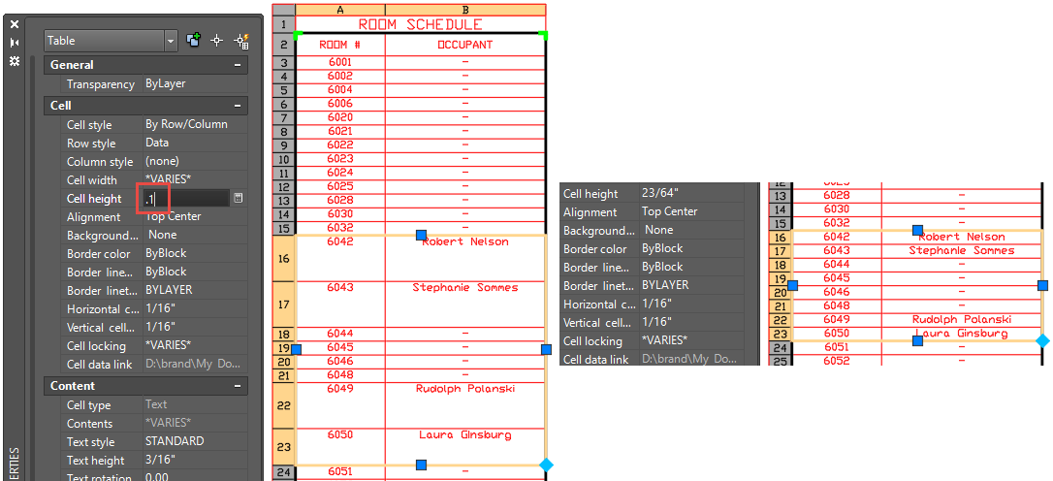

Figure 60 Tricking AutoCAD into an acceptable row height: Before (Left), After (Right)

Summary

We’ve covered a lot of ground in this lab. You’ve learned:

* How to use the Data Extraction command to build updateable reports for things like material take-offs;
* How to extract data from multiple drawings to generate Sheet Index reports;
* How to link AutoCAD and Excel data into a combined report,
* How to link text fields to geometric data that updates when your drawing does.

I hope your mental gears are spinning, thinking of ways you can go home and apply your new mastery of the Data Extract command to tasks in your industry.

If you have any questions about this course, please feel free to contact me at **ben@leadensky.com**.

1. If the Model and Layout tabs are not displayed, use the **OPTIONS command > Display > Layout Elements**, and check **Display Layout and Model tabs**.