##### 融创示范区系统

##### BPM接口

##### 测试报告

**2019年11月**

**修订历史**

| **版本号** | **日期** | **作者** | **修订原因** |
| --- | --- | --- | --- |
| 1.01 | 2019.11.24 | 李梧桐 | 新建 |
|  |  |  |  |
|  |  |  |  |

目 录

1 简介 4

1.1 目的 4

1.2 背景 4

1.3 参考资料 4

1.4 术语与缩写解释 4

2 测试概要 5

2.1 测试接口 5

2.2 测试工具 5

3 测试结果及缺陷分析 5

3.1 测试执行情况与记录 5

3.1.1 测试时间 5

3.2 覆盖分析 6

3.2.1 需求覆盖 6

3.2.2 发起流程接口测试报文 6

3.2.3 ApproveClose接口测试报文 9

3.2.4 SUNAC_556_CreateResult接口测试报文 11

3.2.5 Rework接口测试报文 13

3.3 缺陷的统计与分析 15

3.3.1 缺陷汇总 15

3.3.2 遗留问题 15

4 测试结论与建议 15

4.1 测试结论 15

4.2 改进建议 16

# 简介

## 目的

总结项目过程中发现的BUG情况，以及跟踪BUG修复状况。

## 背景

融创示范区数字工程系统接口测试环境已经测试完成。

## 参考资料

融创BPM-ESB跟业务系统接口文档说明V1.5.docx

集成接口标准化技术实现说明文档-20190731-V2.pdf

## 术语与缩写解释

|  |  |
| --- | --- |
| **术语、缩写** | **解释** |
|  |  |

# 测试概要

## 测试接口

|  |
| --- |
| **测试接口** |
| BPM_SUNAC_557_Audit |
| BPM_SUNAC_556_CreateResult |
| BPM_SUNAC_558_Rework |
| BPM_SUNAC_559_ApproveClose |

## 测试工具

|  |  |  |  |
| --- | --- | --- | --- |
| **工具** | **用途** | **生长厂商/自产** | **版本** |
| *SoapUI* | 发送SOAP请求 |  | 5.12 |

# 测试结果及缺陷分析

## 测试执行情况与记录

### 测试时间

|  |  |  |  |
| --- | --- | --- | --- |
| **任务** | **开始时间** | **结束时间** | **总计（人/天）** |
| *测试用例* | 11月20日 | 11月22日 | 2 |
| *测试执行* | 11月22日 | 11月22日 | 1 |
| *测试报告* | 11月24日 | 11月24日 | 1 |
| **合计** |  |  | 4 |

## 覆盖分析

### 需求覆盖

|  |  |  |  |
| --- | --- | --- | --- |
| **需求（或编号）** | **测试类型** | **是否通过** | **备注** |
| 流程发起成功，向业务系统提交创建结果 | *测试工具* | **[Y]** |  |
| 流程审批(通过)，审批记录知会到业务系统 | *测试工具* | **[Y]** |  |
| 流程审批(退回、发起人取消） | *测试工具* | **[Y]** |  |
| 流程审批结束(通过、拒绝、作废) | *测试工具* | **[Y]** |  |

### 发起流程接口测试报文

请求报文

{

"REQ_BASEINFO": {

"REQ_TRACE_ID": "1dc16113261f45ddb2261bc7ff1e162f",

"REQ_SEND_TIME": "20191122202320",

"REQ_SRC_SYS": "BS-SFQ-D",

"REQ_TAR_SYS": "BS-BPM-D",

"REQ_SERVER_NAME": "SFQ_SUNAC_551_WriteSAPXmlToBPM",

"REQ_SYN_FLAG": "1",

"REQ_BSN_ID": null,

"REQ_RETRY_TIMES": "1",

"REQ_REPEAT_FLAG": "1",

"REQ_REPEAT_CYCLE": null,

"BIZTRANSACTIONID": "SFQ_SUNAC_551_20191122202320488",

"COUNT": "1"

},

"MESSAGE": [{

"BSID": "SUNAC_SFQ",

"BTID": "SUNAC_CREATE_PLAN",

"BOID": "1197068200995454976",

"BSXML": {

"DATA": {

"FSubject": "关于融创示范区上海测试项目dfasdfasdf的计划创建审批",

"projectname": "上海测试项目",

"batchname": "dfasdfasdf",

"plandetail": {

"item": [{

"planid": "1197068200995454976",

"plannodename": "集团节点1",

"profession": null,

"planstarttime": "2019/10/1 0:00:00",

"planendtime": "2019/10/10 0:00:00",

"mainplanendtime": null,

"responsibledepartment": null,

"responsibleperson": null

}, {

"planid": "1197068200995454976",

"plannodename": "区域节点11",

"profession": null,

"planstarttime": "2019/10/1 0:00:00",

"planendtime": "2019/10/10 0:00:00",

"mainplanendtime": null,

"responsibledepartment": null,

"responsibleperson": null

}, {

"planid": "1197068200995454976",

"plannodename": "区域节点2",

"profession": null,

"planstarttime": "2019/10/1 0:00:00",

"planendtime": "2019/10/10 0:00:00",

"mainplanendtime": null,

"responsibledepartment": null,

"responsibleperson": null

}, {

"planid": "1197068200995454976",

"plannodename": "区域节点5",

"profession": null,

"planstarttime": "2019/10/1 0:00:00",

"planendtime": "2019/10/10 0:00:00",

"mainplanendtime": null,

"responsibledepartment": null,

"responsibleperson": null

}, {

"planid": "1197068200995454976",

"plannodename": "区域节点3",

"profession": null,

"planstarttime": "2019/10/1 0:00:00",

"planendtime": "2019/10/10 0:00:00",

"mainplanendtime": null,

"responsibledepartment": null,

"responsibleperson": null

}, {

"planid": "1197068200995454976",

"plannodename": "集团节点2",

"profession": null,

"planstarttime": "2019/10/1 0:00:00",

"planendtime": "2019/10/10 0:00:00",

"mainplanendtime": null,

"responsibledepartment": null,

"responsibleperson": null

}]

},

"ATTACHMENTS1": {

"ITEM": {

"FILENUMBER": "1",

"FILENAME": "a64a1c452828455d9eeea850057c9732上海测试项目dfasdfasdf计划创建流程附件.xlsx",

"DESCRIPTION": "计划创建节点详情Excel表格",

"FILESIZE": "4KB",

"URL": "http://demonstration.ricent.com/api/v2/files/a64a1c452828455d9eeea850057c9732/content"

}

}

}

}

"procInstID": "0",

"userid": "yej18"

}]

}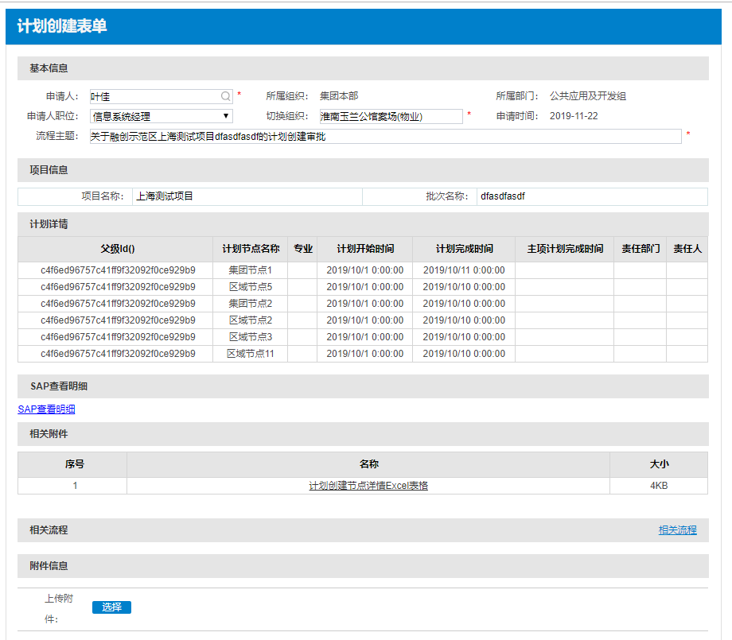

**返回报文：**

"E_RESPONSE": {

"RSP_BASEINFO": {

"RSP_TRACE_ID": "6140f6d4-8c1f-4af9-89fe-b1017e6e4053",

"RSP_REQ_TRACEID": "2620cf44bb044d43be6fadfe1ca5511b",

"RSP_SEND_TIME": "20191122082722",

"RSP_SRC_SYS": "BS-SFQ-D",

"RSP_TAR_SYS": "BS-BPM-D",

"RSP_SERVER_NAME": "SFQ_SUNAC_551_WriteSAPXmlToBPM",

"RSP_BSN_ID": "c4f6ed96757c41ff9f32092f0ce929b9",

"RSP_RETRY_TIMES": "1",

"RSP_STATUS_CODE": "S000",

"RSP_STATUS_MSG": "成功",

"BIZTRANSACTIONID": "SFQ_SUNAC_551_20191122202723138",

"COUNT": null

},

"MESSAGE": [{

"STATUSCODE": "1",

"STATUSMESSAGE": "成功"

}]

}

}}

### ApproveClose接口测试报文

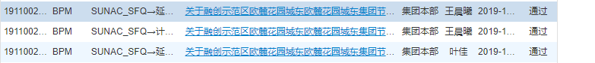

请求报文

ESB请求参数：

{

"REQ_BASEINFO": {

"REQ_TRACE_ID": "aa9f3f9f-171a-4ccc-8a43-b49623d86582",

"REQ_SEND_TIME": "20191122200300",

"REQ_SRC_SYS": "BS-BPM-D",

"REQ_TAR_SYS": "BS-SFQ-D",

"REQ_SERVER_NAME": "BPM_SUNAC_559_ApproveClose_PS",

"REQ_SYN_FLAG": "0",

"REQ_BSN_ID": "1159279651177103360",

"REQ_RETRY_TIMES": "3",

"REQ_REPEAT_FLAG": "0",

"REQ_REPEAT_CYCLE": "0",

"BIZTRANSACTIONID": "BPM_SUNAC_559_ApproveClose_PS20191122200300035",

"COUNT": "1"

},

"MESSAGE": [{

"strBTID": "SUNAC_FINISH_PLAN",

"strBOID": "1159279651177103360",

"iProcInstID": "1911002256",

"eProcessInstanceResult": "1",

"strComment": "流程审批结束",

"dtTime": "2019-11-22 20:01:27"

}]

}

返回报文

{

"E_RESPONSE": {

"RSP_BASEINFO": {

"RSP_TRACE_ID": "15f2edf1177e49a094face051486d235",

"RSP_REQ_TRACEID": "aa9f3f9f-171a-4ccc-8a43-b49623d86582",

"RSP_SEND_TIME": "20191122200300",

"RSP_SRC_SYS": "BS-BPM-D",

"RSP_TAR_SYS": "BS-SFQ-D",

"RSP_SERVER_NAME": "BPM_SUNAC_559_ApproveClose_PS",

"RSP_BSN_ID": "1159279651177103360",

"RSP_RETRY_TIMES": "3",

"RSP_STATUS_CODE": "S000",

"RSP_STATUS_MSG": "流程审批结束回写成功！",

"BIZTRANSACTIONID": "BPM_SUNAC_559_ApproveClose_PS20191122200300035",

"RESULT": "0"

},

"MESSAGE": [{

"success": "1111",

"error": null

}]

}

}审批通过状态：

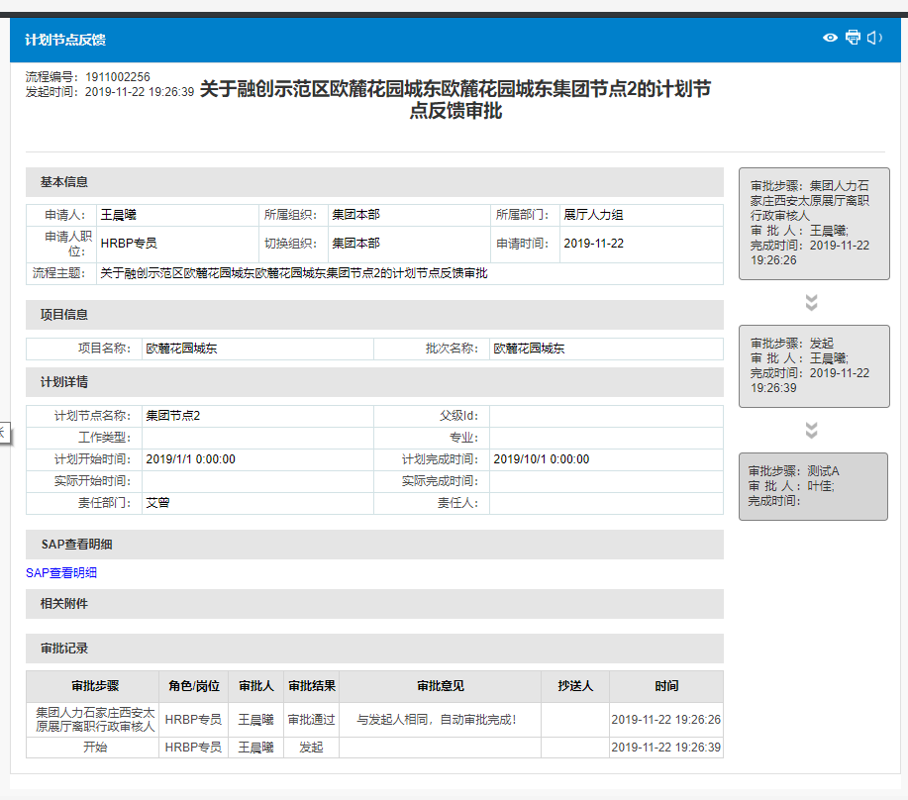

### CreateResult接口测试报文

请求报文：

{

"REQ_BASEINFO": {

"REQ_TRACE_ID": "af3b27dd-1864-4a3e-95d7-f619deccaac8",

"REQ_SEND_TIME": "20191122203238",

"REQ_SRC_SYS": "BS-BPM-D",

"REQ_TAR_SYS": "BS-SFQ-D",

"REQ_SERVER_NAME": "BPM_SUNAC_556_CreateResult_PS",

"REQ_SYN_FLAG": "0",

"REQ_BSN_ID": "c4f6ed96757c41ff9f32092f0ce929b9",

"REQ_RETRY_TIMES": "3",

"REQ_REPEAT_FLAG": "0",

"REQ_REPEAT_CYCLE": "0",

"BIZTRANSACTIONID": "BPM_SUNAC_556_CreateResult_PS20191122203238931",

"COUNT": "1"

},

"MESSAGE": [{

"strBTID": "SUNAC_CREATE_PLAN",

"strBOID": "c4f6ed96757c41ff9f32092f0ce929b9",

"bSuccess": "1",

"iProcInstID": "1911002258",

"procURL": "http://192.168.2.110/Workflow/MTApprovalView.aspx?procInstId=1911002258",

"strMessage": "流程"

}]

}

**返回报文：**

{

"E_RESPONSE": {

"RSP_BASEINFO": {

"RSP_TRACE_ID": "fe0233e07e6b4e47b8db2054449ce965",

"RSP_REQ_TRACEID": "af3b27dd-1864-4a3e-95d7-f619deccaac8",

"RSP_SEND_TIME": "20191122203238",

"RSP_SRC_SYS": "BS-BPM-D",

"RSP_TAR_SYS": "BS-SFQ-D",

"RSP_SERVER_NAME": "BPM_SUNAC_556_CreateResult_PS",

"RSP_BSN_ID": "c4f6ed96757c41ff9f32092f0ce929b9",

"RSP_RETRY_TIMES": "3",

"RSP_STATUS_CODE": "S000",

"RSP_STATUS_MSG": "流程发起回写成功！",

"BIZTRANSACTIONID": "BPM_SUNAC_556_CreateResult_PS20191122203238931",

"RESULT": "0"

},

"MESSAGE": [{

"success": "1111",

"error": null

}]

}

}

审批状态为‘审批中’：



### Rework接口测试报文

请求报文：

{

"REQ_BASEINFO": {

"REQ_TRACE_ID": "daf83313-b36b-4746-b164-c04becc0894b",

"REQ_SEND_TIME": "20191122204449",

"REQ_SRC_SYS": "BS-BPM-D",

"REQ_TAR_SYS": "BS-SFQ-D",

"REQ_SERVER_NAME": "BPM_SUNAC_558_Rework_PS",

"REQ_SYN_FLAG": "0",

"REQ_BSN_ID": "c4f6ed96757c41ff9f32092f0ce929b9",

"REQ_RETRY_TIMES": "3",

"REQ_REPEAT_FLAG": "0",

"REQ_REPEAT_CYCLE": "0",

"BIZTRANSACTIONID": "BPM_SUNAC_558_Rework_PS20191122204449227",

"COUNT": "1"

},

"MESSAGE": [{

"strBTID": "SUNAC_CREATE_PLAN",

"strBOID": "c4f6ed96757c41ff9f32092f0ce929b9",

"iProcInstID": "1911002258",

"strStepName": "测试A",

"strApproverId": "wumn3",

"eAction": "2",

"strComment": "计划创建流程第2次退回修改",

"dtTime": "2019-11-22 20:44:49"

}]

}

返回报文

ERP响应ESB结果： {

{

"REQ_BASEINFO": {

"REQ_TRACE_ID": "daf83313-b36b-4746-b164-c04becc0894b",

"REQ_SEND_TIME": "20191122204449",

"REQ_SRC_SYS": "BS-BPM-D",

"REQ_TAR_SYS": "BS-SFQ-D",

"REQ_SERVER_NAME": "BPM_SUNAC_558_Rework_PS",

"REQ_SYN_FLAG": "0",

"REQ_BSN_ID": "c4f6ed96757c41ff9f32092f0ce929b9",

"REQ_RETRY_TIMES": "3",

"REQ_REPEAT_FLAG": "0",

"REQ_REPEAT_CYCLE": "0",

"BIZTRANSACTIONID": "BPM_SUNAC_558_Rework_PS20191122204449227",

"COUNT": "1"

},

"MESSAGE": [{

"strBTID": "SUNAC_CREATE_PLAN",

"strBOID": "c4f6ed96757c41ff9f32092f0ce929b9",

"iProcInstID": "1911002258",

"strStepName": "测试A",

"strApproverId": "wumn3",

"eAction": "2",

"strComment": "计划创建流程第2次退回修改",

"dtTime": "2019-11-22 20:44:49"

}]

}审批退回，业务系统数据状态为“审批退回”，重新发起流程。

## 缺陷的统计与分析

### 缺陷汇总

* 概括

*【下表按bug 的状态列出bug 的数量】*

|  |  |  |
| --- | --- | --- |
| **Closed Bug 数** | **Pending Bug 数** | **总计** |
| *0* | 0 | 0 |

* 按优先级

|  |  |  |  |  |
| --- | --- | --- | --- | --- |
| **严重** | **一般** | **小缺陷** | **非缺陷** | **总计** |
| 0 | 0 | 0 | 0 | 0 |

### 遗留问题

1. 若需求有变更后，与项目经理沟通之后后续调整；

# 测试结论与建议

## 测试结论

基本功能可正常实现，且无遗留bug。

## 改进建议