融创设计协同办公平台

BPM接口测试报告

**2019年12月**

**修订历史**

| **版本号** | **日期** | **作者** | **修订原因** |
| --- | --- | --- | --- |
| 1.01 | 2019.12.10 | 宋建龙 | 新建 |
|  |  |  |  |
|  |  |  |  |

目 录

1 简介 4

1.1 目的 4

1.2 背景 4

1.3 参考资料 4

1.4 术语与缩写解释 4

2 测试概要 4

2.1 测试接口 4

2.2 测试工具 5

3 测试结果及缺陷分析 5

3.1 测试执行情况与记录 5

3.1.1 测试时间 5

3.2 覆盖分析 5

3.2.1 需求覆盖 6

3.2.2 发起流程接口测试报文 6

3.2.3 审批过程中修改接口测试报文 11

3.2.4 流程作废接口测试报文 12

3.2.5 查询流程实例接口测试报文 13

3.2.6 CreateResult接口测试报文 15

3.2.7 ApproveClose接口测试报文 17

3.2.8 Rework接口测试报文 19

3.2.9 Audit接口测试报文 22

3.3 缺陷的统计与分析 24

3.3.1 缺陷汇总 24

3.3.2 遗留问题 24

4 测试结论与建议 24

4.1 测试结论 24

4.2 改进建议 25

# 简介

## 目的

总结项目过程中发现的BUG情况，以及跟踪BUG修复状况。

## 背景

融创设计协同办公平台接口测试环境已经测试完成。

## 参考资料

融创BPM-ESB跟业务系统接口文档说明V1.5.docx

集成接口标准化技术实现说明文档-20190731-V2.pdf

## 术语与缩写解释

|  |  |
| --- | --- |
| **术语、缩写** | **解释** |
|  |  |

# 测试概要

## 测试接口

|  |
| --- |
| **测试接口** |
| CAD_SUNAC_564_WriteSAPXmlToBPM_PS |
| CAD_SUNAC_566_DoInvalid_PS |
| CAD_SUNAC_567_GetFlowState_PS |
| BPM_SUNAC_569_Audit_PS |
| BPM_SUNAC_568_CreateResult_PS |
| BPM_SUNAC_570_Rework_PS |
| BPM_SUNAC_571_ApproveClose_PS |

## 测试工具

|  |  |  |  |
| --- | --- | --- | --- |
| **工具** | **用途** | **生长厂商/自产** | **版本** |
| *SoapUI* | 发送SOAP请求 |  | 5.12 |

# 测试结果及缺陷分析

## 测试执行情况与记录

### 测试时间

|  |  |  |  |
| --- | --- | --- | --- |
| **任务** | **开始时间** | **结束时间** | **总计（人/天）** |
| *测试用例* | 11月20日 | 11月22日 | 2 |
| *测试执行* | 12月5日 | 11月6日 | 1 |
| *测试报告* | 12月10日 | 12月11日 | 2 |
| **合计** |  |  | 5 |

## 覆盖分析

### 需求覆盖

|  |  |  |  |
| --- | --- | --- | --- |
| **需求（或编号）** | **测试类型** | **是否通过** | **备注** |
| 流程发起 | *测试工具* | **[Y]** |  |
| 流程过程中的修改 | *测试工具* | **[Y]** |  |
| 流程作废 | *测试工具* | **[Y]** |  |
| 流程状态查询 | *测试工具* | **[Y]** |  |
| 流程发起成功，向业务系统提交创建结果 | *测试工具* | **[Y]** |  |
| 流程审批(通过)，审批记录知会到业务系统 | *测试工具* | **[Y]** |  |
| 流程审批(退回、发起人取消） | *测试工具* | **[Y]** |  |
| 流程审批结束(通过、拒绝、作废) | *测试工具* | **[Y]** |  |

### 发起流程接口测试报文

请求报文

<soapenv:Envelope xmlns:soapenv="http://schemas.xmlsoap.org/soap/envelope/" xmlns:cad="http://www.ekingwin.com/esb/CAD_SUNAC_564_WriteSAPXmlToBPM">

<soapenv:Header/>

<soapenv:Body>

<cad:CAD_SUNAC_564_WriteSAPXmlToBPM>

<I_REQUEST>

<REQ_BASEINFO>

<REQ_TRACE_ID>10252C9A4C0C43808770D04E0FB364C7</REQ_TRACE_ID>

<REQ_SEND_TIME>20191125161154</REQ_SEND_TIME>

<REQ_SRC_SYS>BS_CAD_BPM</REQ_SRC_SYS>

<REQ_TAR_SYS>BS_CAD_BPM</REQ_TAR_SYS>

<REQ_SERVER_NAME>CAD_SUNAC_564_WriteSAPXmlToBPM</REQ_SERVER_NAME>

<REQ_SYN_FLAG>0</REQ_SYN_FLAG>

<REQ_BSN_ID>?</REQ_BSN_ID>

<REQ_RETRY_TIMES>?</REQ_RETRY_TIMES>

<REQ_REPEAT_FLAG>?</REQ_REPEAT_FLAG>

<REQ_REPEAT_CYCLE>?</REQ_REPEAT_CYCLE>

<BIZTRANSACTIONID>?</BIZTRANSACTIONID>

<COUNT>?</COUNT>

</REQ_BASEINFO>

<MESSAGE>

<!--Zero or more repetitions:-->

<REQ_ITEM>

<!--Optional:-->

<BSID>vsheji</BSID>

<!--Optional:-->

<BTID>P11</BTID>

<!--Optional:-->

<BOID>78</BOID>

<!--Optional:-->

<BSXML>

<![CDATA[

<?xml version="1.0" encoding="utf-8"?>

<DATA xmlns:xsi="http://www.w3.org/2001/XMLSchema-instance" xmlns:xsd="http://www.w3.org/2001/XMLSchema">

<PageCode>P11</PageCode>

<prototypeID>78</prototypeID>

<region>北京区域,华北区域,上海区域,西南区域,东南区域,广深区域,华中区域,广深区域</region>

<dynamicType>动态模块</dynamicType>

<functionalAreas>厨房,卫生间,卧室,客厅</functionalAreas>

<openType>外开</openType>

<openCount>1扇</openCount>

<isCorner>否</isCorner>

<isMirror>否</isMirror>

<widthRange>1600.00mm- 2000.00mm</widthRange>

<airVolumeFormula>(W1-85)*(H1-85)</airVolumeFormula>

<ATTACHMENTS1>

<ITEM>

<FILENUMBER>1</FILENUMBER>

<FILENAME>WINDOW_WC8_1.DWG</FILENAME>

<DESCRIPTION>WINDOW_WC8_1.DWG</DESCRIPTION>

<FILESIZE>0</FILESIZE>

<URL>http://des.sunac.com.cn/uploader/cad/2019/10/12/8d8e086f-4a97-4ea9-98ec-b95e23a9a87f.dwg</URL>

<FILE_ID_DMS>http://des.sunac.com.cn/uploader/cad/2019/10/12/8d8e086f-4a97-4ea9-98ec-b95e23a9a87f.dwg</FILE_ID_DMS>

</ITEM>

<ITEM>

<FILENUMBER>2</FILENUMBER>

<FILENAME>WINDOW_WC8_1.DWG</FILENAME>

<DESCRIPTION>WINDOW_WC8_1.DWG</DESCRIPTION>

<FILESIZE>0</FILESIZE>

<URL>http://des.sunac.com.cn/uploader/cad/2019/10/12/d9a19b01-7fda-4063-a227-a8d01687e9b2.dwg</URL>

<FILE_ID_DMS>http://des.sunac.com.cn/uploader/cad/2019/10/12/d9a19b01-7fda-4063-a227-a8d01687e9b2.dwg</FILE_ID_DMS>

</ITEM>

<ITEM>

<FILENUMBER>3</FILENUMBER>

<FILENAME>WINDOW_WC8_1_P.DWG</FILENAME>

<DESCRIPTION>WINDOW_WC8_1_P.DWG</DESCRIPTION>

<FILESIZE>0</FILESIZE>

<URL>http://des.sunac.com.cn/uploader/cad/2019/10/12/0ac92a5a-dd62-423e-bda9-1b6895694513.dwg</URL>

<FILE_ID_DMS>http://des.sunac.com.cn/uploader/cad/2019/10/12/0ac92a5a-dd62-423e-bda9-1b6895694513.dwg</FILE_ID_DMS>

</ITEM>

</ATTACHMENTS1>

<SizeParas>

<SizePara>

<code>W1</code>

<valueType>系列</valueType>

<value>650,700</value>

<minValue>0.00</minValue>

<maxValue>0.00</maxValue>

<defaultValue>650.00</defaultValue>

<valueDescription />

</SizePara>

<SizePara>

<code>W2</code>

<valueType>公式</valueType>

<value>W-2a-W1</value>

<minValue>0.00</minValue>

<maxValue>0.00</maxValue>

<defaultValue>0.00</defaultValue>

<valueDescription />

</SizePara>

<SizePara>

<code>W3</code>

<valueType>无</valueType>

<value />

<minValue>0.00</minValue>

<maxValue>0.00</maxValue>

<defaultValue>0.00</defaultValue>

<valueDescription />

</SizePara>

<SizePara>

<code>H1</code>

<valueType>公式</valueType>

<value>H-2a-H2</value>

<minValue>0.00</minValue>

<maxValue>0.00</maxValue>

<defaultValue>0.00</defaultValue>

<valueDescription />

</SizePara>

<SizePara>

<code>H2</code>

<valueType>系列</valueType>

<value>500,400</value>

<minValue>0.00</minValue>

<maxValue>0.00</maxValue>

<defaultValue>400.00</defaultValue>

<valueDescription />

</SizePara>

<SizePara>

<code>H3</code>

<valueType>无</valueType>

<value />

<minValue>0.00</minValue>

<maxValue>0.00</maxValue>

<defaultValue>0.00</defaultValue>

<valueDescription />

</SizePara>

<SizePara>

<code>R</code>

<valueType>无</valueType>

<value />

<minValue>0.00</minValue>

<maxValue>0.00</maxValue>

<defaultValue>0.00</defaultValue>

<valueDescription />

</SizePara>

</SizeParas>

</DATA>

]]>

</BSXML>

<!--Optional:-->

<procInstID>0</procInstID>

<!--Optional:-->

<userid>zhaoy58</userid>

</REQ_ITEM>

</MESSAGE>

</I_REQUEST>

</cad:CAD_SUNAC_564_WriteSAPXmlToBPM>

</soapenv:Body>

</soapenv:Envelope>

**返回报文：**

<soapenv:Envelope xmlns:soapenv="http://schemas.xmlsoap.org/soap/envelope/">

<soap:Body xmlns:xsd="http://www.w3.org/2001/XMLSchema" xmlns:soap="http://schemas.xmlsoap.org/soap/envelope/" xmlns:xsi="http://www.w3.org/2001/XMLSchema-instance">

<wywz:CAD_SUNAC_564_WriteSAPXmlToBPM_RSP xmlns:wywz="http://www.ekingwin.com/esb/CAD_SUNAC_564_WriteSAPXmlToBPM">

<E_RESPONSE>

<RSP_BASEINFO>

<RSP_TRACE_ID>b2e4ef3e-b228-4c73-9d0b-31fd5e2ee903</RSP_TRACE_ID>

<RSP_REQ_TRACEID>10252C9A4C0C43808770D04E0FB364C7</RSP_REQ_TRACEID>

<RSP_SEND_TIME>20191125045222</RSP_SEND_TIME>

<RSP_SRC_SYS>BS_CAD_BPM</RSP_SRC_SYS>

<RSP_TAR_SYS>BS_CAD_BPM</RSP_TAR_SYS>

<RSP_SERVER_NAME>CAD_SUNAC_564_WriteSAPXmlToBPM</RSP_SERVER_NAME>

<RSP_BSN_ID>78</RSP_BSN_ID>

<RSP_RETRY_TIMES>1</RSP_RETRY_TIMES>

<RSP_STATUS_CODE>S000</RSP_STATUS_CODE>

<RSP_STATUS_MSG>成功</RSP_STATUS_MSG>

<BIZTRANSACTIONID>?</BIZTRANSACTIONID>

<RESULT>0</RESULT>

</RSP_BASEINFO>

<MESSAGE>

<RSP_ITEM>

<STATUSCODE>1</STATUSCODE>

<STATUSMESSAGE>成功</STATUSMESSAGE>

</RSP_ITEM>

</MESSAGE>

</E_RESPONSE>

</wywz:CAD_SUNAC_564_WriteSAPXmlToBPM_RSP>

</soap:Body>

</soapenv:Envelope>

发起流程后，业务系统的原型变为待审核状态：

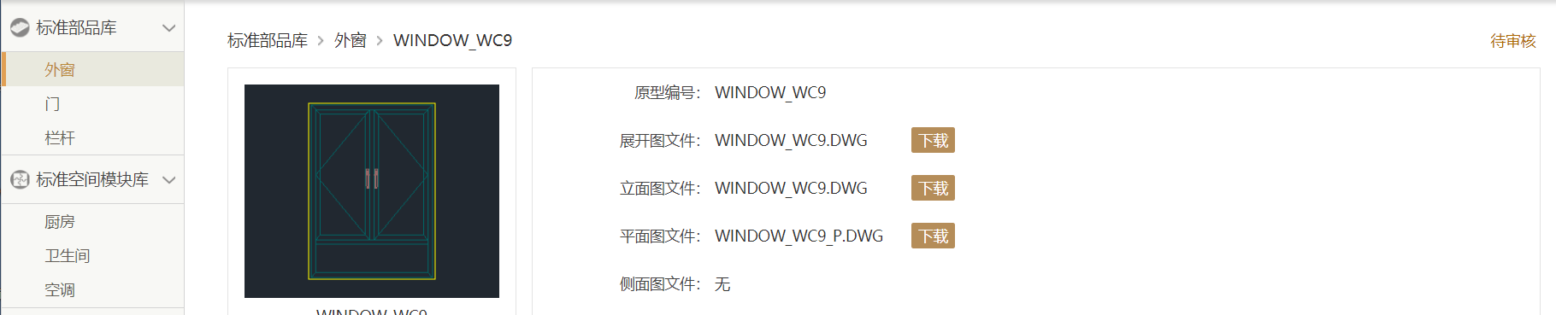

### 审批过程中修改接口测试报文

审批过程中修改接口测试报文的和发起流程同样调用WriteSAPXmlToBPM接口，测试报文和发起流程接口测试报文相同。

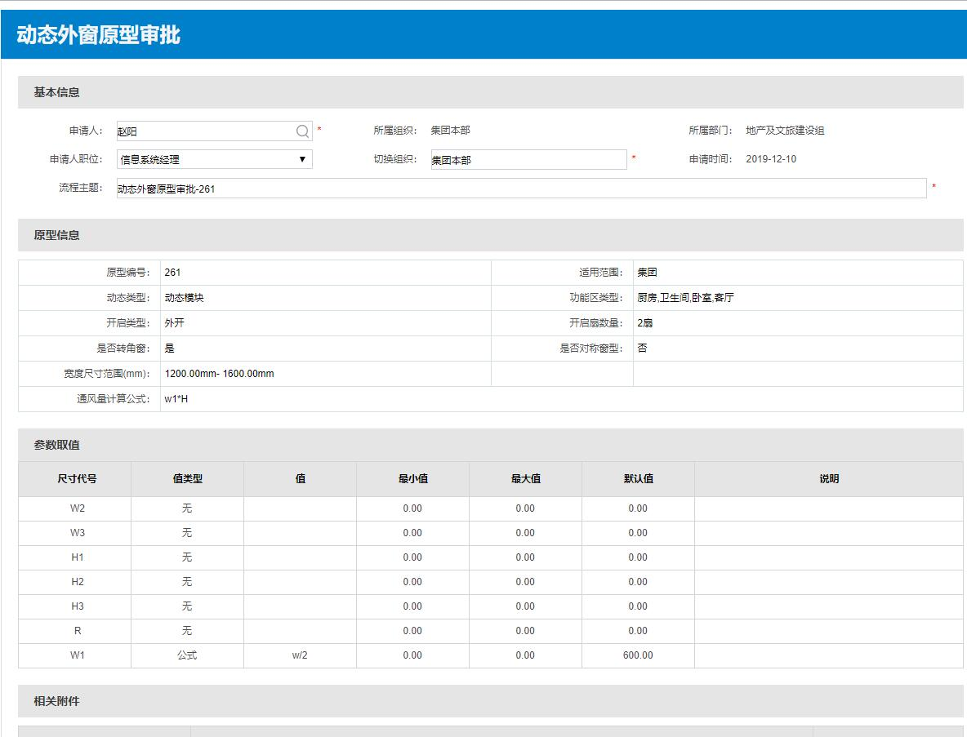

### 流程作废接口测试报文

请求报文

<CAD_SUNAC_566_DoInvalid xmlns="http://www.ekingwin.com/esb/CAD_SUNAC_566_DoInvalid" xmlns:xsd="http://www.w3.org/2001/XMLSchema" xmlns:v1="http://www.ekingwin.com/basi/sb/log/v1"xmlns:soap="http://schemas.xmlsoap.org/soap/envelope/" xmlns:xsi="http://www.w3.org/2001/XMLSchema-instance">

<I_REQUEST xmlns="">

<REQ_BASEINFO>

<REQ_TRACE_ID>52A1E4F7AB6545C395FC0475663334BF</REQ_TRACE_ID>

<REQ_SEND_TIME>20191209181236</REQ_SEND_TIME>

<REQ_SRC_SYS>BS_CAD_BPM</REQ_SRC_SYS>

<REQ_TAR_SYS>BS_CAD_BPM</REQ_TAR_SYS>

<REQ_SERVER_NAME>CAD_SUNAC_566_DoInvalid</REQ_SERVER_NAME>

<REQ_SYN_FLAG>0</REQ_SYN_FLAG>

<BIZTRANSACTIONID>CAD_SUNAC_566_DoInvalid_PS20191209182736</BIZTRANSACTIONID>

</REQ_BASEINFO>

<MESSAGE>

<REQ_ITEM>

<BSID>vsheji</BSID>

<BTID>P11</BTID>

<BOID>256</BOID>

<userid>zhaoy58</userid>

<procInstID>1912000789</procInstID>

<invalidComment>zhaoy58用户撤销</invalidComment>

</REQ_ITEM>

</MESSAGE>

</I_REQUEST>

</CAD_SUNAC_566_DoInvalid>

返回报文

<wywz:CAD_SUNAC_566_DoInvalid_RSP xmlns="" xmlns:wywz="http://www.ekingwin.com/esb/CAD_SUNAC_566_DoInvalid" xmlns:xsd="http://www.w3.org/2001/XMLSchema"xmlns:v1="http://www.ekingwin.com/basi/sb/log/v1" xmlns:soap="http://schemas.xmlsoap.org/soap/envelope/" xmlns:xsi="http://www.w3.org/2001/XMLSchema-instance">

<E_RESPONSE>

<RSP_BASEINFO>

<RSP_TRACE_ID>368e18cd-7c81-4660-b0d3-131457ecaf4a</RSP_TRACE_ID>

<RSP_REQ_TRACEID>52A1E4F7AB6545C395FC0475663334BF</RSP_REQ_TRACEID>

<RSP_SEND_TIME>20191209062759</RSP_SEND_TIME>

<RSP_SRC_SYS>BS_CAD_BPM</RSP_SRC_SYS>

<RSP_TAR_SYS>BS_CAD_BPM</RSP_TAR_SYS>

<RSP_SERVER_NAME>CAD_SUNAC_566_DoInvalid</RSP_SERVER_NAME>

<RSP_BSN_ID>256</RSP_BSN_ID>

<RSP_RETRY_TIMES>1</RSP_RETRY_TIMES>

<RSP_STATUS_CODE>S000</RSP_STATUS_CODE>

<RSP_STATUS_MSG>成功</RSP_STATUS_MSG>

<BIZTRANSACTIONID>CAD_SUNAC_566_DoInvalid_PS20191209182736</BIZTRANSACTIONID>

<RESULT>0</RESULT>

</RSP_BASEINFO>

<MESSAGE>

<RSP_ITEM>

<STATUSCODE>1</STATUSCODE>

<STATUSMESSAGE>成功</STATUSMESSAGE>

</RSP_ITEM>

</MESSAGE>

</E_RESPONSE>

</wywz:CAD_SUNAC_566_DoInvalid_RSP>

业务端在删除退回的原型时才调用流程作废，流程作废后无对应界面

### 查询流程实例接口测试报文

请求报文

ESB需求参数

<CAD_SUNAC_567_GetFlowState xmlns="http://www.ekingwin.com/esb/CAD_SUNAC_567_GetFlowState" xmlns:xsd="http://www.w3.org/2001/XMLSchema" xmlns:v1="http://www.ekingwin.com/basi/sb/log/v1"xmlns:soap="http://schemas.xmlsoap.org/soap/envelope/" xmlns:xsi="http://www.w3.org/2001/XMLSchema-instance">

<I_REQUEST xmlns="">

<REQ_BASEINFO>

<REQ_TRACE_ID>EC25EE02DA82409B946A2505BD7254FE</REQ_TRACE_ID>

<REQ_SEND_TIME>20191210161231</REQ_SEND_TIME>

<REQ_SRC_SYS>BS_CAD_BPM</REQ_SRC_SYS>

<REQ_TAR_SYS>BS_CAD_BPM</REQ_TAR_SYS>

<REQ_SERVER_NAME>CAD_SUNAC_567_GetFlowState_PS</REQ_SERVER_NAME>

<REQ_SYN_FLAG>0</REQ_SYN_FLAG>

<BIZTRANSACTIONID>CAD_SUNAC_567_GetFlowState_PS20191210161231</BIZTRANSACTIONID>

</REQ_BASEINFO>

<MESSAGE>

<REQ_ITEM>

<procInstID>1912000846</procInstID>

<userid>ZHAOY58</userid>

</REQ_ITEM>

</MESSAGE>

</I_REQUEST>

</CAD_SUNAC_567_GetFlowState>

返回报文

<wywz:CAD_SUNAC_567_GetFlowState_RSP xmlns="" xmlns:wywz="http://www.ekingwin.com/esb/CAD_SUNAC_567_GetFlowState" xmlns:xsd="http://www.w3.org/2001/XMLSchema"xmlns:v1="http://www.ekingwin.com/basi/sb/log/v1" xmlns:soap="http://schemas.xmlsoap.org/soap/envelope/" xmlns:xsi="http://www.w3.org/2001/XMLSchema-instance">

<E_RESPONSE>

<RSP_BASEINFO>

<RSP_TRACE_ID>3c6f3969-af0d-43d3-9e27-f35b9131fe3f</RSP_TRACE_ID>

<RSP_REQ_TRACEID>EC25EE02DA82409B946A2505BD7254FE</RSP_REQ_TRACEID>

<RSP_SEND_TIME>20191210041300</RSP_SEND_TIME>

<RSP_SRC_SYS>BS_CAD_BPM</RSP_SRC_SYS>

<RSP_TAR_SYS>BS_CAD_BPM</RSP_TAR_SYS>

<RSP_SERVER_NAME>CAD_SUNAC_567_GetFlowState_PS</RSP_SERVER_NAME>

<RSP_BSN_ID>1912000846</RSP_BSN_ID>

<RSP_RETRY_TIMES>1</RSP_RETRY_TIMES>

<RSP_STATUS_CODE>S000</RSP_STATUS_CODE>

<RSP_STATUS_MSG>成功</RSP_STATUS_MSG>

<BIZTRANSACTIONID>CAD_SUNAC_567_GetFlowState_PS20191210161231</BIZTRANSACTIONID>

<RESULT>0</RESULT>

</RSP_BASEINFO>

<MESSAGE>

<RSP_ITEM>

<STATUSCODE>1</STATUSCODE>

<STATUSMESSAGE>2</STATUSMESSAGE>

</RSP_ITEM>

</MESSAGE>

</E_RESPONSE>

</wywz:CAD_SUNAC_567_GetFlowState_RSP>

业务系统查询原型审核状态后更新原型状态

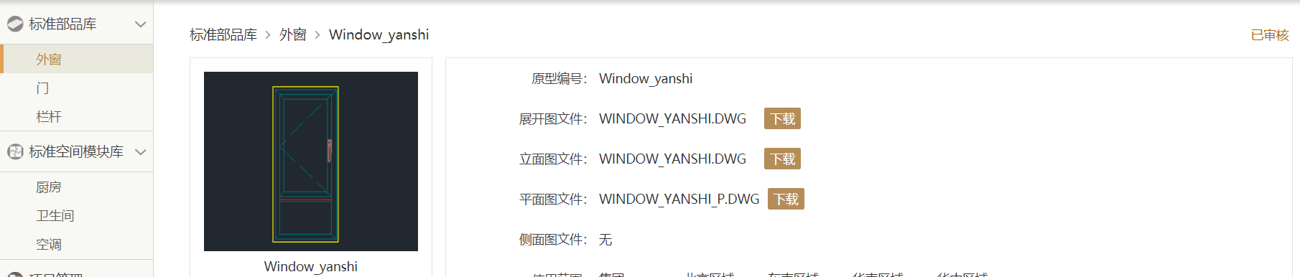

### CreateResult接口测试报文

请求报文：

<soapenv:Envelope xmlns:soapenv="http://schemas.xmlsoap.org/soap/envelope/" xmlns:cad="http://www.ekingwin.com/esb/CAD_SUNAC_568_CreateResult">

<soapenv:Header/>

<soapenv:Body>

<cad:CAD_SUNAC_568_CreateResult>

<I_REQUEST>

<REQ_BASEINFO>

<REQ_TRACE_ID>f7ded48d-ce65-41de-a3e3-8ebec0174d72</REQ_TRACE_ID>

<REQ_SEND_TIME>20191030112004</REQ_SEND_TIME>

<REQ_SRC_SYS>BS-BPM-D</REQ_SRC_SYS>

<REQ_TAR_SYS>BS-CAD-D</REQ_TAR_SYS>

<REQ_SERVER_NAME>BPM_SUNAC_568_CreateResult_PS</REQ_SERVER_NAME>

<REQ_SYN_FLAG>0</REQ_SYN_FLAG>

<REQ_BSN_ID>170</REQ_BSN_ID>

<REQ_RETRY_TIMES>?</REQ_RETRY_TIMES>

<REQ_REPEAT_FLAG>?</REQ_REPEAT_FLAG>

<REQ_REPEAT_CYCLE>?</REQ_REPEAT_CYCLE>

<BIZTRANSACTIONID>CAD_SUNAC_564_WriteSAPXmlToBPM_PS20191211181358</BIZTRANSACTIONID>

<COUNT>1</COUNT>

</REQ_BASEINFO>

<MESSAGE>

<REQ_ITEM><strBTID>P11</strBTID><strBOID>170</strBOID><bSuccess>1</bSuccess><iProcInstID>2510001555</iProcInstID><strMessage>测试</strMessage></REQ_ITEM>

</MESSAGE>

</I_REQUEST>

</cad:CAD_SUNAC_568_CreateResult>

</soapenv:Body>

</soapenv:Envelope>

返回报文：

<soap:Envelope xmlns:xsi="http://www.w3.org/2001/XMLSchema-instance" xmlns:xsd="http://www.w3.org/2001/XMLSchema" xmlns:soap="http://schemas.xmlsoap.org/soap/envelope/">

<soap:Body>

<CreateResultResponse xmlns="http://tempuri.org/">

<E_RESPONSE>

<RSP_BASEINFO>

<RSP_TRACE_ID>f7ded48d-ce65-41de-a3e3-8ebec0174d72</RSP_TRACE_ID>

<RSP_REQ_TRACEID>20191030112004</RSP_REQ_TRACEID>

<RSP_SEND_TIME>20191030112004</RSP_SEND_TIME>

<RSP_SRC_SYS>string</RSP_SRC_SYS>

<RSP_TAR_SYS>string</RSP_TAR_SYS>

<RSP_SERVER_NAME>vsheji</RSP_SERVER_NAME>

<RSP_BSN_ID>170</RSP_BSN_ID>

<RSP_RETRY_TIMES>int</RSP_RETRY_TIMES>

<RSP_STATUS_CODE>int</RSP_STATUS_CODE>

<RSP_STATUS_MSG>string</RSP_STATUS_MSG>

<BIZTRANSACTIONID>CAD_SUNAC_564_WriteSAPXmlToBPM_PS20191211181358</BIZTRANSACTIONID>

<RESULT>1</RESULT>

</RSP_BASEINFO>

<MESSAGE>

<RSP_ITEM>

<Code>100</Code>

<Success>1111</Success>

<Error></Error>

<EProcessInstanceResult></EProcessInstanceResult>

</RSP_ITEM>

</MESSAGE>

</E_RESPONSE>

</CreateResultResponse>

</soap:Body>

</soap:Envelope>

审批状态为‘审批中’

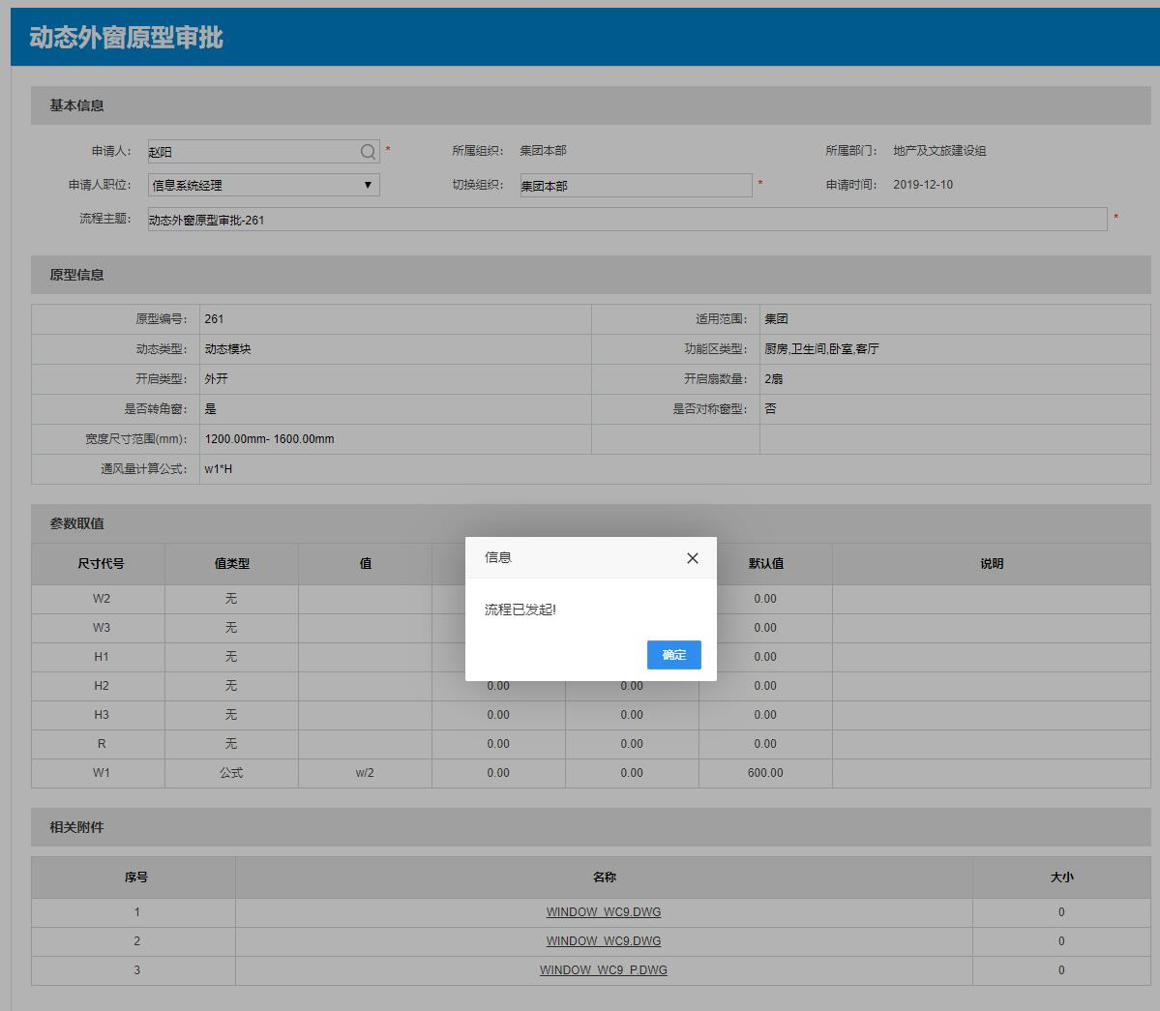

### ApproveClose接口测试报文

请求报文

<soapenv:Envelope xmlns:soapenv="http://schemas.xmlsoap.org/soap/envelope/" xmlns:bpm="http://www.ekingwin.com/esb/BPM_SUNAC_571_ApproveClose">

<soapenv:Header/>

<soapenv:Body>

<bpm:BPM_SUNAC_571_ApproveClose>

<I_REQUEST>

<REQ_BASEINFO>

<REQ_TRACE_ID>198D497A83584322A204D8411D566DCE</REQ_TRACE_ID>

<REQ_SEND_TIME>20191211201220</REQ_SEND_TIME>

<REQ_SRC_SYS>BS-BPM-D</REQ_SRC_SYS>

<REQ_TAR_SYS>BS-CAD-D</REQ_TAR_SYS>

<REQ_SERVER_NAME>vsheji</REQ_SERVER_NAME>

<REQ_SYN_FLAG>?</REQ_SYN_FLAG>

<REQ_BSN_ID>156</REQ_BSN_ID>

<REQ_RETRY_TIMES>?</REQ_RETRY_TIMES>

<REQ_REPEAT_FLAG>?</REQ_REPEAT_FLAG>

<REQ_REPEAT_CYCLE>?</REQ_REPEAT_CYCLE>

<BIZTRANSACTIONID>BPM_SUNAC_571_ApproveClose_PS20191030111959022</BIZTRANSACTIONID>

<COUNT>1</COUNT>

</REQ_BASEINFO>

<MESSAGE>

<!--Zero or more repetitions:-->

<REQ_ITEM>

<!--Optional:-->

<!--Optional:-->

<strBTID>P12</strBTID>

<!--Optional:-->

<strBOID>168</strBOID>

<!--Optional:-->

<iProcInstID>2510001555</iProcInstID>

<!--Optional:-->

<eProcessInstanceResult>1</eProcessInstanceResult><strComment>同意</strComment><dtTime>20191211</dtTime>

<!--Optional:-->

</REQ_ITEM>

</MESSAGE>

</I_REQUEST>

</bpm:BPM_SUNAC_571_ApproveClose>

</soapenv:Body>

</soapenv:Envelope>

返回报文：

<soap:Envelope xmlns:xsi="http://www.w3.org/2001/XMLSchema-instance" xmlns:xsd="http://www.w3.org/2001/XMLSchema" xmlns:soap="http://schemas.xmlsoap.org/soap/envelope/">

<soap:Body>

<CreateResultResponse xmlns="http://tempuri.org/">

<E_RESPONSE>

<RSP_BASEINFO>

<RSP_TRACE_ID>198D497A83584322A204D8411D566DCE</RSP_TRACE_ID>

<RSP_REQ_TRACEID>20191030112004</RSP_REQ_TRACEID>

<RSP_SEND_TIME>20191211201220</RSP_SEND_TIME>

<RSP_SRC_SYS>BS-BPM-D</RSP_SRC_SYS>

<RSP_TAR_SYS>BS-BPM-D</RSP_TAR_SYS>

<RSP_SERVER_NAME>vsheji</RSP_SERVER_NAME>

<RSP_BSN_ID>170</RSP_BSN_ID>

<RSP_RETRY_TIMES>int</RSP_RETRY_TIMES>

<RSP_STATUS_CODE>int</RSP_STATUS_CODE>

<RSP_STATUS_MSG>string</RSP_STATUS_MSG>

<BIZTRANSACTIONID>BPM_SUNAC_571_ApproveClose_PS20191030111959022</BIZTRANSACTIONID>

<RESULT>1</RESULT>

</RSP_BASEINFO>

<MESSAGE>

<RSP_ITEM>

<Code>100</Code>

<Success>1111</Success>

<Error></Error>

<EProcessInstanceResult></EProcessInstanceResult>

</RSP_ITEM>

</MESSAGE>

</E_RESPONSE>

</CreateResultResponse>

</soap:Body>

</soap:Envelope>

### Rework接口测试报文

请求报文：

<soapenv:Envelope xmlns:soapenv="http://schemas.xmlsoap.org/soap/envelope/" xmlns:bpm="http://www.ekingwin.com/esb/BPM_SUNAC_570_Rework">

<soapenv:Header/>

<soapenv:Body>

<bpm:BPM_SUNAC_570_Rework>

<I_REQUEST>

<REQ_BASEINFO>

<REQ_TRACE_ID>B2C5E56DF2FB4660BB133AE3891D3C66</REQ_TRACE_ID>

<REQ_SEND_TIME>20191211201231</REQ_SEND_TIME>

<REQ_SRC_SYS>BS-CAD-D</REQ_SRC_SYS>

<REQ_TAR_SYS>BS-BPM-D</REQ_TAR_SYS>

<REQ_SERVER_NAME>BPM_SUNAC_570_Rework_PS</REQ_SERVER_NAME>

<REQ_SYN_FLAG>?</REQ_SYN_FLAG>

<REQ_BSN_ID>170</REQ_BSN_ID>

<REQ_RETRY_TIMES>?</REQ_RETRY_TIMES>

<REQ_REPEAT_FLAG>?</REQ_REPEAT_FLAG>

<REQ_REPEAT_CYCLE>?</REQ_REPEAT_CYCLE>

<BIZTRANSACTIONID>BPM_SUNAC_570_Rework_PS_PS20191030111959022</BIZTRANSACTIONID>

<COUNT>1</COUNT>

</REQ_BASEINFO>

<MESSAGE>

<!--Zero or more repetitions:-->

<REQ_ITEM>

<!--Optional:-->

<!--Optional:-->

<strBTID>P11</strBTID>

<!--Optional:-->

<strBOID>170</strBOID>

<!--Optional:-->

<iProcInstID>2510001555</iProcInstID>

<!--Optional:-->

<strStepName>测试</strStepName>

<!--Optional:-->

<strApproverId>1</strApproverId>

<!--Optional:-->

<eAction>1</eAction>

<!--Optional:-->

<strComment>同意</strComment><dtTime>2019-12-11</dtTime>

</REQ_ITEM>

</MESSAGE>

</I_REQUEST>

</bpm:BPM_SUNAC_570_Rework>

</soapenv:Body>

</soapenv:Envelope>

返回报文

<soap:Envelope xmlns:xsi="http://www.w3.org/2001/XMLSchema-instance" xmlns:xsd="http://www.w3.org/2001/XMLSchema" xmlns:soap="http://schemas.xmlsoap.org/soap/envelope/">

<soap:Body>

<CreateResultResponse xmlns="http://tempuri.org/">

<E_RESPONSE>

<RSP_BASEINFO>

<RSP_TRACE_ID>B2C5E56DF2FB4660BB133AE3891D3C66</RSP_TRACE_ID>

<RSP_REQ_TRACEID>20191030112004</RSP_REQ_TRACEID>

<RSP_SEND_TIME>20191211201220</RSP_SEND_TIME>

<RSP_SRC_SYS>BS-BPM-D</RSP_SRC_SYS>

<RSP_TAR_SYS>BS-BPM-D</RSP_TAR_SYS>

<RSP_SERVER_NAME>vsheji</RSP_SERVER_NAME>

<RSP_BSN_ID>170</RSP_BSN_ID>

<RSP_RETRY_TIMES>int</RSP_RETRY_TIMES>

<RSP_STATUS_CODE>int</RSP_STATUS_CODE>

<RSP_STATUS_MSG>string</RSP_STATUS_MSG>

<BIZTRANSACTIONID>BPM_SUNAC_570_Rework_PS_PS20191030111959022</BIZTRANSACTIONID>

<RESULT>1</RESULT>

</RSP_BASEINFO>

<MESSAGE>

<RSP_ITEM>

<Code>100</Code>

<Success>1111</Success>

<Error></Error>

<EProcessInstanceResult></EProcessInstanceResult>

</RSP_ITEM>

</MESSAGE>

</E_RESPONSE>

</CreateResultResponse>

</soap:Body>

</soap:Envelope>

审批退回，业务系统数据状态为“待发布”，需修改重新发起流程或删除原型。

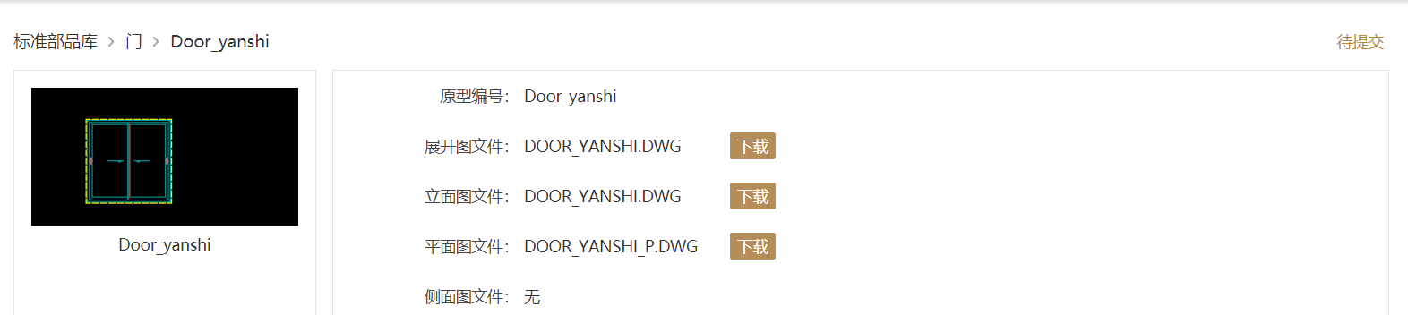

### Audit接口测试报文

请求报文：

<soapenv:Envelope xmlns:soapenv="http://schemas.xmlsoap.org/soap/envelope/" xmlns:bpm="http://www.ekingwin.com/esb/BPM_SUNAC_569_Audit">

<soapenv:Header/>

<soapenv:Body>

<bpm:BPM_SUNAC_569_Audit>

<I_REQUEST>

<REQ_BASEINFO>

<REQ_TRACE_ID>27E8FDB412C44A4A935C384159B4FEBB</REQ_TRACE_ID>

<REQ_SEND_TIME>20191211201250</REQ_SEND_TIME>

<REQ_SRC_SYS>BS-BPM-D</REQ_SRC_SYS>

<REQ_TAR_SYS>BS-CAD-D</REQ_TAR_SYS>

<REQ_SERVER_NAME>BPM_SUNAC_569_Audit_PS</REQ_SERVER_NAME>

<REQ_SYN_FLAG>?</REQ_SYN_FLAG>

<REQ_BSN_ID>170</REQ_BSN_ID>

<REQ_RETRY_TIMES>?</REQ_RETRY_TIMES>

<REQ_REPEAT_FLAG>?</REQ_REPEAT_FLAG>

<REQ_REPEAT_CYCLE>?</REQ_REPEAT_CYCLE>

<BIZTRANSACTIONID>BPM_SUNAC_569_Audit_PS20191030111959022</BIZTRANSACTIONID>

<COUNT>?</COUNT>

</REQ_BASEINFO>

<MESSAGE>

<!--Zero or more repetitions:-->

<REQ_ITEM>

<!--Optional:-->

<!--Optional:-->

<!--Optional:-->

<strBTID>p12</strBTID>

<!--Optional:-->

<strBOID>188</strBOID>

<!--Optional:-->

<iProcInstID>20191211201231</iProcInstID>

<!--Optional:-->

<strStepName>同意</strStepName>

<!--Optional:-->

<strApproverId>100</strApproverId><eAction>1</eAction>

<!--Optional:-->

<strComment>同意</strComment><dtTime>2019121212</dtTime>

</REQ_ITEM>

</MESSAGE>

</I_REQUEST>

</bpm:BPM_SUNAC_569_Audit>

</soapenv:Body>

</soapenv:Envelope>

返回报文：

<soap:Envelope xmlns:xsi="http://www.w3.org/2001/XMLSchema-instance" xmlns:xsd="http://www.w3.org/2001/XMLSchema" xmlns:soap="http://schemas.xmlsoap.org/soap/envelope/">

<soap:Body>

<CreateResultResponse xmlns="http://tempuri.org/">

<E_RESPONSE>

<RSP_BASEINFO>

<RSP_TRACE_ID>27E8FDB412C44A4A935C384159B4FEBB</RSP_TRACE_ID>

<RSP_REQ_TRACEID>20191030112004</RSP_REQ_TRACEID>

<RSP_SEND_TIME>20191211201250</RSP_SEND_TIME>

<RSP_SRC_SYS>BS-BPM-D</RSP_SRC_SYS>

<RSP_TAR_SYS>BS-BPM-D</RSP_TAR_SYS>

<RSP_SERVER_NAME>vsheji</RSP_SERVER_NAME>

<RSP_BSN_ID>170</RSP_BSN_ID>

<RSP_RETRY_TIMES>int</RSP_RETRY_TIMES>

<RSP_STATUS_CODE>int</RSP_STATUS_CODE>

<RSP_STATUS_MSG>string</RSP_STATUS_MSG>

<BIZTRANSACTIONID>BPM_SUNAC_569_Audit_PS20191030111959022</BIZTRANSACTIONID>

<RESULT>1</RESULT>

</RSP_BASEINFO>

<MESSAGE>

<RSP_ITEM>

<Code>100</Code>

<Success>1111</Success>

<Error></Error>

<EProcessInstanceResult></EProcessInstanceResult>

</RSP_ITEM>

</MESSAGE>

</E_RESPONSE>

</CreateResultResponse>

</soap:Body>

</soap:Envelope>



## 缺陷的统计与分析

### 缺陷汇总

* 概括

*【下表按bug 的状态列出bug 的数量】*

|  |  |  |
| --- | --- | --- |
| **Closed Bug 数** | **Pending Bug 数** | **总计** |
| *0* | 0 | 0 |

* 按优先级

|  |  |  |  |  |
| --- | --- | --- | --- | --- |
| **严重** | **一般** | **小缺陷** | **非缺陷** | **总计** |
| 0 | 0 | 0 | 0 | 0 |

### 遗留问题

1. 若需求有变更后，与项目经理沟通之后后续调整；

# 测试结论与建议

## 测试结论

基本功能可正常实现，且无遗留bug。

## 改进建议