User Manual for Field Tech Toolbox™

Table of Contents

Terms of Use 2

Software 2

User Manual 2

Minimum System and Software Requirements 2

What is Field Tech Toolbox™? 2

Field Tech Manager™ Functionality 2

Interface 2

*FTM Main Screen* 2

*Create New Project Window* 4

Common Tasks 6

*Creating a New Project* 6

*Sending a Project to a Tablet for Use with Field Tech Toolbox™* 6

*Loading an Existing Project* 6

Field Tech Toolbox™ Functionality 6

The Interface 6

*FTT Main Screen* 6

*Component Edit window* 8

*Child Object window* 9

Common Tasks 10

*Opening a New Project* 10

*Tagging an Existing Component* 10

*Adding a Field Component that doesn’t exist in the P&ID* 10

*Searching for Field Components on the P&ID* 10

Common Tasks Involving both Field Tech Manager and Field Tech Toolbox 10

Exporting Tag Data from FTT to Project and LeakDAS 10

Tips & Tricks 11

FTM 11

FTT 11

Contact Information 12

# Terms of Use

## Software

Environmental intellect’s Management of Change tool, Field Tech Toolbox™ (FTT) as well as the Field Tech Manager™ (FTM) are the sole property of Environmental intellect (Ei) and may not be distributed without its consent.

Any content generated using FTT, such as P&ID markups and spreadsheets not pertaining to the operation of the software remains the property of its respective owner.

Ei shall not be held responsible for the results of the use of FTT nor FTM.

## User Manual

This document is intended for users of the Environmental intellect LLC (Ei) Management of Change tool, FTT to familiarize themselves with the functionality of the software as well as to troubleshoot any problems they encounter when using the software.

This document may not be copied and distributed in full or in part without the expressed consent of Ei.

# Minimum System and Software Requirements

FTT is meant to be used on a Microsoft Surface Pro Tablet with a minimum of an i5 Processor. Autodesk® Design Review must be installed on the machine in order for FTT to work. Either 32 or 64 bit systems will work with FTT.

# What is Field Tech Toolbox™?

FTT is a tool created by Ei to reduce the cost of LDAR management of change (MOC) projects by integrating P&IDs with LDAR databases in an electronic format. It allows for the use of a project file created through the integration of P&IDs in DWG, PDF, or DWF format with LDAR Database backups for accurate tracking of components in the field. This allows for all LDAR retag and MOC additions to happen within the context of an existing LDAR database. If equipment has been documented previously within an LDAR database, the equipment information can be auto-populated. If the equipment has not been previously documented within an LDAR database, it can be added, and upon completion of the MOC/retag task, all data can be exported to a CSV file format and then uploaded into an LDAR database. The LeakDAS Import Wizard performs quality assurance checks on the data to make sure that all data being sent to quarantine only has fields that are recognized in LeakDAS, and that in the case of LDAR retag, no duplicate tags are input.

# Field Tech Manager™ Functionality

FTM is a tool that performs the integration of P&IDs in .pdf or .dwf format with a copy of a LeakDAS database. This tool is required to generate a project file that is imported into FTT. It also has a utility for uploading data collected in FTT to LeakDAS quarantine.

## Interface

### *FTM Main Screen*

When a project is not loaded, the following items are present on the main screen:

* A tab labelled **file** with toolbar at the top of the window containing the following buttons:

1. **New** – Creates a new project via the Create New Project window
2. **Open** – Opens an existing project
3. **Save** – Saves the project to the existing directory
4. **SaveAs** – Allows for a copy of the project to be saved in a directory of your choosing
5. **Send To** – Allows project to be used in FTT
6. **Import Data** – Brings in data from a .ftte file
7. **Send to LeakDAS** – Sends imported data to LeakDAS, while employing QA/QC Checks along the way

* A tab labelled **help** with nothing in it currently, but that will in future releases link to this document

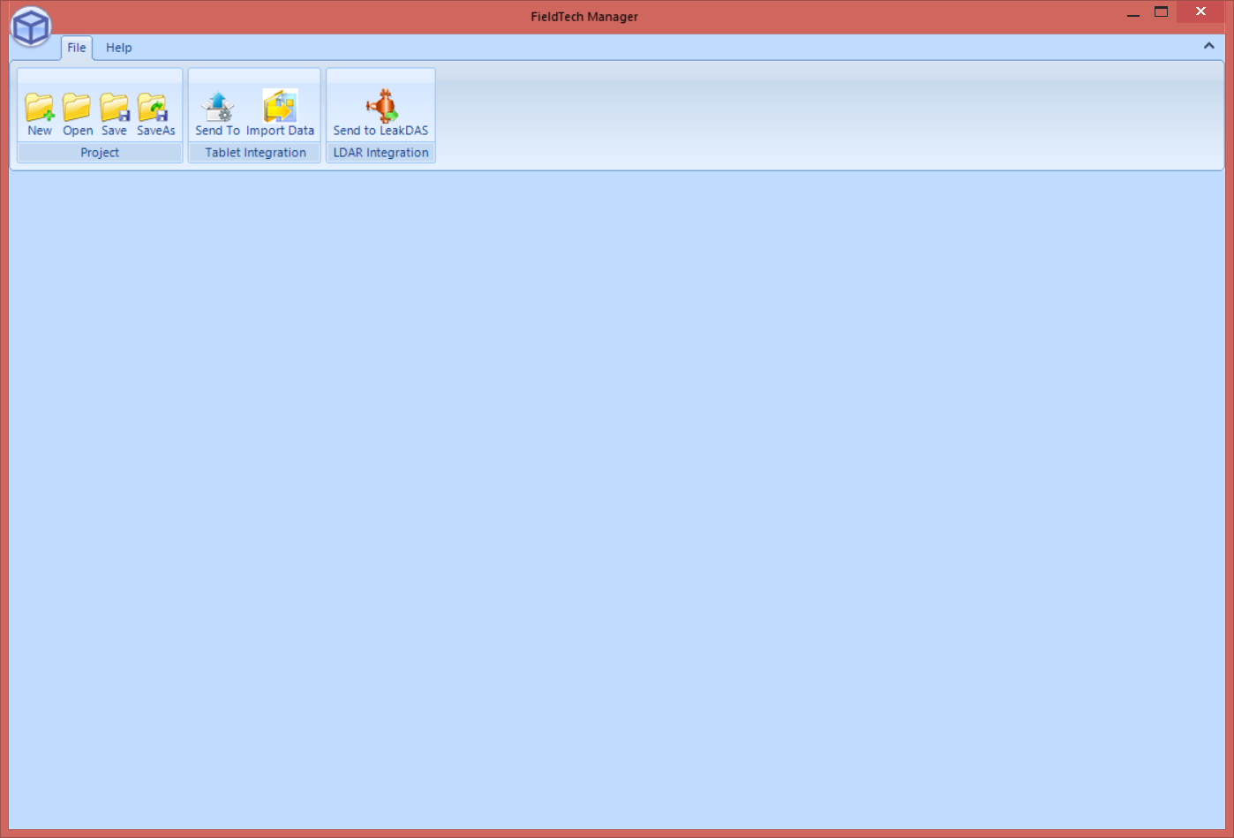

**1 2 3 4 5 6 7**

Figure - Field Tech Manager main window with no project loaded

When a project is loaded, in addition to the above, a series of project-related tabs are present on the screen. The tabs can be viewed individually by clicking on the tab on the left side of the screen

* Project Summary

1. **LDAR Database** – Contains general information about the LDAR database being used, including name and version number. Also contains a summary of the information about the components within the database.
   1. **Sync Database Button** – Updates the LeakDAS database information currently in the project to that of the most recent version of the database that it is linked up to
2. **CAD Drawing Packages** – Has information about the CAD Drawing package, including the directory and drawing count.
   1. **Sync Drawings Button**
3. **Incoming Data**
4. **QA/QC**
5. **Completed Data**

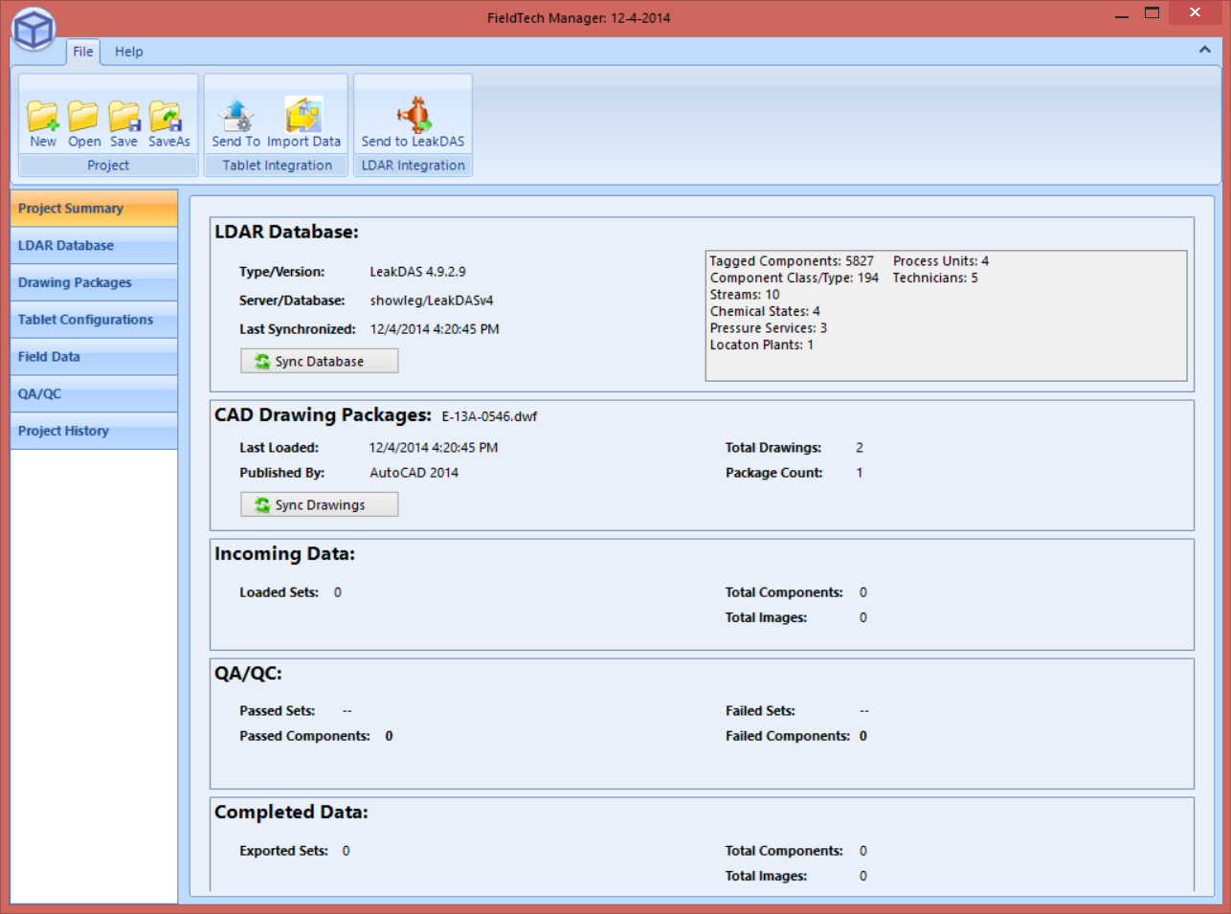

**8**

**9**

**10**

**11**

**12**

Figure - Field Tech Manager main window with a project loaded

* LDAR Database
  + This tab contains all of the data that is within the project and can be uploaded into the LeakDAS database
* Drawing Packages
* Tablet Configurations
* Collected Data QA/QC
  + Contains information about the individual data uploads

### *Create New Project Window*

The Create New Project window allows you to input data that will be used to create a new project. The window contains the following fields that you need to enter information in to create a project:

1. **Project Name:** – This is where you can type in the name of the project
2. **Server:** – In this box, you type in the name of the server on which your LDAR database is stored
3. **Database:** – In this box, you type in the name of your LDAR server
4. **Authentication:** Select the type of authentication you wish to use. Windows authentication is generally used if the LDAR database is on the same machine as FTM, and SQL authentication is used when the LDAR database is on a different machine than FTM
5. **Username:** – When using SQL authentication, type in your username
6. **Password:** – When using SQL authentication, type in your password
7. **File(s):** – Opens an explorer window to select drawings. Valid file formats are .dwf and .pdf
8. **Project File:** – Opens an explorer window to let you select a project.xml file associated with an AutoCAD P&ID project to pull in data fields from that project and cross reference them with the LDAR database

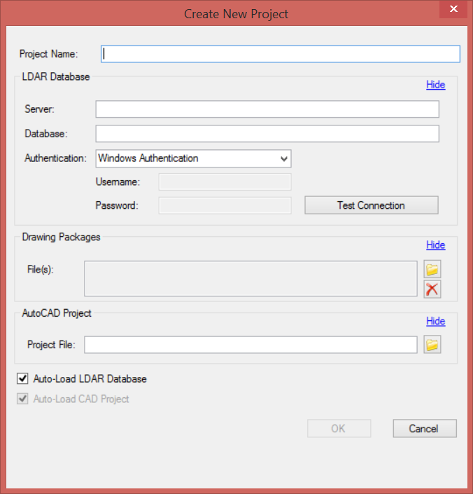

**7**

**8**

**5**

**6**

**1**

**2**

**3**

**4**

Figure - Create New Project window

## Common Tasks

Described below are common tasks performed using Field Tech Manager™.

### *Creating a New Project*

To create a new project in FTM, follow the steps below:

1. Press the “New” button in in the toolbar in the upper-left-hand corner of the manager
   1. The Create New Project window should appear
2. Input a project name
3. The LeakDAS database information including:
   1. Server
   2. Database
4. Set “authentication” to Windows Authentication if the LeakDAS database backup is on your computer, or “SQL Authentication” if it is located on a different machine
5. Type in the proper login credentials
6. Press test connection
   1. If the correct information and credentials were typed in, then a message should appear near the bottom of dialogue saying “Found LeakDAS version” followed by the version of LeakDAS that the database uses
7. Press the folder icon near the “File” space underneath “Load Drawings”
8. Select the drawing package you want to use
9. Press “Open”
10. Press “Ok” when all steps have been completed

### *Sending a Project to a Tablet for Use with Field Tech Toolbox™*

1. On the main screen in the toolbar, press “Send To”
2. Select the file name and location of the .eid file that will be opened in Field Tech Toolbox
3. Press the save button

### *Loading an Existing Project*

1. Press the **Open** button in the toolbar
2. Select a .eip file to open
3. Press **Open**

# Field Tech Toolbox™ Functionality

## The Interface

FTT operates as a plugin to Autodesk® Design Review. As such, many functions in Autodesk Design Review are also available in FTT. However, some tools have been moved around, while others have been made unavailable. Also, FTT only accepts Ei’s propriety .eid file format. Consequently FTT cannot and should not be used as a substitute for Autodesk Design Review. However, users with familiarity with Autodesk® Design Review will be more accustomed to the interface of Field Tech Toolbox™ than those that have no experience with the software.

### *FTT Main Screen*

Figure 4 shows a screenshot of the FTT window. Each section of this display is described below.

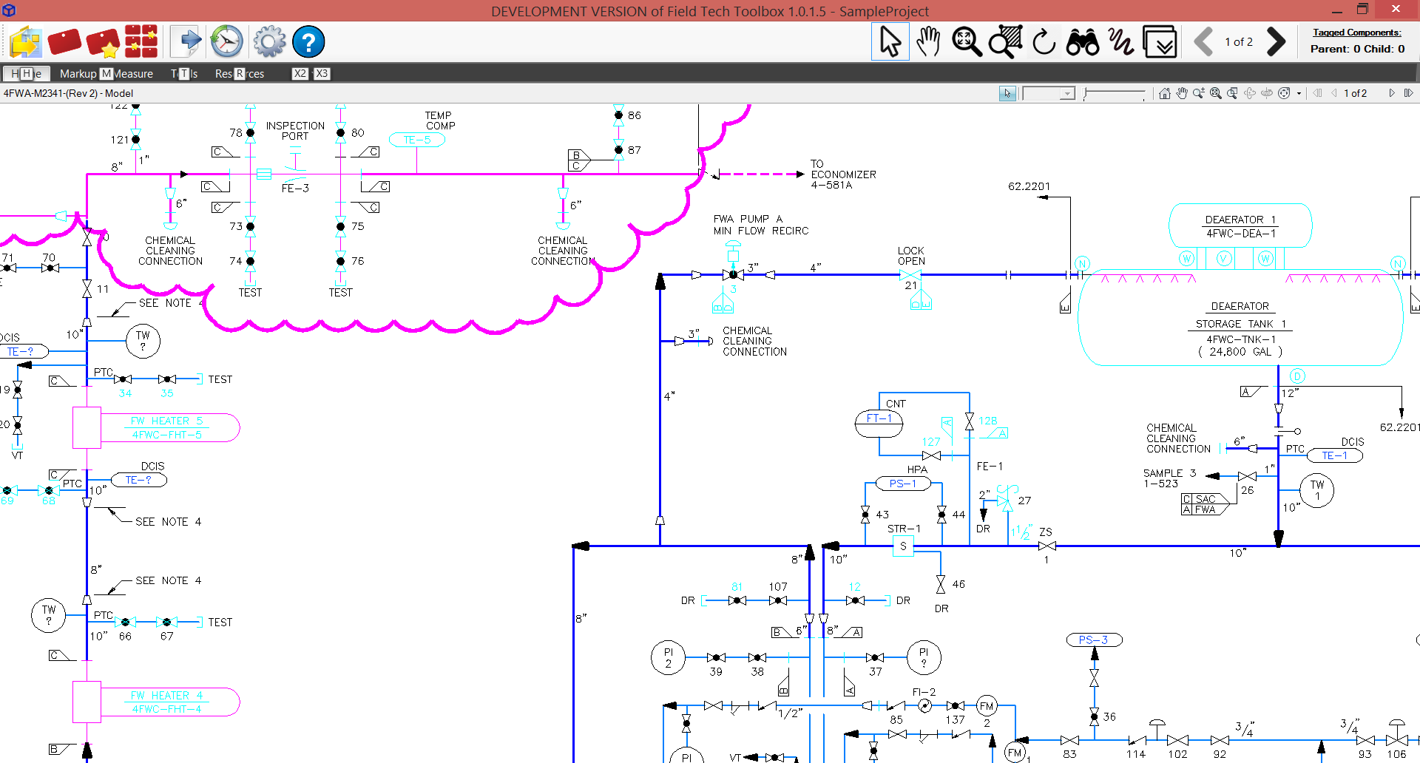

**4**

**3**

**2**

**1**

Figure - Field Tech Toolbox main window with drawing loaded

1. Field Tech Toolbox™ toolbar – This toolbar contains the unique functions of FTT. The buttons from left to right are as follows:
   * **Open Drawing Project** – Clicking this will open a file browser dialogue box allowing the user to locate a .eid file to load into FTT.
   * **Update Drawing Tag** – When an object on the P&ID is selected, this button opens the “Component Edit” dialogue box.
   * **Add Non-Drawing Tag** – Clicking this will open the Component Edit dialogue box. The functionality of this dialogue box is described in detail later on in this guide.
   * **View All Tagged Components** – Clicking this will allow you to see all components that have been validated/added in this project
   * **Export All Tagged Info** – Clicking this will let you save all of the tagging work done in the current FTT session to an .eie file, which can be uploaded into the FTM. For detailed information on how to perform this task, see: Exporting Tag Data From FTT to Project.
   * **Tag History** – Opens up a list of all tagged components in the current FTT Session
   * **Settings** – Opens up the Dialog Settings dialogue box shown below
   * **Help** – Clicking this button opens up this document
2. Autodesk® Design Review toolbar – This toolbar contains functions from Autodesk® Design Review that are necessary for the complete and proper use of Field Tech Toolbox™. The buttons from left to right are as follows:
   * **Select Component** – Clicking this button will change the cursor to a pointer when it enters the drawing field, allowing you to select of data objects within that field.
   * **Pan** –Clicking this button will change the cursor to a hand, allowing you to pan on the drawing field
   * **Reset Zoom** – Zooms out so that the full drawing is in view
   * **Zoom Window** – Clicking this will turn your pointer into a tool that drags a box which your view window will fit into.
   * **Find Components** – Clicking this will open a search bar on the right side of the screen that you can use to search for components or other text objects within the project.
   * **Freehand Tool** – Clicking this will turn the mouse pointer into a freehand drawing tool. Clicking and dragging on the screen will draw data driven freehand objects. This can be used to document components that are not on the P&ID. For information on how to do this, see Adding a New Component to the P&ID.
   * **Next Drawing/Previous Drawing** – Flips to the next/previous page in the drawing set
3. Tagged Components – To the right of the toolbar, the amount of tagged components is listed, showing both child and parent components.
4. P&ID Field – This area is where the P&ID appears when loaded into FTT.

### *Component Edit window*

Figure 5 shows the Component Edit window. In this Box, data related to the MOC can be input. Each field is described in detail below.

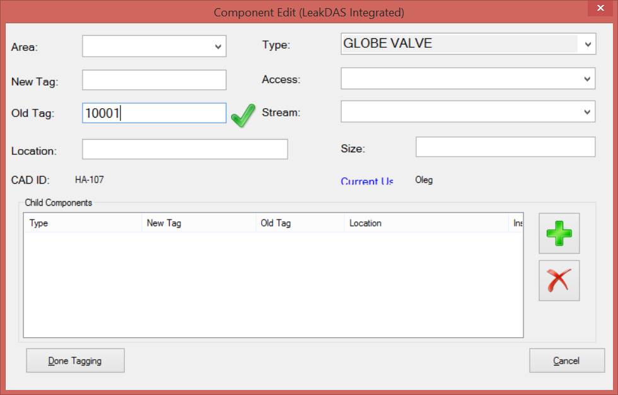

**14**

**3a**

**12**

**13**

**11**

**6**

**7**

**8**

**9**

**10**

**1**

**2**

**3**

**4**

**5**

Figure - Component Edit window

1. **Area:** – Specifies what geographic area of the of the plant the component is in
2. **New Tag:** – In an LDAR Retag project this is where the new tag number is typed in
3. **Old Tag:** – If the component exists an LDAR database and the component has an LDAR tag in the field, the tag can be put in this box to connect the old data with the new data.
   1. **Checkmark** - If the “Old Tag” exists in the LDAR database associated with the project, a checkmark will appear indicating that the tag was found in the currently loaded LDAR database
4. **Location:** – Lists the physical location of the component. Can be pre-populated
5. **CAD ID:** – Process units are often divided into subareas in order to determine efficient tagging routes
6. **Type:** – When clicked, opens a pre-populated list based on the current LDAR database. It is a concatenation of the ‘ComponentClass’ and ‘ComponentType’ fields in LeakDAS.
7. **Access:** – This is used to select the accessibility of a component.
8. **Stream:** – This is used to select the stream from a pre-populated list taken from an imported DWF.
9. **Size:** – Size refers to the inside diameter of the pipe or tubing to which the component is attached. NOTE: Most valves that are four inches or larger will have the valve size stamped on one side of the valve
10. **Current User:** - Lists the current user based on the windows login name
11. **Child Component List:** – Lists all child components such as flanges, plugs, or caps, associated with the component being documented
12. **Add Child Component:** –Opens the Child Object window to allow a child component to be added
13. **Remove Child Component:** –Removes a child component selected in the Child Components List
14. **Done Tagging** – Saves the information input into the Component Edit window and closes it

### *Child Object window*

The child object window is used to add a child component to the component currently being added/edited in the Component Edit window. It has 3 fields which are described below:

1. **Type:** – When clicked, opens a pre-populated list based on the current LeakDAS database. It is a concatenation of the ‘ComponentClass’ and ‘ComponentType’ fields in LeakDAS. It can also be populated manually using a keyboard.
2. **Old Tag:** – This field will auto-populate based on the entry in the Old Tag field of the Component Edit window for the parent component
3. **Location:** – The location description of the child component can be typed in here.

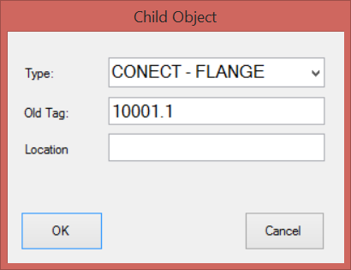

1

2

3

Figure - Child Object window

## EiMOC™

If a .eid file containing a .pdf instead of a .dwf is loaded into FTT, EiMOC™, a module embedded within FTT, opens. EiMOC™ is used to document Management of Change (MOC) projects without the use of paper.

### *Interface*

The interface of EiMOC™ is nearly identical to that of FTT. The only difference is that the “Update Drawing Tag” button will no longer be on the toolbar.

## Common Tasks

### *Opening a New Project*

There are two ways you can open project

1. Double click on the .eid file. This will load the project in Field Tech Toolbox™

OR

1. Open Field Tech Toolbox, press the Open Drawing Project button in the upper left toolbar, and then select the .eid file you want to open

### *Tagging an Existing Component*

1. Click on the component you’d like to tag
2. Press the **Update Drawing Tag** button. The Component Edit window will appear.
3. If there is an existing LDAR tag on the component, type it into the “Old Tag” field. If FTT finds the tag in the uploaded LDAR database, then a checkmark will appear next to the entry.
4. Fill in all relevant tag information that is not already filled in
5. Press **Done Tagging**

### *Adding a Field Component that doesn’t exist in the P&ID*

1. Press the **Freehand** tool.
2. Draw the component you wish to add in one motion, without taking the stylus off the page
3. In the comments section of the markup, write the LDAR Tag.
4. Press the Add Non-Drawing button. The Component window will appear.
5. If there is an existing LDAR tag on the component, type it into the “Old Tag” field. If FTT finds the tag in the uploaded LDAR database, then the refresh button will illuminate
   1. Click the refresh button if it illuminates
6. Fill in all relevant tag information
7. Press **Done Tagging**

### *Searching for Field Components on the P&ID*

1. Click on the **Find Component** button in the FTT Main Screen. An embedded “Find” window will appear on the right side of the screen.
2. Type the search term in the “Find” box
3. Click on the chosen result. The screen will flip to the drawing that has the result. The area of the P&ID that has the result will be highlighted with a transparent circle and annotated with a “T”.
4. Click on the P&ID to remove the highlight and “T”, then proceed as needed

# Common Tasks Involving both Field Tech Manager and Field Tech Toolbox

## Exporting Tag Data from FTT to Project and LeakDAS

After fieldwork is complete, data collected in the field can be uploaded into a LeakDAS database. Below are steps needed to do this:

1. In Field Tech Toolbox™:
   1. Press the **Export All Tagged Info** button
   2. Select an appropriate directory for the export data file (.ftte)
   3. Press the save button
   4. When the “Reset Data On Device” window pops up, select **Yes**, unless instructed otherwise.
2. In Field Tech Manager™
   1. Open the project .eip file
   2. Press the **Import Data** button in the Tablet Integration section of the Project Toolbar
   3. Select the .ftte file you created in Field Tech Toolbox™
   4. Press **Open**

The data in the .ftte file has now become part of the project file. You can confirm the upload is successful by going to Collected Data tab. You should be able to find the file name under the “Device” column. Once all project data has been collected from all users and added to the project file via the methods above, the data can be uploaded to the LeakDAS by the following method:

1. In Field Tech Manager™
   1. Press the **Send to LeakDAS** button. This will open the LeakDAS Component Import Tool
   2. Click the next button several times, ensuring that all the data in each step is accurate
   3. When the dialogue box closes automatically, the data will have been uploaded to LeakDAS Quarantine and you are done

# Tips & Tricks

This section contains information that you may find helpful when using Field Tech Toolbox™ and Field Tech Manager™. If you find yourself stuck on a task, or just want tips on getting the most out of the software, take a look below.

## FTM

## FTT

* **Checking if you’ve tagged a component** – If in the middle of a retagging project, you forget whether you’ve tagged a component, there is a simple of way of checking whether you’ve tagged a component. Click on the component you are unsure of and press the **Update Drawing Tag** button. If you’ve already tagged the component, the component information will be populated in the Component Edit window.
* **Misabeled New Tag** - Say you mislabeled a new tag and added child components. It seems like a chore to go and change all the tag numbers. Thankfully, You don’t have to.

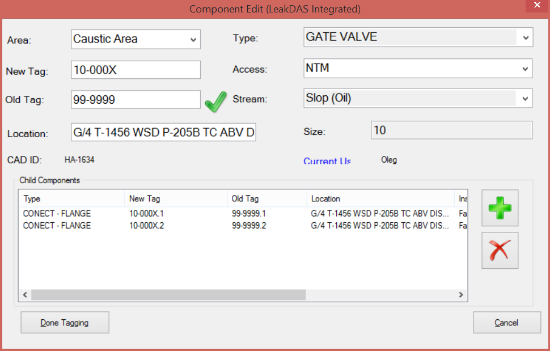

Figure - Component Edit window with mislabeled New Tag

# Contact Information

If you have any questions that were not answered by this user manual, please contact [support@env-int.com](mailto:support@env-int.com).