## 0. 创建页面

先找到自己要放在哪个目录的编码

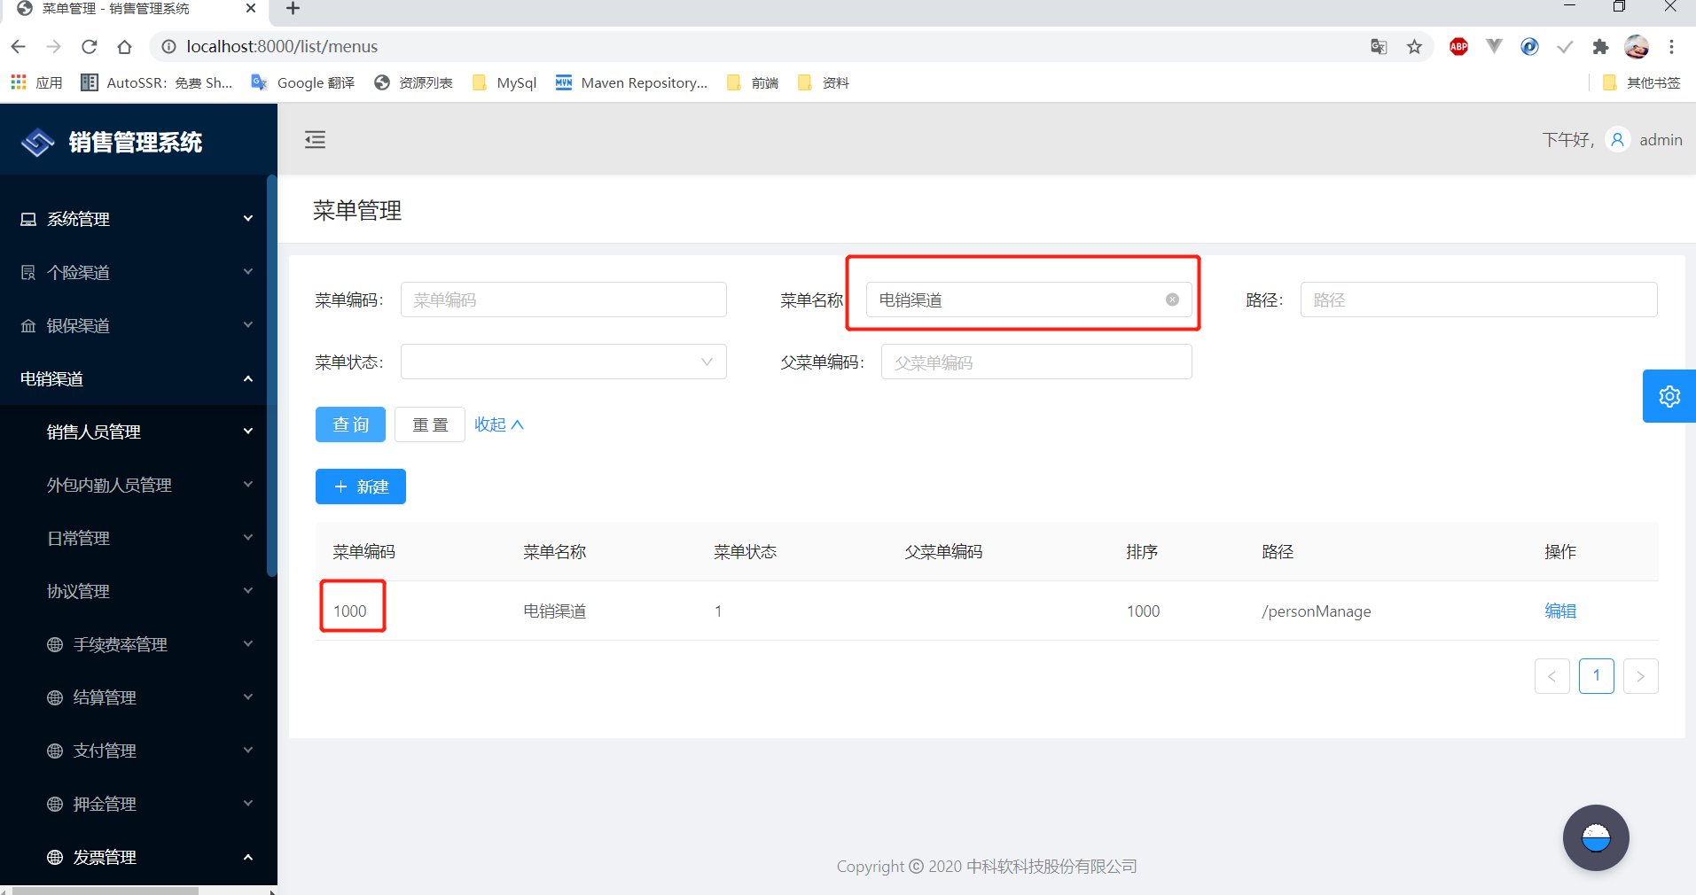

再根据父编码找到里面的模块编码

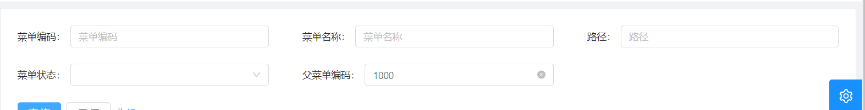



根据父菜单编码查看已经存在的菜单编码，新建一个不存在的编码

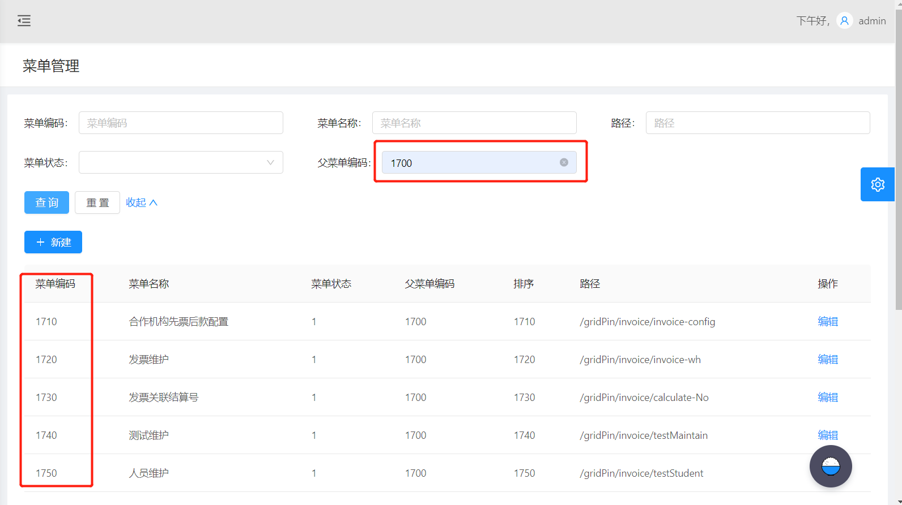

新建菜单

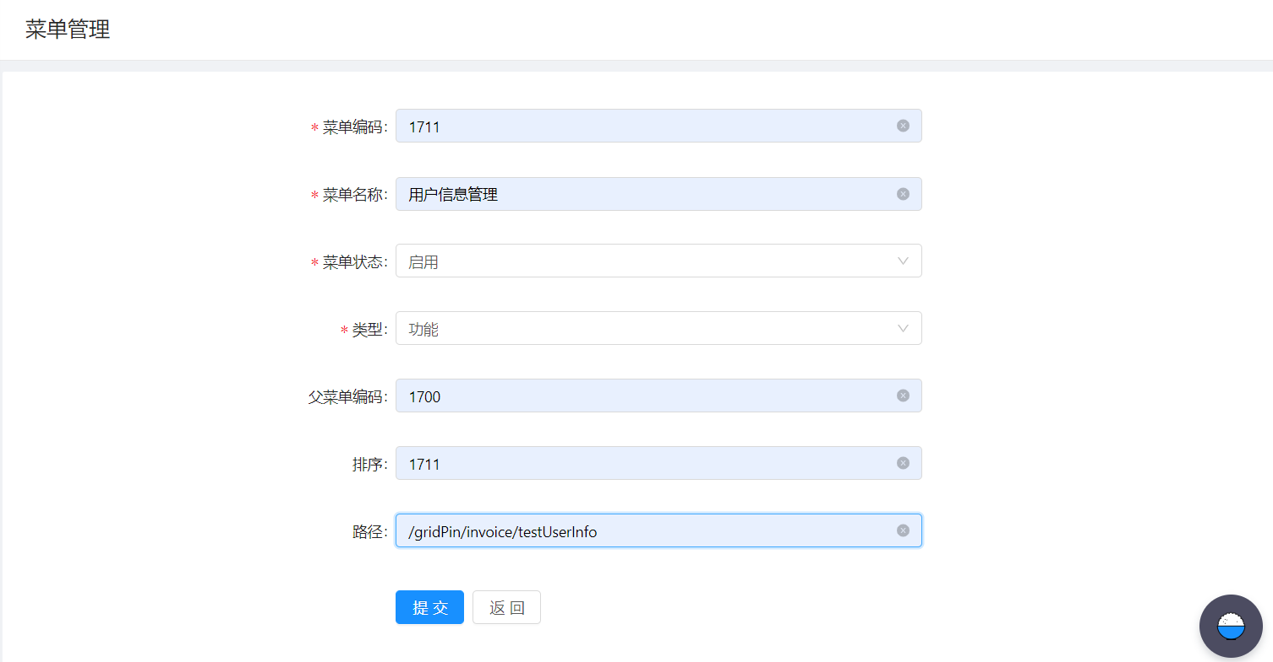

找到登录的角色，点菜单

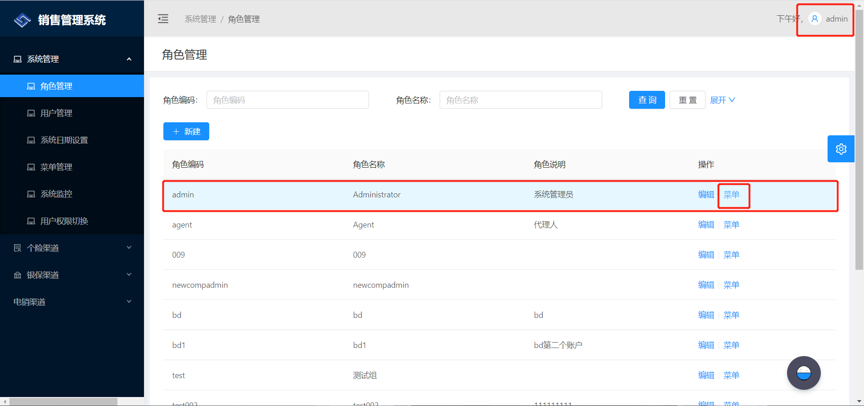

将刚建好的模块勾选

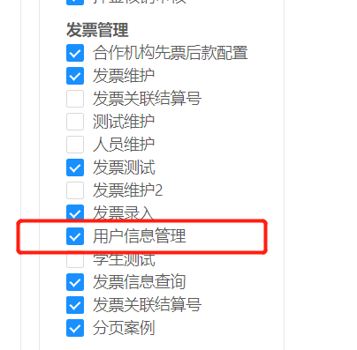

根据路径，在 router.config.js里查找

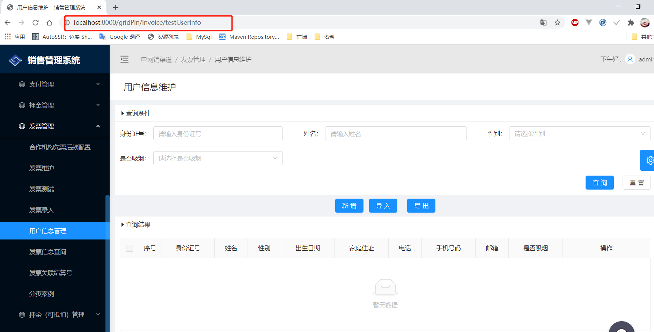

## 1. router.config.js

在config文件夹下找到router.config.js，配置路由

// 用户信息管理  
{  
path: '/gridPin/invoice/testUserInfo', // 浏览器URI路径  
name: 'testUserInfo',   
icon: 'deposit1',  
component: './TestUserInfo/index', // TestUserInfo：pages里的文件夹名称 index：index.js  
},

## 2. index.js

在pages里找到TestUserInfo文件夹，先看index.js

render() {  
 return <div>{this.getView()}</div>; // ctrl+左键，查看getView()  
}

getView = () => {  
 const {  
 testUserInfo: { currView },  
 } = this.props;  
 let result = <Home />; // 当前视图是home.js  
 if (currView === 'edit') { // 如果当前视图是edit，就找edit.js  
 result = <Edit />;  
 }  
 return result;  
};

## 3. home.js

home.js,找到getColumns()方法的return[ {},{},{} ]，大括号里写的是查询结果Table表格的列名  
例如：

{  
 title: formatMessage({ id: 'testUserInfo.name' }), // 列名，这里引用的是国际化，会根据zh-CN.js自动转换为中文  
 dataIndex: 'name',  
 align: config.tableColAlign,  
},

这里的国际化是在当前的TestUserInfo文件夹下的i18n下的zh-CN.js文件里配置的,用姓名举例

'testUserInfo.name': '姓名',

对应的浏览器部分：



home.js文件中自己的render()方法，返回的是组件，是整个页面的布局。

return (  
 <PageHeaderWrapper title={<FormattedMessage id="testUserInfo.home.title" />}>  
 <Card></Card> //这个Card里面主要写的是查询条件模块  
 <div></div> //这个div里面主要写的是需要的按钮  
 <Card></Card> //这个Card里面主要写查询结果模块  
 </PageHeaderWrapper>  
 );

在浏览器的样子是：

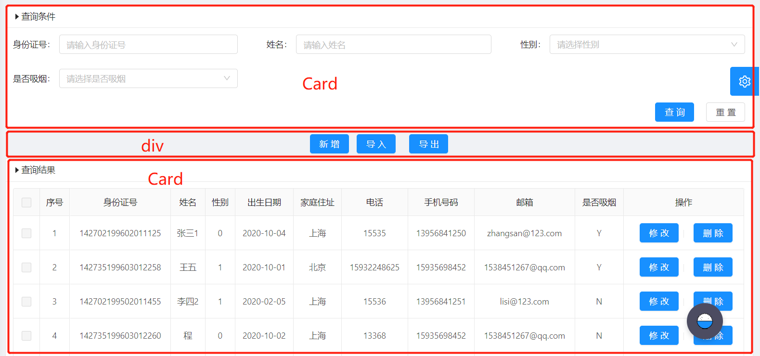

拿第一个Card说明：

<Card  
 bordered={config.cardboard}  
 size={config.cardsize}  
 title={  
 <div>  
 <Icon type="caret-right" />  
 <FormattedMessage id="global.query.title" /> // 每个页面都有查询条件，所以这里引用的是全局国际化，在src下的locales下的zh-CN文件夹下的global.js里'global.query.title': '查询条件'  
 </div>  
>  
 <div className={styles.tableListForm}>  
 <QueryAdvance cz={this.cz} clearSelect={this.clearSelect} />  
 </div>   
</Card>

## 4. queryAdvance.js

queryAdvance.js文件，这个文件主要是做查询条件的组件配置，查看里面的render()方法,

<Form layout="inline" onSubmit={this.handleSearch}>  
 <Row gutter={{ md: 8, lg: 24, xl: 48 }}>  
 // 每个列对应的是查询条件的组件  
 <Col></Col>  
 // 按姓名查询Input组件  
 <Col md={8} sm={24}>  
 <FormItem label={<FormattedMessage id="testUserInfo.name" />}>  
 {getFieldDecorator('name', { initialValue: queryPara.invoType })(  
 <Input allowClear />  
 )}  
 </FormItem>  
 </Col>  
 // 按性别选择Select组件  
 <Col>  
 <FormItem label={<FormattedMessage id="testUserInfo.sex" />}>  
 {getFieldDecorator('sex', { initialValue: queryPara.state })(  
 <Select  
 allowClear  
 placeholder={formatMessage({ id: 'placeholder.testUserInfo.sex' })} //这里写的是组件里面的提示文字，也是用的当前文件的国际化  
 >  
 // SelectOption组件主要是写下拉的选项，记得定义const SelectOption = Select.Option;  
 <SelectOption key='0'>女</SelectOption>  
 <SelectOption key='1'>男</SelectOption>  
 </Select>  
 )}  
 </FormItem>  
 </Col>  
 <Col></Col>  
 </Row>  
 <div style={{ overflow: 'hidden' }}>  
 <div style={{ textAlign: 'right' }}>  
 // 两个按钮，查询和重置  
 <Button htmlType="submit" type="primary" disabled={loading}>  
 <FormattedMessage id="global.query" />  
 </Button>  
 <Button style={{ marginLeft: '20px' }}  
 onClick={this.handleFormReset}  
 disabled={loading}  
 >  
 <FormattedMessage id="global.reset" />  
 </Button>  
 </div>  
 </div>  
</Form>

上面代码对应浏览器的部分：

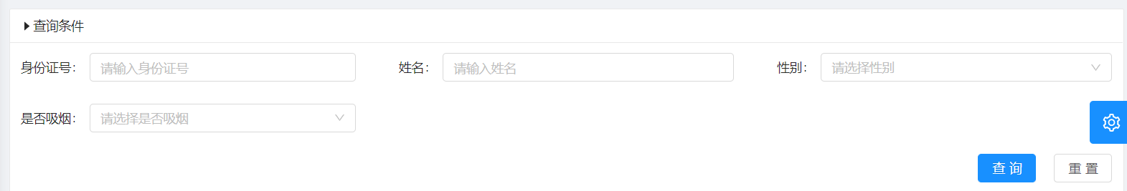

## 5. edit.js

edit.js里主要写的是新打开的视图，新增修改的页面部分，还是先找到render()方法里的return方法，一个里写全部的组件

return (  
 <PageHeaderWrapper title={<FormattedMessage id={this.pageTitle(testUserInfo.op)} />}>  
 <Card bordered={global.cardboard} size={global.cardsize}>  
 <Form onSubmit={this.handleSubmit} style={{ marginTop: 8 }}> //提交表单调用handleSubmit()方法  
 {/* 身份证号 */}  
 <FormItem  
 {...formItemLayout}  
 label={<FormattedMessage id="testUserInfo.cardId" />}  
 >  
 { getFieldDecorator('cardId', {  
 initialValue: currData.cardId,  
 rules: [  
 {  
 required: true, //必须输入  
 message: formatMessage({ id: 'validation.testUserInfo.cardId.required' }), //国际化  
 },  
 ],  
 })(<Input disabled={this.state} allowClear />)}  
 </FormItem>  
 {/* 性别 */}  
 <FormItem  
 {...formItemLayout}  
 label={<FormattedMessage id="testUserInfo.sex" />}  
 >  
 {getFieldDecorator('sex', {  
 initialValue: currData.sex,  
 rules: [  
 {  
 required: true,  
 message: formatMessage({  
 id: 'validation.testUserInfo.sex.required',  
 }),  
 },  
 ],  
 })(  
 <Select  
 disabled={this.state}  
 allowClear  
 placeholder={formatMessage({ id: 'placeholder.testUserInfo.sex' })}  
 >  
 <SelectOption key='0'>女</SelectOption>  
 <SelectOption key='1'>男</SelectOption>  
 </Select>  
 )}  
 </FormItem>  
 /* 出生日期 */}  
 <FormItem {...formItemLayout} label={<FormattedMessage id="testUserInfo.birthday" />}>  
 {getFieldDecorator('birthday', {  
 initialValue: currData.birthday ? moment(currData.birthday) : null,  
 rules: [  
 {  
 required: true,  
 message: formatMessage({  
 id: 'validation.testUserInfo.birthday.required',  
 }),  
 },  
 ],  
 })(  
 <DatePicker  
 disabled = {this.state}  
 style={{ width: '100%' }}  
 placeholder={  
 formatMessage({ id: 'placeholder.testUserInfo.birthday' })  
 }  
 />  
 )}  
 </FormItem>  
 </Form>  
 </Card>  
 </PageHeaderWrapper>  
);

因为新增和修改用的是同一个页面，所以在提交表单的时候，先判断

handleSubmit = e => {  
 const { dispatch, form, testUserInfo } = this.props;  
 e.preventDefault();  
 form.validateFieldsAndScroll((err, values) => {  
 const data = values;  
 if (!err) {  
 let type = 'testUserInfo/add';  
 if (testUserInfo.op === 'update') {  
 type = 'testUserInfo/update';  
 data.id = testUserInfo.currData.id;  
 }  
 dispatch({  
 type,  
 payload: data,  
 });  
 }  
 });  
 };

对应浏览器的部分是：

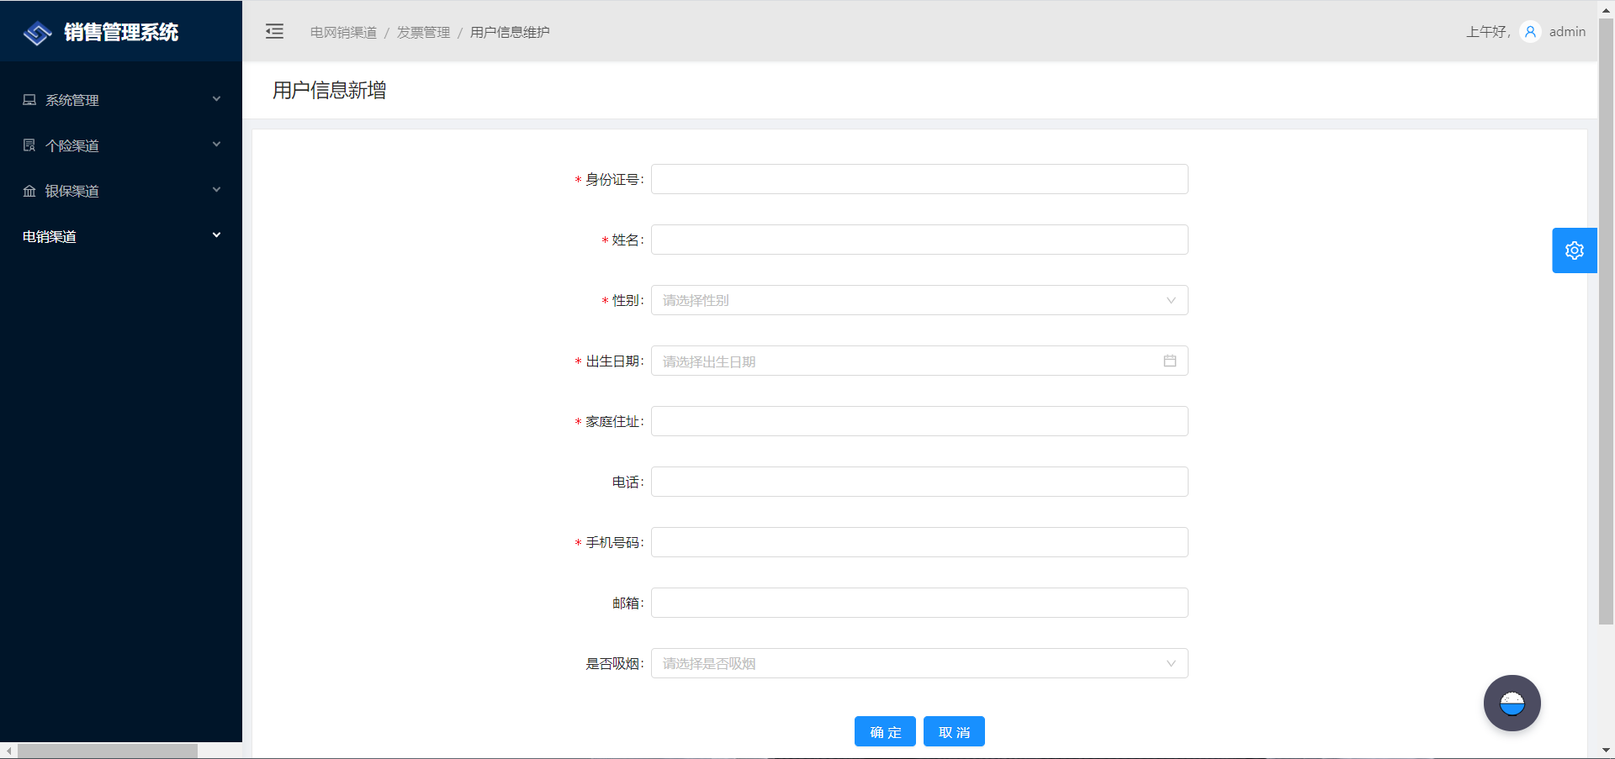

## 6. model.js

model.js里面主要是写与后端交互的增删改查方法

首先看一下命名空间

namespace: 'testUserInfo',

在effects里写方法，其他的js都是通过dispatch里的type对应到这里的方法

## 7. 查询

前端：

*fetch({ queryPara, callback }, { call, put }) { //queryPara是向后端请求的参数  
 const response = yield call(service.pagePost, '/api/test-user-infos/fetch', queryPara);///api/test-user-infos/fetch 与后端对应，service.pagePost：是自己封装的一个api接口，会拼接分页的size，response是响应的结果  
 yield put({  
 type: 'save',  
 payload: response,  
 queryPara,  
 });  
 if (callback) callback(response);  
 },

前端可以通过console.log来调试

console.log('queryPara',queryPara)  
console.log('response' ,response)

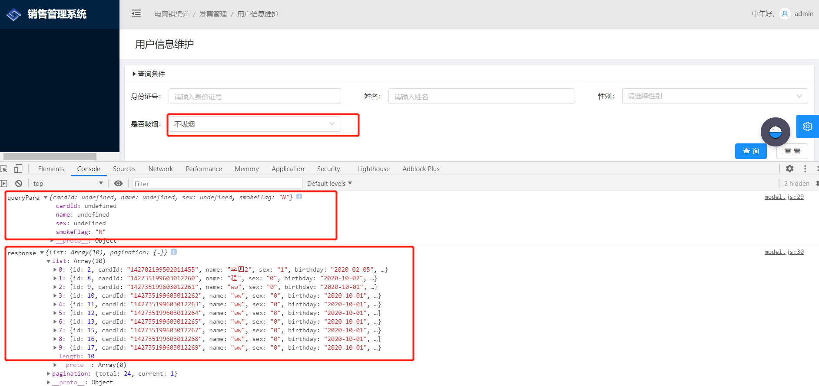

后端的查询部分：

/**  
* 查询所有用户信息  
* @param testUserInfoDTO  
* @param pageable  
* @return  
*/  
 @PostMapping("/test-user-infos/fetch") //与前端对应  
 @Timed  
 public ResponseEntity<List<TestUserInfoDTO>> getAllTestUserInfos(@RequestBody TestUserInfoDTO testUserInfoDTO, Pageable pageable) {  
 log.debug("REST request to get laBankAccNo by criteria: {}", testUserInfoDTO);  
 Page<TestUserInfoDTO> page = testUserInfoQueryService.getAllUserInfo(testUserInfoDTO , pageable);  
 HttpHeaders headers = PaginationUtil.generatePaginationHttpHeaders(page, "/api/test-user-infos/fetch");  
 return ResponseEntity.ok().headers(headers).body(page.getContent());  
 }

/**  
 * 查询所有用户信息，分页  
 *  
 * @param testUserInfoDTO  
 * @param pageable  
 * @return  
 */  
 public Page<TestUserInfoDTO> getAllUserInfo(TestUserInfoDTO testUserInfoDTO, Pageable pageable) {  
 StringBuffer sql = new StringBuffer();  
 Map<String, Object> paraMap = new HashMap<>();  
 // sql.append("select t.ID,t.CARDID,t.NAME,t.SEX,t.BIRTHDAY,t.HOMEADDRESS,t.PHONE,t.PHONE,t.MOBILE,t.EMAIL,t.SMOKEFLAGE from TestUserInfo t where 1=1 ");  
 // 拼sql  
 sql.append("select t.* from TestUserInfo t where 1=1 ");  
 //身份证号  
 if (testUserInfoDTO.getCardId() != null && !"".equals(testUserInfoDTO.getCardId())) {  
 // 用构参的方式，防止sql注入  
 paraMap.put("cardId", testUserInfoDTO.getCardId());  
 sql.append(" and t.CARDID in (:cardId)");  
 }  
  
 //姓名  
 if (testUserInfoDTO.getName() != null && !"".equals(testUserInfoDTO.getName())) {  
 paraMap.put("name", "%" + testUserInfoDTO.getName() + "%");  
 sql.append(" and t.NAME LIKE :name ");  
 }  
  
 //性别  
 if (testUserInfoDTO.getSex() != null && !"".equals(testUserInfoDTO.getSex())) {  
 paraMap.put("sex", testUserInfoDTO.getSex());  
 sql.append(" and t.SEX= :sex ");  
 }  
  
 //出生日期  
 if (testUserInfoDTO.getBirthday() != null && !"".equals(testUserInfoDTO.getBirthday())) {  
 paraMap.put("birthday", testUserInfoDTO.getBirthday());  
 sql.append(" and t.BIRTHDAY = :birthday ");  
 }  
  
 //家庭住址  
 if (testUserInfoDTO.getHomeAddress() != null && !"".equals(testUserInfoDTO.getHomeAddress())) {  
 paraMap.put("homeaddress", testUserInfoDTO.getHomeAddress());  
 sql.append(" and t.HOMEADDRESS = :homeaddress ");  
 }  
  
 //电话  
 if (testUserInfoDTO.getPhone() != null && !"".equals(testUserInfoDTO.getPhone())) {  
 paraMap.put("phone", testUserInfoDTO.getPhone());  
 sql.append(" and t.PHONE = :phone ");  
 }  
  
 //手机号码  
 if (testUserInfoDTO.getMobile() != null && !"".equals(testUserInfoDTO.getMobile())) {  
 paraMap.put("mobile", testUserInfoDTO.getMobile());  
 sql.append(" and t.MOBILE = :mobile ");  
 }  
  
 //邮箱  
 if (testUserInfoDTO.getEmail() != null && !"".equals(testUserInfoDTO.getEmail())) {  
 paraMap.put("eamil", testUserInfoDTO.getEmail());  
 sql.append(" and t.EMAIL = :email ");  
 }  
  
 //是否吸烟  
 if (testUserInfoDTO.getSmokeFlag() != null && !"".equals(testUserInfoDTO.getSmokeFlag())) {  
 paraMap.put("smokeflag", testUserInfoDTO.getSmokeFlag());  
 sql.append(" and t.SMOKEFLAG = :smokeflag ");  
 }  
  
 //页面分页查询 查询total  
 StringBuffer countSql = new StringBuffer();  
 countSql.append("select count(1) from ( ").append(sql).append(") a ");  
 Query countQuery = entityManager.createNativeQuery(countSql.toString());  
  
 List<TestUserInfo> list = new ArrayList<>();  
 Query query = entityManager.createNativeQuery(sql.toString(), TestUserInfo.class);  
 //参数化  
 for (Map.Entry<String, Object> entry : paraMap.entrySet()) {  
 String key = entry.getKey();  
 Object value = entry.getValue();  
 query.setParameter(key, value);  
 countQuery.setParameter(key, value);  
 }  
 //查询的总记录数  
 Integer total = (Integer) countQuery.getSingleResult();  
 if (total > 0) {  
 query.setFirstResult(pageable.getPageNumber() * pageable.getPageSize());  
 if (pageable.getPageNumber() == (total / 10) && total % 10 != 0) { //判断是否是最后一页 若是则修改size  
 query.setMaxResults(total % 10);  
 } else {  
 query.setMaxResults(pageable.getPageSize());  
 }  
 list = query.getResultList();  
 }  
  
 Page<TestUserInfoDTO> page = new PageImpl<TestUserInfoDTO>(testUserInfoMapper.toDto(list), pageable, total);  
 return page;  
 }

## 8. 新增和修改：

新增：

*add({ payload, callback }, { call, put }) {  
 const response = yield call(service.post, '/api/test-user-infos/add', payload);  
 if (response) {  
 yield put({  
 type: 'openView',  
 view: 'home',  
 currData: response,  
 });  
 message.success('添加成功!');  
 }  
 if (callback) callback();  
 },

/**  
 * 新增用户信息  
 * @param testUserInfoDTO  
 * @return  
 * @throws URISyntaxException  
 */  
 @PostMapping("/test-user-infos/add")  
 @Timed  
 public ResponseEntity<TestUserInfoDTO> addTestUserInfo(@RequestBody TestUserInfoDTO testUserInfoDTO) throws URISyntaxException {  
 log.debug("REST request to save LaBank : {}", testUserInfoDTO);  
 if (testUserInfoDTO.getId() != null) {  
 throw new BadRequestAlertException("A new laBank cannot already have an ID", ENTITY_NAME, "idexists");  
 }  
 TestUserInfoDTO result = testUserInfoService.save(testUserInfoDTO);  
 return ResponseEntity.created(new URI("/openapi/test-user-infos/add/" + result.getId()))  
 .headers(HeaderUtil.createEntityCreationAlert(ENTITY_NAME, result.getId().toString()))  
 .body(result);  
 }

修改：

*update({ payload, callback }, { call, put }) {  
 const response = yield call(service.put, '/api/test-user-infos', payload);  
 // console.log(response);  
 if (response) {  
 yield put({  
 type: 'openView',  
 view: 'home',  
 currData: response,  
 });  
 message.success('修改成功!');  
 }  
 if (callback) callback();  
 },

@PutMapping("/test-user-infos")  
 @Timed  
 public ResponseEntity<TestUserInfoDTO> updateTestUserInfo(@Valid @RequestBody TestUserInfoDTO testUserInfoDTO) throws URISyntaxException {  
 log.debug("REST request to update TestUserInfo : {}", testUserInfoDTO);  
 if (testUserInfoDTO.getId() == null) {  
 throw new BadRequestAlertException("Invalid id", ENTITY_NAME, "idnull");  
 }  
 TestUserInfoDTO result = testUserInfoService.save(testUserInfoDTO);  
 return ResponseEntity.ok()  
 .headers(HeaderUtil.createEntityUpdateAlert(ENTITY_NAME, testUserInfoDTO.getId().toString()))  
 .body(result);  
 }

可以看到，新增和修改调用的是同一个service方法

public TestUserInfoDTO save(TestUserInfoDTO testUserInfoDTO) {  
 log.debug("Request to save TestUserInfo : {}", testUserInfoDTO);  
  
 TestUserInfo testUserInfo = testUserInfoMapper.toEntity(testUserInfoDTO);  
 testUserInfo.setOperator(SecurityUtils.getCurrentUserLogin().get());  
 // 新增和修改都需要设置ModifyDate和ModifyTime，写在最前面  
 testUserInfo.setModifyDate(LocalDate.now());  
 testUserInfo.setModifyTime(PubFun.getSimpleCurrentTime());  
 // 如果id是null，代表是新增  
 if( testUserInfo.getId() == null ){  
 testUserInfo.setMakeDate(LocalDate.now());  
 testUserInfo.setMakeTime(PubFun.getSimpleCurrentTime());  
 testUserInfo = testUserInfoRepository.save(testUserInfo);  
 }else {  
 // 否则就是修改，在这里有个问题，会发现用默认的save()方法做修改的话，MakeDate和MakeTime会为null，所以要自己写修改方法，MakeDate和MakeTime不改就是之前保存的  
 testUserInfoRepository.update(testUserInfo.getHomeAddress() , testUserInfo.getPhone() , testUserInfo.getMobile() , testUserInfo.getEmail(), testUserInfo.getSmokeFlag() , testUserInfo.getModifyDate() , testUserInfo.getModifyTime() , testUserInfo.getId());  
 }  
 return testUserInfoMapper.toDto(testUserInfo);  
 }

修改的方法：

/**  
 * 修改用户信息  
 * @param homeAddress  
 * @param phone  
 * @param mobile  
 * @param email  
 * @param smokeFlag  
 * @param id  
 * @return  
 */  
 @Modifying  
 @Query("update TestUserInfo set HOMEADDRESS =?1 , PHONE = ?2 , MOBILE = ?3 , EMAIL = ?4 , SMOKEFLAG = ?5 ,MODIFYDATE = ?6 , MODIFYTIME = ?7 where ID = ?8")  
 Integer update(String homeAddress, String phone, String mobile, String email, String smokeFlag, LocalDate modifyDate , String modifyTime, Long id );  
}

## 9. 删除

前端：

*delete({ payload, callback }, { call, put }) {  
 const response = yield call(service.del, '/api/test-user-infos', payload);  
 if (response) {  
 yield put({  
 type: 'fetch',  
 queryPara: {},  
 });  
 }  
 if (callback) callback();  
 },

后端：

@DeleteMapping("/test-user-infos/{id}")  
 @Timed  
 public ResponseEntity<Void> deleteTestUserInfo(@PathVariable Long id) {  
 log.debug("REST request to delete TestUserInfo : {}", id);  
 testUserInfoService.delete(id);  
 return ResponseEntity.ok().headers(HeaderUtil.createEntityDeletionAlert(ENTITY_NAME, id.toString())).build();  
 }

## 10.分页

前端分页：

在home.js里找到Table标签，添加onChange()方法

<Table  
 rowSelection={{  
 selectedRowKeys,  
 onChange: this.onSelectChange,  
 columnWidth: 45,  
 getCheckboxProps: () => ({  
 disabled: true,  
 }),  
 }} // 表格是否可复选  
 dataSource={data.list}  
 columns={this.getColumns()}  
 rowKey={record => record.id}  
 onChange={this.queryPage}  
 // pagination={data.pagination}  
 pagination={{  
 current: current1,  
 total: data.pagination != null ? data.pagination.total : '', //从后台获取  
 }}  
 loading={loading}  
 size={config.tablesize}  
 bordered={config.tableboard}  
/>

添加onChange的queryPage方法

queryPage = pagination => {  
 const {  
 dispatch,  
 testUserInfo: { queryPara },  
 } = this.props;  
 setTimeout(() => {  
 this.setState({  
 rowSN: (pagination.current - 1) * 10,  
 current1: pagination.current,  
 });  
 }, 0);  
 const rowSN = pagination.current;  
 queryPara.page = pagination.current - 1;  
 queryPara.size = 10;  
 dispatch({  
 type: 'testUserInfo/fetch',  
 queryPara,  
 });  
 dispatch({  
 type: 'testUserInfo/resetNum', //重置分页序号  
 rowSN,  
 });  
};

在render中的state定义current1

const { selectedRowKeys , current1 } = this.state;

点击查询时需要重置current1和rowSN

cz = () => {  
 setTimeout(() => {  
 this.setState({  
 rowSN: 0,  
 current1: 1,  
 });  
 }, 0);  
 };

<div className={styles.tableListForm}>  
 <QueryAdvance cz={this.cz} clearSelect={this.clearSelect} triggerRef={this.bindRef}/>  
</div>

在引入查询模块时传过去，查询时调用cz()方法

handleSearch = e => {  
 e.preventDefault();  
 const { dispatch, form, clearSelect,cz } = this.props;  
 cz();  
}

model.js里调用的就是封装好的pagePost接口，会在路径后拼接size

*fetch({ queryPara, callback }, { call, put }) {  
 const response = yield call(service.pagePost, '/api/test-user-infos/fetch', queryPara);  
 yield put({  
 type: 'save',  
 payload: response,  
 queryPara,  
 });  
 if (callback) callback(response);  
 },

可以在page里的services下的api.js里查看，里面也封装了一些其他接口

export async function pagePost(url, values) {  
 // console.info(values.page);  
 const params2 = {};  
 if (values.page) {  
 params2.page = values.page;  
 }  
 if (values.size) {  
 params2.size = values.size;  
 } else {  
 params2.size = 10;  
 }  
 const str = stringify(params2);  
 let newUrl = url;  
 if (str) {  
 newUrl = `${url}?${str}`;  
 }  
 return request(newUrl, {  
 method: 'POST',  
 body: {  
 ...values,  
 method: 'post',  
 },  
 });  
}

后端分页：

resource层：

@PostMapping("/test-user-infos/fetch")  
@Timed  
public ResponseEntity<List<TestUserInfoDTO>> getAllTestUserInfos(@RequestBody TestUserInfoDTO testUserInfoDTO, Pageable pageable) {  
 log.debug("REST request to get laBankAccNo by criteria: {}", testUserInfoDTO);  
 Page<TestUserInfoDTO> page = testUserInfoQueryService.getAllUserInfo(testUserInfoDTO , pageable);  
 HttpHeaders headers = PaginationUtil.generatePaginationHttpHeaders(page, "/api/test-user-infos/fetch");  
 return ResponseEntity.ok().headers(headers).body(page.getContent());  
}

service层：

/**  
 * 查询所有用户信息  
 *  
 * @param testUserInfoDTO  
 * @param pageable  
 * @return  
 */  
 public Page<TestUserInfoDTO> getAllUserInfo(TestUserInfoDTO testUserInfoDTO, Pageable pageable) {  
 StringBuffer sql = new StringBuffer();  
 Map<String, Object> paraMap = new HashMap<>();  
 // sql.append("select t.ID,t.CARDID,t.NAME,t.SEX,t.BIRTHDAY,t.HOMEADDRESS,t.PHONE,t.PHONE,t.MOBILE,t.EMAIL,t.SMOKEFLAGE from TestUserInfo t where 1=1 ");  
 sql.append("select t.* from TestUserInfo t where 1=1 ");  
  
 //身份证号  
 if (testUserInfoDTO.getCardId() != null && !"".equals(testUserInfoDTO.getCardId())) {  
 paraMap.put("cardId", testUserInfoDTO.getCardId());  
 sql.append(" and t.CARDID in (:cardId)");  
 }  
  
 //姓名  
 if (testUserInfoDTO.getName() != null && !"".equals(testUserInfoDTO.getName())) {  
 paraMap.put("name", "%" + testUserInfoDTO.getName() + "%");  
 sql.append(" and t.NAME LIKE :name ");  
 }  
  
 //性别  
 if (testUserInfoDTO.getSex() != null && !"".equals(testUserInfoDTO.getSex())) {  
 paraMap.put("sex", testUserInfoDTO.getSex());  
 sql.append(" and t.SEX= :sex ");  
 }  
  
 //出生日期  
 if (testUserInfoDTO.getBirthday() != null && !"".equals(testUserInfoDTO.getBirthday())) {  
 paraMap.put("birthday", testUserInfoDTO.getBirthday());  
 sql.append(" and t.BIRTHDAY = :birthday ");  
 }  
  
 //家庭住址  
 if (testUserInfoDTO.getHomeAddress() != null && !"".equals(testUserInfoDTO.getHomeAddress())) {  
 paraMap.put("homeaddress", testUserInfoDTO.getHomeAddress());  
 sql.append(" and t.HOMEADDRESS = :homeaddress ");  
 }  
  
 //电话  
 if (testUserInfoDTO.getPhone() != null && !"".equals(testUserInfoDTO.getPhone())) {  
 paraMap.put("phone", testUserInfoDTO.getPhone());  
 sql.append(" and t.PHONE = :phone ");  
 }  
  
 //手机号码  
 if (testUserInfoDTO.getMobile() != null && !"".equals(testUserInfoDTO.getMobile())) {  
 paraMap.put("mobile", testUserInfoDTO.getMobile());  
 sql.append(" and t.MOBILE = :mobile ");  
 }  
  
 //邮箱  
 if (testUserInfoDTO.getEmail() != null && !"".equals(testUserInfoDTO.getEmail())) {  
 paraMap.put("eamil", testUserInfoDTO.getEmail());  
 sql.append(" and t.EMAIL = :email ");  
 }  
  
 //是否吸烟  
 if (testUserInfoDTO.getSmokeFlag() != null && !"".equals(testUserInfoDTO.getSmokeFlag())) {  
 paraMap.put("smokeflag", testUserInfoDTO.getSmokeFlag());  
 sql.append(" and t.SMOKEFLAG = :smokeflag ");  
 }  
  
  
 //页面分页查询 查询total  
 StringBuffer countSql = new StringBuffer();  
 countSql.append("select count(1) from ( ").append(sql).append(") a ");  
 Query countQuery = entityManager.createNativeQuery(countSql.toString());  
  
 List<TestUserInfo> list = new ArrayList<>();  
 Query query = entityManager.createNativeQuery(sql.toString(), TestUserInfo.class);  
 //参数化  
 for (Map.Entry<String, Object> entry : paraMap.entrySet()) {  
 String key = entry.getKey();  
 Object value = entry.getValue();  
 query.setParameter(key, value);  
 countQuery.setParameter(key, value);  
 }  
 //查询的总记录数，返回给前端  
 Integer total = (Integer) countQuery.getSingleResult();  
 if (total > 0) {  
 query.setFirstResult(pageable.getPageNumber() * pageable.getPageSize());  
 if (pageable.getPageNumber() == (total / 10) && total % 10 != 0) { //判断是否是最后一页 若是则修改size  
 query.setMaxResults(total % 10);  
 } else {  
 query.setMaxResults(pageable.getPageSize());  
 }  
 list = query.getResultList();  
 }  
 Page<TestUserInfoDTO> page = new PageImpl<TestUserInfoDTO>(testUserInfoMapper.toDto(list), pageable, total);  
 return page;  
 }

## 11. 导入

导入的目的是用户可以根据导入模板，上传自己写好的excel文件，通过Java解析，将excel文件里的数据添加到数据库里面

像新增修改那样，点击导入按钮的时候，打开一个新视图，这个页面我们可以复制过来别人的

首先在index.js里配置一下复制过来的upload.js

let result = <Home />;  
 if (currView === 'edit') {  
 result = <Edit />;  
 }else if(currView === 'upload'){  
 result = <Uploading /> // 这里写Uploading，是因为upload.js里写的是export default Uploading;  
 }  
return result;

在home.js里新增一个导入按钮

{/* 导入 */}  
<Button  
 style={{ marginRight: 23 }}  
 type="primary"  
 disabled={loading}  
 onClick={() =>  
 dispatch({ type: 'testUserInfo/openView', view: 'upload'}) //点击按钮，触发点击事件，会打开upload.js  
 }  
>  
 <FormattedMessage id="testUserInfo.home.importConfig" /> //这里自己改国际化  
</Button>

upload.js

import React, { PureComponent } from 'react';  
import { connect } from 'dva';  
import { Form, Card, Button, Icon, Upload,message,Select,notification } from 'antd';  
import { FormattedMessage, formatMessage } from 'umi/locale';  
import PageHeaderWrapper from '@/components/PageHeaderWrapper';  
import styles from '@/assets/styles/common.less';  
  
const FormItem = Form.Item;  
  
  
@connect(({ testUserInfo, loading, config, codeselect }) => ({  
 testUserInfo,  
 config,  
 codeselect,  
 loading: loading.models.testUserInfo,  
}))  
@Form.create()  
class Uploading extends PureComponent {  
 state = {  
 fileList: [],  
 };  
  
 // 导入模板  
 modelExport = () => {  
 const { dispatch } = this.props;  
 dispatch({  
 type: 'testUserInfo/modelExport',  
 payload: 'export',  
 });  
 };  
  
 // 上传  
 handleUpload = () => {  
 const { fileList } = this.state;  
 const { dispatch, form } = this.props;  
 const type = 'testUserInfo/upload';  
 const formData = new FormData();  
 if (fileList.length === 0) {  
 message.warn(formatMessage({ id: 'mapping.message.warning.file' }));  
 return;  
 }  
  
 if (fileList.length > 1) {  
 message.warn(formatMessage({ id: 'mapping.message.warning.one' }));  
 return;  
 }  
 fileList.forEach(file => {  
 formData.append('file', file, encodeURI(file.name));  
 // 校验excel格式  
 const fileName = file.name;  
 const extend = fileName.substring(fileName.lastIndexOf('.'));  
 if(!(extend === '.xlsx' || extend === '.xls') ){  
 notification.warning({  
 message: '提示',  
 description: '文件格式错误，请导入EXCEL文件！',  
 duration: 3,  
 });  
 }  
 else {  
 dispatch({  
 type,  
 payload: formData,  
 });  
 }  
 });  
  
 };  
  
 render() {  
 const {  
 testUserInfo: { queryPara },  
 form: { getFieldDecorator },  
 config,  
 codeselect,  
 loading,  
 dispatch,  
 } = this.props;  
 const itemLayout = {  
 labelCol: {  
 xs: { span: 24 },  
 sm: { span: 11 },  
 },  
 wrapperCol: {  
 xs: { span: 24 },  
 sm: { span: 12 },  
 md: { span: 10 },  
 },  
 };  
 const { fileList } = this.state;  
 const props = {  
 dispatch,  
 onRemove: file => {  
 this.setState(state => {  
 const index = state.fileList.indexOf(file);  
 const newFileList = state.fileList.slice();  
 newFileList.splice(index, 1);  
 return {  
 fileList: newFileList,  
 };  
 });  
 },  
 beforeUpload: file => {  
 this.setState(state => ({  
 fileList: [...state.fileList, file],  
 }));  
 return false;  
 },  
 fileList,  
 };  
  
 return (  
 <PageHeaderWrapper title={<FormattedMessage id="testUserInfo.packagepzdr" />}>  
 <Form style={{ marginTop: 8 }} className={styles.tableListForm}>  
 <Card bordered={config.cardboard} size={config.cardsize} className={styles.card}>  
 {/* 导入文件 */}  
 <FormItem {...itemLayout} label={<FormattedMessage id="aRisk.dr" />}>  
 {getFieldDecorator('uploadFile', {  
 rules: [{ required: true, message: '导入文件不能为空!' }],  
 initialValue: queryPara.uploadFile,  
 })(  
 <Upload {...props}>  
 <Button>  
 <Icon type="upload" /> 请选择导入文件  
 </Button>  
 </Upload>  
 )}  
 </FormItem>  
  
 <span>  
 备注：点击此处<a disabled={loading} onClick={this.modelExport}>下载导入模板</a>  
 </span>  
 <div style={{ overflow: 'hidden' }}>  
 <div style={{ textAlign: 'center' }}>  
 {/* 执行 */}  
 <Button type="primary" htmlType="submit" disabled={loading} onClick={this.handleUpload}>  
 <FormattedMessage id="aRisk.zx" />  
 </Button>  
 {/* 取消 */}  
 <Button  
 type="primary"  
 style={{ marginLeft: 8 }}  
 onClick={() => dispatch({ type: 'testUserInfo/openView', view: 'home' })}  
 >  
 <FormattedMessage id="global.cancle" />  
 </Button>  
 </div>  
 </div>  
 </Card>  
 </Form>  
 </PageHeaderWrapper>  
 );  
 }  
}  
  
export default Uploading;

前端页面到这里就配置好了，

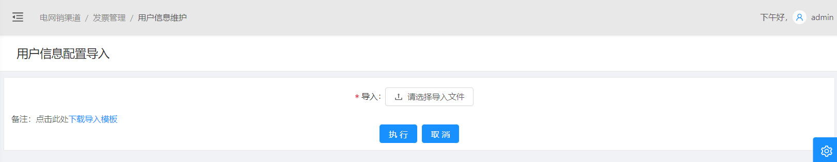

接下来是实现导入模板

在upload.js里，点击下载导入模板连接，会调用modelExport()方法

// 导入模板  
 modelExport = () => {  
 const { dispatch } = this.props;  
 dispatch({  
 type: 'testUserInfo/modelExport',  
 payload: 'export',  
 });  
 };

跳到model.js里的modelExport()方法

// 导入模板下载  
 *modelExport({ payload }, { call }) {  
 yield call(  
 service.port,  
 '/api/test-user-infos/PackageConfigImport/modelExport',  
 payload,  
 'TestUserInfoConfigImport.xlsx' //下载好的文件名  
 );  
 },

用到的是api中封装好的port接口

export async function port(url, values, filename) {  
 return fetch(url, {  
 method: 'POST',  
 headers: {  
 Accept: 'application/json',  
 'Content-Type': 'application/json; charset=utf-8',  
 Authorization: `Bearer ${localStorage.getItem('token')}`,  
 },  
 body: JSON.stringify(values),  
 }).then(response => {  
 if (response.status !== 200 && response.status !== 201) {  
 message.error('出错了，请将错误信息excel反馈给管理员');  
 }  
 response.blob().then(blob => {  
 saveAs(blob, filename);  
 });  
 });  
}

根据路径，调用后端方法

resource层：

//下载导入模板  
 @PostMapping("/test-user-infos/PackageConfigImport/modelExport")  
 @Timed  
 public ResponseEntity<byte[]> newModelExport(@RequestBody String requestMap) throws IOException {  
 log.debug("REST request to exportProjects");  
 return testUserInfoService.newModelExport();  
 }

service层：

/** 导入模板下载 */  
 public ResponseEntity<byte[]> newModelExport() throws IOException {  
 InputStream stream = getClass().getClassLoader().getResourceAsStream("static/tempExcel/TestUserInfoConfigImport.xlsx");  
 XSSFWorkbook xssfWorkbook = new XSSFWorkbook(stream);  
 // 直接导出模板--不许写入数据  
 XSSFSheet sheet = xssfWorkbook.getSheetAt(0);  
 ExcelExportUtil edl = new ExcelExportUtil(xssfWorkbook,sheet);  
 return edl.outputExcelName(xssfWorkbook, "TestUserInfoConfigImport.xlsx" );  
 }

记得将自己写好的导入模板放在static/tempExcel这里

点击执行的时候，会调用handleUpload()方法,会进行excel格式校验，再转发到model.js

// 上传  
handleUpload = () => {  
 const { fileList } = this.state;  
 const { dispatch, form } = this.props;  
 const type = 'testUserInfo/upload';  
 const formData = new FormData();  
 if (fileList.length === 0) {  
 message.warn(formatMessage({ id: 'mapping.message.warning.file' }));  
 return;  
 }  
 if (fileList.length > 1) {  
 message.warn(formatMessage({ id: 'mapping.message.warning.one' }));  
 return;  
 }  
 fileList.forEach(file => {  
 formData.append('file', file, encodeURI(file.name));  
 // 校验excel格式  
 const fileName = file.name;  
 const extend = fileName.substring(fileName.lastIndexOf('.'));  
 if(!(extend === '.xlsx' || extend === '.xls') ){  
 notification.warning({  
 message: '提示',  
 description: '文件格式错误，请导入EXCEL文件！',  
 duration: 3,  
 });  
 }  
 else {  
 dispatch({  
 type,  
 payload: formData,  
 });  
 }  
 });  
  
};

在model.js里实现upload()方法

// 上传导入文件  
*upload({ payload, callback }, { call, put }) {  
 const response = yield call(  
 service.upload,  
 `/api/test-user-infos/PackageConfigImport`,  
 payload  
 );  
 // 系统异常提示  
 if (response.code === '-1') {  
 notification.error({  
 message: '系统异常,请联系运维人员!',  
 description: response.message,  
 duration: 3, // 三秒自动关闭，可以自定义，不加默认4.5  
 });  
 }  
 if (response.code === '1') {  
 notification.warning({  
 message: '提示：',  
 description: response.message,  
 duration: 3,  
 });  
 }  
 if (response.code === '0') {  
 notification.success({  
 message: '提示：',  
 description: response.message,  
 duration: 3,  
 });  
 }  
 yield put({  
 type: 'uploadFile',  
 currData: response,  
 });  
 if (callback) callback();  
},

进入后端，

resource层：

/** 上传导入文件 */  
@PostMapping("/test-user-infos/PackageConfigImport")  
@Timed  
public ResponseEntity<NError> packageConfigImport(@RequestParam("file") MultipartFile file) throws URISyntaxException {  
 log.debug("Request to save PackageConfig");  
 NError nError = testUserInfoService.packageConfigImport(file);  
 return ResponseEntity.created(new URI("/api/test-user-infos/PackageConfigImport"))  
 .headers(HeaderUtil.createEntityCreationAlert(ENTITY_NAME,""))  
 .body(nError);  
}

service层：

/**  
 * 上传导入文件  
 * @param file  
 * @return  
 */  
public NError packageConfigImport(MultipartFile file) {  
 log.debug("Request to save PackageConfig");  
 NError nError = new NError();  
 InputStream is = null;  
 Workbook wb = null;  
  
 try{  
 TestUserInfoDTO laFile = UpLoadUtilTest.uploadFile(file,"static/fileupload/","");  
 File tempFile = new File(laFile.getFilePath());  
 //根据新建的文件实例化输入流  
 is = new FileInputStream(tempFile);  
 //根据文件名判断文件是2003版本还是2007版本  
 if(ExcelImportUtil.isExcel2007(laFile.getFileName())){  
 wb = new XSSFWorkbook(is);  
 }else{  
 wb = new HSSFWorkbook(is);  
 }  
 nError= importData(wb);//校验excel文件  
 //删除上传的临时文件  
 if(tempFile.exists()){  
 tempFile.delete();  
 }  
 }catch(Exception e){  
 e.getStackTrace();  
 nError.setCode("-1");  
 nError.setClassName("Class: TestUserInfoService");  
 nError.setFunctionName("Function: TestUserInfoConfigImport");  
 nError.setErrorMessage("Exception: "+e.getClass().getName());  
 nError.addErrorInfoMessage();  
 return nError;  
 } finally {  
 if (is != null) {  
 try {  
 is.close();  
 } catch (IOException e) {  
 e.printStackTrace();  
 }  
 }  
 }  
 return nError;  
}

/**  
 * 校验保存excel数据  
 * @param wb  
 * @return  
 */  
 public NError importData(Workbook wb){  
 NError nError = new NError();  
 String operator = SecurityUtils.getCurrentUserLogin().get();  
 LocalDate currentDate = PubFun.getCurrentLocalDate();  
 String currentTime = PubFun.getSimpleCurrentTime();  
 // 得到第一个sheet  
 Sheet sheet1 = wb.getSheetAt(0);  
 try {  
 //校验表单数据--上传excle中的sheet名字必须跟模板一样  
 String sheetName1 = sheet1.getSheetName();  
 if (!"用户信息导入模板".equals(sheetName1)) {  
 nError.setCode("1");  
 nError.setMessage("请使用页面下载的模板上传数据！");  
 return nError;  
 }  
  
 }catch (Exception e) {  
 nError.setCode("1");  
 nError.setMessage("解析Excel失败，是否文件类型不正确？");  
 return nError;  
 }  
  
 try{  
 //获取第一个sheet页  
 //数据为空，模板行有4行  
 if (sheet1.getLastRowNum() < 5) {  
 nError.setCode("1");  
 nError.setMessage("至少添加一条记录，请调整重试！");  
 return nError;  
 }  
  
 int sheet1LastRowNum = sheet1.getLastRowNum(); // 看看sheet1有多少行  
 // System.out.println(sheet1LastRowNum);  
 for(int i=4;i<=sheet1LastRowNum;i++){  
 int num = i+1;  
 Row row = sheet1.getRow(i);  
 if (row == null) {  
 nError.setCode("1");  
 nError.setMessage("表格中存在空白行，请调整重试！");  
 return nError;  
 }  
 Cell cell1 = row.getCell(1);  
 cell1.setCellType(CellType.STRING);  
 if(cell1 == null || "".equals(cell1.getStringCellValue().trim())){  
 nError.setCode("1");  
 nError.setMessage("解析数据失败，第"+num+"行身份证号不能为空！");  
 return nError;  
 }  
 //将excel数据与数据库对比不能重复，在用户输入身份证的时候可以用excel自带的数据校验重复项来实现  
 String cardId = cell1.getStringCellValue();  
 //select * from TestUserInfo where CARDID = '142735199603012259'  
 String csql = "select count(*) from TestUserInfo where CARDID =?1 ";  
 Query cquery = entityManager.createNativeQuery(csql);  
 cquery.setParameter(1,cardId);  
 Integer resultList = (Integer) cquery.getSingleResult();  
 //System.out.println(resultList);  
 if (resultList>0){  
 nError.setCode("1");  
 nError.setMessage("解析数据失败，第"+num+"行身份证号已存在！");  
 return nError;  
 }  
  
 }  
  
 // 校验后进行数据处理  
 for (int i=4;i<=sheet1LastRowNum;i++) {  
 // 先获取每一行  
 Row row = sheet1.getRow(i);  
 // 再获取当前行的每个单元格  
 //身份证号  
 Cell cell1 = row.getCell(1);  
 String cardId = getStringCellValue(cell1); //这里自己写的一个方法，用来获取单元格的内容  
 //姓名  
 Cell cell2 = row.getCell(2);  
 String name = getStringCellValue(cell2);  
 //性别  
 Cell cell3 = row.getCell(3);  
 String sex = getStringCellValue(cell3);  
 sex = "女".equals(sex)?"0":"1";   
 //出生日期  
 Cell cell4 = row.getCell(4);  
 String birthday = getStringCellValue(cell4);  
 //家庭住址  
 Cell cell5 = row.getCell(5);  
 String homeAddress = getStringCellValue(cell5);  
 //电话  
 Cell cell6 = row.getCell(6);  
 String phone = getStringCellValue(cell6);  
 //手机号码  
 Cell cell7 = row.getCell(7);  
 String mobile = getStringCellValue(cell7);  
 //邮箱  
 Cell cell8 = row.getCell(8);  
 String email = getStringCellValue(cell8);  
 //是否吸烟  
 Cell cell9 = row.getCell(9);  
 String smokeFlag = getStringCellValue(cell9);  
 smokeFlag = "是".equals(smokeFlag)?"Y":"N";  
 //将数据插入数据库中  
 String csql = "insert into TestUserInfo(CARDID,NAME,SEX,BIRTHDAY,HOMEADDRESS,PHONE,MOBILE,EMAIL,SMOKEFLAG,OPERATOR,MAKEDATE,MAKETIME) values (?1,?2,?3,?4,?5,?6,?7,?8,?9,?10,?11,?12)";  
 Query cquery = entityManager.createNativeQuery(csql);  
 cquery.setParameter(1,cardId).setParameter(2,name).setParameter(3,sex)  
 .setParameter(4,birthday).setParameter(5,homeAddress).setParameter(6,phone)  
 .setParameter(7,mobile).setParameter(8,email)  
 .setParameter(9,smokeFlag).setParameter(10,operator).setParameter(11,currentDate)  
 .setParameter(12,currentTime);  
 cquery.executeUpdate();  
 }  
  
 }  
 catch(Exception e){  
 e.printStackTrace();  
 nError.setCode("-1");  
 nError.setClassName("Class: TestUserInfoService");  
 nError.setFunctionName("Function: importData");  
 nError.setErrorMessage("Exception: "+e.getClass().getName());  
 nError.addErrorInfoMessage();  
 return nError;  
 }  
 nError.setCode("0");  
 nError.setMessage("导入成功");  
 return nError;  
 }

// 获取单元格的内容  
private static String getStringCellValue(Cell cell){  
 if (cell==null){  
 return null;  
 }else {  
 cell.setCellType(CellType.STRING); //将单元格的类型转化为String类型  
 return cell.getStringCellValue().trim();  
 }  
}

## 12. 导出

首先在home.js里添加导出按钮

{/* 导出 */}  
<Button type="primary" onClick={this.export} loading={loading}>  
 <FormattedMessage id="aRisk.dc" />  
</Button>

这里用到了父子组件，因为是根据查询条件来导出相关的内容

// 从this.child取出方法  
export = () => {  
 this.child.printExcel();  
};

在queryAdvance.js里写导出方法

// 打印报表  
printExcel = () => {  
 const { form, dispatch } = this.props;  
 form.validateFields((err, fieldsValue) => {  
 if (err) return;  
 // 导出  
 // 报表名称  
 const fileName = `TestUserInfoPrint.xlsx`;  
 // console.log('export',fieldsValue);  
 dispatch({  
 type: 'testUserInfo/export',  
 queryPara: fieldsValue,  
 exportName: fileName,  
 });  
 });  
};

父子组件传递属性

const { dispatch,triggerRef } = this.props;  
triggerRef(this); // 把子组件中的方法，属性带到父组件

// 把子组件中的方法属性放入this.child中  
bindRef = ref => { this.child = ref };  
<QueryAdvance cz={this.cz} clearSelect={this.clearSelect} triggerRef={this.bindRef}/>

在model.js里写export方法

// 导出  
*export({ queryPara,exportName}, { call }) {  
 yield call(service.port, '/api/test-user-infos/testUserInfoExport', queryPara, exportName);  
},

跳转到后端：

resource层：

/**  
 * 导出  
 * @param queryPara  
 * @return  
 * @throws IOException  
 */  
@PostMapping("/test-user-infos/testUserInfoExport")  
@Timed  
public ResponseEntity<byte[]> testUserInfoExport(@RequestBody TestUserInfoQueryParaModel queryPara) throws IOException {  
 log.debug("export agentInfoList by queryPara : {}",queryPara );  
 return testUserInfoService.testUserInfoExport(queryPara);  
}

service层：

/**  
 * 用户信息导出  
 * @param queryPara  
 * @return  
 */  
 public ResponseEntity<byte[]> testUserInfoExport(TestUserInfoQueryParaModel queryPara) throws IOException {  
  
 //查询要导出的明细信息  
 List<TestUserInfo> modelList = testUserInfoQueryService.testUserInfoExportQuery(queryPara);  
  
 // 0、设置导入模板  
 // 1.1、找到模板的位置  
 InputStream stream = getClass().getClassLoader().getResourceAsStream("static/tempExcel/TestUserInfoConfigImport.xlsx");  
 // 1.2、读取excel模板  
 XSSFWorkbook xssfWorkbook = new XSSFWorkbook(stream);  
 SXSSFWorkbook wb = new SXSSFWorkbook(xssfWorkbook,100);  
 // 1.3、读取了模板内所有sheet内容。(这里只读取第1个sheet页）  
 //Sheet sheet = wb.getSheetAt(0);  
 XSSFSheet sheet = xssfWorkbook.getSheetAt(0);  
 // 1.4、将wb sheet 初始化到ExcelExportUtil文件中去  
 ExcelExportUtil1 edl = new ExcelExportUtil1(wb,sheet);  
  
 // 1.5 设置一下打印样式  
 // （1）字体  
 XSSFFont font = xssfWorkbook.createFont();  
 font.setFontName("宋体");  
 font.setFontHeightInPoints((short)10);  
 CellStyle cellStyle = wb.createCellStyle();  
 cellStyle.setFont(font);  
 // (2) 边框  
 cellStyle.setBorderBottom(BorderStyle.THIN); //下边框  
 cellStyle.setBorderLeft(BorderStyle.THIN);//左边框  
 cellStyle.setBorderTop(BorderStyle.THIN);//上边框  
 cellStyle.setBorderRight(BorderStyle.THIN);//右边框  
 //（3）对齐方式  
 cellStyle.setAlignment(HorizontalAlignment.CENTER);  
 cellStyle.setVerticalAlignment(VerticalAlignment.CENTER);  
 //-------------------------------------业务区域开始------------------------------------------  
 // 2、处理业务逻辑(将数据添加进excel表中)  
 XSSFRow row = null;  
 for (int i = 0; i < modelList.size(); i++) {  
 // 2.1、创建list.size()行数据  
 row = sheet.createRow(i + 4); // 在第五行开始写  
 // 2.2、把值一一写进单元格里  
 TestUserInfo model = modelList.get(i);  
 int j = 1; // j 为列号  
 // 目前样式没有什么好方法去设置，目前只通过单个设置单元格处理  
 XSSFCell cell01 = row.createCell(j);  
 cell01.setCellStyle(cellStyle);  
 cell01.setCellValue(model.getCardId() != null ? model.getCardId() : ""); // 身份证号  
 XSSFCell cell02 = row.createCell(++j);  
 cell02.setCellStyle(cellStyle);  
 cell02.setCellValue(model.getName()!=null?model.getName():""); // 姓名  
 XSSFCell cell03 = row.createCell(++j);  
 cell03.setCellStyle(cellStyle);  
 cell03.setCellValue(model.getSex()!=null&&("0".equals(model.getSex()))?"女":"男"); // 性别  
 XSSFCell cell04 = row.createCell(++j);  
 cell04.setCellStyle(cellStyle);  
 cell04.setCellValue(model.getBirthday().toString()!=null?model.getBirthday().toString():""); // 出生日期  
 XSSFCell cell05 = row.createCell(++j);  
 cell05.setCellStyle(cellStyle);  
 cell05.setCellValue(model.getHomeAddress()!=null?model.getHomeAddress():""); // 家庭住址  
 XSSFCell cell07 = row.createCell(++j);  
 cell07.setCellStyle(cellStyle);  
 cell07.setCellValue(model.getPhone()!=null?model.getPhone():""); // 电话  
 XSSFCell cell08 = row.createCell(++j);  
 cell08.setCellStyle(cellStyle);  
 cell08.setCellValue(model.getMobile()!=null?model.getMobile():""); // 手机号码  
 XSSFCell cell09 = row.createCell(++j);  
 cell09.setCellStyle(cellStyle);  
 cell09.setCellValue(model.getEmail()!=null?model.getEmail():""); // 邮箱  
 XSSFCell cell10 = row.createCell(++j);  
 cell10.setCellStyle(cellStyle);  
 cell10.setCellValue(model.getSmokeFlag()!=null&&("Y".equals(model.getSmokeFlag()))?"是":"否"); // 是否吸烟  
 }  
  
 String currdate = PubFun.getSimpleCurrentDate();  
 // 制表时间  
 XSSFCell currdateCell = sheet.getRow(2).getCell(6);  
 currdateCell.setCellValue(currdate);  
  
  
 //-------------------------------------业务区域结束------------------------------------------  
 //**********************************公共信息******************************************************  
 return edl.outputExcelName(wb, "TestUserInfoPrint.xlsx");  
  
 }