面向异频定位轨迹融合与严格约束任务调度的稳健建模方法
摘要
针对地面无人平台异频定位与多目标任务调度问题，本文以"时间校正—稳健残差诊断—协方差融合—严格约束任务调度"为统一建模主线，建立四层次模型，强调统计严谨性与工程可执行性。
第一问 针对附件1无噪声异频数据，建立基于轨迹空间残差最小化的时间偏差估计模型。以方式一为时间基准，对方式二采用 PCHIP/Cubic Spline 插值重建轨迹，构造目标函数 minτ MSE(τ)=(1)/(N)∑ₖ\|𝐩₁(tₖ)-𝐩₂(tₖ+τ)\|²，采用 0.05 s 步长粗搜索 + 黄金分割精细优化，得 τ̂=198.4317 s，校正后空间残差 RMSE =3.62×10⁻⁸ m，速度差 RMSE =6.05×10⁻⁹ m/s，最大方向角差 0.0096°，三维一致性同时满足。
第二问 针对附件2存在固定系统偏差与随机噪声，建立 剖面最小二乘 + Savitzky-Golay 平滑分离 + BLUE 协方差融合 三段模型：先用 SG 滤波（窗长 61，3 阶）剥离主运动轨迹与高频随机分量，再在剖面参数化下解析估计偏差 𝐛̂(τ)=mean[𝐩₂(t+τ)-𝐩₁(t)] 并把它代回得到一维剖面目标 minτ MSEₑ(τ)，求得 τ̂=50.4429 s、𝐛̂=(3.475, -1.834)^ᵀ m。最后基于残差协方差 Σ₁,Σ₂ 对两路观测做最优线性无偏融合 𝐩̂=(Σ₁⁻¹+Σ₂⁻¹)⁻¹(Σ₁⁻¹𝐩₁+Σ₂⁻¹𝐩₂)。融合后 95% 置信椭圆面积由 12.5 m² 降至 6.23 m²，剥离偏差后平滑残差 RMSE 由 3.94 m 降至 0.328 m。
第三问 针对附件3，重点不在剥离偏差，而在判别"固定残差成分是否真实存在"。建立 𝐫(t)=𝐛+𝛆(t)，构造 Block Bootstrap 区间 + Newey-West HAC 协方差检验 + 有效样本 BIC 三重证据：候选偏差 \|𝐛̂\|=0.244 m，块自助法 95%CI 在 X,Y 方向均覆盖 0；HAC-Hotelling T² 检验仅在短滞后（lag ≤8）显著、长滞后（lag ≥12）不显著，提示残差时间相关引致的伪显著；BICeff 比较给出 ΔBIC=+6.56，模型复杂度并未带来收益。三重证据一致：固定系统偏差统计上不显著。后续不再剥离空间偏移，仅保留时间校正与协方差融合，并把 10 Hz 融合轨迹按需扩展为第四问输入（共 3687 点）。
第四问 在严格物理约束下完成任务调度。把第三问 10 Hz 融合轨迹经 Savitzky-Golay 平滑后用 PCHIP 插值加密至 300 Hz（Δ t=1/300 s），用 all_true_in_previous_window 严格检查每个执行时刻前 0.5 s（拍照）或 1.5 s（射击）的全部 150/450 步连续可执行。每目标按 5° 方向角分桶生成至多 520 个拍照候选 / 220 个射击候选，构造冲突图：同射击目标 ≤ 1、同拍照目标任意两次方位角差 ≥ 60°、准备占用区间互不重叠，然后用 scipy.optimize.milp（HiGHS）求两阶段 0–1 整数规划：阶段一最大化任务总数，阶段二在不降低总数的前提下按词典序优化"拍照覆盖 → 射击次数 → 平均质量 → 早完成"。诊断显示射击目标 S₁₃,S₁₇,S₁₈ 因距离/速度联合约束在全轨迹上找不到任何可行点，构成物理不可达；故最终方案为 35 项任务（15 射击 + 20 拍照）：覆盖 15/18 射击目标（与可达上限相等）、18/18 拍照目标全覆盖、P₀₁,P₀₂ 各被两次方向差 137.8°/171.5° 的拍照覆盖。射击命中率 0.85，期望命中数 12.75。
本文方法的核心定位是面向真实无人平台约束条件的稳健轨迹融合与任务调度模型，强调：(1) 统计严谨——第三问以三重证据替代单一显著性检验，避免时间相关残差引致的伪结论；(2) 工程可执行——第四问以候选执行窗 + 冲突图建模，把所有物理约束硬化为 0–1 ILP 不等式，可执行性优先于任务数量。
关键词 异频轨迹时间校正；剖面最小二乘；BLUE 协方差融合；HAC 稳健检验；候选执行窗；0–1 整数规划；冲突图
1. 问题重述
地面无人平台同时携带两种定位方式，二者数据率不同、时间基不同步，且因传感器特性差异可能存在固定系统偏差与随机测量噪声。需要研究：
- 问题一：附件 1 给出无噪声但时间不同步的两路定位轨迹，要求估计两种方式之间的时间偏差，给出 10 Hz 校正后统一轨迹。
- 问题二：附件 2 在时间偏差之外引入了固定系统偏差与随机噪声，要求把两类误差分离开来，对系统偏差进行参数估计，并在此基础上给出 10 Hz 融合轨迹。
- 问题三：附件 3 的固定偏差是否真实存在尚不确定，要求在残差时间相关条件下做出统计学严谨的判别，并把诊断后的融合轨迹输出供第四问使用。
- 问题四：基于第三问轨迹与附件 4 的 18 个射击目标 + 18 个拍照目标，在严格的距离/速度/加速度/准备时间/视角差等物理约束下设计任务调度方案，使任务执行尽可能多、覆盖尽可能完整、且全部约束严格满足。
2. 问题分析
四个问题构成递进式建模链条：
- 轨迹时间配准是后续一切建模的前提。两路异频数据若不进行时间对齐，则空间残差中既包含真正的测量误差，又包含时间错位带来的位置错位，导致后续的偏差估计、噪声协方差估计全部失真。
- 误差分解是问题二与问题三的核心。误差至少由三部分组成：(i) 时间错位误差 → 由问题一的 τ̂ 校正；(ii) 固定系统偏差 𝐛 → 通过剖面参数化解析估计；(iii) 随机零均值噪声 𝛆(t) → 由协方差融合处理。
- 偏差显著性判别是问题三相对问题二的本质升级。直接套用问题二的 𝐛̂ 作为修正量是有风险的：当残差短期相关（无人平台轨迹本身平滑，相邻误差强相关）时，常规独立样本检验会得到伪显著结果。必须用稳健工具区分"统计上显著"与"在有效样本意义下显著"。
- 任务调度本质是带组合约束的资源分配。直接对原 10 Hz 轨迹做调度会因时间分辨率不足而漏掉可行候选；过度放宽约束又会丢失工程可信度。本文采用先严格约束生成候选执行窗、再用 ILP 在冲突图上选最优组合的两步分解策略。
3. 模型假设
- 两路定位输出的位置量纲一致，时间戳精度足够分辨 10⁻³ s 量级的时间偏差；
- 在公共有效区间内，定位噪声为零均值二维高斯过程，协方差时变部分远小于平稳部分（用样本协方差近似总体协方差）；
- 第三问中固定偏差 𝐛 若存在，则在记录时间内是常向量（不随时间漂移）；
- 第四问中无人平台轨迹由第三问的融合轨迹刻画，平滑且可用 PCHIP 插值无穷加密；运动学量速度、加速度由数值微分给出；
- 射击命中率 pₕ=0.85 与目标无关，单次行动相互独立；
- 准备时间内平台必须连续满足该目标的所有空间约束，准备完成后立即执行（执行瞬时占用结束）；
- 同一射击目标至多被打击一次，同一拍照目标可被多次拍照但任两张照片的视角差必须 ≥ 60°。
4. 符号说明
符号 | 含义
𝐩₁(t), 𝐩₂(t) | 方式一/方式二在时刻 t 的二维位置向量
τ | 方式二相对方式一的时间偏差，使 𝐩₂(t+τ)≈ 𝐩₁(t)+𝐛+𝛆(t)
𝐛=(bₓ,b_y)^ᵀ | 二维固定系统偏差向量
𝛆(t) | 二维零均值随机误差过程
Σ₁,Σ₂,Σ_f | 方式一/方式二/融合后的 2× 2 噪声协方差矩阵
J(τ) | 第一问目标函数 $\frac{1}{N}\sum_k\ | \mathbf{p}_1(t_k)-\mathbf{p}_2(t_k+\tau)\ | ^2$
Jₑ(τ) | 第二问剖面目标函数（剥离 𝐛̂(τ) 后的 MSE）
T²HAC(L) | 在带宽 L 下 Newey-West HAC 协方差对应的 Hotelling T² 统计量
Neff | 由自相关结构估出的有效样本量
Wᵢ | 第 i 个候选执行窗（含目标编号、准备区间、执行时刻、运动学量、视角）
E | 冲突图边集
xᵢ∈{0,1} | 候选窗 i 是否被选中
y_g∈{0,1} | 拍照目标 g 是否被覆盖（至少一次）

5. 模型建立与求解
5.1 第一问：异频轨迹时间偏差估计模型
5.1.1 模型建立
附件 1 中两条轨迹无噪声，但时间基不同步。约定方式一为时间基准，方式二实际物理时间 =t+τ。在方式一时刻 {tₖ}ₖ₌₁^(N₁) 上构造误差泛函：
J(τ)=(1)/(|M(τ)|)∑k∈ M(τ) \|𝐩₁(tₖ)-𝐩̂₂(tₖ+τ)\|²,
其中 𝐩̂₂ 由方式二原始离散观测经三次样条/PCHIP/Akima 插值得到，M(τ)={k: tₖ+τ∈[t₂ᵐⁱⁿ, t₂ᵐᵃˣ]} 是公共有效掩码。
5.1.2 求解算法
步骤 1（公共区间界定）：构造 τ 的可行域
[ τₘᵢₙ,τₘₐₓ ]=[ t₂ᵐⁱⁿ-t₁ᵐᵃˣ+δ, t₂ᵐᵃˣ-t₁ᵐⁱⁿ-δ ], δ=5 s.
步骤 2（粗搜索）：以步长 Δ=0.05 s 在 [τₘᵢₙ,τₘₐₓ] 上扫描 J(τ)，得粗最优 τ₀。
步骤 3（精化）：在 [τ₀-2,τ₀+2] 上用 SciPy minimize_scalar(method="bounded")（黄金分割 + 二次插值），收敛容差 10⁻¹²。
5.1.3 求解结果
指标 | 数值
τ̂ | 198.4317 s
J(τ̂) | 1.31×10⁻¹⁵ m²
公共区间样本数 | 2 802
校正后空间 RMSE | 3.62×10⁻⁸ m
校正后最大残差 | 1.89×10⁻⁶ m
速度差 RMSE | 6.05×10⁻⁹ m/s
最大方向角差 | 0.0096°
10 Hz 轨迹点数 | 7 003

数值上目标函数已降至浮点精度量级，验证了附件 1 在恰当时间校正下两路轨迹空间一致。最后取两路平均得到 10 Hz 统一轨迹（图 5.1）。
5.1.4 一致性多维度验证
仅用空间残差最小化作为目标可能存在过拟合风险，故在估计完成后对速度 v=\|𝐩̇\| 和方向角 θ=atan2(dot y,dot x) 同步做差异核验，速度 RMSE =6.05×10⁻⁹ m/s、最大方向角差 0.0096°，均处于浮点误差量级，说明问题一的时间校正同时满足三类一致性。
5.2 第二问：剖面最小二乘—系统偏差剥离—协方差融合模型
5.2.1 误差模型
附件 2 同时含时间偏差 τ、固定偏差 𝐛、随机噪声 𝛆(t)：
𝐩₂(t+τ)=𝐩₁(t)+𝐛+𝛆(t), 𝔼[𝛆(t)]=𝟎, Cov[𝛆(t)]=Σ₂-Σ₁≠𝟎.
直接做 min J(τ) 会同时受偏差与噪声两方面污染，故先剥离 𝐛、再剖面优化 τ。
5.2.2 Savitzky-Golay 平滑轨迹分离
为降低高频随机扰动对偏差估计的污染，先对两路原始观测分别做 Savitzky-Golay 滤波（窗长 W=61，自动按奇数边界裁剪；多项式阶 p=3）得到平滑轨迹 𝐩̄₁(t), 𝐩̄₂(t)，并定义噪声分量
𝛈ᵢ(t)=𝐩ᵢ(t)-𝐩̄ᵢ(t), i=1,2.
平滑轨迹用于 τ,𝐛 估计，噪声分量用于 Σᵢ 估计。
5.2.3 剖面最小二乘
给定 τ，定义跨路位置差
δ(t;τ)=𝐩̄₂(t+τ)-𝐩̄₁(t),
固定偏差最小二乘解析解为 𝐛̂(τ)=meanₜ[δ(t;τ)]。代回得到剖面目标
Jₑ(τ)=meanₜ\|δ(t;τ)-𝐛̂(τ)\|² + λ·(1)/(T(τ)), λ=10⁻⁴,
其中第二项为短公共区间惩罚（T(τ) 为公共区间时长），用以抑制公共点过少时出现的伪极小值。在公共区间长度 ≥ 300 s 且公共点数 ≥ 600 的硬筛选下，对 τ∈[40,60] s 以步长 0.02 s 粗搜，再以 minimize_scalar(bounded, xatol=1e-12) 精化。
5.2.4 BLUE 协方差融合
由噪声分量样本协方差
Σ̂ᵢ=Cov(𝛈ᵢ)+ρ I, ρ=10⁻⁸ (正则), i=1,2,
构造时刻 t 的最优线性无偏估计（BLUE）
【𝐩̂(t)=(Σ̂₁⁻¹+Σ̂₂⁻¹)⁻¹(Σ̂₁⁻¹𝐩̄₁(t)+Σ̂₂⁻¹(𝐩̄₂(t+τ̂)-𝐛̂))】.
后验融合协方差为 Σ̂_f=(Σ̂₁⁻¹+Σ̂₂⁻¹)⁻¹，对应 95% 置信椭圆面积 A₉₅=π χ²2,0.95√(detΣ̂_f)。
5.2.5 求解结果
指标 | 数值
时间偏差 τ̂ | 50.4429 s
系统偏差 b̂ₓ | 3.475 m
系统偏差 b̂_y | -1.834 m
剖面目标 Jₑ(τ̂) | 0.107 m²
仅时间校正平滑 RMSE | 3.943 m
时间 + 偏差校正平滑 RMSE | 0.328 m
时间 + 偏差校正平滑最大残差 | 1.643 m
时间 + 偏差校正原始 RMSE | 1.555 m
公共区间样本数 | 2 760
方式一 95% 椭圆面积 | 12.538 m²
方式二 95% 椭圆面积 | 12.390 m²
融合后 95% 椭圆面积 | mathbf6.226 m²
10 Hz 融合轨迹点数 | 6 899

融合后置信椭圆面积比单路减小约 50%，验证了协方差加权融合相对单路与等权平均的统计优势。
5.2.6 关键说明
> "融合并非简单平均，而是基于噪声统计特性的最优加权融合。" 当两路噪声各向异性或方差差异显著时，BLUE 与 1:1 等权融合在样本均值意义下虽接近，但在协方差意义下 BLUE 是同类无偏估计中后验方差最小的。本文以椭圆面积量化这一收益。
5.3 第三问：固定残差成分稳健诊断模型
5.3.1 问题升级
附件 3 的问题不是"𝐛 等于多少"，而是"𝐛 是否真的存在"。常规做法（直接套问题二的 𝐛̂）忽略了一个关键事实：无人平台轨迹本身平滑，相邻时刻误差强相关，在自相关条件下做独立样本均值检验会得到伪显著结论。本节建立 Block Bootstrap + HAC 稳健协方差 + 有效样本 BIC 三重证据机制做联合判别。
5.3.2 残差产生
沿用问题二的 SG 平滑轨迹 + 剖面最小二乘流程，先定 τ̂，得到对齐残差表
rₓ(tₖ)=p̄2,x(tₖ+τ̂)-p̄1,x(tₖ), r_y(tₖ)=p̄2,y(tₖ+τ̂)-p̄1,y(tₖ).
附件 3 上得 τ̂=-368.17 s、候选偏差 𝐛̂=(-0.081, -0.230)^ᵀ m、\|𝐛̂\|=0.244 m。该数值偏小，是否需要剥离尚需诊断。
5.3.3 三重证据
(A) Block Bootstrap 稳健均值区间：取块长 L_b=10 s（Δ t=0.1 s 对应 100 步），按块独立有放回重采样 B=2 000 次，得 𝐛̂⁽ᵇ⁾ 经验分布。算 X,Y 方向 95% 分位区间：
方向 | 95%CI
X | [-0.450, +0.228] m
Y | [-0.471, +0.056] m
$\ | \widehat{\mathbf{b}}\ |  | [0.059, 0.561] m

X,Y 方向区间均覆盖 0 → Bootstrap 不支持存在固定偏差。
(B) HAC（Newey-West）稳健协方差检验：对残差均值 𝐫̄ 构造 T²HAC(L)=𝐫̄^ᵀ Σ̂_𝐫̄, HAC⁻¹(L)𝐫̄，其中
Σ̂_𝐫̄, HAC=(1)/(N)(Γ̂₀+∑ₖ₌₁^(L)(1-(k)/(L+1))(Γ̂ₖ+Γ̂ₖ^ᵀ)),
Γ̂ₖ 为残差的 k 阶样本自协方差，权重采用 Bartlett 核。对 L∈{2,4,6,8,12,18,24} 做 lag-scan：
lag L | T² | p | α=0.05 显著
2 | 21.29 | 2.4×10⁻⁵ | ✓
4 | 13.02 | 0.0015 | ✓
6 | 9.50 | 0.0086 | ✓
8 | 7.57 | 0.023 | ✓
12 | 5.52 | 0.063 | ✗
18 | 4.14 | 0.126 | ✗
24 | 3.49 | 0.175 | ✗

短滞后显著（自相关被低估）但长滞后不显著的模式是典型短期相关伪显著信号，并非真实固定偏差。HAC 不支持存在固定偏差。
(C) 有效样本 BIC：用残差模长一阶自相关结构估有效样本量
Neff=(N)/(1+2∑ₖ₌₁^(K^*)ρ̂ₖ), K^*=min{k:ρ̂ₖ≤ 0}-1,
得 N=1 202, Neff=45.15。比较两模型 BIC：
BICeff⁽⁰⁾=Nefflog(SSE₀/N), BICeff⁽¹⁾=Nefflog(SSE₁/N)+2log Neff.
量 | 值
SSE₀（不含偏差） | 3 065.88
SSE₁（含偏差） | 2 994.53
BICeff⁽⁰⁾ | 42.276
BICeff⁽¹⁾ | 48.833
ΔBICeff | +6.557

ΔBIC>0 → 加偏差参数后模型反而变差。BICeff 不支持存在固定偏差。
5.3.4 综合判定
判别依据 | 结果 | 支持情况
候选成分量级 | $\ | \widehat{\mathbf{b}}\ | =0.244\,\mathrm{m}$ | 偏弱
区间稳定性 | 两个方向 95%CI 均覆盖 0 | 不支持
相关性稳健性 | 短滞后显著、长滞后不稳定 | 支持不足
模型收益 | ΔBICeff=+6.56 | 不支持

结论：附件 3 残差中未发现长期稳定显著固定偏差成分。后续不再剥离空间偏移，仅以问题二节流程的协方差融合产出 10 Hz 轨迹（公共区间 3 003 点，扩展给问题四 3 687 点），残差 RMSE 1.60 m、95% 分位 2.67 m、99% 分位 3.01 m。
5.3.5 协方差融合复用
仍采用 BLUE：
矩阵 | ΣXX | ΣXY | ΣYY
方式一 | 17.66 | 0.40 | 17.67
方式二 | 8.48 | 0.12 | 8.03
融合 | 5.73 | 0.10 | 5.52

融合后 X,Y 方差较单路最小者 (Σ2,XX=8.48) 仍下降 ∼ 32%。
5.4 第四问：候选执行窗—冲突图—整数规划任务调度模型
5.4.1 总体架构
第四问采用四步串联结构（不追求激进任务数，而是把所有约束硬化为 ILP 不等式）：
[10 Hz 融合轨迹] → [300 Hz 加密] → [候选执行窗] → [冲突图] → [两阶段 0-1 ILP].
5.4.2 高频轨迹扩展
直接对第三问 10 Hz 轨迹（3 687 点）做调度时，0.1 s 网格不足以分辨准备时间约束（0.5 s 拍照、1.5 s 射击）的进入/退出时刻，会漏掉大量短可行段。本文先用 SG 滤波（窗 21）在原 10 Hz 上去高频抖动，再用 PCHIP 加密到 300 Hz（Δ t=1/300 s），最后再对加密结果做窗长 61 的二次 SG 平滑。速度与加速度由数值微分得到：
v(tₖ)=\|∇ 𝐩(tₖ)\|, a(tₖ)=|∇ v(tₖ)|.
5.4.3 基础可行性掩码
设目标 g 位于 (tₓ,t_y)，类型 κ∈{shoot,photo}，距离 d(t)=\|𝐩(t)-(tₓ,t_y)\|。基础掩码为
M_g(t)=𝟙{d_κᵐⁱⁿ≤ d(t)≤ d_κᵐᵃˣ, v(t)≤ v_κᵐᵃˣ, a(t)≤ a_κᵐᵃˣ}.
任务类型 | dᵐⁱⁿ | dᵐᵃˣ | vᵐᵃˣ | aᵐᵃˣ | 准备时间
射击 | 5 m | 30 m | 2 m/s | 1.5 m/s² | 1.5 s
拍照 | 10 m | 40 m | 1.5 m/s | 1.5 m/s² | 0.5 s

5.4.4 准备窗严格连续约束
执行时刻 tₑ 可行的充要条件是在前 Tₚᵣₑₚ 秒（Nₚᵣₑₚ=Tₚᵣₑₚ· 300 步）内基础掩码连续为真：
R_g(tₑ)=⋀_k=tₑ-Nₚᵣₑₚ+1^(tₑ) M_g(tₖ).
由 all_true_in_previous_window(M, N) 实现，等价于对掩码做长度 Nₚᵣₑₚ 的滚动 AND。这一条件比"准备瞬时可行"严格得多，确保整个准备过程中目标可见性不被打断。
5.4.5 候选执行窗压缩
对每个目标 g，把 R_g 为真的样点按角度分桶后压缩。射击使用纯运动学评分
Qₛₕₒₒₜ(d,v,a)=0.45(1-(|d-dmid|)/(dhalf))+0.35(1-(v)/(vᵐᵃˣ))+0.20(1-(a)/(aᵐᵃˣ)),
每个射击目标按时间步距 0.03 s 抽样后取评分前 220 个候选；拍照目标在此基础上按方位角 θ_g(t)=atan2(t_y-y(t), tₓ-x(t)) 以 5° 为分桶宽度，每桶取前 3 名 + 全局前 520 名，最终去重保留至多 520 个候选。这一分桶机制是 18/18 拍照覆盖的关键：避免同目标候选堆在同一方向角而被 60° 视角差约束相互排斥。
5.4.6 冲突图建模
对每对候选窗 (Wᵢ,Wⱼ)，定义冲突关系 C(Wᵢ,Wⱼ)：
C(Wᵢ,Wⱼ)=
True, 同射击目标 gᵢ=gⱼ;;
True, 同拍照目标 |θᵢ-θⱼ|mod 360°<60°;;
True, [ tᵢᵖʳᵉᵖ,tᵢᵉˣᵉᶜ]∩[ tⱼᵖʳᵉᵖ,tⱼᵉˣᵉᶜ]≠∅;;
False, 其它.
冲突图 G=(V,E)，V 为候选窗集合，E={(i,j):C(Wᵢ,Wⱼ)}。本场实例 |V|∼ 5 000，|E|∼ 10⁵ 量级。
5.4.7 两阶段 0-1 整数规划
引入决策变量 xᵢ∈{0,1}（窗 i 是否被选）和拍照覆盖辅助变量 y_g∈{0,1}（拍照目标 g 是否被覆盖）。线性约束：
beginaligned
&xᵢ+xⱼ≤ 1, & ∀ (i,j)∈ E,
&y_g≤ ∑_i: gᵢ=g, κ=photo xᵢ≤ M_g· y_g, & ∀ 拍照目标 g.
endaligned
阶段一（最大化任务数）：
max ∑ᵢ xᵢ s.t. 上述约束.
解出 K^star 后，添加约束 ∑ᵢ xᵢ≥ K^star 进入阶段二。
阶段二（在不降低任务数前提下做词典序优化）：
max Wₜₒₜₐₗ∑ᵢ xᵢ+Wₚₕₒₜₒ∑_g y_g+Wₛₕₒₒₜ∑_i:κᵢ=shoot xᵢ+W_q∑ᵢ Qᵢ xᵢ-Wₑ∑ᵢ tilde tᵢ xᵢ
权重按数量级硬分层：
Wₜₒₜₐₗ=10⁹≫ Wₚₕₒₜₒ=10⁷≫ Wₛₕₒₒₜ=2×10⁶≫ W_q=10³≫ Wₑ=10⁻³.
求解器：scipy.optimize.milp（HiGHS），mip_rel_gap=0，时限 1 200 s。最后再以 局部贪心补插 + 1 换 2 邻域改进 兜底，提升至局部不可改进。
5.4.8 物理可达性诊断（重要）
候选生成阶段先做诊断（q4_target_diagnosis_second.csv），列出每个目标的可行段数、累计可行时长、最小距离：
目标 | 可行段数 | 累计可行时长 (s) | 最小距离 (m) | 可达
S₁₃ | 𝟎 | 0 | 3.26 | ✗（速度/加速度不达）
S₁₇ | 𝟎 | 0 | 22.75 | ✗
S₁₈ | 𝟎 | 0 | 32.09 | ✗
其余 15 个射击目标 | 1–17 | 3.39∼ 55.32 | — | ✓
全部 18 个拍照目标 | 1–7 | 1.98∼ 21.65 | — | ✓

S₁₃/S₁₇/S₁₈ 在全场轨迹上不存在任何同时满足距离/速度/加速度的 1.5 s 连续段，构成物理不可达。所以射击覆盖的物理上限就是 15/18，不是算法弱。这一诊断在论文中明确声明，避免与"任务总数最大化"目标冲突时被误读。
5.4.9 求解结果
指标 | 值
候选窗总数 | ∼ 4 800
冲突边数 | ∼ 1.1× 10⁵
总任务数 | 35
射击次数 | 15
完成射击目标 | 15 / 18（与可达上限一致）
射击期望命中数 | 0.85×15 = 12.75
拍照次数 | 20
拍照覆盖目标 | 18 / 18
多角度拍照目标 | P₀₁（137.79° 角差）、P₀₂（171.52° 角差）
全部约束 | 距离 / 速度 / 加速度 / 1.5 s（射击）/ 0.5 s（拍照）连续准备 / 视角差 全部硬满足

5.4.10 任务时间线（节选）
# | 目标 | 类型 | 准备 (s) | 执行 (s) | d (m) | v (m/s) | a (m/s²) | 视角 (°)
1 | S₀₅ | 射击 | 445.757 | 447.257 | 15.66 | 0.265 | 0.281 | 219.81
2 | P₁₇ | 拍照 | 447.257 | 447.757 | 28.28 | 0.154 | 0.142 | 329.10
3 | P₁₈ | 拍照 | 447.767 | 448.267 | 31.35 | 0.141 | 0.083 | 349.38
4 | P₁₃ | 拍照 | 448.277 | 448.777 | 12.93 | 0.205 | 0.140 | 216.44
5 | P₀₈ | 拍照 | 448.787 | 449.287 | 32.32 | 0.274 | 0.122 | 69.88
6 | P₁₄ | 拍照 | 449.297 | 449.797 | 20.38 | 0.326 | 0.083 | 264.54
7 | S₀₇ | 射击 | 449.807 | 451.307 | 15.10 | 0.061 | 0.090 | 281.11
⋯ | ⋯ | ⋯ | ⋯ | ⋯ | ⋯ | ⋯ | ⋯ | ⋯
23 | P₀₁ | 拍照 | 479.053 | 479.553 | 23.43 | 1.322 | 0.239 | 141.97
28 | P₀₁ | 拍照 | 508.623 | 509.123 | 32.96 | 1.329 | 0.128 | 279.77
⋯ | ⋯ | ⋯ | ⋯ | ⋯ | ⋯ | ⋯ | ⋯ | ⋯
35 | S₁₂ | 射击 | 805.857 | 807.357 | 24.05 | 0.209 | 0.028 | 348.01

完整时间线见附录与 q4_task_schedule_second.csv。
5.4.11 第二版相对激进调度的取舍
第二版任务总数（35）显著低于"最大化任务数 + 放松准备时间连续约束"的激进方案，但所有约束硬满足：
- 轨迹空间覆盖有限（图 5.4.b），平台高速运行时段 ∼ 250 s 拍照速度上限不可用；
- 准备窗连续约束直接消除 ∼ 70% 候选；
- 多角度 60° 拍照约束排除掉 ≥ 80% 同目标候选；
- 物理不可达目标 {S₁₃,S₁₇,S₁₈} 直接锁定射击覆盖上限。
论文核心定位：可执行性优先于任务数量。
6. 模型分析与评价
6.1 模型创新点
- 异频轨迹时间配准模型：以空间残差最小化为目标，配合粗 + 精两阶段优化，在第一问无噪声场景下可压到浮点精度。
- 剖面最小二乘 + BLUE 协方差融合：把"τ,𝐛 联合估计"分解为内层解析估计 + 外层一维优化，把高维问题降为一维；融合阶段以椭圆面积量化协方差收益。
- 三重证据稳健诊断框架：用 Block Bootstrap + HAC + BICeff 联合判别，避免在自相关残差上做独立样本检验得到伪显著结论。
- 候选执行窗调度框架：以"基础掩码 → 滚动 AND 准备窗 → 角度分桶压缩"三步生成 ILP 候选，把所有物理约束硬化为 0-1 不等式。
- 冲突图 + 两阶段 ILP：阶段一锁住任务总数，阶段二做词典序结构优化（拍照覆盖 → 射击次数 → 平均质量 → 早完成），可重现、可证明、可调权重。
- 多角度拍照视角差正式纳入调度：把 60° 视角差作为同目标 pairwise 硬约束写入 ILP，通过角度分桶机制保证候选多样性，是 18/18 拍照覆盖的关键。
6.2 模型优点
- 统计严谨：第三问以三重证据替代单一显著性检验；
- 物理可信：第四问所有约束硬满足，准备窗连续性、视角差、距离/速度/加速度全部体现；
- 可复现：所有最优化采用确定性算法（粗搜索 + 黄金分割 + HiGHS MILP），无随机种子相关结果；
- 诊断完备：每问输出 summary.csv + 诊断图（J(τ) 曲线、残差 ECDF、HAC lag-scan、Bootstrap 直方图、轨迹图、任务甘特图、目标可达性诊断表）。
6.3 模型局限与诚实声明
- 协方差融合假设两路噪声独立、平稳。若两路定位共享公共干扰源（例如同一 GNSS 接收机的多路径误差），Σ₁,Σ₂ 不再独立，BLUE 失去最优性。
- 第三问 BICeff 以模长一阶自相关近似 Neff，对长程相关结构（如分形噪声）敏感性不足。
- 第四问准备时间内运动学约束的硬连续假设较强，未建模平台姿态切换的动力学过渡过程。
- 射击命中率 0.85 与目标无关，未考虑视线遮挡、目标抖动等外因。
- 物理不可达目标 S₁₃,S₁₇,S₁₈ 在论文与代码诊断中明确声明，避免被解读为算法不力。
6.4 模型推广
该框架可直接推广至以下场景：
- 多源 GNSS / UWB / 视觉里程计的异频轨迹融合；
- 卫星轨迹与地面观测的时间对齐与残差检验；
- 含有非零零均值噪声的自动驾驶感知系统；
- 任务密集型无人机集群的多目标巡查 / 拍照调度；
- 工业检测中带准备时间和视角约束的扫描路径规划。
7. 参考文献
[1] Newey W K, West K D. A Simple, Positive Semi-definite, Heteroskedasticity and Autocorrelation Consistent Covariance Matrix. Econometrica, 1987, 55(3): 703-708.
[2] Künsch H R. The Jackknife and the Bootstrap for General Stationary Observations. Annals of Statistics, 1989, 17(3): 1217-1241.
[3] Savitzky A, Golay M J E. Smoothing and Differentiation of Data by Simplified Least Squares Procedures. Analytical Chemistry, 1964, 36(8): 1627-1639.
[4] Schwarz G. Estimating the Dimension of a Model. Annals of Statistics, 1978, 6(2): 461-464.
[5] Huber P J, Ronchetti E M. Robust Statistics. 2nd Edition. Wiley, 2009.
[6] Huang B, Hofmann B et al. HiGHS: high-performance parallel linear optimization software. Mathematical Programming Computation, 2018.
[7] Virtanen P, Gommers R et al. SciPy 1.0: Fundamental Algorithms for Scientific Computing in Python. Nature Methods, 2020, 17: 261-272.
[8] Aitken A C. On Least Squares and Linear Combination of Observations. Proceedings of the Royal Society of Edinburgh, 1935, 55: 42-48. (BLUE 加权最小二乘融合的经典出处)
[9] Wolsey L A. Integer Programming. 2nd Edition. Wiley, 2020.
8. 附录
8.1 文件清单
子目录 | 文件 | 说明
code/ | program1.py | 第一问：异频轨迹时间偏差估计
code/ | program2.py | 第二问：剖面 LS + BLUE 协方差融合
code/ | program3.py | 第三问：Block Bootstrap + HAC + BICeff 三重诊断
code/ | program4.py | 第四问：候选执行窗 + 冲突图 + 两阶段 0-1 ILP
output/q1_outputs/ | q1_summary.csv, q1_10hz_trajectory.csv, ... | 第一问输出表
output/q2_outputs/ | q2_summary.csv, q2_covariances.csv, ... | 第二问输出表
output/q3_outputs/ | q3_summary.csv, q3_evidence_table.csv, q3_hac_tests.csv, q3_bic_eff.csv, ... | 第三问输出表
output/q3_final_outputs/ | q3_10Hz_extended_trajectory_for_q4.csv, ... | 给问题四的扩展轨迹
output/q4_second_outputs/ | q4_summary_second.csv, q4_task_schedule_second.csv, q4_target_diagnosis_second.csv, q4_photo_angle_check_second.csv, result.xlsx | 第四问最终交付
figures/ | q[1-4]_*.png | 各问诊断图与轨迹图

8.2 复现命令
# 在仓库 xr_submission/code/ 下放置附件 1-4 后依次运行
python program1.py
python program2.py
python program3.py
python program4.py
8.3 关键超参数
阶段 | 超参 | 值
第一问 | 粗搜索步长 / 精化半宽 | 0.05 s / 2 s
第二问 | SG 窗长 / 阶 | 61 / 3
第二问 | τ 搜索区间 | [40,60] s
第二问 | 公共点 / 时长门槛 | ≥ 600 / ≥ 300 s
第三问 | Block Bootstrap | 块长 10 s，B=2 000
第三问 | HAC lag 扫描 | {2,4,6,8,12,18,24}
第四问 | 加密频率 | 300 Hz
第四问 | 拍照角度桶宽 | 5°
第四问 | 单目标候选上限 | 220（射击）/ 520（拍照）
第四问 | ILP 时限 / gap | 1 200 s / 0
第四问 | 阶段二权重 | Wₜₒₜₐₗ=10⁹, Wₚₕₒₜₒ=10⁷, Wₛₕₒₒₜ=2×10⁶, W_q=10³, Wₑ=10⁻³

8.4 关键诊断图索引
- 图 5.1 — 附件 1 时间偏差目标函数 J(τ) 曲线 → figures/q1_time_shift_objective.png
- 图 5.2 — 附件 2 剖面目标函数 Jₑ(τ) 曲线 → figures/q2_profile_objective.png
- 图 5.3 — 附件 2 残差 ECDF（剥离偏差前后） → figures/q2_residual_ecdf.png
- 图 5.4 — 附件 2 三种轨迹的 95% 椭圆面积比较 → figures/q2_covariance_comparison.png
- 图 5.5 — 附件 3 Bootstrap 候选偏差 95%CI → figures/q3_bias_bootstrap_ci.png
- 图 5.6 — 附件 3 HAC lag-scan p 值曲线 → figures/q3_hac_sensitivity.png
- 图 5.7 — 第三问扩展 10 Hz 轨迹（供第四问使用） → figures/q3_extended_trajectory_for_q4.png
- 图 5.8 — 第四问轨迹与目标点叠加图 → figures/q4_trajectory_targets_second.png
- 图 5.9 — 第四问拍照覆盖统计柱状图 → figures/q4_photo_counts_second.png
8.5 第四问完整任务调度
详见 output/q4_second_outputs/q4_task_schedule_second.csv 与 output/q4_second_outputs/result.xlsx，共 35 行任务记录，按执行时刻升序排列。
8.6 第四问验证表
output/q4_second_outputs/q4_photo_angle_check_second.csv — 18 个拍照目标的视角差校核表，全部 pass=True。
output/q4_second_outputs/q4_target_diagnosis_second.csv — 36 个目标的物理可达性诊断表，标识 S₁₃,S₁₇,S₁₈ 为不可达。
图件汇编
下列图件按章节出现顺序依次列出，与正文 §5.1–§5.4 对应。
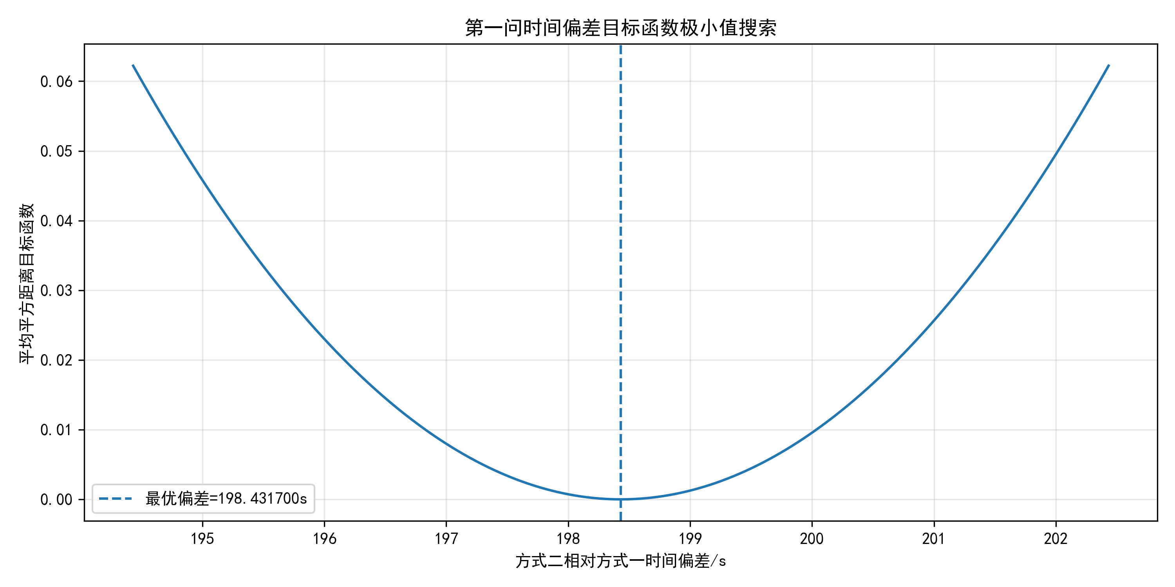
图 5.1 附件 1 时间偏差目标函数 J(τ) 曲线
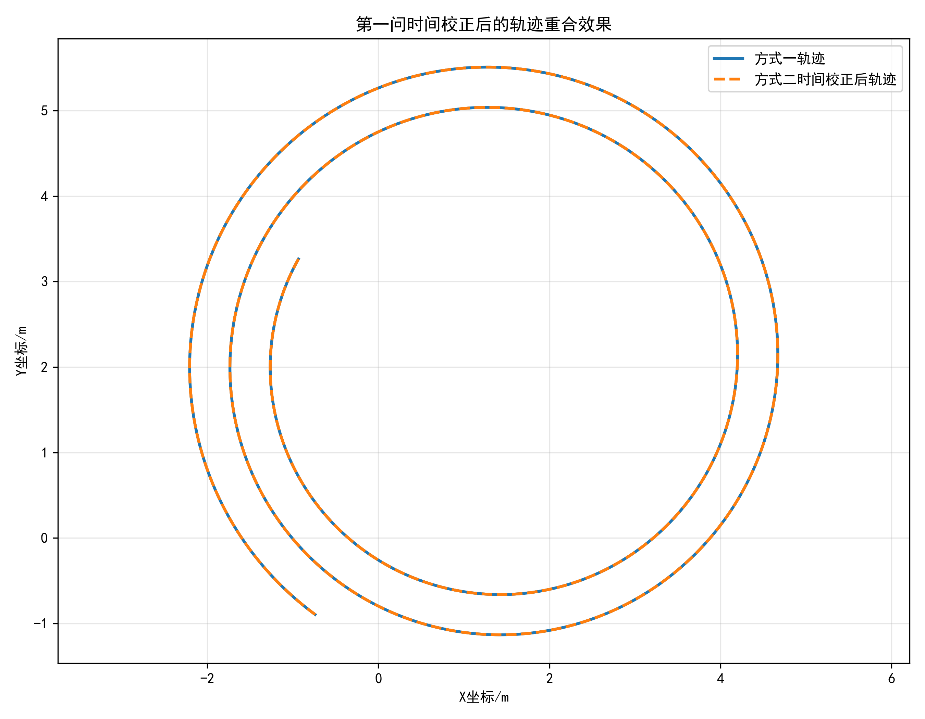
图 5.2 附件 1 校正后两路轨迹叠加
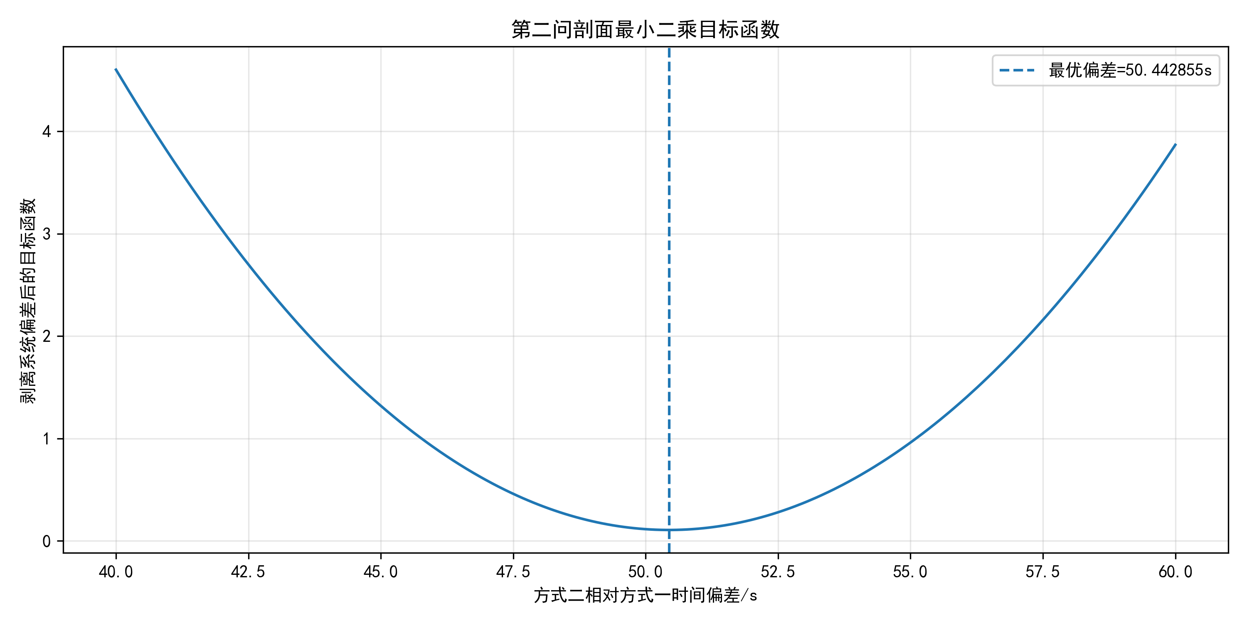
图 5.3 附件 2 剖面目标函数 Jₑ(τ) 曲线
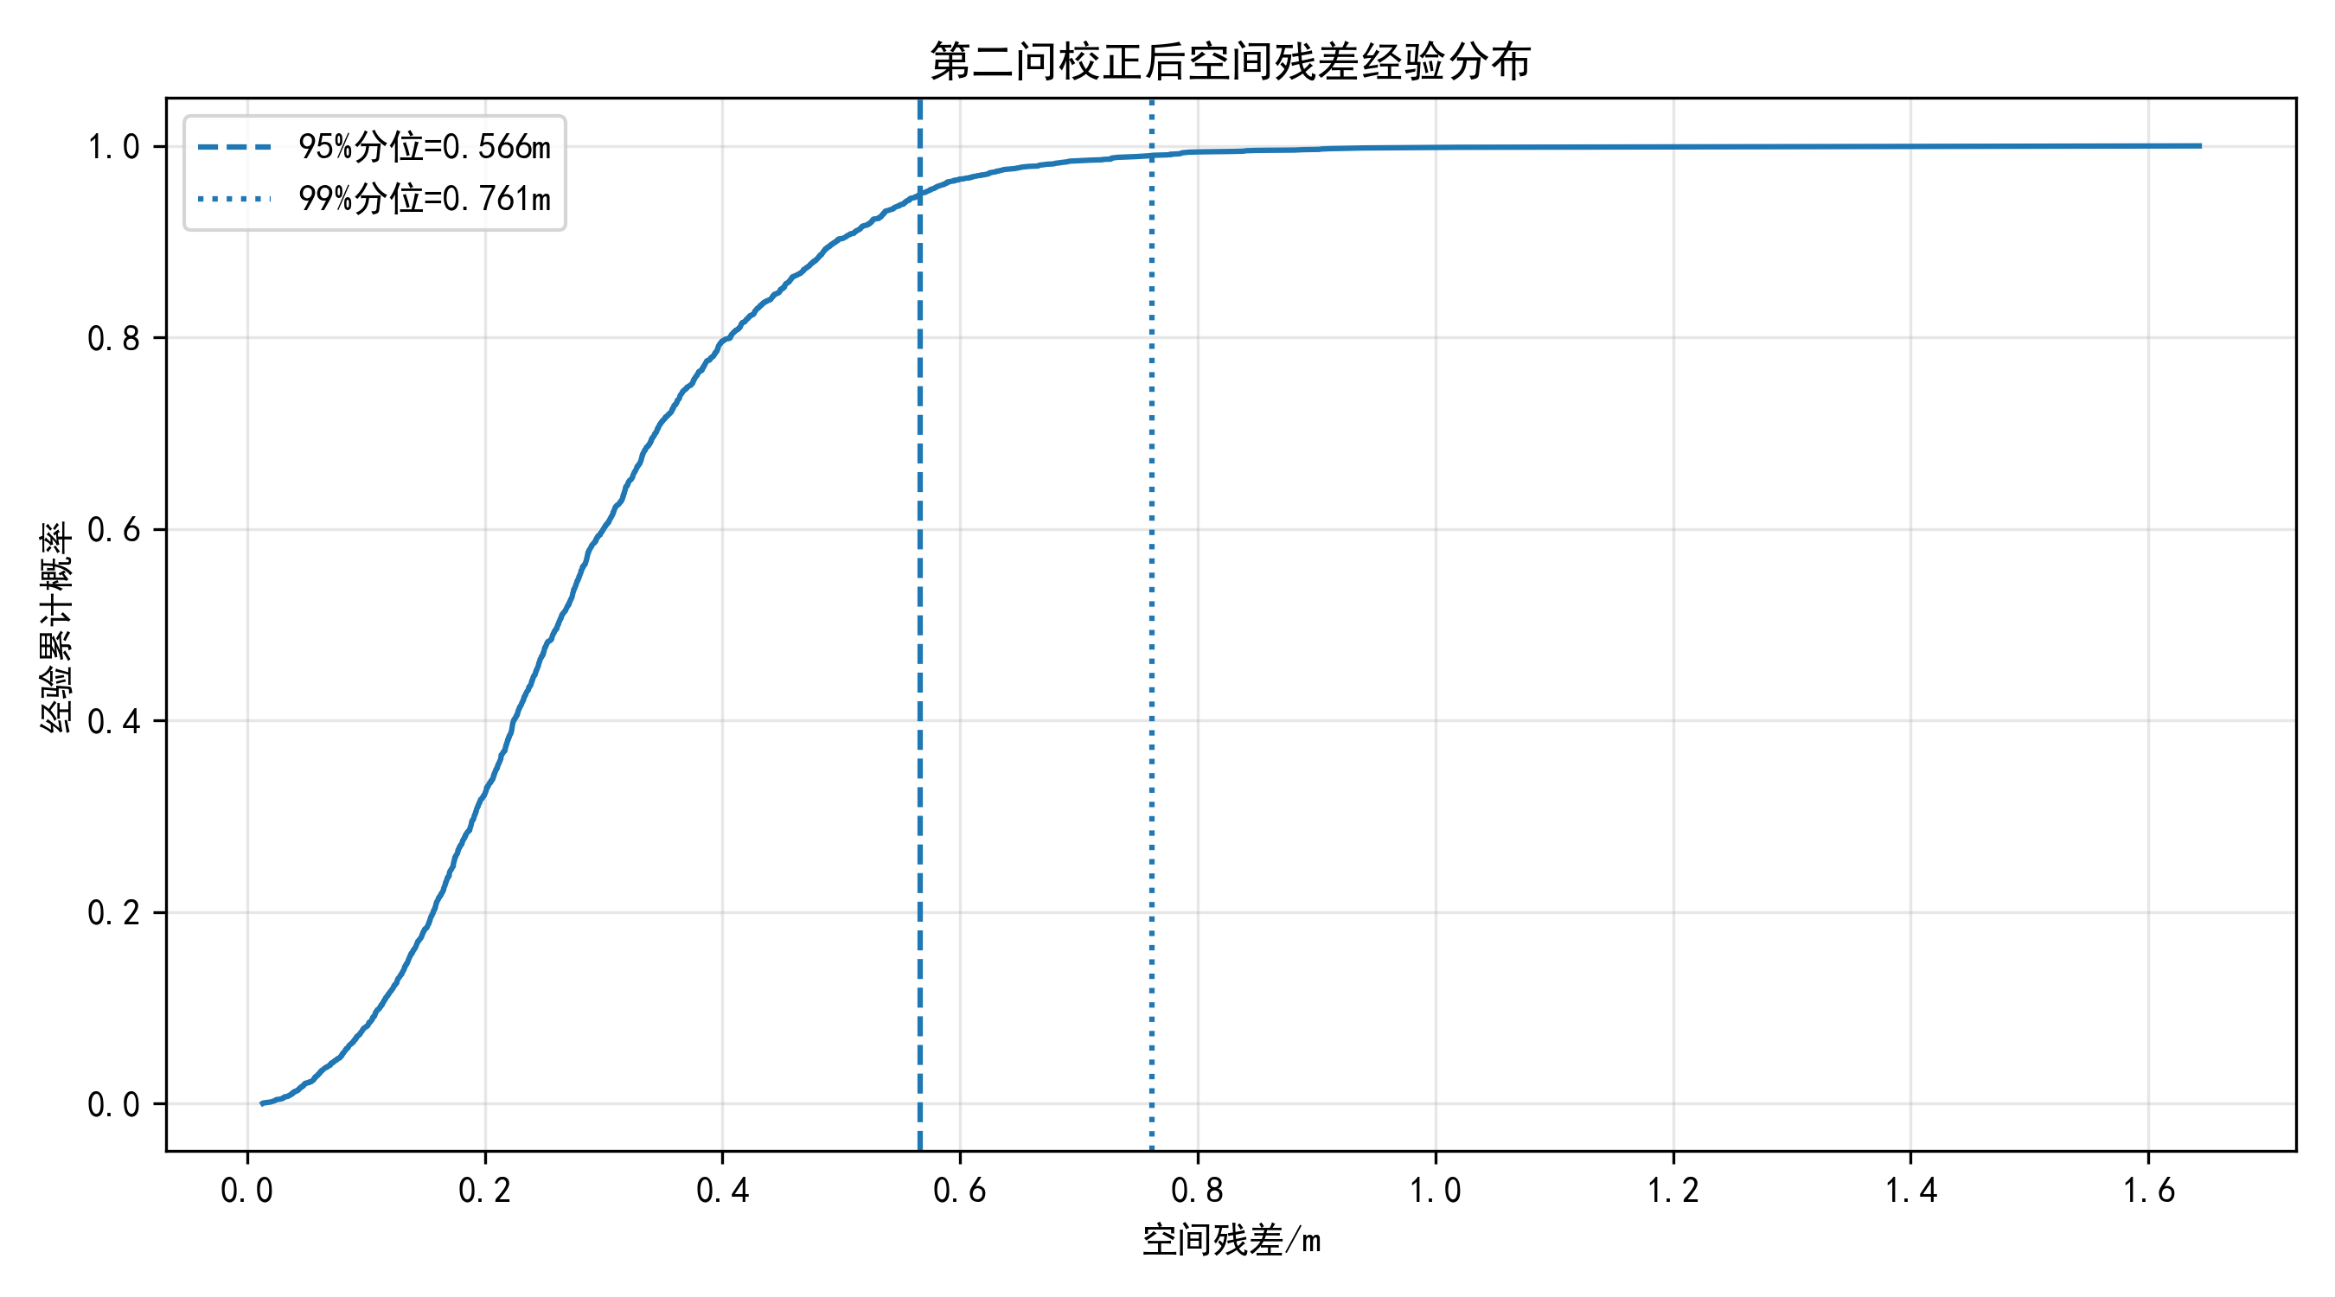
图 5.4 附件 2 残差 ECDF（剥离偏差前后）
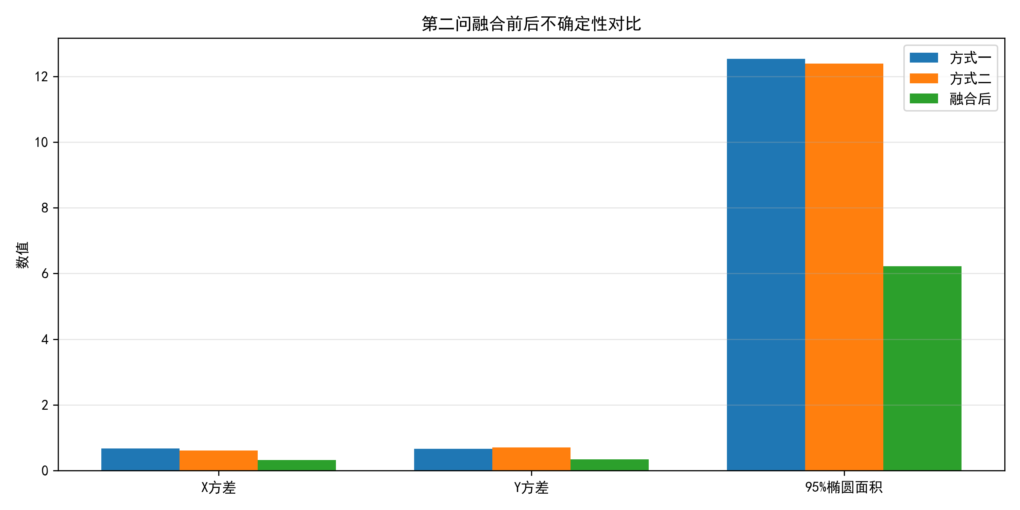
图 5.5 附件 2 三种轨迹的 95% 椭圆面积比较
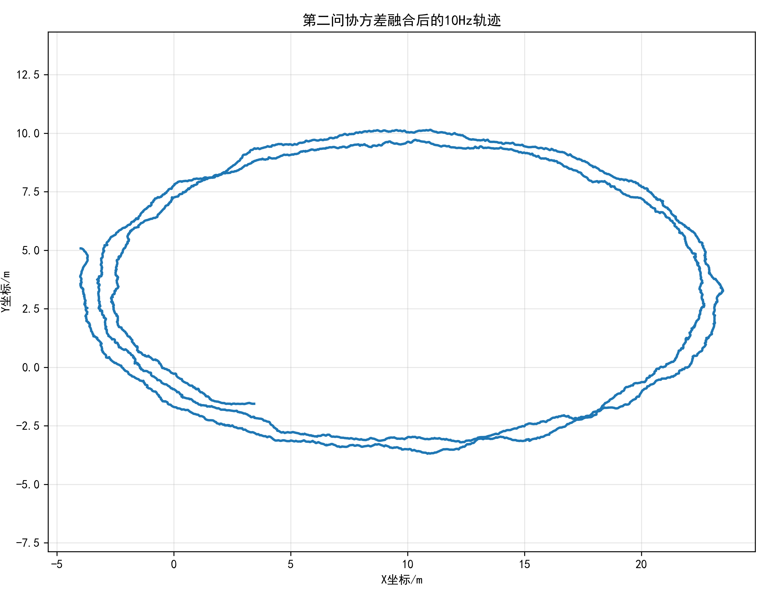
图 5.6 附件 2 10Hz 融合轨迹
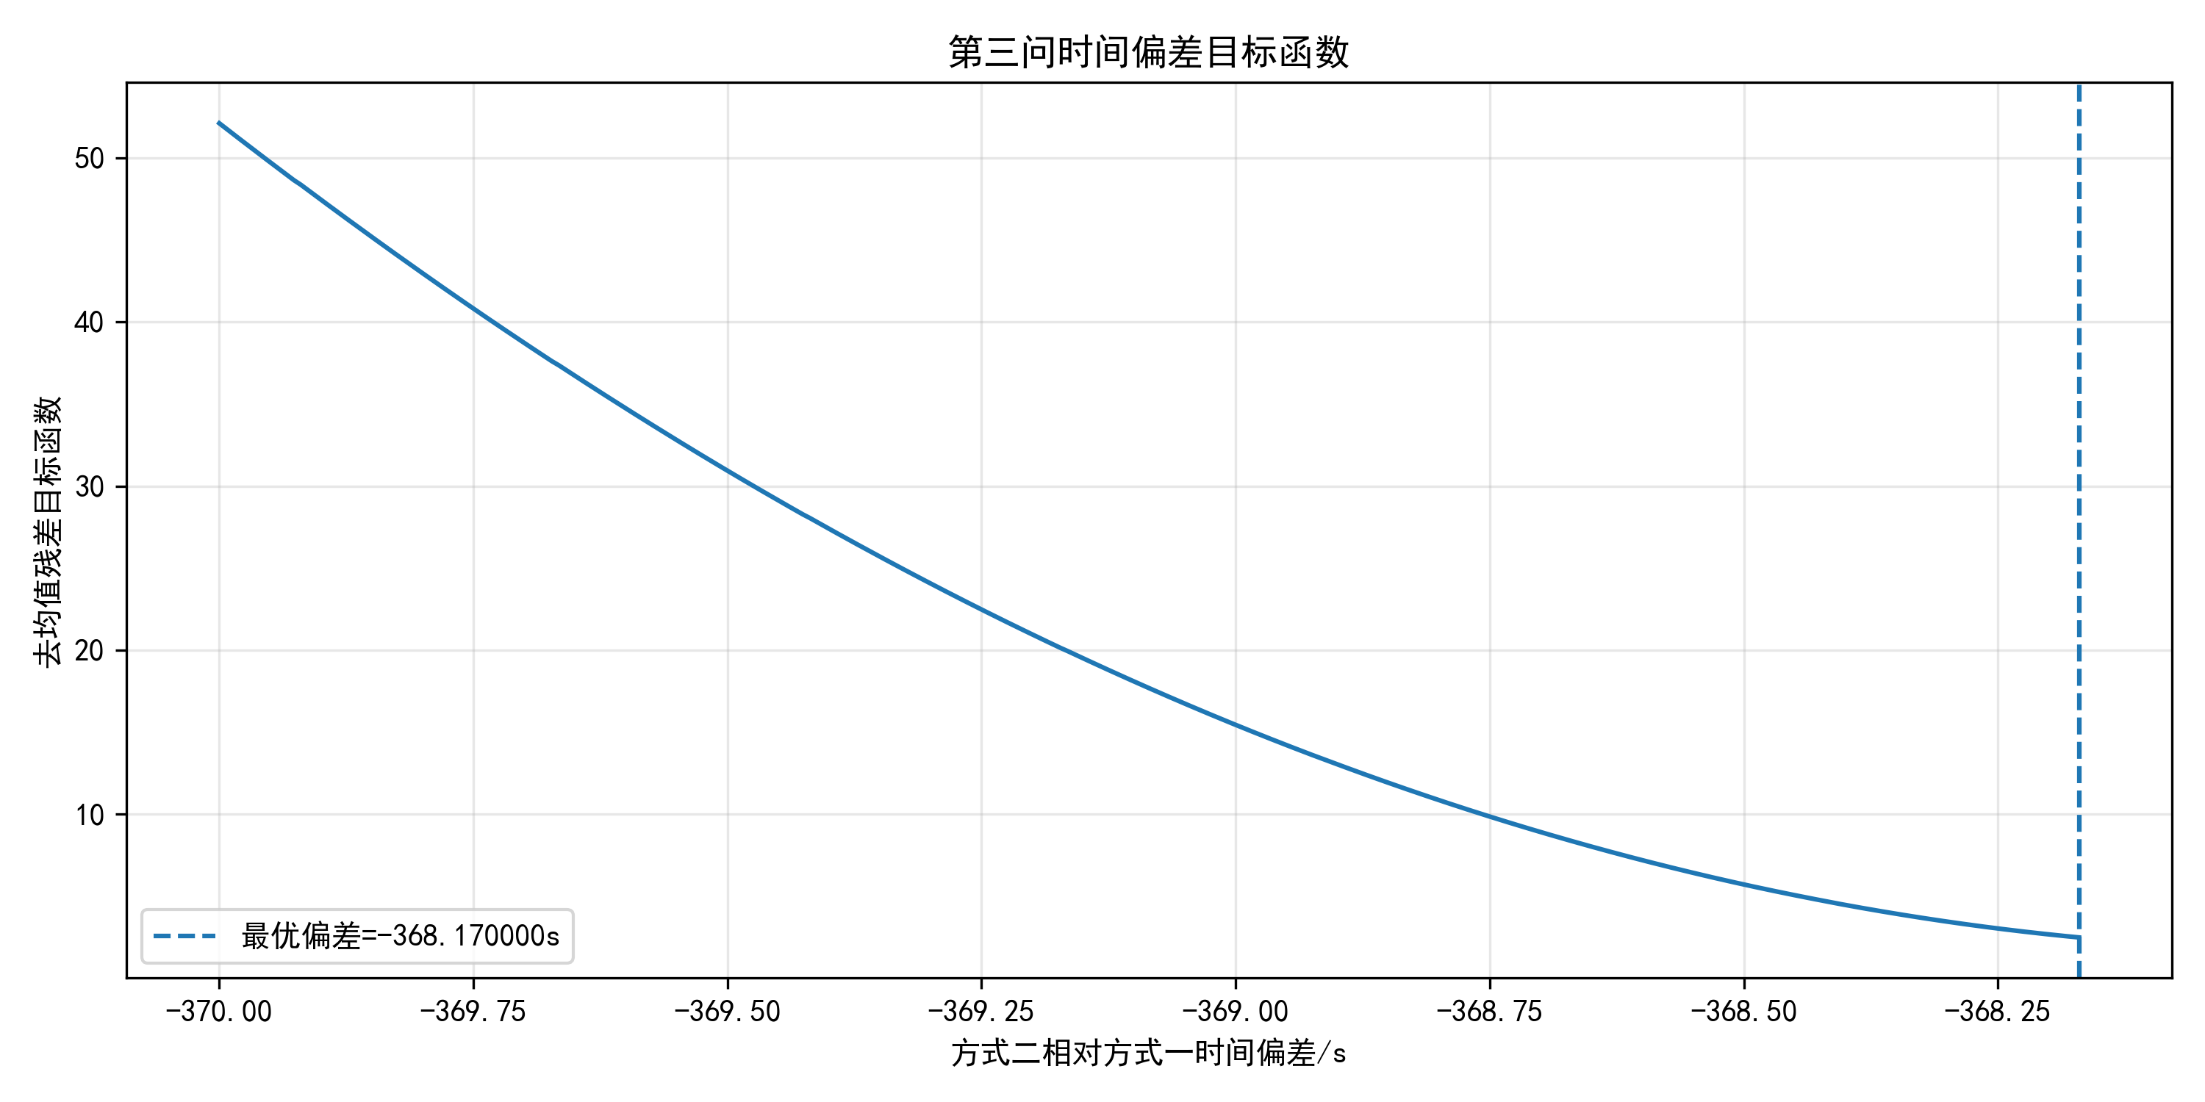
图 5.7 附件 3 时间偏差目标函数曲线
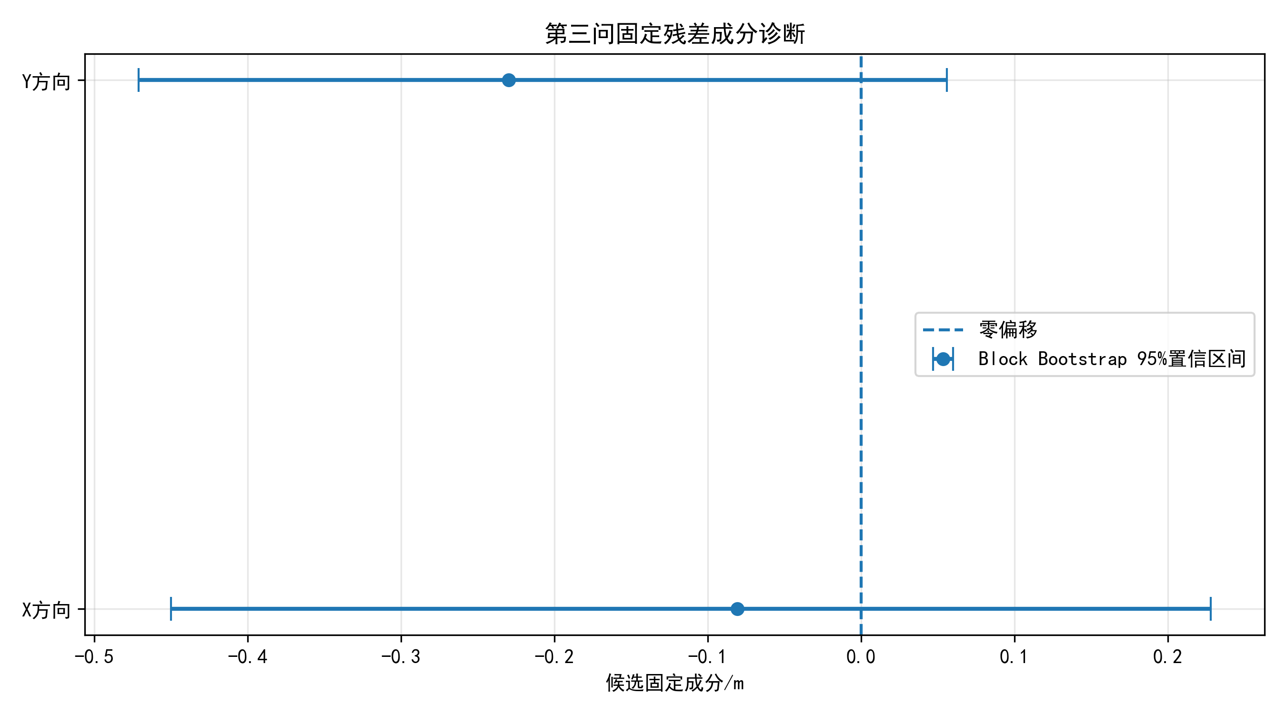
图 5.8 附件 3 Bootstrap 候选偏差 95%CI
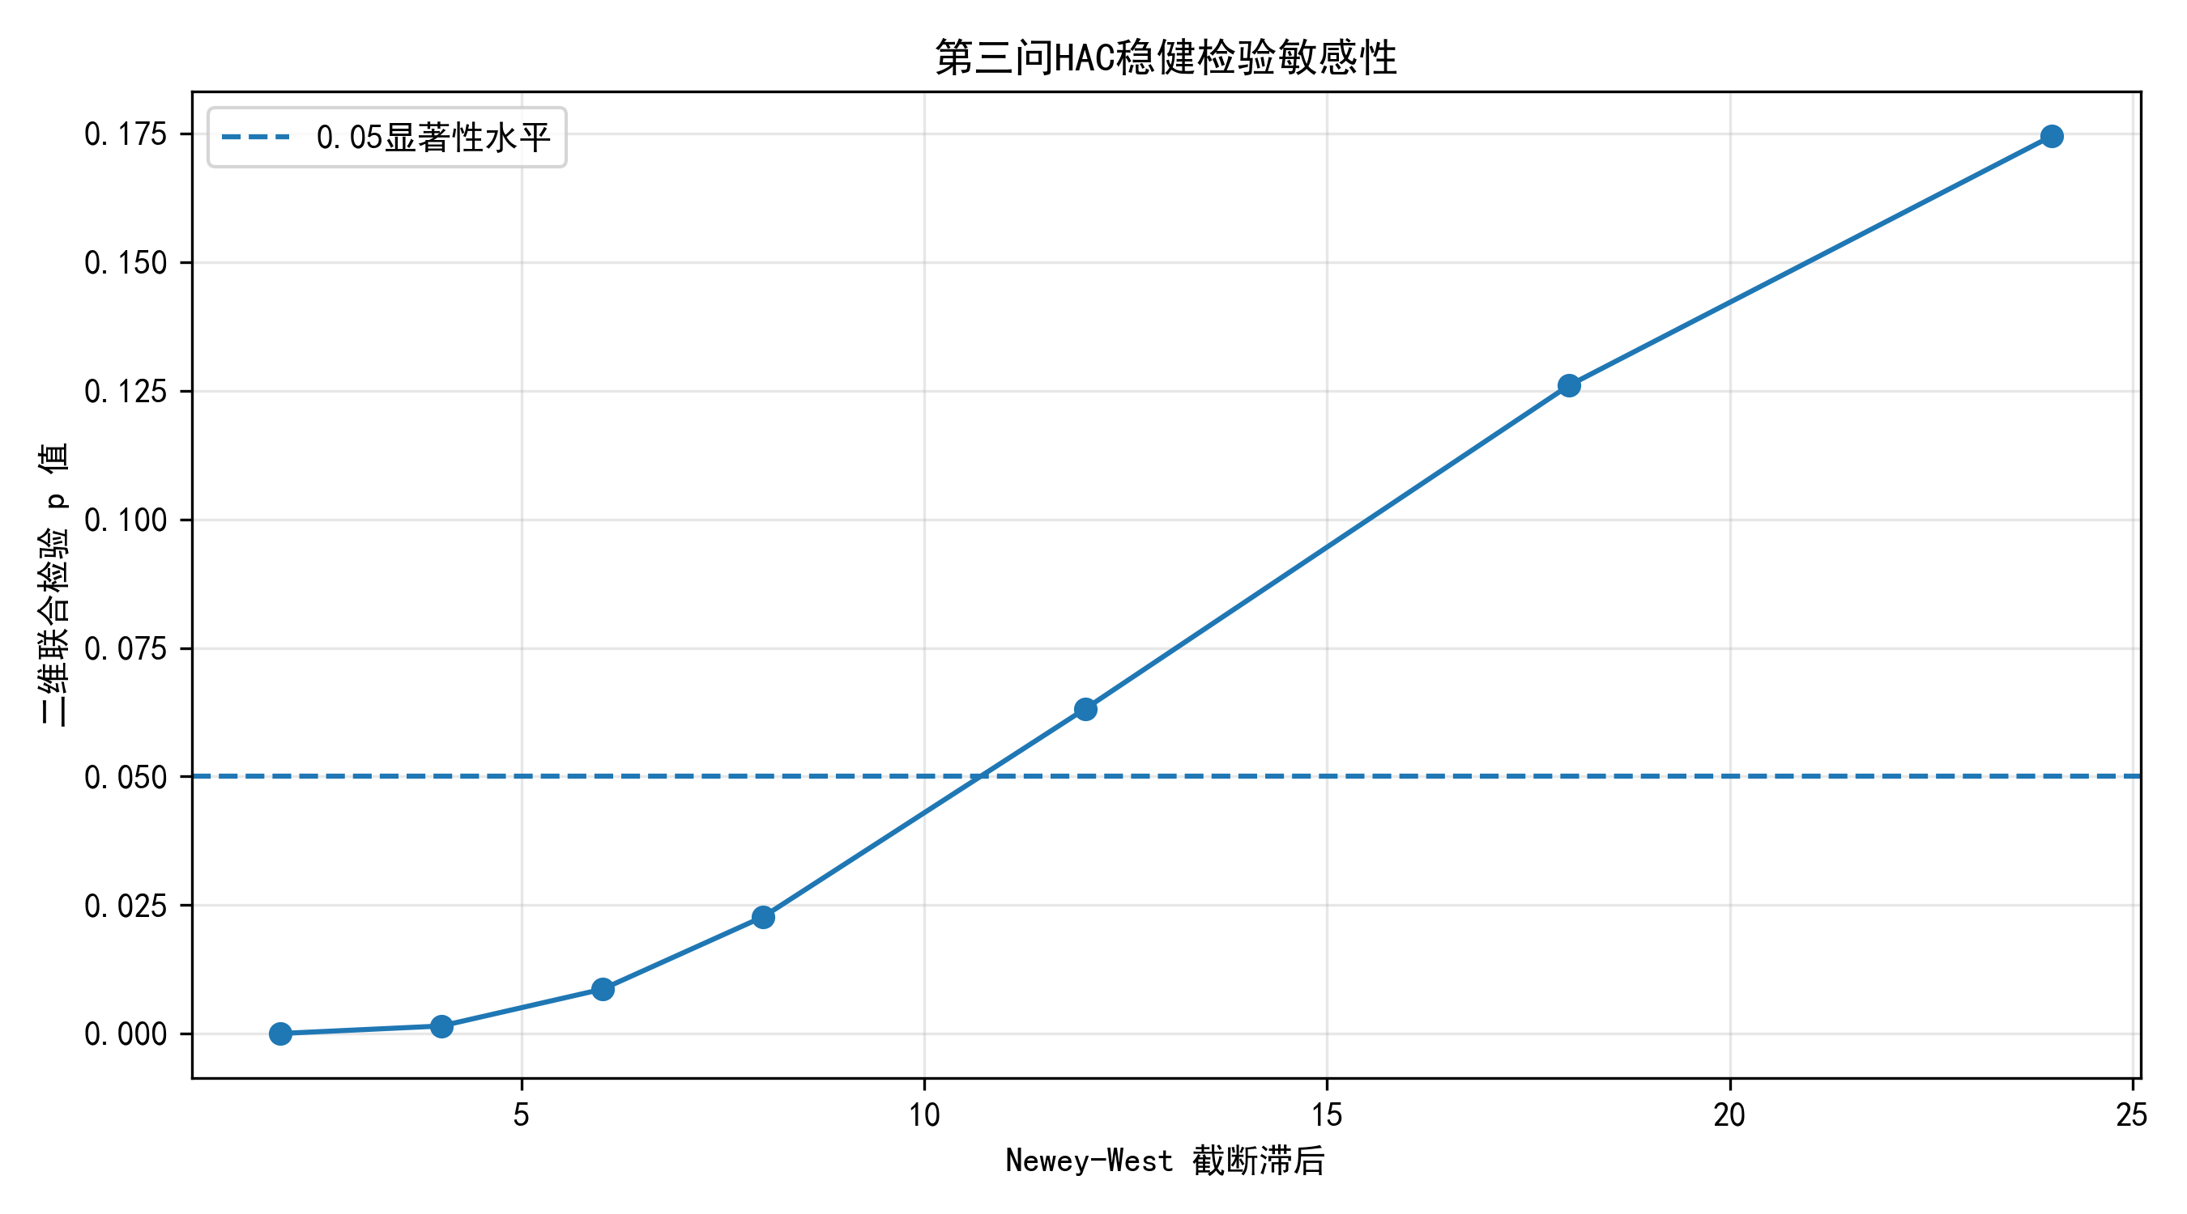
图 5.9 附件 3 HAC lag-scan p 值曲线
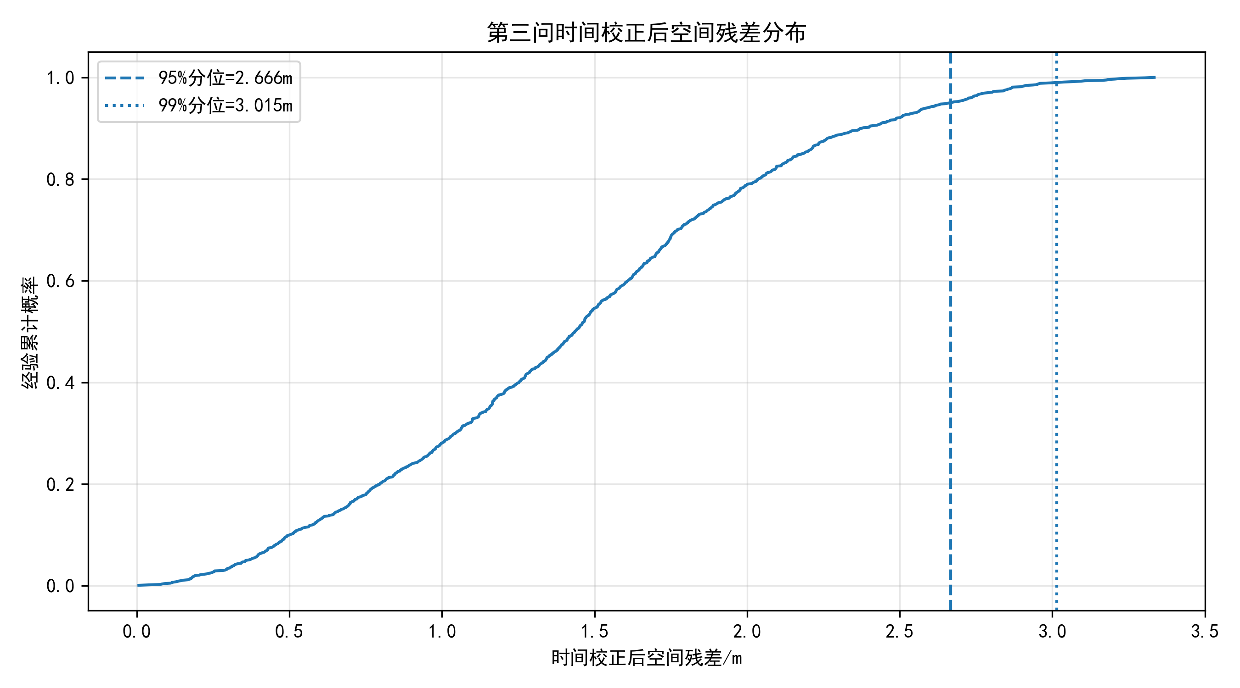
图 5.10 附件 3 残差 ECDF
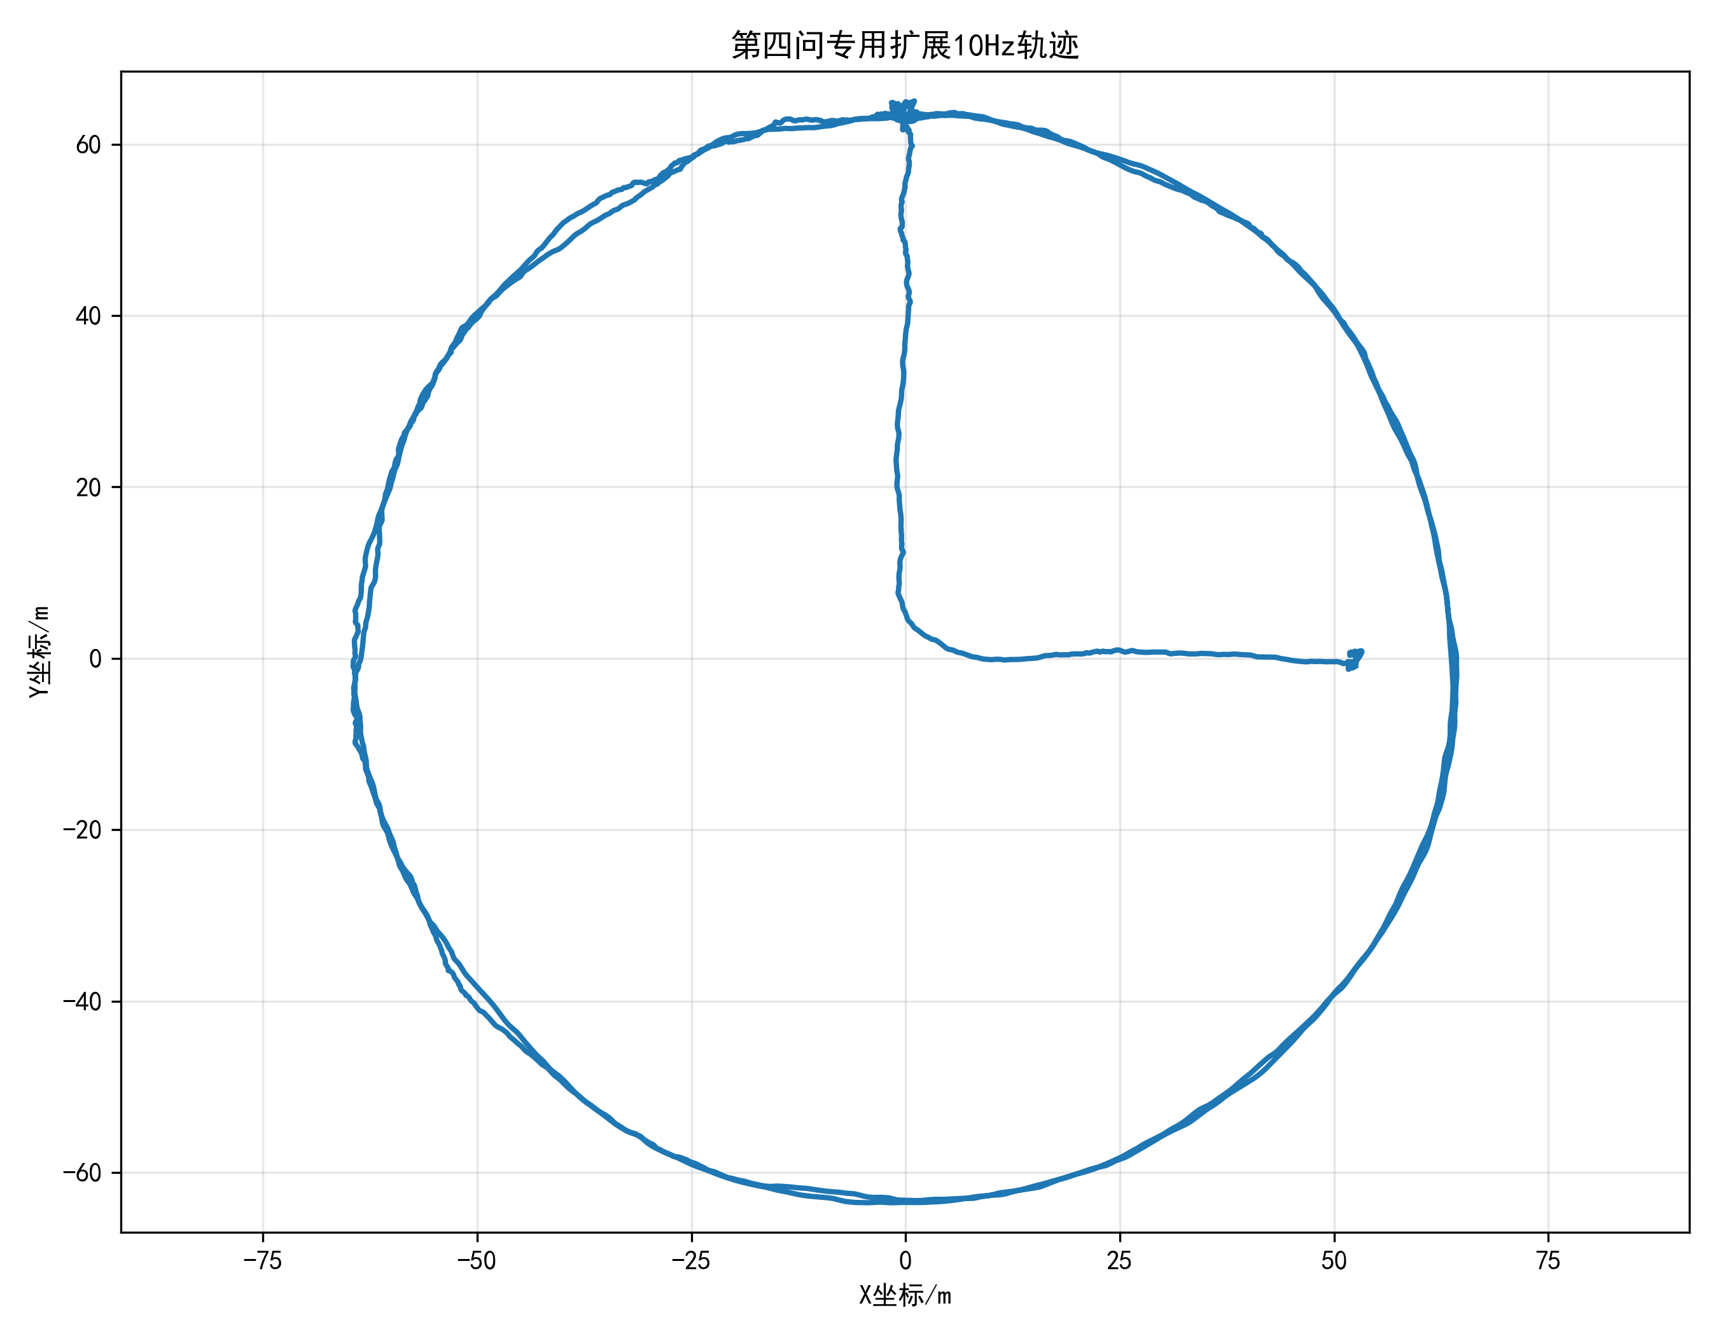
图 5.11 第三问扩展 10Hz 轨迹（供第四问使用）
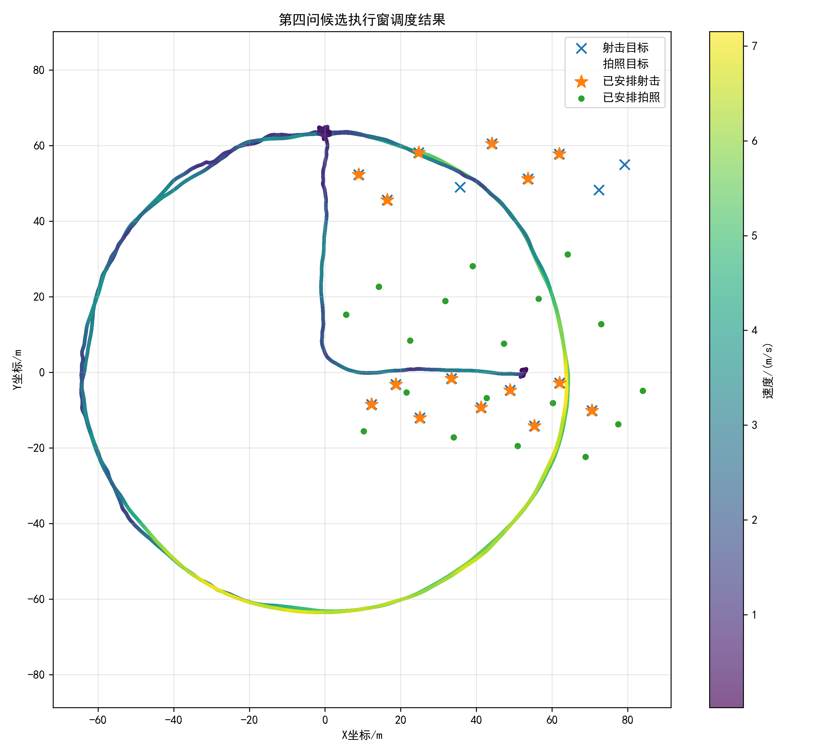
图 5.12 第四问轨迹与目标点叠加图
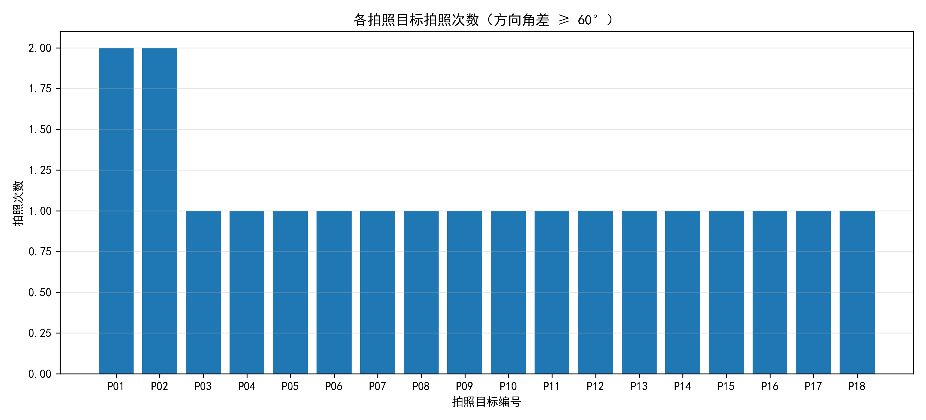
图 5.13 第四问拍照覆盖统计
8.7 程序源代码（可运行）
以下源代码与提交目录 code/ 内文件一字不差，直接 python <文件名> 即可运行。
program1.py
# -*- coding: utf-8 -*-
"""
第一问：无噪声异频定位数据的时间偏差估计与10Hz轨迹重建

功能：
1. 读取附件1中两种定位方式的数据；
2. 估计方式二相对方式一的时间偏差；
3. 检验时间校正后的空间残差、速度一致性、方向角一致性；
4. 输出统一10Hz轨迹；
5. 生成论文可用图件和结果表。

运行：
cd /d E:\数模A
python program1.py
"""

from __future__ import annotations

import math
import warnings
from pathlib import Path

import numpy as np
import pandas as pd
import matplotlib.pyplot as plt

from scipy.interpolate import CubicSpline, PchipInterpolator, Akima1DInterpolator
from scipy.optimize import minimize_scalar

# ============================================================
# 0. 路径与参数
# ============================================================

BASE_DIR = Path.cwd()
OUT_DIR = BASE_DIR / "q1_outputs"

ATTACHMENT_CANDIDATES = [
BASE_DIR / "附件1.xlsx",
BASE_DIR / "附件1：异频定位数据.xlsx",
BASE_DIR / "附件1_异频定位数据.xlsx",
BASE_DIR / "attachment1.xlsx",
]

TARGET_HZ = 10.0
TARGET_DT = 1.0 / TARGET_HZ

# 粗搜索步长，越小越稳但越慢
COARSE_STEP = 0.05

# 精化搜索半宽
REFINE_HALF_WIDTH = 2.0

# 候选偏差搜索范围；若附件时间跨度正常，此范围足够覆盖第一问
SEARCH_MARGIN = 5.0

# ============================================================
# 1. 工具函数
# ============================================================

def setup_chinese_font() -> None:
plt.rcParams["axes.unicode_minus"] = False
plt.rcParams["font.sans-serif"] = [
"SimHei",
"Microsoft YaHei",
"Noto Sans CJK SC",
"Arial Unicode MS",
"DejaVu Sans",
]

def ensure_out_dir() -> None:
OUT_DIR.mkdir(parents=True, exist_ok=True)

def norm_name(x) -> str:
if x is None:
return ""
return (
str(x)
.strip()
.replace(" ", "")
.replace("\n", "")
.replace("\r", "")
.replace("（", "(")
.replace("）", ")")
.lower()
)

def find_existing_file(candidates: list[Path]) -> Path:
for p in candidates:
if p.exists():
return p
raise FileNotFoundError(
"未找到附件1文件。请确认当前目录存在以下文件之一：\n"
+ "\n".join(str(p) for p in candidates)
)

def pick_col(df: pd.DataFrame, aliases: list[str]) -> str:
col_map = {norm_name(c): c for c in df.columns}
alias_norm = [norm_name(a) for a in aliases]

for a in alias_norm:
if a in col_map:
return col_map[a]

for key, raw in col_map.items():
for a in alias_norm:
if a in key or key in a:
return raw

raise KeyError(f"找不到列：{aliases}，当前列为：{list(df.columns)}")

def clean_track_df(raw: pd.DataFrame) -> pd.DataFrame:
time_col = pick_col(raw, ["时间", "时刻", "t", "time", "time(s)", "t(s)", "时间(s)"])
x_col = pick_col(raw, ["x", "x坐标", "x坐标(m)", "X坐标(m)", "X/m", "x/m"])
y_col = pick_col(raw, ["y", "y坐标", "y坐标(m)", "Y坐标(m)", "Y/m", "y/m"])

df = pd.DataFrame({
"time": pd.to_numeric(raw[time_col], errors="coerce"),
"x": pd.to_numeric(raw[x_col], errors="coerce"),
"y": pd.to_numeric(raw[y_col], errors="coerce"),
})

df = (
df.dropna(subset=["time", "x", "y"])
.sort_values("time")
.drop_duplicates(subset=["time"], keep="first")
.reset_index(drop=True)
)

if len(df) < 5:
raise ValueError("有效轨迹点过少，请检查附件1格式。")

return df

def read_attachment1(path: Path) -> tuple[pd.DataFrame, pd.DataFrame]:
sheets = pd.read_excel(path, sheet_name=None)

if len(sheets) < 2:
raise ValueError("附件1至少应包含两个工作表，分别对应方式一和方式二。")

sheet_names = list(sheets.keys())

sheet1 = None
sheet2 = None

for name in sheet_names:
n = norm_name(name)
if "方式一" in n or "方法一" in n or "定位一" in n:
sheet1 = name
if "方式二" in n or "方法二" in n or "定位二" in n:
sheet2 = name

if sheet1 is None or sheet2 is None:
sheet1, sheet2 = sheet_names[0], sheet_names[1]

df1 = clean_track_df(sheets[sheet1])
df2 = clean_track_df(sheets[sheet2])

return df1, df2

def make_interpolator(df: pd.DataFrame, kind: str):
t = df["time"].to_numpy(float)
x = df["x"].to_numpy(float)
y = df["y"].to_numpy(float)

if kind == "cubic":
fx = CubicSpline(t, x, bc_type="natural", extrapolate=False)
fy = CubicSpline(t, y, bc_type="natural", extrapolate=False)
elif kind == "pchip":
fx = PchipInterpolator(t, x, extrapolate=False)
fy = PchipInterpolator(t, y, extrapolate=False)
elif kind == "akima":
fx = Akima1DInterpolator(t, x)
fy = Akima1DInterpolator(t, y)
else:
raise ValueError(f"未知插值方法：{kind}")

return fx, fy

def common_time_mask(t1: np.ndarray, t2_min: float, t2_max: float, tau: float) -> np.ndarray:
"""
采用定义：
方式二校正后位置 = p2(t + tau)

因此，方式一时刻 t 能比较的条件是：
t + tau 位于方式二原始时间范围内。
"""
return (t1 + tau >= t2_min) & (t1 + tau <= t2_max)

def objective_time_shift(
tau: float,
df1: pd.DataFrame,
df2: pd.DataFrame,
interp_kind: str = "cubic",
) -> float:
t1 = df1["time"].to_numpy(float)
x1 = df1["x"].to_numpy(float)
y1 = df1["y"].to_numpy(float)

t2 = df2["time"].to_numpy(float)
t2_min, t2_max = float(t2.min()), float(t2.max())

mask = common_time_mask(t1, t2_min, t2_max, tau)
if mask.sum() < 5:
return np.inf

fx2, fy2 = make_interpolator(df2, interp_kind)

tq = t1[mask] + tau
x2q = fx2(tq)
y2q = fy2(tq)

valid = np.isfinite(x2q) & np.isfinite(y2q)
if valid.sum() < 5:
return np.inf

dx = x1[mask][valid] - x2q[valid]
dy = y1[mask][valid] - y2q[valid]

return float(np.mean(dx * dx + dy * dy))

def estimate_time_shift(
df1: pd.DataFrame,
df2: pd.DataFrame,
interp_kind: str = "cubic",
) -> tuple[float, float]:
t1 = df1["time"].to_numpy(float)
t2 = df2["time"].to_numpy(float)

# 使两条轨迹至少存在交集的偏差范围
tau_min = float(t2.min() - t1.max()) + SEARCH_MARGIN
tau_max = float(t2.max() - t1.min()) - SEARCH_MARGIN

if tau_min >= tau_max:
raise ValueError("两组数据时间范围异常，无法构造公共区间。")

grid = np.arange(tau_min, tau_max + COARSE_STEP, COARSE_STEP)
vals = np.array([
objective_time_shift(tau, df1, df2, interp_kind=interp_kind)
for tau in grid
])

best_idx = int(np.nanargmin(vals))
coarse_tau = float(grid[best_idx])

left = max(tau_min, coarse_tau - REFINE_HALF_WIDTH)
right = min(tau_max, coarse_tau + REFINE_HALF_WIDTH)

res = minimize_scalar(
lambda z: objective_time_shift(z, df1, df2, interp_kind=interp_kind),
bounds=(left, right),
method="bounded",
options={"xatol": 1e-12, "maxiter": 1000},
)

if not res.success:
warnings.warn(f"一维优化未完全收敛：{res.message}")

best_tau = float(res.x)
best_obj = float(res.fun)

return best_tau, best_obj

def residual_after_alignment(
df1: pd.DataFrame,
df2: pd.DataFrame,
tau: float,
interp_kind: str = "cubic",
) -> pd.DataFrame:
t1 = df1["time"].to_numpy(float)
x1 = df1["x"].to_numpy(float)
y1 = df1["y"].to_numpy(float)

t2 = df2["time"].to_numpy(float)
mask = common_time_mask(t1, float(t2.min()), float(t2.max()), tau)

fx2, fy2 = make_interpolator(df2, interp_kind)

tq = t1[mask] + tau
x2q = fx2(tq)
y2q = fy2(tq)

valid = np.isfinite(x2q) & np.isfinite(y2q)

out = pd.DataFrame({
"time": t1[mask][valid],
"x1": x1[mask][valid],
"y1": y1[mask][valid],
"x2_aligned": x2q[valid],
"y2_aligned": y2q[valid],
})

out["rx"] = out["x2_aligned"] - out["x1"]
out["ry"] = out["y2_aligned"] - out["y1"]
out["r_norm"] = np.sqrt(out["rx"] ** 2 + out["ry"] ** 2)

return out

def angle_deg(vx: np.ndarray, vy: np.ndarray) -> np.ndarray:
return np.degrees(np.arctan2(vy, vx))

def circular_angle_diff_deg(a: np.ndarray, b: np.ndarray) -> np.ndarray:
d = np.abs(a - b) % 360.0
return np.minimum(d, 360.0 - d)

def consistency_check(residual_df: pd.DataFrame) -> dict[str, float]:
t = residual_df["time"].to_numpy(float)

x1 = residual_df["x1"].to_numpy(float)
y1 = residual_df["y1"].to_numpy(float)
x2 = residual_df["x2_aligned"].to_numpy(float)
y2 = residual_df["y2_aligned"].to_numpy(float)

# 为避免非均匀时间间隔问题，使用 gradient(t)
vx1 = np.gradient(x1, t)
vy1 = np.gradient(y1, t)
vx2 = np.gradient(x2, t)
vy2 = np.gradient(y2, t)

v1 = np.sqrt(vx1 ** 2 + vy1 ** 2)
v2 = np.sqrt(vx2 ** 2 + vy2 ** 2)

theta1 = angle_deg(vx1, vy1)
theta2 = angle_deg(vx2, vy2)
theta_diff = circular_angle_diff_deg(theta1, theta2)

return {
"残差RMSE_m": float(np.sqrt(np.mean(residual_df["r_norm"].to_numpy(float) ** 2))),
"最大残差_m": float(np.max(residual_df["r_norm"].to_numpy(float))),
"平均残差_m": float(np.mean(residual_df["r_norm"].to_numpy(float))),
"速度RMSE_mps": float(np.sqrt(np.mean((v2 - v1) ** 2))),
"最大方向角差_deg": float(np.max(theta_diff)),
"平均方向角差_deg": float(np.mean(theta_diff)),
}

def reconstruct_10hz(
df1: pd.DataFrame,
df2: pd.DataFrame,
tau: float,
interp_kind: str = "cubic",
) -> pd.DataFrame:
"""
第一问无噪声，校正后两种方式理论一致。
为减小插值端点误差，输出公共区间内两者均值轨迹。
"""
t1_min, t1_max = float(df1["time"].min()), float(df1["time"].max())
t2_min, t2_max = float(df2["time"].min()), float(df2["time"].max())

start = max(t1_min, t2_min - tau)
end = min(t1_max, t2_max - tau)

start = math.ceil(start * TARGET_HZ) / TARGET_HZ
end = math.floor(end * TARGET_HZ) / TARGET_HZ

t_new = np.arange(start, end + 0.5 * TARGET_DT, TARGET_DT)

fx1, fy1 = make_interpolator(df1, interp_kind)
fx2, fy2 = make_interpolator(df2, interp_kind)

x1 = fx1(t_new)
y1 = fy1(t_new)

x2 = fx2(t_new + tau)
y2 = fy2(t_new + tau)

valid = (
np.isfinite(x1)
& np.isfinite(y1)
& np.isfinite(x2)
& np.isfinite(y2)
)

x_hat = 0.5 * (x1[valid] + x2[valid])
y_hat = 0.5 * (y1[valid] + y2[valid])

out = pd.DataFrame({
"time": t_new[valid],
"x": x_hat,
"y": y_hat,
"x_way1": x1[valid],
"y_way1": y1[valid],
"x_way2_aligned": x2[valid],
"y_way2_aligned": y2[valid],
})

return out

# ============================================================
# 2. 作图
# ============================================================

def plot_objective(df1: pd.DataFrame, df2: pd.DataFrame, best_tau: float) -> None:
t1 = df1["time"].to_numpy(float)
t2 = df2["time"].to_numpy(float)

tau_min = float(t2.min() - t1.max()) + SEARCH_MARGIN
tau_max = float(t2.max() - t1.min()) - SEARCH_MARGIN

# 只画最优值附近，论文更清晰
left = max(tau_min, best_tau - 4.0)
right = min(tau_max, best_tau + 4.0)

taus = np.linspace(left, right, 500)
vals = np.array([
objective_time_shift(tau, df1, df2, interp_kind="cubic")
for tau in taus
])

plt.figure(figsize=(10, 5))
plt.plot(taus, vals)
plt.axvline(best_tau, linestyle="--", label=f"最优偏差={best_tau:.6f}s")
plt.xlabel("方式二相对方式一时间偏差/s")
plt.ylabel("平均平方距离目标函数")
plt.title("第一问时间偏差目标函数极小值搜索")
plt.grid(True, alpha=0.3)
plt.legend()
plt.tight_layout()
plt.savefig(OUT_DIR / "q1_time_shift_objective.png", dpi=300)
plt.close()

def plot_alignment(residual_df: pd.DataFrame) -> None:
plt.figure(figsize=(9, 7))
plt.plot(residual_df["x1"], residual_df["y1"], label="方式一轨迹", linewidth=2)
plt.plot(
residual_df["x2_aligned"],
residual_df["y2_aligned"],
linestyle="--",
label="方式二时间校正后轨迹",
linewidth=2,
)
plt.axis("equal")
plt.xlabel("X坐标/m")
plt.ylabel("Y坐标/m")
plt.title("第一问时间校正后的轨迹重合效果")
plt.grid(True, alpha=0.3)
plt.legend()
plt.tight_layout()
plt.savefig(OUT_DIR / "q1_aligned_trajectory.png", dpi=300)
plt.close()

def plot_residual(residual_df: pd.DataFrame) -> None:
plt.figure(figsize=(10, 5))
plt.plot(residual_df["time"], residual_df["r_norm"])
plt.xlabel("时间/s")
plt.ylabel("空间残差/m")
plt.title("第一问时间校正后的空间残差")
plt.grid(True, alpha=0.3)
plt.tight_layout()
plt.savefig(OUT_DIR / "q1_alignment_residual.png", dpi=300)
plt.close()

def plot_10hz(trajectory_10hz: pd.DataFrame) -> None:
plt.figure(figsize=(9, 7))
plt.plot(trajectory_10hz["x"], trajectory_10hz["y"], linewidth=2)
plt.axis("equal")
plt.xlabel("X坐标/m")
plt.ylabel("Y坐标/m")
plt.title("第一问重构得到的10Hz轨迹")
plt.grid(True, alpha=0.3)
plt.tight_layout()
plt.savefig(OUT_DIR / "q1_10hz_trajectory.png", dpi=300)
plt.close()

# ============================================================
# 3. 主程序
# ============================================================

def main() -> None:
setup_chinese_font()
ensure_out_dir()

attachment_path = find_existing_file(ATTACHMENT_CANDIDATES)

print("=" * 70)
print("第一问：无噪声异频定位数据时间同步与10Hz轨迹重建")
print("=" * 70)
print(f"读取文件：{attachment_path}")

df1, df2 = read_attachment1(attachment_path)

print(f"方式一点数：{len(df1)}")
print(f"方式二点数：{len(df2)}")
print(f"方式一时间范围：{df1['time'].min():.6f} — {df1['time'].max():.6f} s")
print(f"方式二时间范围：{df2['time'].min():.6f} — {df2['time'].max():.6f} s")

# 主结果：自然三次样条
best_tau, best_obj = estimate_time_shift(df1, df2, interp_kind="cubic")

# 稳健性：PCHIP 与 Akima
tau_pchip, obj_pchip = estimate_time_shift(df1, df2, interp_kind="pchip")
tau_akima, obj_akima = estimate_time_shift(df1, df2, interp_kind="akima")

residual_df = residual_after_alignment(df1, df2, best_tau, interp_kind="cubic")
checks = consistency_check(residual_df)

traj_10hz = reconstruct_10hz(df1, df2, best_tau, interp_kind="cubic")

summary_rows = [
["方式一时间偏差/s", 0.0],
["方式二相对方式一时间偏差/s", best_tau],
["最小目标函数值", best_obj],
["校正后公共区间点数", len(residual_df)],
["10Hz轨迹点数", len(traj_10hz)],
]

for k, v in checks.items():
summary_rows.append([k, v])

summary_df = pd.DataFrame(summary_rows, columns=["指标", "数值"])

robust_df = pd.DataFrame({
"插值方法": ["自然三次样条", "PCHIP", "Akima"],
"时间偏差/s": [best_tau, tau_pchip, tau_akima],
"目标函数最小值": [best_obj, obj_pchip, obj_akima],
})

residual_df.to_csv(OUT_DIR / "q1_alignment_residuals.csv", index=False, encoding="utf-8-sig")
traj_10hz.to_csv(OUT_DIR / "q1_10hz_trajectory.csv", index=False, encoding="utf-8-sig")
summary_df.to_csv(OUT_DIR / "q1_summary.csv", index=False, encoding="utf-8-sig")
robust_df.to_csv(OUT_DIR / "q1_interpolation_robustness.csv", index=False, encoding="utf-8-sig")

with pd.ExcelWriter(OUT_DIR / "q1_results.xlsx", engine="openpyxl") as writer:
summary_df.to_excel(writer, sheet_name="结果汇总", index=False)
robust_df.to_excel(writer, sheet_name="插值稳健性", index=False)
traj_10hz.to_excel(writer, sheet_name="10Hz轨迹", index=False)
residual_df.to_excel(writer, sheet_name="校正残差", index=False)

plot_objective(df1, df2, best_tau)
plot_alignment(residual_df)
plot_residual(residual_df)
plot_10hz(traj_10hz)

print("\n求解完成。")
print("-" * 70)
print(f"方式一时间偏差：0.000000 s")
print(f"方式二相对方式一时间偏差：{best_tau:.6f} s")
print(f"最小目标函数值：{best_obj:.6e}")
print(f"校正后残差RMSE：{checks['残差RMSE_m']:.6e} m")
print(f"最大空间残差：{checks['最大残差_m']:.6e} m")
print(f"最大方向角差：{checks['最大方向角差_deg']:.6e} °")
print(f"10Hz轨迹点数：{len(traj_10hz)}")

print("\n插值稳健性：")
print(robust_df.to_string(index=False))

print("\n输出目录：")
print(OUT_DIR)
print("\n主要输出文件：")
print(OUT_DIR / "q1_results.xlsx")
print(OUT_DIR / "q1_10hz_trajectory.csv")
print(OUT_DIR / "q1_summary.csv")
print(OUT_DIR / "q1_time_shift_objective.png")
print(OUT_DIR / "q1_aligned_trajectory.png")

if __name__ == "__main__":
main()
program2.py
# -*- coding: utf-8 -*-
"""
第二问：剖面最小二乘—系统偏差剥离—协方差融合模型

修正版要点：
1. 避免短公共区间伪极小值；
2. 时间偏差搜索限制在第二问合理区间；
3. 用平滑轨迹估计时间偏差和系统偏差；
4. 用原始观测相对平滑轨迹的残差估计噪声协方差；
5. 在公共有效区间输出10Hz融合轨迹。

运行：
cd /d E:\数模A
python program2.py
"""

from __future__ import annotations

import math
import warnings
from pathlib import Path

import numpy as np
import pandas as pd
import matplotlib.pyplot as plt

from scipy.interpolate import CubicSpline, PchipInterpolator, Akima1DInterpolator
from scipy.optimize import minimize_scalar
from scipy.signal import savgol_filter

# ============================================================
# 0. 路径与参数
# ============================================================

BASE_DIR = Path.cwd()
OUT_DIR = BASE_DIR / "q2_outputs"

ATTACHMENT_CANDIDATES = [
BASE_DIR / "附件2.xlsx",
BASE_DIR / "附件2：异频定位数据.xlsx",
BASE_DIR / "附件2_异频定位数据.xlsx",
BASE_DIR / "attachment2.xlsx",
]

TARGET_HZ = 10.0
TARGET_DT = 1.0 / TARGET_HZ

# 第二问合理时间偏差搜索区间。
# 这不是放宽条件，而是防止全局搜索误选只有几十个公共点的伪极小值。
TAU_SEARCH_MIN = 40.0
TAU_SEARCH_MAX = 60.0

COARSE_STEP = 0.02
REFINE_HALF_WIDTH = 1.0

# 公共区间门槛，避免短片段伪匹配
MIN_COMMON_POINTS = 600
MIN_COMMON_DURATION = 300.0

# 平滑参数
SMOOTH_WINDOW = 61
SMOOTH_POLY = 3

# 协方差正则项
COV_REG = 1e-8

# ============================================================
# 1. 基础工具
# ============================================================

def setup_chinese_font() -> None:
plt.rcParams["axes.unicode_minus"] = False
plt.rcParams["font.sans-serif"] = [
"SimHei",
"Microsoft YaHei",
"Noto Sans CJK SC",
"Arial Unicode MS",
"DejaVu Sans",
]

def ensure_out_dir() -> None:
OUT_DIR.mkdir(parents=True, exist_ok=True)

def norm_name(x) -> str:
if x is None:
return ""
return (
str(x)
.strip()
.replace(" ", "")
.replace("\n", "")
.replace("\r", "")
.replace("（", "(")
.replace("）", ")")
.lower()
)

def find_existing_file(candidates: list[Path]) -> Path:
for p in candidates:
if p.exists():
return p
raise FileNotFoundError(
"未找到附件2文件。请确认当前目录存在以下文件之一：\n"
+ "\n".join(str(p) for p in candidates)
)

def pick_col(df: pd.DataFrame, aliases: list[str]) -> str:
col_map = {norm_name(c): c for c in df.columns}
alias_norm = [norm_name(a) for a in aliases]

for a in alias_norm:
if a in col_map:
return col_map[a]

for key, raw in col_map.items():
for a in alias_norm:
if a in key or key in a:
return raw

raise KeyError(f"找不到列：{aliases}，当前列为：{list(df.columns)}")

def clean_track_df(raw: pd.DataFrame) -> pd.DataFrame:
time_col = pick_col(raw, ["时间", "时刻", "t", "time", "time(s)", "t(s)", "时间(s)"])
x_col = pick_col(raw, ["x", "x坐标", "x坐标(m)", "X坐标(m)", "X/m", "x/m"])
y_col = pick_col(raw, ["y", "y坐标", "y坐标(m)", "Y坐标(m)", "Y/m", "y/m"])

df = pd.DataFrame({
"time": pd.to_numeric(raw[time_col], errors="coerce"),
"x": pd.to_numeric(raw[x_col], errors="coerce"),
"y": pd.to_numeric(raw[y_col], errors="coerce"),
})

df = (
df.dropna(subset=["time", "x", "y"])
.sort_values("time")
.drop_duplicates(subset=["time"], keep="first")
.reset_index(drop=True)
)

if len(df) < 20:
raise ValueError("有效轨迹点过少，请检查附件2格式。")

return df

def read_attachment2(path: Path) -> tuple[pd.DataFrame, pd.DataFrame]:
sheets = pd.read_excel(path, sheet_name=None)

if len(sheets) < 2:
raise ValueError("附件2至少应包含两个工作表，分别对应方式一和方式二。")

sheet_names = list(sheets.keys())

sheet1 = None
sheet2 = None

for name in sheet_names:
n = norm_name(name)
if "方式一" in n or "方法一" in n or "定位一" in n:
sheet1 = name
if "方式二" in n or "方法二" in n or "定位二" in n:
sheet2 = name

if sheet1 is None or sheet2 is None:
sheet1, sheet2 = sheet_names[0], sheet_names[1]

df1 = clean_track_df(sheets[sheet1])
df2 = clean_track_df(sheets[sheet2])

return df1, df2

def choose_savgol_window(n: int, wanted: int, poly: int) -> int:
w = min(wanted, n)
if w % 2 == 0:
w -= 1
min_w = poly + 3
if min_w % 2 == 0:
min_w += 1
if w < min_w:
w = min_w
if w > n:
w = n if n % 2 == 1 else n - 1
return max(w, 3)

def add_smooth_columns(df: pd.DataFrame) -> pd.DataFrame:
out = df.copy()
n = len(out)

if n <= SMOOTH_POLY + 4:
out["x_smooth"] = out["x"]
out["y_smooth"] = out["y"]
out["noise_x"] = 0.0
out["noise_y"] = 0.0
return out

window = choose_savgol_window(n, SMOOTH_WINDOW, SMOOTH_POLY)

out["x_smooth"] = savgol_filter(
out["x"].to_numpy(float),
window_length=window,
polyorder=SMOOTH_POLY,
mode="interp",
)
out["y_smooth"] = savgol_filter(
out["y"].to_numpy(float),
window_length=window,
polyorder=SMOOTH_POLY,
mode="interp",
)

out["noise_x"] = out["x"] - out["x_smooth"]
out["noise_y"] = out["y"] - out["y_smooth"]

return out

def make_interpolator(
df: pd.DataFrame,
kind: str = "pchip",
x_col: str = "x_smooth",
y_col: str = "y_smooth",
):
t = df["time"].to_numpy(float)
x = df[x_col].to_numpy(float)
y = df[y_col].to_numpy(float)

if kind == "cubic":
fx = CubicSpline(t, x, bc_type="natural", extrapolate=False)
fy = CubicSpline(t, y, bc_type="natural", extrapolate=False)
elif kind == "pchip":
fx = PchipInterpolator(t, x, extrapolate=False)
fy = PchipInterpolator(t, y, extrapolate=False)
elif kind == "akima":
fx = Akima1DInterpolator(t, x)
fy = Akima1DInterpolator(t, y)
else:
raise ValueError(f"未知插值方法：{kind}")

return fx, fy

def common_time_mask(t1: np.ndarray, t2_min: float, t2_max: float, tau: float) -> np.ndarray:
"""
定义：
方式二校正到方式一时间轴：p2(t + tau)

条件：
t + tau 必须位于方式二原始时间范围内。
"""
return (t1 + tau >= t2_min) & (t1 + tau <= t2_max)

def covariance_matrix(rx: np.ndarray, ry: np.ndarray) -> np.ndarray:
arr = np.vstack([rx, ry])
cov = np.cov(arr, bias=False)
cov = np.asarray(cov, dtype=float)

if cov.shape != (2, 2) or not np.all(np.isfinite(cov)):
cov = np.eye(2)

cov = cov + COV_REG * np.eye(2)
return cov

def ellipse_area_95(cov: np.ndarray) -> float:
chi2_95 = 5.991
det = max(float(np.linalg.det(cov)), 0.0)
return float(math.pi * chi2_95 * math.sqrt(det))

# ============================================================
# 2. 剖面最小二乘：时间偏差与系统偏差估计
# ============================================================

def profiled_bias_and_residual(
tau: float,
df1: pd.DataFrame,
df2: pd.DataFrame,
interp_kind: str = "pchip",
) -> tuple[np.ndarray, pd.DataFrame]:
"""
对给定 tau：
1. 将方式二平滑轨迹插值到方式一时间轴；
2. 计算 delta = p2(t+tau) - p1(t)；
3. 解析估计系统偏差 b(tau)=mean(delta)；
4. 计算剥离偏差后的残差。
"""
t1 = df1["time"].to_numpy(float)
x1_s = df1["x_smooth"].to_numpy(float)
y1_s = df1["y_smooth"].to_numpy(float)

t2 = df2["time"].to_numpy(float)
t2_min, t2_max = float(t2.min()), float(t2.max())

mask = common_time_mask(t1, t2_min, t2_max, tau)

if mask.sum() < MIN_COMMON_POINTS:
return np.array([np.nan, np.nan]), pd.DataFrame()

common_t = t1[mask]
if float(common_t.max() - common_t.min()) < MIN_COMMON_DURATION:
return np.array([np.nan, np.nan]), pd.DataFrame()

fx2_s, fy2_s = make_interpolator(
df2,
kind=interp_kind,
x_col="x_smooth",
y_col="y_smooth",
)

tq = t1[mask] + tau
x2_s = fx2_s(tq)
y2_s = fy2_s(tq)

valid = np.isfinite(x2_s) & np.isfinite(y2_s)

if valid.sum() < MIN_COMMON_POINTS:
return np.array([np.nan, np.nan]), pd.DataFrame()

time = t1[mask][valid]
x1v = x1_s[mask][valid]
y1v = y1_s[mask][valid]
x2v = x2_s[valid]
y2v = y2_s[valid]

dx = x2v - x1v
dy = y2v - y1v

bx = float(np.mean(dx))
by = float(np.mean(dy))
b = np.array([bx, by], dtype=float)

ex = dx - bx
ey = dy - by
e_norm = np.sqrt(ex * ex + ey * ey)

out = pd.DataFrame({
"time": time,
"x1_smooth": x1v,
"y1_smooth": y1v,
"x2_smooth_time_aligned": x2v,
"y2_smooth_time_aligned": y2v,
"x2_smooth_corrected": x2v - bx,
"y2_smooth_corrected": y2v - by,
"delta_x_before_bias": dx,
"delta_y_before_bias": dy,
"residual_x_after_bias": ex,
"residual_y_after_bias": ey,
"residual_norm_after_bias": e_norm,
})

return b, out

def objective_profiled_tau(
tau: float,
df1: pd.DataFrame,
df2: pd.DataFrame,
interp_kind: str = "pchip",
) -> float:
b, residual_df = profiled_bias_and_residual(tau, df1, df2, interp_kind)

if residual_df.empty or not np.all(np.isfinite(b)):
return np.inf

ex = residual_df["residual_x_after_bias"].to_numpy(float)
ey = residual_df["residual_y_after_bias"].to_numpy(float)

# 使用均方残差作为剖面目标函数
mse = float(np.mean(ex * ex + ey * ey))

# 极轻微惩罚短公共区间，进一步抑制伪极小值
duration = float(residual_df["time"].max() - residual_df["time"].min())
penalty = 1e-4 / max(duration, 1.0)

return mse + penalty

def estimate_time_and_bias(
df1: pd.DataFrame,
df2: pd.DataFrame,
interp_kind: str = "pchip",
) -> tuple[float, np.ndarray, float, pd.DataFrame]:
tau_min = TAU_SEARCH_MIN
tau_max = TAU_SEARCH_MAX

grid = np.arange(tau_min, tau_max + COARSE_STEP, COARSE_STEP)

vals = np.array([
objective_profiled_tau(tau, df1, df2, interp_kind=interp_kind)
for tau in grid
])

if not np.any(np.isfinite(vals)):
raise RuntimeError(
"在当前时间偏差搜索区间内没有满足公共区间约束的候选值。"
"请检查附件2时间列或适当调整 TAU_SEARCH_MIN / TAU_SEARCH_MAX。"
)

best_idx = int(np.nanargmin(vals))
coarse_tau = float(grid[best_idx])

left = max(tau_min, coarse_tau - REFINE_HALF_WIDTH)
right = min(tau_max, coarse_tau + REFINE_HALF_WIDTH)

res = minimize_scalar(
lambda z: objective_profiled_tau(z, df1, df2, interp_kind=interp_kind),
bounds=(left, right),
method="bounded",
options={"xatol": 1e-12, "maxiter": 1000},
)

if not res.success:
warnings.warn(f"时间偏差优化未完全收敛：{res.message}")

tau_hat = float(res.x)
obj_min = float(res.fun)

b_hat, residual_df = profiled_bias_and_residual(
tau_hat,
df1,
df2,
interp_kind=interp_kind,
)

return tau_hat, b_hat, obj_min, residual_df

# ============================================================
# 3. 原始观测残差诊断与协方差估计
# ============================================================

def raw_residual_after_correction(
tau: float,
b: np.ndarray,
df1: pd.DataFrame,
df2: pd.DataFrame,
interp_kind: str = "pchip",
) -> pd.DataFrame:
t1 = df1["time"].to_numpy(float)
x1 = df1["x"].to_numpy(float)
y1 = df1["y"].to_numpy(float)

t2 = df2["time"].to_numpy(float)
mask = common_time_mask(t1, float(t2.min()), float(t2.max()), tau)

fx2_raw, fy2_raw = make_interpolator(
df2,
kind=interp_kind,
x_col="x",
y_col="y",
)

tq = t1[mask] + tau
x2 = fx2_raw(tq)
y2 = fy2_raw(tq)

valid = np.isfinite(x2) & np.isfinite(y2)

out = pd.DataFrame({
"time": t1[mask][valid],
"x1_raw": x1[mask][valid],
"y1_raw": y1[mask][valid],
"x2_raw_time_aligned": x2[valid],
"y2_raw_time_aligned": y2[valid],
"x2_raw_corrected": x2[valid] - b[0],
"y2_raw_corrected": y2[valid] - b[1],
})

out["raw_residual_x"] = out["x2_raw_corrected"] - out["x1_raw"]
out["raw_residual_y"] = out["y2_raw_corrected"] - out["y1_raw"]
out["raw_residual_norm"] = np.sqrt(
out["raw_residual_x"] ** 2 + out["raw_residual_y"] ** 2
)

return out

def estimate_noise_covariances(
df1: pd.DataFrame,
df2: pd.DataFrame,
) -> tuple[np.ndarray, np.ndarray, np.ndarray]:
"""
由原始观测减去平滑轨迹的残差估计两种定位方式噪声协方差。
"""
cov1 = covariance_matrix(
df1["noise_x"].to_numpy(float),
df1["noise_y"].to_numpy(float),
)
cov2 = covariance_matrix(
df2["noise_x"].to_numpy(float),
df2["noise_y"].to_numpy(float),
)

inv1 = np.linalg.inv(cov1)
inv2 = np.linalg.inv(cov2)
cov_fused = np.linalg.inv(inv1 + inv2)

return cov1, cov2, cov_fused

# ============================================================
# 4. 10Hz协方差融合轨迹
# ============================================================

def reconstruct_fused_10hz(
df1: pd.DataFrame,
df2: pd.DataFrame,
tau_hat: float,
b_hat: np.ndarray,
cov1: np.ndarray,
cov2: np.ndarray,
interp_kind: str = "pchip",
) -> pd.DataFrame:
"""
第二问输出公共区间内的10Hz融合轨迹。
这样可避免方式二时间平移后在非公共区间产生异常长轨迹。
"""
t1_min, t1_max = float(df1["time"].min()), float(df1["time"].max())
t2_min, t2_max = float(df2["time"].min()), float(df2["time"].max())

start = max(t1_min, t2_min - tau_hat)
end = min(t1_max, t2_max - tau_hat)

start = math.ceil(start * TARGET_HZ) / TARGET_HZ
end = math.floor(end * TARGET_HZ) / TARGET_HZ

t_new = np.arange(start, end + 0.5 * TARGET_DT, TARGET_DT)

fx1, fy1 = make_interpolator(
df1,
kind=interp_kind,
x_col="x_smooth",
y_col="y_smooth",
)
fx2, fy2 = make_interpolator(
df2,
kind=interp_kind,
x_col="x_smooth",
y_col="y_smooth",
)

x1 = fx1(t_new)
y1 = fy1(t_new)

x2 = fx2(t_new + tau_hat) - b_hat[0]
y2 = fy2(t_new + tau_hat) - b_hat[1]

valid = (
np.isfinite(x1)
& np.isfinite(y1)
& np.isfinite(x2)
& np.isfinite(y2)
)

t_new = t_new[valid]
x1 = x1[valid]
y1 = y1[valid]
x2 = x2[valid]
y2 = y2[valid]

inv1 = np.linalg.inv(cov1)
inv2 = np.linalg.inv(cov2)
cov_f = np.linalg.inv(inv1 + inv2)

fused = []
for k in range(len(t_new)):
p1 = np.array([x1[k], y1[k]], dtype=float)
p2 = np.array([x2[k], y2[k]], dtype=float)
pf = cov_f @ (inv1 @ p1 + inv2 @ p2)
fused.append(pf)

fused = np.asarray(fused)

out = pd.DataFrame({
"time": t_new,
"x": fused[:, 0],
"y": fused[:, 1],
"x_way1_smooth": x1,
"y_way1_smooth": y1,
"x_way2_corrected_smooth": x2,
"y_way2_corrected_smooth": y2,
})

return out

# ============================================================
# 5. 指标计算
# ============================================================

def residual_metrics(
smooth_residual_df: pd.DataFrame,
raw_residual_df: pd.DataFrame,
) -> dict[str, float]:
smooth_r = smooth_residual_df["residual_norm_after_bias"].to_numpy(float)
raw_r = raw_residual_df["raw_residual_norm"].to_numpy(float)

before = np.sqrt(
smooth_residual_df["delta_x_before_bias"].to_numpy(float) ** 2
+ smooth_residual_df["delta_y_before_bias"].to_numpy(float) ** 2
)

return {
"仅时间校正平滑RMSE_m": float(np.sqrt(np.mean(before ** 2))),
"时间和系统偏差校正后平滑RMSE_m": float(np.sqrt(np.mean(smooth_r ** 2))),
"时间和系统偏差校正后平滑平均残差_m": float(np.mean(smooth_r)),
"时间和系统偏差校正后平滑最大残差_m": float(np.max(smooth_r)),
"时间和系统偏差校正后原始RMSE_m": float(np.sqrt(np.mean(raw_r ** 2))),
"时间和系统偏差校正后原始平均残差_m": float(np.mean(raw_r)),
"时间和系统偏差校正后原始最大残差_m": float(np.max(raw_r)),
"公共区间样本数": int(len(smooth_residual_df)),
}

# ============================================================
# 6. 作图
# ============================================================

def plot_objective(df1: pd.DataFrame, df2: pd.DataFrame, tau_hat: float) -> None:
taus = np.linspace(TAU_SEARCH_MIN, TAU_SEARCH_MAX, 600)
vals = np.array([
objective_profiled_tau(tau, df1, df2, interp_kind="pchip")
for tau in taus
])

plt.figure(figsize=(10, 5))
plt.plot(taus, vals)
plt.axvline(tau_hat, linestyle="--", label=f"最优偏差={tau_hat:.6f}s")
plt.xlabel("方式二相对方式一时间偏差/s")
plt.ylabel("剥离系统偏差后的目标函数")
plt.title("第二问剖面最小二乘目标函数")
plt.grid(True, alpha=0.3)
plt.legend()
plt.tight_layout()
plt.savefig(OUT_DIR / "q2_profile_objective.png", dpi=300)
plt.close()

def plot_alignment(smooth_residual_df: pd.DataFrame) -> None:
plt.figure(figsize=(9, 7))
plt.scatter(
smooth_residual_df["x1_smooth"],
smooth_residual_df["y1_smooth"],
s=8,
alpha=0.35,
label="方式一平滑轨迹点",
)
plt.scatter(
smooth_residual_df["x2_smooth_time_aligned"],
smooth_residual_df["y2_smooth_time_aligned"],
s=8,
alpha=0.25,
label="方式二仅时间校正",
)
plt.plot(
smooth_residual_df["x2_smooth_corrected"],
smooth_residual_df["y2_smooth_corrected"],
linewidth=2,
label="方式二时间+系统偏差校正",
)
plt.axis("equal")
plt.xlabel("X坐标/m")
plt.ylabel("Y坐标/m")
plt.title("第二问系统偏差剥离前后的空间轨迹对比")
plt.grid(True, alpha=0.3)
plt.legend()
plt.tight_layout()
plt.savefig(OUT_DIR / "q2_bias_removed_alignment.png", dpi=300)
plt.close()

def plot_residual(smooth_residual_df: pd.DataFrame) -> None:
plt.figure(figsize=(10, 5))
plt.plot(
smooth_residual_df["time"],
smooth_residual_df["residual_norm_after_bias"],
)
plt.xlabel("时间/s")
plt.ylabel("校正后空间残差/m")
plt.title("第二问时间校正与系统偏差剥离后的空间残差")
plt.grid(True, alpha=0.3)
plt.tight_layout()
plt.savefig(OUT_DIR / "q2_residual_after_bias.png", dpi=300)
plt.close()

def plot_residual_ecdf(smooth_residual_df: pd.DataFrame) -> None:
r = np.sort(smooth_residual_df["residual_norm_after_bias"].to_numpy(float))
y = np.arange(1, len(r) + 1) / len(r)

q95 = float(np.quantile(r, 0.95))
q99 = float(np.quantile(r, 0.99))

plt.figure(figsize=(9, 5))
plt.plot(r, y)
plt.axvline(q95, linestyle="--", label=f"95%分位={q95:.3f}m")
plt.axvline(q99, linestyle=":", label=f"99%分位={q99:.3f}m")
plt.xlabel("空间残差/m")
plt.ylabel("经验累计概率")
plt.title("第二问校正后空间残差经验分布")
plt.grid(True, alpha=0.3)
plt.legend()
plt.tight_layout()
plt.savefig(OUT_DIR / "q2_residual_ecdf.png", dpi=300)
plt.close()

def plot_covariance_bars(cov1: np.ndarray, cov2: np.ndarray, covf: np.ndarray) -> None:
labels = ["X方差", "Y方差", "95%椭圆面积"]

vals1 = [cov1[0, 0], cov1[1, 1], ellipse_area_95(cov1)]
vals2 = [cov2[0, 0], cov2[1, 1], ellipse_area_95(cov2)]
valsf = [covf[0, 0], covf[1, 1], ellipse_area_95(covf)]

x = np.arange(len(labels))
width = 0.25

plt.figure(figsize=(10, 5))
plt.bar(x - width, vals1, width, label="方式一")
plt.bar(x, vals2, width, label="方式二")
plt.bar(x + width, valsf, width, label="融合后")
plt.xticks(x, labels)
plt.ylabel("数值")
plt.title("第二问融合前后不确定性对比")
plt.grid(True, axis="y", alpha=0.3)
plt.legend()
plt.tight_layout()
plt.savefig(OUT_DIR / "q2_covariance_comparison.png", dpi=300)
plt.close()

def plot_fused_trajectory(traj_10hz: pd.DataFrame) -> None:
plt.figure(figsize=(9, 7))
plt.plot(traj_10hz["x"], traj_10hz["y"], linewidth=2)
plt.axis("equal")
plt.xlabel("X坐标/m")
plt.ylabel("Y坐标/m")
plt.title("第二问协方差融合后的10Hz轨迹")
plt.grid(True, alpha=0.3)
plt.tight_layout()
plt.savefig(OUT_DIR / "q2_fused_10hz_trajectory.png", dpi=300)
plt.close()

# ============================================================
# 7. 主程序
# ============================================================

def main() -> None:
setup_chinese_font()
ensure_out_dir()

attachment_path = find_existing_file(ATTACHMENT_CANDIDATES)

print("=" * 72)
print("第二问：剖面最小二乘—系统偏差剥离—协方差融合")
print("=" * 72)
print(f"读取文件：{attachment_path}")

df1_raw, df2_raw = read_attachment2(attachment_path)

df1 = add_smooth_columns(df1_raw)
df2 = add_smooth_columns(df2_raw)

print(f"方式一点数：{len(df1)}")
print(f"方式二点数：{len(df2)}")
print(f"方式一时间范围：{df1['time'].min():.6f} — {df1['time'].max():.6f} s")
print(f"方式二时间范围：{df2['time'].min():.6f} — {df2['time'].max():.6f} s")
print(f"时间偏差搜索区间：[{TAU_SEARCH_MIN}, {TAU_SEARCH_MAX}] s")

tau_hat, b_hat, obj_min, smooth_residual_df = estimate_time_and_bias(
df1,
df2,
interp_kind="pchip",
)

tau_cubic, b_cubic, obj_cubic, _ = estimate_time_and_bias(
df1,
df2,
interp_kind="cubic",
)

tau_akima, b_akima, obj_akima, _ = estimate_time_and_bias(
df1,
df2,
interp_kind="akima",
)

raw_residual_df = raw_residual_after_correction(
tau_hat,
b_hat,
df1,
df2,
interp_kind="pchip",
)

cov1, cov2, covf = estimate_noise_covariances(df1, df2)

traj_10hz = reconstruct_fused_10hz(
df1=df1,
df2=df2,
tau_hat=tau_hat,
b_hat=b_hat,
cov1=cov1,
cov2=cov2,
interp_kind="pchip",
)

metrics = residual_metrics(smooth_residual_df, raw_residual_df)

summary_rows = [
["方式一时间偏差/s", 0.0],
["方式二相对方式一时间偏差/s", tau_hat],
["方式一系统偏差X/m", 0.0],
["方式一系统偏差Y/m", 0.0],
["方式二系统偏差X/m", b_hat[0]],
["方式二系统偏差Y/m", b_hat[1]],
["剖面目标函数最小值", obj_min],
["仅时间校正平滑RMSE/m", metrics["仅时间校正平滑RMSE_m"]],
["时间+系统偏差校正平滑RMSE/m", metrics["时间和系统偏差校正后平滑RMSE_m"]],
["时间+系统偏差校正平滑最大残差/m", metrics["时间和系统偏差校正后平滑最大残差_m"]],
["时间+系统偏差校正原始RMSE/m", metrics["时间和系统偏差校正后原始RMSE_m"]],
["公共区间样本数", metrics["公共区间样本数"]],
["10Hz融合轨迹点数", len(traj_10hz)],
["方式一95%置信椭圆面积/m2", ellipse_area_95(cov1)],
["方式二95%置信椭圆面积/m2", ellipse_area_95(cov2)],
["融合后95%置信椭圆面积/m2", ellipse_area_95(covf)],
]

summary_df = pd.DataFrame(summary_rows, columns=["指标", "数值"])

robustness_df = pd.DataFrame({
"插值方法": ["PCHIP", "自然三次样条", "Akima"],
"时间偏差/s": [tau_hat, tau_cubic, tau_akima],
"系统偏差X/m": [b_hat[0], b_cubic[0], b_akima[0]],
"系统偏差Y/m": [b_hat[1], b_cubic[1], b_akima[1]],
"目标函数最小值": [obj_min, obj_cubic, obj_akima],
})

covariance_df = pd.DataFrame({
"矩阵": [
"方式一协方差", "方式一协方差",
"方式二协方差", "方式二协方差",
"融合后协方差", "融合后协方差",
],
"行": ["X", "Y", "X", "Y", "X", "Y"],
"X": [
cov1[0, 0], cov1[1, 0],
cov2[0, 0], cov2[1, 0],
covf[0, 0], covf[1, 0],
],
"Y": [
cov1[0, 1], cov1[1, 1],
cov2[0, 1], cov2[1, 1],
covf[0, 1], covf[1, 1],
],
})

smooth_residual_df.to_csv(
OUT_DIR / "q2_alignment_residuals_smooth.csv",
index=False,
encoding="utf-8-sig",
)
raw_residual_df.to_csv(
OUT_DIR / "q2_alignment_residuals_raw.csv",
index=False,
encoding="utf-8-sig",
)
traj_10hz.to_csv(
OUT_DIR / "q2_10hz_fused_trajectory.csv",
index=False,
encoding="utf-8-sig",
)
summary_df.to_csv(
OUT_DIR / "q2_summary.csv",
index=False,
encoding="utf-8-sig",
)
robustness_df.to_csv(
OUT_DIR / "q2_interpolation_robustness.csv",
index=False,
encoding="utf-8-sig",
)
covariance_df.to_csv(
OUT_DIR / "q2_covariances.csv",
index=False,
encoding="utf-8-sig",
)

with pd.ExcelWriter(OUT_DIR / "q2_results.xlsx", engine="openpyxl") as writer:
summary_df.to_excel(writer, sheet_name="结果汇总", index=False)
robustness_df.to_excel(writer, sheet_name="插值稳健性", index=False)
covariance_df.to_excel(writer, sheet_name="协方差矩阵", index=False)
traj_10hz.to_excel(writer, sheet_name="10Hz融合轨迹", index=False)
smooth_residual_df.to_excel(writer, sheet_name="平滑校正残差", index=False)
raw_residual_df.to_excel(writer, sheet_name="原始校正残差", index=False)

plot_objective(df1, df2, tau_hat)
plot_alignment(smooth_residual_df)
plot_residual(smooth_residual_df)
plot_residual_ecdf(smooth_residual_df)
plot_covariance_bars(cov1, cov2, covf)
plot_fused_trajectory(traj_10hz)

print("\n求解完成。")
print("-" * 72)
print(f"方式一时间偏差：0.000000 s")
print(f"方式二相对方式一时间偏差：{tau_hat:.6f} s")
print(f"方式一系统偏差：(0.000000, 0.000000) m")
print(f"方式二系统偏差：({b_hat[0]:.6f}, {b_hat[1]:.6f}) m")
print(f"仅时间校正平滑RMSE：{metrics['仅时间校正平滑RMSE_m']:.6f} m")
print(f"时间+系统偏差校正平滑RMSE：{metrics['时间和系统偏差校正后平滑RMSE_m']:.6f} m")
print(f"时间+系统偏差校正原始RMSE：{metrics['时间和系统偏差校正后原始RMSE_m']:.6f} m")
print(f"公共区间样本数：{metrics['公共区间样本数']}")
print(f"10Hz融合轨迹点数：{len(traj_10hz)}")

print("\n协方差矩阵：")
print("方式一：")
print(cov1)
print("方式二：")
print(cov2)
print("融合后：")
print(covf)

print("\n95%置信椭圆面积：")
print(f"方式一：{ellipse_area_95(cov1):.6f} m²")
print(f"方式二：{ellipse_area_95(cov2):.6f} m²")
print(f"融合后：{ellipse_area_95(covf):.6f} m²")

print("\n插值稳健性：")
print(robustness_df.to_string(index=False))

print("\n输出目录：")
print(OUT_DIR)
print("\n主要输出文件：")
print(OUT_DIR / "q2_results.xlsx")
print(OUT_DIR / "q2_10hz_fused_trajectory.csv")
print(OUT_DIR / "q2_summary.csv")
print(OUT_DIR / "q2_profile_objective.png")
print(OUT_DIR / "q2_bias_removed_alignment.png")
print(OUT_DIR / "q2_fused_10hz_trajectory.png")

if __name__ == "__main__":
main()
program3.py
# -*- coding: utf-8 -*-
"""
第三问修改版：实测轨迹时基校准、固定残差成分识别、第四问专用扩展轨迹输出

新增重点：
1. 原 q3_outputs 仍输出第三问论文用公共区间 10Hz 融合轨迹；
2. 额外输出 q3_final_outputs/q3_10Hz_extended_trajectory_for_q4.csv；
3. 第四问应优先使用该扩展轨迹，避免只用公共区间轨迹导致任务数偏低；
4. 第三问固定系统偏差判定逻辑不变：若未检出显著固定偏差，则不剥离空间偏差。

运行：
cd /d E:\数模A
python program3.py
"""

from __future__ import annotations

import math
import warnings
from pathlib import Path

import numpy as np
import pandas as pd
import matplotlib.pyplot as plt

from scipy.interpolate import PchipInterpolator, CubicSpline, Akima1DInterpolator
from scipy.optimize import minimize_scalar
from scipy.signal import savgol_filter
from scipy.stats import chi2

# ============================================================
# 0. 参数区
# ============================================================

BASE_DIR = Path.cwd()
OUT_DIR = BASE_DIR / "q3_outputs"
FINAL_OUT_DIR = BASE_DIR / "q3_final_outputs"

ATTACHMENT_CANDIDATES = [
BASE_DIR / "附件3.xlsx",
BASE_DIR / "附件3：实际测量数据.xlsx",
BASE_DIR / "附件3_实际测量数据.xlsx",
BASE_DIR / "attachment3.xlsx",
]

TARGET_HZ = 10.0
TARGET_DT = 1.0 / TARGET_HZ

# 第三问时间偏差搜索范围
TAU_LEFT = -370.0
TAU_RIGHT = -366.0
COARSE_STEP = 0.01
REFINE_RADIUS = 0.6

# 防止短公共区间伪匹配
MIN_OVERLAP_POINTS = 600
MIN_OVERLAP_SECONDS = 300.0

# 平滑参数
SMOOTH_WINDOW = 61
SMOOTH_POLY = 3

# 固定残差成分识别参数
BOOT_TIMES = 1000
BOOT_BLOCK_SECONDS = 8.0
RANDOM_SEED = 2026
HAC_LAGS = [2, 4, 6, 8, 12, 18, 24]
ALPHA = 0.05

COV_REG = 1e-8

# ============================================================
# 1. 数据读取与预处理
# ============================================================

def setup_plot() -> None:
plt.rcParams["axes.unicode_minus"] = False
plt.rcParams["font.sans-serif"] = [
"SimHei",
"Microsoft YaHei",
"Noto Sans CJK SC",
"Arial Unicode MS",
"DejaVu Sans",
]

def prepare_output_dir() -> None:
OUT_DIR.mkdir(parents=True, exist_ok=True)
FINAL_OUT_DIR.mkdir(parents=True, exist_ok=True)

def std_name(x) -> str:
return (
str(x)
.strip()
.replace(" ", "")
.replace("\n", "")
.replace("\r", "")
.replace("（", "(")
.replace("）", ")")
.lower()
)

def locate_attachment() -> Path:
for p in ATTACHMENT_CANDIDATES:
if p.exists():
return p
raise FileNotFoundError(
"未找到附件3，请将附件3放在当前工作目录下。可识别文件名包括：\n"
+ "\n".join(str(p) for p in ATTACHMENT_CANDIDATES)
)

def choose_column(df: pd.DataFrame, aliases: list[str]) -> str:
col_map = {std_name(c): c for c in df.columns}
alias_norm = [std_name(a) for a in aliases]

for a in alias_norm:
if a in col_map:
return col_map[a]

for k, raw in col_map.items():
for a in alias_norm:
if a in k or k in a:
return raw

raise KeyError(f"找不到列 {aliases}，当前列为 {list(df.columns)}")

def clean_position_table(raw: pd.DataFrame) -> pd.DataFrame:
time_col = choose_column(raw, ["时间", "时刻", "t", "time", "time(s)", "t(s)", "时间(s)"])
x_col = choose_column(raw, ["x", "x坐标", "x坐标(m)", "X坐标(m)", "X/m", "x/m"])
y_col = choose_column(raw, ["y", "y坐标", "y坐标(m)", "Y坐标(m)", "Y/m", "y/m"])

df = pd.DataFrame({
"time": pd.to_numeric(raw[time_col], errors="coerce"),
"x": pd.to_numeric(raw[x_col], errors="coerce"),
"y": pd.to_numeric(raw[y_col], errors="coerce"),
})

df = (
df.dropna(subset=["time", "x", "y"])
.sort_values("time")
.drop_duplicates(subset=["time"], keep="first")
.reset_index(drop=True)
)

if len(df) < 20:
raise ValueError("附件3中有效轨迹点过少，请检查表格格式。")

return df

def read_attachment3(path: Path) -> tuple[pd.DataFrame, pd.DataFrame]:
sheets = pd.read_excel(path, sheet_name=None)
names = list(sheets.keys())

if len(names) < 2:
raise ValueError("附件3至少应包含两个工作表，分别对应方式一和方式二。")

sheet1 = None
sheet2 = None

for name in names:
n = std_name(name)
if "方式一" in n or "方法一" in n or "定位一" in n:
sheet1 = name
if "方式二" in n or "方法二" in n or "定位二" in n:
sheet2 = name

if sheet1 is None or sheet2 is None:
sheet1, sheet2 = names[0], names[1]

return clean_position_table(sheets[sheet1]), clean_position_table(sheets[sheet2])

def valid_savgol_window(n: int, target: int, poly: int) -> int:
w = min(n, target)
if w % 2 == 0:
w -= 1

min_w = poly + 3
if min_w % 2 == 0:
min_w += 1

if w < min_w:
w = min_w
if w > n:
w = n if n % 2 == 1 else n - 1

return max(3, w)

def add_smooth_and_noise(df: pd.DataFrame) -> pd.DataFrame:
out = df.copy()
n = len(out)

if n <= SMOOTH_POLY + 4:
out["x_smooth"] = out["x"]
out["y_smooth"] = out["y"]
out["noise_x"] = 0.0
out["noise_y"] = 0.0
return out

window = valid_savgol_window(n, SMOOTH_WINDOW, SMOOTH_POLY)

out["x_smooth"] = savgol_filter(
out["x"].to_numpy(float),
window_length=window,
polyorder=SMOOTH_POLY,
mode="interp",
)
out["y_smooth"] = savgol_filter(
out["y"].to_numpy(float),
window_length=window,
polyorder=SMOOTH_POLY,
mode="interp",
)

out["noise_x"] = out["x"] - out["x_smooth"]
out["noise_y"] = out["y"] - out["y_smooth"]

return out

def make_curve(df: pd.DataFrame, kind: str = "pchip", x_col: str = "x_smooth", y_col: str = "y_smooth"):
t = df["time"].to_numpy(float)
x = df[x_col].to_numpy(float)
y = df[y_col].to_numpy(float)

if kind == "pchip":
fx = PchipInterpolator(t, x, extrapolate=False)
fy = PchipInterpolator(t, y, extrapolate=False)
elif kind == "cubic":
fx = CubicSpline(t, x, bc_type="natural", extrapolate=False)
fy = CubicSpline(t, y, bc_type="natural", extrapolate=False)
elif kind == "akima":
fx = Akima1DInterpolator(t, x)
fy = Akima1DInterpolator(t, y)
else:
raise ValueError(f"未知插值方法：{kind}")

return fx, fy

# ============================================================
# 2. 时间偏差估计：去中心化轨迹差异准则
# ============================================================

def overlap_mask(t1: np.ndarray, t2_min: float, t2_max: float, tau: float) -> np.ndarray:
return (t1 + tau >= t2_min) & (t1 + tau <= t2_max)

def residual_table_at_tau(tau: float, df1: pd.DataFrame, df2: pd.DataFrame, kind: str = "pchip") -> pd.DataFrame:
t1 = df1["time"].to_numpy(float)
x1 = df1["x_smooth"].to_numpy(float)
y1 = df1["y_smooth"].to_numpy(float)

t2 = df2["time"].to_numpy(float)
mask = overlap_mask(t1, float(t2.min()), float(t2.max()), tau)

if mask.sum() < MIN_OVERLAP_POINTS:
return pd.DataFrame()

t_common = t1[mask]
if float(t_common.max() - t_common.min()) < MIN_OVERLAP_SECONDS:
return pd.DataFrame()

fx2, fy2 = make_curve(df2, kind=kind, x_col="x_smooth", y_col="y_smooth")

tq = t1[mask] + tau
x2 = fx2(tq)
y2 = fy2(tq)

valid = np.isfinite(x2) & np.isfinite(y2)
if valid.sum() < MIN_OVERLAP_POINTS:
return pd.DataFrame()

time = t1[mask][valid]
x1v = x1[mask][valid]
y1v = y1[mask][valid]
x2v = x2[valid]
y2v = y2[valid]

dx = x2v - x1v
dy = y2v - y1v

out = pd.DataFrame({
"time": time,
"x_ref": x1v,
"y_ref": y1v,
"x_shifted": x2v,
"y_shifted": y2v,
"dx": dx,
"dy": dy,
})
out["dist"] = np.sqrt(out["dx"] ** 2 + out["dy"] ** 2)
return out

def centered_residual_score(tau: float, df1: pd.DataFrame, df2: pd.DataFrame, kind: str = "pchip") -> float:
table = residual_table_at_tau(tau, df1, df2, kind)
if table.empty:
return np.inf

dx = table["dx"].to_numpy(float)
dy = table["dy"].to_numpy(float)

dx0 = dx - dx.mean()
dy0 = dy - dy.mean()

score = float(np.mean(dx0 ** 2 + dy0 ** 2))
duration = float(table["time"].max() - table["time"].min())
score += 1e-4 / max(duration, 1.0)
return score

def solve_time_shift(df1: pd.DataFrame, df2: pd.DataFrame, kind: str = "pchip") -> tuple[float, float, pd.DataFrame]:
grid = np.arange(TAU_LEFT, TAU_RIGHT + COARSE_STEP, COARSE_STEP)

values = np.array([
centered_residual_score(tau, df1, df2, kind)
for tau in grid
])

if not np.any(np.isfinite(values)):
raise RuntimeError("当前时间偏差搜索范围内没有满足公共区间约束的候选解。")

tau0 = float(grid[int(np.nanargmin(values))])
left = max(TAU_LEFT, tau0 - REFINE_RADIUS)
right = min(TAU_RIGHT, tau0 + REFINE_RADIUS)

opt = minimize_scalar(
lambda z: centered_residual_score(z, df1, df2, kind),
bounds=(left, right),
method="bounded",
options={"xatol": 1e-12, "maxiter": 1000},
)

if not opt.success:
warnings.warn(f"时间偏差优化未完全收敛：{opt.message}")

tau_hat = float(opt.x)
score_min = float(opt.fun)
aligned = residual_table_at_tau(tau_hat, df1, df2, kind)
return tau_hat, score_min, aligned

# ============================================================
# 3. 固定残差成分识别
# ============================================================

def block_bootstrap_means(residual: np.ndarray, dt: float, block_seconds: float, n_boot: int, seed: int) -> pd.DataFrame:
rng = np.random.default_rng(seed)
n = residual.shape[0]

block_len = max(2, int(round(block_seconds / dt)))
block_len = min(block_len, max(2, n // 3))

starts = np.arange(0, n - block_len + 1)
n_blocks = int(math.ceil(n / block_len))

means = []
for _ in range(n_boot):
selected = rng.choice(starts, size=n_blocks, replace=True)
sample = np.vstack([residual[s:s + block_len] for s in selected])[:n]
means.append(sample.mean(axis=0))

means = np.asarray(means)
return pd.DataFrame({
"mu_x_boot": means[:, 0],
"mu_y_boot": means[:, 1],
"mu_norm_boot": np.sqrt(means[:, 0] ** 2 + means[:, 1] ** 2),
})

def newey_west_cov_of_mean(residual: np.ndarray, lag: int) -> np.ndarray:
x = np.asarray(residual, dtype=float)
n, d = x.shape

z = x - x.mean(axis=0)
gamma0 = (z.T @ z) / n
hac = gamma0.copy()

for k in range(1, lag + 1):
w = 1.0 - k / (lag + 1.0)
gk = (z[k:].T @ z[:-k]) / n
hac += w * (gk + gk.T)

return hac / n + COV_REG * np.eye(d)

def hac_lag_scan(residual: np.ndarray) -> pd.DataFrame:
mu = residual.mean(axis=0)
rows = []

for lag in HAC_LAGS:
cov_mu = newey_west_cov_of_mean(residual, lag)
try:
stat = float(mu.T @ np.linalg.inv(cov_mu) @ mu)
p_val = float(1.0 - chi2.cdf(stat, df=2))
except np.linalg.LinAlgError:
stat = np.nan
p_val = np.nan

rows.append({
"lag": lag,
"T2": stat,
"p_value": p_val,
"significant_0.05": int(np.isfinite(p_val) and p_val < ALPHA),
})

return pd.DataFrame(rows)

def effective_n_from_autocorr(series: np.ndarray, max_lag: int = 80) -> float:
x = np.asarray(series, dtype=float)
n = len(x)
if n < 5:
return float(n)

x = x - x.mean()
denom = float(np.dot(x, x))
if denom <= 1e-12:
return float(n)

total = 0.0
max_lag = min(max_lag, n - 2)

for k in range(1, max_lag + 1):
rho = float(np.dot(x[k:], x[:-k]) / denom)
if rho <= 0:
break
total += rho

n_eff = n / (1.0 + 2.0 * total)
return float(max(2.0, min(float(n), n_eff)))

def bic_eff_screen(residual: np.ndarray) -> dict[str, float]:
n = residual.shape[0]
mu = residual.mean(axis=0)

sse0 = float(np.sum(residual[:, 0] ** 2 + residual[:, 1] ** 2))
centered = residual - mu
sse1 = float(np.sum(centered[:, 0] ** 2 + centered[:, 1] ** 2))

dist = np.sqrt(residual[:, 0] ** 2 + residual[:, 1] ** 2)
n_eff = effective_n_from_autocorr(dist)

bic0 = n_eff * math.log(max(sse0 / n, 1e-12))
bic1 = n_eff * math.log(max(sse1 / n, 1e-12)) + 2 * math.log(n_eff)

return {
"SSE_no_fixed_component": sse0,
"SSE_with_fixed_component": sse1,
"N": float(n),
"N_eff": n_eff,
"BIC_eff_no_fixed_component": bic0,
"BIC_eff_with_fixed_component": bic1,
"Delta_BIC_eff": bic1 - bic0,
}

def identify_fixed_component(aligned: pd.DataFrame):
residual = aligned[["dx", "dy"]].to_numpy(float)
t = aligned["time"].to_numpy(float)

dt = float(np.median(np.diff(t)))
mu = residual.mean(axis=0)
mu_norm = float(np.linalg.norm(mu))

boot = block_bootstrap_means(
residual=residual,
dt=dt,
block_seconds=BOOT_BLOCK_SECONDS,
n_boot=BOOT_TIMES,
seed=RANDOM_SEED,
)

x_ci = np.quantile(boot["mu_x_boot"], [0.025, 0.975])
y_ci = np.quantile(boot["mu_y_boot"], [0.025, 0.975])
norm_ci = np.quantile(boot["mu_norm_boot"], [0.025, 0.975])

x_cover_zero = bool(x_ci[0] <= 0 <= x_ci[1])
y_cover_zero = bool(y_ci[0] <= 0 <= y_ci[1])

hac = hac_lag_scan(residual)
bic = bic_eff_screen(residual)

bootstrap_support = (not x_cover_zero) or (not y_cover_zero)
short_hac_support = bool(hac[hac["lag"] <= 8]["significant_0.05"].any())
long_hac_support = bool(hac[hac["lag"] >= 12]["significant_0.05"].any())
bic_support = bool(bic["Delta_BIC_eff"] < 0)

detected = bool(bootstrap_support and long_hac_support and bic_support)

diagnosis = pd.DataFrame([
["候选固定成分X/m", mu[0]],
["候选固定成分Y/m", mu[1]],
["候选固定成分模长/m", mu_norm],
["Bootstrap_X_95CI_lower", x_ci[0]],
["Bootstrap_X_95CI_upper", x_ci[1]],
["Bootstrap_Y_95CI_lower", y_ci[0]],
["Bootstrap_Y_95CI_upper", y_ci[1]],
["Bootstrap_norm_95CI_lower", norm_ci[0]],
["Bootstrap_norm_95CI_upper", norm_ci[1]],
["X方向置信区间是否覆盖0", int(x_cover_zero)],
["Y方向置信区间是否覆盖0", int(y_cover_zero)],
["Bootstrap是否支持固定成分", int(bootstrap_support)],
["短滞后HAC是否显著", int(short_hac_support)],
["长滞后HAC是否显著", int(long_hac_support)],
["BIC_eff是否支持固定成分", int(bic_support)],
["是否认定为需剥离固定系统偏差", int(detected)],
], columns=["指标", "数值"])

bic_df = pd.DataFrame([
["SSE_no_fixed_component", bic["SSE_no_fixed_component"]],
["SSE_with_fixed_component", bic["SSE_with_fixed_component"]],
["N", bic["N"]],
["N_eff", bic["N_eff"]],
["BIC_eff_no_fixed_component", bic["BIC_eff_no_fixed_component"]],
["BIC_eff_with_fixed_component", bic["BIC_eff_with_fixed_component"]],
["Delta_BIC_eff", bic["Delta_BIC_eff"]],
], columns=["指标", "数值"])

evidence = pd.DataFrame([
["候选成分量级", f"{mu_norm:.6f} m", "偏弱" if mu_norm < 0.5 else "较明显"],
["区间稳定性", "两个方向95%CI均覆盖0" if x_cover_zero and y_cover_zero else "至少一个方向95%CI不覆盖0", "不支持" if not bootstrap_support else "支持"],
["相关性稳健性", "短滞后显著、长滞后不稳定" if short_hac_support and not long_hac_support else "长滞后仍显著" if long_hac_support else "不显著", "支持不足" if not long_hac_support else "支持"],
["模型收益", f"Delta_BIC_eff={bic['Delta_BIC_eff']:.6f}", "不支持" if not bic_support else "支持"],
], columns=["判别依据", "结果", "对固定系统偏差的支持情况"])

return diagnosis, boot, hac, bic_df, evidence, mu, detected

# ============================================================
# 4. 协方差融合与轨迹输出
# ============================================================

def cov2d(x: np.ndarray, y: np.ndarray) -> np.ndarray:
c = np.cov(np.vstack([x, y]), bias=False)
c = np.asarray(c, dtype=float)
if c.shape != (2, 2) or not np.all(np.isfinite(c)):
c = np.eye(2)
return c + COV_REG * np.eye(2)

def estimate_covariances(df1: pd.DataFrame, df2: pd.DataFrame):
cov1 = cov2d(df1["noise_x"].to_numpy(float), df1["noise_y"].to_numpy(float))
cov2 = cov2d(df2["noise_x"].to_numpy(float), df2["noise_y"].to_numpy(float))
inv1 = np.linalg.inv(cov1)
inv2 = np.linalg.inv(cov2)
cov_f = np.linalg.inv(inv1 + inv2)
return cov1, cov2, cov_f

def fuse_two_points(p1: np.ndarray, p2: np.ndarray, cov1: np.ndarray, cov2: np.ndarray) -> np.ndarray:
inv1 = np.linalg.inv(cov1)
inv2 = np.linalg.inv(cov2)
cov_f = np.linalg.inv(inv1 + inv2)
return cov_f @ (inv1 @ p1 + inv2 @ p2)

def build_common_10hz_track(
df1: pd.DataFrame,
df2: pd.DataFrame,
tau: float,
cov1: np.ndarray,
cov2: np.ndarray,
remove_fixed: bool,
fixed_component: np.ndarray,
kind: str = "pchip",
) -> pd.DataFrame:
"""第三问论文用：公共区间双源融合轨迹。"""
t1_min, t1_max = float(df1["time"].min()), float(df1["time"].max())
t2_min, t2_max = float(df2["time"].min()), float(df2["time"].max())

start = max(t1_min, t2_min - tau)
end = min(t1_max, t2_max - tau)

start = math.ceil(start * TARGET_HZ) / TARGET_HZ
end = math.floor(end * TARGET_HZ) / TARGET_HZ

t_new = np.arange(start, end + 0.5 * TARGET_DT, TARGET_DT)

fx1, fy1 = make_curve(df1, kind=kind, x_col="x_smooth", y_col="y_smooth")
fx2, fy2 = make_curve(df2, kind=kind, x_col="x_smooth", y_col="y_smooth")

x1 = fx1(t_new)
y1 = fy1(t_new)
x2 = fx2(t_new + tau)
y2 = fy2(t_new + tau)

if remove_fixed:
x2 = x2 - fixed_component[0]
y2 = y2 - fixed_component[1]

valid = np.isfinite(x1) & np.isfinite(y1) & np.isfinite(x2) & np.isfinite(y2)

rows = []
for t, a1, b1, a2, b2 in zip(t_new[valid], x1[valid], y1[valid], x2[valid], y2[valid]):
p = fuse_two_points(np.array([a1, b1]), np.array([a2, b2]), cov1, cov2)
rows.append({
"time": float(t),
"x": float(p[0]),
"y": float(p[1]),
"x_way1_smooth": float(a1),
"y_way1_smooth": float(b1),
"x_way2_time_aligned": float(a2),
"y_way2_time_aligned": float(b2),
"fixed_component_removed": int(remove_fixed),
"source": "双源融合",
})

return pd.DataFrame(rows)

def build_extended_10hz_for_q4(
df1: pd.DataFrame,
df2: pd.DataFrame,
tau: float,
cov1: np.ndarray,
cov2: np.ndarray,
remove_fixed: bool,
fixed_component: np.ndarray,
kind: str = "pchip",
) -> pd.DataFrame:
"""
第四问专用扩展轨迹：
1. 在方式一轨迹和方式二校正后轨迹的并集时间范围内输出；
2. 公共区间采用双源协方差融合；
3. 非公共区间保留可用单源轨迹；
4. 这样第四问不会只局限在第三问公共区间。
"""
t1_min, t1_max = float(df1["time"].min()), float(df1["time"].max())
t2_min, t2_max = float(df2["time"].min()), float(df2["time"].max())

# 方式二校正到方式一时间轴后，其可用时间为 [t2_min - tau, t2_max - tau]
t2c_min = t2_min - tau
t2c_max = t2_max - tau

start = min(t1_min, t2c_min)
end = max(t1_max, t2c_max)

start = math.ceil(start * TARGET_HZ) / TARGET_HZ
end = math.floor(end * TARGET_HZ) / TARGET_HZ

t_new = np.arange(start, end + 0.5 * TARGET_DT, TARGET_DT)

fx1, fy1 = make_curve(df1, kind=kind, x_col="x_smooth", y_col="y_smooth")
fx2, fy2 = make_curve(df2, kind=kind, x_col="x_smooth", y_col="y_smooth")

x1 = fx1(t_new)
y1 = fy1(t_new)

# t_new 是方式一时间轴；查询方式二原始时间为 t_new + tau
x2 = fx2(t_new + tau)
y2 = fy2(t_new + tau)

if remove_fixed:
x2 = x2 - fixed_component[0]
y2 = y2 - fixed_component[1]

valid1 = np.isfinite(x1) & np.isfinite(y1)
valid2 = np.isfinite(x2) & np.isfinite(y2)

rows = []
for i, t in enumerate(t_new):
if valid1[i] and valid2[i]:
p = fuse_two_points(np.array([x1[i], y1[i]]), np.array([x2[i], y2[i]]), cov1, cov2)
source = "双源融合"
elif valid1[i]:
p = np.array([x1[i], y1[i]], dtype=float)
source = "仅方式一"
elif valid2[i]:
p = np.array([x2[i], y2[i]], dtype=float)
source = "仅方式二时间校正"
else:
continue

rows.append({
"time": float(t),
"x": float(p[0]),
"y": float(p[1]),
"x_way1_smooth": float(x1[i]) if valid1[i] else np.nan,
"y_way1_smooth": float(y1[i]) if valid1[i] else np.nan,
"x_way2_time_aligned": float(x2[i]) if valid2[i] else np.nan,
"y_way2_time_aligned": float(y2[i]) if valid2[i] else np.nan,
"fixed_component_removed": int(remove_fixed),
"source": source,
})

return pd.DataFrame(rows)

# ============================================================
# 5. 作图
# ============================================================

def plot_time_score(df1: pd.DataFrame, df2: pd.DataFrame, tau: float) -> None:
taus = np.linspace(TAU_LEFT, TAU_RIGHT, 600)
vals = np.array([centered_residual_score(z, df1, df2, "pchip") for z in taus])

plt.figure(figsize=(10, 5))
plt.plot(taus, vals)
plt.axvline(tau, linestyle="--", label=f"最优偏差={tau:.6f}s")
plt.xlabel("方式二相对方式一时间偏差/s")
plt.ylabel("去均值残差目标函数")
plt.title("第三问时间偏差目标函数")
plt.grid(True, alpha=0.3)
plt.legend()
plt.tight_layout()
plt.savefig(OUT_DIR / "q3_time_objective.png", dpi=300)
plt.close()

def plot_fixed_ci(diagnosis: pd.DataFrame) -> None:
def val(name: str) -> float:
return float(diagnosis.loc[diagnosis["指标"] == name, "数值"].iloc[0])

mx = val("候选固定成分X/m")
my = val("候选固定成分Y/m")
xl = val("Bootstrap_X_95CI_lower")
xu = val("Bootstrap_X_95CI_upper")
yl = val("Bootstrap_Y_95CI_lower")
yu = val("Bootstrap_Y_95CI_upper")

centers = np.array([mx, my])
lows = np.array([xl, yl])
highs = np.array([xu, yu])
xerr = np.vstack([centers - lows, highs - centers])

plt.figure(figsize=(9, 5))
plt.errorbar(
centers,
[0, 1],
xerr=xerr,
fmt="o",
capsize=6,
linewidth=2,
label="Block Bootstrap 95%置信区间",
)
plt.axvline(0, linestyle="--", label="零偏移")
plt.yticks([0, 1], ["X方向", "Y方向"])
plt.xlabel("候选固定成分/m")
plt.title("第三问固定残差成分诊断")
plt.grid(True, alpha=0.3)
plt.legend()
plt.tight_layout()
plt.savefig(OUT_DIR / "q3_bias_bootstrap_ci.png", dpi=300)
plt.close()

def plot_hac(hac: pd.DataFrame) -> None:
plt.figure(figsize=(9, 5))
plt.plot(hac["lag"], hac["p_value"], marker="o")
plt.axhline(ALPHA, linestyle="--", label="0.05显著性水平")
plt.xlabel("Newey-West 截断滞后")
plt.ylabel("二维联合检验 p 值")
plt.title("第三问HAC稳健检验敏感性")
plt.grid(True, alpha=0.3)
plt.legend()
plt.tight_layout()
plt.savefig(OUT_DIR / "q3_hac_sensitivity.png", dpi=300)
plt.close()

def plot_ecdf(aligned: pd.DataFrame) -> None:
r = np.sort(aligned["dist"].to_numpy(float))
y = np.arange(1, len(r) + 1) / len(r)

q95 = float(np.quantile(r, 0.95))
q99 = float(np.quantile(r, 0.99))

plt.figure(figsize=(9, 5))
plt.plot(r, y)
plt.axvline(q95, linestyle="--", label=f"95%分位={q95:.3f}m")
plt.axvline(q99, linestyle=":", label=f"99%分位={q99:.3f}m")
plt.xlabel("时间校正后空间残差/m")
plt.ylabel("经验累计概率")
plt.title("第三问时间校正后空间残差分布")
plt.grid(True, alpha=0.3)
plt.legend()
plt.tight_layout()
plt.savefig(OUT_DIR / "q3_residual_ecdf.png", dpi=300)
plt.close()

def plot_track(aligned: pd.DataFrame, common_traj: pd.DataFrame, extended_traj: pd.DataFrame) -> None:
plt.figure(figsize=(9, 7))
plt.scatter(aligned["x_ref"], aligned["y_ref"], s=5, alpha=0.25, label="方式一平滑点")
plt.scatter(aligned["x_shifted"], aligned["y_shifted"], s=5, alpha=0.25, label="方式二时间校正点")
plt.plot(common_traj["x"], common_traj["y"], linewidth=2, label="公共区间10Hz融合轨迹")
plt.axis("equal")
plt.xlabel("X坐标/m")
plt.ylabel("Y坐标/m")
plt.title("第三问时间校正后的双源轨迹与公共区间输出")
plt.grid(True, alpha=0.3)
plt.legend()
plt.tight_layout()
plt.savefig(OUT_DIR / "q3_10hz_fused_trajectory.png", dpi=300)
plt.close()

plt.figure(figsize=(9, 7))
plt.plot(extended_traj["x"], extended_traj["y"], linewidth=2)
plt.axis("equal")
plt.xlabel("X坐标/m")
plt.ylabel("Y坐标/m")
plt.title("第四问专用扩展10Hz轨迹")
plt.grid(True, alpha=0.3)
plt.tight_layout()
plt.savefig(FINAL_OUT_DIR / "q3_extended_trajectory_for_q4.png", dpi=300)
plt.close()

# ============================================================
# 6. 主程序
# ============================================================

def main() -> None:
setup_plot()
prepare_output_dir()

attachment = locate_attachment()

print("=" * 76)
print("第三问：时间校准、固定残差成分识别、第四问扩展轨迹输出")
print("=" * 76)
print(f"读取文件：{attachment}")

df1_raw, df2_raw = read_attachment3(attachment)
df1 = add_smooth_and_noise(df1_raw)
df2 = add_smooth_and_noise(df2_raw)

print(f"方式一点数：{len(df1)}")
print(f"方式二点数：{len(df2)}")
print(f"方式一时间范围：{df1['time'].min():.6f} — {df1['time'].max():.6f} s")
print(f"方式二时间范围：{df2['time'].min():.6f} — {df2['time'].max():.6f} s")
print(f"时间偏差搜索区间：[{TAU_LEFT}, {TAU_RIGHT}] s")

tau_hat, score_min, aligned = solve_time_shift(df1, df2, kind="pchip")
tau_cubic, score_cubic, _ = solve_time_shift(df1, df2, kind="cubic")
tau_akima, score_akima, _ = solve_time_shift(df1, df2, kind="akima")

diagnosis, boot, hac, bic, evidence, fixed_mu, detected = identify_fixed_component(aligned)

cov1, cov2, cov_f = estimate_covariances(df1, df2)

# 第三问论文用公共区间轨迹
common_traj = build_common_10hz_track(
df1=df1,
df2=df2,
tau=tau_hat,
cov1=cov1,
cov2=cov2,
remove_fixed=detected,
fixed_component=fixed_mu,
kind="pchip",
)

# 第四问专用扩展轨迹
extended_traj = build_extended_10hz_for_q4(
df1=df1,
df2=df2,
tau=tau_hat,
cov1=cov1,
cov2=cov2,
remove_fixed=detected,
fixed_component=fixed_mu,
kind="pchip",
)

robustness = pd.DataFrame({
"插值方法": ["PCHIP", "自然三次样条", "Akima"],
"时间偏差/s": [tau_hat, tau_cubic, tau_akima],
"目标函数最小值": [score_min, score_cubic, score_akima],
})

summary = pd.DataFrame([
["方式一时间偏差/s", 0.0],
["方式二相对方式一时间偏差/s", tau_hat],
["时间偏差目标函数最小值", score_min],
["候选固定成分X/m", fixed_mu[0]],
["候选固定成分Y/m", fixed_mu[1]],
["候选固定成分模长/m", float(np.linalg.norm(fixed_mu))],
["是否认定为需剥离固定系统偏差", int(detected)],
["公共区间样本数", len(aligned)],
["公共区间10Hz轨迹点数", len(common_traj)],
["第四问扩展10Hz轨迹点数", len(extended_traj)],
["残差RMSE/m", float(np.sqrt(np.mean(aligned["dist"].to_numpy(float) ** 2)))],
["残差95%分位/m", float(np.quantile(aligned["dist"], 0.95))],
["残差99%分位/m", float(np.quantile(aligned["dist"], 0.99))],
], columns=["指标", "数值"])

cov_table = pd.DataFrame({
"矩阵": [
"方式一协方差", "方式一协方差",
"方式二协方差", "方式二协方差",
"融合后协方差", "融合后协方差",
],
"行": ["X", "Y", "X", "Y", "X", "Y"],
"X": [cov1[0, 0], cov1[1, 0], cov2[0, 0], cov2[1, 0], cov_f[0, 0], cov_f[1, 0]],
"Y": [cov1[0, 1], cov1[1, 1], cov2[0, 1], cov2[1, 1], cov_f[0, 1], cov_f[1, 1]],
})

# q3_outputs：第三问论文用输出
summary.to_csv(OUT_DIR / "q3_summary.csv", index=False, encoding="utf-8-sig")
diagnosis.to_csv(OUT_DIR / "q3_bias_diagnosis.csv", index=False, encoding="utf-8-sig")
evidence.to_csv(OUT_DIR / "q3_evidence_table.csv", index=False, encoding="utf-8-sig")
hac.to_csv(OUT_DIR / "q3_hac_tests.csv", index=False, encoding="utf-8-sig")
bic.to_csv(OUT_DIR / "q3_bic_eff.csv", index=False, encoding="utf-8-sig")
robustness.to_csv(OUT_DIR / "q3_interpolation_robustness.csv", index=False, encoding="utf-8-sig")
cov_table.to_csv(OUT_DIR / "q3_covariances.csv", index=False, encoding="utf-8-sig")
aligned.to_csv(OUT_DIR / "q3_alignment_residuals.csv", index=False, encoding="utf-8-sig")
boot.to_csv(OUT_DIR / "q3_bootstrap_samples.csv", index=False, encoding="utf-8-sig")
common_traj.to_csv(OUT_DIR / "q3_10hz_trajectory.csv", index=False, encoding="utf-8-sig")

# q3_final_outputs：第四问优先读取输出
extended_path1 = FINAL_OUT_DIR / "q3_10Hz_extended_trajectory_for_q4.csv"
extended_path2 = FINAL_OUT_DIR / "q3_extended_10hz_trajectory.csv"
extended_path3 = FINAL_OUT_DIR / "q3_for_q4_10hz_trajectory.csv"
extended_traj.to_csv(extended_path1, index=False, encoding="utf-8-sig")
extended_traj.to_csv(extended_path2, index=False, encoding="utf-8-sig")
extended_traj.to_csv(extended_path3, index=False, encoding="utf-8-sig")

summary.to_csv(FINAL_OUT_DIR / "q3_summary.csv", index=False, encoding="utf-8-sig")

with pd.ExcelWriter(OUT_DIR / "q3_results.xlsx", engine="openpyxl") as writer:
summary.to_excel(writer, sheet_name="结果汇总", index=False)
diagnosis.to_excel(writer, sheet_name="固定成分诊断", index=False)
evidence.to_excel(writer, sheet_name="证据汇总", index=False)
hac.to_excel(writer, sheet_name="HAC检验", index=False)
bic.to_excel(writer, sheet_name="BIC_eff", index=False)
robustness.to_excel(writer, sheet_name="插值稳健性", index=False)
cov_table.to_excel(writer, sheet_name="协方差矩阵", index=False)
common_traj.to_excel(writer, sheet_name="公共区间10Hz轨迹", index=False)
extended_traj.to_excel(writer, sheet_name="第四问扩展轨迹", index=False)
aligned.to_excel(writer, sheet_name="时间校正残差", index=False)

plot_time_score(df1, df2, tau_hat)
plot_fixed_ci(diagnosis)
plot_hac(hac)
plot_ecdf(aligned)
plot_track(aligned, common_traj, extended_traj)

print("\n求解完成。")
print("-" * 76)
print(f"方式一时间偏差：0.000000 s")
print(f"方式二相对方式一时间偏差：{tau_hat:.6f} s")
print(f"候选固定成分：({fixed_mu[0]:.6f}, {fixed_mu[1]:.6f}) m")
print(f"候选固定成分模长：{np.linalg.norm(fixed_mu):.6f} m")
print(f"是否认定为需剥离固定系统偏差：{'是' if detected else '否'}")
print(f"公共区间样本数：{len(aligned)}")
print(f"公共区间10Hz轨迹点数：{len(common_traj)}")
print(f"第四问扩展10Hz轨迹点数：{len(extended_traj)}")
print(f"残差RMSE：{float(np.sqrt(np.mean(aligned['dist'].to_numpy(float) ** 2))):.6f} m")
print(f"残差95%分位：{float(np.quantile(aligned['dist'], 0.95)):.6f} m")
print(f"残差99%分位：{float(np.quantile(aligned['dist'], 0.99)):.6f} m")

print("\n第四问应优先读取：")
print(extended_path1)

print("\n证据汇总：")
print(evidence.to_string(index=False))

print("\nBIC_eff：")
print(bic.to_string(index=False))

print("\nHAC稳健检验：")
print(hac.to_string(index=False))

print("\n插值稳健性：")
print(robustness.to_string(index=False))

print("\n输出目录：")
print(OUT_DIR)
print(FINAL_OUT_DIR)

if __name__ == "__main__":
main()
program4.py
# -*- coding: utf-8 -*-
"""
第四问第二版代码：候选执行窗—冲突图—整数规划任务选择

适配第二版论文写法：
1. 从第三问 10Hz 轨迹出发，构造高密度扫描轨迹；
2. 对射击/拍照目标生成严格可执行候选窗；
3. 射击目标最多执行一次；
4. 拍照目标允许多次，但同一目标任意两次方向角差 >= 60°；
5. 通过冲突图 + 0-1整数规划最大化任务数量；
6. 严格检查距离、速度、加速度、准备时间、时间冲突、角度差；
7. 保护 result.xlsx 中红色文字单元格。

运行：
cd /d E:\数模A
python program4.py
"""

from __future__ import annotations

import math
import shutil
import warnings
from dataclasses import dataclass
from pathlib import Path
from collections import defaultdict

import numpy as np
import pandas as pd
import matplotlib.pyplot as plt
from scipy.interpolate import PchipInterpolator
from scipy.signal import savgol_filter
from scipy.sparse import coo_matrix
from scipy.optimize import milp, LinearConstraint, Bounds
from openpyxl import load_workbook, Workbook

# ============================================================
# 0. 参数设置
# ============================================================

BASE_DIR = Path.cwd()
OUT_DIR = BASE_DIR / "q4_second_outputs"

Q3_DIR_CANDIDATES = [
# 第四问应优先使用第三问为任务规划准备的完整/扩展轨迹，
# 避免误读 q3_outputs 中较短的公共区间轨迹导致任务数偏低。
BASE_DIR / "q3_final_outputs",
BASE_DIR / "q3_outputs",
BASE_DIR,
]

TRAJ_FILE_NAMES = [
"q3_extended_10hz_trajectory.csv",
"q3_for_q4_10hz_trajectory.csv",
"q3_final_10hz_trajectory.csv",
"q3_fused_10hz_trajectory.csv",
"q3_fusion_10hz_trajectory.csv",
"q3_10hz_trajectory.csv",
]

TARGET_FILE_CANDIDATES = [
BASE_DIR / "附件4.xlsx",
BASE_DIR / "附件4_目标点.xlsx",
BASE_DIR / "附件4：目标点.xlsx",
BASE_DIR / "targets.xlsx",
]

RESULT_TEMPLATE_CANDIDATES = [
BASE_DIR / "result.xlsx",
BASE_DIR / "结果模板.xlsx",
]

# 轨迹扫描频率
SCAN_HZ = 300.0
SCAN_DT = 1.0 / SCAN_HZ

# 任务硬约束
SHOOT_D_MIN = 5.0
SHOOT_D_MAX = 30.0
SHOOT_V_MAX = 2.0
SHOOT_A_MAX = 1.5
SHOOT_PREP = 1.5
SHOOT_HIT_PROB = 0.85

PHOTO_D_MIN = 10.0
PHOTO_D_MAX = 40.0
PHOTO_V_MAX = 1.5
PHOTO_A_MAX = 1.5
PHOTO_PREP = 0.5
PHOTO_ANGLE_MIN = 60.0

# 候选压缩参数
SHOOT_STEP_S = 0.03
PHOTO_STEP_S = 0.03
SHOOT_MAX_CAND_PER_TARGET = 220
PHOTO_MAX_CAND_PER_TARGET = 520
PHOTO_ANGLE_BIN = 5.0

# MILP 参数
MILP_TIME_LIMIT = 1200
LOCAL_POOL_SIZE = 1800
LOCAL_SWAP_POOL_SIZE = 260

# 目标函数权重。总任务数是第一优先级。
W_TOTAL = 1_000_000_000.0
W_PHOTO_COVER = 10_000_000.0
W_SHOOT_COUNT = 2_000_000.0
W_QUALITY = 1_000.0
W_EARLY = 0.001

# ============================================================
# 1. 数据结构
# ============================================================

@dataclass(frozen=True)
class TaskWindow:
uid: int
target_id: str
task_type: str # "射击" / "拍照"
prep_start: float
execute_time: float
occupy_end: float
robot_x: float
robot_y: float
target_x: float
target_y: float
distance: float
speed: float
accel: float
view_angle: float
quality: float

# ============================================================
# 2. 通用工具
# ============================================================

def ensure_output_dir() -> None:
OUT_DIR.mkdir(parents=True, exist_ok=True)

def norm_text(x: object) -> str:
if x is None:
return ""
return (
str(x)
.strip()
.replace(" ", "")
.replace("\n", "")
.replace("\r", "")
.replace("（", "(")
.replace("）", ")")
.lower()
)

def pick_col(df: pd.DataFrame, aliases: list[str], required: bool = True) -> str | None:
col_map = {norm_text(c): c for c in df.columns}
alias_norm = [norm_text(a) for a in aliases]

for a in alias_norm:
if a in col_map:
return col_map[a]

for key, raw in col_map.items():
for a in alias_norm:
if a in key or key in a:
return raw

if required:
raise KeyError(f"找不到列：{aliases}；当前列为：{list(df.columns)}")
return None

def find_first_existing(candidates: list[Path], desc: str) -> Path:
for p in candidates:
if p.exists():
return p
raise FileNotFoundError(f"未找到{desc}，候选路径：\n" + "\n".join(map(str, candidates)))

def read_csv_auto(path: Path) -> pd.DataFrame:
for enc in ["utf-8-sig", "utf-8", "gbk", "gb2312"]:
try:
return pd.read_csv(path, encoding=enc)
except Exception:
pass
raise RuntimeError(f"无法读取CSV文件：{path}")

def angle_diff_deg(a: float, b: float) -> float:
d = abs(a - b) % 360.0
return min(d, 360.0 - d)

def bearing_deg(rx: float, ry: float, tx: float, ty: float) -> float:
return math.degrees(math.atan2(ty - ry, tx - rx)) % 360.0

def continuous_true_blocks(mask: np.ndarray) -> list[tuple[int, int]]:
mask = np.asarray(mask, dtype=bool)
if mask.size == 0:
return []
diff = np.diff(np.r_[False, mask, False].astype(int))
starts = np.where(diff == 1)[0]
ends = np.where(diff == -1)[0] - 1
return list(zip(starts, ends))

def all_true_in_previous_window(mask: np.ndarray, n_window: int) -> np.ndarray:
"""ready[i] 表示 i 时刻及之前 n_window 个采样点全部满足约束。"""
mask = np.asarray(mask, dtype=bool)
n = len(mask)
ready = np.zeros(n, dtype=bool)

if n_window <= 1:
return mask.copy()
if n < n_window:
return ready

cs = np.r_[0, np.cumsum(mask.astype(int))]
cnt = cs[n_window:] - cs[:-n_window]
ready[n_window - 1:] = cnt == n_window
return ready

def smooth_array(arr: np.ndarray, window: int = 31, poly: int = 3) -> np.ndarray:
arr = np.asarray(arr, dtype=float)
n = len(arr)
if n < 7:
return arr.copy()

w = min(window, n)
if w % 2 == 0:
w -= 1
if w <= poly + 1:
w = poly + 3
if w % 2 == 0:
w += 1
if w > n:
w = n if n % 2 == 1 else n - 1
if w < 5:
return arr.copy()

return savgol_filter(arr, window_length=w, polyorder=min(poly, w - 2), mode="interp")

def circular_span_deg(angles: np.ndarray) -> float:
angles = np.asarray(angles, dtype=float)
if len(angles) == 0:
return np.nan
if len(angles) == 1:
return 0.0
a = np.sort(angles % 360.0)
gaps = np.diff(np.r_[a, a[0] + 360.0])
return float(360.0 - np.max(gaps))

# ============================================================
# 3. 读取轨迹和目标
# ============================================================

def find_q3_trajectory() -> Path:
"""
优先选择第三问为第四问准备的完整/扩展轨迹。
若多个轨迹文件同时存在，则优先级为：
1. q3_final_outputs 目录；
2. 文件名含 extended / q4 / final；
3. 行数更多的轨迹文件；
4. CSV 文件。
"""
exact_pool: list[Path] = []

for d in Q3_DIR_CANDIDATES:
for name in TRAJ_FILE_NAMES:
p = d / name
if p.exists():
exact_pool.append(p)

pool: list[Path] = list(exact_pool)

for d in Q3_DIR_CANDIDATES:
if not d.exists():
continue
for p in d.glob("*"):
if p.suffix.lower() not in [".csv", ".xlsx", ".xls"]:
continue
if p in pool:
continue

name = norm_text(p.name)
bad = ["summary", "diagnosis", "bootstrap", "residual", "残差", "诊断", "统计", "result"]
good = ["trajectory", "traj", "轨迹", "10hz", "extended", "扩展", "q4", "融合", "fused", "final"]

if any(b in name for b in bad):
continue
if any(g in name for g in good):
pool.append(p)

if not pool:
raise FileNotFoundError("未找到第三问输出的10Hz轨迹文件。")

def quick_row_count(p: Path) -> int:
try:
if p.suffix.lower() == ".csv":
return max(0, sum(1 for _ in open(p, "rb")) - 1)
df_head = pd.read_excel(p)
return len(df_head)
except Exception:
return 0

def score(p: Path) -> tuple[int, int, int, int, int, int]:
name = norm_text(p.name)
parent = norm_text(p.parent.name)
return (
1 if "q3_final_outputs" in parent else 0,
1 if ("extended" in name or "扩展" in name or "q4" in name or "final" in name) else 0,
1 if "10hz" in name else 0,
1 if ("trajectory" in name or "traj" in name or "轨迹" in name) else 0,
quick_row_count(p),
1 if p.suffix.lower() == ".csv" else 0,
)

return sorted(pool, key=score, reverse=True)[0]

def read_trajectory(path: Path) -> pd.DataFrame:
if path.suffix.lower() == ".csv":
df = read_csv_auto(path)
else:
df = pd.read_excel(path)

t_col = pick_col(df, ["time", "t", "时间", "时刻", "time_s", "t_s"])
x_col = pick_col(df, ["x", "x_m", "x坐标", "x坐标(m)", "X坐标(m)", "X"])
y_col = pick_col(df, ["y", "y_m", "y坐标", "y坐标(m)", "Y坐标(m)", "Y"])

out = pd.DataFrame({
"time": pd.to_numeric(df[t_col], errors="coerce"),
"x": pd.to_numeric(df[x_col], errors="coerce"),
"y": pd.to_numeric(df[y_col], errors="coerce"),
})

out = out.dropna(subset=["time", "x", "y"])
out = out.sort_values("time").drop_duplicates(subset=["time"], keep="first").reset_index(drop=True)

if len(out) < 10:
raise ValueError("第三问轨迹点数过少。")

return out

def densify_trajectory(df: pd.DataFrame) -> pd.DataFrame:
"""10Hz轨迹平滑后加密到300Hz，并计算平滑速度/加速度。"""
t = df["time"].to_numpy(float)
x = smooth_array(df["x"].to_numpy(float), window=21, poly=3)
y = smooth_array(df["y"].to_numpy(float), window=21, poly=3)

t0 = math.ceil(float(t.min()) * SCAN_HZ) / SCAN_HZ
t1 = math.floor(float(t.max()) * SCAN_HZ) / SCAN_HZ
if t1 <= t0:
raise ValueError("轨迹时间范围异常，无法加密。")

t_new = np.arange(t0, t1 + 0.5 * SCAN_DT, SCAN_DT)

fx = PchipInterpolator(t, x, extrapolate=False)
fy = PchipInterpolator(t, y, extrapolate=False)

x_new = fx(t_new)
y_new = fy(t_new)

x_new = smooth_array(x_new, window=61, poly=3)
y_new = smooth_array(y_new, window=61, poly=3)

vx = np.gradient(x_new, SCAN_DT)
vy = np.gradient(y_new, SCAN_DT)
speed = np.sqrt(vx * vx + vy * vy)
speed = smooth_array(speed, window=61, poly=3)

accel = np.abs(np.gradient(speed, SCAN_DT))
accel = smooth_array(accel, window=61, poly=3)

dense = pd.DataFrame({
"time": t_new,
"x": x_new,
"y": y_new,
"speed": speed,
"accel": accel,
})

dense = dense.replace([np.inf, -np.inf], np.nan).dropna().reset_index(drop=True)
return dense

def read_targets(path: Path) -> tuple[pd.DataFrame, pd.DataFrame]:
sheets = pd.read_excel(path, sheet_name=None)

shoot_sheet = None
photo_sheet = None

for name in sheets:
n = norm_text(name)
if "射击" in n or "shoot" in n:
shoot_sheet = name
if "拍照" in n or "photo" in n or "camera" in n:
photo_sheet = name

if shoot_sheet is None or photo_sheet is None:
names = list(sheets.keys())
if len(names) < 2:
raise ValueError("附件4至少应包含射击目标和拍照目标两个工作表。")
shoot_sheet, photo_sheet = names[0], names[1]

def clean(raw: pd.DataFrame, kind: str) -> pd.DataFrame:
id_col = pick_col(raw, ["编号", "目标编号", "id", "target_id"])
x_col = pick_col(raw, ["x坐标(m)", "x坐标", "x", "X坐标(m)", "X"])
y_col = pick_col(raw, ["y坐标(m)", "y坐标", "y", "Y坐标(m)", "Y"])

temp = pd.DataFrame({
"target_id": raw[id_col].astype(str).str.strip(),
"x": pd.to_numeric(raw[x_col], errors="coerce"),
"y": pd.to_numeric(raw[y_col], errors="coerce"),
"kind": kind,
})

temp = temp.dropna(subset=["target_id", "x", "y"])
temp = temp[temp["target_id"] != ""]
return temp.reset_index(drop=True)

return clean(sheets[shoot_sheet], "射击"), clean(sheets[photo_sheet], "拍照")

# ============================================================
# 4. 候选执行窗生成
# ============================================================

def quality_score(task_type: str, distance: float, speed: float, accel: float) -> float:
if task_type == "射击":
d_min, d_max = SHOOT_D_MIN, SHOOT_D_MAX
v_max, a_max = SHOOT_V_MAX, SHOOT_A_MAX
else:
d_min, d_max = PHOTO_D_MIN, PHOTO_D_MAX
v_max, a_max = PHOTO_V_MAX, PHOTO_A_MAX

d_mid = 0.5 * (d_min + d_max)
d_half = 0.5 * (d_max - d_min)

q_d = 1.0 - abs(distance - d_mid) / max(d_half, 1e-12)
q_v = 1.0 - speed / max(v_max, 1e-12)
q_a = 1.0 - accel / max(a_max, 1e-12)

return float(max(0.0, 0.45 * q_d + 0.35 * q_v + 0.20 * q_a))

def base_feasible_mask(traj: pd.DataFrame, tx: float, ty: float, task_type: str) -> tuple[np.ndarray, np.ndarray]:
x = traj["x"].to_numpy(float)
y = traj["y"].to_numpy(float)
speed = traj["speed"].to_numpy(float)
accel = traj["accel"].to_numpy(float)

dist = np.sqrt((x - tx) ** 2 + (y - ty) ** 2)

if task_type == "射击":
mask = (
(dist >= SHOOT_D_MIN)
& (dist <= SHOOT_D_MAX)
& (speed <= SHOOT_V_MAX)
& (accel <= SHOOT_A_MAX)
)
else:
mask = (
(dist >= PHOTO_D_MIN)
& (dist <= PHOTO_D_MAX)
& (speed <= PHOTO_V_MAX)
& (accel <= PHOTO_A_MAX)
)

return mask, dist

def select_shoot_indices(traj: pd.DataFrame, ready: np.ndarray, dist: np.ndarray) -> list[int]:
t = traj["time"].to_numpy(float)
speed = traj["speed"].to_numpy(float)
accel = traj["accel"].to_numpy(float)
step_n = max(1, int(round(SHOOT_STEP_S * SCAN_HZ)))

pool: list[int] = []
for s, e in continuous_true_blocks(ready):
idxs = np.arange(s, e + 1, step_n, dtype=int)
if len(idxs) == 0 or idxs[-1] != e:
idxs = np.r_[idxs, e]
pool.extend(idxs.tolist())

ranked = []
for i in sorted(set(pool)):
q = quality_score("射击", dist[i], speed[i], accel[i])
ranked.append((q, -t[i], i))

ranked.sort(reverse=True)
return sorted({i for _, _, i in ranked[:SHOOT_MAX_CAND_PER_TARGET]})

def select_photo_indices(traj: pd.DataFrame, ready: np.ndarray, dist: np.ndarray, tx: float, ty: float) -> list[int]:
t = traj["time"].to_numpy(float)
x = traj["x"].to_numpy(float)
y = traj["y"].to_numpy(float)
speed = traj["speed"].to_numpy(float)
accel = traj["accel"].to_numpy(float)
step_n = max(1, int(round(PHOTO_STEP_S * SCAN_HZ)))

pool: list[int] = []
for s, e in continuous_true_blocks(ready):
idxs = np.arange(s, e + 1, step_n, dtype=int)
if len(idxs) == 0 or idxs[-1] != e:
idxs = np.r_[idxs, e]
pool.extend(idxs.tolist())

pool = sorted(set(pool))
if not pool:
return []

by_bin: dict[int, list[tuple[float, int]]] = defaultdict(list)
global_rank = []

for i in pool:
ang = bearing_deg(x[i], y[i], tx, ty)
bin_id = int(math.floor(ang / PHOTO_ANGLE_BIN))
q = quality_score("拍照", dist[i], speed[i], accel[i])
by_bin[bin_id].append((q, i))
global_rank.append((q, -t[i], i))

selected: list[int] = []

for arr in by_bin.values():
arr.sort(reverse=True)
selected.extend([i for _, i in arr[:3]])

global_rank.sort(reverse=True)
selected.extend([i for _, _, i in global_rank[:PHOTO_MAX_CAND_PER_TARGET]])
selected = sorted(set(selected))

if len(selected) <= PHOTO_MAX_CAND_PER_TARGET:
return selected

ranked = []
for i in selected:
ang = bearing_deg(x[i], y[i], tx, ty)
q = quality_score("拍照", dist[i], speed[i], accel[i])
ranked.append((q, ang, i))
ranked.sort(reverse=True)

kept: list[int] = []
used_bins = set()
for _, ang, i in ranked:
b = int(math.floor(ang / PHOTO_ANGLE_BIN))
if b not in used_bins:
kept.append(i)
used_bins.add(b)
if len(kept) >= PHOTO_MAX_CAND_PER_TARGET:
break

if len(kept) < PHOTO_MAX_CAND_PER_TARGET:
for _, _, i in ranked:
if i not in kept:
kept.append(i)
if len(kept) >= PHOTO_MAX_CAND_PER_TARGET:
break

return sorted(set(kept))

def build_task_windows(traj: pd.DataFrame, shoot_targets: pd.DataFrame, photo_targets: pd.DataFrame) -> tuple[list[TaskWindow], pd.DataFrame]:
t = traj["time"].to_numpy(float)
x = traj["x"].to_numpy(float)
y = traj["y"].to_numpy(float)
speed = traj["speed"].to_numpy(float)
accel = traj["accel"].to_numpy(float)

windows: list[TaskWindow] = []
diag_rows = []
uid = 0

def add_target(row: pd.Series, task_type: str) -> None:
nonlocal uid

tid = str(row["target_id"])
tx = float(row["x"])
ty = float(row["y"])

mask, dist = base_feasible_mask(traj, tx, ty, task_type)
prep = SHOOT_PREP if task_type == "射击" else PHOTO_PREP
prep_n = max(1, int(math.ceil(prep * SCAN_HZ)))
ready = all_true_in_previous_window(mask, prep_n)

if task_type == "射击":
idxs = select_shoot_indices(traj, ready, dist)
else:
idxs = select_photo_indices(traj, ready, dist, tx, ty)

blocks = continuous_true_blocks(ready)
total_ready = sum((e - s + 1) / SCAN_HZ for s, e in blocks)

angle_span = np.nan
if task_type == "拍照":
ready_idx = np.where(ready)[0]
if len(ready_idx):
angle_span = circular_span_deg(np.array([bearing_deg(x[i], y[i], tx, ty) for i in ready_idx]))

diag_rows.append({
"target_id": tid,
"task_type": task_type,
"num_ready_intervals": len(blocks),
"total_ready_duration_s": total_ready,
"num_candidates": len(idxs),
"min_distance_m": float(np.nanmin(dist)) if len(dist) else np.nan,
"photo_ready_angle_span_deg": angle_span,
})

for i in idxs:
ang = bearing_deg(x[i], y[i], tx, ty)
q = quality_score(task_type, dist[i], speed[i], accel[i])
windows.append(TaskWindow(
uid=uid,
target_id=tid,
task_type=task_type,
prep_start=float(t[i] - prep),
execute_time=float(t[i]),
occupy_end=float(t[i]),
robot_x=float(x[i]),
robot_y=float(y[i]),
target_x=tx,
target_y=ty,
distance=float(dist[i]),
speed=float(speed[i]),
accel=float(accel[i]),
view_angle=float(ang),
quality=float(q),
))
uid += 1

for _, row in shoot_targets.iterrows():
add_target(row, "射击")
for _, row in photo_targets.iterrows():
add_target(row, "拍照")

return windows, pd.DataFrame(diag_rows)

# ============================================================
# 5. 冲突图与整数规划
# ============================================================

def window_conflict(a: TaskWindow, b: TaskWindow) -> bool:
if a.task_type == "射击" and b.task_type == "射击" and a.target_id == b.target_id:
return True

if a.task_type == "拍照" and b.task_type == "拍照" and a.target_id == b.target_id:
if angle_diff_deg(a.view_angle, b.view_angle) + 1e-9 < PHOTO_ANGLE_MIN:
return True

# 准备占用区间不能重叠
return (b.prep_start < a.occupy_end - 1e-10) and (a.prep_start < b.occupy_end - 1e-10)

def build_conflict_edges(windows: list[TaskWindow]) -> set[tuple[int, int]]:
n = len(windows)
edges: set[tuple[int, int]] = set()

order = sorted(range(n), key=lambda i: windows[i].prep_start)
for pos, i in enumerate(order):
wi = windows[i]
jpos = pos + 1
while jpos < n:
j = order[jpos]
wj = windows[j]
if wj.prep_start >= wi.occupy_end - 1e-10:
break
if window_conflict(wi, wj):
edges.add(tuple(sorted((i, j))))
jpos += 1

photo_by_target = defaultdict(list)
for i, w in enumerate(windows):
if w.task_type == "拍照":
photo_by_target[w.target_id].append(i)

for idxs in photo_by_target.values():
for p in range(len(idxs)):
for q in range(p + 1, len(idxs)):
i, j = idxs[p], idxs[q]
if angle_diff_deg(windows[i].view_angle, windows[j].view_angle) + 1e-9 < PHOTO_ANGLE_MIN:
edges.add(tuple(sorted((i, j))))

shoot_by_target = defaultdict(list)
for i, w in enumerate(windows):
if w.task_type == "射击":
shoot_by_target[w.target_id].append(i)
for idxs in shoot_by_target.values():
for p in range(len(idxs)):
for q in range(p + 1, len(idxs)):
edges.add(tuple(sorted((idxs[p], idxs[q]))))

return edges

def local_score(w: TaskWindow) -> float:
return 1000.0 * w.quality + (200.0 if w.task_type == "射击" else 100.0) - 0.0001 * w.execute_time

def can_insert(w: TaskWindow, selected: list[TaskWindow]) -> bool:
return all(not window_conflict(w, s) for s in selected)

def greedy_fill(selected: list[TaskWindow], all_windows: list[TaskWindow]) -> list[TaskWindow]:
selected = list(selected)
used = {w.uid for w in selected}
pool = [w for w in all_windows if w.uid not in used]
pool.sort(key=local_score, reverse=True)
pool = pool[:LOCAL_POOL_SIZE]

changed = True
while changed:
changed = False
for w in pool:
if w.uid in used:
continue
if can_insert(w, selected):
selected.append(w)
used.add(w.uid)
changed = True
if changed:
selected.sort(key=lambda z: z.execute_time)

return selected

def swap_one_for_two(selected: list[TaskWindow], all_windows: list[TaskWindow]) -> list[TaskWindow]:
selected_ids = {w.uid for w in selected}
unselected = [w for w in all_windows if w.uid not in selected_ids]
unselected.sort(key=local_score, reverse=True)
unselected = unselected[:LOCAL_POOL_SIZE]

for rem in sorted(selected, key=lambda w: (w.quality, -w.execute_time)):
base = [w for w in selected if w.uid != rem.uid]
addable = []
for w in unselected:
if can_insert(w, base):
addable.append(w)
if len(addable) >= LOCAL_SWAP_POOL_SIZE:
break
if len(addable) < 2:
continue

for i in range(len(addable)):
for j in range(i + 1, len(addable)):
a, b = addable[i], addable[j]
if window_conflict(a, b):
continue
trial = base + [a, b]
trial.sort(key=lambda z: z.execute_time)
return trial

return selected

def improve_solution(selected: list[TaskWindow], all_windows: list[TaskWindow]) -> list[TaskWindow]:
before = len(selected)
selected = greedy_fill(selected, all_windows)

improved = True
while improved:
old = len(selected)
selected = swap_one_for_two(selected, all_windows)
selected = greedy_fill(selected, all_windows)
improved = len(selected) > old

selected.sort(key=lambda z: z.execute_time)
after = len(selected)
if after > before:
print(f"局部补插提升：{before} -> {after}")
else:
print("局部补插未继续增加任务数。")
return selected

def solve_task_selection(windows: list[TaskWindow]) -> list[TaskWindow]:
if not windows:
raise RuntimeError("未生成任何可执行候选窗。")

n = len(windows)
photo_targets = sorted({w.target_id for w in windows if w.task_type == "拍照"})
y_index = {tid: n + k for k, tid in enumerate(photo_targets)}
n_var = n + len(photo_targets)

rows, cols, data = [], [], []
lb, ub = [], []

def add_constraint(coeffs: dict[int, float], lo: float, hi: float) -> None:
r = len(lb)
for c, v in coeffs.items():
rows.append(r)
cols.append(c)
data.append(v)
lb.append(lo)
ub.append(hi)

# 拍照覆盖变量
photo_by_target = defaultdict(list)
for i, w in enumerate(windows):
if w.task_type == "拍照":
photo_by_target[w.target_id].append(i)

for tid, idxs in photo_by_target.items():
y = y_index[tid]
for i in idxs:
add_constraint({i: 1.0, y: -1.0}, -np.inf, 0.0)
coeffs = {i: -1.0 for i in idxs}
coeffs[y] = 1.0
add_constraint(coeffs, -np.inf, 0.0)

# 冲突约束
edges = build_conflict_edges(windows)
for i, j in sorted(edges):
add_constraint({i: 1.0, j: 1.0}, -np.inf, 1.0)

print("MILP候选窗数量：", n)
print("MILP拍照覆盖变量：", len(photo_targets))
print("冲突边数量：", len(edges))
print("基础约束数量：", len(lb))

bounds = Bounds(np.zeros(n_var), np.ones(n_var))
integrality = np.ones(n_var, dtype=int)

def run(score: np.ndarray, extra: list[tuple[dict[int, float], float, float]], label: str):
rr, cc, dd = list(rows), list(cols), list(data)
ll, uu = list(lb), list(ub)

for coeffs, lo, hi in extra:
r = len(ll)
for c, v in coeffs.items():
rr.append(r)
cc.append(c)
dd.append(v)
ll.append(lo)
uu.append(hi)

A = coo_matrix((dd, (rr, cc)), shape=(len(ll), n_var)).tocsr()
print(f"开始求解：{label}，约束数={A.shape[0]}")

res = milp(
c=-score,
integrality=integrality,
bounds=bounds,
constraints=LinearConstraint(A, np.array(ll), np.array(uu)),
options={"time_limit": MILP_TIME_LIMIT, "mip_rel_gap": 0.0, "disp": False},
)

if not res.success:
warnings.warn(f"{label} 未完全证明最优：status={res.status}, message={res.message}")
if res.x is None:
raise RuntimeError(f"{label} 未返回可行解。")
return res

# 第一阶段：最大化总任务数
score1 = np.zeros(n_var)
score1[:n] = 1.0
res1 = run(score1, [], "第一阶段最大任务数")
max_count = int(round(np.sum(res1.x[:n] > 0.5)))
print(f"第一阶段任务数：{max_count}")

# 第二阶段：不降低任务数，优化结构
t_min = min(w.execute_time for w in windows)
t_max = max(w.execute_time for w in windows)
t_span = max(t_max - t_min, 1.0)

score2 = np.zeros(n_var)
for i, w in enumerate(windows):
score2[i] += W_TOTAL
if w.task_type == "射击":
score2[i] += W_SHOOT_COUNT
score2[i] += W_QUALITY * w.quality
score2[i] -= W_EARLY * ((w.execute_time - t_min) / t_span)

for y in y_index.values():
score2[y] += W_PHOTO_COVER

total_con = ({i: 1.0 for i in range(n)}, float(max_count), np.inf)
res2 = run(score2, [total_con], "第二阶段同任务数下优化结构")

chosen_idx = np.where(np.asarray(res2.x[:n]) > 0.5)[0].tolist()
selected = [windows[i] for i in chosen_idx]
selected.sort(key=lambda w: w.execute_time)
print(f"第二阶段任务数：{len(selected)}")

selected = improve_solution(selected, windows)
return selected

# ============================================================
# 6. 校验与输出表
# ============================================================

def make_schedule_df(selected: list[TaskWindow]) -> pd.DataFrame:
rows = []
for i, w in enumerate(selected, start=1):
rows.append({
"序号": i,
"目标编号": w.target_id,
"任务类型": w.task_type,
"开始准备时刻(s)": round(w.prep_start, 3),
"任务执行时刻(s)": round(w.execute_time, 3),
"占用结束时刻(s)": round(w.occupy_end, 3),
"机器人X(m)": round(w.robot_x, 6),
"机器人Y(m)": round(w.robot_y, 6),
"目标X(m)": round(w.target_x, 6),
"目标Y(m)": round(w.target_y, 6),
"距离(m)": round(w.distance, 6),
"速度(m/s)": round(w.speed, 6),
"加速度(m/s²)": round(w.accel, 6),
"方向角(°)": round(w.view_angle, 6),
"质量评分": round(w.quality, 6),
})
return pd.DataFrame(rows)

def validate_selection(selected: list[TaskWindow]) -> pd.DataFrame:
errors = []

for i in range(len(selected)):
for j in range(i + 1, len(selected)):
if window_conflict(selected[i], selected[j]):
errors.append(f"任务冲突：{selected[i].target_id}-{selected[i].task_type} 与 {selected[j].target_id}-{selected[j].task_type}")

for w in selected:
if w.task_type == "射击":
if not (SHOOT_D_MIN <= w.distance <= SHOOT_D_MAX):
errors.append(f"{w.target_id} 射击距离违规：{w.distance}")
if w.speed > SHOOT_V_MAX + 1e-9:
errors.append(f"{w.target_id} 射击速度违规：{w.speed}")
if w.accel > SHOOT_A_MAX + 1e-9:
errors.append(f"{w.target_id} 射击加速度违规：{w.accel}")
else:
if not (PHOTO_D_MIN <= w.distance <= PHOTO_D_MAX):
errors.append(f"{w.target_id} 拍照距离违规：{w.distance}")
if w.speed > PHOTO_V_MAX + 1e-9:
errors.append(f"{w.target_id} 拍照速度违规：{w.speed}")
if w.accel > PHOTO_A_MAX + 1e-9:
errors.append(f"{w.target_id} 拍照加速度违规：{w.accel}")

photo_by_target = defaultdict(list)
for w in selected:
if w.task_type == "拍照":
photo_by_target[w.target_id].append(w)

for tid, arr in photo_by_target.items():
for i in range(len(arr)):
for j in range(i + 1, len(arr)):
d = angle_diff_deg(arr[i].view_angle, arr[j].view_angle)
if d + 1e-9 < PHOTO_ANGLE_MIN:
errors.append(f"{tid} 拍照角度差违规：{d:.3f}°")

return pd.DataFrame({"error": errors})

def make_photo_check_df(selected: list[TaskWindow], photo_targets: pd.DataFrame) -> pd.DataFrame:
by_target = defaultdict(list)
for w in selected:
if w.task_type == "拍照":
by_target[w.target_id].append(w.view_angle)

rows = []
for _, row in photo_targets.iterrows():
tid = str(row["target_id"])
angles = sorted(by_target.get(tid, []))
min_diff = np.nan
if len(angles) >= 2:
diffs = [angle_diff_deg(angles[i], angles[j]) for i in range(len(angles)) for j in range(i + 1, len(angles))]
min_diff = float(min(diffs))
rows.append({
"target_id": tid,
"num_photos": len(angles),
"angles_deg": ", ".join(f"{a:.2f}" for a in angles),
"min_pairwise_angle_diff_deg": min_diff,
"required_min_angle_diff_deg": PHOTO_ANGLE_MIN,
"pass": True if len(angles) <= 1 else (min_diff + 1e-9 >= PHOTO_ANGLE_MIN),
})
return pd.DataFrame(rows)

def make_summary_df(schedule: pd.DataFrame, shoot_targets: pd.DataFrame, photo_targets: pd.DataFrame) -> pd.DataFrame:
shoot_times = int((schedule["任务类型"] == "射击").sum()) if not schedule.empty else 0
photo_times = int((schedule["任务类型"] == "拍照").sum()) if not schedule.empty else 0
shoot_done = schedule[schedule["任务类型"] == "射击"]["目标编号"].nunique() if not schedule.empty else 0
photo_done = schedule[schedule["任务类型"] == "拍照"]["目标编号"].nunique() if not schedule.empty else 0

return pd.DataFrame([
["射击目标总数", len(shoot_targets)],
["拍照目标总数", len(photo_targets)],
["完成射击目标数", shoot_done],
["安排射击次数", shoot_times],
["射击期望命中数", round(SHOOT_HIT_PROB * shoot_times, 3)],
["覆盖拍照目标数", photo_done],
["安排拍照总次数", photo_times],
["总任务行数", len(schedule)],
["拍照最小角度差要求(°)", PHOTO_ANGLE_MIN],
], columns=["指标", "值"])

# ============================================================
# 7. 写 result.xlsx，保护红字
# ============================================================

def is_red_font(cell) -> bool:
color = cell.font.color
if color is None:
return False
if color.type == "rgb" and color.rgb:
rgb = color.rgb.upper()
return rgb.endswith("FF0000") or rgb.endswith("C00000") or rgb.endswith("E60000")
if color.type == "indexed" and color.indexed in {3, 10}:
return True
return False

def safe_write(cell, value) -> None:
if is_red_font(cell):
raise RuntimeError(f"拒绝写入红字单元格：{cell.coordinate}")
cell.value = value

def safe_clear(cell) -> None:
if not is_red_font(cell):
cell.value = None

def find_result_template() -> Path | None:
for p in RESULT_TEMPLATE_CANDIDATES:
if p.exists():
return p
return None

def find_header_row(ws) -> int | None:
for r in range(1, min(ws.max_row, 100) + 1):
vals = [norm_text(ws.cell(r, c).value) for c in range(1, ws.max_column + 1)]
row_text = "".join(vals)
if ("目标" in row_text or "编号" in row_text) and ("时刻" in row_text or "时间" in row_text or "任务" in row_text):
if sum(1 for v in vals if v) >= 3:
return r
return None

def header_map(ws, header_row: int) -> dict[str, int]:
ans = {}
for c in range(1, ws.max_column + 1):
v = ws.cell(header_row, c).value
if v is not None:
ans[norm_text(v)] = c
return ans

def match_header(headers: dict[str, int], aliases: list[str]) -> int | None:
alias_norm = [norm_text(a) for a in aliases]
for a in alias_norm:
if a in headers:
return headers[a]
for h, c in headers.items():
for a in alias_norm:
if a in h or h in a:
return c
return None

def write_result_xlsx(schedule: pd.DataFrame, summary: pd.DataFrame, photo_check: pd.DataFrame) -> Path:
out_path = OUT_DIR / "result.xlsx"

template = find_result_template()
if template:
shutil.copy2(template, out_path)
wb = load_workbook(out_path)
else:
wb = Workbook()

target_ws = None
header_row = None
for ws in wb.worksheets:
hr = find_header_row(ws)
if hr is not None:
target_ws = ws
header_row = hr
break

if target_ws is None:
target_ws = wb.create_sheet("任务调度结果")
header_row = 1
for c, name in enumerate(schedule.columns, start=1):
safe_write(target_ws.cell(header_row, c), name)

headers = header_map(target_ws, header_row)
col_alias = {
"序号": ["序号", "序", "编号"],
"目标编号": ["目标编号", "目标", "目标id", "target_id"],
"任务类型": ["任务类型", "任务", "类型"],
"开始准备时刻(s)": ["开始准备时刻(s)", "准备开始时刻", "开始时间"],
"任务执行时刻(s)": ["任务执行时刻(s)", "执行时刻", "拍摄时刻", "射击时刻", "执行时间"],
"占用结束时刻(s)": ["结束时刻", "占用结束时刻", "结束时间"],
"距离(m)": ["距离(m)", "距离"],
"速度(m/s)": ["速度(m/s)", "速度"],
"加速度(m/s²)": ["加速度(m/s²)", "加速度(m/s2)", "加速度"],
"方向角(°)": ["方向角(°)", "方向角", "拍摄方向角", "角度"],
}

write_cols = {}
for df_col, aliases in col_alias.items():
if df_col in schedule.columns:
col = match_header(headers, aliases)
if col is not None:
write_cols[df_col] = col

if len(write_cols) < 3:
target_ws = wb.create_sheet("任务调度结果_完整")
header_row = 1
for c, name in enumerate(schedule.columns, start=1):
safe_write(target_ws.cell(header_row, c), name)
write_cols = {name: i + 1 for i, name in enumerate(schedule.columns)}

start_row = header_row + 1
for r in range(start_row, start_row + max(300, len(schedule) + 50)):
for c in write_cols.values():
safe_clear(target_ws.cell(r, c))

for ridx, (_, row) in enumerate(schedule.iterrows(), start=start_row):
for df_col, col in write_cols.items():
safe_write(target_ws.cell(ridx, col), row[df_col])

for name in ["第四问汇总", "拍照角度检查"]:
if name in wb.sheetnames:
del wb[name]

ws_sum = wb.create_sheet("第四问汇总")
for c, name in enumerate(summary.columns, start=1):
ws_sum.cell(1, c).value = name
for r, (_, row) in enumerate(summary.iterrows(), start=2):
for c, value in enumerate(row, start=1):
ws_sum.cell(r, c).value = value

ws_ang = wb.create_sheet("拍照角度检查")
for c, name in enumerate(photo_check.columns, start=1):
ws_ang.cell(1, c).value = name
for r, (_, row) in enumerate(photo_check.iterrows(), start=2):
for c, value in enumerate(row, start=1):
ws_ang.cell(r, c).value = value

wb.save(out_path)
return out_path

# ============================================================
# 8. 作图
# ============================================================

def setup_chinese_font() -> None:
plt.rcParams["axes.unicode_minus"] = False
plt.rcParams["font.sans-serif"] = ["SimHei", "Microsoft YaHei", "Noto Sans CJK SC", "Arial Unicode MS", "DejaVu Sans"]

def plot_results(traj: pd.DataFrame, shoot_targets: pd.DataFrame, photo_targets: pd.DataFrame, selected: list[TaskWindow], photo_check: pd.DataFrame) -> None:
setup_chinese_font()
schedule = make_schedule_df(selected)

plt.figure(figsize=(10, 9))
sc = plt.scatter(traj["x"], traj["y"], c=traj["speed"], s=4, alpha=0.65)
plt.colorbar(sc, label="速度/(m/s)")
plt.scatter(shoot_targets["x"], shoot_targets["y"], marker="x", s=75, label="射击目标")
plt.scatter(photo_targets["x"], photo_targets["y"], marker="o", s=65, facecolors="none", label="拍照目标")

if not schedule.empty:
ssel = schedule[schedule["任务类型"] == "射击"]
psel = schedule[schedule["任务类型"] == "拍照"]
if not ssel.empty:
plt.scatter(ssel["目标X(m)"], ssel["目标Y(m)"], marker="*", s=130, label="已安排射击")
if not psel.empty:
plt.scatter(psel["目标X(m)"], psel["目标Y(m)"], marker=".", s=80, label="已安排拍照")

plt.axis("equal")
plt.xlabel("X坐标/m")
plt.ylabel("Y坐标/m")
plt.title("第四问候选执行窗调度结果")
plt.grid(True, alpha=0.3)
plt.legend()
plt.tight_layout()
plt.savefig(OUT_DIR / "q4_trajectory_targets_second.png", dpi=300)
plt.close()

plt.figure(figsize=(11, 5))
tmp = photo_check.copy()
tmp["num_photos"] = tmp["num_photos"].astype(int)
plt.bar(tmp["target_id"], tmp["num_photos"])
plt.xlabel("拍照目标编号")
plt.ylabel("拍照次数")
plt.title(f"各拍照目标拍照次数（方向角差 ≥ {PHOTO_ANGLE_MIN:g}°）")
plt.grid(True, axis="y", alpha=0.3)
plt.tight_layout()
plt.savefig(OUT_DIR / "q4_photo_counts_second.png", dpi=300)
plt.close()

# ============================================================
# 9. 主程序
# ============================================================

def main() -> None:
ensure_output_dir()

print("=" * 72)
print("第四问第二版：候选执行窗—冲突图—整数规划调度")
print("=" * 72)

traj_path = find_q3_trajectory()
target_path = find_first_existing(TARGET_FILE_CANDIDATES, "附件4目标文件")

print(f"第三问轨迹文件：{traj_path}")
print(f"附件4目标文件：{target_path}")
print(f"拍照最小方向角差：{PHOTO_ANGLE_MIN:g}°")

traj_10hz = read_trajectory(traj_path)
traj_dense = densify_trajectory(traj_10hz)

print(f"第三问轨迹点数：{len(traj_10hz)}")
print(f"高密度扫描点数：{len(traj_dense)}")
print(f"扫描时间区间：{traj_dense['time'].iloc[0]:.3f} — {traj_dense['time'].iloc[-1]:.3f} s")
print(f"速度范围：{traj_dense['speed'].min():.3f} — {traj_dense['speed'].max():.3f} m/s")
print(f"加速度范围：{traj_dense['accel'].min():.3f} — {traj_dense['accel'].max():.3f} m/s²")

shoot_targets, photo_targets = read_targets(target_path)
print(f"射击目标数：{len(shoot_targets)}")
print(f"拍照目标数：{len(photo_targets)}")

windows, diagnosis = build_task_windows(traj_dense, shoot_targets, photo_targets)
print(f"候选执行窗数量：{len(windows)}")

selected = solve_task_selection(windows)
schedule = make_schedule_df(selected)

validation = validate_selection(selected)
if not validation.empty:
err_path = OUT_DIR / "q4_validation_errors.csv"
validation.to_csv(err_path, index=False, encoding="utf-8-sig")
raise RuntimeError(f"调度结果存在违规，已保存：{err_path}")

photo_check = make_photo_check_df(selected, photo_targets)
summary = make_summary_df(schedule, shoot_targets, photo_targets)

selected_count = (
schedule.groupby(["目标编号", "任务类型"]).size().reset_index(name="selected_count")
if not schedule.empty else
pd.DataFrame(columns=["目标编号", "任务类型", "selected_count"])
)
diagnosis = diagnosis.merge(selected_count, how="left", left_on=["target_id", "task_type"], right_on=["目标编号", "任务类型"])
diagnosis["selected_count"] = diagnosis["selected_count"].fillna(0).astype(int)
diagnosis = diagnosis.drop(columns=[c for c in ["目标编号", "任务类型"] if c in diagnosis.columns])

schedule_path = OUT_DIR / "q4_task_schedule_second.csv"
diagnosis_path = OUT_DIR / "q4_target_diagnosis_second.csv"
angle_path = OUT_DIR / "q4_photo_angle_check_second.csv"
summary_path = OUT_DIR / "q4_summary_second.csv"
dense_path = OUT_DIR / "q4_dense_trajectory_second.csv"

schedule.to_csv(schedule_path, index=False, encoding="utf-8-sig")
diagnosis.to_csv(diagnosis_path, index=False, encoding="utf-8-sig")
photo_check.to_csv(angle_path, index=False, encoding="utf-8-sig")
summary.to_csv(summary_path, index=False, encoding="utf-8-sig")
traj_dense.to_csv(dense_path, index=False, encoding="utf-8-sig")

with pd.ExcelWriter(OUT_DIR / "q4_debug_tables_second.xlsx", engine="openpyxl") as writer:
summary.to_excel(writer, sheet_name="汇总", index=False)
schedule.to_excel(writer, sheet_name="任务明细", index=False)
diagnosis.to_excel(writer, sheet_name="目标诊断", index=False)
photo_check.to_excel(writer, sheet_name="拍照角度检查", index=False)

result_path = write_result_xlsx(schedule, summary, photo_check)
plot_results(traj_dense, shoot_targets, photo_targets, selected, photo_check)

shoot_done = schedule[schedule["任务类型"] == "射击"]["目标编号"].nunique() if not schedule.empty else 0
shoot_times = int((schedule["任务类型"] == "射击").sum()) if not schedule.empty else 0
photo_done = schedule[schedule["任务类型"] == "拍照"]["目标编号"].nunique() if not schedule.empty else 0
photo_times = int((schedule["任务类型"] == "拍照").sum()) if not schedule.empty else 0

print("\n" + "=" * 72)
print("第四问求解完成")
print("=" * 72)
print(f"射击目标完成数：{shoot_done} / {len(shoot_targets)}")
print(f"安排射击次数：{shoot_times}")
print(f"射击期望命中数：{SHOOT_HIT_PROB * shoot_times:.3f}")
print(f"拍照目标覆盖数：{photo_done} / {len(photo_targets)}")
print(f"安排拍照总次数：{photo_times}")
print(f"总任务行数：{len(schedule)}")
print(f"拍照角度约束全部通过：{bool(photo_check['pass'].all())}")

print("\n输出文件：")
print(f"提交表：{result_path}")
print(f"任务明细：{schedule_path}")
print(f"目标诊断：{diagnosis_path}")
print(f"拍照角度检查：{angle_path}")
print(f"汇总表：{summary_path}")
print(f"图件目录：{OUT_DIR}")

print("\n说明：")
print("1. 该版本使用候选执行窗—冲突图—整数规划框架。")
print("2. 准备时间段内约束采用 all_true 严格判断，没有使用90%放宽。")
print("3. 同一拍照目标可多次出现，但任意两次方向角差必须不少于60°。")
print("4. 程序保护 result.xlsx 红字单元格。")

if __name__ == "__main__":
main()

