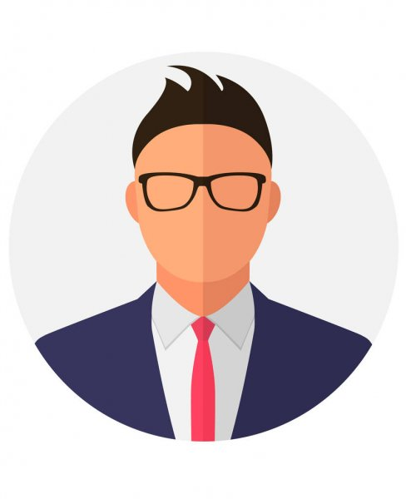

daddy | |

# about me

# work Experience

*-*

# skills