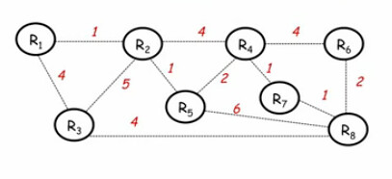

|  |  |  |  |  |  |  |  |  |
| --- | --- | --- | --- | --- | --- | --- | --- | --- |
|  | 0 | 1 | 2 | 3 | 4 | 5 | 6 | 7 |
| Shortest path set | R8 | R8 R7 | R8 R7 R6 R4 | R8 R7 R6 R4 R3 | R8 R7 R6 R4 R3 | R8 R7 R6 R4 R3 R2 | R8 R7 R6 R4 R3 R2 R1 | R8 R7 R6 R4 R3 R2  R1 R5 R3 |
| Candidate set | R3 R5  R6 R7 | R3 R5  R6 R4 | R3 R5  R4 | R3 R5  R2 | R5 R2  R1 | R5 R1 | R1 | - |
| Add | R7 | R6 | R4 | R3 | R2 | R1 | R5 | DONE |

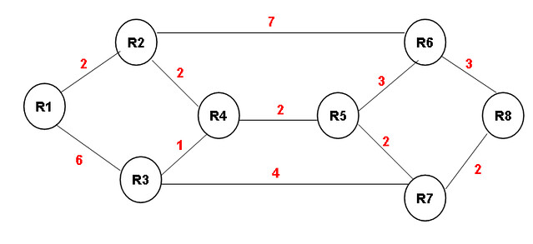

|  |  |  |  |  |  |  |  |  |
| --- | --- | --- | --- | --- | --- | --- | --- | --- |
|  | 0 | 1 | 2 | 3 | 4 | 5 | 6 | 7 |
| Shortest path set | R8 | R8 R7 | R8 R7 R5 R6 | R8 R7 R5 R6 R4 | R8 R7 R5 R6 R4 R3 | R8 R7 R5 R6 R4 R3 R1 | R8 R7 R5 R6 R4 R3 R1 R2 | R8 R7 R5 R6 R4 R3 R1 R2 |
| Candidate set | R6 R7 | R6 R3 R5 | R3 R2 R4 | R3 R2 | R3 R2 R1 | R2 R1 | R1 | - |
| Add | R7 | R5 | R6 | R4 | R3 | R1 | R2 | DONE |



|  |  |  |  |  |  |  |  |  |  |  |  |
| --- | --- | --- | --- | --- | --- | --- | --- | --- | --- | --- | --- |
| R1 | ∞ | R1 | ∞ | R1 | 8 R3 | R1 | 8 R3 | R1 | 7 R2 | R1 | 6 R4 |
| R2 | ∞ | R2 | ∞ | R2 | 7 R5 | R2 | 6 R4 | R2 | 5 R5 | R2 | 5 R5 |
| R3 | ∞ | R3 | 4 | R3 | 4 | R3 | 4 | R3 | 4 | R3 | 4 |
| R4 | ∞ | R4 | ∞ | R4 | 2 R7 | R4 | 2 R7 | R4 | 2 R7 | R4 | 2 R7 |
| R5 | ∞ | R5 | 6 | R5 | 6 | R5 | 4 R4 | R5 | 4 R4 | R5 | 4 R4 |
| R6 | ∞ | R6 | 2 | R6 | 2 | R6 | 2 | R6 | 2 | R6 | 2 |
| R7 | ∞ | R7 | 1 | R7 | 1 | R7 | 1 | R7 | 1 | R7 | 1 |
| R8 | - | R8 | - | R8 | - | R8 | - | R8 | - | R8 | - |



|  |  |  |  |  |  |  |  |  |  |  |  |
| --- | --- | --- | --- | --- | --- | --- | --- | --- | --- | --- | --- |
| R1 | ∞ | R1 | ∞ | R1 | 12R2 | R1 | 12R2 | R1 | 12R2 | R1 | 10R2 |
| R2 | ∞ | R2 | ∞ | R2 | 10R6 | R2 | 10R6 | R2 | 8 R4 | R2 | 8 R4 |
| R3 | ∞ | R3 | ∞ | R3 | 6 R7 | R3 | 6 R7 | R3 | 6 R7 | R3 | 6 R7 |
| R4 | ∞ | R4 | ∞ | R4 | 6 R5 | R4 | 6 R5 | R4 | 6 R5 | R4 | 6 R5 |
| R5 | ∞ | R5 | ∞ | R5 | 4 R7 | R5 | 4 R7 | R5 | 4 R7 | R5 | 4 R7 |
| R6 | ∞ | R6 | 3 | R6 | 3 | R6 | 2 | R6 | 2 | R6 | 2 |
| R7 | ∞ | R7 | 2 | R7 | 2 | R7 | 1 | R7 | 1 | R7 | 1 |
| R8 | - | R8 | - | R8 | - | R8 | - | R8 | - | R8 | - |