* **Device name**: OnePlus 6T
* **Configuration of the device**:
  + Processor: Snapdragon 845
  + Storage: 128GB ROM+8GB RAM
* **Operating system**: OxygenOS (based on Android Pie, upgradable to Android 10)

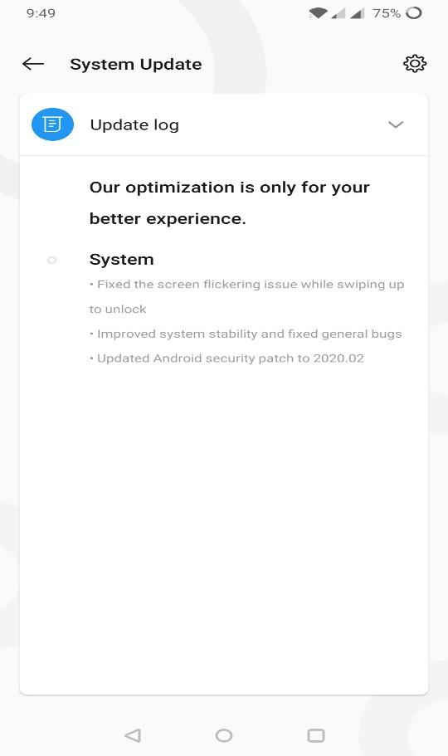

* **Applications being used**:
  + Paytm update:

We don’t need some of the permissions for the functionality of paytm. So, we should make sure the app has correct permissions for sharing only useful data. The update was about scratch cards which is not an immediate necessary for the app. These type of updates should be monitored so that no other malware gets access to the bank details stored in the app.

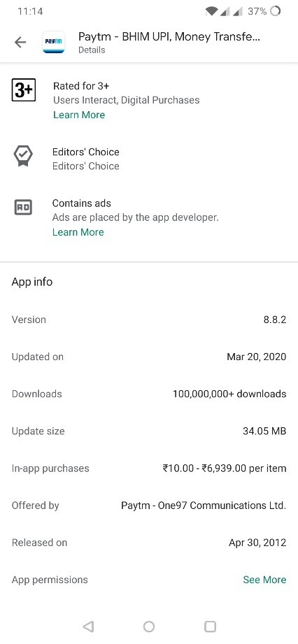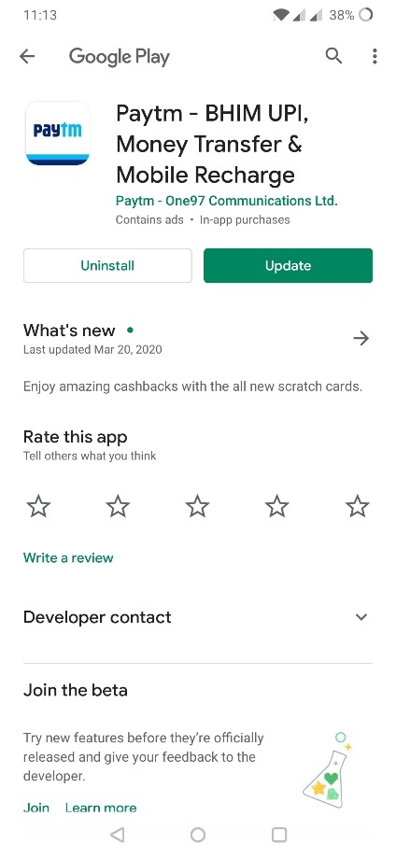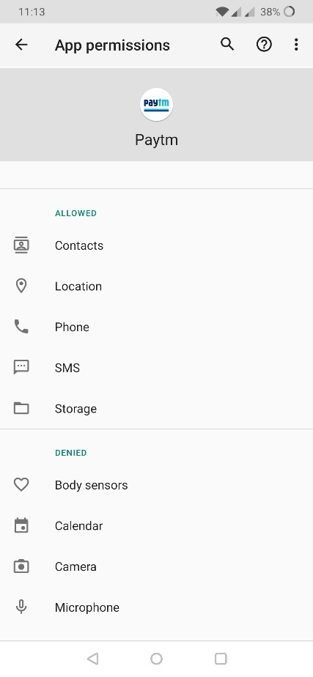

* + Phonepay app: Phone pay had an update regarding one-click payment and user-friendliness. Updates that are really necessary only needs to be installed. Permissions required by the app is also mentioned here.

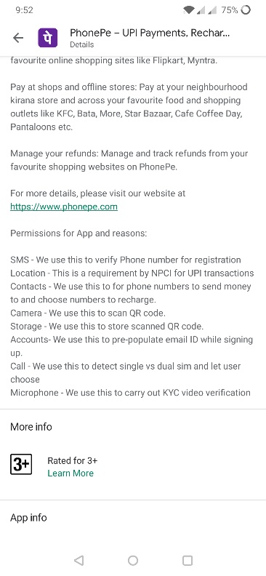 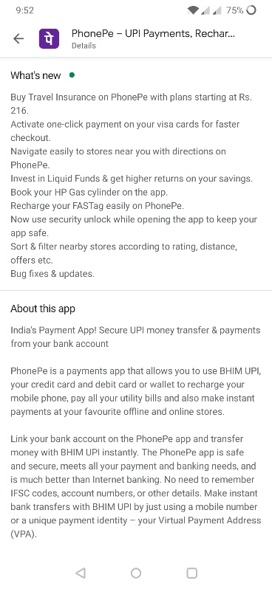

* + Google app: This has an update about voice commands for navigations and trouble shooting connectivity.

