Assignment -1:

1) Facebook: Checked the privacy setting in Facebook and updated the privacy settings.

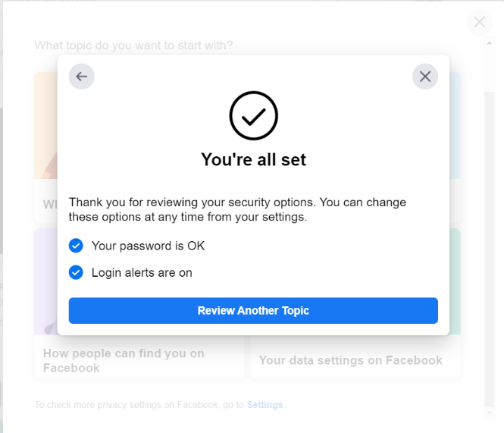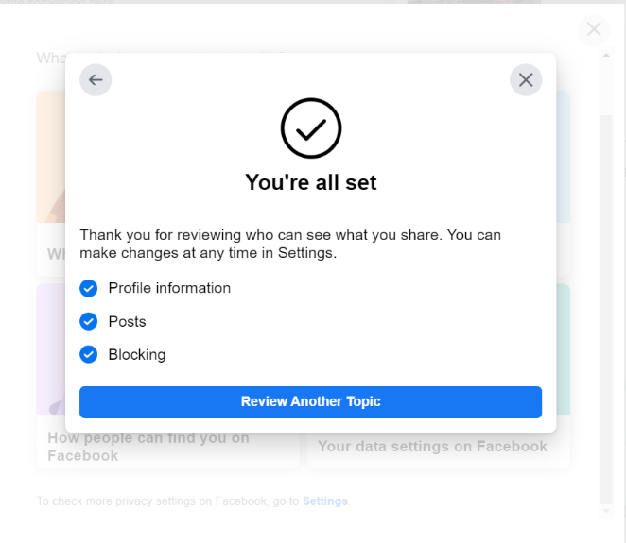

2) Instagram: Checked the privacy setting and updated the passwords.

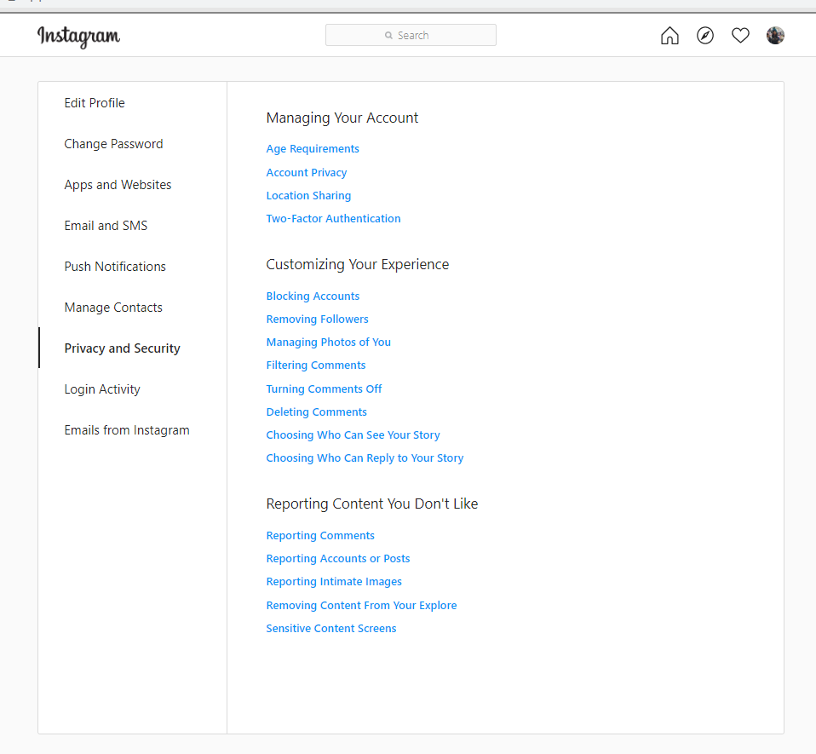

3) LinkedIn: Checked the privacy settings and changed the viewing of my posts.

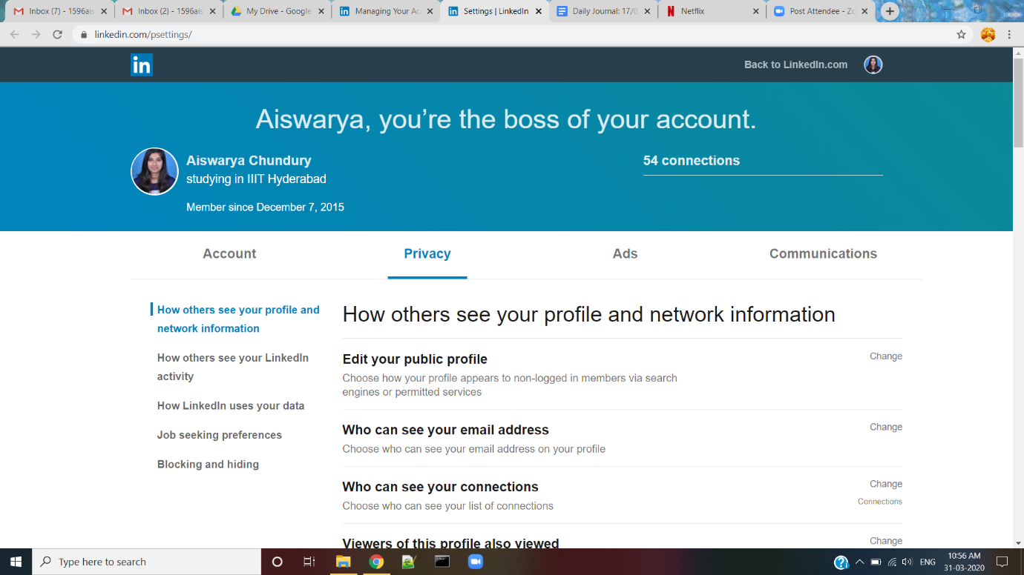

Assignment -2:

Downloaded the anonymous browsing tool: ToR Browser (Tor is a software for enabling anonymous communication.)

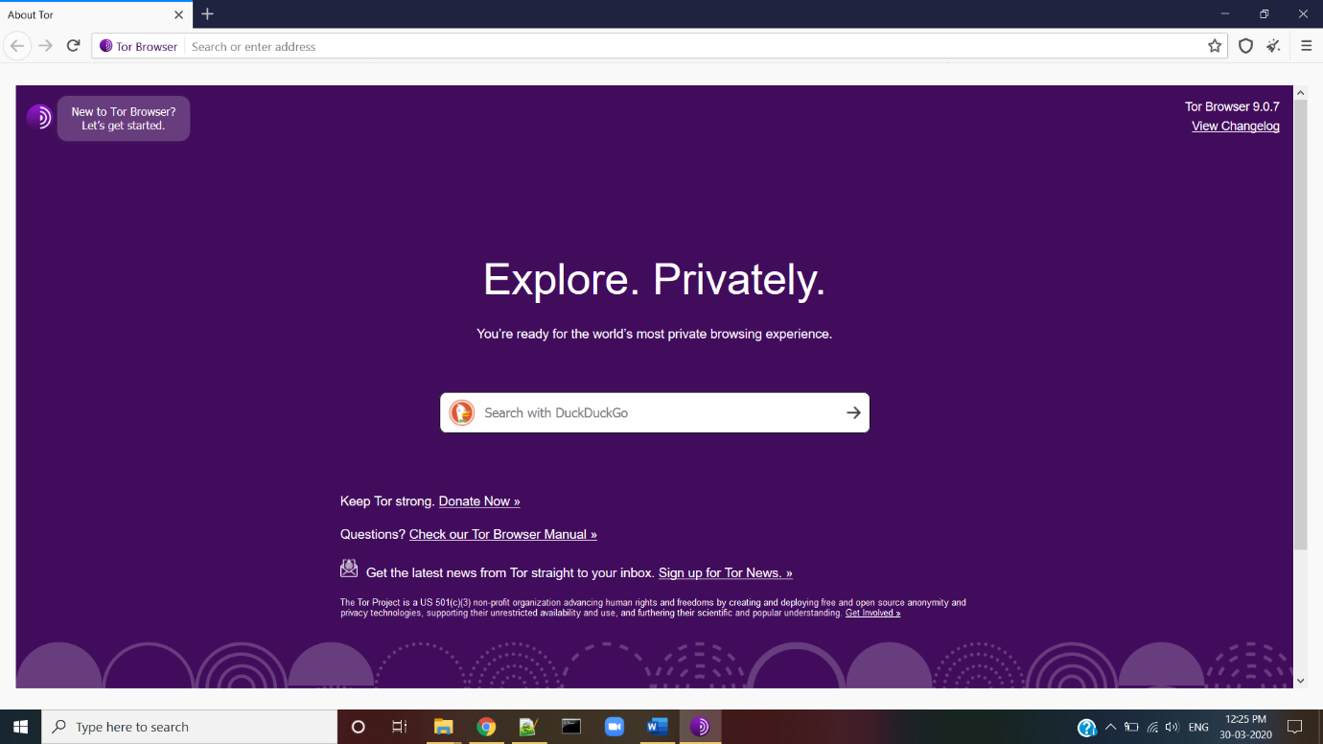

Mobile privacy tools: There are different kings of apps present to protect your personal data in your mobile device. Some of them are app locks, safe browsing, private browsing like Firefox Focus, GlassWire to monitor data usage.