Assignment -1:

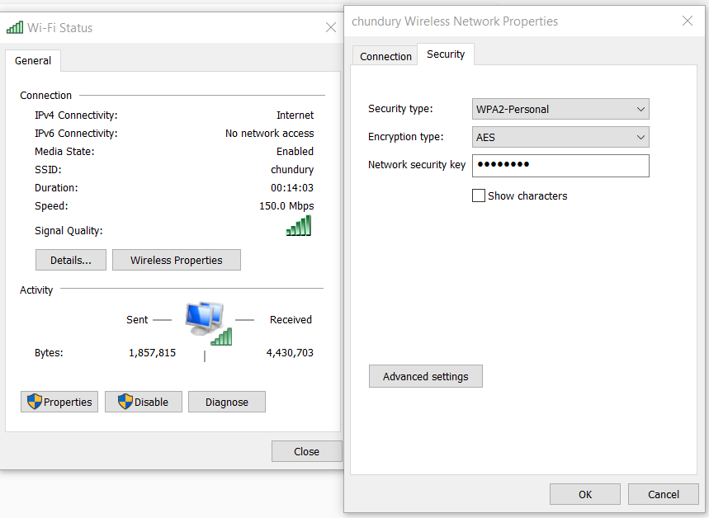

Changed the default SSID to a different name, enable WPA2 and set a security key. Firewall is also enabled.

Assignment -2:

Host based intrusion detection system - Suricata / Snort

A host-based IDS is an intrusion detection system that monitors the computer infrastructure on which it is installed, analysing traffic and logging malicious behaviour.

Snort is an example of host based intrusion detection system, which is a packet sniffer that monitors network traffic in real time, checking each packet closely to detect a dangerous payload or suspicious anomalies. It can be used as a monitoring devive, and analyse the traffic.