Hole Game

# How to play

1. Before running the game, add the "main" and "game" scenes in the folder scene to the "scenes in build" column of the "build settings" interface.
2. If you think the game is running slowly, you can adjust the "time scale" item in "edit / project settings / time" with the recommended value of "2".
3. first run the scene "main" in the folder "scene".
4. 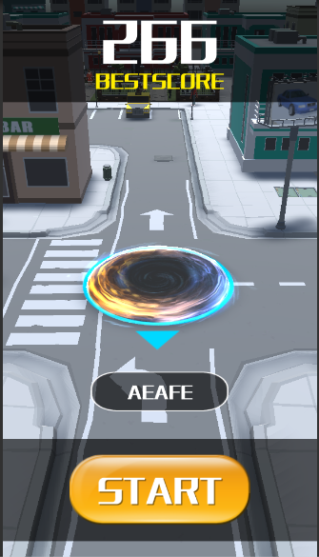  Enter player name， Click to start the game.
5. The game automatically jumps to the scene "game".
6. 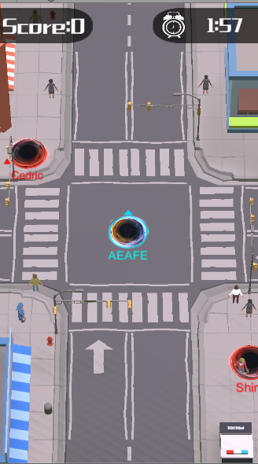 In the game, click the drag mouse to control your black hole (blue) to move.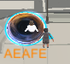 Include the target in the circle, swallow the target, if the target size exceeds the current size of the black hole, can not swallow.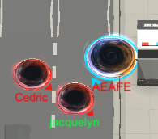 You can swallow black holes that are smaller than you, and you will be swallowed up by bigger black holes than you.
7. All objects in the scene, including buildings, can be swallowed up, as long as your black hole is big enough.
8. 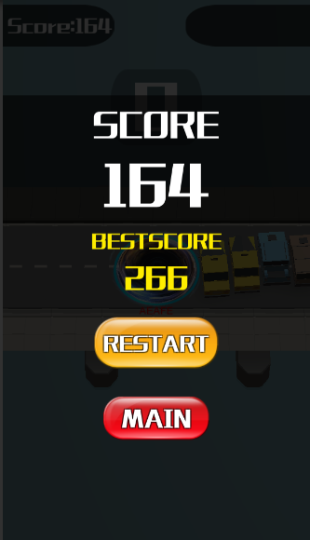 At the end of the game, or when your black hole is swallowed by a larger black hole, it pops up to end the game and can be restarted or returned to the main screen.

# Advanced Scripts

BestScore.cs: score and best score display

CameraRay.cs: the building that shielded the black hole becomes translucent.

Enemy.cs: competitors' AI

ExistTime.cs: used for removal after special effects are played.

GameManage.cs: controlling the basic process of game

GameManageMain.cs: control the main function of the main interface.

Name.cs: showing the names of players and competitors.

ObjScore.cs: control the phagocytic items.

PlayerControl.cs: players control black holes.

RandomColor.cs: random control of game scene tones

SoundResources.cs: sound playback control

# Basic function control of game

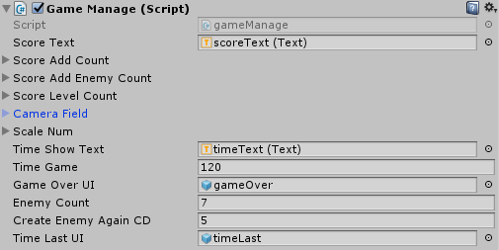

1.  Phagocytosis of fractions obtained from each stage
2.  Phagocytosis of scores obtained by competitors at each stage
3.  The black hole needs to be increased every stage.
4.  The camera field size corresponding to each stage of the black hole.
5.  The size of black holes corresponding to each stage
6.  Game duration / sec
7. Number of competitors from the beginning
8.  How many times a new competitor will be added every time?

# Make your own game

## Basic function control of game



1.  Phagocytosis of fractions obtained from each stage
2.  Phagocytosis of scores obtained by competitors at each stage
3.  The black hole needs to be increased every stage.
4.  The camera field size corresponding to each stage of the black hole.
5.  The size of black holes corresponding to each stage
6.  Game duration / sec
7. Number of competitors from the beginning
8.  How many times a new competitor will be added every time?

## Modifying the appearance of a black hole

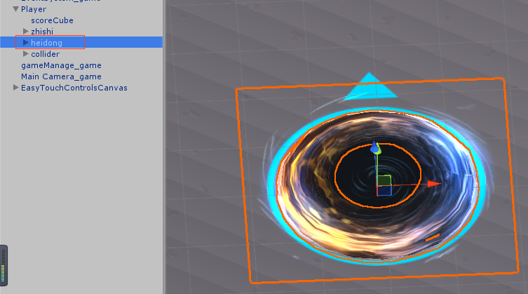

Replace the above model.

## Modifying black hole shape

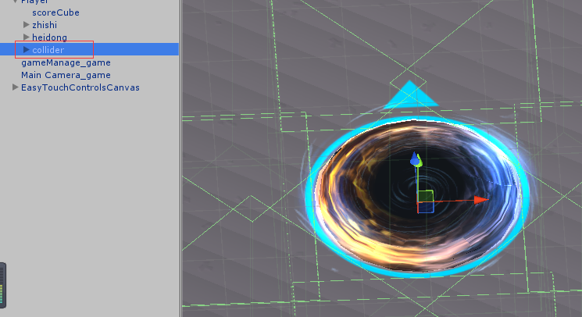

If you modify the shape of the black hole, you need to modify the collision box accordingly.

## Modifying the speed of moving black holes

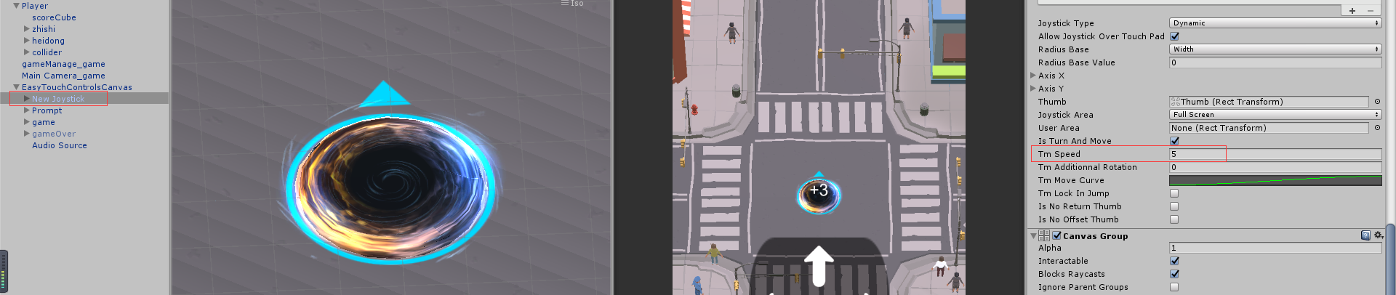

Here is to modify the movement speed of the black hole of the player. To modify the moving speed of the enemy AI, we need to set up the following settings.

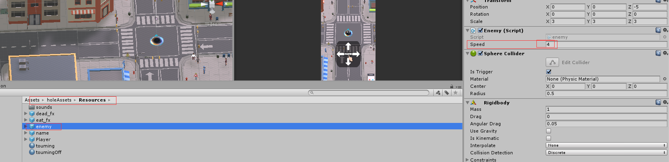

## Each phagocytic object requires a corresponding phagocytic level.

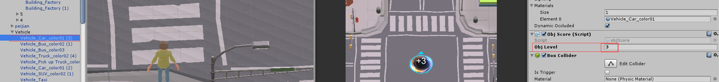

The script "objScore. cs" is added to each phagosable object to allow the enemy AI to recognize the size of the object. The higher the phagocytic level, the higher the score obtained after phagocytosis.

# How to get support

Contact to us ：soyskyapple@outlook.com

Remember attach your invoice otherwise there would not be my reply.

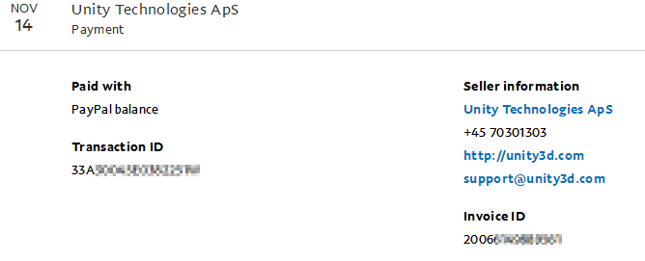

The invoice you can get from your paypal account records.

If you do not have a invoice. Grab some screenshot to confirm your buy successful flow is also ok.