Wireshark Lab:  SSL v8.0  SOLUTIONS  Supplement to Computer Networking: A Top-Down Approach, 8th ed., J.F. Kurose and K.W. Ross  “Tell me and I forget. Show me and I remember. Involve me and I understand.” Chinese proverb  © 2005-2020, J.F Kurose and K.W. Ross, All Rights Reserved | 

A Look at the Captured Trace:

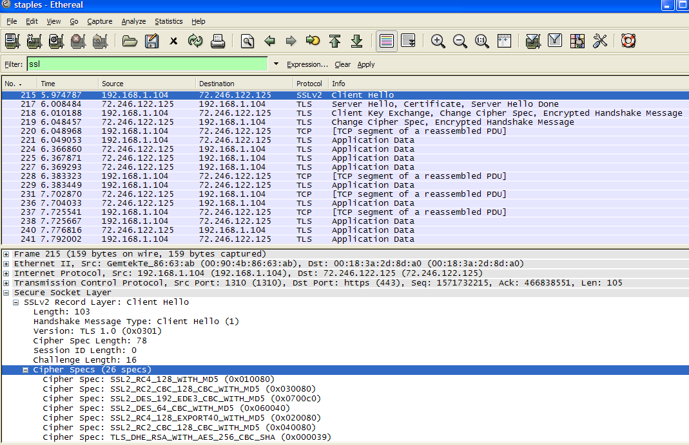
Captured SSL Packets

1. Details of the first 8 captured Ethernet frames (SSL) are listed in the following table:

Frame #  in Ethereal | Frame # | Source | Destination | # of SSL  Records | List of SSL Records
215 | 1 | 192.168.1.104 | 72.246.122.125 | 1 | Client Hello
217 | 2 | 72.246.122.125 | 192.168.1.104 | 3 | Server Hello  Certificate  Server Hello Done
218 | 3 | 192.168.1.104 | 72.246.122.125 | 3 | Client Key Exchange  Change Cipher spec  Encrypted Handshake msg
219 | 4 | 72.246.122.125 | 192.168.1.104 | 2 | Change Cipher spec  Encrypted Handshake msg
221 | 5 | 192.168.1.104 | 72.246.122.125 | 1 | Application Data
224 | 6 | 72.246.122.125 | 192.168.1.104 | 1 | Application Data
225 | 7 | 72.246.122.125 | 192.168.1.104 | 1 | Application Data
227 | 8 | 72.246.122.125 | 192.168.1.104 | 1 | Application Data
Details of the first 8 Ethernet Frames for SSL

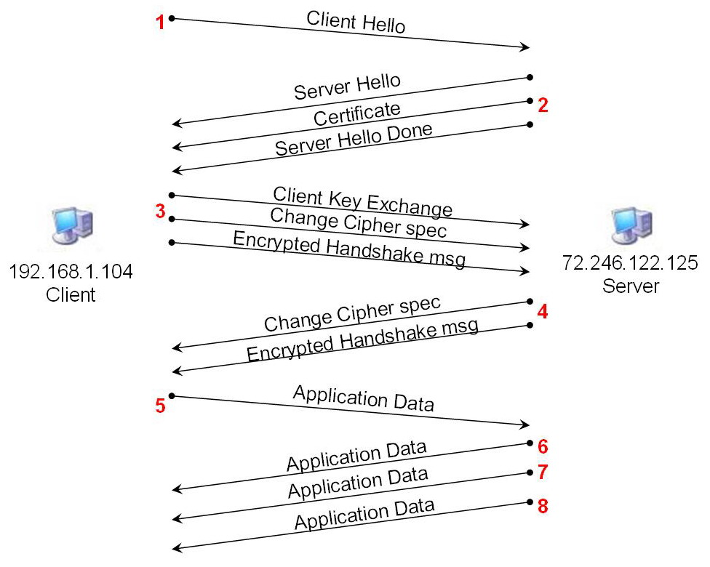
Timing Diagram of the SSL Session

2. Each SSL record begins with the same three fields (content type, version, and length). The values for each SSL record type are listed as follow:

Frame # | SSL Record Types | Content Type | Version | Length
1 | Client Hello | Handshake (22) | TLS 1.0 (0x0301) | 103
2 | Server Hello | Handshake (22) | TLS 1.0 (0x0301) | 74
 | Certificate | Handshake (22) | TLS 1.0 (0x0301) | 989
 | Server Hello Done | Handshake (22) | TLS 1.0 (0x0301) | 4
3 | Client Key Exchange | Handshake (22) | TLS 1.0 (0x0301) | 134
 | Change Cipher spec | ChangeCipherSpec(20) | TLS 1.0 (0x0301) | 1
 | Encrypted Handshake msg | Handshake (22) | TLS 1.0 (0x0301) | 48
4 | Change Cipher spec | ChangeCipherSpec(20) | TLS 1.0 (0x0301) | 1
 | Encrypted Handshake msg | Handshake (22) | TLS 1.0 (0x0301) | 48
5 | Application Data | Application Data (23) | TLS 1.0 (0x0301) | 1552
6 | Application Data | Application Data (23) | TLS 1.0 (0x0301) | 912
7 | Application Data | Application Data (23) | TLS 1.0 (0x0301) | 32
8 | Application Data | Application Data (23) | TLS 1.0 (0x0301) | 32
Client Hello Record

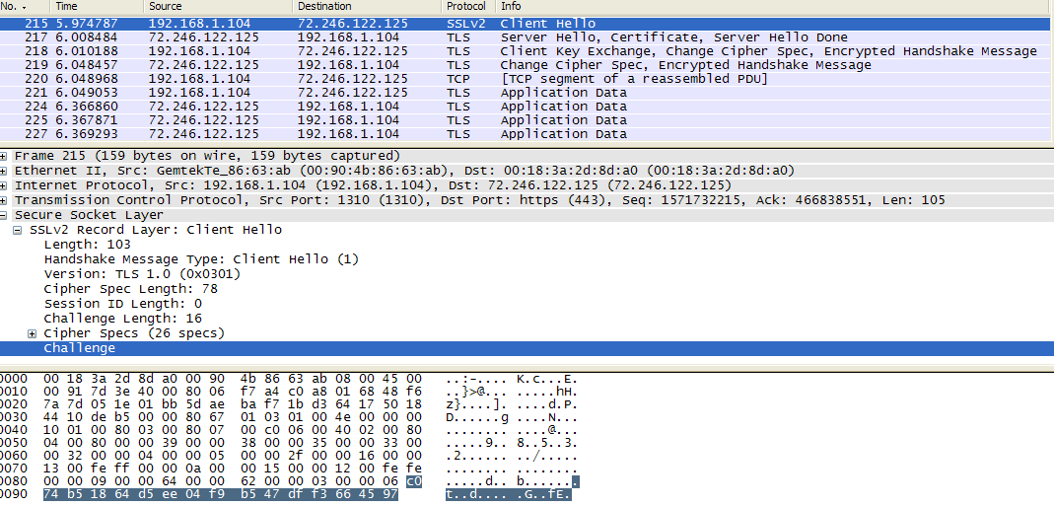
Expanded Client Hello Record

3. The value of the content type is Handshake (22) because this is handshake message type (as shown above).

4. Yes, the Client Hello record contains a challenge and its value in HEX is 0xC074B51864D5EE04F9B547DFF3664597

5. Yes, Client Hello record advertises the cipher suite it supports, as shown below.
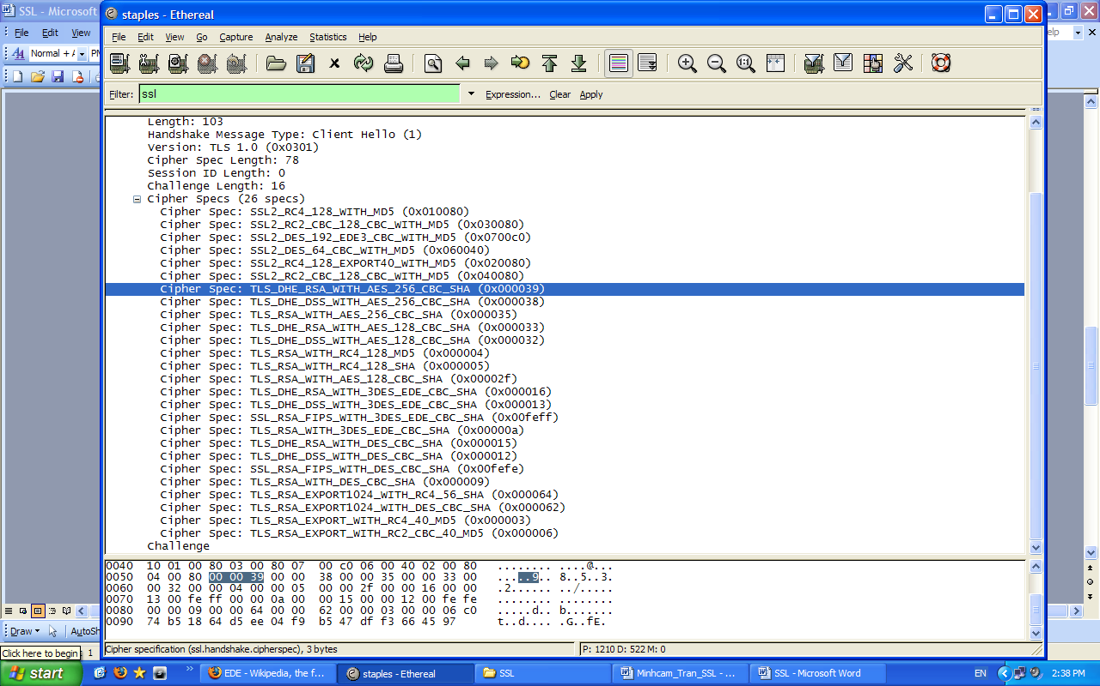
Client Hello Record’s Cipher specs

The first listed TLS (SSLv3) cipher spec (highlighted above) is: DHE and RSA (public-key algorithms) with 256-bit CBC AES (symmetric-key) with SHA (hash algorithm).
Server Hello Record

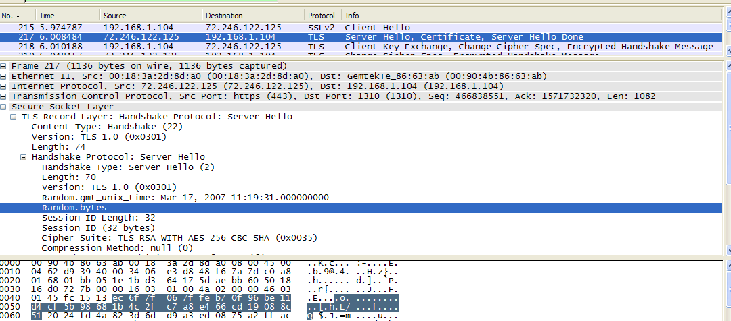
Expanded Server Hello Record

6. Yes, this record specifies a cipher suite. The chosen suite is TLS_RSA_WITH_AES_256_CBC_SHA (0x0035). In other words, RSA (public-key) 256-bit CBC AES (symmetric) and SHA (hash algorithm) are chosen.

7. Yes, this record includes a nonce, as known as Random.bytes, and it is 28 bytes long (as highlighted above). The purpose of the client and server nonces in SSL is to prevent attacker from replaying or reordering records.

8. Yes, this record includes a Session ID which is 32-bytes long. Its purpose is to allow session resumption, which can significantly reduce the number of time-consuming server handshake to crease a new session ID. In the Client Hello record, a nonzero session ID means that the client to resume its previously established session; and a zero session ID means that the client wishes to establish a new session with the server.

9. Yes, this record contains a certificate. The certificate is 982 bytes long, thus it can fit into a single Ethernet frame.

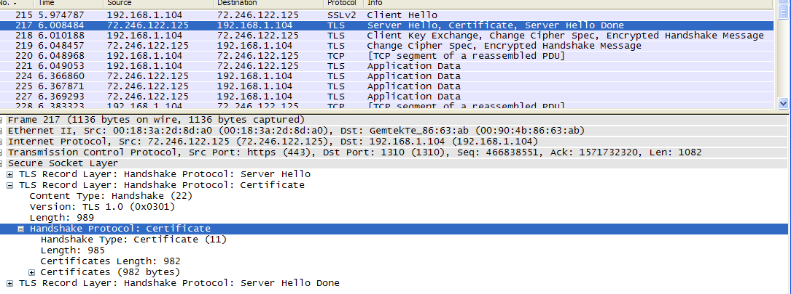
Expanded Server Hello Record (2)

Client Key Exchange Record

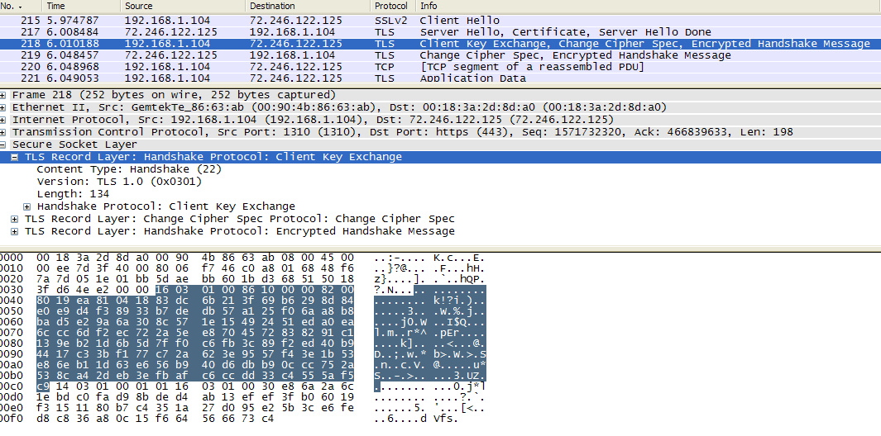
Expanded Client Key Exchange Record

10. Yes, this record contains a pre-master secret (highlighted above). This encrypted pre-master secret is decrypted at the server side and is used to produce a master secret. Then this master secret is used to produces “key block”, which is then sliced and diced into client MAC key, server MAC key, client encryption key, server encryption key, client IV and serve IV. The secret is encrypted using server’s public key. The encrypted secret is 130-byte long.

Change Cipher Spec and Encrypted Handshake Records

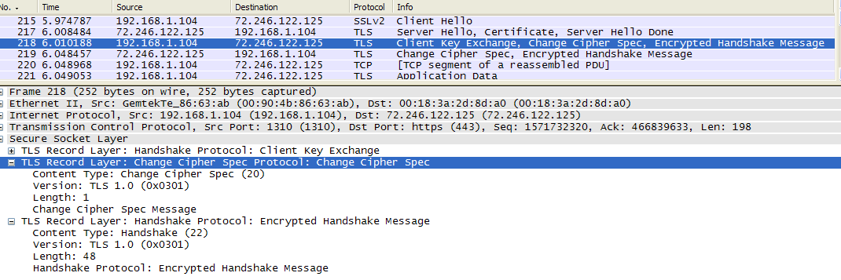
Expanded Change Cipher Spec and Encrypted Handshake Records

11. The purpose of Change Cipher Spec is to indicate change in encryption and authentication algorithms and to update the cipher suite to be used on this connection. This record is only 1 byte long in my trace.

12. The sender of this Encrypted Handshake Records and all handshake messages up to but not including this message are encrypted in record. This information is concatenated and hashed using two hash algorithms, MD5 and SHA. The content of this record is the concatenation of these two hash values. The Encrypted Handshake Record is used to verify that key exchange and authentication processes were successful.

13. Yes, the server also sends its own Change Cipher Spec and Encrypted Handshake records. The only difference is the sender of this record; the sender is now the server while the sender was the client in previous message.

Application Data Records

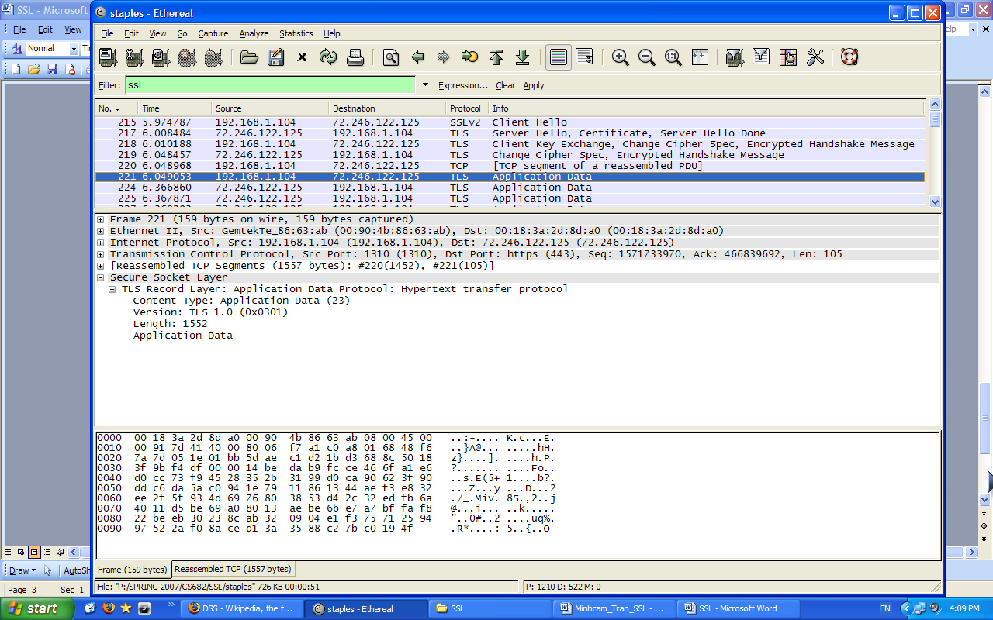
Expanded Application Data Record

14. The application data is encrypted using the specified algorithms in the chosen cipher suite; in my case, RSA (public-key), 256-bit CBC AES (symmetric), and SHA (hash algorithm). Yes, the records containing application data include a MAC; however, Ethereal does not distinguish between the encrypted application data and the MAC.

