Scritchy Scratchy
Systems Design Analysis

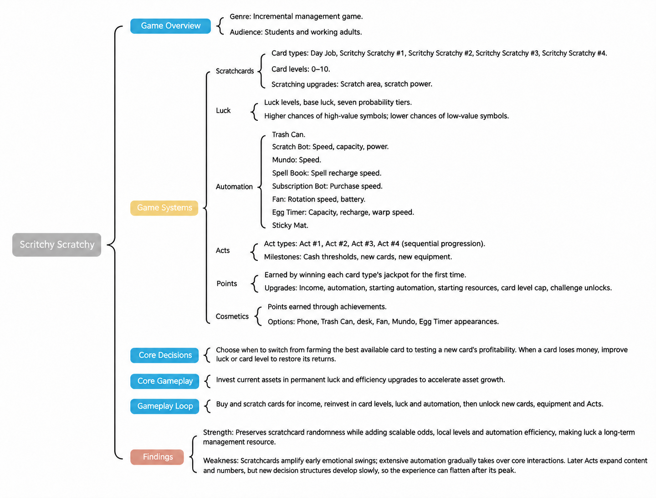

01 Game Overview and Key Findings

1.1 Overview and Four Core Systems
Scritchy Scratchy is an incremental management game built around virtual scratchcards. Players buy cards, improve luck and card levels, unlock automated scratching equipment, and pursue larger returns. Compared with the one-off, purely random experience of real scratchcards, the game embeds random outcomes in persistent progression and efficiency optimization, turning each scratch into an investment in a long-term income system.
Core System | What the Player Sees | System Function
Scratchcards | Cards with different prices, rules, prizes, and negative outcomes | Random returns, short reveal cycles, and content variety
Luck | Prize distributions change as luck improves | Makes randomness a global progression system worth investing in
Automation | Equipment such as Scratch Bot, Mundo, Subscription Bot, and Egg Timer | Gradually replaces repetitive work and increases throughput
Points | Abilities retained across Acts and progression through resets | Compresses mastered stages and changes the next run's starting conditions

1.2 Central Design Question
Design Question
How can a luck-driven activity with a single payout become a management and incremental experience lasting several hours? This analysis also asks why the game is particularly compelling early on, yet more likely to flatten out later.

1.3 Method and Scope
This analysis combines hands-on play, game configuration data, formula derivation, and timed automation tests. It focuses on economic growth, probability progression, automation efficiency, Act progression, progression across Acts, and player experience. UI, characters, and art are outside the main scope.
What I Analyzed | How I Verified It | What I Found
Scratchcard economics, luck progression, automation, Acts, and progression across Acts | Hands-on observation + configuration data + expected-value calculations + automation timing | Scratchcards amplify early emotional swings; extensive automation flattens the later experience

1.4 Main Argument
Scratchcards amplify the early game; automation flattens the late game.
Frequent immediate feedback concentrates the strongest rewards of management progression in the early part of the overall experience. As automation takes over player actions, later systems offer too few equally engaging new decisions to sustain that intensity. Diminishing returns therefore begin earlier, extending the period of low emotional variation.

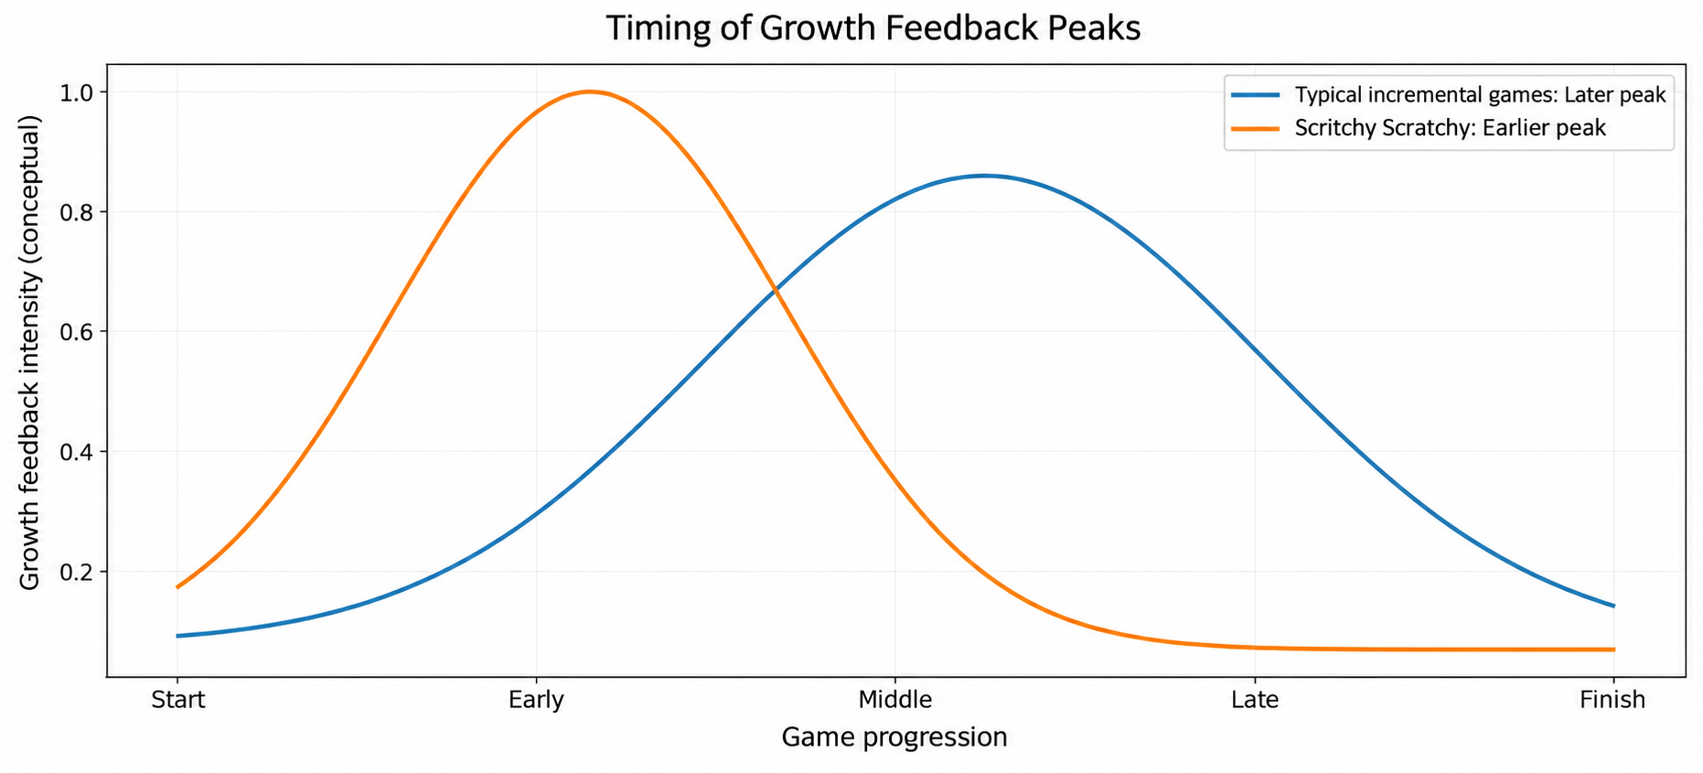

1.5 Key Findings
- A random activity becomes a manageable system: card levels, luck, and automation turn one-off random outcomes into a long-term system that players can develop and optimize.
- Two progression paths create soft gates: new cards can be uneconomical at low luck or low card levels, encouraging continued investment in both global luck and individual card progression.
- The experience peaks early: scratchcards' immediate reveals strengthen the early game, while extensive automation later reduces both interaction frequency and decision density, making diminishing returns apparent sooner.
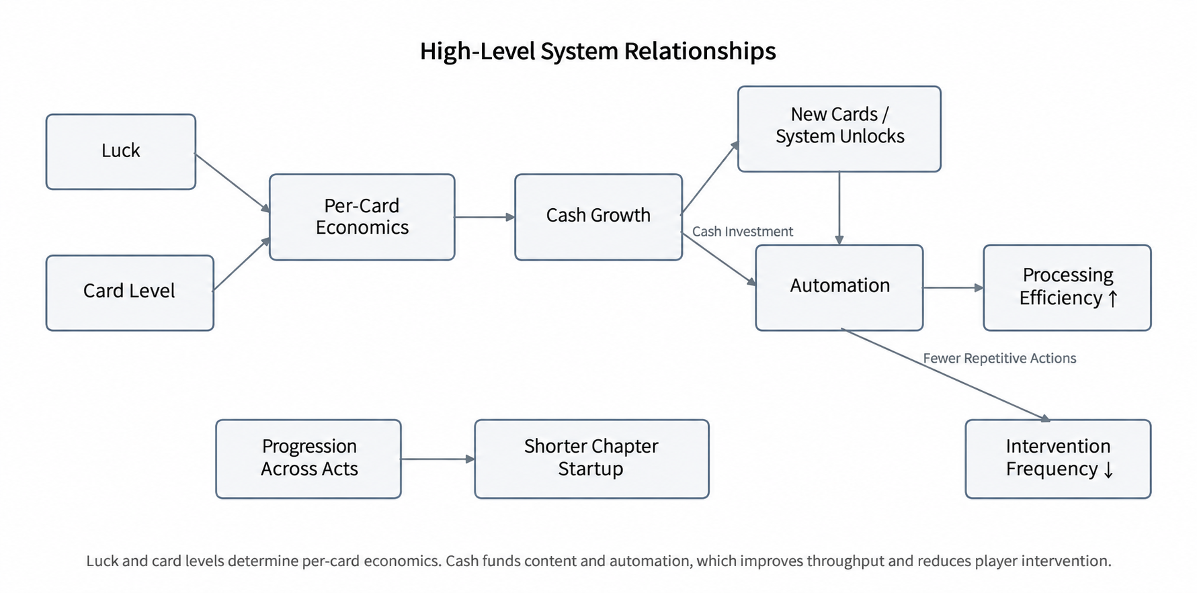
Figure 1 | High-Level System Relationships
Reading the diagram: Luck and card levels determine per-card economics; money unlocks new cards and automation; automation increases throughput while reducing the frequency of player intervention.

02 Core Gameplay Loop

2.1 The Single-Card Loop
Stage | Player Action | Feedback
Purchase | Pay the current card price | Accept financial risk
Scratch | Continuously remove the coating with the mouse or touch input | Reveal cells one at a time, building anticipation
Read the Result | Identify symbols, matching conditions, or negative outcomes | Immediate emotional feedback
Resolve | Collect prizes or absorb losses | Money changes and experience increases
Repeat / Upgrade | Buy again or invest in upgrades | Connect random outcomes to long-term progression
The single-card loop provides frequent reveals with little delay. On its own, it cannot sustain long-term management, so each resolution also feeds experience, card levels, money, luck, and automation unlocks.

2.2 The Overall Management Loop
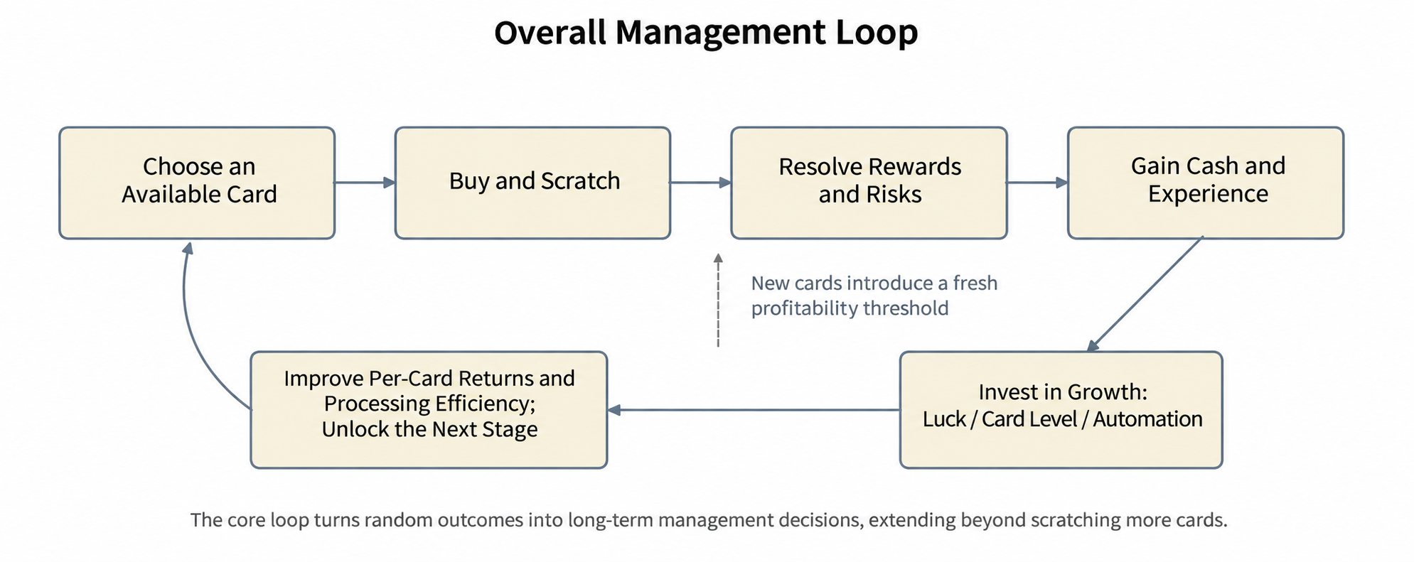

The overall loop centers on scratching more cards and turning each random outcome into a long-term management decision: when to keep developing an old card, move to a new one, increase luck, or improve automation efficiency.

03 Scratchcard Economics and Card Levels

3.1 Basic Card Structure
Card | Price | Base Luck | Initial XP | XP Multiplier | Reward Multiplier
Day Job | $1 | 0 | 5 | 1.5 | 1.5
Two Win | $10 | 0 | 5 | 1.2 | 1.3
Mini Scratch | $100 | 1 | 10 | 1.2 | 1.3
Apple Tree | $2,000 | 3 | 10 | 1.2 | 1.3
Quick Cash | $10,000 | 4 | 10 | 1.2 | 1.3
Lucky Cat | $300,000 | 6 | 10 | 1.2 | 1.3
Sand Dollars | $20,000,000 | 9 | 10 | 1.2 | 1.3
Berry Picking | 2.0e+19 | 26 | 10 | 1.2 | 1.3
A common progression template for ordinary cards starts at roughly 10 XP, multiplies subsequent XP requirements by about 1.2, and multiplies rewards by about 1.3 per level. Early content such as Day Job and Two Win uses lighter progression, while Final Chance cards largely sit outside the ordinary leveling path.

3.2 The Design Role of Card Levels
Card levels provide local progression: repeatedly buying and completing one card type increases its rewards. Repeated scratching becomes a cumulative investment in efficiency and creates local optima. A highly leveled old card can be more reliable in the short term than a newly unlocked one.

3.3 Experience and Leveling Pace
In the base model, each valid card resolution can be treated as roughly 1 XP. Ordinary cards' XP requirements grow by about 1.2 per level, while rewards grow by about 1.3. The first few levels therefore tend to offer a clear return on investment. XP bonuses from abilities carried across Acts further change leveling speed but are excluded from the main base model.
Design Implication
Card levels make old cards feel like assets and establish the basis for alternating luck and card-level requirements.

04 Luck and Probability Progression

4.1 Seven Probability Tiers
Each card's symbol configuration contains seven sets of weights. Luck moves the card between these preset distributions, rather than applying a fixed percentage bonus to every reward.

4.2 Base Luck and Tier Mapping
Core Formula
Luck tier = current luck level − base luck + 3
Clamp the result to tiers 0–6.
How to read this: When current luck equals base luck, the card uses the middle tier, 3. Each additional luck level moves it up one tier.
Example: For base luck 9, luck 7 → tier 1; luck 9 → tier 3; luck 10 → tier 4; luck 12 or higher → tier 6.

Base luck is the central anchor of the seven probability distributions. It does not restrict access. A card uses tier 3 when current luck equals its base luck and reaches the tier-6 cap at three levels above base luck. Older cards gradually reach their cap as luck improves; new cards create renewed progression pressure through higher base luck.
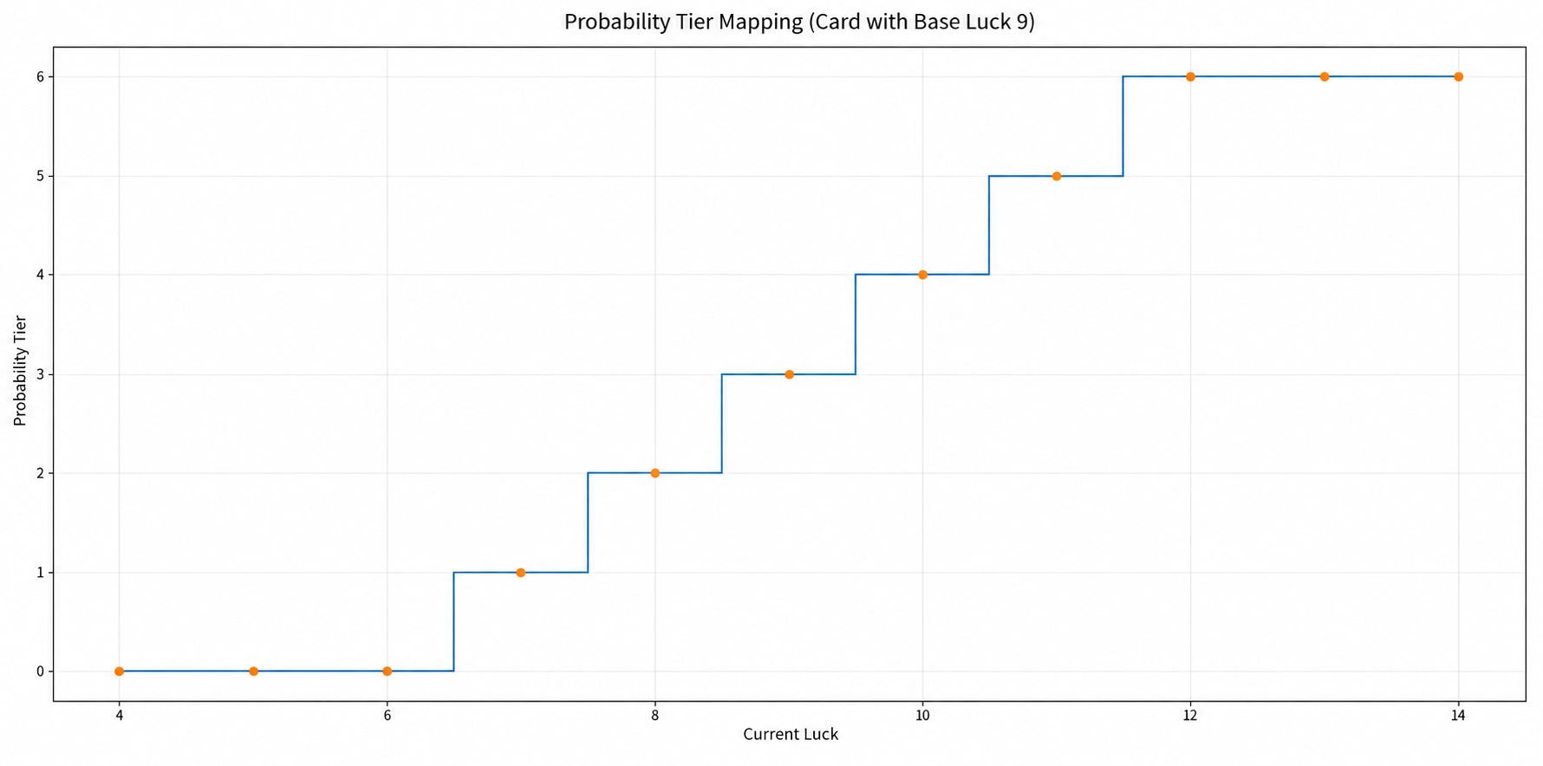

4.3 The Lasting Value of Global Luck Progression
With card levels alone, players could remain on one locally optimal card for a long time. Luck improves several cards' distributions at once. Increasing base luck for later cards creates tension between fully developed old cards and risky new ones.

05 Expected-Value Thresholds and Interleaved Progression

5.1 Expected-Value Model
Expected value (EV) indicates whether repeatedly buying a card is worthwhile on average at the current luck and card levels. For cards that pay for three matching symbols, first convert the current tier's weights into the probability of a target symbol in one cell. Then calculate the probability of that symbol appearing at least three times across the card.
Expected-Value Calculation
① Three-match win probability = the total probability of the target symbol appearing at least three times across the cells.
② Expected prize per card = Σ(each prize’s trigger probability × its payout).
③ Net EV = expected prize per card × 1.3^card level − card price.
Explanation: Calculate each prize’s average contribution, add them, and subtract the price. Moving between luck tiers can amplify three-match probabilities and produce jumps in net EV.

5.2 Sand Dollars: A Representative Soft Gate
Sand Dollars costs $20,000,000 and has base luck 9. Players can buy it at lower luck, but low probability tiers put its base expected payout well below its price. This creates an economic soft gate: players can access the content early, while the results guide them back toward progression.
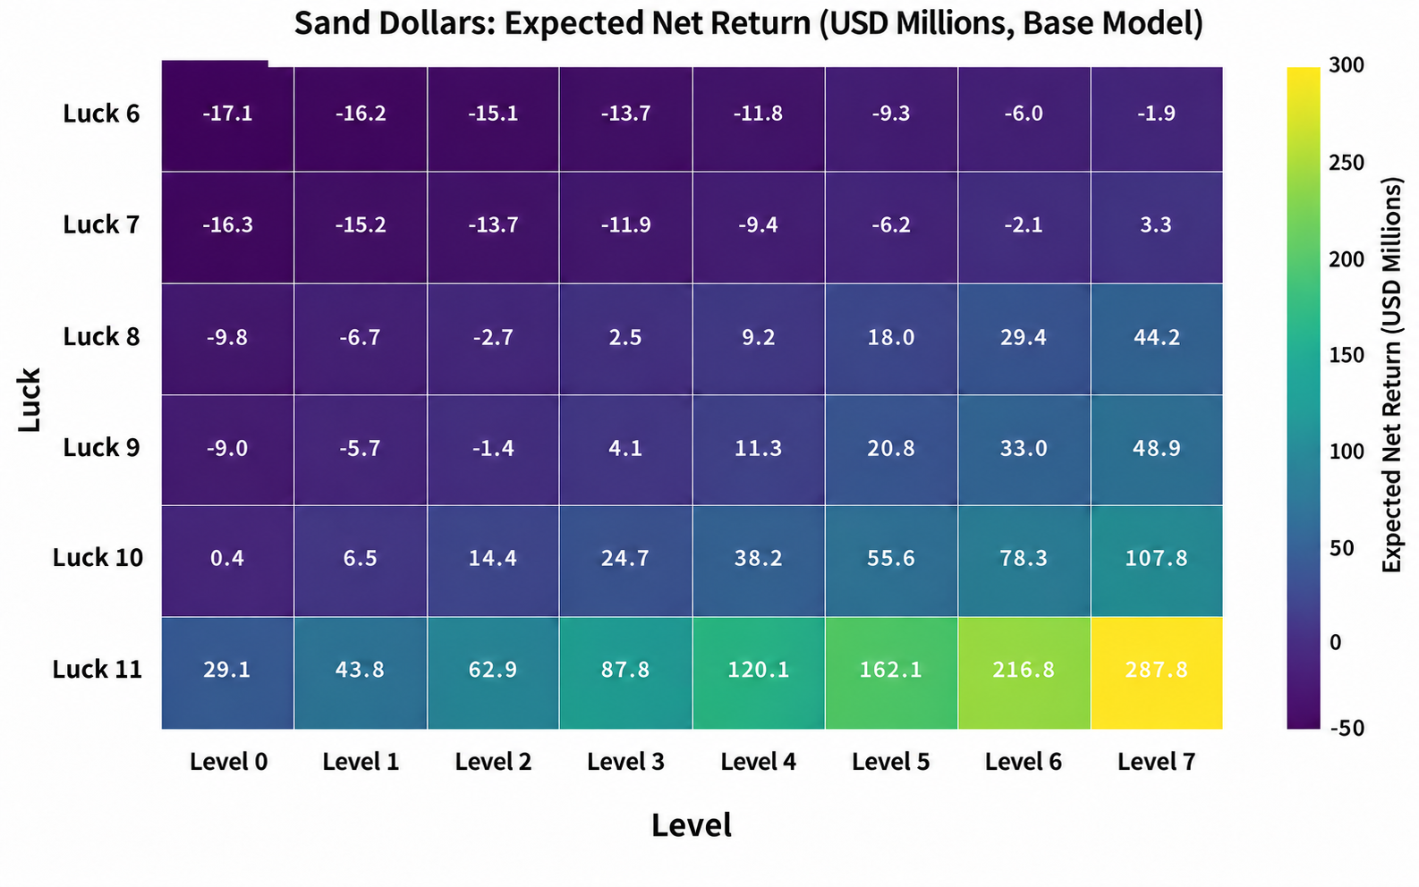
The base model suggests that at luck 7, roughly card level 7 is required to break even; at luck 8–9, roughly level 3 is sufficient. At luck 10, level 0 is already near or above positive net EV. One global luck upgrade can therefore outperform several local card levels.

5.3 Luck and Card-Level Thresholds
Key Finding
The game encourages global upgrades by interleaving new cards that depend more heavily on luck with cards whose profitability can be restored through leveling. Local optima periodically stop working, drawing players back into global progression.

This interleaving keeps progression from following just one path. Players move between pressure from new content, local leveling, global investment, and returning to new content.

06 Representative Card Mechanics and EV Differences
Case | Core Rule | Reason for Selection
Apple Tree | Independent cell payouts, with negative-value Worms and several Apple rewards | An independent-cell card with direct downside risk
Quick Cash | Three matching symbols trigger prizes; different rewards can trigger independently and accumulate | An early combination-based payout structure
Sand Dollars | Three matching symbols, high base luck, and a high price | The clearest illustration of luck and card-level soft gates
Berry Picking | An independent payout area plus a separate 1× / 2× / 3× multiplier area | A late-game multiplier area changes the composition of EV

6.1 Apple Tree: Risk Enters Each Cell's Expected Value
In Apple Tree, a Worm is worth −$2,000, while several types of apples provide positive returns. Higher luck shifts weight from negative or zero-value outcomes toward more valuable ones. This makes the effect of luck clear: it reshapes the entire outcome distribution, extending beyond the chance of winning.

6.2 Quick Cash: Multiple Three-Match Prizes Can Accumulate
Quick Cash contains symbols of different values. Each symbol type is checked independently for three matching occurrences. When calculating EV, adding prize-trigger probabilities does not give the overall probability of winning a card. Calculate each prize's trigger probability separately, then sum their expected monetary contributions.

6.3 Berry Picking: A Separate Multiplier Area
Berry Picking costs 2×10^19 and has base luck 26. Alongside ordinary payout symbols, it has an independent 1× / 2× / 3× multiplier area whose three weights remain essentially constant. This extends late-game payouts into a combination of base returns and an independent multiplier. Both areas influence expected returns and variation.
Design Implication
Berry Picking introduces a new payout structure. The change primarily affects outcome values; it does not automatically add new long-term management decisions.

07 Automation Progression

7.1 Automation Unlock Path
Milestone | Configured Requirement | Main Function
Scratch Bot | $1,000 | Begins replacing manual scratching
Fan / Sticky Mat | $50k / $100k | Improves the interaction and processing workflow
Mundo | $2B | Takes over more card handling
Subscription Bot | $1e17 | Automates purchasing and reduces restocking actions
Egg Timer | $1e24 | Late-game tool for time and batch-processing efficiency
Automation progresses by taking over entire parts of the player's workflow: scratching, handling, purchasing, and waiting. Speed increases support this gradual conversion of a manual scratchcard process into an automated one.

7.2 Throughput and Player Intervention Frequency
This analysis uses cards processed per minute as its primary efficiency metric. Money earned per minute is less suitable because automation can make low-EV cards lose money faster, obscuring the equipment's processing capacity. A second metric, player intervention frequency, tracks how often the player needs to act again.

7.3 Speed Formula and Cross-Validation
Speed Growth Formula
Speed multiplier = 1 + 0.5 × speed level
Processing time per card = level-0 processing time ÷ speed multiplier
Cards per minute = 60 ÷ processing time per card
Explanation: Level 0 is 1× speed; each level adds 0.5×. For a base time of 10 seconds per card, level 2 gives 2× speed, or about 5 seconds per card.

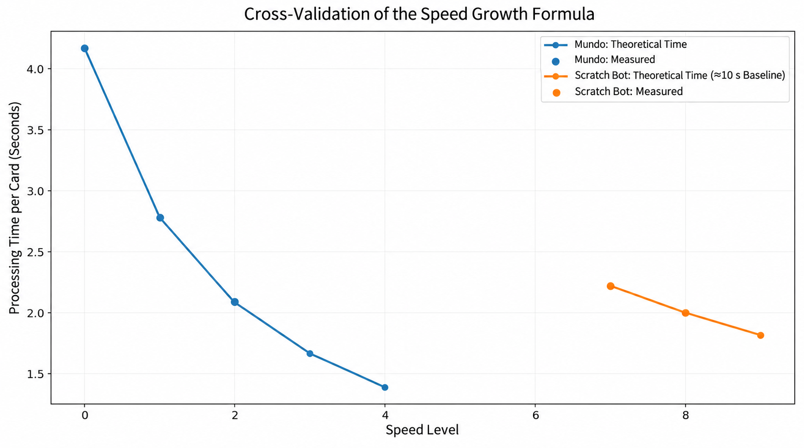
Measured Mundo times were approximately 4.17 seconds at level 0, 2.78 at level 1, and 2.09 at level 2, closely matching the formula. Scratch Bot measurements at effective levels 7–8 were approximately 2.22 and 2.00 seconds, also consistent with an additional 0.5× speed per level.
From Direct Action to System Management
Automation successfully removes repetition. The key question is whether new higher-level decisions take over the player's attention as low-level actions disappear.

Automation Device | Upgrade | Gain per Level | Maximum Upgrades
Scratch Bot | Scratch Bot Speed | +0.5× speed | 30
Scratch Bot | Scratch Bot Capacity | +3 capacity | 10
Scratch Bot | Scratch Bot Strength | +1 strength | 20
Fan | Fan Speed | +0.5× speed | 5
Fan | Fan Battery | ×2 | 5
Spell Book | Spell Charge Speed | +0.5× speed | 10
Mundo | Mundo Speed | +0.5× speed | 10
Subscription Bot | Buying Speed | +0.5× speed | 10
Egg Timer | Timer Capacity | +0.5 | 10
Egg Timer | Timer Charge | +0.5 | 10
Egg Timer | Warp Speed | +0.5× speed | 3

08 How Two Progression Paths Create Incremental Management

8.1 Economic Progression
Money → new cards → card levels / luck → higher expected returns → more money forms the economic progression path. This lets players repeatedly overcome the financial thresholds introduced by new cards.

8.2 Efficiency Progression
Money → automation equipment → speed / capacity / strength upgrades → more cards processed per minute → less frequent player intervention forms the efficiency progression path.

8.3 Expected Value × Throughput
The Key to Management Gameplay
Long-term returns ≈ EV per card × processing speed (throughput).
Economic progression determines whether a card is worth processing; efficiency progression determines how many cards can be processed in a given time.

8.4 From Scratching Cards to Managing a System
Together, these paths shift the player's focus from what a single card reveals to which card is worth running continuously, whether probability or throughput should improve first, and what automation should process. This is how the game turns a random toy into an incremental management system.

09 Act Structure, Points, and Progression Across Acts

9.1 Content Expansion Across Four Acts
Dimension | Act 1 | Act 2 | Act 3 | Act 4
Card Categories | #1 | #1 + #2 | #1 + #2 + #3 | All
Representative New Cards | Apple Tree / Quick Cash / Lucky Cat | Sand Dollars / Scratch My Back / Snake Eyes | Bank Break / Berry Picking | Trick or Treat / Slot Machine / To the Moon
Key Automation | Scratch Bot / Fan | Mundo | Spell Book / Subscription Bot | Egg Timer
Main Interaction | Scratch / resolve / upgrade | The same interaction expands | The same interaction expands | The same interaction expands
End Point | Final Chance | Final Chance_2 | Final Chance_3 | Final Chance_4

9.2 Consistency of Experience and Interaction
Each Act rebuilds its rhythm through familiar low-tier scratching and work interactions. Even Day Job, which is not a scratchcard, uses a similar back-and-forth wiping motion. This continuity keeps relearning costs low and lets players carry their existing understanding into the next Act.

9.3 How Points Change an Act's Starting State
Ability Type | Representative Abilities | Main Effect | Effect on Act Pacing
Starting Equipment | Starter Kit / Air Condition / Pet Lover / Fully Automated | Start with Scratch Bot / Fan / Mundo / Subscription Bot | Skip the inefficient period of repurchasing equipment
Efficiency | Booster Kit | Higher starting Scratch Bot capacity, strength, and speed | Compress the opening stage of an Act
Returns | Self Made Millionaire / Smart Investment | Increase manual returns or card-level rewards | Make familiar cards consistently profitable sooner
Progression | Experienced / Built Different / Learn by Doing | Faster experience growth and higher level caps | Change the time needed for local leveling
Rule Adjustments | Picky Eater / Shopping Spree / Hotkeys | Mundo handles bad cards / bulk purchasing | Reduce repetitive management

9.4 Progression Across Acts Compresses Mastered Content
An Act has no fixed-length early, middle, or late experience. Persistent abilities let players enter the next Act at higher efficiency. For example, starting with a faster Scratch Bot compresses an opening stage that previously took much longer to establish. Efficiency once associated with the late game may appear midway through a later Act.

9.5 The Four Acts Converge Structurally
Continuity reduces learning costs, but the four Acts share highly similar progression structures, interactions, and endings. Content expands faster than the variety of problems players must solve. Later Acts therefore feel like running the same management process at larger numerical scales, laying the groundwork for diminishing returns.

10 Player Experience: An Early Peak in Management Progression

10.1 Early Game: Scratchcards Amplify Emotional Swings
The physical act of scratching creates frequent cycles of anticipation, reveal, and profit or loss. Each card supplies a short burst of stimulation beyond simply watching numbers rise. Economic progression amplifies this effect: new cards periodically disrupt profitability, and upgrades restore it.

10.2 The Larger Emotional Loop: Control → Loss of Control → Restored Control
Early-Game Loop
Establish stable income → unlock a riskier or more demanding card → EV deteriorates and control weakens → improve luck / card levels → EV recovers → control returns → the next card disrupts it again.

Problems emerge quickly and are solved quickly. Players repeatedly complete a positive loop of problem, growth, and resolution in the early part of the overall game. Much of the strongest progression feedback is delivered up front.

10.3 Late Game: Automation Flattens the Experience
As Scratch Bot, Mundo, and Subscription Bot take over the workflow, player intervention becomes less frequent. If too few new higher-level decisions replace the removed actions, decision density declines alongside interaction frequency.
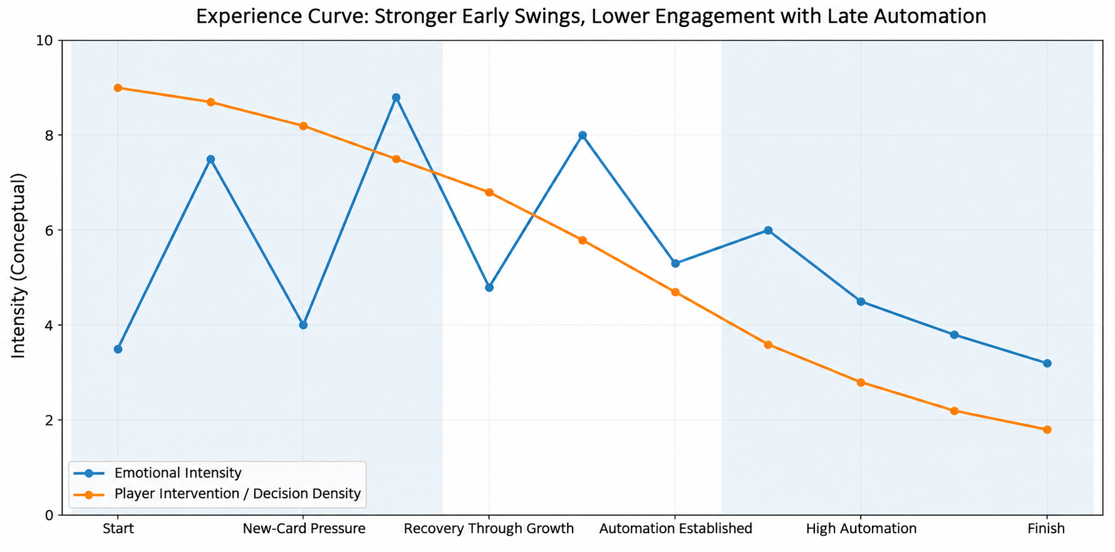

10.4 Diminishing Returns
Here, diminishing returns means that players continue becoming stronger and more efficient, while each similar upgrade contributes less novelty, less change in interaction, and less emotional reward. Scritchy Scratchy retains this familiar management-game problem. Its earlier peak also brings forward the period of low emotional variation.

10.5 Supporting Evidence from Player Reviews
The Steam page and recent user reviews contain two coexisting responses: some emphasize addictive play and satisfying feedback; others mention mid-to-late-game repetition, automation making the game feel like a background process, and lengthy progression through later stages after resets. These responses align with the analysis of strong early feedback and a flatter late game. They serve as supporting context here, not the primary evidence.

11 Design Conclusions

11.1 What the Game Does Well
Strength
The game retains the randomness of scratchcards while adding improvable probabilities, individual card levels, and automation efficiency. Luck becomes a long-term management resource.

Soft gates let players access new content early while economic outcomes guide progression. Alternating luck and card-level requirements periodically break local optima. Progression across Acts compresses mastered content so the next run returns more quickly to decisions that still matter.

11.2 Limitation: Too Few Equally Engaging Experiences After the Early Peak
Limitation
Scratchcard mechanics amplify early emotional swings, while extensive automation gradually removes the main interactions. Later Acts expand content and numerical scale without an equivalent expansion in decision structure, making the experience more likely to flatten after its peak.

11.3 Transferable Systems Design Principles
Principle | Transferable Lesson | Limits of Applicability
Automation and New Decisions | When automation replaces repetitive low-level actions, consider whether new higher-level decisions will sustain player attention. | Low intervention is not necessarily a problem when observing production or passive accumulation is the core appeal.
Soft Gates | Players need not be barred from advanced content. Economic results can communicate that they are not ready yet, guiding progression more gently. | Players must understand that losses result from insufficient progression, rather than arbitrary random punishment.
Compression Across Acts | One benefit of persistent progression is shortening mastered stages with little remaining decision value. | Excessive compression shortens content lifespan; later stages still need new decisions or goals.
Managing Experience Peaks | Strong early stimulation quickly builds appeal. If it exhausts the main forms of feedback too soon, later play needs new layers of experience to avoid a flat long tail. | Not every management game needs another equally intense mid-to-late-game peak.

11.4 Overall Assessment
Scritchy Scratchy is a clear example of incremental management design. Luck, card levels, and automation turn random scratchcard payouts into a long-term growth problem. Its most useful lesson is how random outcomes become something players can invest in, improve, and automate. Its limitation is equally clear: after delivering strong early stimulation, growth in the experience does not fully keep pace with efficiency gains, so marginal utility continues to decline.

Appendix A Core Configuration Parameters

A.1 Representative Card Parameters
Card | Price | Base Luck | Scratch Hardness | Initial XP | XP Requirement Multiplier | Reward Multiplier
Apple Tree | 2e+03 | 3 | 2 | 10 | 1.2 | 1.3
Quick Cash | 1e+04 | 4 | 3 | 10 | 1.2 | 1.3
Lucky Cat | 3e+05 | 6 | 4 | 10 | 1.2 | 1.3
Sand Dollars | 2e+07 | 9 | 5 | 10 | 1.2 | 1.3
Scratch My Back | 5e+08 | 11 | 6 | 10 | 1.2 | 1.3
Snake Eyes | 1e+10 | 13 | 7 | 10 | 1.2 | 1.3
Bank Break | 2e+14 | 19 | 9 | 10 | 1.2 | 1.3
Berry Picking | 2e+19 | 26 | 12 | 10 | 1.2 | 1.3
Trick or Treat | 6e+22 | 31 | 14 | 10 | 1.2 | 1.3
Slot Machine | 5e+24 | 34 | 15 | 10 | 1.2 | 1.3
To the Moon | 8e+26 | 37 | 16 | 10 | 1.2 | 1.3
Booster Pack | 3e+28 | 40 | 17 | 10 | 1.2 | 1.3

A.2 Luck Configuration
Parameter | Configuration
Available Upgrades | 45
Base Price | 200.0
Price Multiplier | 5.0
Value Added per Level | 1.0

A.3 Automation Upgrade Configuration (Additional Reference)
Upgrade | Levels | Base Price | Price Multiplier | Gain per Level
Scratch Bot Speed | 30 | 5e+03 | 5.0 | 0.5
Scratch Bot Capacity | 10 | 2.5e+03 | 10.0 | 3.0
Scratch Bot Strength | 20 | 2e+03 | 20.0 | 1.0
Fan Speed | 5 | 2.5e+05 | 5.0 | 0.5
Fan Battery | 5 | 1e+05 | 4.0 | 2.0
Mundo Speed | 10 | 1e+10 | 5.0 | 0.5
Spell Charge Speed | 10 | 1e+16 | 5.0 | 0.5
Buying Speed | 10 | 1e+18 | 5.0 | 0.5
Timer Capacity | 10 | 5e+24 | 5.0 | 0.5
Timer Charge | 10 | 1e+25 | 5.0 | 0.5
Warp Speed | 3 | 1e+27 | 1000.0 | 0.5

Appendix B Representative Symbols and Probability Tiers

Apple Tree
Symbol | Value | Count Required to Trigger | Weights at Tiers 0–6
Worm | -2e+03 | 1 | 500 / 420 / 160 / 160 / 140 / 120 / 50
Leaf | 0 | 1 | 143 / 153 / 190 / 160 / 140 / 120 / 50
Bee | 0 | 1 | 143 / 153 / 190 / 160 / 140 / 120 / 50
Flower | 0 | 1 | 143 / 153 / 190 / 160 / 140 / 120 / 50
Green Apple | 1e+03 | 1 | 50 / 100 / 155 / 180 / 220 / 220 / 300
Red Apple | 2e+03 | 1 | 20 / 20 / 110 / 170 / 190 / 220 / 300
Golden Apple | 5e+03 | 1 | 1 / 1 / 5 / 10 / 30 / 80 / 200

Sand Dollars
Symbol | Value | Count Required to Trigger | Weights at Tiers 0–6
Shell | 1e+06 | 3 | 698 / 500 / 250 / 250 / 150 / 10 / 10
Pennies_SD | 2e+06 | 3 | 698 / 500 / 250 / 250 / 150 / 10 / 10
Lunch Money_SD | 5e+06 | 3 | 100 / 300 / 250 / 200 / 150 / 150 / 50
Gold Ring | 1e+07 | 3 | 100 / 100 / 250 / 250 / 250 / 165 / 150
Wallet | 2.5e+07 | 3 | 100 / 90 / 230 / 250 / 250 / 250 / 190
Wrist Watch | 5e+07 | 3 | 1 / 9 / 19 / 49 / 190 / 275 / 250
Diamond Necklace | 1e+08 | 3 | 1 / 1 / 1 / 1 / 10 / 150 / 350

Berry Picking
Symbol | Value | Count Required to Trigger | Weights at Tiers 0–6
Worm_BP | -2e+20 | 1 | 500 / 420 / 160 / 160 / 140 / 120 / 50
Bee_BP | 0 | 1 | 143 / 153 / 190 / 160 / 140 / 120 / 50
Gooseberry | 5e+17 | 1 | 143 / 153 / 190 / 160 / 140 / 120 / 50
Cherry | 1e+18 | 1 | 50 / 100 / 155 / 180 / 220 / 220 / 300
Strawberry | 1e+19 | 1 | 20 / 20 / 110 / 170 / 190 / 220 / 300
Blueberry | 5e+19 | 1 | 1 / 1 / 5 / 10 / 30 / 80 / 200
x1 | 1 | 1 | 334 / 334 / 334 / 334 / 334 / 334 / 334
x2 | 2 | 1 | 333 / 333 / 333 / 333 / 333 / 333 / 333
x3 | 3 | 1 | 333 / 333 / 333 / 333 / 333 / 333 / 333

Appendix C Sand Dollars Expected-Value Table
Luck | Probability Tier | Level 0 | Level 1 | Level 2 | Level 3
6 | 0 | -17.11 | -16.24 | -15.12 | -13.65
7 | 1 | -16.29 | -15.18 | -13.74 | -11.86
8 | 2 | -9.76 | -6.69 | -2.70 | 2.49
9 | 3 | -9.03 | -5.73 | -1.45 | 4.11
10 | 4 | 0.37 | 6.47 | 14.42 | 24.74
11 | 5 | 29.05 | 43.77 | 62.90 | 87.77
Luck | Probability Tier | Level 4 | Level 5 | Level 6 | Level 7
6 | 0 | -11.75 | -9.27 | -6.05 | -1.87
7 | 1 | -9.41 | -6.24 | -2.11 | 3.26
8 | 2 | 9.24 | 18.01 | 29.42 | 44.24
9 | 3 | 11.34 | 20.75 | 32.97 | 48.86
10 | 4 | 38.16 | 55.61 | 78.30 | 107.79
11 | 5 | 120.10 | 162.12 | 216.76 | 287.79
Unit: net EV in millions of dollars. The base model assumes nine independent symbol cells. Each prize triggers when its symbol appears at least three times, and card rewards scale by 1.3^level. Abilities carried across Acts, special global bonuses, and interface rounding are excluded.

Appendix D Speed Test Summary
Device | Speed Level | Measured Processing Time | Theoretical Multiplier | Theoretical Processing Time
Mundo | 0 | ≈4.17s | 1.0× | 4.17s
Mundo | 1 | ≈2.78s | 1.5× | 2.78s
Mundo | 2 | ≈2.09s | 2.0× | 2.09s
Scratch Bot | Effective Lv. 7 | ≈2.22s | 4.5× | ≈2.22 s (base ≈10 s)
Scratch Bot | Effective Lv. 8 | ≈2.00s | 5.0× | ≈2.00 s (base ≈10 s)

Appendix E Representative Abilities
Ability | Effect
Starter Kit | Start with Scratch Bot
Booster Kit | Scratch Bot starts with higher capacity, strength, and speed
Self Made Millionaire | +20% returns from manually scratched cards
Smart Investment | +10% returns per card level
Learn by Doing | Manually scratched cards gain 3× XP
Air Condition | Start with Fan
Pet Lover | Start with Mundo
Shopping Spree | Unlock bulk purchasing for cards and upgrades
Experienced | Card level cap +10
Picky Eater | Mundo automatically handles bad cards
Fully Automated | Start with Subscription Bot
Built Different | Card leveling requires 15% less XP
PlateMaster5000 | Remove Day Job's level cap and double its leveling speed
Muscle Memory | Permanently unlocked after one death; all card returns +25%
Allowance | Permanently unlocked after two deaths; start with $100
Time Travel | Permanently unlocked after four deaths; start with Egg Timer

Appendix F Key Act Unlocks
Required Money | Key Unlock
3 | Trash Can
10 | Act 1 Catalog, Two Win
50 | Upgrade Catalog
100 | Mini Scratch
1e+03 | Scratch Bot, Scratch Bot Speed, Scratch Bot Capacity, Scratch Bot Strength
2e+03 | Apple Tree
1e+04 | Quick Cash
5e+04 | Fan, Fan Speed, Fan Battery
1e+05 | Sticky Mat
3e+05 | Lucky Cat
5e+07 | Final Chance
2e+07 | Act 2 Catalog, Sand Dollars, Prestige Button
1e+08 | Badge Collection
5e+08 | Scratch My Back
2e+09 | Mundo, Mundo Speed
1e+10 | Snake Eyes
2e+11 | The Bomb
5e+12 | Final Chance_2
2e+14 | Act 3 Catalog, Bank Break
1e+15 | Spell Book, Spell Charge Speed
1e+16 | Xmas Countdown
1e+17 | Subscription Bot, Buying Speed
5e+17 | Thrift Store
2e+19 | Berry Picking
1e+21 | Final Chance_3
1e+23 | Act 4 Catalog, Trick or Treat
1e+24 | Egg Timer, Timer Capacity, Timer Charge, Warp Speed
5e+24 | Slot Machine
8e+26 | To the Moon
3e+28 | Booster Pack
1e+30 | Final Chance_4

Data and Verification Notes
Internal data: abilities, progression goals, upgrades, cards, and symbols from exported game configurations. External supporting context: the Steam store page's description of incremental gameplay and user feedback about repetition and automation making later play feel like a background process.
Note: The emotional curves and the comparison with a typical gradual management progression curve are design-analysis illustrations, not statistical measurements. The EV table uses a base model to explain progression thresholds. It does not represent final in-game returns with every persistent ability included.

