TengFei
Design Document for:
Fairy Blackjack

First-Person 3D Multiplayer Card Game

All work Copyright © 2026 by TengFei Dennis
Version # 1.1
Friday, August 07, 2026

Contents
Fairy Blackjack GDD V1.1
Section | Topic | Page
01 | Core Rules | 3
02 | Systems Design | 5
03 | Item Card Design | 8
04 | Key Gameplay Decisions | 13
05 | Game Structure and Core Flow | 14
06 | Balance and Design Tradeoffs | 15
07 | Comparable Games and References | 16
08 | Art Direction and Visual UI/UX | 17
09 | Audio Direction | 19
10 | Future Expansion | 20

GDD V1.1

Fairy Blackjack
A Light-Strategy Multiplayer Party Card Game | Project Overview
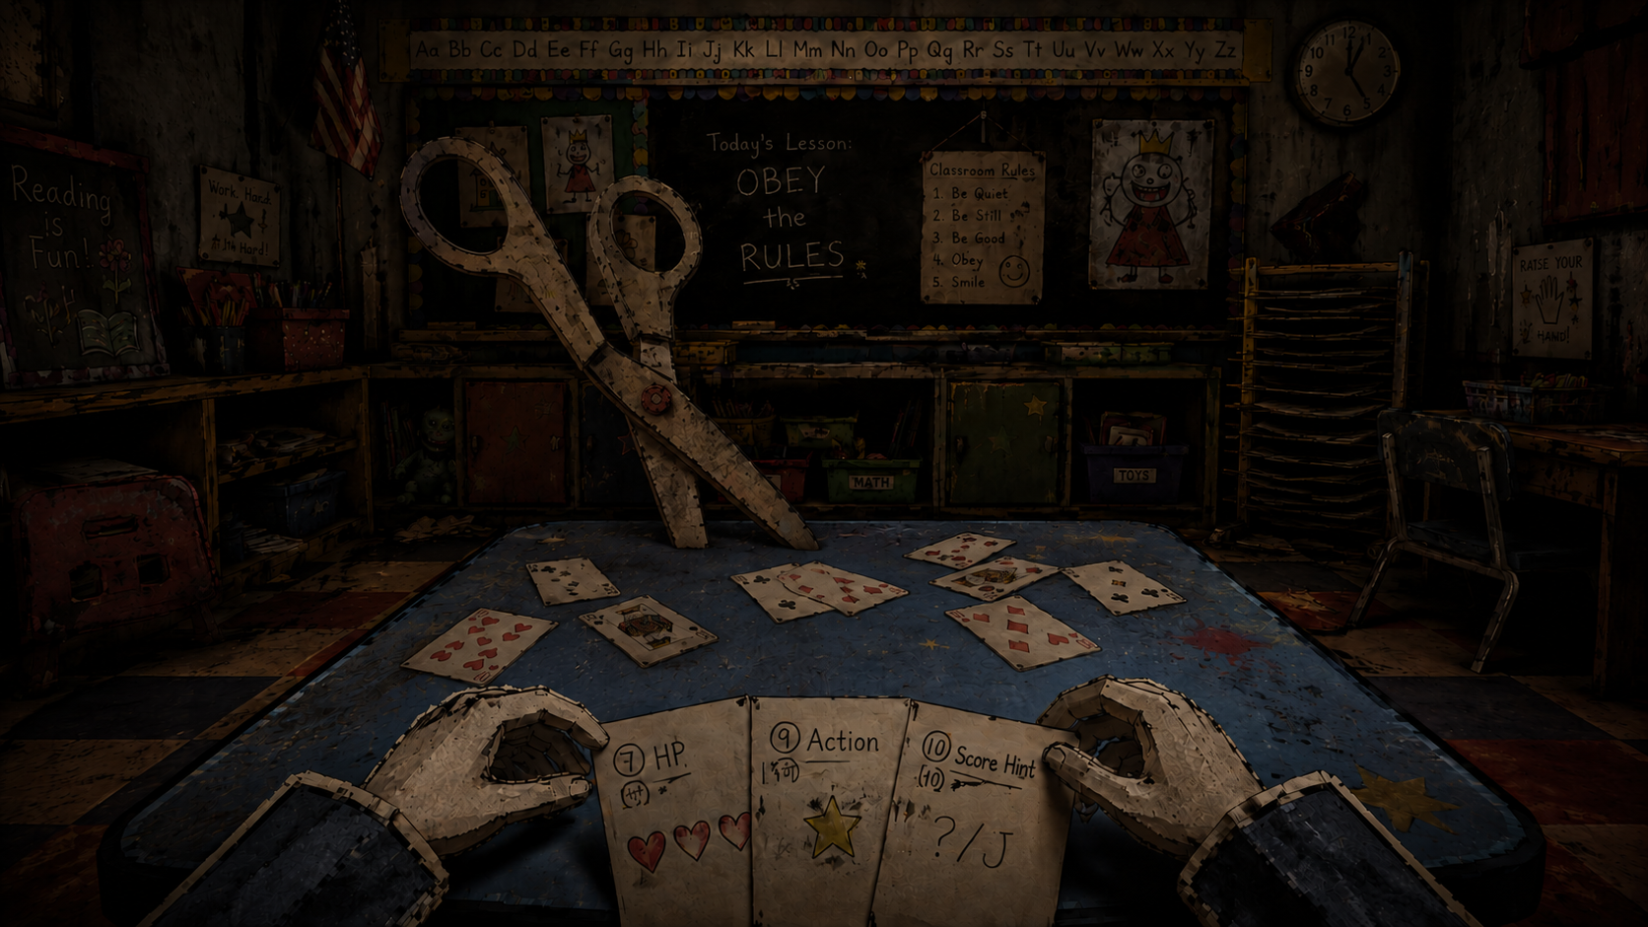

Fairy Blackjack is a light-strategy party game for 2–4 players built around reworked blackjack rules. It retains the advantage of getting closer to 21 and the risk of busting when drawing again, while removing the dealer and making players compete directly against one another.
Each Round, players must assess their own score risk, their opponents' public states, and whether another action is worth taking. Even the owner of a hidden score card cannot see its value. Item cards can also change scores, information, and who bears the risk, so players repeatedly reconsider whether to keep going.
This project prioritizes demonstrating its gameplay systems. The visual direction combines dark fairy tales with a tabletop world of paper cutouts. Paper fairy-tale characters sit around a table in a windowless classroom. Physical tabletop UI and oversized stationery used for punishments reinforce wins and losses. Art direction and visual UI are covered later in this document.
Genre | Light multiplayer strategy / Party game / Card game
Player Count | 2–4 players; 3–4 recommended
Target Match Length | To be recalibrated for 3 HP and the Unique 21 rule
Platform | PC
Development Platform | Unreal Engine 5.7
My Role | Sole designer and lead artist: gameplay, systems, items, gameplay UI/UX, and art direction

My Design Contributions
Fairy Blackjack is a solo project. I designed the multiplayer blackjack rules; the Match, Round, and Turn structure; score cards and hidden information; standing and initiative; the 45-card item system; risk and rewards; health and elimination; resources carried across Rounds; simultaneous resolution and information reveal order; and the gameplay UI/UX information structure. I also established the overall art direction.
The central systems goal is to keep other players, hidden information, and limited item resources relevant to every decision within blackjack's familiar risk structure.
FAIRY BLACKJACK GDD V1.1

01 Core Rules
Scores, Health, Action Limits, and Win Conditions

Score Card Rules
Card Face | Value
2–10 | Face value
J / Q / K | 10
A | 1 or 11, whichever benefits the player most

A final score above 21 is a bust. Each player can have at most 5 score cards per Round: 1 shared card, 1 face-up personal card, and up to 3 hidden cards. Hidden score cards remain invisible to everyone until simultaneous resolution. The standard score-card deck is reshuffled each Round.

Player Actions
On their Turn, a player chooses to continue or stand. Continuing draws 1 hidden score card. Each player may actively use at most 1 item card on each of their Turns. Drawing stops automatically at 5 score cards. In the first Round, the starting player is chosen randomly and play proceeds clockwise. In later Rounds, the player who lost health in the preceding Round starts.

Health and Elimination
Each player starts with 3 HP. After health loss is applied, any player at 0 HP is eliminated and takes no further part in the game.

Win Condition
Players are eliminated at 0 HP and no longer participate. When only 1 player remains alive, the Match ends and that player wins.

Unique Highest Non-Bust Reward
If exactly one non-busted player has the highest final score, that player draws 1 additional item card next Round. A tie for the highest score grants no reward. A player with Five Cards Without Busting can still receive this reward if they also have the unique highest non-bust score. A Unique 21 player also receives it when eligible.

Five Cards Without Busting
During simultaneous resolution, a player with 5 score cards and a final score of 21 or less triggers Five Cards Without Busting. They are removed from the pool of potential losers and cannot lose HP this Round, including when another player triggers Unique 21.

Determining the Loser
When Unique 21 does not trigger group health loss, first remove players with Five Cards Without Busting from the potential losers. If anyone remaining has busted, the busted player with the highest final score loses 1 HP. If nobody has busted, the player with the lowest final score loses 1 HP.

Unique 21 Reward
After final scores are calculated, if exactly 1 player has a score of 21, Unique 21 triggers. Every other player still participating in resolution loses 1 HP, except those protected by Five Cards Without Busting. The Unique 21 player loses no HP from this group penalty and remains eligible for the Unique Highest Non-Bust reward. If multiple players reach 21, or nobody reaches 21, there is no group penalty. Resolve the normal loser and Unique Highest Non-Bust reward instead.

Standing
After standing, a player cannot draw more score cards or actively use any item cards for the rest of the Round. Other players can still target them with items. Although Negate does not consume an active item use, it is also unavailable after standing.

FAIRY BLACKJACK GDD V1.1

02 Systems Design
Risk, Initiative, Information, Resources, and the Unique 21 Payoff

Risk System
Risk Source | How It Arises | Player Response
Bust risk | Drawing hidden score cards; score modifiers or card-value transformations increase the final score | Stand, reduce the score, defend, or use information to assess risk
Lowest-score risk | Standing too early or finishing with too low a score | Keep taking risks, adjust your score, or interfere with other low-scoring players
Unique 21 group-penalty risk | Exactly one other player finishes with 21 | Use information to assess the situation; modify or transform a key card; create a tie at 21 to disable the reward
Item-card risk | Opponents' face-down items, Redirect, and score changes applied at resolution | Remove, Negate, Redirect, and careful target and timing decisions
Information risk | Players cannot see their own or other players' hidden score cards | Observe public information, use information cards, and infer from behavior

Initiative as a Resource
The ability to keep influencing the situation acts as an implicit resource. Continuing means accepting more score-card risk while retaining future Turns: each Turn offers up to 1 active item use, and immediate counterplay remains available. Standing prevents new draw risk but closes all later active item windows and counterplay.

Incentives Across Rounds
The Unique Highest Non-Bust player draws 1 extra item next Round, encouraging players to pursue a win as well as avoid health loss. Five Cards Without Busting provides safety only in the current Round. Prepare trades an active item use now for extra resources next Round. Conceal delays its effect until the next Round and changes that Round's information structure.

Unique 21 as a High-Impact Goal
21 is both the highest safe score and a target that can threaten everyone's health at once. This raises the value of information and basic score modifiers before resolution, making timing more important. Players may use information and transformations to reach Unique 21 themselves, or disrupt an opponent approaching 21 with additions, subtractions, ×2, or ÷2 effects. When multiple players reach 21, group health loss is disabled, so preventing uniqueness becomes a defensive option.

Item Resource Cycle
Each player draws 4 items in the first Round and 3 by default in later Rounds. The previous Round's Unique Highest Non-Bust reward and Prepare each add 1, and they stack. The item deck contains 45 cards. Players may actively use at most 1 item on each of their Turns. At Round end, manual or automatic discards reduce the hand to at most 3 cards, forming a cycle of acquisition, Turn-by-Turn use, retention or discard, and replenishment next Round.

Information States
There are four information states. The shared score card and face-up personal cards are public. Ordinary hidden score cards are unknown to everyone, including their owners. Conceal makes the next Round's face-up personal card visible only to its owner. Peek, Interrogate, and Forecast provide temporary opportunities to gain information. Discarded items enter the discard pile face up, making resource expenditure observable as well.

Player Decision Cycle
Observe → Assess → Choose → Interact → Reveal → Resolve
Every action requires players to reassess their score risk, other players' states, available information, and whether and which item to use this Turn. Choices evolve throughout the Round. Newly drawn hidden cards remain invisible even to their owners, while opponents' items and decisions to stand continue to change the risk. Players therefore revisit whether to draw again throughout the Round.

Observe the situation → Assess risk → Choose an action → Affect opponents or adjust your risk → Reveal the result → Gain an advantage or lose HP → Begin the next Round

Key Decisions
- Draw again or stand? Players must weigh the value of accepting another unknown score against retaining future action windows.
- When should I stand? Beyond deciding whether their score is safe enough, players must decide whether to give up future active item use and access to Negate.
- Who should an item target, and which card should it affect? Target value depends on public scores, known hidden-card information, proximity to Unique 21, standing status, and whether a key score card has been identified.

Player Emotion Curve
The intended emotional arc moves from control toward uncertainty and mutual pressure. Standing and competition for Unique 21 create hesitation. Simultaneous reveal is the Round's peak of tension, followed by a clear release through group health loss, the normal loser penalty, or rewards.
The emotion curve follows the system's pacing. Shared and personal starting cards initially provide a relatively clear basis for judgment. As hidden cards accumulate, Conceal creates private information, and items are played, certainty declines. Information cards briefly restore it, while transformation cards can still reverse the significance of a known score at resolution.
Simultaneous reveal carries the Round's emotional peak. Hidden scores, basic additions and subtractions, and ×2 or ÷2 transformations are resolved together, alongside the Unique 21 check. A result that would affect one loser may become simultaneous health loss for several players. Health changes, elimination, and next-Round resource rewards then release the pressure.

Managing the Item Hand
Each Round ends with a timed discard phase. Discarded items enter the discard pile face up. If a player still holds more than 3 cards when time expires, the system randomly discards cards until 3 remain. There is no hard hand limit during play, but the end-of-Round retention limit prevents long-term hoarding. Face-up discards also provide a secondary source of public information.

FAIRY BLACKJACK GDD V1.1

03 Item Card Design
How Limited Resources Change Risk While Keeping Blackjack Central
The main challenge in adding items is keeping players focused on blackjack's score risk. Items should help players adjust the situation, while final judgments still revolve around scores. Their value should come primarily from timing and target selection; resource quantity alone should not dominate the outcome.

Score Cards Define the Rules and Items Modify the Risk
Score cards determine the fundamental outcome: who is close to 21, who might bust, who might finish lowest, and whether another draw is worthwhile. Regardless of how many interactions occur, final resolution returns to scores.
Items fall into five groups around that risk. Basic score modifiers add to or subtract from the final score. Card-value transformations change one score card's value at resolution. Information cards reduce uncertainty or create unequal access to information. Defense and counter cards address opposing interference. Cycling and resource cards improve the current hand or next Round's resources. These items continually reshape blackjack decisions without creating separate win conditions.

Items Form a Continuous Chain of Interactions
The chain runs from resource adjustment to information access or asymmetry, risk assessment, score modification or single-card transformation, defense or redirection, and reassessment. Peek, Interrogate, and Forecast reveal a card or clarify the next draw's risk; Conceal creates private information. Once a key card is identified, a player can add or subtract points, or use ×2 or ÷2 for a precise, larger reversal at resolution.
Functional Group | Core Function | Examples in the 45-Card Pool
Basic score modifiers | Directly adjust final scores to force a bust, manage your own risk, or disrupt Unique 21 | +1 / +2 / +3 / -1 / -2
Card-value transformations | Change one score card's value at resolution for a larger, precise reversal | Last card / Face-up personal card / Chosen card ×2 or ÷2
Information cards | Reveal hidden information, assess the next draw, or create information asymmetry | Peek / Interrogate / Forecast / Conceal
Defense and counter cards | Remove, cancel, or redirect opposing interference | Remove / Negate / Redirect
Cycling and resource cards | Improve item combinations or generate resources for the next Round | Exchange / Prepare

Current Item Pool of 45 Cards
Category | Item Card | Count
Basic score modifiers | +1 | 2
Basic score modifiers | +2 | 3
Basic score modifiers | +3 | 2
Basic score modifiers | -1 | 2
Basic score modifiers | -2 | 3
Card-value transformations | Last Score Card ×2 | 1
Card-value transformations | Last Score Card ÷2 | 1
Card-value transformations | Face-Up Personal Score Card ×2 | 1
Card-value transformations | Face-Up Personal Score Card ÷2 | 1
Card-value transformations | Chosen Score Card ×2 | 2
Card-value transformations | Chosen Score Card ÷2 | 2
Information cards | Peek | 4
Information cards | Interrogate | 4
Information cards | Forecast | 2
Information cards | Conceal | 2
Defense and counter cards | Remove | 3
Defense and counter cards | Negate | 2
Defense and counter cards | Redirect | 1
Cycling and resource cards | Exchange | 5
Cycling and resource cards | Prepare | 2
Total |  | 45

Breakdown by Type
Type | Count | Share
Basic score modifiers | 12 | 26.7%
Card-value transformations | 8 | 17.8%
Information cards | 12 | 26.7%
Defense and counter cards | 6 | 13.3%
Cycling and resource cards | 7 | 15.6%

Core Card Effects
Shared Transformation Rules
Transformation cards change one score card's value during simultaneous resolution. All ÷2 results round up: for example, 7 ÷ 2 = 4, 5 ÷ 2 = 3, and 9 ÷ 2 = 5. Last Score Card means the target player's most recently acquired personal score card this Round. Face-Up Personal Score Card means the personal card dealt face up at Round start. Chosen Score Card can target that card or a face-down card previously identified using an information card.
Item Card | Target or Scope | Timing | Effect
Basic score modifiers | Self or another player | Simultaneous resolution | Apply the printed +1, +2, +3, -1, or -2 to the target's final score.
Last Score Card ×2 | Target's most recently acquired personal score card | Choose on use; calculate at resolution | Double the value of the target's last personal score card acquired this Round. Excludes the shared card and item cards.
Last Score Card ÷2 | Target's most recently acquired personal score card | Choose on use; calculate at resolution | Halve that card's value at resolution, rounding up.
Face-Up Personal Score Card ×2 | Target's face-up personal score card dealt at Round start | Choose on use; calculate at resolution | Double that face-up personal score card's value at resolution. The item retains the name Face-Up Personal Score Card.
Face-Up Personal Score Card ÷2 | Target's face-up personal score card dealt at Round start | Choose on use; calculate at resolution | Halve that face-up personal score card's value at resolution, rounding up.
Chosen Score Card ×2 | One legally targetable score card in front of the target player | Choose on use; calculate at resolution | Choose a score card in front of the target and double its resolution value. It may be the face-up personal card or a face-down card previously identified through an information card.
Chosen Score Card ÷2 | One legally targetable score card in front of the target player | Choose on use; calculate at resolution | Choose a score card in front of the target and halve its resolution value, rounding up.
Peek | One hidden score card belonging to a chosen player | Immediate | The user looks at 1 of the target player's hidden score cards.
Interrogate | A chosen player | Immediate | The target chooses 1 of their hidden score cards for the user to inspect.
Forecast | Top of the score-card deck | Immediate | Look at the top score card. Return it to the top or place it on the bottom of the deck.
Conceal | Self | Delayed until next Round | At the start of the next Round, place your face-up personal score card face down so only you can see it. Other players may still inspect it using information cards such as Peek or Interrogate.
Remove | An opponent's face-down item in front of you | Immediate | Remove 1 unresolved opposing face-down item from in front of you without looking at it first.
Negate | Self only | Immediately before an effect resolves | Cancel the corresponding item effect about to affect you. Available only before standing. Does not consume the Turn's active item use.
Redirect | An opposing face-down item in front of you → a preselected target | Early simultaneous resolution | Secretly choose a destination when played. During resolution, move 1 unresolved opposing face-down item from in front of you to that destination.
Exchange | Self | Immediate | Discard 1 item and draw 1 replacement. This is an active item use and consumes the current Turn's allowance.
Prepare | Self | Delayed until next Round | Draw 1 additional item next Round. This is an active item use and stacks with the Unique Highest Non-Bust reward.

Decks and Public Information
Items use a separate 45-card deck, reshuffled each Round. Players' item hands are private, and opposing face-down items remain unknown until resolution. Both manual and automatic discards enter the discard pile face up. The remaining item-deck count does not need to be permanently displayed.

Usage Limits
- Each player may actively use at most 1 item on each of their Turns.
- Negate is a special immediate counter that does not consume the Turn's active item use. The player must not have stood, and may use it only when the corresponding effect is about to affect them.
- Resolution-time items targeting other players are usually placed face down in front of the target. Self-targeted items are usually public.
- Information and cycling items usually resolve immediately. Score modifiers and card-value transformations contribute to the final result during simultaneous resolution.

04 Key Gameplay Decisions
Why These Decisions Create Hesitation, Interaction, and Reversals
Fairy Blackjack's appeal comes from several competing decisions within a Round. A safer move may give up control. An aggressive move may yield a better reward or cause a bust. The situations below illustrate how these rules become player experiences.

Example A Why Hesitate to Stand at 16
Player A has a public score of 16, has not stood, and holds a defensive or counter item. Drawing again might move them toward 21 or cause a bust. Standing ends new draw risk, but also removes future active defense and immediate counterplay.
Tradeoff: score safety versus initiative. Standing in blackjack now carries an explicit opportunity cost.

Example B Why Playing Safe at 12 Can Fail
If nobody busts this Round, the lowest-scoring player loses. Standing at 12 reduces bust risk but may lock the player into last place. Drawing again offers an escape from that position while reintroducing unknown score risk.
Tradeoff: bust risk versus lowest-score risk. A conservative approach has consequences of its own.

Example C Why the Same +3 Can Be Strong or Weak
A +3 card's value depends on the target's public score, hidden-card count, standing status, and counter resources. Used early while everyone has a low score, it may change little. Against a player near 21 with limited counterplay, it may directly change who loses. Information cards make target assessment more accurate.
Item strength depends on information, target, timing, and the opponent's state, alongside its printed value.

Example D Why Keep Watching Other Players
A player plans to stand, but before their Turn returns, a low-scoring player draws again, a high-scoring player stands, and another spends an item use. Each action changes the ordering of risks, available counters, and likely targets, requiring the original plan to be reconsidered.

Why Simultaneous Reveal Creates a Climax
Hidden scores, face-down items, and earlier decisions to stand do not reveal their full consequences immediately. Players first accept that uncertainty, then discover together whether they busted, what their opponents really held, whether face-down items changed the outcome, and whether they stood too early. The uncertainty accumulated earlier is released at once.
The central player question is: I had a plan, but the situation has changed. Should I still follow it?

FAIRY BLACKJACK GDD V1.1

05 Game Structure and Core Flow
Match, Round, Turn, and Simultaneous Resolution

Structural Hierarchy
A Match consists of multiple Rounds, each containing multiple Turns. Players act in a fixed direction. At Round end, simultaneous resolution determines health loss. Players at 0 HP are eliminated, and the last survivor wins.

Round Start
- Reveal 1 shared score card.
- Deal each player 1 face-up personal score card.
- Deal each player 4 items in the first Round and 3 by default in later Rounds.
- Apply extra draws from the previous Round's Unique Highest Non-Bust reward and delayed resource effects such as Prepare.

Turn Actions
On their Turn, a player may continue or stand. Continuing draws 1 hidden score card, invisible to everyone including its owner. The player may then use an item within the rules, with at most 1 active item use per Turn. Drawing stops automatically at 5 score cards.

Game Structure Overview
Match, Round, and Turn form a nested structure. Match defines when the overall game begins and ends; Round manages dealing, resolution, and resource changes; Turn contains each player’s actual actions. The hierarchy is Match > Round > Turn. These nested loops connect player actions to simultaneous resolution, health loss, elimination, and the next Round.

Match Loop
The Match layer handles overall state: players join and receive starting health, a random first player is selected, and the action direction is fixed. Rounds repeat, checking health after resolution. Players at 0 HP are eliminated until only 1 survivor remains.

Round Loop
The Round layer resets the score-card deck, establishes public starting information, deals items, repeats Turns, and then resolves health loss, rewards, elimination, and the next starting player. Rewards and Prepare effects from the previous Round become new item resources here.

Turn Loop
Eligible players act in order from the current starting player and in the fixed direction. After every eligible player has acted once, check whether anyone has neither stood nor reached 5 score cards. If so, begin another Turn cycle; otherwise, proceed to simultaneous resolution.
FAIRY BLACKJACK GDD V1.1

06 Balance and Design Tradeoffs
Reasons Behind the Current Rules
Design Issue | Current Approach | Rationale
Items overshadow blackjack | At most 1 active item use per Turn | Limit single-action bursts while allowing information, transformations, and defense to combine across Turns
Standing is too safe | Standing removes active item use and counterplay | Add an initiative cost to the safety of avoiding further draw risk
Overlap between Five Cards Without Busting and the unique-highest reward | Five cards provide safety; the unique-highest reward provides next-Round resources | The highest non-bust score is harder to achieve and gives a party game a clear winner
Pacing of Unique 21 group health loss | Raise starting health to 3 HP; Unique 21 costs other players 1 HP each | Preserve the impact of Unique 21 while preventing rapid group elimination under a 2-HP system
Excessive item hoarding | Discard to at most 3 at Round end; randomly discard on timeout; discards are public | Limit long-term resource snowballing while creating public information

Current Balance Direction
Starting health has increased from 2 to 3 HP to support simultaneous health loss caused by Unique 21. Earlier Match-length estimates for 2 or 3 HP are no longer current conclusions. The 45-card pool, transformations, and limit of 1 active item per Turn all affect Round duration and elimination speed. Timing simulations and human playtests must therefore be repeated.

FAIRY BLACKJACK GDD V1.1

07 Design References
Reference | Main Takeaway | Elements Excluded | Influence on Fairy Blackjack
Liar’s Bar | Cards, a dark tabletop atmosphere, and direct player interaction can support a party game | Deception, bluffing, and social deduction as the core | Retain first-person tabletop pressure, health, and punishment feedback, with risk management at the center
Balatro | Familiar playing cards substantially reduce the cost of learning the rules | Heavy roguelike deck-building, complex builds, and information-heavy multiplayer deck systems | Use familiar card values as the foundation, with items providing limited risk adjustments
Buckshot Roulette | A confined oppressive space, strong resolution, and tangible punishment objects heighten tension and the desire to win | Firearms and realistic violence | Use paper characters and oversized stationery for stylized, darkly comic punishments

These three games are not direct competitors in the same category. This section examines design references and positioning. Fairy Blackjack draws on established experiences from these games, keeping the elements suited to its light tabletop format and leaving out systems that do not fit.

FAIRY BLACKJACK GDD V1.1

08 Art Direction and Visual UI/UX
A Dark Fairy-Tale Tabletop World of Paper Cutouts
The game takes place in an oppressive, windowless American classroom filled with children's craft materials. Players and opponents are fairy-tale paper figures cut out by a child. The table, UI, cards, and punishments all follow the idea of a children's craft world twisted into a dangerous game.
Visual hook: paper fairy-tale characters play a dangerous card game in an eerie, windowless classroom. Losers are handled like toys by oversized stationery.

Character and Technical Direction
Characters use thin, low-poly 3D paper puppets with pixelated hand-painted textures and black outlines, rather than relying entirely on 2D sprites. The head-to-body ratio is approximately 1:2. Movement emphasizes exaggerated puppet-like swaying and slight mechanical pauses. In first person, players can see the edge of their own paper torso and both arms; other players are fully visible.

Environment and Materials
The main setting is a windowless American children's classroom. A dark, worn plastic card table sits in the center, with a blackboard or classroom display and teaching podium at the front. Behind it are overlapping upright and fallen storage cabinets and scattered craft supplies. The palette uses subdued, dirty children's colors. Materials emphasize colored paper, homework sheets, old plastic, chalk, crayons, tape, and wooden classroom furniture.

Punishment Visuals
Punishments act on paper bodies with a darkly comic, stylized tone. Familiar stationery such as scissors, erasers, pencils, craft knives, shredders, and staplers becomes oversized. Paper scraps, cuts, eraser marks, ink stains, and torn edges communicate health loss and elimination.

Visual UI/UX
The visual UI remains physically grounded in the tabletop. Separate table areas distinguish shared cards, face-up personal cards, hidden cards, and opposing face-down items. The screen HUD shows only health, player states, the current action, and necessary prompts. Torn homework paper and hand-drawn frames can reinforce the craft world without compromising strategic readability.
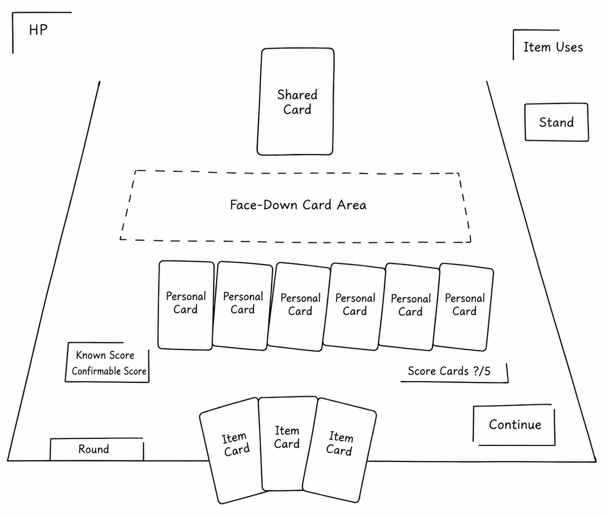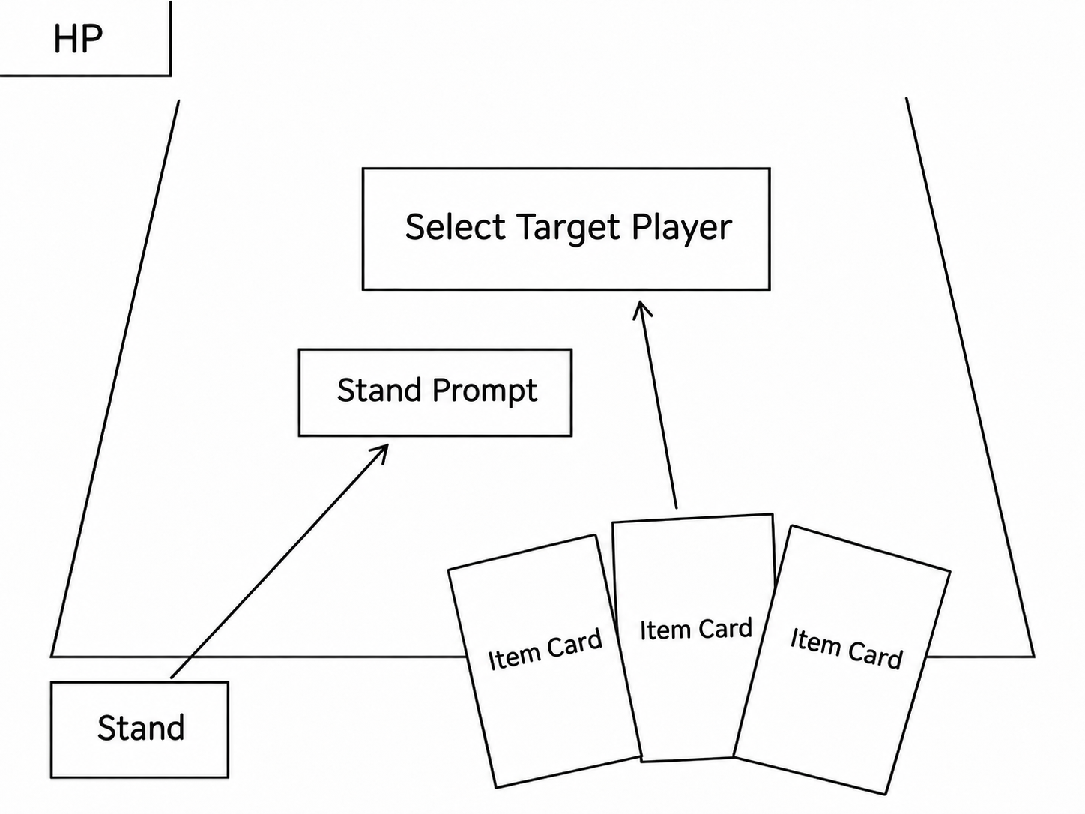

FAIRY BLACKJACK GDD V1.1

09 Audio Direction
Eerie Children's Music and Dark Nursery Rhymes
Audio should make the children's environment feel familiar yet unsafe. Eerie children's tunes and dark nursery rhymes are the main musical direction. Melodies can be simple and repetitive, avoiding an overly epic style. Fluorescent-light noise, low room tones, and slight mechanical sounds establish an oppressive ambience.
Audio Layer | Direction | Purpose
Music | Dark nursery rhymes, eerie children's melodies, slight distortion, and repetition | Maintain the children's setting and a persistent sense of unease
Score-card interactions | Shuffling, drawing, paper sliding, placing face down, and revealing | Reinforce the physical tabletop
Item-card interactions | Pencils, scissors, tearing paper, erasers, stickers, and other material sounds | Connect item cards to objects in the world
Simultaneous resolution | Build through waiting, reveal, effect triggers, and confirmation of the loser | Support each Round's emotional peak
Punishment | Stylized cutting, erasing, puncturing, and shredding sounds | Give health loss and elimination greater impact

FAIRY BLACKJACK GDD V1.1

10 Future Expansion
Directions Outside the Current Core Version
The current phase will not add further rule complexity. The following are possibilities for later development, to be reassessed only after the initial core loop passes human playtesting.
Direction | Example | Design Value | Main Risk
Conditional or probability-based score items | Trigger extra effects based on the last hidden card's parity, card count, or public score | Increase synergies with information cards | Increase learning cost and potentially overcomplicate scoring
Special interference | Prevent players from learning some newly available information | Increase spectacle and uncertainty | Reduce the sense of control
Deck manipulation | Inspect multiple score cards, reorder cards, or control the deck more deeply | Increase card control and strategic depth | Make the light tabletop format more demanding and lengthen decision time
Rule changes | Temporarily alter the bust threshold, global rules, or calculation methods | Create unusual situations and memorable moments | Add a heavy rules burden and risk undermining basic readability
More modes or players | 5–6 players or special party modes | Support more social settings | Substantially increase information load and waiting time

