RRB GROUP OF SCHOOLS
UNIT TEST
CLASS: 11 — SUBJECT: PHYSICS
Time Allowed: 1 Hour | Maximum Marks: 25
Teacher: Admin | Date: 22/08/2026
――――――――――――――――――――――――――――――――――――――――――――――――――――――――――
Section A: Multiple Choice Questions
Note: Choose the correct option for each of the following questions.
Q1. The displacement-time graph of a particle moving along a straight line is a curve. The slope of the tangent drawn at any point on this graph represents: [1M]
(a) Instantaneous acceleration
(b) Instantaneous velocity
(c) Average speed
(d) Total distance covered
Q2. The ratio of the magnitude of displacement to the total distance covered by a moving body is always: [1M]
(a) Equal to 1
(b) Greater than 1
(c) Less than or equal to 1
(d) Greater than or equal to 1
Q3. The position \( x \) of a particle moving along a straight line varies with time \( t \) according to the equation \( x = 2t^3 - 3t^2 + 5 \) (where \( x \) is in meters and \( t \) is in seconds). The acceleration of the particle at \( t = 2\text{ s} \) is: [1M]
(a) \( 18\text{ m/s}^2 \)
(b) \( 12\text{ m/s}^2 \)
(c) \( 24\text{ m/s}^2 \)
(d) \( 6\text{ m/s}^2 \)
Q4. A stone is dropped freely from the top of a tower and reaches the ground in \( 4\text{ seconds} \). The height of the tower is (taking \( g = 9.8\text{ m/s}^2 \)): [1M]
(a) \( 19.6\text{ m} \)
(b) \( 39.2\text{ m} \)
(c) \( 78.4\text{ m} \)
(d) \( 156.8\text{ m} \)
Q5. Which of the following graphs is physically impossible for one-dimensional motion of a particle? [1M]
(a) A position-time graph with a negative slope
(b) A position-time graph where a single instant of time corresponds to two different positions
(c) A velocity-time graph with a constant positive slope
(d) An acceleration-time graph parallel to the time axis
Section B: Fill in the Blanks
Note: Fill in the blanks with the correct scientific terms or values.
Q6. The area bounded by the velocity-time graph and the time axis represents the total _______ of the moving object during that time interval. [1M]
Q7. If a particle moves with a uniform velocity along a straight path, its instantaneous acceleration is equal to _______. [1M]
Section C: Assertion-Reason
Note: Select the correct option from (a), (b), (c), and (d) based on the statements given below.
Q8. Assertion (A): A body can have zero velocity at a particular instant and yet experience a non-zero acceleration at that same instant.
Reason (R): At the highest point of its vertical path, a body thrown vertically upward momentarily comes to rest while acceleration due to gravity continues to act downwards. [1M]
(a) Both Assertion (A) and Reason (R) are true and Reason (R) is the correct explanation of Assertion (A).
(b) Both Assertion (A) and Reason (R) are true but Reason (R) is NOT the correct explanation of Assertion (A).
(c) Assertion (A) is true but Reason (R) is false.
(d) Assertion (A) is false but Reason (R) is true.
Section D: Very Short Answer Questions
Note: Answer the following questions briefly.
Q9. Distinguish between distance and displacement by stating any two fundamental points of difference. [2M]
Q10. A car covers the first half of the total distance between two locations at a speed of \( 40\text{ km/h} \) and the remaining half distance at a speed of \( 60\text{ km/h} \). Calculate the average speed of the car for the entire journey. [2M]
Q11. Define instantaneous velocity. Write its mathematical expression using differential calculus notation. [2M]
Section E: Short Answer Questions
Note: Answer the following questions with complete steps and derivations.
Q12. Using the velocity-time graph for a uniformly accelerated body shown below, derive the kinematic equation of motion for displacement: \( s = ut + \frac{1}{2}at^2 \). [3M]

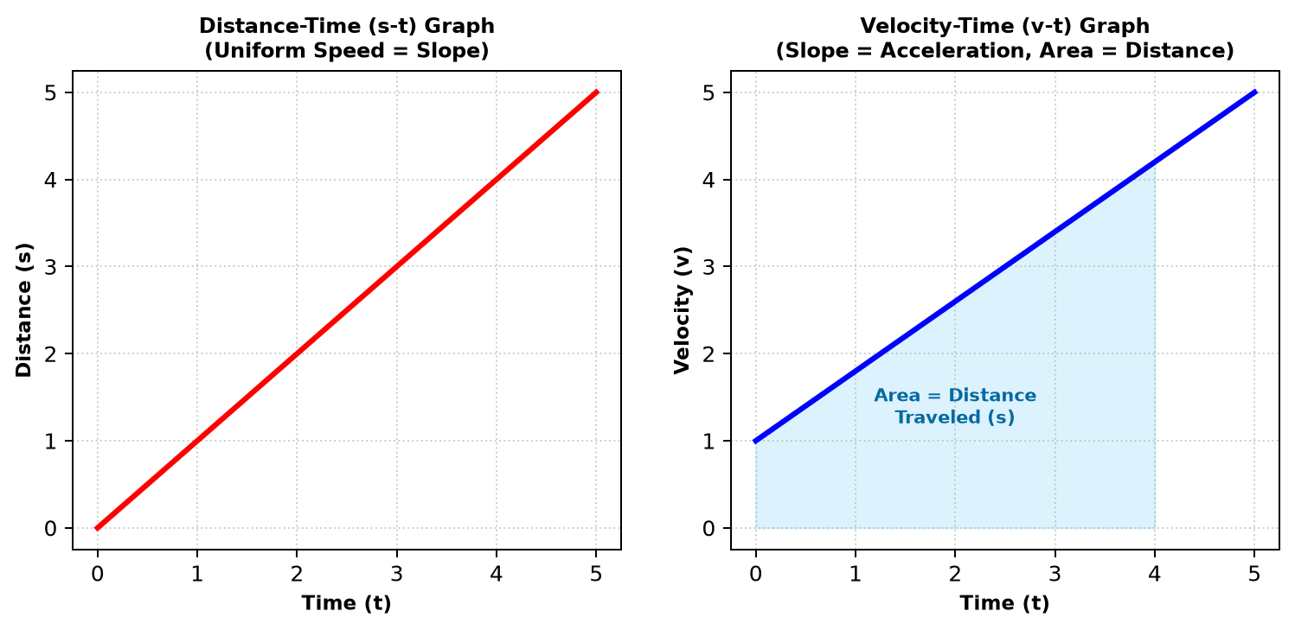
Q13. A ball is thrown vertically upward with an initial velocity of \( 20\text{ m/s} \) from the top of a multi-storey building of height \( 25\text{ m} \). Taking \( g = 10\text{ m/s}^2 \):
(i) Calculate the maximum height reached by the ball above the point of launch.
(ii) Find the total time elapsed before the ball hits the ground. [3M]
Section F: Long Answer Question
Note: Answer all parts of the following question clearly.
Q14. Answer the following multi-part question: [5M]
(a) Draw position-time (x-t) graphs for: (i) an object moving with uniform positive velocity, (ii) an object moving with uniform negative velocity, and (iii) an object at rest.
(b) Two trains A and B, each of length \( 400\text{ m} \), are moving on two parallel tracks with a uniform speed of \( 72\text{ km/h} \) in the same direction, with train A ahead of train B. The driver of train B decides to overtake train A and accelerates at \( 1\text{ m/s}^2 \). If after \( 50\text{ s} \), the guard of train B just brushes past the driver of train A, calculate the original distance between the two trains.
*** End of Question Paper ***
Generated by RRB CBT · Developed by Gaurav Shukla & Team

