
RRB GROUP OF SCHOOLS
PRACTICE SET — UNIT TEST
CLASS: 11 | SUBJECT: PHYSICS
TOPIC / CHAPTER: 4. Laws of Motion
Time Allowed: Self-Paced
Teacher: Admin | Date: 05/09/2026
――――――――――――――――――――――――――――――――――――――――――――――――――――――――――――
Section A: Multiple Choice Questions
Note: Choose the correct option for each of the following questions.
Q1. A block of mass \(m_1 = 2\text{ kg}\) rests on top of a block of mass \(m_2 = 4\text{ kg}\), which is placed on a smooth horizontal floor. The coefficient of static friction between the two blocks is \(\mu_s = 0.4\). What is the maximum horizontal force \(F\) that can be applied to the lower block \(m_2\) such that both blocks move together without slipping? (Take \(g = 10\text{ m/s}^2\))

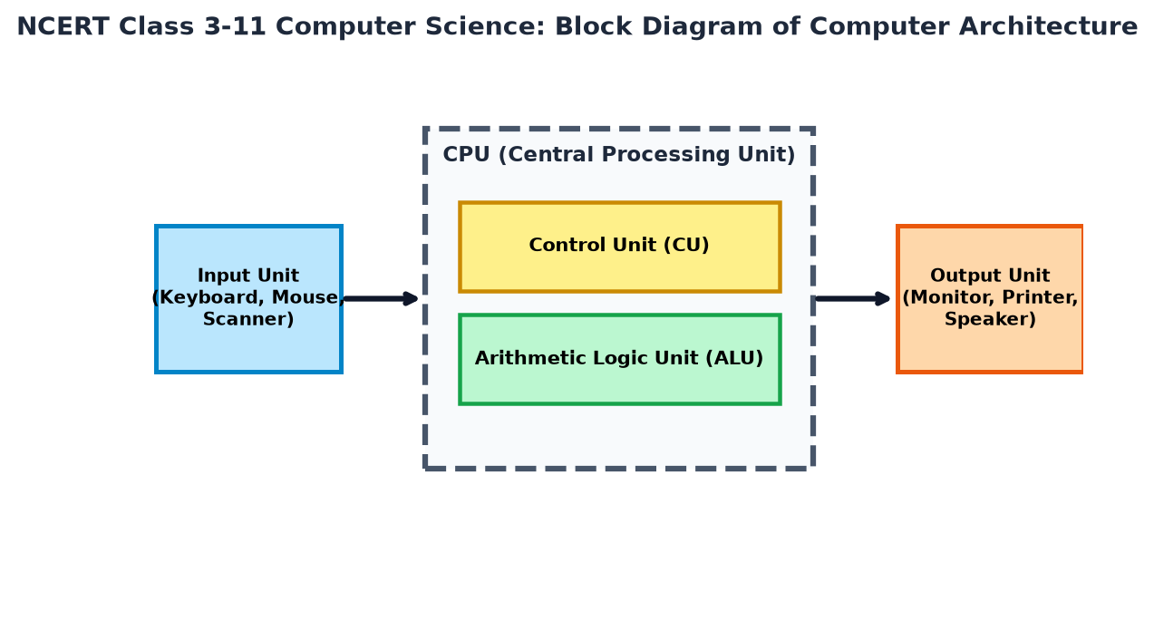
(a) \(8\text{ N}\)
(b) \(16\text{ N}\)
(c) \(24\text{ N}\)
(d) \(12\text{ N}\)
Q2. A smooth wedge of mass \(M\) with an inclined face making an angle \(\alpha\) with the horizontal is placed on a frictionless horizontal floor. A block of mass \(m\) is allowed to slide down the inclined face of the wedge. The horizontal acceleration of the wedge is:

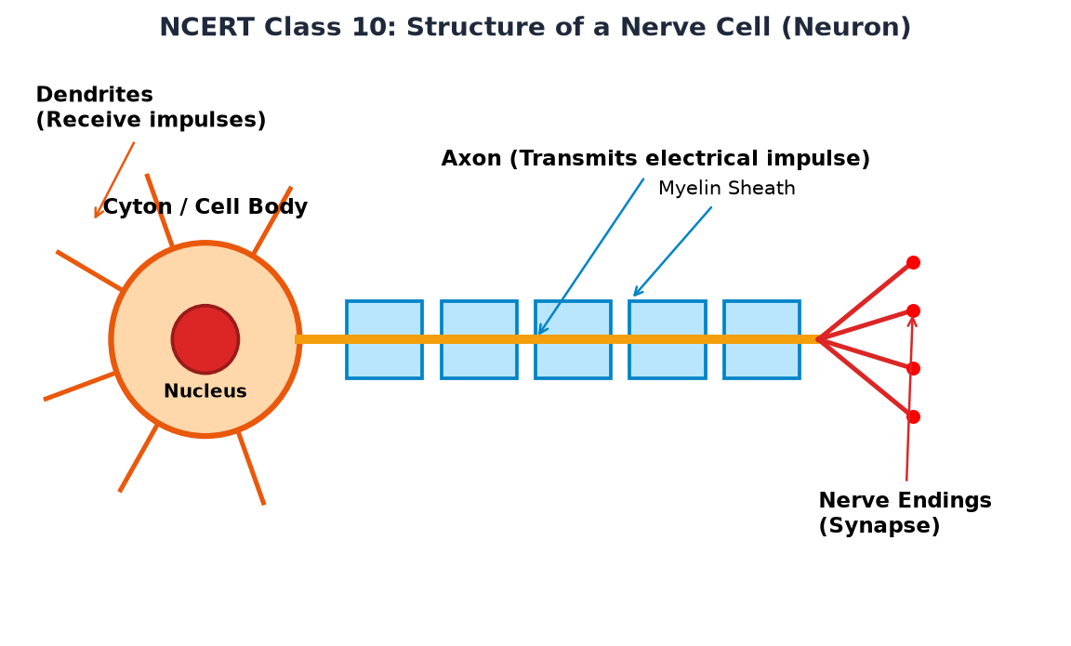
(a) \(\frac{m g \sin\alpha \cos\alpha}{M + m \sin^2\alpha}\)
(b) \(\frac{m g \sin\alpha}{M + m}\)
(c) \(\frac{M g \sin\alpha \cos\alpha}{M + m \cos^2\alpha}\)
(d) \(\frac{m g \cos\alpha}{M + m \sin\alpha}\)
Q3. A time-dependent force \(\vec{F} = (6t^2 \hat{i} + 4t \hat{j})\text{ N}\) acts on a particle of mass \(2\text{ kg}\) initially at rest at the origin. What is the speed of the particle at \(t = 3\text{ s}\)?
(a) \(27\text{ m/s}\)
(b) \(15\text{ m/s}\)
(c) \(9\sqrt{5}\text{ m/s}\)
(d) \(3\sqrt{10}\text{ m/s}\)
Q4. A particle moves in a circle of radius \(R\) with a constant tangential acceleration \(a_t\). If the net acceleration vector makes an angle of \(45^\circ\) with the velocity vector at time \(t\), then \(t\) is equal to:
(a) \(\sqrt{\frac{R}{a_t}}\)
(b) \(\frac{R}{a_t}\)
(c) \(\sqrt{\frac{2R}{a_t}}\)
(d) \(\frac{2R}{a_t}\)
Q5. A uniform rope of mass \(M\) and length \(L\) is pulled along a frictionless horizontal surface by a constant horizontal force \(F\) applied at one end. What is the tension in the rope at a distance \(x\) from the end where the force is applied?
(a) \(F \left(1 - \frac{x}{L}\right)\)
(b) \(F \frac{x}{L}\)
(c) \(F \left(1 + \frac{x}{L}\right)\)
(d) \(F\)
Q6. A rocket of mass \(1000\text{ kg}\) burns fuel at the rate of \(10\text{ kg/s}\) with an exhaust velocity of \(500\text{ m/s}\) relative to the rocket. If the rocket is fired vertically upwards from the ground, the initial net acceleration of the rocket is (take \(g = 10\text{ m/s}^2\)):
(a) \(5\text{ m/s}^2\)
(b) \(-5\text{ m/s}^2\)
(c) \(0\text{ m/s}^2\)
(d) \(10\text{ m/s}^2\)
Q7. What is the minimum force required to pull a body of mass \(m\) along a rough horizontal surface having angle of friction \(\phi\)?
(a) \(m g \sin\phi\)
(b) \(m g \cos\phi\)
(c) \(m g \tan\phi\)
(d) \(\mu m g\)
Q8. A bead of mass \(m\) is free to slide on a smooth circular wire loop of radius \(R\) placed in a vertical plane. The wire loop rotates about its vertical diameter with a constant angular velocity \(\omega\). The angle \(\theta\) made by the radius vector joining the bead to the center with the downward vertical in equilibrium (for \(\omega^2 > g/R\)) is given by:

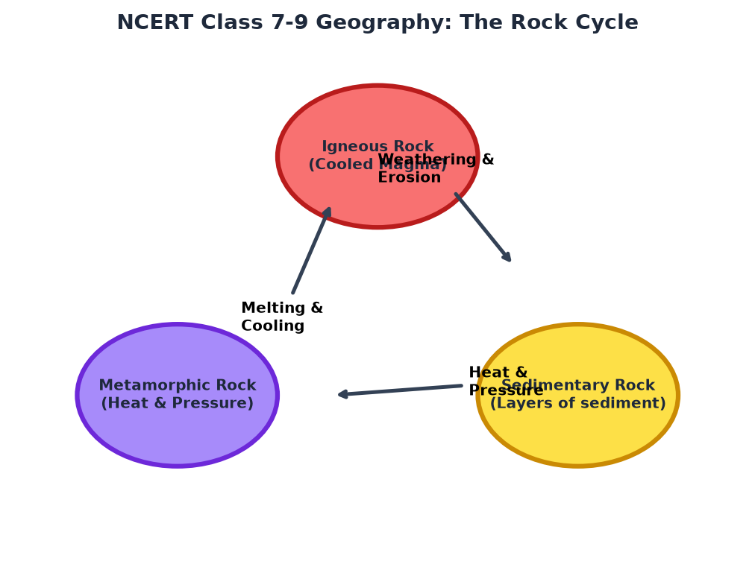
(a) \(\cos\theta = \frac{g}{\omega^2 R}\)
(b) \(\sin\theta = \frac{g}{\omega^2 R}\)
(c) \(\tan\theta = \frac{\omega^2 R}{g}\)
(d) \(\cos\theta = \frac{\omega^2 R}{g}\)
Q9. Two masses \(m_1 = 3\text{ kg}\) and \(m_2 = 5\text{ kg}\) are connected by a light string passing over a frictionless fixed pulley. The system is released from rest. What is the downward acceleration of mass \(m_2\)? (Take \(g = 10\text{ m/s}^2\))

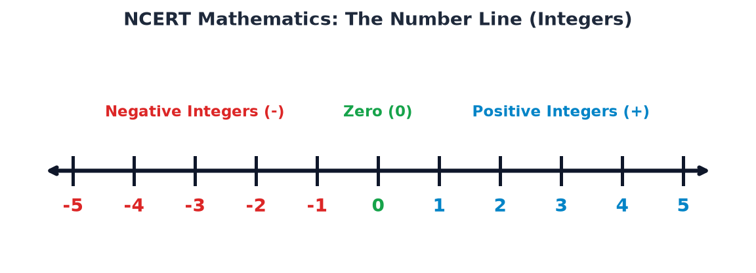
(a) \(2.5\text{ m/s}^2\)
(b) \(3.75\text{ m/s}^2\)
(c) \(5.0\text{ m/s}^2\)
(d) \(1.25\text{ m/s}^2\)
Q10. A body of mass \(m\) slides down a rough inclined plane of inclination \(\theta\) with a constant velocity. The coefficient of kinetic friction \(\mu_k\) between the body and the plane is equal to:
(a) \(\sin\theta\)
(b) \(\cos\theta\)
(c) \(\tan\theta\)
(d) \(\cot\theta\)
Q11. An elevator cab of mass \(m\) accelerates upwards with an acceleration \(a = g/2\). A passenger of mass \(m_0\) inside the elevator experiences an apparent weight of:
(a) \(m_0 g / 2\)
(b) \(m_0 g\)
(c) \(3 m_0 g / 2\)
(d) \(2 m_0 g\)
Q12. A particle of mass \(m\) is kept on a smooth sphere of radius \(R\) at its topmost point. The sphere is fixed. If the particle is given a slight push, at what height \(h\) from the top point will it lose contact with the sphere?

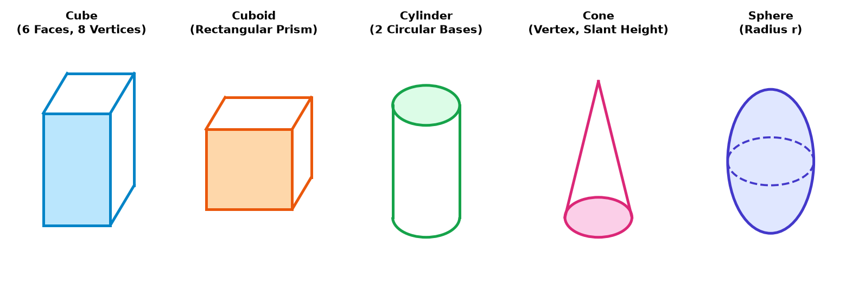
(a) \(R/3\)
(b) \(2R/3\)
(c) \(R/2\)
(d) \(R/4\)
Q13. A force-time graph for a particle moving along a straight line shows a triangular area with base \(\Delta t = 4\text{ s}\) and maximum height \(F_{\max} = 10\text{ N}\). The total impulse imparted to the particle is:
(a) \(40\text{ N s}\)
(b) \(20\text{ N s}\)
(c) \(10\text{ N s}\)
(d) \(80\text{ N s}\)
Q14. A block of mass \(m\) is held against a vertical wall by applying a horizontal force \(F\). If the coefficient of static friction is \(\mu\), the minimum force \(F\) required to prevent the block from falling is:
(a) \(\mu m g\)
(b) \(\frac{m g}{\mu}\)
(c) \(\frac{\mu}{m g}\)
(d) \(m g\)
Q15. In a non-inertial frame of reference accelerating horizontally with acceleration \(a_0\), the net pseudo force acting on a particle of mass \(m\) is:
(a) \(m a_0\) in the direction of \(a_0\)
(b) \(m a_0\) opposite to the direction of \(a_0\)
(c) Zero
(d) \(m g\) vertically downwards
Section B: Fill in the Blanks
Note: Fill in the missing values or terms in each of the following statements.
Q1. The minimum horizontal force required to push a block of mass \(m\) against a vertical wall to keep it from sliding down, given coefficient of friction \(\mu\), is _______.
Q2. The magnitude of thrust on a rocket burning fuel at a rate \(r = -\frac{dm}{dt}\) with exhaust speed \(u_r\) relative to the rocket engine is equal to _______.
Q3. A block resting on a rough inclined plane of inclination \(\theta\) begins to slide down when \(\tan\theta\) just exceeds the coefficient of _______ friction.
Q4. For a vehicle taking a circular turn of radius \(R\) on a smooth banked road inclined at angle \(\theta\), the optimum velocity without relying on friction is _______.
Q5. When a spring balance carrying a body of mass \(m\) drops freely under gravity, the reading on the spring balance is _______.
Section C: True / False
Note: State whether the following statements are True or False.
Q1. Static friction is a self-adjusting force whose value ranges from zero up to a maximum limiting friction value \(f_s^{\max} = \mu_s N\).
True
False
Q2. Action and reaction forces according to Newton's Third Law act on the same body and cancel each other out.
True
False
Q3. Pseudo forces must be introduced to apply Newton's second law in non-inertial (accelerating) reference frames.
True
False
Q4. Centripetal force does non-zero work on a body undergoing uniform circular motion.
True
False
Q5. The coefficient of kinetic friction \(\mu_k\) is generally slightly less than the coefficient of static friction \(\mu_s\) for the same pair of surfaces.
True
False
Section D: Very Short Answer
Note: Answer the following questions in brief.
Q1. State the Impulse-Momentum Theorem mathematically and express its S.I. units.
Q2. Why is static friction called a self-adjusting force?
Q3. A helicopter of mass \(M\) accelerates upwards with an acceleration \(a\). Write down the force equation for the vertical lift force \(F_L\) exerted by the surrounding air on the helicopter rotors.
Q4. Explain why a cricketer pulls his hands backward while catching a fast-moving cricket ball.
Q5. Write the constraint relationship between the accelerations \(a_1\) and \(a_2\) of two blocks connected by an inextensible string passing over a single movable pulley connected to one of the blocks.
Section E: Short Answer
Note: Answer all questions with appropriate derivation and explanations where necessary.
Q1. A block of mass \(m_1 = 5\text{ kg}\) rests on a rough horizontal surface with coefficient of static friction \(\mu_s = 0.5\). A second block of mass \(m_2 = 2\text{ kg}\) is placed on top of \(m_1\) with friction coefficient \(\mu_{12} = 0.3\) between them. Calculate the maximum horizontal force \(F\) that can be applied to mass \(m_1\) such that mass \(m_2\) does not slip on \(m_1\).
[IMAGE NEEDED: NCERT Diagram: ]
*** End of Question Paper ***
Generated by RRB CBT · Developed by Gaurav Shukla & Team

