RRB GROUP OF SCHOOLS
PRE-BOARD
CLASS: 10 — SUBJECT: PHYSICS
Time Allowed: 3 Hours | Maximum Marks: 100
Teacher: GAURAV SHUKLA | Date: 21/08/2026
――――――――――――――――――――――――――――――――――――――――――――――――――――――――――
Section A: Multiple Choice Questions
Note: Choose the correct option for each of the following questions.
Q1. An object is placed at a distance of 15 cm in front of a concave mirror of focal length 10 cm. The image formed will be: [1M]
(a) Virtual, erect, and magnified
(b) Real, inverted, and magnified
(a) Real, inverted, and diminished
(d) Virtual, erect, and diminished
Q2. The refractive index of medium A with respect to medium B is 1.5. What is the refractive index of medium B with respect to medium A? [1M]
(a) 1.5
(b) 0.67
(c) 0.5
(d) 2.0
Q3. A person cannot see objects beyond 2 m distinctly. This defect can be corrected by using a lens of power: [1M]
(a) +0.5 D
(b) -0.5 D
(c) +0.2 D
(d) -0.2 D
Q4. Which component of white light undergoes the maximum deviation while passing through a triangular glass prism? [1M]
(a) Red light
(b) Yellow light
(c) Green light
(d) Violet light
Q5. If the length of a metallic wire is doubled while keeping its cross-sectional area constant, its resistance will: [1M]
(a) Remain unchanged
(b) Become half
(c) Become double
(d) Become four times
Q6. Two resistors of 6 \(\Omega\) and 12 \(\Omega\) are connected in parallel. Their equivalent resistance is: [1M]
(a) 18 \(\Omega\)
(b) 4 \(\Omega\)
(c) 2 \(\Omega\)
(d) 8 \(\Omega\)
Q7. An electric iron consumes 1 kW energy when operated at 220 V. The current flowing through the iron is approximately: [1M]
(a) 4.55 A
(b) 2.2 A
(c) 10 A
(d) 0.45 A
Q8. The magnetic field inside a long straight current-carrying solenoid is: [1M]
(a) Zero
(b) Decreases as we move towards its ends
(c) Increases as we move towards its ends
(d) Is uniform at all points
Q9. According to Fleming's Left-Hand Rule, the middle finger indicates the direction of: [1M]
(a) Magnetic Field
(b) Electric Current
(c) Motion of Conductor
(d) Induced Current
Q10. The phenomenon of electromagnetic induction is the process of: [1M]
(a) Charging a body
(b) Generating magnetic field due to current passing through a coil
(c) Producing induced current in a coil due to relative motion between a magnet and the coil
(d) Rotating a coil of an electric motor
Q11. The SI unit of electrical resistivity is: [1M]
(a) \(\Omega\)
(b) \(\Omega\cdot\text{m}\)
(c) \(\Omega / \text{m}\)
(d) \(\text{W}\cdot\text{m}\)
Q12. Twinkling of stars is primarily due to which optical phenomenon? [1M]
(a) Atmospheric dispersion
(b) Atmospheric scattering
(c) Atmospheric refraction
(d) Total internal reflection
Q13. Which color of light scatters the least when light passes through the atmosphere? [1M]
(a) Blue
(b) Violet
(c) Red
(d) Green
Q14. The focal length of a spherical mirror is +20 cm. The mirror is: [1M]
(a) Concave mirror
(b) Convex mirror
(c) Plane mirror
(d) Parabolic mirror
Q15. The commercial unit of electrical energy is kilowatt-hour (kWh). 1 kWh is equal to: [1M]
(a) \(3.6 \times 10^{6} \text{ J}\)
(b) \(3.6 \times 10^{5} \text{ J}\)
(c) \(10^{3} \text{ J}\)
(d) \(3.6 \times 10^{3} \text{ J}\)
Q16. In a domestic circuit, the color of the insulation covering on the live wire is usually: [1M]
(a) Green
(b) Black
(c) Red or Brown
(d) Blue
Q17. A soft iron core placed inside a current-carrying solenoid behaves as an electromagnet because: [1M]
(a) It gains permanent magnetism
(b) It gets magnetized only as long as current flows
(c) It reduces the strength of magnetic field
(d) It opposes current flow
Section B: Assertion-Reason Questions
Note: For each question, select the appropriate option:
(a) Both Assertion and Reason are true and Reason is the correct explanation of Assertion.
(b) Both Assertion and Reason are true but Reason is NOT the correct explanation of Assertion.
(c) Assertion is true but Reason is false.
(d) Assertion is false but Reason is true.
Q18. Assertion (A): The focal length of a convex lens increases when submerged in water.\nReason (R): The refractive index of glass with respect to water is less than that of glass with respect to air. [1M]
(a) Both (A) and (R) are true and (R) is the correct explanation of (A).
(b) Both (A) and (R) are true but (R) is NOT the correct explanation of (A).
(c) (A) is true but (R) is false.
(d) (A) is false but (R) is true.
Q19. Assertion (A): Connectors of electric heaters are made of alloys rather than pure metals.\nReason (R): Alloys generally have higher resistivity and do not oxidize (burn) readily at high temperatures. [1M]
(a) Both (A) and (R) are true and (R) is the correct explanation of (A).
(b) Both (A) and (R) are true but (R) is NOT the correct explanation of (A).
(c) (A) is true but (R) is false.
(d) (A) is false but (R) is true.
Q20. Assertion (A): Magnetic field lines around a current-carrying straight conductor form concentric circles.\nReason (R): The direction of magnetic field lines is given by Fleming's Right-Hand Rule. [1M]
(a) Both (A) and (R) are true and (R) is the correct explanation of (A).
(b) Both (A) and (R) are true but (R) is NOT the correct explanation of (A).
(c) (A) is true but (R) is false.
(d) (A) is false but (R) is true.
Section C: Very Short Answer Questions
Note: Answer all questions briefly. Numerical problems must show formula and calculation steps.
Q21. State Snell's Law of refraction. Write its mathematical expression. [2M]
Q22. An object 5 cm in height is placed at a distance of 20 cm in front of a convex mirror of radius of curvature 30 cm. Find the position and nature of the image. [2M]
Q23. Why does the Sun appear reddish early in the morning and at sunset? [2M]
Q24. Define 1 Dioptre power of a lens. A lens has a power of -2.5 D. State the nature and focal length of this lens. [2M]
Q25. Refer to the given series resistor circuit. Calculate the total equivalent resistance and the current drawn from the battery. [2M]

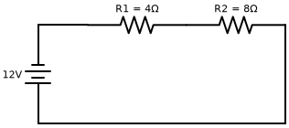
Q26. State Ohm's Law. Draw the V-I graph for an ohmic conductor. [2M]
Q27. What is a solenoid? Mention two methods to increase the strength of the magnetic field produced by a solenoid. [2M]
Q28. State Fleming's Left-Hand Rule clearly specifying the parameter represented by each finger. [2M]
Q29. What is short-circuiting? Explain how an electric fuse prevents damage to appliances during short-circuiting. [2M]
Q30. An electric bulb is rated 220 V and 100 W. Calculate its resistance and the current flowing through it when operated at rated voltage. [2M]
Section D: Short Answer Questions
Note: Answer the following questions in detail.
Q31. Draw a neat ray diagram showing refraction of light through a rectangular glass slab. Label the incident ray, refracted ray, emergent ray, angle of incidence, angle of refraction, and angle of emergence. [3M]

[IMAGE NEEDED: Diagram for Q31]
Q32. A person suffering from Hypermetropia (farsightedness) cannot clearly see objects closer than 75 cm. Calculate the power of the lens required to read a book clearly held at 25 cm. [3M]
Q33. For the parallel resistor combination shown, find: (i) Total equivalent resistance of the circuit, (ii) Total current supplied by the source. [3M]

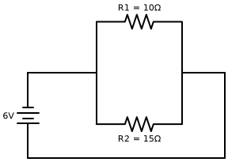
Q34. Derive the mathematical expression for the equivalent resistance \(R_p\) of three resistors \(R_1\), \(R_2\), and \(R_3\) connected in parallel across a voltage source \(V\). [3M]
Q35. Describe an experiment with a neat labelled diagram to trace the magnetic field lines around a straight current-carrying wire. State the Right-Hand Thumb Rule. [3M]
[IMAGE NEEDED: NCERT Diagram: magnetic field lines, straight conductor, right hand thumb rule]
Q36. An electric heater of resistance 50 \(\Omega\) is connected to a 220 V power supply for 2 hours daily. Calculate: (i) Energy consumed in kWh in 30 days, (ii) Total cost of electricity if the cost per unit is Rs. 6.00. [3M]
Section E: Long Answer Questions
Note: Answer the following comprehensive questions.
Q37. (a) Derive the Lens Formula \(\frac{1}{f} = \frac{1}{v} - \frac{1}{u}\) or state the relation using sign convention.
(b) An object of height 4 cm is placed perpendicular to the principal axis of a concave lens of focal length 20 cm. If the distance of the object from the lens is 30 cm, find the position, size, and nature of the image formed. Draw a ray diagram to illustrate. [5M]

[IMAGE NEEDED: Diagram for Q37]
Q38. (a) Trace the path of a light ray passing through a glass prism. Label the angle of incidence, angle of refraction, angle of emergence, and angle of deviation.
(b) Explain white light dispersion using a glass prism.
(c) How did Isaac Newton prove that white light is composed of seven constituent colors? Draw a diagram showing recombination of spectrum using two identical prisms. [5M]

[IMAGE NEEDED: Diagram for Q38]
Q39. For the Wheatstone bridge circuit balanced network shown below, answer the following:
(a) Check if the bridge is balanced.
(b) Calculate the total equivalent resistance between terminals A and B.
(c) Determine the current supplied by the battery. [5M]

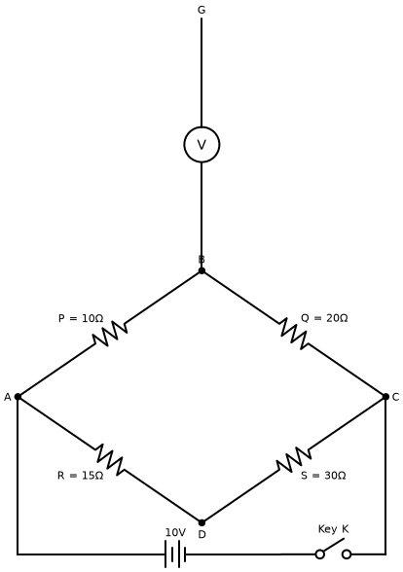
Q40. (a) What is electromagnetic induction? State Faraday's laws of electromagnetic induction.
(b) Explain the principle, construction, and working of an AC Generator with a suitable labelled diagram.
(c) What change is needed to convert an AC Generator into a DC Generator? [5M]
[IMAGE NEEDED: NCERT Diagram: AC generator, electromagnetic induction, slip rings, armature coil]
Q41. (a) Draw a neat labelled diagram of the human eye and explain the functions of: (i) Cornea, (ii) Iris, (iii) Ciliary muscles, (iv) Retina.
(b) What is power of accommodation of the eye?
(c) What is presbyopia? Mention its causes and mode of correction. [5M]
[IMAGE NEEDED: NCERT Diagram: human eye, cornea, retina, ciliary muscles]
*** End of Question Paper ***

