
RRB GROUP OF SCHOOLS
DESCRIPTIVE PAPER — UNIT TEST
CLASS: 11 | SUBJECT: PHYSICS
TOPIC / CHAPTER: 4. Laws of Motion
Time Allowed: 2 Hours | Maximum Marks (MM): 50
Teacher: Admin | Date: 05/09/2026
――――――――――――――――――――――――――――――――――――――――――――――――――――――――――――
Section A: Multiple Choice Questions
Note: Choose the correct option for each of the following questions.
Q1. A particle of mass $m$ is moving in a circular path of radius $r$ under the action of a centripetal force $F = - \frac{k}{r^2}$ where $k$ is a positive constant. The total energy of the particle is:
[1M]
(a) $-\frac{k}{2r}$
(b) $\frac{k}{2r}$
(c) $-\frac{k}{r}$
(d) $\frac{k}{r}$
Q2. A block of mass $m$ is placed on a rough inclined plane of inclination $\theta$ keeping horizontal. If the coefficient of static friction is $\mu_s$, the minimum force $F$ required to move the block up the inclined plane is:
[1M]
(a) $mg \sin\theta$
(b) $mg(\sin\theta + \mu_s \cos\theta)$
(c) $mg(\sin\theta - \mu_s \cos\theta)$
(d) $\mu_s mg \cos\theta$
Q3. Three blocks of masses $m_1$, $m_2$ and $m_3$ are connected as shown in the system. If a force $F$ is applied to mass $m_3$, the tension $T_1$ between $m_1$ and $m_2$ is:
[1M]

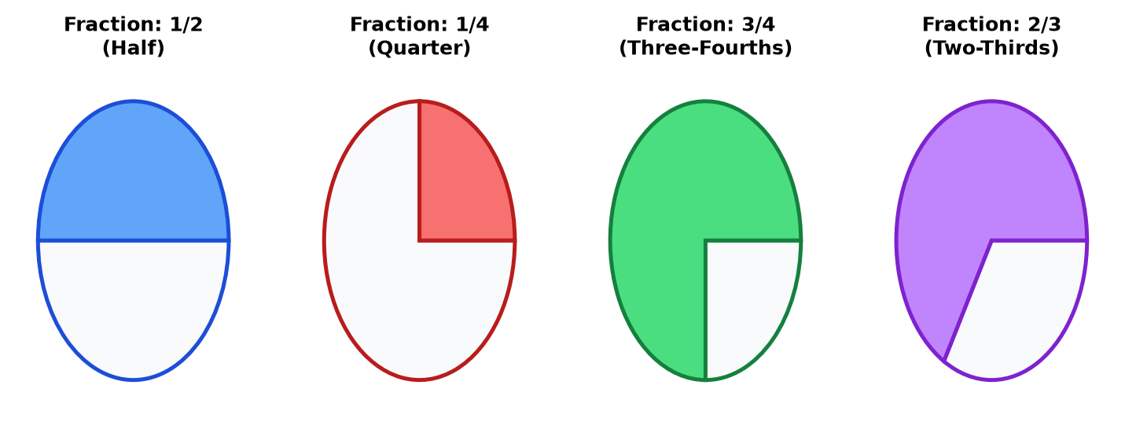
(a) $\frac{m_1 F}{m_1 + m_2 + m_3}$
(b) $\frac{(m_1 + m_2)F}{m_1 + m_2 + m_3}$
(c) $\frac{m_3 F}{m_1 + m_2 + m_3}$
(d) $\frac{(m_2 + m_3)F}{m_1 + m_2 + m_3}$
Q4. A bullet of mass $0.05\text{ kg}$ moving with a speed of $200\text{ m/s}$ enters a heavy wooden block and is stopped after a distance of $0.5\text{ m}$. What is the average resistive force exerted by the block on the bullet?
[1M]
(a) $2000\text{ N}$
(b) $4000\text{ N}$
(c) $200\text{ N}$
(d) $400\text{ N}$
Q5. A rocket with a lift-off mass $20,000\text{ kg}$ is blasted upwards with an initial acceleration of $5.0\text{ m/s}^2$. The initial thrust of the blast is ($g = 10\text{ m/s}^2$):
[1M]
(a) $1.0 \times 10^5\text{ N}$
(b) $2.0 \times 10^5\text{ N}$
(c) $3.0 \times 10^5\text{ N}$
(d) $3.5 \times 10^5\text{ N}$
Q6. A body of mass $2\text{ kg}$ travels according to the relation $x(t) = pt^3 + qt^2 + rt$, where constants are $p = 3\text{ m/s}^3$, $q = 4\text{ m/s}^2$, and $r = 5\text{ m/s}$. The force acting on the body at $t = 2\text{ s}$ is:
[1M]
(a) $64\text{ N}$
(b) $32\text{ N}$
(c) $128\text{ N}$
(d) $16\text{ N}$
Q7. The coefficient of friction between a tire and a road is $0.4$. The maximum safe speed of a car of mass $1000\text{ kg}$ to negotiate a circular curve of radius $100\text{ m}$ without skidding is ($g = 10\text{ m/s}^2$):
[1M]
(a) $20\text{ m/s}$
(b) $40\text{ m/s}$
(c) $10\text{ m/s}$
(d) $15\text{ m/s}$
Q8. A chain of mass $M$ and length $L$ is hanging over a smooth table with $1/n$th of its length hanging freely. The work done in pulling the hanging part back on the table is:
[1M]
(a) $\frac{MgL}{n^2}$
(b) $\frac{MgL}{2n^2}$
(c) $\frac{MgL}{n}$
(d) $\frac{MgL}{2n}$
Q9. An elevator accelerates upwards with an acceleration $a$. A person inside the elevator weighs a body using a spring balance. The reading of the spring balance compared to the true weight is:
[1M]
(a) less than true weight
(b) greater than true weight
(c) equal to true weight
id) zero
Q10. A force vector applied on a mass is represented as $\vec{F} = (6\hat{i} - 8\hat{j} + 10\hat{k})\text{ N}$ and accelerates the mass at $1\text{ m/s}^2$. What is the mass of the body?
[1M]
(a) $10\sqrt{2}\text{ kg}$
(b) $2\sqrt{10}\text{ kg}$
(c) $10\text{ kg}$
(d) $100\text{ kg}$
Section B: Fill in the Blanks
Note: Fill in the blanks with appropriate words or expressions.
Q1. The property of a body by virtue of which it opposes any change in its state of rest or uniform motion is called _______.
[1M]
Q2. The impulse of a force is equal to the change in _______ of the body.
[1M]
Q3. The maximum value of static friction is called _______ friction.
[1M]
Q4. For a banking angle $\theta$ on a curved road of radius $r$, the optimum speed to avoid wear and tear of tires is given by $\text{v} =$ _______.
[1M]
Section C: Assertion-Reason Type Questions
Note: Read the assertion and reason carefully and choose the correct option: (a) Both Assertion and Reason are true and Reason is the correct explanation of Assertion. (b) Both Assertion and Reason are true but Reason is not the correct explanation of Assertion. (c) Assertion is true but Reason is false. (d) Assertion is false and Reason is true.
Q1. Assertion (A): A rocket works on the principle of conservation of linear momentum.
Reason (B): The total momentum of an isolated system of interacting bodies remains conserved.
[1M]
(a) Both Assertion and Reason are true and Reason is the correct explanation of Assertion.
(b) Both Assertion and Reason are true but Reason is not the correct explanation of Assertion.
(c) Assertion is true but Reason is false.
(d) Assertion is false and Reason is true.
Q2. Assertion (A): It is easier to pull a heavy lawn roller than to push it.
Reason (B): Pulling creates a component of force acting upwards, which decreases the effective normal reaction and hence the limiting friction.
[1M]
(a) Both Assertion and Reason are true and Reason is the correct explanation of Assertion.
(b) Both Assertion and Reason are true but Reason is not the correct explanation of Assertion.
(c) Assertion is true but Reason is false.
(d) Assertion is false and Reason is true.
Section D: Very Short Answer Questions
Note: Answer all questions in brief.
Q1. State Newton's second law of motion in terms of momentum and write its mathematical form in vector notation.
[2M]
Q2. Why are wheels provided with mudguards? Explain briefly on the basis of laws of motion.
[2M]
Q3. Define angle of friction. Prove that the coefficient of static friction is equal to the tangent of the angle of friction.
[2M]
Q4. A batsman deflects a ball by an angle of $60^{\circ}$ without changing its initial speed of $54\text{ km/h}$. Calculate the impulse imparted to the ball if its mass is $0.15\text{ kg}$.
[2M]
Section E: Short Answer Questions
Note: Answer all questions with proper derivations or step-by-step solutions.
Q1. State and prove the Law of Conservation of Linear Momentum using Newton's third law of motion.
[3M]
Q2. Derive an expression for the maximum safe speed of a vehicle on a banked circular road of radius $r$ and banking angle $\theta$, taking friction into account.
[3M]
Q3. Two masses $m_1 = 4\text{ kg}$ and $m_2 = 6\text{ kg}$ are connected by a light string passing over a frictionless fixed pulley. Find the acceleration of the masses and the tension in the string when the masses are released.
[3M]

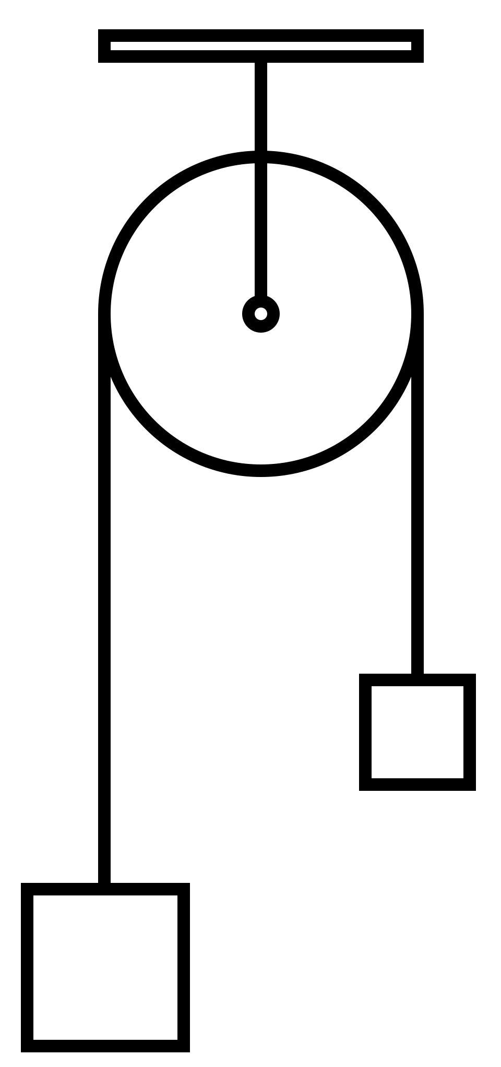
Q4. Explain why centripetal force is necessary for circular motion. A stone of mass $1\text{ kg}$ tied to the end of a string of length $1\text{ m}$ is whirled in a horizontal circle at a angular speed of $2\text{ rad/s}$. What is the maximum tension the string can bear if it breaks at a breaking tension of $10\text{ N}$? Compute the maximum angular velocity.
[3M]
Section F: Long Answer Questions
Note: Provide detailed answers with complete derivations and numerical steps.
Q1. (a) Define friction. Distinguish between static friction, kinetic friction, and rolling friction.
(b) A block of mass $10\text{ kg}$ rests on a horizontal plane. The coefficient of static friction is $0.5$ and kinetic friction is $0.3$. Calculate the frictional force acting on the block if a horizontal force of $20\text{ N}$ is applied, and also when the applied force becomes $60\text{ N}$. ($g = 10\text{ m/s}^2$)
[5M]
Q2. (a) Using free-body diagrams, find the acceleration of a body sliding down a rough inclined plane making an angle $\theta$ with the horizontal, where $\mu_k$ is the coefficient of kinetic friction.
(b) A block takes twice as much time to slide down a $45^{\circ}$ rough incline as it takes to slide down a frictionless $45^{\circ}$ incline of the same length. Calculate the coefficient of kinetic friction between the block and the rough incline.
[5M]

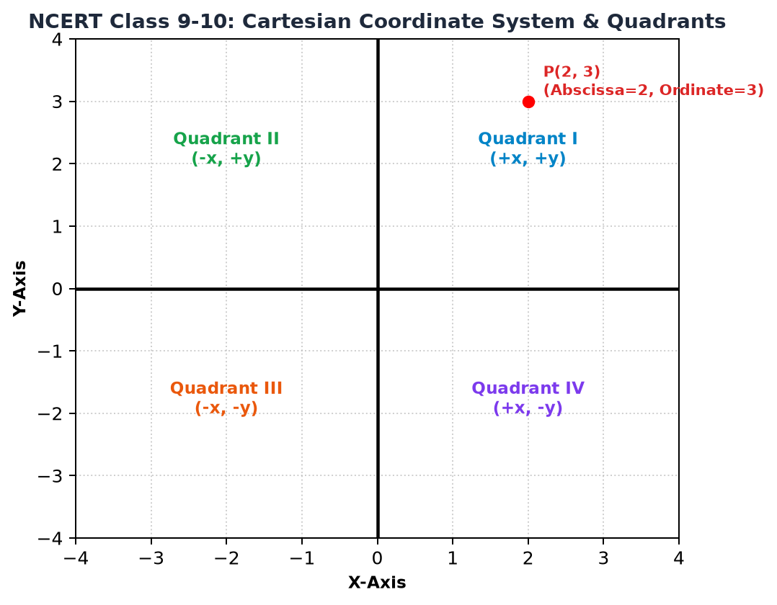
Section G: Case Study Based Question
Note: Read the passage carefully and answer the questions that follow.
Q1. Read the following passage on Newton's laws of motion and dynamic equilibrium, and answer the sub-questions below:
Newton's first law defines inertial frames of reference and states that a body continues in its state of rest or uniform motion unless acted upon by an external net force. Newton's second law quantifies force as the rate of change of linear momentum. In many real-world engineering problems, systems are analyzed using connected bodies, pulleys, lifts, and inclined planes where constraints dictate the motion. When all forces balance out, the body is in translational equilibrium.
[4M]
(a) What is an inertial frame of reference? Give one example.
(b) Why is Newton's first law considered not merely a special case of Newton's second law, but fundamental?
(c) A lift of mass $500\text{ kg}$ is ascending with an upward acceleration of $2\text{ m/s}^2$. Calculate the tension in the supporting cable. ($g = 9.8\text{ m/s}^2$)
*** End of Question Paper ***
Generated by RRB CBT · Developed by Gaurav Shukla & Team

