RRB GROUP OF SCHOOLS
UNIT TEST
CLASS: 10 — SUBJECT: BIOLOGY
Time Allowed: 1 Hour | Maximum Marks: 25
Teacher: Admin | Date: 22/08/2026
――――――――――――――――――――――――――――――――――――――――――――――――――――――――――
Section A: Multiple Choice Questions
Note: Choose the correct answer from the given options.
Q1. Which of the following is the structural and functional unit of the human kidney? [1M]
(a) Neuron
(b) Nephron
(c) Alveolus
(d) Malpighian tubule
Q2. The blood vessel that carries blood away from the glomerulus is the: [1M]
(a) Afferent arteriole
(b) Renal artery
(c) Efferent arteriole
(d) Renal vein
Q3. Which hormone acts on the collecting duct to increase water reabsorption when the body is dehydrated? [1M]
(a) Insulin
(b) Antidiuretic Hormone (ADH)
(c) Thyroxine
(d) Adrenaline
Q4. The abnormal presence of glucose in urine is known as: [1M]
(a) Hematuria
(b) Glycosuria
(c) Uremia
(d) Diuresis
Q5. Which major nitrogenous waste product is excreted in human urine? [1M]
(a) Uric acid
(b) Ammonia
(c) Urea
(d) Creatinine
Section B: Fill in the Blanks
Note: Fill in the blanks with appropriate terms.
Q1. The knot of blood capillaries present inside the Bowman's capsule is called _______. [1M]
Q2. The outer dark cortex region of the human kidney contains the _______ of nephrons. [1M]
Section C: Assertion-Reason
Note: Select the correct option based on the Assertion and Reason provided.
Q1. Assertion (A): Ultrafiltration occurs under high hydrostatic pressure in the glomerulus.
Reason (R): The lumen of the efferent arteriole is narrower than that of the afferent arteriole. [1M]
(a) Both Assertion (A) and Reason (R) are true and Reason (R) is the correct explanation of Assertion (A).
(b) Both Assertion (A) and Reason (R) are true but Reason (R) is not the correct explanation of Assertion (A).
(c) Assertion (A) is true but Reason (R) is false.
(d) Assertion (A) is false but Reason (R) is true.
Section D: Very Short Answer
Note: Answer the following questions briefly.
Q1. Define Osmoregulation and state its importance in the human body. [2M]
Q2. Differentiate between Glomerular Filtrate and Urine based on their chemical composition. [2M]
Q3. Name two major constituents of blood that do not pass into the Bowman's capsule during ultrafiltration. Give a reason for their absence in the filtrate. [2M]
Section E: Short Answer
Note: Answer the following questions in detail.
Q1. Study the diagram of the human urinary system given below and answer the questions that follow: [3M]

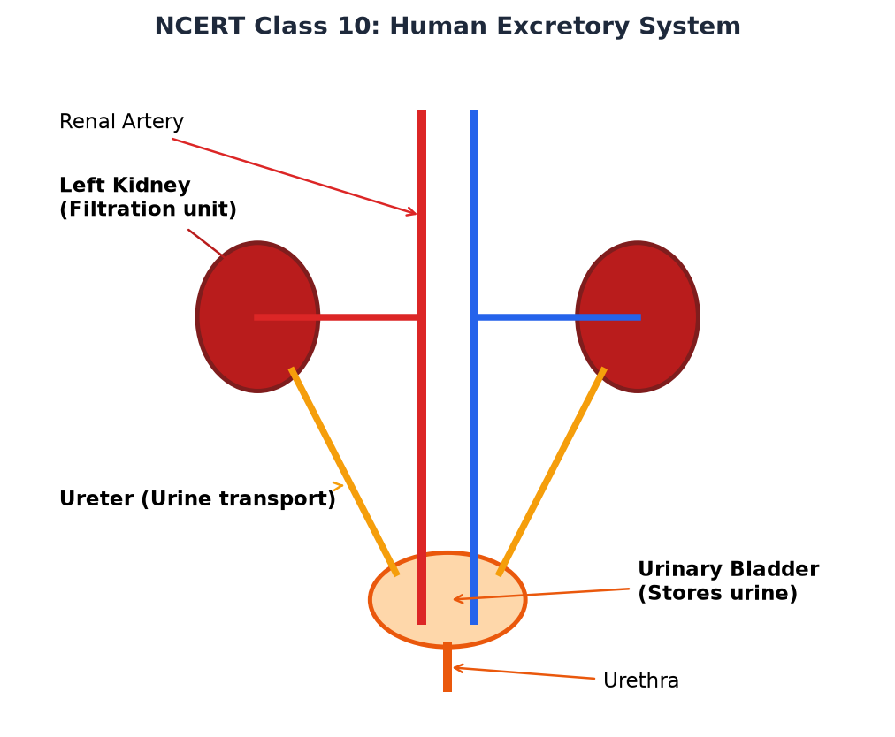
(a) Identify and label the parts marked as renal artery, ureter, and urinary bladder.
(b) State the function of the ureter in the excretory process.
(c) What is the structural difference between the male and female urethra?
Q2. Explain the three main physiological steps involved in urine formation: Ultrafiltration, Selective Reabsorption, and Tubular Secretion. [3M]
Section F: Long Answer
Note: Answer the multi-part question clearly with precise scientific explanations.
Q1. Refer to the structural diagram of a human Nephron provided below and answer the following questions: [5M]

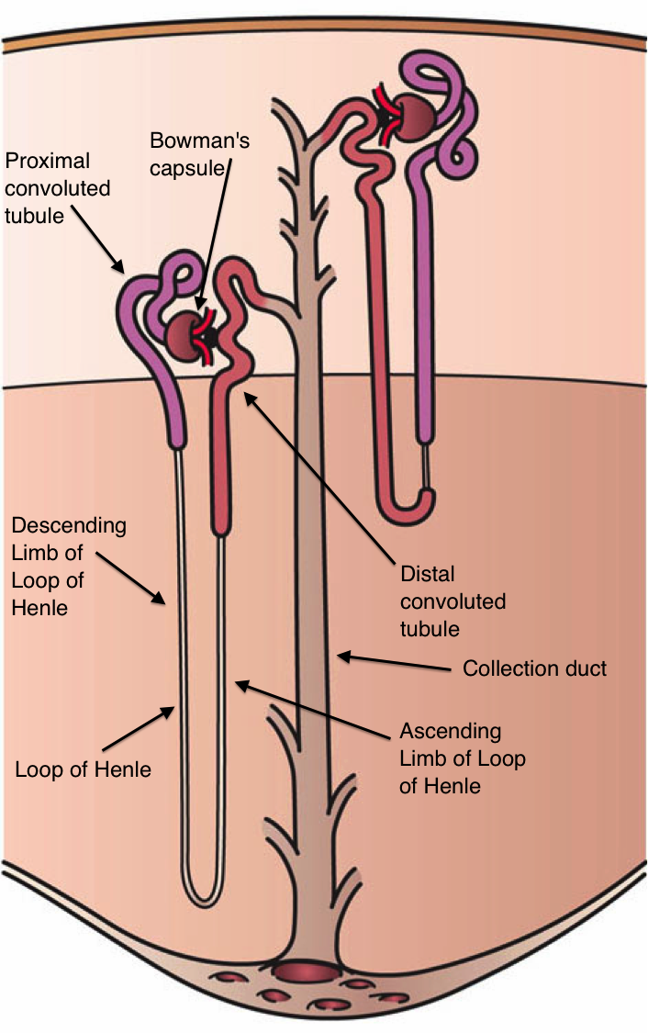
(a) Identify the parts labeled: Glomerulus, Bowman's capsule, Loop of Henle, and Collecting duct.
(b) Describe how the structural adaptation of the capillaries in the Glomerulus enables Ultrafiltration.
(c) Which useful substances present in the initial filtrate are selectively reabsorbed back into blood capillaries along the Proximal Convoluted Tubule (PCT)?
(d) Define Hemodialysis and explain under what clinical condition an artificial kidney is required by a patient.
*** End of Question Paper ***

