RRB GROUP OF SCHOOLS
UNIT TEST
CLASS: 10 — SUBJECT: PHYSICS
Time Allowed: 1 Hours | Maximum Marks: 30
Teacher: GAURAV SHUKLA | Date: 21/08/2026
――――――――――――――――――――――――――――――――――――――――――――――――――――――――――
Section A: Long Answer Questions
Note: Answer all questions. Show necessary circuit analysis and steps clearly.
Q1. An electrical circuit is set up with a DC voltage source connected to two resistors in series. Calculate the equivalent resistance of the combination and the current flowing through the circuit. [3M]

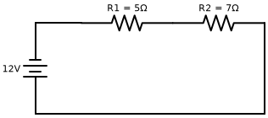
Q2. Two resistors are connected in a parallel network across a power supply. Determine the effective resistance of the parallel combination and the total current drawn from the source. [3M]

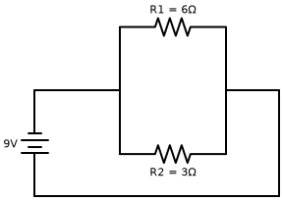
Q3. A complex resistive network is analyzed using a potential divider setup. Find the voltage drop across the second resistor given the input potential and resistance values. [3M]

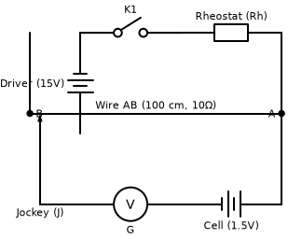
Q4. In a bridge circuit arrangement, four resistors are connected. Calculate the current flowing through the galvanometer arm when the bridge is unbalanced with the given parameters. [3M]

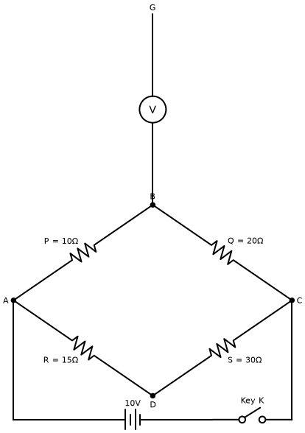
Q5. Three resistors of values \(\text{R}_1 = 4\,\Omega\), \(\text{R}_2 = 6\,\Omega\), and \(\text{R}_3 = 12\,\Omega\) are connected in parallel across a \(24\,\text{V}\) battery. Find the total current in the circuit and the current flowing through each resistor. [3M]
Q6. State Joule's law of heating. An electric iron consumes energy at a rate of \(840\,\text{W}\) when heating is at the maximum rate and \(360\,\text{W}\) when the heating is at the minimum. The voltage is \(220\,\text{V}\). Calculate the current and the resistance in each case. [3M]
Q7. Define electric power and write its SI unit. Derive the relation between power, potential difference, and resistance in an electrical circuit. A \(100\,\text{W}\) bulb is connected to a \(220\,\text{V}\) supply. Calculate the resistance of the bulb. [3M]
Q8. On what factors does the resistance of a conductor depend? Explain each factor with the help of appropriate formulas. A copper wire of length \(2\,\text{m}\) and area of cross-section \(1.7 \times 10^{-6}\,\text{m}^2\) has a resistance of \(2 \times 10^{-2}\,\Omega\). Calculate the resistivity of copper. [3M]
Q9. Explain why parallel circuit arrangement is preferred over series circuit arrangement for domestic wiring. Give any three valid reasons supporting your answer. [3M]
Q10. An electric refrigerator rated \(400\,\text{W}\) operates 8 hours a day and an electric toaster rated \(300\,\text{W}\) operates 2 hours a day. What is the cost of the energy to operate them for 30 days at ₹ 3.00 per kWh? [3M]
*** End of Question Paper ***

