RRB PUBLIC SCHOOL
UNIT TEST
CLASS: 10 — SUBJECT: PHYSICS
Time Allowed: 2 Hours | Maximum Marks: 50
Teacher: Test Teacher | Date: 21/08/2026
――――――――――――――――――――――――――――――――――――――――――――――――――――――――――
Section A: Physics Numerical & Diagrams
Note: Show all calculations.
Q1. For the Wheatstone bridge shown below, determine whether the bridge is balanced. [5M]

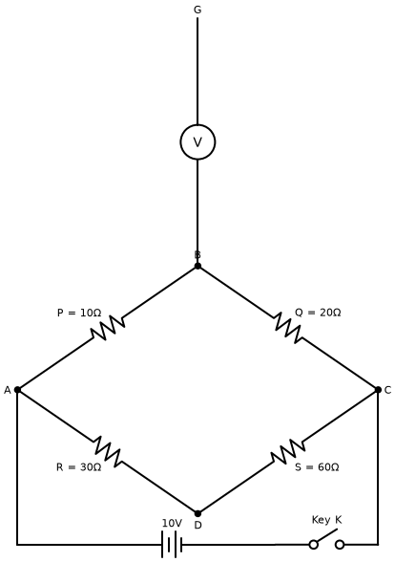
(a) Balanced
(b) Unbalanced
(c) Cannot be determined
(d) None
Q2. Explain the structure of a plant cell with a labeled diagram. [5M]

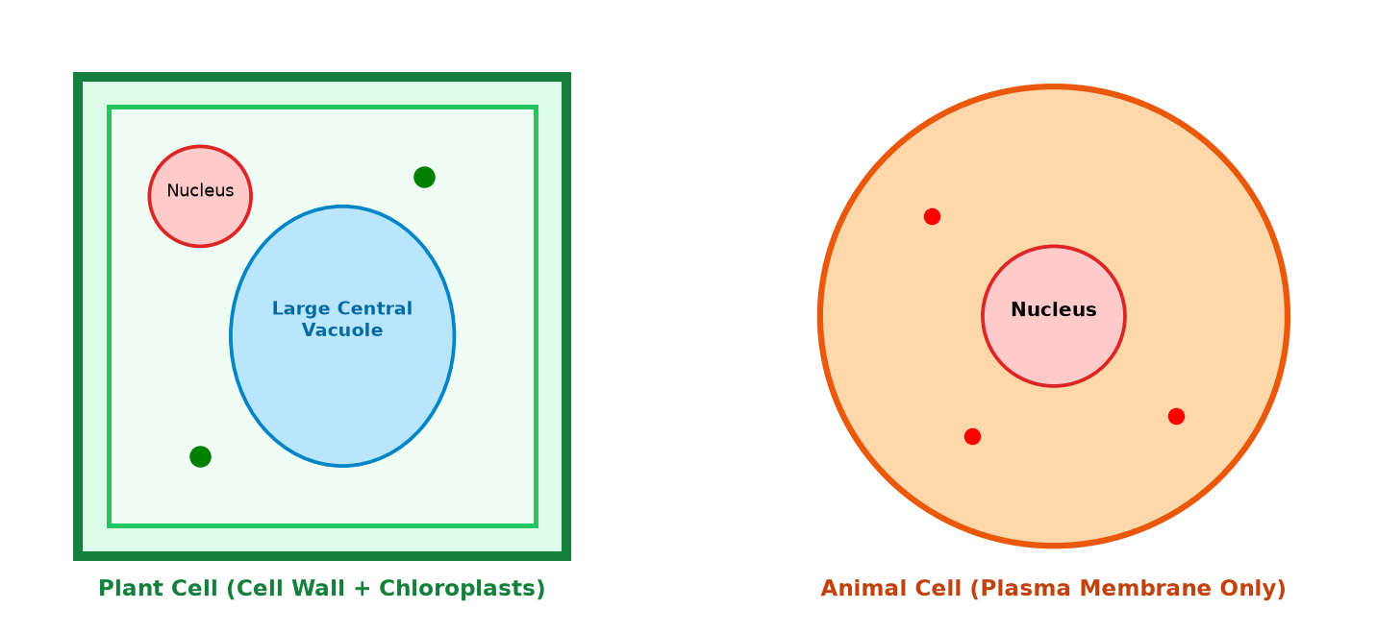
*** End of Question Paper ***

