TEST HIGH SCHOOL
PRE-BOARD
CLASS: 10 — SUBJECT: SCIENCE
Time Allowed: 3 Hours | Maximum Marks: 100
Teacher: Faculty | Date: 21/08/2026
――――――――――――――――――――――――――――――――――――――――――――――――――――――――――
Section A: MCQs & Diagrams
Note: Answer all questions.
Q1. Which labeled part of the Human Heart pumps oxygenated blood to the body? [1M]

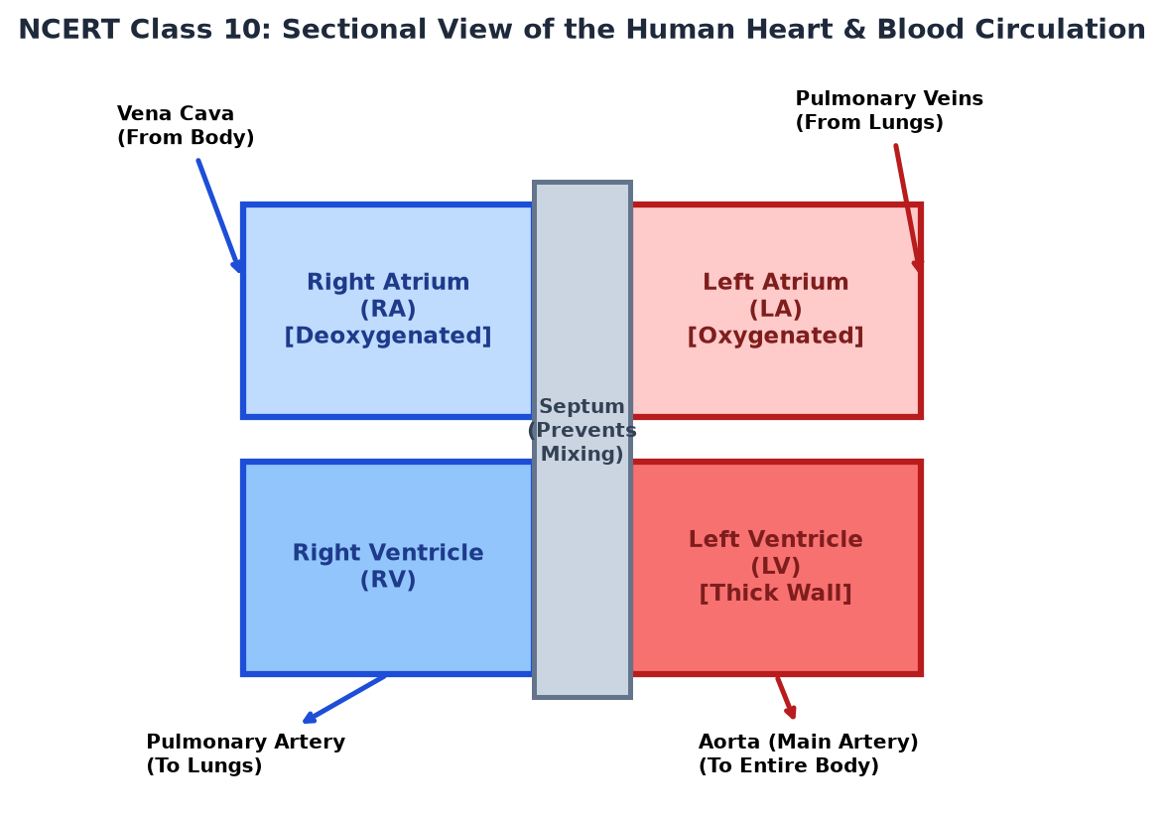
(a) Right Atrium
(b) Left Ventricle
(c) Pulmonary Artery
(d) Vena Cava
*** End of Question Paper ***

