RRB GROUP OF SCHOOLS
UNIT TEST
CLASS: 10 — SUBJECT: SCIENCE
Time Allowed: 1 Hour | Maximum Marks: 25
Teacher: Admin | Date: 22/08/2026
――――――――――――――――――――――――――――――――――――――――――――――――――――――――――
Section A: Multiple Choice Questions
Note: Choose the correct answer for each of the following questions.
Q1. Which of the following events does NOT occur during the process of photosynthesis in green plants? [1M]
(a) Absorption of light energy by chlorophyll
(b) Conversion of light energy to chemical energy
(c) Oxidation of carbon dioxide to carbohydrates
(d) Reduction of carbon dioxide to carbohydrates
Q2. Refer to the given diagram showing an open stomatal pore. Identify the label 'X' that controls the opening and closing of the stomatal pore. [1M]

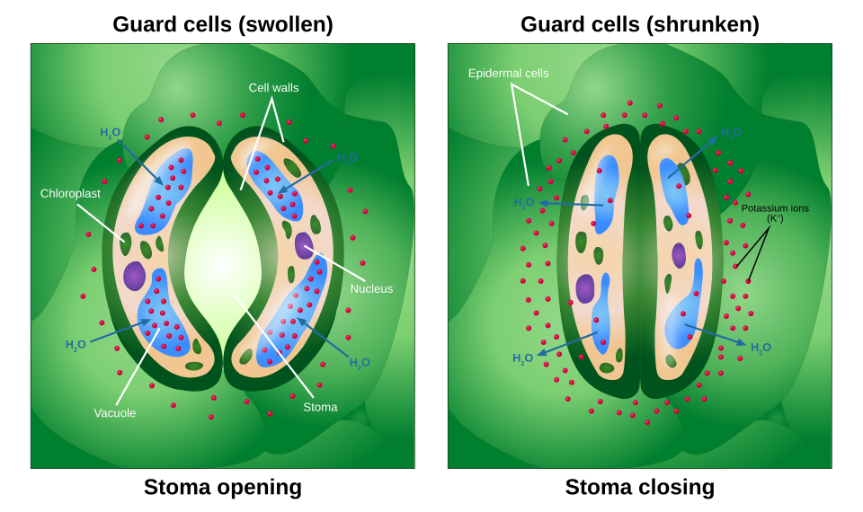
(a) Chloroplast
(b) Guard cell
(c) Epidermal cell
(d) Stomatal pore
Q3. During heavy physical exercise, accumulation of which substance in muscle cells causes painful cramps? [1M]
(a) Ethanol
(b) Lactic acid
(c) Carbon dioxide
(d) Pyruvate
Q4. In the human digestive system, the enzymes trypsin and lipase are secreted respectively by which organ? [1M]
(a) Stomach
(b) Liver
(c) Pancreas
(d) Small intestine
Q5. Which component of blood is primarily responsible for clotting at the site of an injury? [1M]
(a) Red Blood Corpuscles (RBCs)
(b) White Blood Corpuscles (WBCs)
(c) Blood Platelets
(d) Plasma
Section B: Assertion-Reason Questions
Note: For the following questions, two statements are given — one labelled Assertion (A) and the other labelled Reason (R). Select the correct choice from options (a), (b), (c), and (d):
(a) Both Assertion (A) and Reason (R) are true and Reason (R) is the correct explanation of Assertion (A).
(b) Both Assertion (A) and Reason (R) are true but Reason (R) is NOT the correct explanation of Assertion (A).
(c) Assertion (A) is true but Reason (R) is false.
(d) Assertion (A) is false but Reason (R) is true.
Q6. Assertion (A): Rings of cartilage are present in the human trachea.
Reason (R): Rings of cartilage ensure that the air passage does not collapse when there is less air in it. [1M]
(a) Both Assertion (A) and Reason (R) are true and Reason (R) is the correct explanation of Assertion (A).
(b) Both Assertion (A) and Reason (R) are true but Reason (R) is NOT the correct explanation of Assertion (A).
(c) Assertion (A) is true but Reason (R) is false.
(d) Assertion (A) is false but Reason (R) is true.
Q7. Assertion (A): The inner lining of the small intestine has numerous finger-like projections called villi.
Reason (R): Villi decrease the surface area for efficient absorption of digested food. [1M]
(a) Both Assertion (A) and Reason (R) are true and Reason (R) is the correct explanation of Assertion (A).
(b) Both Assertion (A) and Reason (R) are true but Reason (R) is NOT the correct explanation of Assertion (A).
(c) Assertion (A) is true but Reason (R) is false.
(d) Assertion (A) is false but Reason (R) is true.
Q8. Assertion (A): The left ventricle of the human heart has thicker muscular walls than the right ventricle.
Reason (R): The left ventricle has to pump oxygenated blood to various distant body organs under high pressure. [1M]
(a) Both Assertion (A) and Reason (R) are true and Reason (R) is the correct explanation of Assertion (A).
(b) Both Assertion (A) and Reason (R) are true but Reason (R) is NOT the correct explanation of Assertion (A).
(c) Assertion (A) is true but Reason (R) is false.
(d) Assertion (A) is false but Reason (R) is true.
Q9. Assertion (A): Transpiration helps in the absorption and upward movement of water and minerals dissolved in it from roots to leaves.
Reason (R): Transpiration also plays a key role in temperature regulation in plants. [1M]
(a) Both Assertion (A) and Reason (R) are true and Reason (R) is the correct explanation of Assertion (A).
(b) Both Assertion (A) and Reason (R) are true but Reason (R) is NOT the correct explanation of Assertion (A).
(c) Assertion (A) is true but Reason (R) is false.
(d) Assertion (A) is false but Reason (R) is true.
Section C: Very Short Answer Questions
Note: Answer the following questions concisely.
Q10. What is emulsification of fats? Name the secretion that brings about this process in the human alimentary canal. [2M]
Q11. State the dual function of mucus present in the gastric juice secreted by the stomach lining. [2M]
Q12. Differentiate between xylem and phloem transport in plants based on:
(i) Direction of transport
(ii) Energy requirement (ATP expenditure) [2M]
Q13. Why do aquatic organisms exhibit a much faster rate of breathing than terrestrial organisms? [2M]
Q14. Name two nitrogenous waste products excreted by the human kidney. Mention the functional unit of the human kidney. [2M]
Section D: Short Answer Questions
Note: Answer the following questions in detail.
Q15. Explain the three different pathways of breakdown of glucose in living cells under different conditions (presence of oxygen, absence of oxygen, and lack of oxygen). Write the end products for each pathway. [3M]
Q16. Study the given schematic diagram of a human nephron and answer the questions that follow: [3M]

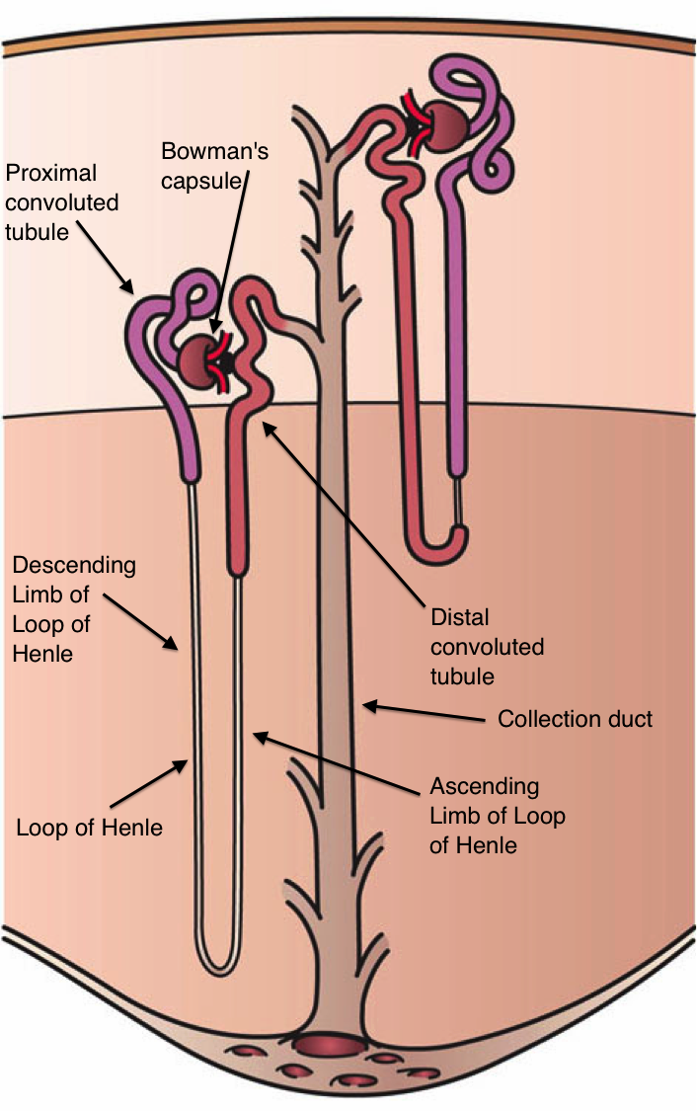
(a) Identify the cup-shaped structure where ultrafiltration occurs and the capillary network associated with it.
(b) Name two substances present in the initial filtrate that are selectively reabsorbed as the filtrate flows through the nephron tube.
(c) What factors determine the amount of water reabsorbed in the renal tubule?
Section E: Long Answer Questions
Note: Answer the following question in detail.
Q17. The human circulatory system is a closed double circulatory system involving the heart, blood, and blood vessels. [5M]

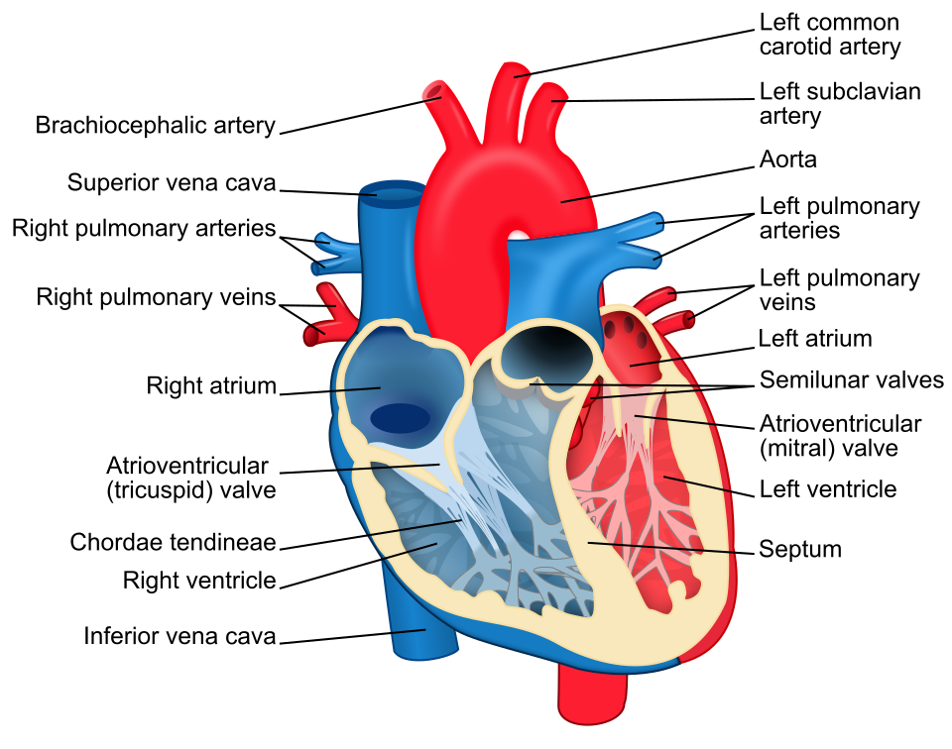
(a) Explain the pathway of blood circulation through the human heart with the help of a flow diagram or labeled diagram, starting from deoxygenated blood entering the right atrium until oxygenated blood leaves the heart.
(b) Why is double circulation necessary in warm-blooded animals such as mammals and birds?
(c) How does the circulation system of amphibians differ from that of mammals?
*** End of Question Paper ***
Generated by RRB CBT · Developed by Gaurav Shukla & Team

