**C# Documentation**

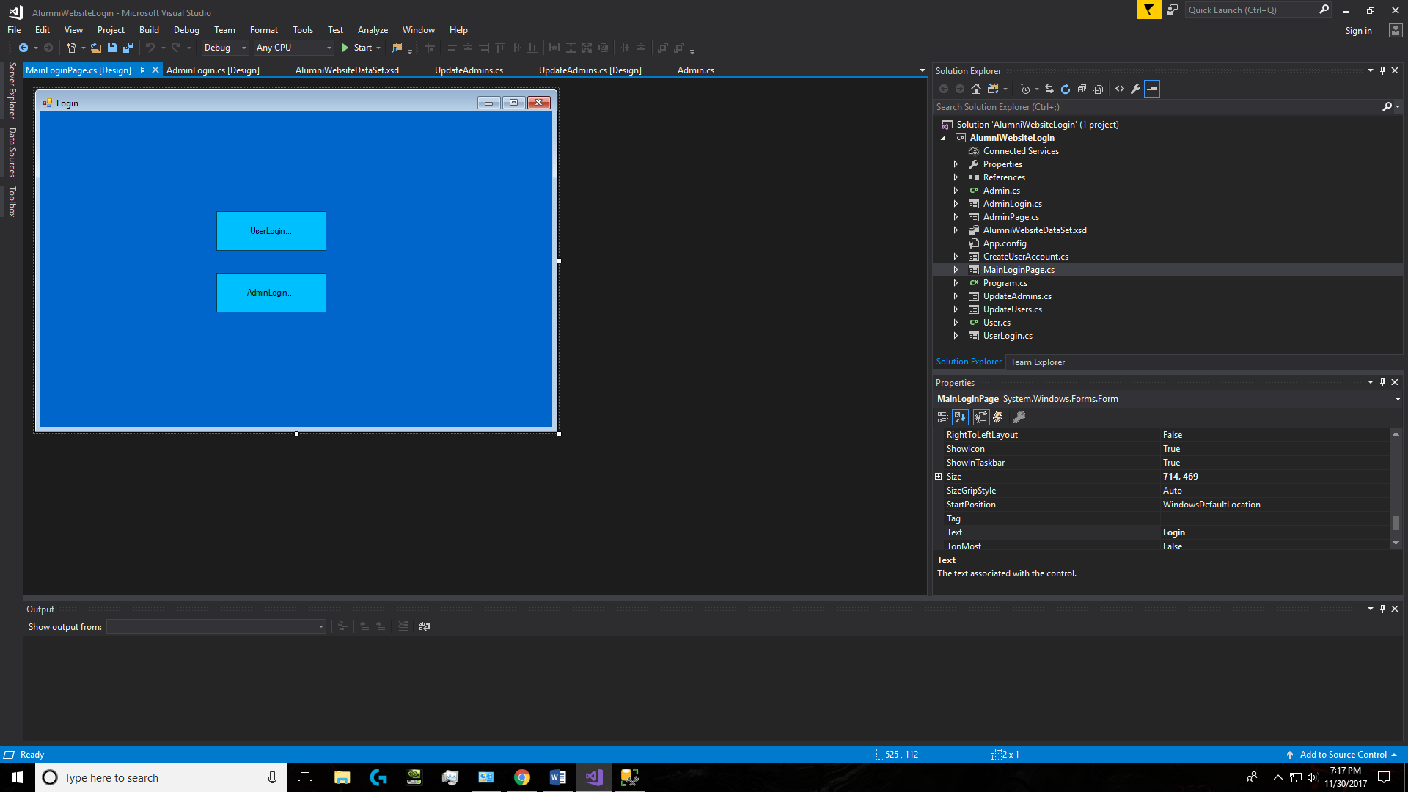

1.

2.

1. When btnUserLogin is clicked it will take user to UserLogin form, where they may then login or go to CreateAccount form to make an account.
2. When AdminLogin is clicked it will take user to AdminLogin form where they may login as an admin.

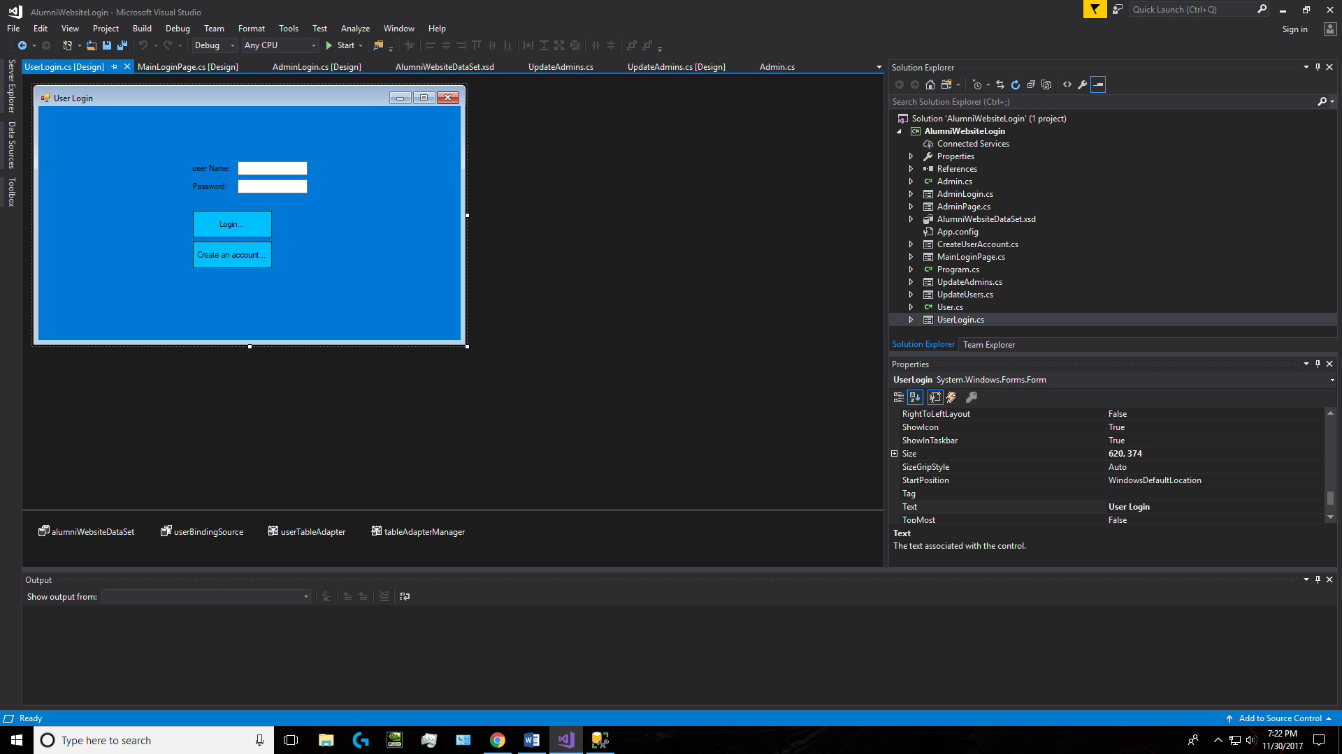

4.

3.

2.

1.

1.userNameTextBox will be used in a select sql statement that will check the User table to see if this username and password exists in the table with the same UserID. This will ensure that someone can’t login by using one admins login and another’s password.

2. passwordNameTextBox will be used in a select sql statement that will check the User table to see if this username and password exists in the table with the same UserID. This will ensure that someone can’t login by using one admins login and another’s password.

3. when btnLogin is clicked it will use a select statement that will check to see if the information is in the database. If it is it’ll let the user login, if not it will display a textbox saying, “Incorrect username or password”.

4. btnCreateAccount will take user to CreateAccount form when clicked, this form will allow a new user to make an account.

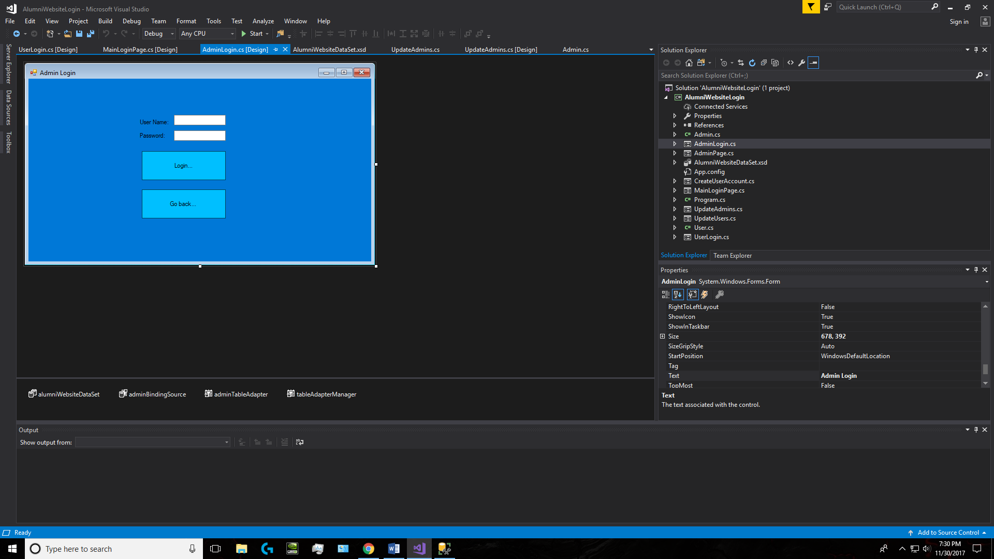

4.

3.

2.

1.

1. userNameTextBox will be used in a select sql statement that will check the User table to see if this username and password exists in the table with the same AdminID. This will ensure that someone can’t login by using one admins login and another’s password.
2. passwordNameTextBox will be used in a select sql statement that will check the User table to see if this username and password exists in the table with the same AdminID. This will ensure that someone can’t login by using one admins login and another’s password.
3. when btnLogin is clicked it will use a select statement that will check to see if the information is in the database. If it is it’ll let the admin login, if not it will display a textbox saying, “Incorrect username or password”. If login is valid it will take user to the AdminPage form where they can update users or update admins using sql statements.
4. When btnGoBack is clicked it will hide this form and return user to MainLoginPage which is the first form.

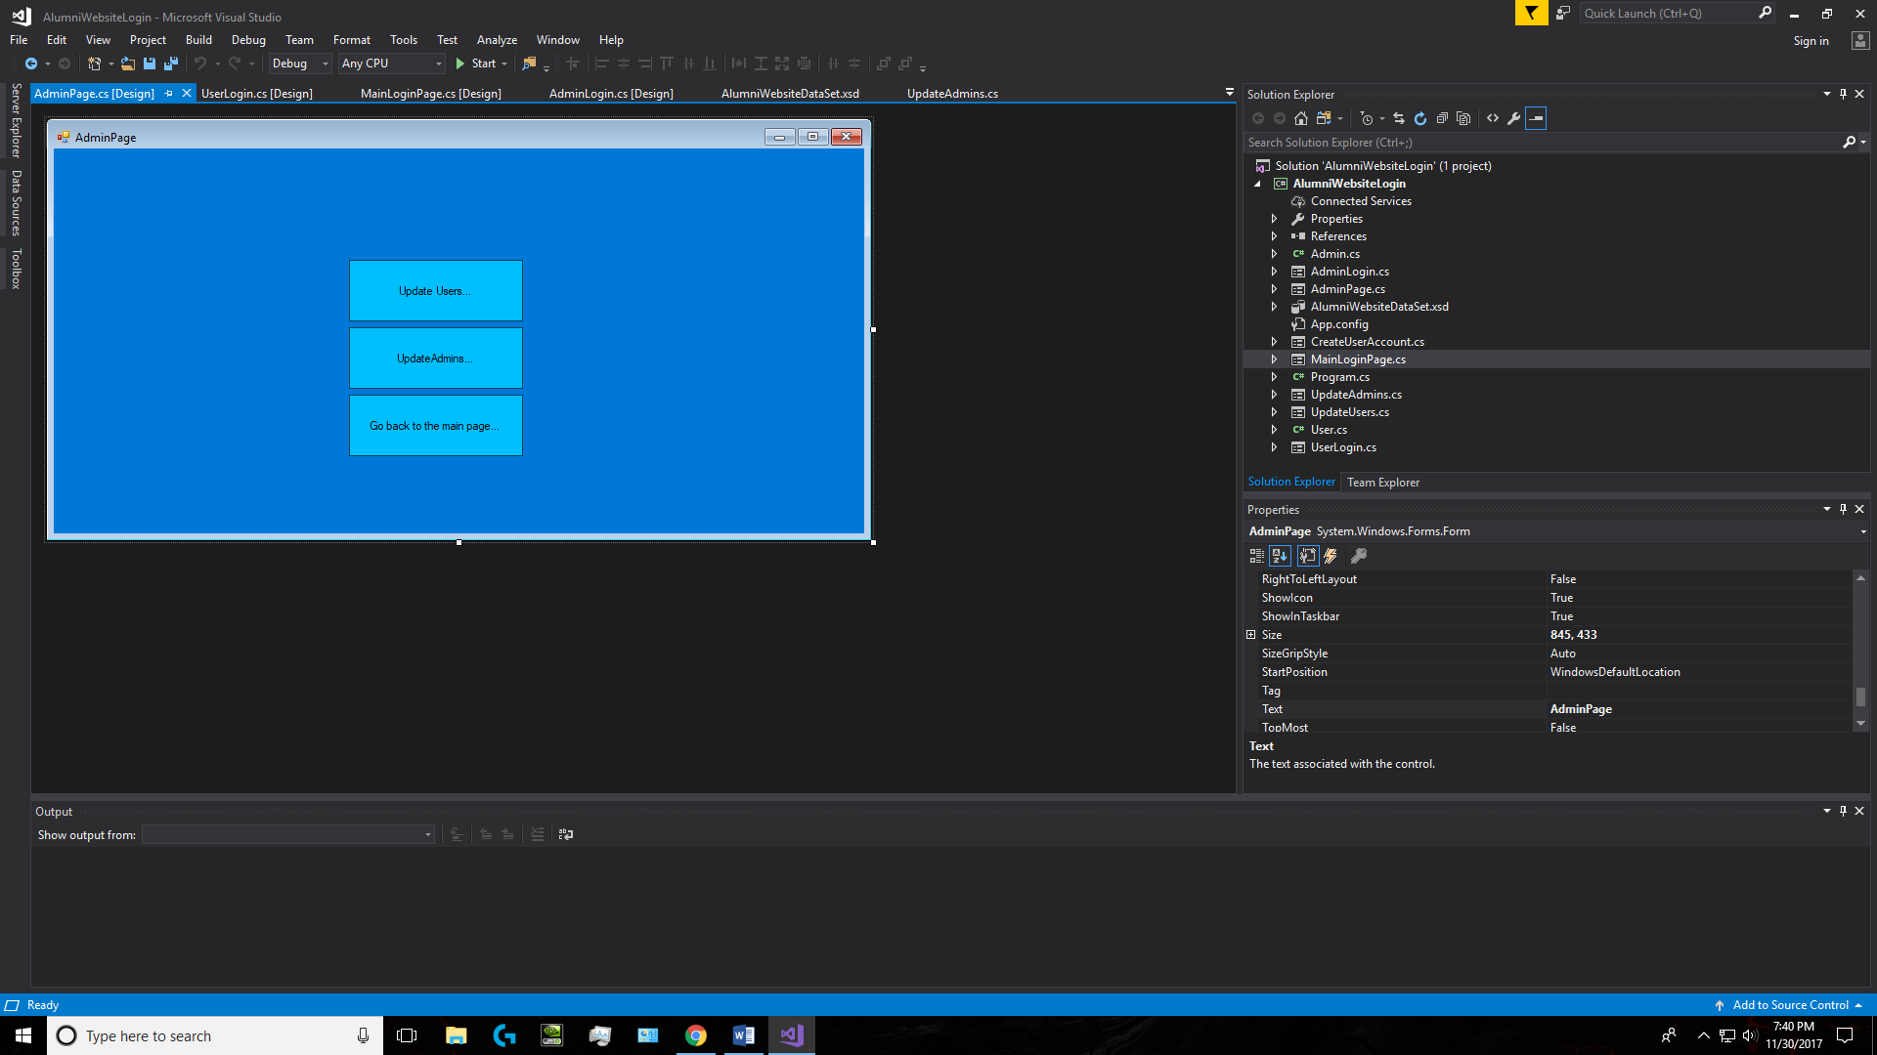

3.

2.

1.

1. When btnUpdateUser is clicked it will take user to UpdateUser form where they can insert, update or delete user accounts.
2. When btnUpdateAdmin is clicked it will take user to UpdateAdmin form where they can insert, update or delete adminaccounts.
3. When btnGoBackToMain is clicked it will return the user to MainLoginPage form.

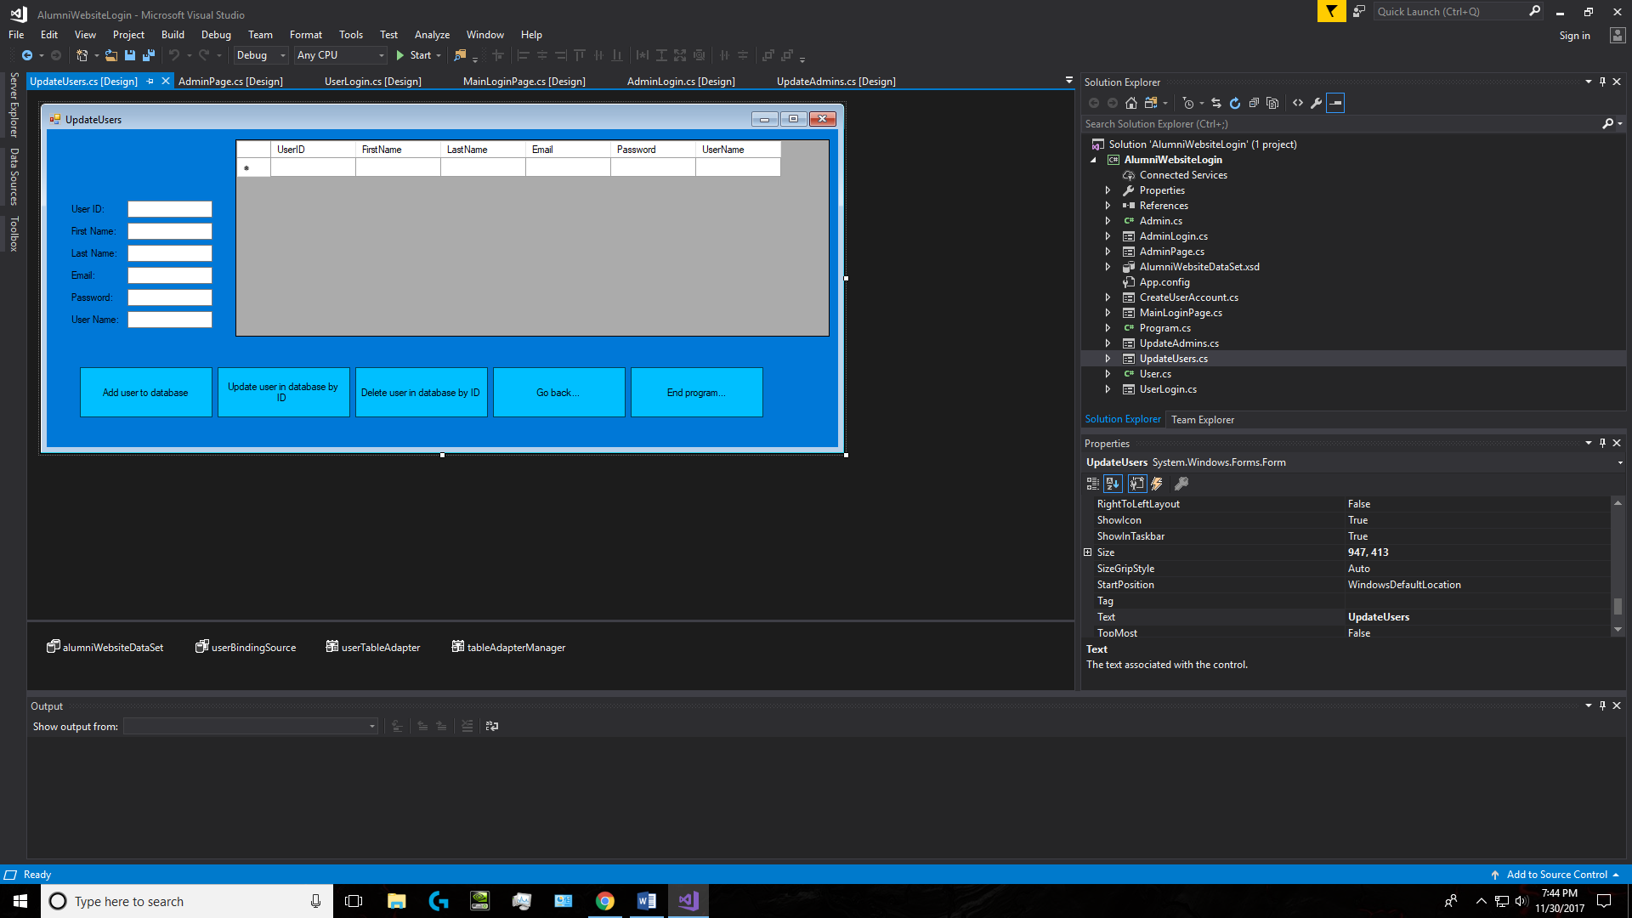

7.

5.

6.

4.

3.

2.

1.

1. These TextBoxs will be used to insert, update or delete a user account, depending on which button has been clicked.
2. When btnAddUser is clicked an insert sql statement will be used to add the data entered from the TextBoxs to the database if they match the datatype in the parameters. If they don’t match the datatype a MessageBox with appear saying “DB error:” + ex.Message.
3. When btnUpdateUser is clicked an update sql statement will be used to update the data entered from the TextBoxs to the database, user will be updated by using UserID. If they match the datatype in the parameters. If they don’t match the datatype a MessageBox with appear saying “DB error:” + ex.Message.
4. When btnDeleteUser is clicked a delete sql statement will be used to delete the data entered from the TextBoxs to the database, user will be deleted by using UserID. If they match the datatype in the parameters. If they don’t match the datatype a MessageBox with appear saying “DB error:” + ex.Message.
5. When btnGoBack is clicked it hide this form and it will return the user to AdminPage form.
6. When btnEnd is clicked the application will be ended.
7. This datagridview is connection to the AlumniWebsite and is populated by all the user information. It will be updated to some changes in the table every time a button is clicked.

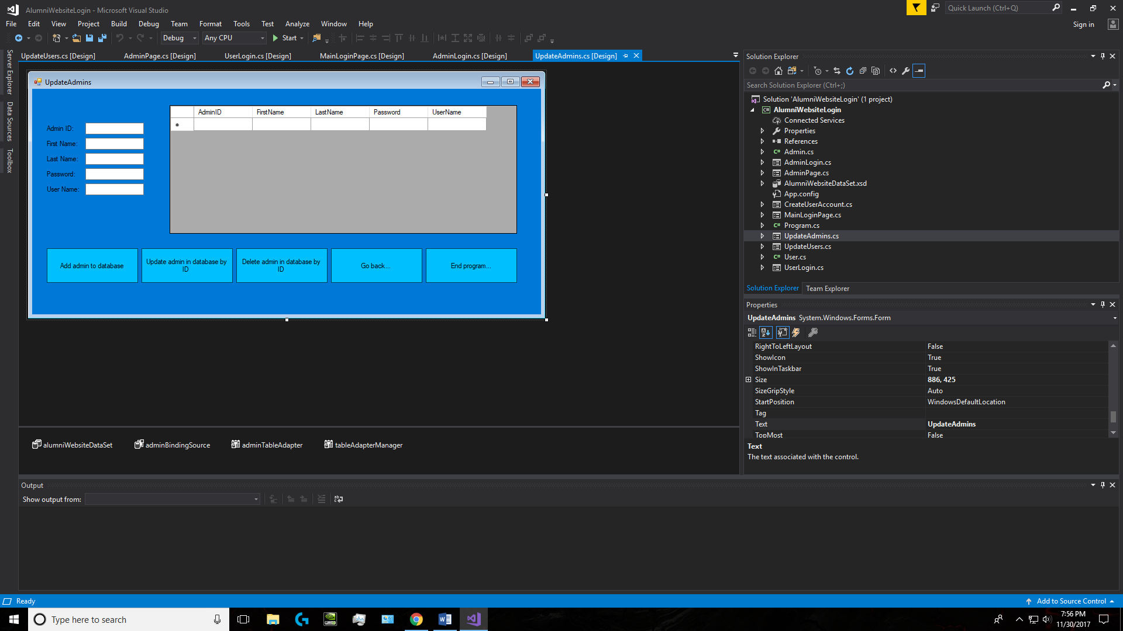

6.

4.

1.

7.

3.

5.

2.

1. 1. These TextBoxs will be used to insert, update or delete a admin account, depending on which button has been clicked.
2. When btnAddAdmin is clicked an insert sql statement will be used to add the data entered from the TextBoxs to the database if they match the datatype in the parameters. If they don’t match the datatype a MessageBox with appear saying “DB error:” + ex.Message.
3. When btnUpdateAdmin is clicked an update sql statement will be used to update the data entered from the TextBoxs to the database, user will be updated by using AdminID. If they match the datatype in the parameters. If they don’t match the datatype a MessageBox with appear saying “DB error:” + ex.Message.
4. When btnDeleteAdminis clicked a delete sql statement will be used to delete the data entered from the TextBoxs to the database, user will be deleted by using AdminID. If they match the datatype in the parameters. If they don’t match the datatype a MessageBox with appear saying “DB error:” + ex.Message.
5. When btnGoBack is clicked it hide this form and it will return the user to AdminPage form.
6. When btnEnd is clicked the application will be ended.
7. This datagridview is connection to the AlumniWebsite and is populated by all the admin information. It will be updated to some changes in the table every time a button is clicked.