Back-plane Setup

Connectors
Four PCIe connectors creating a possible 98 Pins Per card.

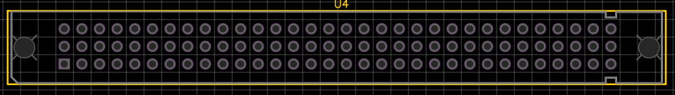
Power Pins
- A1 – 24V
- A2 – 12V
- A3 – 5V
- A4 – 3.3V
- A32 – GND

Setup Pins
Setup pins are used to help master card to self arrange to detect what card and what pins are being used by each card in each slot. A simple RxTx CS setup using possibly I2C can send from the slave when Rx is high what pins are used.
The RxTx CS pins are:
- A5 – Rx
- A6 – Tx
- A7:A9 – CS

Analog Pin Range
- A10 – A31

Digital Out Pin Range
- B1 – B16

Digital In Pin Range
- B15 - B32

PWM Out Adapter Pins
- C1 – C10

PWM Response Signals
- C11 – C20

Ligh and Safety Pins
- C21 - C32

