**PERSONAL INFORMATION**

**Date of birth:**  27 November 2003

**Gender:** male

**Marital Status:** Unmarried

**Father’ Name**: Jitendra

**Languages Known:** English,

Hindi,

Marathi

**Religion:** Hindu

**Hobbies:** Reading books & Listening to music.

**CONTACT DETAIL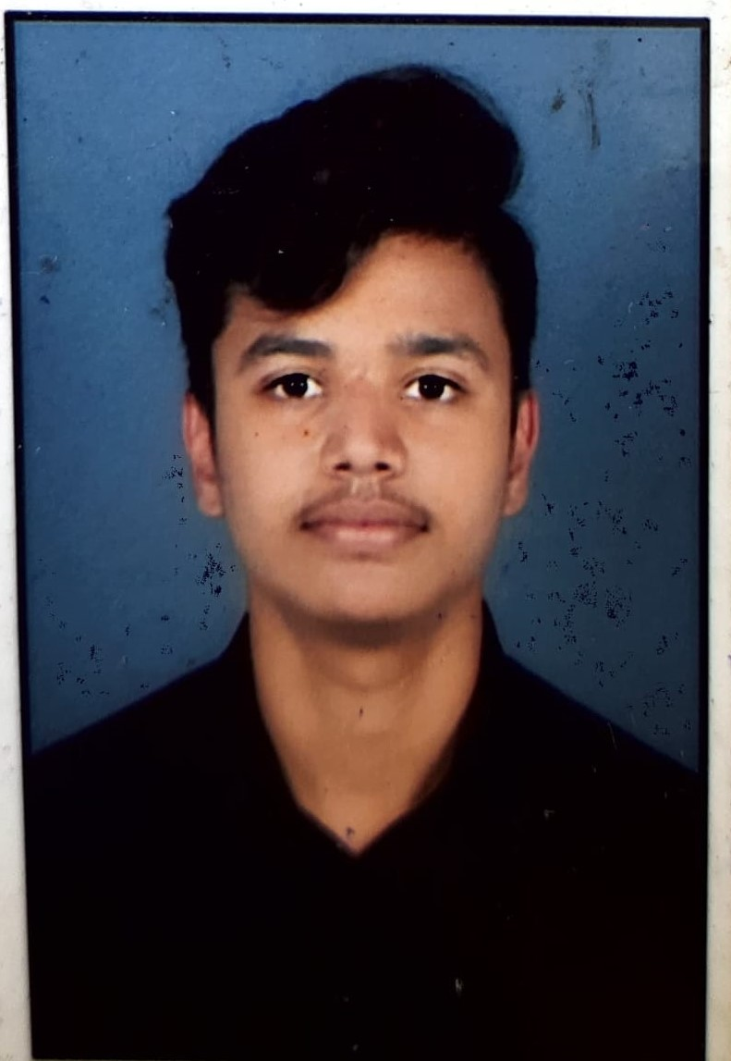S**



**EDUCATION**

* **BCA (Computer Science)**

Institution: GH Raisoni Institute of Science & Technology

Year of Passing:

* **12th - HSC Board**

Institution:  Dinanath Jr College

Year of Passing: 2021

Percentage: 80.00

* **10th - SSC Board**

Institution: VDPM High School

Year of Passing: 2019

Percentage: 61.80

A BCA student looking to working in a growth-oriented organization which offers me challenging opportunities to enhance my profession and technical knowledge.

**PROFILE SUMMARY**

**TECHNICAL SKILLS**

* Programming Languages: JavaScript, C, C++
* Databases: Oracle, MYSQL, MONGODB
* Web Technologies: Java Script, Bootstrap, React, CSS, HTML
* Operating Systems: Windows

**OTHER SKILLS**

* AutoCAD
* Photoshop
* MS Office

**HIMANSHU KALE**

**Email ID:** himanshukale266@gmail.com

**Mobile:**

9529029495

**Address:**

5, Joshi Wadi, Gopal Nagar, Nagpur 440022.