# Theresa Cheng | Nandita Vijayakumar

# 1/19/2016

# This script provides descriptive stats on the duration of inclusion and exclusion blocks within Cyberball runs

## Loading required package: plyr

## Loading required package: dplyr

##   
## Attaching package: 'dplyr'

## The following objects are masked from 'package:plyr':  
##   
## arrange, count, desc, failwith, id, mutate, rename, summarise,  
## summarize

## The following objects are masked from 'package:stats':  
##   
## filter, lag

## The following objects are masked from 'package:base':  
##   
## intersect, setdiff, setequal, union

## Loading required package: tidyr

## Loading required package: data.table

##   
## Attaching package: 'data.table'

## The following objects are masked from 'package:dplyr':  
##   
## between, last

## Loading required package: R.matlab

## R.matlab v3.2.0 (2015-02-24) successfully loaded. See ?R.matlab for help.

##   
## Attaching package: 'R.matlab'

## The following objects are masked from 'package:base':  
##   
## getOption, isOpen

## Loading required package: chron

## Loading required package: knitr

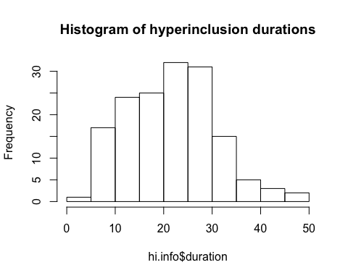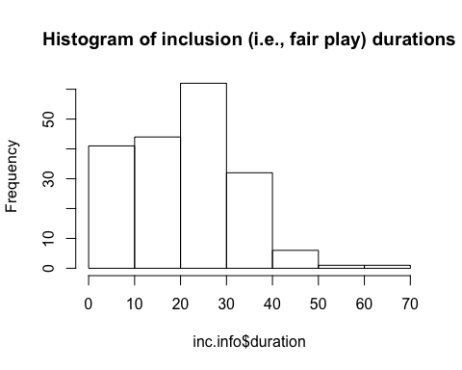

|  |  |
| --- | --- |
|  | c(per_short.hi, per_long.hi, per_short.inc, per_long.inc) |
| %age of short hi blocks | 1.935484 |
| %age of long hi blocks | 6.451613 |
| %age of short inc blocks | 9.625668 |
| %age of long inc blocks | 14.973262 |

#list the files   
 setwd("/Volumes/research/tds/behavioral/cyberball/TDS2_cyberball_summary")  
listFiles<-list.files(summary_files_folder,recursive=T, pattern='cyb.*_2.csv$') # Can be 1 or 2 to examine inc or exc runs   
 df<-do.call("rbind", lapply(listFiles, read.csv, header = TRUE))  
   
 exc.info<-subset(df,df$name=="exc") # OR exc  
 fp.info<-subset(df,df$name=="fp") # and FP  
 pt_2.info<-subset(df,df$name=="pt")  
   
 hist(exc.info$duration, main= "Histogram of exclusion durations")

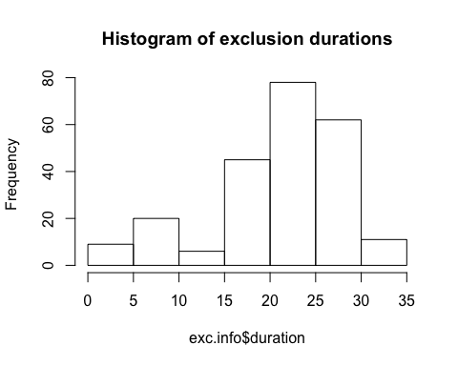

hist(fp.info$duration, main= "Histogram of fair play (within exc runs) durations")

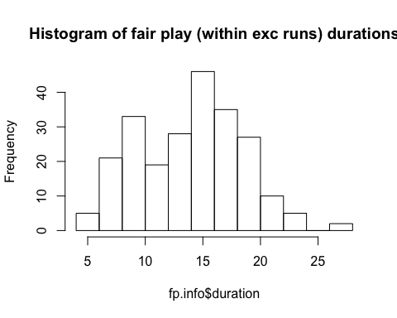

per_short.exc<-NROW(subset(exc.info, duration<7))/NROW(exc.info)*100  
 per_long.exc<-NROW(subset(exc.info, duration>35))/NROW(exc.info)*100  
   
 per_short.fp<-NROW(subset(fp.info, duration<7))/NROW(fp.info)*100   
 per_long.fp<-NROW(subset(fp.info, duration>35))/NROW(fp.info)*100  
   
 per_wrongduration_2<-as.data.frame(c(per_short.exc, per_long.exc, per_short.fp, per_long.fp), row.names=c("%age of short exc blocks", "%age of long exc blocks", "%age of short fp blocks", "%age of long fp blocks"))  
 kable(format="pandoc", per_wrongduration_2)

|  |  |
| --- | --- |
|  | c(per_short.exc, per_long.exc, per_short.fp, per_long.fp) |
| %age of short exc blocks | 9.523810 |
| %age of long exc blocks | 0.000000 |
| %age of short fp blocks | 3.463204 |
| %age of long fp blocks | 0.000000 |