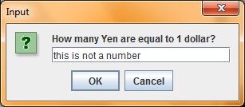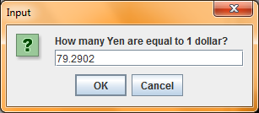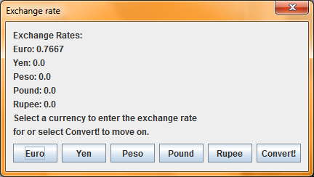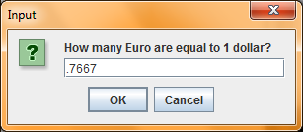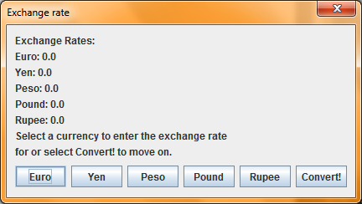

Displayed on execution.

User selects Euro and enters .7667 for the exchange rate.

Program returns to the exchange rate screen and the exchange rate for Euro that user just entered is displayed.

User selects Yen and enters 79.2902 for exchange rate.

Note: If, while entering exchange rates, user enters a value that is not a number, or an empty String…

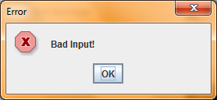 …they get an error message…

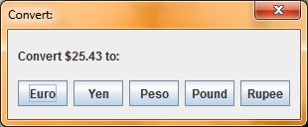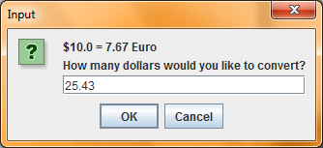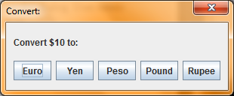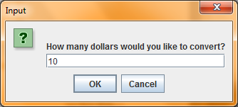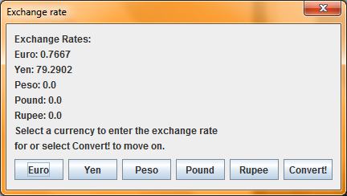

…and are returned to the exchange rate screen.

Clicking “Convert!” brings up this dialog. User enters $10.

User is prompted for which currency they would like to convert to. User selects Euro.

Conversion is displayed, rounded to two decimal places. User is prompted again for conversion amount, and user enters $25.43.

User is prompted for which currency to convert to. User selects Yen.

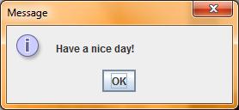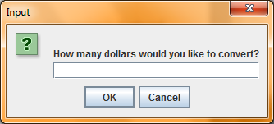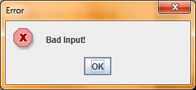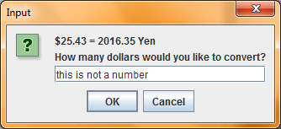

Conversion is displayed, rounded to two decimal places. Note: like the input dialog for entering the exchange rate, if user enters a non-number…

…then an error message is displayed…

…and user is reprompted.

To exit the program, user does one of the following:

* closes any dialog
* clicks cancel on any input dialog
* clicks “Ok” on a conversion input dialog (not exchange rate input dialog) without entering anything

… and then a farewell message is displayed.