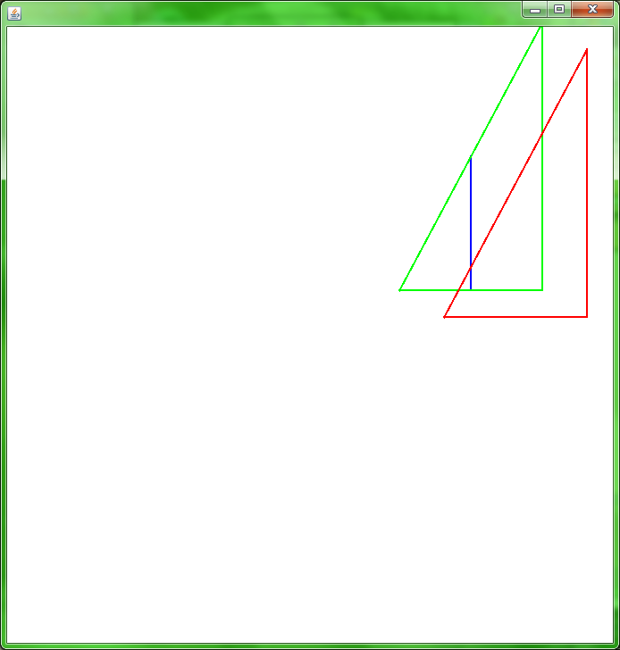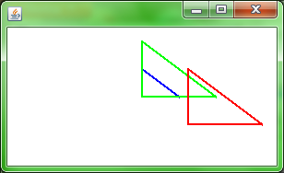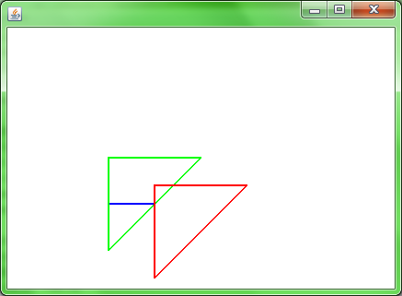 These are the output TurtleGraphics, corresponding to the three sets of data shown in the terminal window starting at the picture directly below and continuing clockwise.