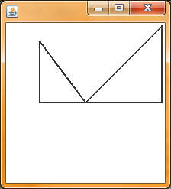

This is the first drawing. The triangle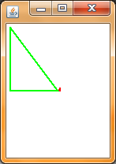 on the right is t1 and on the left is t2. Both are black.

This is the second drawing. On the right is t1, reduced to 3.0 x 3.0 and changed to red. On the left is t2, the same size but changed to green.