16009442

David Geraghty

[Project report]

CSCCOREC001AZ2016/7

Report Contents

Glossary of technical terms (Section 1) 2

Introduction (Section 2) 3

Design (Section 3) 3

Implementation (Section 4) 4

Conclusion (Section 5) 4

Appendices (Section 6.0) 5

Appendices A (6.1) 5

Appendices B (6.2) 5

# Glossary of technical terms (Section 1)

CSS – Cascading style sheet

2D – Two dimensional

3D – Three dimensional

HTML – Hypertext mark-up language

JS – JavaScript

WS – Website

# Introduction (Section 2)

This project describes the process of designing a static website, a static website was chosen rather than a dynamic website because of the improved performance for end users. It was created using hypertext mark-up language (HTML) cascading style sheets (CSS) and JavaScript (JS).

The idea behind creating this website was to provide an online gallery and shop for a multi skilled artist, upon doing research into similar websites it became apparent that the majority were generic and not very artistic, I wanted this project to be different. It was of great importance that it is user friendly, can be used cross platform on online devices and is aseptically pleasing, the last point is the most important to create for this project, in achieving all of this I hope it will increase product awareness and generate more sales for the artist.

As the aesthetics of the website were the most important part of the project, ideas were researched for the website to try and set it apart from the usually craft website, as most websites are 2D and can look flat on the screen it was key that this WS would have a 3D look and layers/levels on the different sections of the website.

# Design (Section 3)

The design process was broken up into Four stages. The first stage was to decide a layout for the website and identifying what sections would be in the HMTL, how many pages it would consist of and the location of the different sections to be displayed on the WS (See appendices A). The next stage was to identify tags and div tags for use in implementing the initial stage of the design process that would create a general layout for future development of the WS (see appendices B).

The second stage was to search online for jpg images that would appear on the WS, following this the content was added to the sections they were required in. The idea of having the website look 3D was of great importance to the scope of work for the WS project, upon doing research into how to make the WS appear 3D to the end user it became apparent that the use of padding, shadows and borders defined in the CSS would be crucial to achieve this. The third stage was the styling of the WS, through trial and error the sizes of padding, shadow and borders were defined in pixels within the CSS for most sections and certain tags within the website, this aided in building from the base canvas of the website to make certain sections appear lower and some sections appear higher and create that 3D look that was so important for this WS project. Following this a flexible box model was created to enable the WS to be used on different online devices.

The third stage was to identify was JS would be need to be implemented on the WS, Three JS Implementations were chosen the first being the user of the WS would not be able to right click and save images on the WS, this was of great importance because of the nature of the WS and it displaying and artists work, it would stop users saving images and forging them. The second was to display a clock in the footer, the third was to create a contact form so the artist could be contacted from users of the WS for enquiries.

# Implementation (Section 4)

Upon starting the implementation of the WS, research was key to decide what development kit would be used for implementing the WS, as the website needed to be hand coded it limited the choices available for developing the WS. The choices were narrowed down to Three, those being Microsoft visual studio, notepad and notepad ++. Notepad ++ was chosen because of its application speed and its capability to minimise and maximise sections of the code, this was important because of length of the code used to implement the WS, it enabled the use of minimising the sections that were not being worked on, therefore made it much easier to code and not get lost in the other sections of code.

Upon trying to develop the website a couple of problems were encountered, the first being using CSS to style the img tag that appeared on the WS, as the styling for the img tag was defined using padding and shadows to create a 3D look on the social images it made every image that was added to the WS using the img tag look the same, this was solved by creating a new tag social img that would just define the styling of those images. The next problem that was encountered was trying to implement a clock in the footer of the WS, although the JS had been implemented correctly the clock would still not display in the footer of the WS, this was solved by changing the body tag to body onload="startTime()" following this the clock displayed in the footer.

# Conclusion (Section 5)

To conclude the project has achieved everything that was set out for it, it has a 3D look and has an artistic feel to the WS, the use of the matching colour schemes and all the CSS used within the WS make it very aesthetically pleasing and the clear fonts and easy navigation make it easy to use for the end user. Although much was achieved for the website a few things were not. Future developments for the website would involve creating a live feed on the news section displaying the artists Facebook, an initial screen that when the user clicks a button it would action graphics and then the home screen of the WS would appear. Finally, a flexible box model would be researched and implemented for the images that appear in the main section, as the way it is when the screen is scaled down for mobile use the images break out of the main section.

# Appendices (Section 6.0)

## Appendices A (6.1)

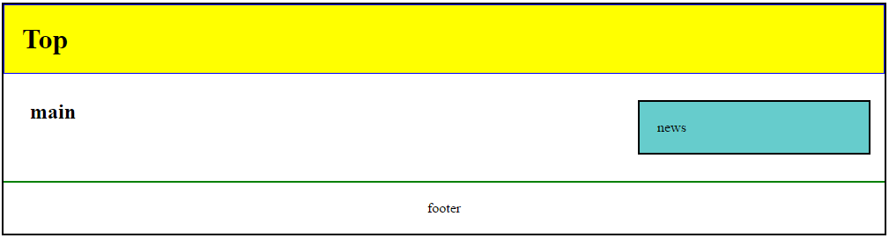

## Appendices B (6.2)

<!DOCTYPE html>

<html lang="en">

<head>

<script></script>

<title></title>

</head>

<body>

<div id="big_wrapper">

<header id="top_header">

<div id="social">

<tr>

<td><a /></a></td>

</tr>

</div>

</header>

<nav id="top_menu">

<ul>

<li><a> </a></li>

</ul>

</nav>

<section id="main_section">

<article>

<Header>

<hgroup>

</hgroup>

</article>

</section>

<aside id="side_news">

</aside>

</div>

<footer id="the_footer">

</footer>

</div>

</body>

</html>