**RESEARCH**

**Scope**

**Objectives**

Let the users to communicate with MMU University online system in a convenient platform and in a playful way.

**Audit**

**Business and marketing plans**

|  |  |
| --- | --- |
|  | **Marketing Theme: Convenient and fun platform** |
| **Category** | **Strategy** |
| Users: | 1. MMU University students |
| What is important to users based on their behaviour: | 1. 1. A playful campus environment  2. 2. Music and grades are the most important for motivation in studying.  3. 3. Playing games and watching drama are the main options for users to enjoy after finishing work.  4. 4. A multifunctional application is preferable |
| Existence of this project: | Let the users to communicate with MMU University online system in a convenient platform and in a playful way. |
| What sets this project apart from the rest: | 1. 1. A platform that creates informative, playfulness and convenience to users.  2. 2. A multifunctional website is created to combine all MMU online systems ( i.e Camsys and MMLS) with only one access password.  3. 3. A game is added as optional to create playfulness for students.  4. 4. A setup character as users themselves, and upgrade to higher level by upgrading their own grades. Users can beat other students by having higher grade. Coins are earned through the accessing of MMU system website. |
| Goals: | 1. 1. To motivate users to study for good grades  2. 2. To let users communicating with MMU system frequently  3. 3. To let the users have a playful campus environment  4. 4. To let the users to have a multifunctional and convenient platform |
| Platform to be presented: | 1. MMU system website |
| What will trigger users to think of this project: | 1. 1. A playful platform and yet informative and convenient  2. 2. A not traditional kind of university platform for students to communicate with |
| Programs that are running to reach the goals: | 1. 1. The design elements of the website  2. 2. The multifunctional application in the website |

2.branding strategy

|  |  |
| --- | --- |
|  |  |
| **Brand Story** | **Description** |
| Brand Vision | All students in MMU University want to visit MMU system not only for the exam or finance purpose. |
| Brand Values | 1.  1. Fun  The concept of fun needs to be cultivated in the campus. Fun environment is one of the important essentials for students to achieve good grades.  2. 2. Informative  A good platform needs to have variety and useful information for letting students to know the latest information.  3. 3. Convenience  The convenience purpose is important for students to get information from one source, which students only need to access one platform and remember one password. |
| Users Promise | “Information and convenience are both important in our lives but playfulness are definitely the most important to be part of our lives.”  Information, convenience and playfulness are promised to be gained in this program. This platform is able to help users in academic process and gain information in a convenience and playful way. |
| Collaboration | 1. 1. SRC |

3. Competitors

Camsys, MMLS

**Stakeholder Interviews**

1. **Product vision**
2. Users able to have a playful campus environment while study for good grades.
3. Users can enjoy playing games and studying at the same time.

**2. Risks**

1. Users do not think that study can make a campus environment to become playful.
2. Users ignore the game if they think it is not interesting and playful.

**3. Constraints**

Users are limited to upgrade their game levels in a short time period.

**User Interviews & Observations**

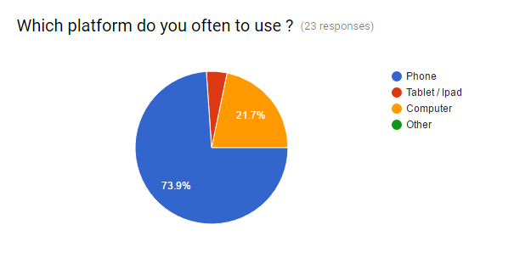

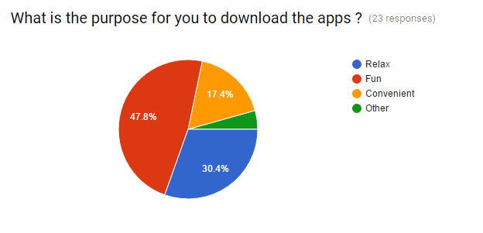

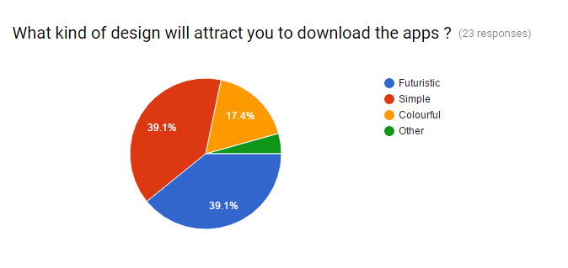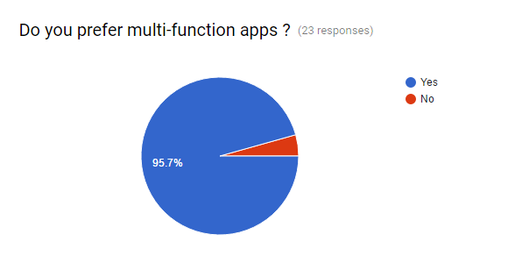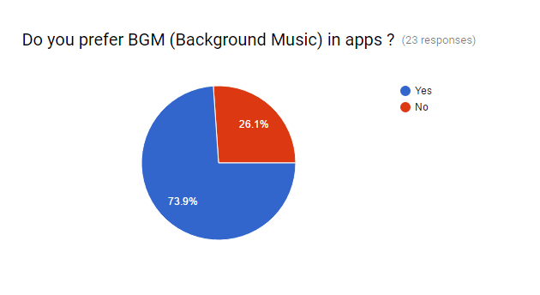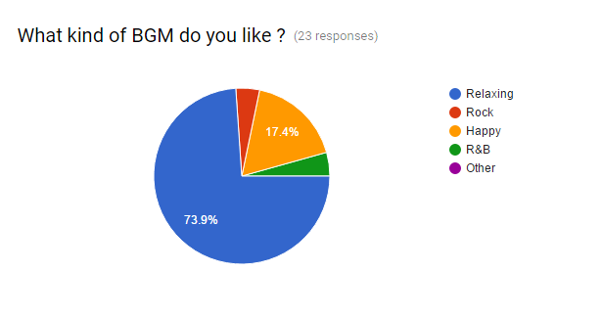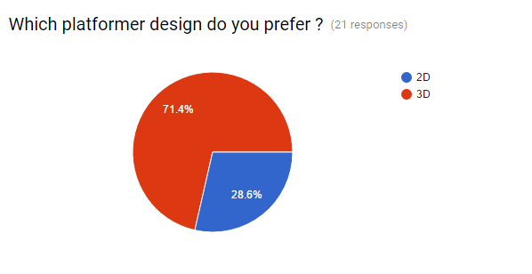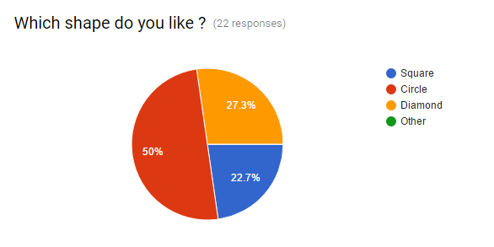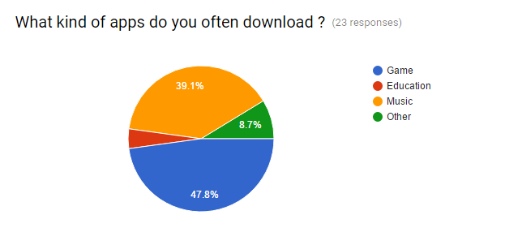

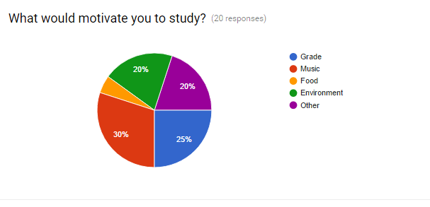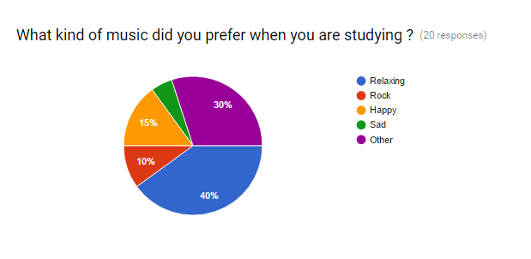

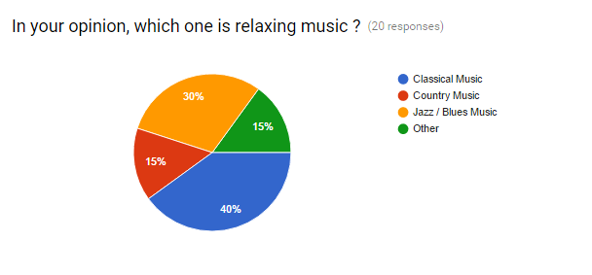

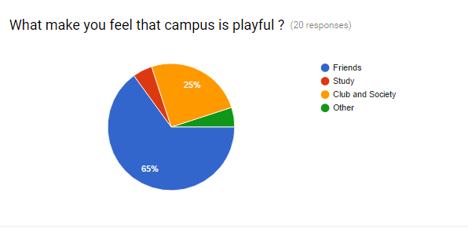

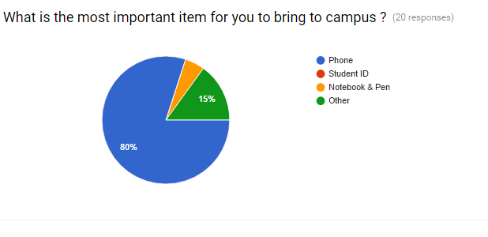

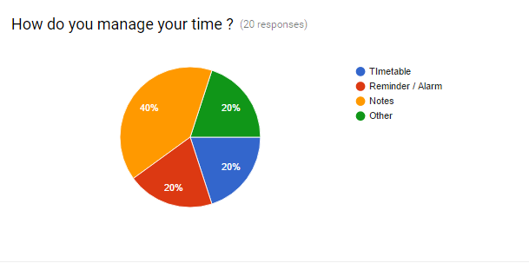

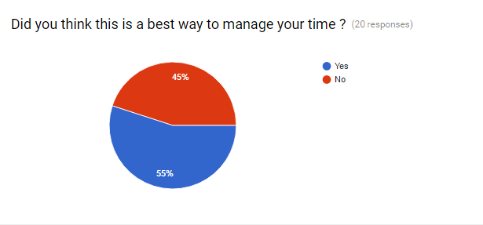

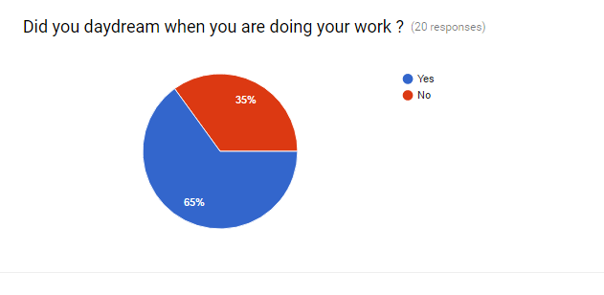

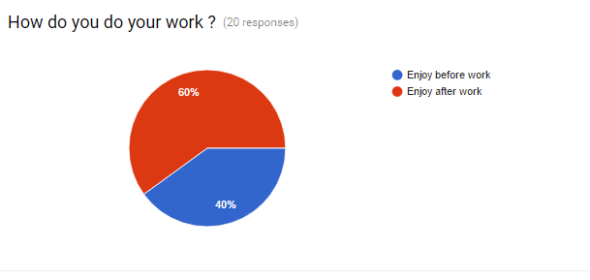

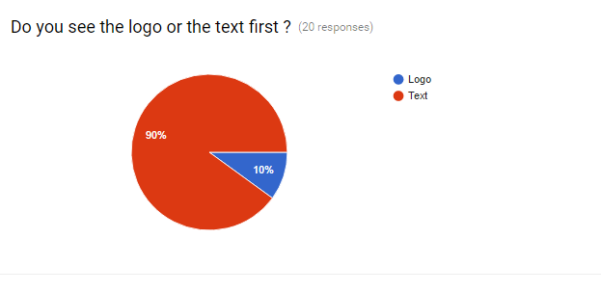

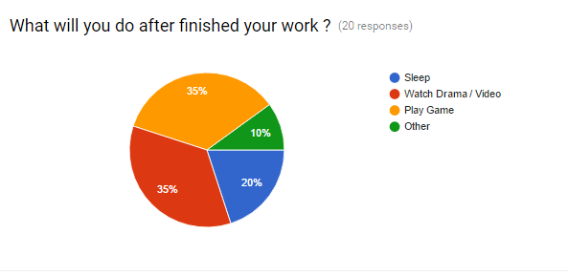

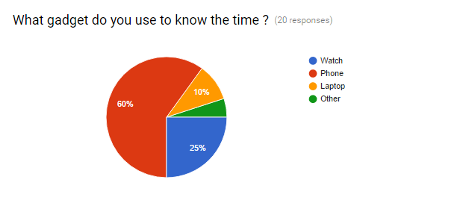

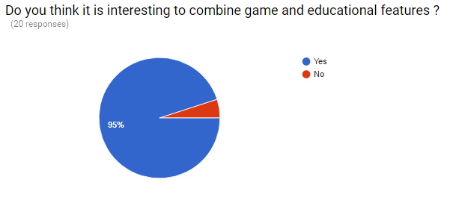

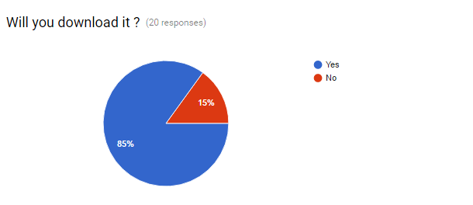

**MODELING**

**Personas**

|  |  |
| --- | --- |
| ***Name*** | Susan |
| ***Age*** | 22 years old |
| ***Gender*** | Female |
| ***Occupation*** | University Student |
| ***Faculty*** | Faculty of Management |
| ***Status*** | Single |

**Bio**

Susan is an undergrad business management student in Multimedia University, Cyberjaya. She constantly use her phone to download game and music when she is free. During the study week, music is her motivation to study. While she is downloading her note and exam slip , she found that the online system of her campus is inconvenient to use. She needs to login to the two different online system to download the essential information that she need throughout her academic studies everytime.

After finished her work, she will like to play online game with her friends for relax from the stress. She like to play challenging game with her friends because she feels connected with her friends. She like the simple design instead of colourful design.

**Goal**

* To have a multifunction apps for her study life.
* Need a more convenient platform to assist her academic study.

**Pattern in User & Customer Behaviors**

* **Campus Life**



***Playful Stress***

* **Type of Music**



***Rock Relaxing***

* **Purpose Dowload Apps**



***Fun Relax***

* **Platformer**



***2D 3D***

* **Activity after finished work**



***Play Game Sleep***

**Attitudes**

* Hardworking
* Outgoing
* Challenging
* Friendly

**Aptitudes**

Software 

Mobile Apps 

Online Game 

Social Networks 

**Environments**

* Noisy
* Limited space for study

**Tools**

Phone 

Tablet 

Computer 

**Challenges**

* Futuristic and simple visual design
* Multifunction feature
* Convenient to assist